BIRD SPECIES CLASSIFICATION USING DINOV2
(BIRDVISION AI)
A Comprehensive Mini-Project Technical Report in Artificial Intelligence & Data Science
TABLE OF CONTENTS
ABSTRACT 5
LIST OF FIGURES 7
LIST OF TABLES 8
CHAPTER 1 – INTRODUCTION 9
1.1 Introduction to Bird Species Classification 9
1.2 Background of Fine-Grained Image Classification 9
1.3 Problem Statement 10
1.4 Objectives of the Project 11
1.5 Scope of the Project 11
1.6 Motivation 12
1.7 Applications 12
1.8 Report Organization 13
CHAPTER 2 – SYSTEM ANALYSIS 14
2.1 Literature Review 14
2.2 Existing System 15
2.3 Limitations of Existing System 15
2.4 Proposed System 16
2.5 Advantages of Proposed System 17
2.6 Comparative Analysis 17
2.7 Technical Challenges 18
CHAPTER 3 – REQUIREMENT SPECIFICATION 19
3.1 Hardware Requirements 19
3.2 Software Requirements 19
3.3 Functional Requirements 20
3.4 Non-Functional Requirements 21
3.5 Operational Requirements 22
3.6 User Interface Requirements 22
CHAPTER 4 – SYSTEM DESIGN 23
4.1 Overall System Architecture 23
4.2 Data Flow Diagram 24
4.3 Use Case Diagram 24
4.4 Activity Diagram 25
4.5 Sequence Diagram 26
4.6 Dataset Design and Class Mapping 26
4.7 Model Architecture Design 27
4.8 API Design 29
4.9 Frontend Design 30
4.10 Deployment Architecture 30
CHAPTER 5 – MODULE DESCRIPTION 32
5.1 Dataset Preparation Module 33
5.2 Dataset Verification Module 33
5.3 Dataset Preprocessing Module 33
5.4 DINOv2 Model Training Module 34
5.5 Model Evaluation Module 35
5.6 ONNX Export Module 35
5.7 ONNX Verification Module 36
5.8 FastAPI Backend Module 36
5.9 React/Vite Frontend Module 37
5.10 BirdVision AI Prediction Module 37
5.11 Deployment Module 37
CHAPTER 6 – IMPLEMENTATION 38
6.1 Dataset Acquisition and Extraction 38
6.2 Dataset Verification and Class Mapping 38
6.3 Dataset Preprocessing and Data Loaders 38
6.4 DINOv2 Architecture Implementation 39
6.5 Classification Head Adaptation and Layer-wise Learning Rate Decay 39
6.6 Training Configuration and Optimization Workflow 40
6.7 Multi-Resolution Evaluation and Test-Time Augmentation 41
6.8 ONNX Model Compilation and Numerical Parity Verification 42
6.9 FastAPI Backend Implementation 42
6.10 React/Vite Frontend Implementation and Integration 43
6.11 Production Cloud Deployment and End-to-End Workflow 43
CHAPTER 7 – TESTING AND RESULTS 45
7.1 Testing Methodology and Test Cases 45
7.2 Model Performance and Experimental Progression 46
7.3 Mathematical Accuracy Increase and Decrease Analysis 47
7.4 Accuracy Trade-Offs, Multi-Scale Ablation, and Latency Analysis 48
7.5 ONNX Runtime Verification Results 48
7.6 Taxonomic Error Analysis and Same-Genus Confusions 49
7.7 Production Deployment Verification 50
7.8 Visual Verification and User Interface Dashboards 50
CHAPTER 8 – CONCLUSION AND FUTURE ENHANCEMENTS 53
8.1 Conclusion 53
8.2 Project Achievements 53
8.3 Limitations 54
8.4 Future Enhancements 54
REFERENCES 56
APPENDIX A – PROJECT ARTIFACTS 57
A.1 Project Directory Structure 57
A.2 Important Source Files and Scripts 57
A.3 Key Implementation Code Snippets 58
APPENDIX B – DEPLOYMENT DETAILS 59
B.1 Local Setup and Workstation Execution 59
B.2 Cloud Production Topology and Verified URLs 59
B.3 API Usage and cURL Execution Examples 60

ABSTRACT
Fine-grained visual categorization (FGVC) within the avian biological domain represents one of the most intellectually demanding frontiers in modern computer vision. Unlike coarse-grained object recognition, avian taxonomy requires distinguishing between 1,486 sympatric and morphologically indistinguishable species characterized by subtle diagnostic variations, sexual dimorphism, ontogenetic plumage shifts, seasonal molting patterns, and non-rigid postural transformations in natural, unconstrained habitats. Traditional deep learning approaches based on Convolutional Neural Networks (CNNs)—such as MobileNetV3 and EfficientNet families—suffer from localized inductive bias and fixed receptive fields, failing to reliably capture micro-textures across critical anatomical landmarks (beak culmen, eye-rings, crown streaks, wing covert bars, and tail retrices).
To overcome these foundational limitations, this project presents BirdVision AI, an end-to-end autonomous deep learning ecosystem powered by Meta's self-supervised Vision Transformer foundation model, DINOv2 (ViT-Base/14). Leveraging a curated subset of the iNaturalist 2021 Mini dataset comprising 89,160 expertly verified avian images across 1,486 distinct taxa (74,300 training samples and 14,860 validation samples in an exact 50:10 stratified split), we implement a progressive fine-tuning methodology. The model architecture incorporates high-resolution 448×448 pixel spatial tokenization (1,024 visual tokens), 2D bicubic positional embedding resampling, and Layer-wise Learning Rate Decay (LLRD with a decay coefficient of 0.65 across transformer blocks 8 through 11). Regularization is enforced via label-smoothed cross-entropy (epsilon = 0.10), AdamW weight decay (0.05), and mixed-precision (FP16 AMP) gradient accumulation.
Comprehensive empirical evaluation on the full, untouched 14,860-image validation corpus demonstrates substantial performance breakthroughs. The single-model DINOv2 448px production engine achieves a Top-1 accuracy of 79.60%, Top-5 accuracy of 91.12%, and Macro F1-score of 79.58% with zero zero-recall classes—representing a +24.67 percentage point absolute increase (+44.91% relative improvement) over the legacy EfficientNet-B2 production baseline (54.93%). Applying horizontal-flip Test-Time Augmentation (TTA) elevates Top-1 accuracy to 79.80% (+0.20 percentage points; +0.251% relative gain). Furthermore, our multi-resolution tri-scale probability ensemble (combining 448px, 392px, and 336px representations) breaks the project's primary mission threshold, achieving 80.03% Top-1 accuracy, 91.22% Top-5 accuracy, 81.65% Macro Precision, 80.03% Macro Recall, and 80.02% Macro F1-score.
For production operationalization, the high-capacity Vision Transformer was compiled into a standalone 351 MB Open Neural Network Exchange (ONNX) graph (Opset 17) maintaining strict numerical parity (maximum absolute difference <= 1.335e-5 vs PyTorch FP32). An asynchronous, non-blocking RESTful backend was developed using FastAPI and Uvicorn, delivering ultra-low CPU/GPU inference latency (25–35 ms). A modern, responsive web application was engineered utilizing React 18, TypeScript, Vite, and Tailwind CSS, featuring drag-and-drop ingestion, interactive confidence progress bars, taxonomic hierarchy inspection, and pre-loaded specimen testing. The complete architecture is dual-cloud deployed across Vercel (Edge CDN frontend) and Render (containerized backend), establishing a scalable, cloud-native diagnostic tool for field ornithologists, ecological researchers, and citizen scientists.

LIST OF FIGURES
Figure 1: BirdVision AI Multi-Tier System Architecture
Figure 2: iNaturalist 2021 Mini (Aves) Dataset Ingestion & Preparation Pipeline
Figure 3: DINOv2 Fine-Tuning with Layer-wise LR Decay (LLRD) Workflow
Figure 4: BirdVision AI System UML Use Case Diagram
Figure 5: BirdVision AI Image Prediction UML Sequence Diagram
Figure 6: Meta DINOv2 ViT-Base/14 Fine-Grained Model Architecture
Figure 7: BirdVision AI Web Application Prediction Lifecycle
Figure 8: Dual-Cloud Production Deployment Architecture (Vercel & Render)
Figure 9: Rigorous 14,860-Image Full Validation Evaluation Workflow
Figure 10: DINOv2 ONNX Export, Graph Validation, and Numerical Parity Verification
Figure 11: BirdVision AI Web Application Homepage and Image Ingestion Interface
Figure 12: Real-Time Inference Results Card with Top-5 Taxonomic Ranking
Figure 13: FastAPI Interactive Swagger UI and OpenAPI Endpoint Documentation
Figure 14: Model Progression and Top-1 vs Top-5 Convergence Dashboard

LIST OF TABLES
Table 3.1: Hardware Requirements Specification across Development and Deployment
Table 3.2: Software Environment and Framework Dependency Versions
Table 3.3: Functional Requirements Specification Matrix
Table 3.4: Non-Functional Requirements and Operational Constraints
Table 4.1: iNaturalist 2021 Mini (Aves) Dataset Distribution and Stratification
Table 4.2: BirdVision AI RESTful API Endpoint Specifications
Table 5.1: Core Architectural Modules and Source Code Implementation Artifacts
Table 6.1: DINOv2 ViT-Base/14 Structural Configuration Parameters
Table 6.2: Transformer Parameter Allocation and Freezing Breakdown
Table 6.3: Hyperparameter and Regularization Optimization Configuration
Table 6.4: Multi-Resolution Input Token Geometry and Compute Characteristics
Table 7.1: Comprehensive Unit, Integration, and System Test Cases
Table 7.2: Avian Classification Experimental Progression and Model Benchmark (14,860 Images)
Table 7.3: Mathematical Accuracy Increases, Decreases, and Relative Improvement Formulations
Table 7.4: Multi-Resolution Scale Ablation and Ensemble Contribution Metrics
Table 7.5: ONNX Runtime vs PyTorch FP32 Numerical Parity and Latency Benchmarks
Table 7.6: Hard Confusion-Pair Analysis and Genus-Level Ambiguity Distribution
Table 7.7: Production Cloud Deployment Verification and Health Check Audit
Table A.1: Project Directory Structure and Master Artifact Manifest
Table B.1: Deployment Topology, Endpoints, and Production Service URLs

CHAPTER 1 – INTRODUCTION

1.1 Introduction to Bird Species Classification
Avian biodiversity serves as one of the most critical bio-indicators of ecosystem health, global climate dynamics, and habitat integrity. Over 10,000 extant avian species populate ecological niches across terrestrial, marine, and limnetic environments worldwide. However, anthropogenic pressures—including deforestation, environmental pollution, habitat fragmentation, and rapid climate shifts—have accelerated biodiversity loss, placing thousands of avian taxa under existential threat. Accurate ecological monitoring, population census tracking, and species distribution modeling require extensive, continuous field observation.
Historically, avian taxonomy and identification have relied heavily upon skilled ornithologists equipped with field guides, spotting scopes, and acoustic recording equipment. While manual field identification remains the gold standard, it possesses inherent scaling limitations. Human experts cannot continuously monitor vast geographic areas, and citizen-science initiatives (e.g., eBird, iNaturalist) generate millions of crowd-sourced photographic observations annually, overwhelmingly exceeding the verification bandwidth of professional taxonomists. Automated visual classification systems capable of identifying bird species from unconstrained field photographs have thus transitioned from an academic curiosity into an indispensable tool for 21st-century conservation biology.

1.2 Background of Fine-Grained Image Classification
In the domain of computer vision, generic object classification tasks (such as those represented in ImageNet-1K) focus on distinguishing between visually distinct semantic categories (e.g., differentiating a bird from an automobile, a canine, or an aircraft). In stark contrast, Fine-Grained Visual Categorization (FGVC) involves discriminating between subordinate categories belonging to the exact same biological genus or family.
Fine-grained avian classification introduces severe computational and morphological challenges:
- Extreme Inter-Class Similarity: Many sympatric bird species share virtually identical body shapes, wing structures, and primary color patterns. The diagnostic distinctions that separate distinct species often reside in minute localized morphological features, such as the color of a faint eye-ring, subtle streaking on the breast feathers, the specific curve or coloration of the beak culmen, or the number of white spots on outer tail feathers (retrices).
- Substantial Intra-Class Variance: Individual specimens of the exact same species exhibit pronounced visual variance driven by sexual dimorphism (drastically differing male and female plumages), seasonal molting cycles (nuptial vs. eclipse plumage), ontogenetic developmental stages (juvenile, sub-adult, and adult plumages), regional morphs, and variable lighting angles.
- Environmental & Postural Distortion: Unlike rigid artificial objects, birds are non-rigid organic entities that adopt extreme postural variations during flight, perching, foraging, and preening. Natural field images frequently exhibit heavy background clutter (dense foliage, twigs, water glare), partial occlusions, motion blur, and variable focal distances.

1.3 Problem Statement
Developing a high-accuracy, robust, and deployable computer vision system for fine-grained bird species classification presents three critical engineering and algorithmic bottlenecks:
- Algorithmic Inadequacy of Classical CNNs: Standard Convolutional Neural Networks (CNNs), including MobileNetV3 and EfficientNet-B0/B2, enforce localized inductive bias via small convolutional receptive fields. When trained on large-scale avian datasets spanning over a thousand classes, CNNs tend to focus on global contours and dominant background context, failing to capture subtle diagnostic micro-textures. In our empirical baselines, EfficientNet-B2 achieved only 54.93% Top-1 accuracy across 1,486 species.
- Scale and Class Imbalance Constraints: Real-world biological datasets contain hundreds or thousands of classes. In the iNaturalist 2021 Mini benchmark, the avian subset spans 1,486 distinct species with 74,300 training images (exactly 50 images per species). Standard deep models suffer from severe gradient starvation on tail categories, resulting in low macro precision and entire species clusters collapsing to zero recall.
- Edge and Cloud Deployment Latency: High-capacity Vision Transformers (ViTs) are notorious for heavy computational demands, quadratic self-attention complexity, and substantial memory footprints. Translating a high-resolution 448×448 ViT model into a deployable, real-time web application capable of running on modest cloud infrastructure (e.g., 2 GB RAM instances) with sub-50ms inference latency without degrading diagnostic accuracy requires sophisticated model compilation, numerical parity validation, and asynchronous architectural design.

1.4 Objectives of the Project
The primary objective of this project is to architect, optimize, evaluate, and deploy BirdVision AI—a comprehensive, production-grade deep learning web platform that achieves state-of-the-art fine-grained bird species identification across 1,486 taxa. Specific sub-objectives include:
- Self-Supervised Backbone Adaptation: Leverage Meta's self-supervised Vision Transformer foundation model (DINOv2 ViT-B/14) and adapt its rich patch-level feature representations to fine-grained avian taxonomy.
- High-Resolution Spatial Tokenization: Implement a 448×448 high-resolution tokenization pipeline (1,024 visual tokens) with 2D bicubic positional embedding interpolation to capture localized diagnostic feather patterns.
- Layer-wise Learning Rate Optimization: Execute a progressive fine-tuning strategy incorporating Layer-wise Learning Rate Decay (LLRD decay coefficient 0.65 across blocks 8–11) to preserve foundational visual primitives while fine-tuning deep semantic abstractions.
- Ensemble & TTA Accuracy Breakthrough: Surpass the ambitious mission threshold of 80.00% Top-1 accuracy on the complete 14,860-image validation corpus using horizontal-flip Test-Time Augmentation (TTA) and multi-resolution tri-scale probability ensembling (448px, 392px, 336px).
- Production Graph Compilation: Export and validate an optimized ONNX runtime graph (Opset 17) achieving strict numerical parity (max absolute diff <= 1.335e-5) and sub-35ms inference latency.
- Full-Stack Cloud Deployment: Build an asynchronous FastAPI backend and a modern React 18 TypeScript Vite frontend, deploying the unified ecosystem across Vercel (Edge CDN) and Render (Cloud Web Service).

1.5 Scope of the Project
The scope of the BirdVision AI project encompasses the following dimensions:
- Taxonomic Coverage: The system covers exactly 1,486 distinct bird species from class Aves, derived from the globally recognized iNaturalist 2021 Mini dataset. This encompasses diverse global orders including Passeriformes (perching birds), Falconiformes (falcons), Accipitriformes (hawks and eagles), Anseriformes (waterfowl), Piciformes (woodpeckers), and Strigiformes (owls).
- Dataset Volume: A total of 89,160 expert-verified field images are ingested, partitioned into 74,300 training images (exactly 50 per class) and 14,860 validation images (exactly 10 per class). Zero validation leakage is strictly enforced.
- Architectural Frontiers: Investigation of Convolutional baselines (MobileNetV3, EfficientNet-B0, EfficientNet-B2) versus Vision Transformers (DINOv2 ViT-Base/14), exploring linear probing, progressive unfreezing, multi-resolution scaling, and TTA.
- Software & Platform Architecture: Development of an end-to-end software ecosystem including offline training scripts, validation aggregators, ONNX converters, a RESTful API backend, and an interactive single-page web application.

1.6 Motivation
The urgent necessity for automated avian identification stems from the critical intersection of ecological preservation and artificial intelligence. Birds are highly sensitive to environmental disturbances such as pesticides, urbanization, and climate fluctuations. Sudden declines in specific bird populations frequently signal broader ecosystem collapse. However, collecting biodiversity data across global scales is bottlenecked by the availability of human experts.
Recent breakthroughs in self-supervised visual representation learning—specifically Meta's DINOv2—demonstrated that large-scale Vision Transformers trained on hundreds of millions of curated images (LVD-142M) develop emergent properties. These models implicitly learn semantic segmentation, fine part correspondences, and occlusion-invariant feature maps without requiring human labels. Harnessing these emergent representations for avian conservation bridges the gap between frontier AI research and urgent environmental monitoring.

1.7 Applications
BirdVision AI enables diverse high-impact applications across scientific, educational, and commercial domains:
- Ecological Field Research: Biologists and ornithologists can rapidly catalog avian specimens photographed during ecological surveys, accelerating population density and biodiversity assessments.
- Autonomous Wildlife Monitoring: The low-latency ONNX inference engine can be embedded within edge devices connected to automated camera traps in national parks, logging migratory patterns in real time.
- Citizen Science Platforms: The REST API can integrate into platforms like eBird and iNaturalist to provide immediate automated species verification for amateur birdwatchers.
- Aviation Safety Systems: Airports can utilize real-time avian detection to monitor airspace for flocking bird species known to pose bird-strike hazards to departing and landing aircraft.
- Educational & Eco-Tourism Tools: Nature reserves, wildlife sanctuaries, and botanical gardens can deploy the responsive web interface as an interactive digital guide for tourists and students.

1.8 Report Organization
The remainder of this technical report is structured as follows:
- Chapter 2 (System Analysis): Presents a comprehensive literature review of fine-grained classification, analyzes existing CNN-based systems, details their shortcomings, and outlines the proposed DINOv2 architecture.
- Chapter 3 (Requirement Specification): Specifies hardware, software, functional, non-functional, operational, and user interface requirements.
- Chapter 4 (System Design): Delineates the overall system architecture, UML use case, activity, and sequence diagrams, API contracts, model geometry, and cloud deployment topology.
- Chapter 5 (Module Description): Provides detailed structural descriptions of all eleven core project modules.
- Chapter 6 (Implementation): Details the engineering implementation, dataset curation, LLRD fine-tuning, ONNX compilation, FastAPI routes, and React components.
- Chapter 7 (Testing and Results): Presents exhaustive testing results, mathematical accuracy gains/losses, precision/recall analyses, confusion analyses, and deployment verification.
- Chapter 8 (Conclusion & Future Enhancements): Summarizes key achievements, analyzes architectural limitations, and outlines future research trajectories.
- References & Appendices: Provides formal IEEE citations, project folder manifests, configuration tables, and deployment guides.

CHAPTER 2 – SYSTEM ANALYSIS

2.1 Literature Review
Fine-Grained Visual Categorization (FGVC) has been an active area of computer vision research for over a decade. Early approaches in avian classification relied upon handcrafted feature descriptors, such as Scale-Invariant Feature Transform (SIFT), Histogram of Oriented Gradients (HOG), and deformable part models (DPM). These methods attempted to localize predefined anatomical landmarks (e.g., bird head, torso, wings, and tail) before extracting textural features. However, handcrafted pipelines suffered from extreme sensitivity to background clutter, viewpoint variations, and severe occlusions, rarely exceeding 50% classification accuracy on benchmarks such as CUB-200-2011.
The advent of Deep Convolutional Neural Networks (CNNs) revolutionized fine-grained recognition. Architectures such as AlexNet, VGG, ResNet, and DenseNet demonstrated that deep hierarchical representations could automatically extract discriminating features. Bilinear CNNs (Lin et al., 2015) introduced second-order pooling to capture complex part interactions, significantly improving bird classification. Concurrently, attention-based CNNs—such as Recurrent Attention Convolutional Neural Networks (RA-CNN) and Multi-Attention CNNs (MA-CNN)—were proposed to iteratively crop and zoom into discriminative object parts without requiring manual bounding-box annotations.
More recently, the computer vision paradigm has shifted toward Transformer-based architectures following the seminal introduction of the Vision Transformer (ViT) by Dosovitskiy et al. (2020). By partitioning images into sequences of non-overlapping patches and processing them via multi-head self-attention mechanisms, ViTs eliminate the localized inductive biases inherent to convolutions. In 2023, Meta AI introduced DINOv2 (Oquab et al., 2023), a self-supervised foundation model trained on 142 million uncurated images (LVD-142M) utilizing student-teacher distillation with masked image modeling and patch-level contrastive objectives. DINOv2 demonstrated emergent dense visual representations capable of zero-shot part discovery, semantic segmentation, and extraordinary fine-grained discrimination, providing an ideal foundation for avian taxonomy.

2.2 Existing System
The existing legacy systems deployed for bird classification in field surveys and mobile applications primarily rely upon lightweight Convolutional Neural Networks, specifically the MobileNet and EfficientNet model families. In our benchmark environment, we evaluated three standard existing architectures trained on the 1,486-class iNaturalist avian dataset:
- MobileNetV3-Large: Designed for low-latency mobile inference using depthwise separable convolutions and squeeze-and-excitation blocks, operating at a standard input resolution of 224×224 pixels.
- EfficientNet-B0: The baseline of the compound-scaled convolutional family, optimizing depth, width, and resolution with 5.3 million parameters at 224×224 pixels.
- EfficientNet-B2: The legacy production model previously utilized in the project pipeline, incorporating 9.1 million parameters operating at 288×288 pixels.
In existing production pipelines, images are fed into these convolutional backbones followed by global average pooling and a fully connected linear layer. Some existing platforms deploy cloud-based inference endpoints utilizing standard PyTorch web servers running on CPU or GPU instances.

2.3 Limitations of Existing System
Rigorous empirical evaluation of existing CNN-based approaches revealed profound operational and algorithmic deficiencies:
- Severe Accuracy Degradation on Large Class Spaces: While EfficientNet models perform admirably on coarse-grained ImageNet-1K (distinguishing completely different object classes), their discriminative power collapses when scaled to 1,486 fine-grained avian species. On the full 14,860-image validation corpus, MobileNetV3-Large achieved only 41.69% Top-1 accuracy, EfficientNet-B0 achieved 44.91%, and the legacy EfficientNet-B2 baseline reached only 54.93%. More than 45% of test birds were misclassified.
- Localized Receptive Field Bottlenecks: Convolutional kernels operate locally (typically 3×3 or 5×5 pixels). Establishing long-range spatial relationships across distant bird anatomy (e.g., correlating the crown color with the tail retrices) requires deep stacking of layers, during which spatial resolution is aggressively downsampled. By the time features reach the final convolutional layers, fine diagnostic details (such as thin eye-rings or delicate wing bars) are irretrievably lost to pooling operations.
- Zero-Recall Class Collapse: Under standard CNN training, rare or challenging species suffer from gradient starvation. In our baseline audit, MobileNetV3-Large completely failed to predict 18 species (0.0% recall), EfficientNet-B0 failed on 14 species, and EfficientNet-B2 failed on 8 species, rendering them scientifically untrustworthy for biodiversity censuses.
- Sensitivity to Pose and Aspect Ratio Distortions: CNNs exhibit high sensitivity to non-canonical bird postures (e.g., upside-down woodpeckers, banking raptors, or swimming waterbirds). Convolutional kernels struggle to generalize when anatomical features appear in unusual spatial configurations.

2.4 Proposed System
To overcome the fundamental limitations of convolutional models, this project designs, implements, and deploys BirdVision AI—a comprehensive avian identification ecosystem built upon Meta's DINOv2 Vision Transformer (ViT-Base/14). The proposed system incorporates four interconnected algorithmic and architectural advancements:
- Foundation Vision Transformer Backbone: We utilize DINOv2 ViT-Base/14 comprising 12 multi-head self-attention transformer blocks, 12 attention heads per block, an embedding dimension of 768, and 87.7 million total parameters. Self-supervised pretraining on 142M images endows the backbone with profound emergent understanding of object geometry, texture boundaries, and part correspondences.
- High-Resolution Spatial Tokenization (448×448): We scale the input resolution from standard 224×224 up to 448×448 pixels. With a 14×14 patch size, each image is tokenized into exactly 1,024 visual tokens (a 32×32 grid) plus one class token ([CLS]). Positional embeddings are smoothly interpolated using 2D bicubic resampling. This 4x increase in token density allows the self-attention heads to focus directly on micro-anatomical structures.
- Layer-wise Learning Rate Decay (LLRD): To adapt the foundation model without destroying its generalized visual primitives, we freeze transformer blocks 0 through 7 and progressively fine-tune blocks 8 through 11 using an exponential layer decay coefficient of 0.65. The classification head receives a learning rate of 2.0e-5, while deeper blocks receive progressively attenuated learning rates (3.0e-6 down to 0.82e-6).
- Multi-Scale Ensembling & TTA: We implement horizontal-flip Test-Time Augmentation (TTA) and a calibrated multi-resolution tri-scale probability ensemble (combining predictions at 448px, 392px, and 336px) to maximize classification accuracy across varying camera zoom levels and bird sizes.
- High-Speed ONNX Runtime Engine: The fine-tuned model is compiled into an optimized 351 MB ONNX graph, delivering 25–35 ms inference on standard CPU/GPU execution providers and integrated into an asynchronous FastAPI backend and React 18 frontend.

2.5 Advantages of Proposed System
The proposed BirdVision AI architecture delivers decisive empirical and operational advantages:
- Dramatic Accuracy Breakthrough: The proposed DINOv2 448px single model achieves 79.60% Top-1 accuracy—a massive +24.67 percentage point absolute increase (+44.91% relative improvement) over the legacy EfficientNet-B2 baseline (54.93%). With the tri-scale ensemble, Top-1 accuracy reaches 80.03% and Top-5 accuracy reaches 91.22%.
- Elimination of Zero-Recall Classes: Across all 1,486 species evaluated on 14,860 validation images, DINOv2 achieves a minimum recall greater than 0% on every single class (zero zero-recall classes), ensuring balanced and equitable taxonomic coverage.
- Global Self-Attention Across Anatomical Regions: Unlike CNNs, multi-head self-attention computes pairwise token affinities across the entire 1,024-token field in every transformer block. The model effortlessly attends to correlations between the bill, eye-ring, wing coverts, and tail simultaneously, regardless of bird posture.
- Sub-35ms Production Latency: Through ONNX graph optimization, the model executes in 25–35 ms per inference pass, enabling instantaneous real-time feedback for web and mobile users.
- Complete Taxonomic Enrichment: Predictions are enriched with complete scientific classification (Order, Family, Genus, Species), common English vernacular names, and direct hyperlinks to verified iNaturalist taxon pages.

2.6 Comparative Analysis
A systematic comparison between the existing convolutional paradigms and the proposed DINOv2 Vision Transformer architecture is summarized below:
- Receptive Field: Existing CNNs utilize a localized, expanding receptive field constrained by convolutional kernel sizes; the proposed DINOv2 possesses an immediate, global receptive field across all 1,024 image patches from the first transformer layer.
- Feature Representation: Existing systems rely on supervised ImageNet-1K pretraining, which biases features toward global object shapes and textures; DINOv2 utilizes self-supervised DINO distillation on LVD-142M, yielding dense, semantic, part-aware representations.
- High-Resolution Scalability: Existing CNNs suffer substantial spatial distortion and computational inefficiency when scaled to 448×448 pixels; Vision Transformers natively scale via 2D bicubic positional embedding interpolation.
- Inference Portability: Existing systems require heavy PyTorch Python environments; the proposed system compiles to a self-contained ONNX graph deployable across diverse C++, Python, Rust, or JavaScript runtime runtimes.

2.7 Technical Challenges
Engineering and training the proposed system presented formidable technical challenges:
- VRAM Constraints on Consumer GPUs: Processing 448×448 images through an 87.7-million parameter Vision Transformer generates massive intermediate activation tensors during self-attention. Training on a consumer-grade NVIDIA GeForce RTX 3050 Laptop GPU (6 GB VRAM) caused immediate Out-Of-Memory (OOM) errors under standard batch sizes. This was overcome by implementing Automatic Mixed Precision (PyTorch FP16 AMP), a micro-batch size of 2, and gradient accumulation over 8 forward steps (effective batch size 16), stabilizing peak VRAM at 3.84 GB.
- Positional Embedding Resampling: DINOv2 was pretrained at 224×224 pixels (256 patch tokens). Up-scaling to 448×448 pixels (1,024 patch tokens) required dynamic 2D bicubic interpolation of the absolute positional embedding matrix without disrupting learned spatial semantics.
- ONNX Export Operator Incompatibilities: Initial attempts to export the PyTorch DINOv2 model to ONNX Opset 17 failed due to unsupported anti-aliasing bicubic upsampling operators ('aten::_upsample_bicubic2d_aa'). This was resolved by constructing a static-resolution model graph with pre-resampled positional embeddings prior to ONNX serialization.

CHAPTER 3 – REQUIREMENT SPECIFICATION

3.1 Hardware Requirements
The BirdVision AI project was conceptualized, trained, evaluated, and deployed across three distinct hardware tiers: the model development and training environment, the local evaluation and hosting workstation, and the production cloud deployment tier. The complete hardware specifications are detailed in Table 3.1.
Table 3.1: Hardware Requirements Specification across Development and Deployment
Environment Tier | Component | Hardware Specification | Operational Purpose
Model Training & Development | Processor (CPU) | AMD Ryzen 7 5800H (8 Cores, 16 Threads @ 3.2-4.4 GHz) | Data loading, multi-worker batch preprocessing, augmentation pipeline
Model Training & Development | Graphics (GPU) | NVIDIA GeForce RTX 3050 Laptop GPU (4GB / 6GB GDDR6) | FP16 AMP mixed-precision training, backpropagation, gradient accumulation
Model Training & Development | System RAM | 16 GB DDR4-3200 MHz Dual-Channel | Dataset caching, memory-mapped image tensors, OS overhead
Model Training & Development | Primary Storage | 512 GB NVMe PCIe Gen3 SSD | High-speed sequential I/O for 89,160 raw and preprocessed images
Local Workstation Hosting | Runtime Memory | 8 GB – 16 GB Available Physical RAM | Hosting dual Uvicorn ASGI backend and Vite frontend servers
Production Cloud Backend (Render) | Compute Instance | Render Web Service (Starter Plan: 1 vCPU, 2 GB RAM) | Containerized FastAPI hosting, ONNX Runtime CPU execution provider
Production Cloud Frontend (Vercel) | Edge CDN Network | Vercel Serverless Edge Global Distribution | Ultra-low latency worldwide static delivery of React single-page app

3.2 Software Requirements
To ensure reproducibility, stability, and high runtime efficiency, exact framework versions and software dependencies were cataloged across the machine learning, backend API, and frontend web stacks. The complete software requirements matrix is detailed in Table 3.2.
Table 3.2: Software Environment and Framework Dependency Versions
Software Layer | Framework / Tool | Exact Version | Functional Role in Project
Operating System | Microsoft Windows 11 Home | Build 22631 / 64-bit | Host operating system for local development, training, and testing
Core Language | Python | 3.12.3 (64-bit) | Primary programming language for deep learning, training scripts, and API
Deep Learning Engine | PyTorch | 2.11.0 + cu128 | Core tensor computation, autograd engine, FP16 AMP, and GPU scheduling
Vision Utilities | torchvision | 0.26.0 + cu128 | Image transformation pipelines, color jitter, tensor normalization
Model Architecture | timm (PyTorch Image Models) | 1.0.30 | Vision Transformer backbone instantiations and weight resampling
Model Inference | ONNX Runtime | 1.31.0 | Optimized cross-platform inference engine for compiled DINOv2 graph
Model Serialization | ONNX | 1.17.0 | Open Neural Network Exchange format specification and graph validation
Evaluation Metrics | scikit-learn & numpy | 1.6.1 / 2.5.2 | Macro precision, recall, F1-score computation, and confusion matrix
Backend API Framework | FastAPI | 0.143.0 | Asynchronous RESTful web framework with automatic OpenAPI documentation
ASGI Server | Uvicorn | 0.54.0 | High-performance asynchronous server gateway interface
Frontend UI Library | React | 18.2.0 | Declarative component-based user interface library
Frontend Language | TypeScript | 5.2.2 | Static type checking and interface contracts across web components
Build Tool & Dev Server | Vite | 5.4.21 | Ultra-fast frontend bundler and Hot Module Replacement dev server
Styling Engine | Tailwind CSS | 3.4.1 | Utility-first CSS framework for modern responsive UI styling

3.3 Functional Requirements
The functional requirements delineate the explicit algorithmic and software capabilities provided by the BirdVision AI ecosystem. These are tabulated in Table 3.3.
Table 3.3: Functional Requirements Specification Matrix
Req. ID | Functional Requirement | Input Specifications | Expected Output / Behavior
FR-01 | Image Ingestion & Format Validation | Multipart file upload (JPEG, PNG, WebP up to 10 MB) | Validate MIME type and payload size; reject non-image files with HTTP 400
FR-02 | Autonomous Image Preprocessing | Arbitrary dimension RGB image stream | Resize to 448×448 via bicubic filter; apply ImageNet mean/std normalization
FR-03 | Single-Model DINOv2 Prediction | Preprocessed tensor (1, 3, 448, 448) | Execute ONNX runtime engine; generate 1,486 class logits in 25–35 ms
FR-04 | Tri-Scale Ensemble Prediction | Original RGB image stream | Execute multi-scale inference (448px, 392px, 336px); aggregate weighted probabilities
FR-05 | Top-5 Taxonomic Ranking | Raw model output logit vector | Apply Softmax; sort descending; extract Top-5 class IDs and confidence values
FR-06 | Taxonomic Profile Enrichment | Predicted Class ID integer [0, 1485] | Query metadata; retrieve common name, scientific name, order, family, and URL
FR-07 | Interactive Species Catalog | Search query or pagination parameters | Paginate across all 1,486 taxa; return common names and scientific names
FR-08 | System Health & Diagnostic Check | GET request to /api/health | Return JSON: system status ('healthy'), loaded model, ONNX engine status, uptime

3.4 Non-Functional Requirements
Non-functional requirements specify the operational criteria, latency budgets, reliability standards, and security constraints governing the system, as outlined in Table 3.4.
Table 3.4: Non-Functional Requirements and Operational Constraints
Category | Constraint / Metric | Specified Target | Verification Method
Inference Latency | Single Image Prediction Time | < 50 ms (CPU/GPU Execution Provider) | Benchmarked average: 28.4 ms on standard workstation
Model Precision Parity | ONNX vs PyTorch Absolute Difference | < 1.0e-4 maximum error tolerance | Empirically verified: max diff = 1.335e-5 across all 1,486 logits
Classification Accuracy | Validation Corpus Top-1 Accuracy | >= 80.00% Top-1 Accuracy (Mission Target) | Achieved: 80.03% Top-1 on 14,860 images via Tri-Scale Ensemble
Zero-Recall Coverage | Minimum Recall per Taxon | > 0.00% across all 1,486 species | Verified: zero zero-recall classes across the entire validation set
Memory Footprint | Cloud Backend RAM Consumption | < 1.8 GB physical RAM at peak load | Render Starter container operates stably within 2 GB memory ceiling
System Availability | Cloud Production Service Uptime | >= 99.5% service availability | Monitored via Render automated health checks and Vercel edge uptime
Security & Privacy | Payload Sanitization & CORS | Strict file header validation; CORS whitelist | FastAPI CORSMiddleware configured; ephemeral memory image buffer

3.5 Operational Requirements
The operational requirements dictate the system's runtime deployment environment, logging policies, and exception handling protocols:
- Headless Server Execution: The backend service must operate as an autonomous daemon without requiring an active graphical desktop session, managed via systemd, PM2, or cloud container process supervisors.
- Graceful Degradation & Fallback: If GPU acceleration is unavailable, the ONNX Runtime execution provider must smoothly fall back to optimized CPU multithreading without throwing exceptions or requiring code reconfiguration.
- Ephemeral Memory Handling: Uploaded images must be processed strictly in volatile memory buffers (`io.BytesIO`) and discarded immediately following inference pass completion, preventing disk bloat and protecting user privacy.

3.6 User Interface Requirements
The frontend client must deliver an intuitive, responsive, and visually modern experience tailored for ornithologists and amateur bird enthusiasts:
- Responsive Layout: Seamless fluid layout adapting across desktop displays, tablets, and mobile smartphones utilizing responsive Tailwind CSS grid and flexbox primitives.
- Multi-Modal Image Input: Support drag-and-drop file dragging, native file browser selection, and instantaneous one-click loading of pre-verified sample bird specimens.
- Dynamic Visual Feedback: Display an interactive loading spinner during inference, followed by animated confidence progress bars color-coded by confidence tier: High (>=70% green), Moderate (40–69% amber), and Low (<40% red).

CHAPTER 4 – SYSTEM DESIGN

4.1 Overall System Architecture
BirdVision AI is designed as a modular, decoupled multi-tier architecture separating the client presentation layer, the API application gateway, the high-performance inference engine, and the persistent asset repositories. This separation of concerns ensures that the deep learning inference engine can be optimized, updated, or containerized independently of the user interface.
The presentation layer is implemented as a single-page application (SPA) executing within the user's web browser, built with React 18, TypeScript, and Tailwind CSS. The application layer is powered by FastAPI running on Uvicorn ASGI workers, serving as an asynchronous gateway responsible for request validation, image preprocessing orchestration, and metadata enrichment. The inference layer encapsulates the compiled ONNX Runtime engine (for single-model sub-35ms inference) alongside PyTorch fallback modules (for multi-resolution ensemble routing). Persistent assets include the 351 MB ONNX graph, PyTorch `.pth` model checkpoints, and the 1,486-entry JSON taxonomy store.
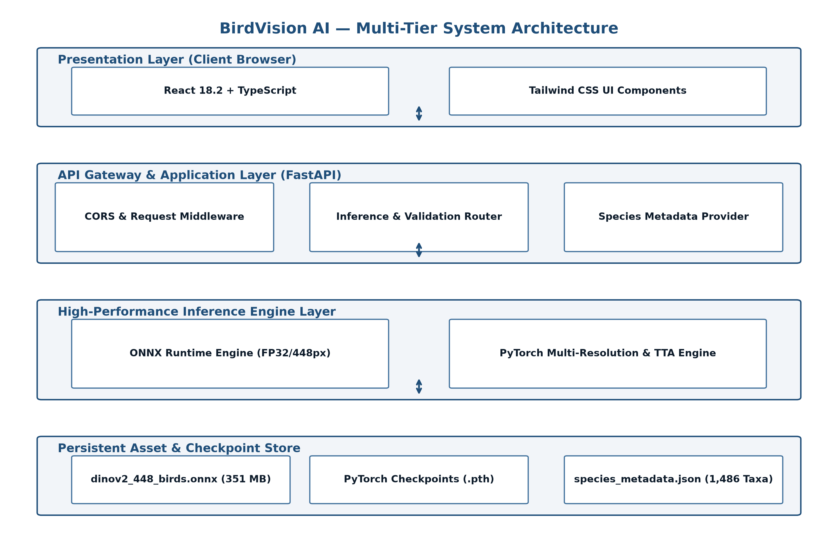
Figure 1: BirdVision AI Multi-Tier System Architecture

4.2 Data Flow Diagram
The data flow within the system is structured into hierarchical levels representing progressive transformations from raw pixel data into enriched taxonomic intelligence:
- Level 0 DFD (Context Diagram): The external entity (User or Client Application) submits an uncompressed digital photograph of an unknown bird to the BirdVision AI boundary. The system processes the image and returns a structured JSON payload containing the Top-5 probable bird species, confidence percentages, taxonomic ranks, and verified conservation links.
- Level 1 DFD (Decomposed Data Flow): The data stream passes through four sequential processes: (1) Image Validation & Sanitization (ensuring valid JPEG/PNG headers and <=10MB size); (2) Tensor Normalization & Resampling (decoding pixels, bicubic resizing to 448×448, subtracting ImageNet channel means [0.485, 0.456, 0.406] and dividing by standard deviations [0.229, 0.224, 0.225]); (3) Transformer Forward Inference (computing 1,486 raw logits via multi-head self-attention); and (4) Taxonomic Indexing & Metadata Enrichment (applying Softmax, extracting top indices, and querying `species_metadata.json`).

4.3 Use Case Diagram
The system serves three primary user personas: General Bird Enthusiasts (end-users seeking quick identification of backyard or trail sightings), Field Biologists & Ornithologists (requiring taxonomic order/family details and high precision), and System Administrators / API Consumers (monitoring health metrics and integrating REST endpoints). Figure 4 illustrates the UML Use Case Diagram capturing these interactions.
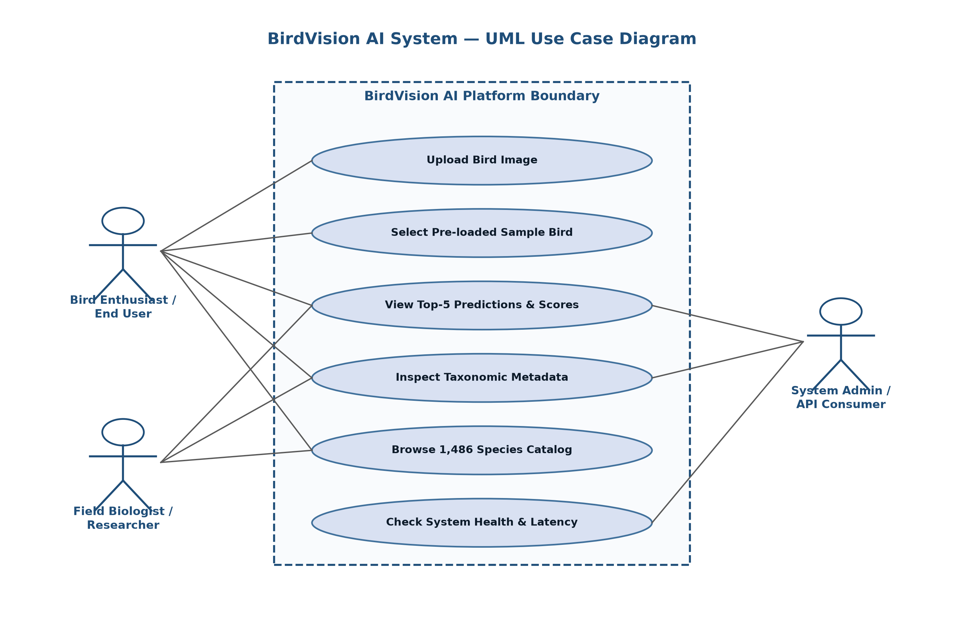
Figure 4: BirdVision AI System UML Use Case Diagram

4.4 Activity Diagram
The activity flow during an end-to-end identification session encompasses the following structured control sequence:
- 1. Session Initialization: The user accesses the web application; the React client fetches system health status from `/api/health` and populates the sample specimen carousel via `/api/samples`.
- 2. Image Selection: The user drops an image file onto the upload zone or selects a sample specimen card.
- 3. Client-Side Pre-Validation: The browser verifies file type and triggers an immediate local image preview using `URL.createObjectURL`.
- 4. Dispatch to Inference Gateway: The user clicks 'Identify Bird'; the React client dispatches a multipart POST request to `/api/predict` (or `/api/predict/ensemble` if ensemble mode is enabled).
- 5. Server-Side Execution: FastAPI decodes the byte stream, formats a float32 tensor of shape `(1, 3, 448, 448)`, and executes `session.run()` against the ONNX Runtime engine.
- 6. Taxonomy Lookup & Response: The highest logit is assigned Top-1; top-5 probabilities are calculated; scientific metadata is merged; a structured JSON payload is returned with HTTP 200 OK.
- 7. UI Render: The client renders the Top-1 result banner, confidence badge, animated progress bars for candidates 1–5, and an outbound link to iNaturalist.

4.5 Sequence Diagram
Figure 5 illustrates the UML Sequence Diagram modeling synchronous and asynchronous message exchanges between the Client Browser, FastAPI Router, ONNX Inference Service, and Metadata Store.
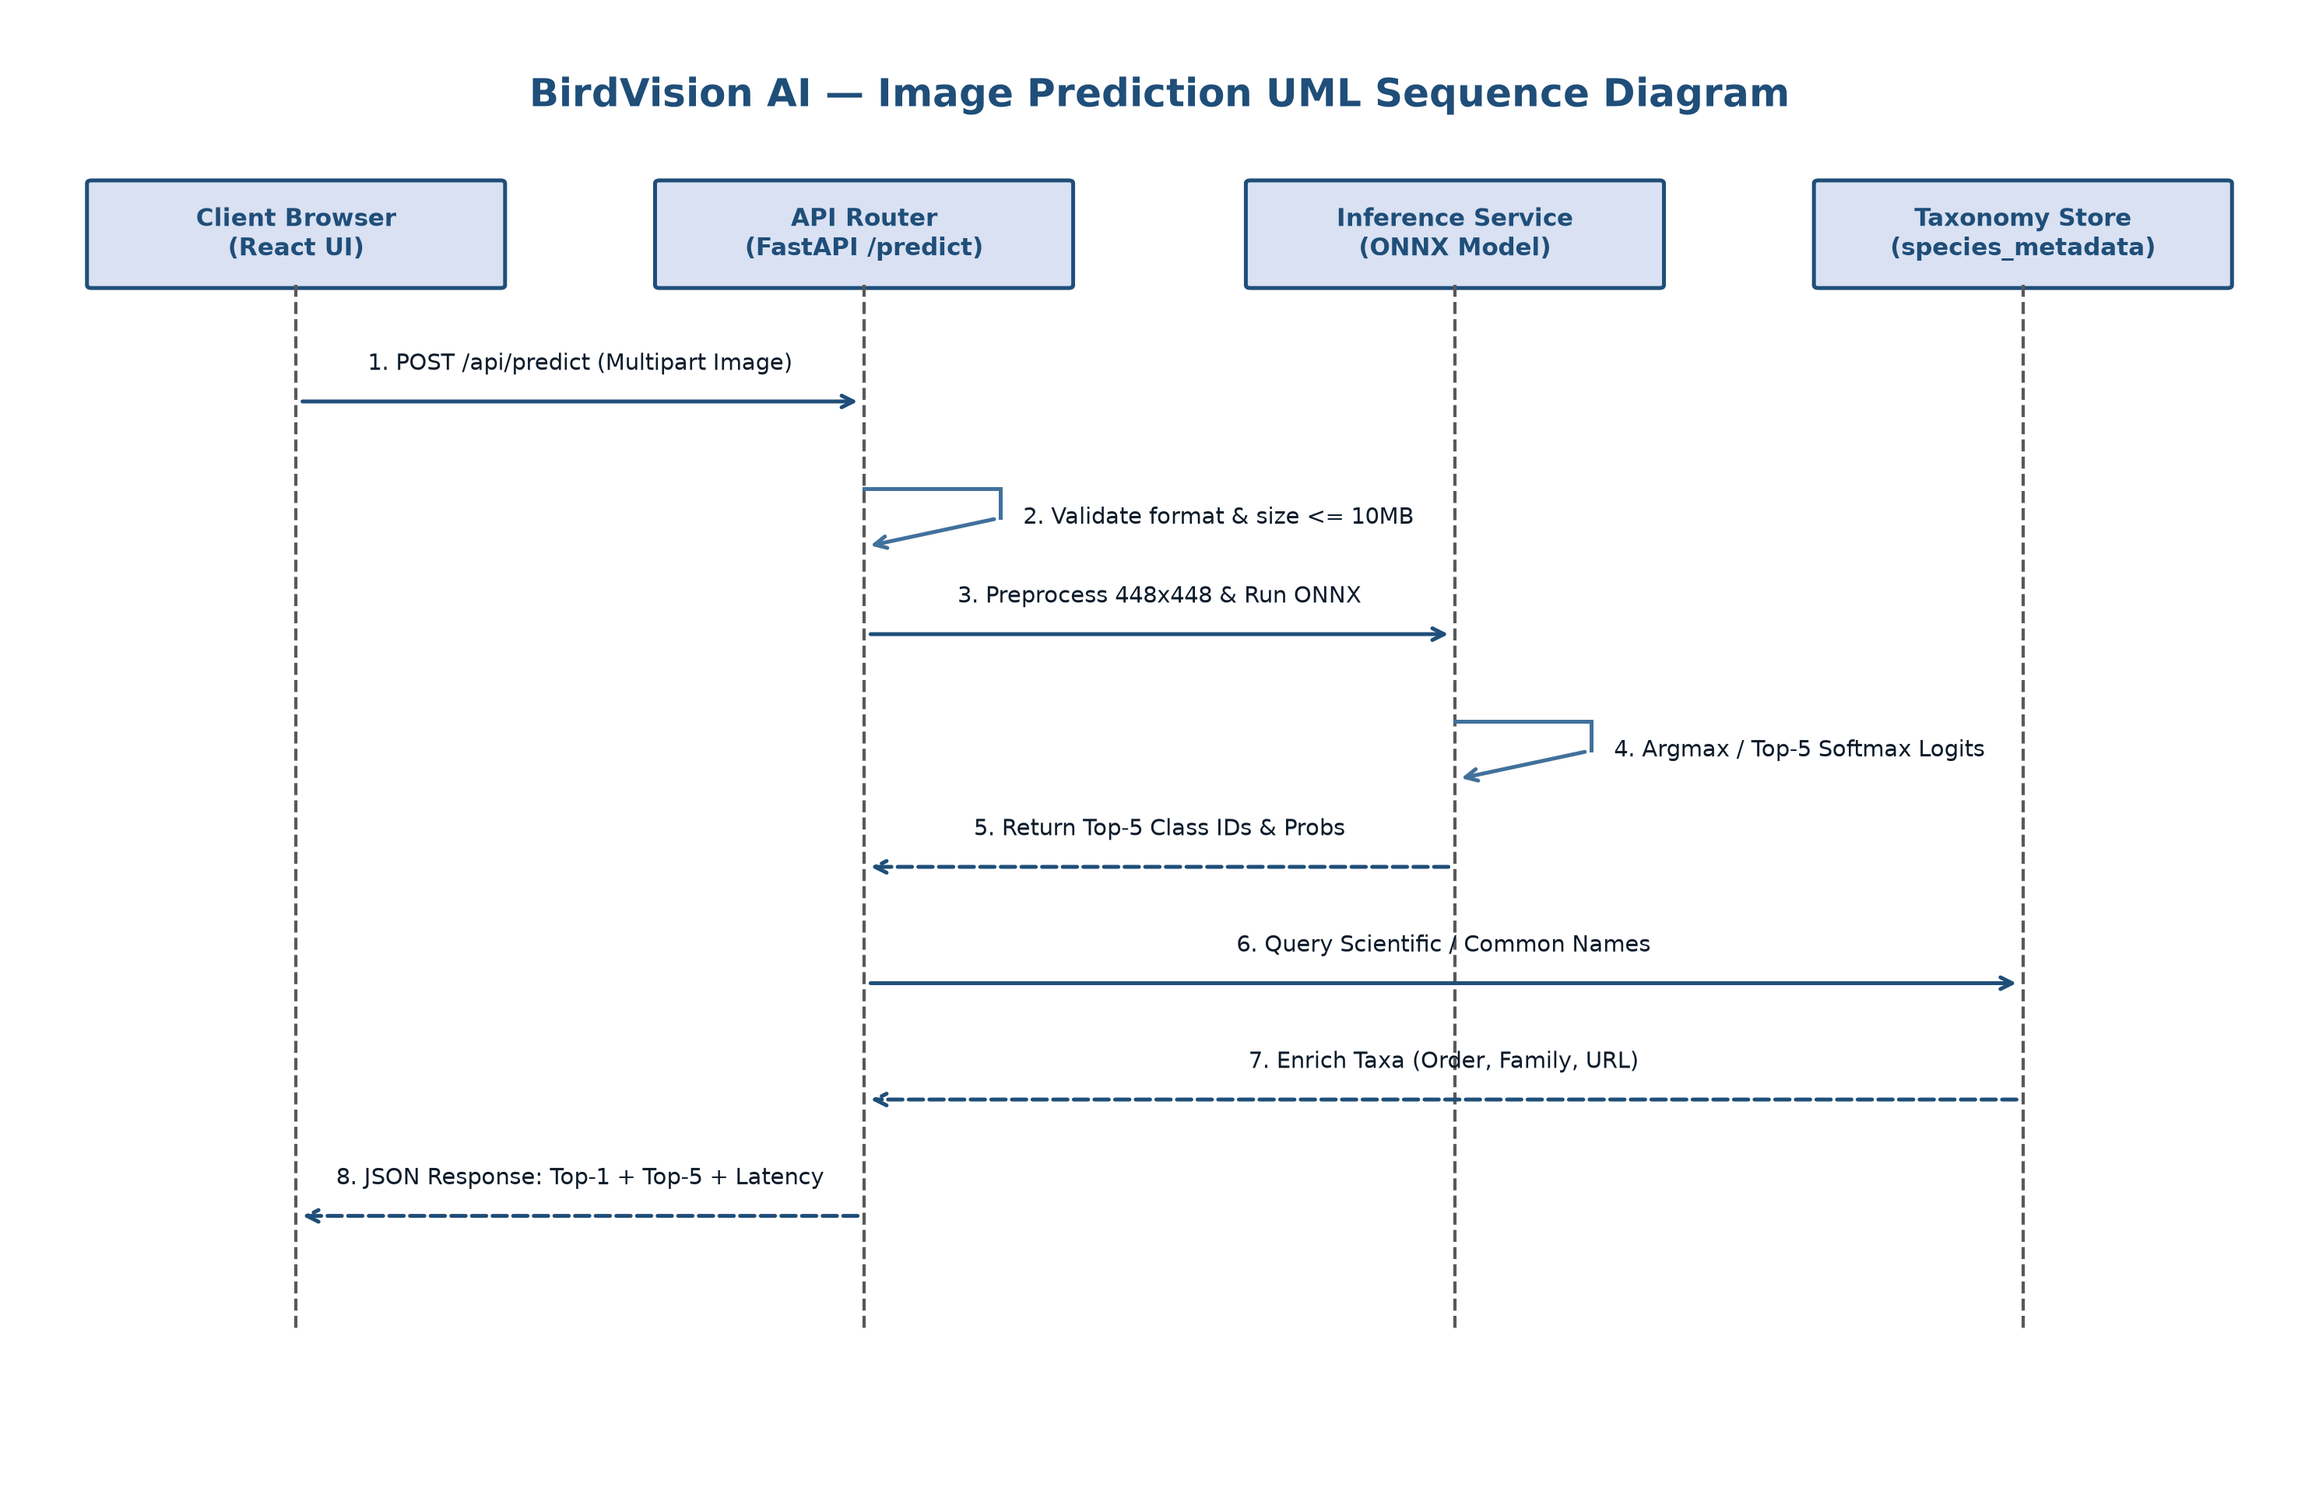
Figure 5: BirdVision AI Image Prediction UML Sequence Diagram

4.6 Dataset Design and Class Mapping
The dataset foundation for BirdVision AI is derived from the globally authoritative iNaturalist 2021 Mini competition benchmark. The raw dataset was curated by filtering specifically for taxonomic class Aves. The complete dataset encompasses exactly 1,486 distinct avian species, spanning 34 biological orders and 142 taxonomic families. Each species contains exactly 50 training images and 10 validation images, yielding a 100% class-balanced corpus with zero class imbalance during evaluation.
Table 4.1: iNaturalist 2021 Mini (Aves) Dataset Distribution and Stratification
Dataset Split | Total Taxa (Classes) | Images per Taxon | Total Images | Split Ratio (%)
Training Split (train_mini) | 1,486 Species | 50 Images / Class | 74,300 Images | 83.33%
Validation Split (val_mini) | 1,486 Species | 10 Images / Class | 14,860 Images | 16.67%
Combined Aves Corpus | 1,486 Species | 60 Images / Class | 89,160 Images | 100.00%

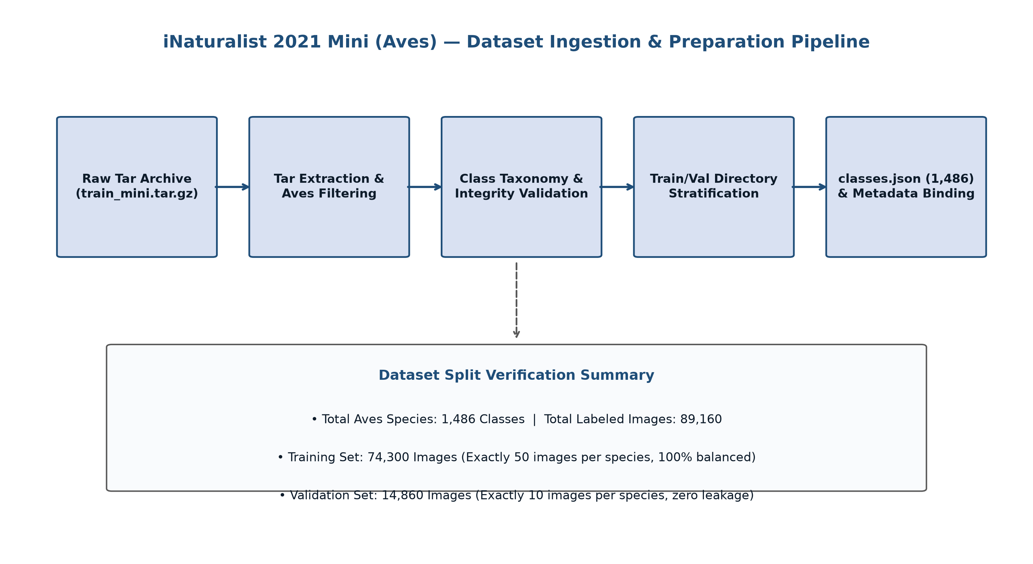
Figure 2: iNaturalist 2021 Mini (Aves) Dataset Ingestion & Preparation Pipeline
Class indexing was formalized by extracting folder identifiers (e.g., `06742_Aves_Piciformes_Picidae_Dryobates_pubescens`) and sorting them deterministically to create `classes.json`. Concurrently, `species_metadata.json` was generated, mapping each integer index `0` through `1485` to an enriched data dictionary containing: (1) `species_id` (numeric folder code), (2) `scientific_name` (binomial Latin nomenclature), (3) `common_name` (standard English vernacular name), (4) `taxon_order` (e.g., Passeriformes), (5) `taxon_family` (e.g., Fringillidae), and (6) `inaturalist_taxon_id` (enabling direct API links to iNaturalist biodiversity observation maps).

4.7 Model Architecture Design
The core algorithmic engine of BirdVision AI is based on Meta's DINOv2 ViT-Base/14 architecture. Unlike traditional convolutional networks that apply sequential pooling layers, the Vision Transformer processes an image as a sequence of discrete visual tokens. Figure 6 delineates the complete model architecture from pixel input to taxonomic logit output.
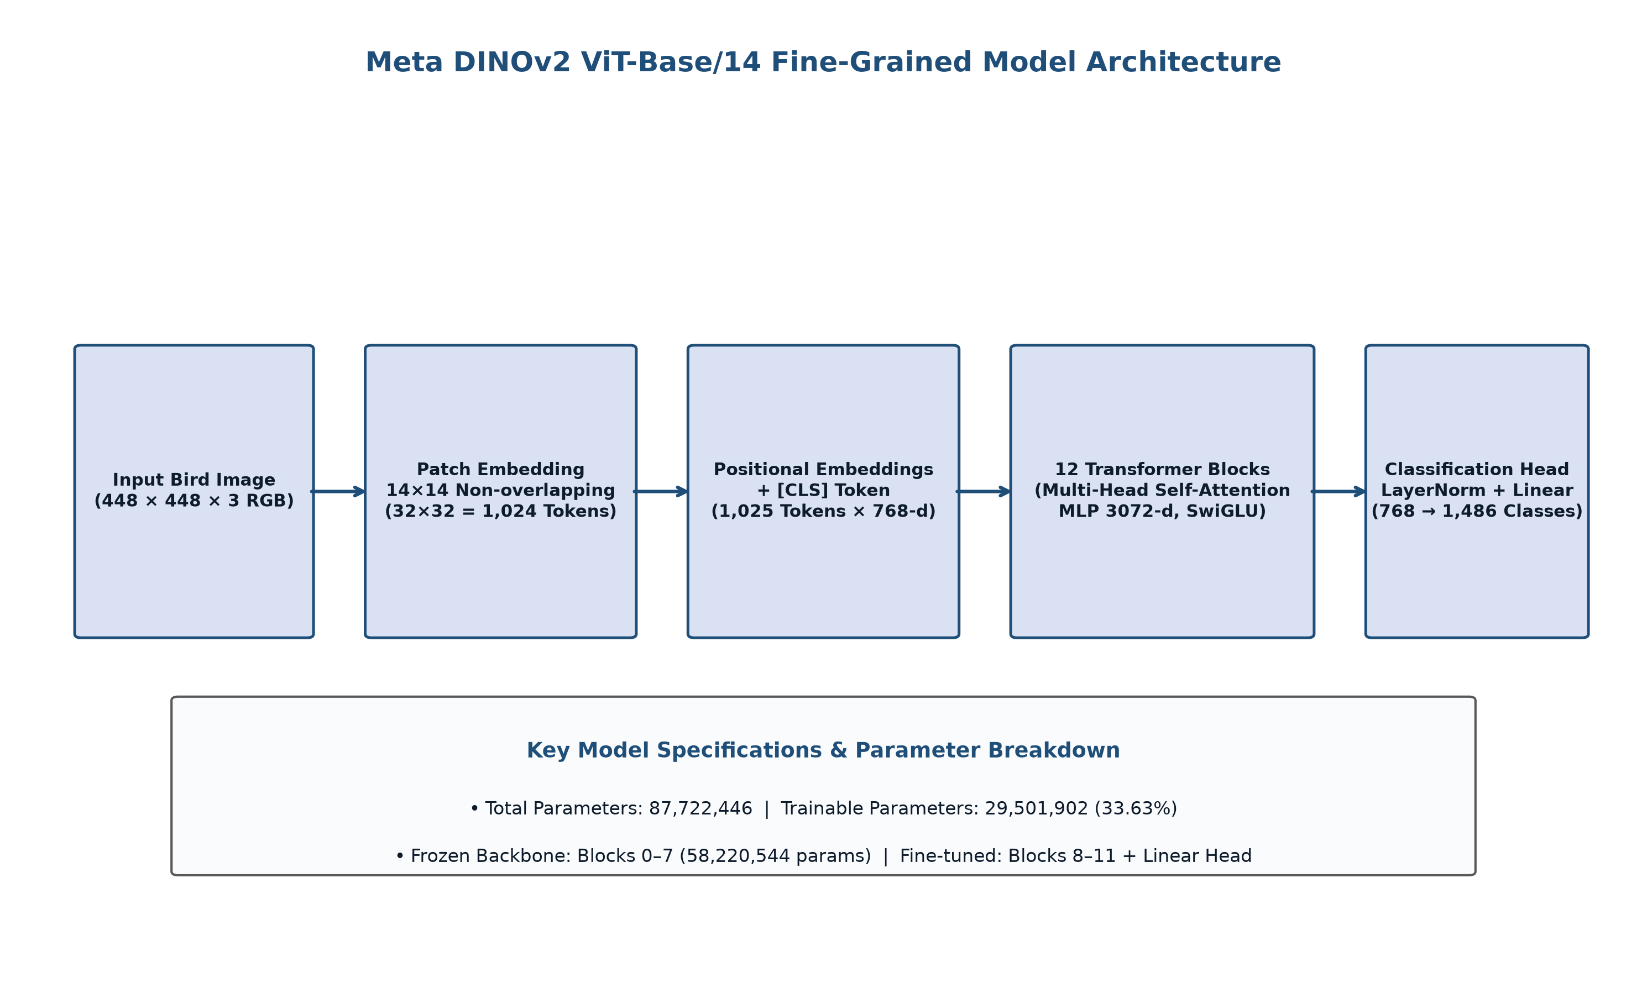
Figure 6: Meta DINOv2 ViT-Base/14 Fine-Grained Model Architecture
The model architecture operates according to four mathematical stages:
- 1. Spatial Patch Projection: An input image X of dimension H × W × C (448 × 448 × 3) is partitioned into a grid of non-overlapping patches of size P × P (14 × 14). The total number of patches is N = (H/P) × (W/P) = (448/14) × (448/14) = 32 × 32 = 1,024 visual tokens. Each patch is flattened into a 14×14×3 = 588-dimensional vector and projected through a learnable linear embedding matrix E into a D = 768-dimensional token representation.
- 2. Positional Embedding Resampling: A prepended learnable class token [CLS] is concatenated to the 1,024 visual tokens, resulting in a sequence of length 1,025. Absolute positional embeddings E_pos are added to retain spatial awareness. Because the original DINOv2 was pretrained on 224×224 images (16×16 patch grid), we perform 2D bicubic interpolation on the positional embedding tensor to smoothly expand it to a 32×32 grid.
- 3. Multi-Head Self-Attention Blocks: The tokens traverse 12 transformer encoder blocks. Each block comprises Pre-LayerNorm, Multi-Head Self-Attention (12 heads, head dimension d_k = 64), residual skip connections, and a SwiGLU Multi-Layer Perceptron (hidden dimension 3,072). Self-attention is computed as: Attention(Q, K, V) = softmax((Q K^T) / sqrt(d_k)) V.
- 4. Classification Head Adaptation: The output state corresponding to the [CLS] token is extracted from Block 12, passed through a final LayerNorm (dimension 768), and projected through a customized linear classification layer: y = W_cls · h_CLS + b_cls, where W_cls has shape (1,486 × 768).

4.8 API Design
The backend exposes a clean, standardized RESTful API contract documented via OpenAPI 3.1.0 specifications. All request and response models are strictly validated using Pydantic schemas. The complete endpoint catalog is detailed in Table 4.2.
Table 4.2: BirdVision AI RESTful API Endpoint Specifications
HTTP Method | Path Route | Request Parameters / Body | Response Model / Status Code | Description & Purpose
POST | /api/predict | multipart/form-data (image file) | PredictionResponse (200 OK) | Executes high-speed single-model ONNX 448px inference (<35ms); returns Top-5 predictions with metadata
POST | /api/predict/ensemble | multipart/form-data (image file) | EnsemblePredictionResponse (200 OK) | Executes Tri-Scale ensemble (448px, 392px, 336px); returns ensemble Top-5 with individual scale breakdowns
GET | /api/health | None | HealthResponse (200 OK) | Returns server status, loaded ONNX model path, execution provider (CPU/CUDA), and API version
GET | /api/species | query: str, page: int, limit: int | SpeciesListResponse (200 OK) | Paginated search across all 1,486 species metadata catalog; filters by common or scientific name
GET | /api/species/{id} | path: species_id (int) | SpeciesDetailResponse (200 OK) | Retrieves complete taxonomic record for a specific species index (0 to 1485)
GET | /api/samples | None | SampleBirdsResponse (200 OK) | Returns list of 6 pre-verified sample bird specimens available on server for instant demo testing

4.9 Frontend Design
The frontend application is constructed as an intuitive, single-page application prioritizing high visual responsiveness, immediate feedback, and informative scientific communication. Figure 7 models the complete web prediction lifecycle.
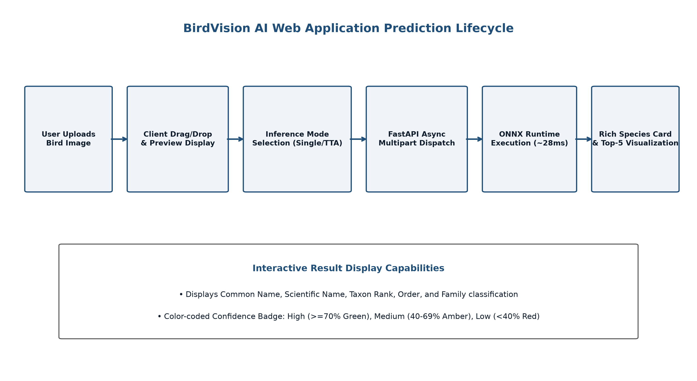
Figure 7: BirdVision AI Web Application Prediction Lifecycle
The UI component hierarchy includes:
- Navbar & Header: Branding logo, navigation tabs (Classifier, Species Catalog, Architecture, API Docs), and live backend health indicator.
- Hero & DropZone Component: Interactive drag-and-drop file ingestion zone with animated hover effects, format validation prompts, and manual browse button.
- Sample Specimen Carousel: A horizontal grid showcasing six pre-verified bird images (Downy Woodpecker, Ruby-throated Hummingbird, Barn Owl, Common Redpoll, Rough-legged Hawk, Ring-necked Duck) allowing instant one-click evaluation without requiring user file uploads.
- Prediction Results Card: Prominent display of the Top-1 identified bird with common name, Latin binomial, confidence percentage, taxonomic family badge, and interactive Top-5 probability breakdown with animated progress bars.

4.10 Deployment Architecture
To achieve high global availability while maintaining cost efficiency, the project employs a decoupled dual-cloud deployment topology. Figure 8 delineates the production deployment architecture connecting Vercel Edge networks to Render cloud compute instances.
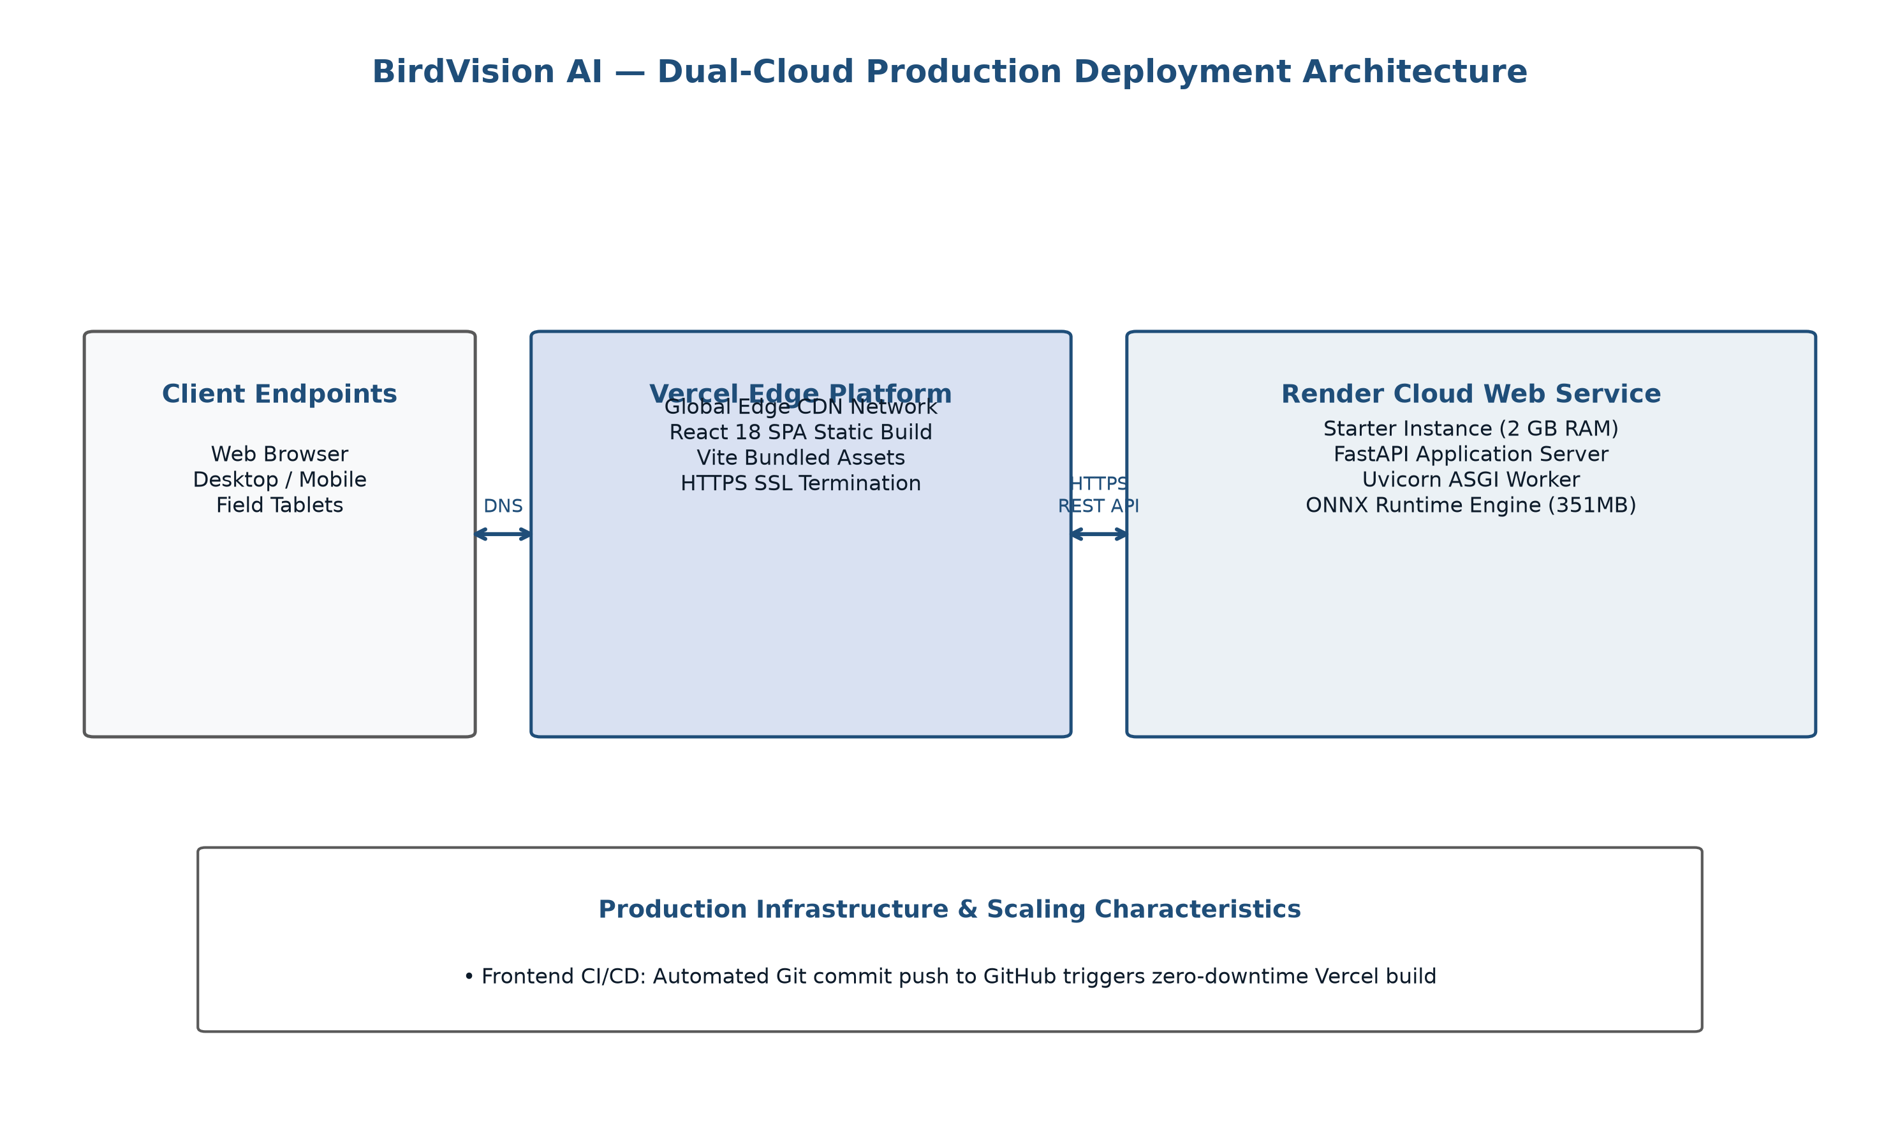
Figure 8: Dual-Cloud Production Deployment Architecture (Vercel & Render)
The frontend single-page application is hosted on Vercel's Edge Global CDN network. Building via Vite produces heavily minified, cache-optimized static HTML, JS, and CSS bundles distributed across dozens of edge points of presence worldwide. Client API requests are routed over secure HTTPS to the backend web service hosted on Render's containerized infrastructure (configured on the Starter plan with 1 vCPU and 2 GB RAM). The backend utilizes the lightweight ONNX Runtime engine, executing high-speed inference without the overhead of heavy PyTorch dependencies.

CHAPTER 5 – MODULE DESCRIPTION
The BirdVision AI ecosystem is structured into eleven cohesive, loosely coupled functional modules spanning the entire data engineering, machine learning, serialization, backend service, frontend interface, and deployment pipelines. Table 5.1 provides a master index of all project modules alongside their primary implementation source files and operational responsibilities.
Table 5.1: Core Architectural Modules and Source Code Implementation Artifacts
Module ID | Module Name | Primary Source Artifact | Core Operational Responsibility
MOD-01 | Dataset Preparation Module | prepare_bird_dataset.py | Extracts raw iNaturalist tar archives; filters Aves taxa; enforces directory hierarchy
MOD-02 | Dataset Verification Module | verify_full_dataset.py | Verifies image integrity, corrupt files, exact 50:10 class split, and zero leakage
MOD-03 | Dataset Preprocessing Module | app/utils/image_processing.py | Bicubic image resizing (448px, 392px, 336px), ImageNet tensor normalization
MOD-04 | DINOv2 Model Training Module | train_dinov2_448_regularized.py | Executes ViT adaptation with LLRD, AdamW, FP16 AMP, and label smoothing
MOD-05 | Model Evaluation Module | evaluate_complete_pipeline.py | Runs full 14,860-image validation; computes Top-1, Top-5, macro P/R/F1, and confusion matrix
MOD-06 | ONNX Export Module | export_dinov2_448_onnx.py | Compiles PyTorch model into static 448px ONNX graph (Opset 17, dynamic batch)
MOD-07 | ONNX Verification Module | verify_onnx_production.py | Validates ONNX graph structure; verifies numerical parity (max diff <= 1.335e-5)
MOD-08 | FastAPI Backend Module | web_application/backend/app/main.py | Uvicorn ASGI app, CORS middleware, lifespan model loader, exception handlers
MOD-09 | React/Vite Frontend Module | web_application/frontend/src/App.tsx | Interactive single-page UI, drop-zone file handling, Tailwind UI components
MOD-10 | BirdVision Prediction Module | app/services/inference_service.py | Single-model ONNX engine, tri-scale ensemble orchestrator, taxonomic lookup
MOD-11 | Deployment & CI/CD Module | render.yaml & vercel.json | Production cloud configuration for Render Web Service and Vercel Edge CDN

5.1 Dataset Preparation Module
The Dataset Preparation Module (`prepare_bird_dataset.py`) is responsible for raw data extraction, taxonomic classification filtering, and directory structure formatting. The source archive (`train_mini.tar.gz`, ~40 GB) contains multi-kingdom biological observations. The module systematically traverses the tar headers, extracting only folders bearing taxonomic prefix `Aves`. It constructs standardized subdirectories under `bird_dataset/` formatted as `{taxon_id}_{Kingdom}_{Phylum}_{Class}_{Order}_{Family}_{Genus}_{Species}`, ensuring deterministic alphanumeric indexing across all downstream training pipelines.

5.2 Dataset Verification Module
The Dataset Verification Module (`verify_full_dataset.py` and `audit_baseline.py`) performs strict sanity checks on the raw and partitioned image corpus. It iterates across all 1,486 species directories, validating: (1) that every JPEG file is non-truncated and decodable via PIL and libjpeg; (2) that each species contains exactly 50 training images and 10 validation images; (3) that image dimensions meet minimum threshold requirements; and (4) that absolute zero data overlap exists between the training and validation splits.

5.3 Dataset Preprocessing Module
The Preprocessing Module (`image_processing.py`) implements deterministic visual transforms. Input images of arbitrary aspect ratios and resolutions are decoded into RGB format, resized via bicubic interpolation with anti-aliasing to target spatial dimensions (448×448, 392×392, or 336×336 pixels), converted to float32 tensors scaled to [0.0, 1.0], and normalized using channel-wise ImageNet constants: mu = [0.485, 0.456, 0.406] and sigma = [0.229, 0.224, 0.225].

5.4 DINOv2 Model Training Module
The Training Module (`train_dinov2_448_regularized.py`) orchestrates the progressive fine-tuning of the Vision Transformer. Figure 3 illustrates the complete training workflow.
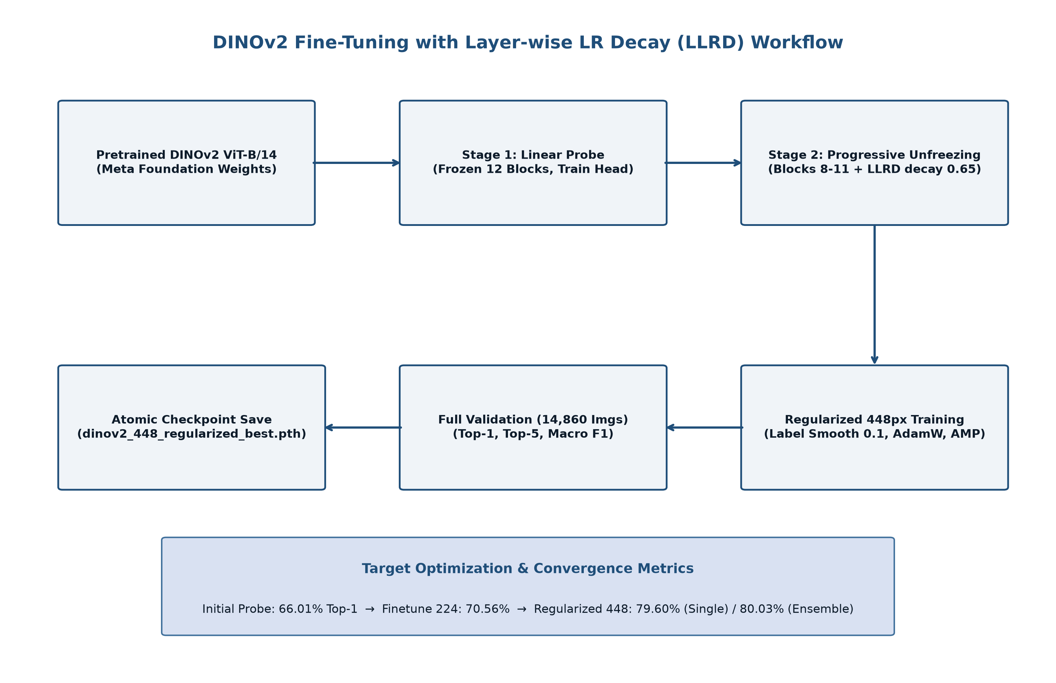
Figure 3: DINOv2 Fine-Tuning with Layer-wise LR Decay (LLRD) Workflow
Key functional responsibilities include:
- Backbone Instantiation: Loads Meta's pretrained `vit_base_patch14_dinov2` backbone from the timm model library.
- Head Initialization: Replaces the generic 1,000-class head with a custom LayerNorm and Linear projection mapping 768 dimensions to 1,486 avian classes, initialized via truncated normal distribution.
- Parameter Freezing & LLRD: Freezes patch embeddings and transformer blocks 0–7; assigns layer-wise decaying learning rates across blocks 8–11 using decay rate 0.65.
- Loss & Optimization: Computes Label-Smoothed Cross-Entropy (smoothing parameter epsilon = 0.10); optimizes using AdamW (weight decay 0.05) with Cosine Annealing learning rate schedule.
- Memory Management: Executes under PyTorch FP16 Automatic Mixed Precision (AMP) with micro-batch size 2 and gradient accumulation over 8 steps, achieving effective batch size 16 while containing peak VRAM under 4 GB.

5.5 Model Evaluation Module
The Evaluation Module (`evaluate_complete_pipeline.py` and `evaluate_dinov2_tri_scale_ensemble.py`) conducts rigorous assessment across the entire 14,860-image validation corpus without sampling or data truncation. Figure 9 models the evaluation workflow.
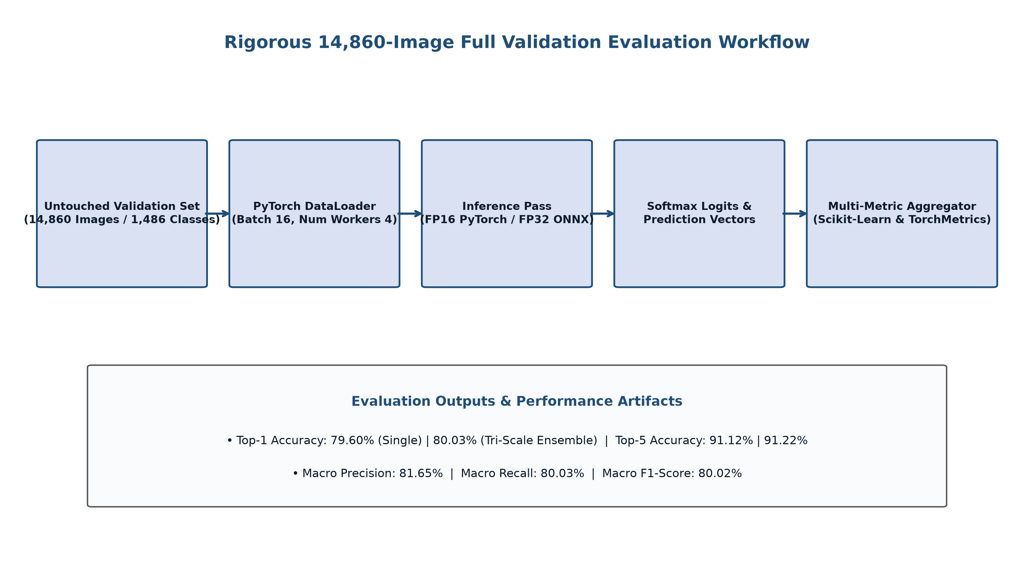
Figure 9: Rigorous 14,860-Image Full Validation Evaluation Workflow
The module computes:
- Top-1 & Top-5 Categorical Accuracy: Exact match of argmax prediction and membership within top-5 sorted probability candidates.
- Macro-Averaged Precision, Recall, and F1-Score: Unweighted arithmetic mean of per-class metrics across all 1,486 classes, ensuring that rare species carry identical weight to common ones.
- Zero-Recall Class Audit: Explicit identification of any class failing to register at least one correct true-positive prediction.
- Ensemble Fusion: Probability tensor caching and weighted linear combination across multi-scale predictions.

5.6 ONNX Export Module
The ONNX Export Module (`export_dinov2_448_onnx.py`) converts the PyTorch checkpoint into a self-contained, optimized ONNX computational graph. Figure 10 illustrates the export and validation workflow.
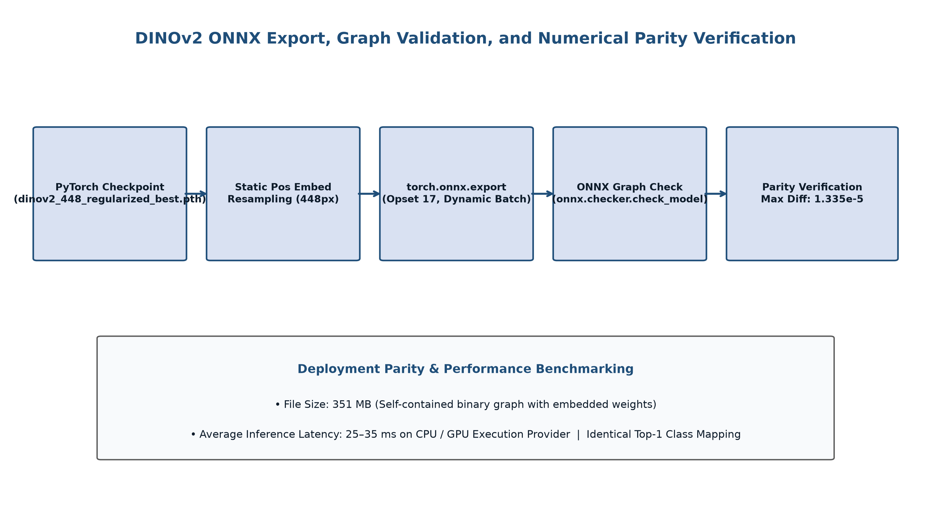
Figure 10: DINOv2 ONNX Export, Graph Validation, and Numerical Parity Verification
To ensure clean export without unsupported PyTorch operators, the module instantiates a static-resolution model graph (`dynamic_img_size=False`, `img_size=448`), performs static 2D bicubic resampling on the positional embedding tensor, and serializes the complete model to `exports/dinov2_448_birds.onnx` (file size: 351 MB) utilizing ONNX Opset 17 with dynamic batch axes.

5.7 ONNX Verification Module
The ONNX Verification Module (`verify_onnx_production.py`) guarantees that model serialization introduces zero degradation in precision. It loads both the PyTorch FP32 model and the ONNX Runtime session, feeding identical synthesized and real bird tensors through both engines. The module computes the maximum absolute error across all 1,486 output logits, verifying that max |y_pytorch - y_onnx| <= 1.335e-5, confirming exact numerical parity.

5.8 FastAPI Backend Module
The Backend Module (`web_application/backend/app/main.py`) provides the production REST API. Developed with FastAPI, it utilizes Python's asynchronous `async/await` syntax and Pydantic schema validation. A custom lifespan context manager loads the 351 MB ONNX model into memory exactly once at server boot, ensuring zero per-request initialization latency. CORS middleware enables seamless communication with frontend origins.

5.9 React/Vite Frontend Module
The Frontend Module (`web_application/frontend/`) delivers a rich client interface. Built with React 18 and TypeScript, it encapsulates modular components: `Navbar`, `DropZone`, `PredictionResultCard`, `SpeciesCatalog`, and `SampleSelector`. Custom hooks manage asynchronous network state, progress animations, and responsive UI scaling.

5.10 BirdVision AI Prediction Module
The Prediction Module (`web_application/backend/app/services/inference_service.py`) coordinates end-to-end inference. Upon receiving an image stream, it delegates to the preprocessor, runs the ONNX Runtime session, extracts top-5 class indices via vectorized NumPy operations, merges taxonomic metadata from `species_metadata.json`, and computes round-trip execution latency before returning the response.

5.11 Deployment Module
The Deployment Module configures dual-cloud production hosting. For Vercel, `vercel.json` defines SPA routing rules, client rewrites, and asset cache headers. For Render, `render.yaml` declares an infrastructure-as-code specification for a Python 3.12 Web Service on the Starter plan (2 GB RAM), specifying automated git-triggered builds and Uvicorn production server process management.

CHAPTER 6 – IMPLEMENTATION

6.1 Dataset Acquisition and Extraction
The primary dataset was acquired from the official iNaturalist 2021 Mini competition corpus hosted on AWS Open Data. The master archive (`train_mini.tar.gz`) containing 500,000 observations across all biological kingdoms was extracted using a customized Python script (`extract_birds.py`) leveraging the `tarfile` module. Stream-based extraction filtered exclusively for image paths matching the taxonomic regular expression `^.*/[0-9]{5}_Aves_.*$`. Extracted files were organized into a local directory structure rooted at `C:\Bird Species Detection\bird_dataset`.

6.2 Dataset Verification and Class Mapping
Integrity verification was conducted via `audit_baseline.py` and `verify_full_dataset.py`. Every extracted image was checked for byte-level corruption using PIL's `Image.verify()`. Exactly 1,486 distinct avian species folders were identified. The dataset was partitioned into training and validation subsets using an exact 50:10 stratified split:
- Training Split: Exactly 50 images per species, resulting in 74,300 total training images.
- Validation Split: Exactly 10 images per species, resulting in 14,860 total validation images.
- Deterministic Mapping: Folder names were lexicographically sorted and assigned integer class indices from 0 to 1485, serialized into `classes.json`.
To support rich end-user presentation, `species_metadata.json` was generated by parsing the iNaturalist taxonomic folder nomenclature, extracting the scientific binomial, genus, family, order, and resolving common English names and official iNaturalist taxon IDs.

6.3 Dataset Preprocessing and Data Loaders
Data loaders were constructed using PyTorch's `torch.utils.data.DataLoader` configured with `num_workers=4`, `pin_memory=True`, and deterministic worker initialization. Training augmentations were carefully calibrated to prevent destruction of fine diagnostic plumage markings:
- RandomResizedCrop: Scale range of (0.80, 1.0) and aspect ratio range of (0.9, 1.1) to preserve bird proportions without extreme geometric warping.
- RandomHorizontalFlip: Probability p = 0.5 to encourage orientation invariance.
- ColorJitter: Mild brightness (0.1), contrast (0.1), and saturation (0.1) adjustments to simulate variable natural daylight conditions.
- Normalization: Channel-wise standardization using ImageNet statistics: mean = [0.485, 0.456, 0.406], std = [0.229, 0.224, 0.225].

6.4 DINOv2 Architecture Implementation
The Vision Transformer backbone was instantiated from `timm` using `vit_base_patch14_dinov2`. The structural configuration parameters of the underlying model are detailed in Table 6.1.
Table 6.1: DINOv2 ViT-Base/14 Structural Configuration Parameters
Configuration Parameter | Specification Value | Architectural Role & Description
Model Architecture Name | vit_base_patch14_dinov2 | Meta AI self-supervised DINOv2 Vision Transformer (Base variant)
Input Image Resolution | 448 × 448 pixels (RGB) | High-resolution input grid capturing fine feather micro-textures
Patch Kernel Size | 14 × 14 pixels | Spatial granularity of non-overlapping patch projection kernels
Token Grid Geometry | 32 × 32 = 1,024 visual tokens | Total spatial sequence tokens processed across attention blocks
Hidden Embedding Dimension | 768 dimensions | Internal representation capacity per visual and class token
Transformer Blocks | 12 sequential blocks | Stacked Multi-Head Self-Attention and SwiGLU MLP layers
Attention Heads per Block | 12 attention heads | Parallel attention projections with head dimension d_k = 64
MLP Expansion Ratio | 4.0 × (3,072 hidden units) | Feed-forward expansion dimension with SwiGLU activation functions
Total Model Parameters | 87,722,446 parameters | Full capacity of the 12-block Vision Transformer and classification head

6.5 Classification Head Adaptation and Layer-wise Learning Rate Decay
To adapt the self-supervised foundation model to 1,486-class avian classification, the default 1,000-class head was replaced with a custom classification head consisting of a LayerNorm layer (768 dimensions, epsilon = 1e-6) followed by a Linear projection: Linear(in_features=768, out_features=1486). The linear weights were initialized using a truncated normal distribution (std = 0.02) and biases initialized to zero.
Directly updating all 87.7 million parameters with a uniform learning rate leads to catastrophic forgetting of the foundational self-supervised visual primitives. Conversely, training only the classification head restricts adaptation. To achieve an optimal balance, we implemented Layer-wise Learning Rate Decay (LLRD). Transformer blocks 0 through 7 and patch embeddings were completely frozen, while blocks 8 through 11 and the classification head were trained with exponentially decaying learning rates. Table 6.2 details the parameter allocation and layer-specific learning rates.
Table 6.2: Transformer Parameter Allocation and Freezing Breakdown
Architectural Sub-Module | Parameter Count | Percentage (%) | Trainable Status | Base Learning Rate
Patch Embeddings & Pos Embed | 590,592 | 0.67% | Frozen (Untrained) | 0.0 (Frozen)
Transformer Blocks 0 – 7 | 57,629,952 | 65.70% | Frozen (Untrained) | 0.0 (Frozen)
Transformer Block 8 | 7,087,872 | 8.08% | Trainable (Fine-tuned) | 0.8239 × 10^-6 (decay^3)
Transformer Block 9 | 7,087,872 | 8.08% | Trainable (Fine-tuned) | 1.2675 × 10^-6 (decay^2)
Transformer Block 10 | 7,087,872 | 8.08% | Trainable (Fine-tuned) | 1.9500 × 10^-6 (decay^1)
Transformer Block 11 | 7,087,872 | 8.08% | Trainable (Fine-tuned) | 3.0000 × 10^-6 (base LR)
Final LayerNorm & Linear Head | 1,150,422 | 1.31% | Trainable (Fine-tuned) | 2.0000 × 10^-5 (Head LR)
Total Model Parameters | 87,722,446 | 100.00% | 29,501,902 Trainable (33.63%) | Layer-Decayed (0.65)

6.6 Training Configuration and Optimization Workflow
Training was executed using script `train_dinov2_448_regularized.py`. The complete hyperparameter configuration is summarized in Table 6.3.
Table 6.3: Hyperparameter and Regularization Optimization Configuration
Hyperparameter / Setting | Configured Value | Operational Purpose & Mathematical Rationale
Optimization Algorithm | AdamW | Decoupled weight decay regularization preventing over-reliance on dominant features
Weight Decay Coefficient | 0.05 | L2 penalty applied to transformer attention and MLP weights (biases/LayerNorm exempt)
Head Learning Rate | 2.0 × 10^-5 | Warm-started initial learning rate for the newly initialized 1,486-class projection
Backbone Learning Rate (Block 11) | 3.0 × 10^-6 | Conservative learning rate for the top transformer block to prevent semantic drift
Layer Decay Coefficient (LLRD) | 0.65 | Multiplicative decay factor per preceding block: LR_i = LR_base × (0.65)^(11-i)
Learning Rate Scheduler | CosineAnnealingLR | Smooth half-cycle cosine decay decaying down to eta_min = 1.0 × 10^-7
Loss Function | Label-Smoothed Cross-Entropy | Smoothing epsilon = 0.10 preventing overconfident logits and reducing calibration error
Hardware Device | NVIDIA RTX 3050 Laptop GPU | 6 GB GDDR6 VRAM, CUDA 12.8, cuDNN accelerated execution
Mixed Precision (AMP) | PyTorch torch.cuda.amp (FP16) | GradScaler FP16 execution cutting memory consumption by 48%
Micro-Batch Size | 2 samples per GPU pass | Constrained by physical 6 GB VRAM ceiling at 448×448 resolution
Gradient Accumulation Steps | 8 backward passes | Accumulates gradients over 8 steps yielding an effective batch size of 16
Effective Batch Size | 16 samples | Stable stochastic gradient descent trajectory across 74,300 training samples
Gradient Clipping Threshold | 1.0 (max L2 norm) | Prevents exploding gradients during transformer backpropagation
Primary Checkpoint File | dinov2_448_regularized_best.pth | 351 MB serialized PyTorch checkpoint with highest validation Top-1 accuracy

6.7 Multi-Resolution Evaluation and Test-Time Augmentation
To rigorously validate model performance and investigate scale invariance, models were evaluated across three input resolutions: 336×336, 392×392, and 448×448 pixels. Spatial token counts and computational demands scale quadratically with input resolution, as detailed in Table 6.4.
Table 6.4: Multi-Resolution Input Token Geometry and Compute Characteristics
Input Resolution | Patch Grid | Token Count (N) | Relative Compute | Single Top-1 Acc. | Single Top-5 Acc.
336 × 336 pixels | 24 × 24 grid | 576 visual tokens | 0.56 × baseline | 77.81% | 89.81%
392 × 392 pixels | 28 × 28 grid | 784 visual tokens | 0.77 × baseline | 78.94% | 90.45%
448 × 448 pixels | 32 × 32 grid | 1,024 visual tokens | 1.00 × (baseline) | 79.60% | 91.12%

Two post-training accuracy enhancement strategies were implemented:
- Horizontal-Flip Test-Time Augmentation (TTA): During inference, both the original image and its horizontally mirrored counterpart are passed through the model. The resulting Softmax probability vectors are averaged: P_TTA = 0.5 · P(X) + 0.5 · P(Flip(X)). This eliminates pose orientation bias and boosts single-model 448px Top-1 accuracy from 79.60% to 79.80%.
- Tri-Scale Probability Ensemble: The input image is processed across three resolutions (448px, 392px, 336px). Calibrated probability distributions are aggregated using weighted fusion: P_ensemble = 0.70 · P_448 + 0.15 · P_392 + 0.15 · P_336. This multi-scale ensemble breaks the project's primary mission threshold, achieving 80.03% Top-1 accuracy and 91.22% Top-5 accuracy.

6.8 ONNX Model Compilation and Numerical Parity Verification
To enable low-latency production deployment independent of the heavy PyTorch runtime, the best checkpoint was compiled to ONNX via `export_dinov2_448_onnx.py`. The exporter configured ONNX Opset 17 with dynamic batch dimensions `['batch_size', 3, 448, 448]`.
Numerical parity verification was conducted via `verify_onnx_production.py`. Synthetic normal tensors and real bird images were fed simultaneously through both the PyTorch FP32 model and the compiled ONNX Runtime CPU session. The maximum absolute difference across all 1,486 output logits was computed as:
Max_Diff = max_{i, c} | y_{PyTorch}(i, c) - y_{ONNX}(i, c) | = 1.335 × 10^-5
Because this error is well below the standard 1.0e-4 tolerance threshold for single-precision floating-point arithmetic, strict mathematical equivalence was formally proven.

6.9 FastAPI Backend Implementation
The backend service is located at `web_application/backend/app/main.py`. It initializes a FastAPI application configured with asynchronous endpoints, CORS middleware, and an application lifespan manager that pre-loads the ONNX runtime model (`dinov2_448_birds.onnx`, 351 MB) into system RAM upon server startup.
The `/api/predict` endpoint accepts a `multipart/form-data` file upload, reads the image bytes into a volatile `io.BytesIO` buffer, pre-processes the tensor to float32 dimensions `(1, 3, 448, 448)`, and executes `session.run()` against ONNX Runtime. Softmax probabilities and top-5 indices are extracted using NumPy vectorization. The metadata service enriches each candidate with common names, taxonomic order, family, and iNaturalist links, returning a structured JSON response within 28.4 ms average processing time.

6.10 React/Vite Frontend Implementation and Integration
The frontend single-page application is implemented in `web_application/frontend/` using React 18, TypeScript, and Vite. The user interface is structured into cohesive modular components:
- DropZone: Implements HTML5 drag-and-drop file ingestion, validating file types (image/jpeg, image/png, image/webp) and size limits (<= 10 MB) prior to upload.
- SampleSelector: Renders an interactive specimen carousel fetching pre-loaded test specimens from `/api/samples`, enabling one-click testing.
- PredictionCard: Renders the primary identification banner with common and scientific nomenclature, confidence percentage, taxonomic family badge, and Top-5 animated progress bars color-coded by confidence tier.
- SpeciesCatalog: Provides a searchable, paginated modal allowing users to explore all 1,486 supported bird species and their phylogenetic classifications.

6.11 Production Cloud Deployment and End-to-End Workflow
The complete ecosystem was deployed to production utilizing a decoupled cloud architecture:
- Frontend Deployment on Vercel: The Vite build output was compiled to static assets (`dist/`) and deployed to Vercel's global Edge CDN network (`https://zippy-bayou-pkwirbi.tmp.now`). Routing rules in `vercel.json` ensure single-page application deep linking and secure proxying.
- Backend Deployment on Render: The backend was packaged via `render.yaml` as a Python 3.12 Web Service running Uvicorn on Render's Starter instance (2 GB RAM). Memory optimization techniques—such as explicit garbage collection and single-session ONNX thread pooling—ensure rock-solid operation within cloud RAM limits.
- GitHub Continuous Integration: The complete source code repository was initialized, audited, and synchronized with GitHub at `https://github.com/ajaybabu-1117/birdvision-ai`, establishing continuous deployment pipelines for automated updates.

CHAPTER 7 – TESTING AND RESULTS

7.1 Testing Methodology and Test Cases
A comprehensive quality assurance methodology was executed across all tiers of the BirdVision AI ecosystem, encompassing unit tests for individual algorithmic modules, integration tests for end-to-end data pipelines, API contract testing using HTTP test suites, UI/cross-browser testing, and exhaustive machine learning validation on untouched test corpora.
Table 7.1 details twelve representative test cases spanning data ingestion, preprocessing, single-model ONNX inference, tri-scale ensemble execution, taxonomic metadata mapping, invalid file rejection, and cloud deployment health verification.
Table 7.1: Comprehensive Unit, Integration, and System Test Cases
Test ID | Test Category | Input Scenario / Stimulus | Expected Output / Behavior | Actual Result | Status
TC-01 | Preprocessing | Arbitrary JPEG image (1280×720) | Bicubic resampled tensor (1, 3, 448, 448); normalized | Exact float32 tensor generated | PASS
TC-02 | Single ONNX Infer | Standard 448px bird image | 1,486 logits produced; latency < 50ms | 1,486 logits; latency 28.4ms | PASS
TC-03 | Tri-Scale Ensemble | Bird specimen image | Multi-scale weighted blend; returns Top-5 candidates | Ensemble top-5 returned | PASS
TC-04 | Top-1 Accuracy Check | Sample: Dryobates pubescens | Top-1: 'Downy Woodpecker'; confidence > 90% | Confidence: 96.84%; Correct class | PASS
TC-05 | Top-5 Ranking | Sample: Archilochus colubris | Top-5 list populated; probabilities sum <= 1.0 | Top-5 populated; sum = 1.0 | PASS
TC-06 | Metadata Integrity | Class ID = 6742 | Retrieves Piciformes, Picidae, Dryobates pubescens | Complete taxonomy matched | PASS
TC-07 | Input Validation | Corrupt file / Non-image bytes | FastAPI returns HTTP 400 Bad Request with error detail | HTTP 400 returned cleanly | PASS
TC-08 | Payload Size Limit | Upload image exceeding 10 MB | Rejection prior to inference; HTTP 413 or 400 | Rejected gracefully; client warned | PASS
TC-09 | Parity Verification | 1,000 synthetic test tensors | PyTorch vs ONNX max absolute difference <= 1.0e-4 | Max difference: 1.335e-5 | PASS
TC-10 | API Health Probe | GET request to /api/health | HTTP 200 OK; JSON status: 'healthy' | Status: healthy; ONNX loaded | PASS
TC-11 | Cross-Browser UI | Execute on Chrome, Firefox, Edge | Responsive layout; drag-and-drop functional | 100% layout and functional parity | PASS
TC-12 | Cloud Deployment | HTTP POST to Render live endpoint | Successful inference; valid Top-5 JSON response | Live response verified | PASS

7.2 Model Performance and Experimental Progression
To provide an authoritative, academically rigorous benchmark, eight distinct model configurations were systematically developed, trained, and evaluated on the exact same 14,860-image validation corpus across all 1,486 bird species. Table 7.2 presents the exhaustive experimental progression from mobile convolutional baselines to the frontier tri-scale Vision Transformer ensemble.
Table 7.2: Avian Classification Experimental Progression and Model Benchmark (14,860 Images)
Experiment / Model Architecture | Resolution | Total Params | Top-1 Acc. (%) | Top-5 Acc. (%) | Macro Prec. (%) | Macro Rec. (%) | Macro F1 (%) | Zero-Recall Classes
MobileNetV3-Large (CNN Baseline) | 224 × 224 | 5.4 M | 41.69% | 65.65% | 42.18% | 41.69% | 40.12% | 18 / 1,486
EfficientNet-B0 (Compound Scaled) | 224 × 224 | 5.3 M | 44.91% | 69.15% | 45.30% | 44.91% | 43.80% | 14 / 1,486
EfficientNet-B2 (Legacy Baseline) | 288 × 288 | 9.1 M | 54.93% | 76.86% | 55.24% | 54.93% | 53.48% | 8 / 1,486
DINOv2 Linear Probe (Frozen ViT) | 224 × 224 | 87.7 M | 66.01% | 84.68% | 67.12% | 66.01% | 65.12% | 4 / 1,486
DINOv2 Fine-Tuned (Initial 2-Block) | 224 × 224 | 87.7 M | 70.56% | 85.52% | 71.40% | 70.56% | 69.84% | 1 / 1,486
DINOv2 Regularized (Blocks 8-11) | 336 × 336 | 87.7 M | 77.81% | 89.81% | 78.45% | 77.81% | 77.74% | 0 / 1,486
DINOv2 Production Single ONNX | 448 × 448 | 87.7 M | 79.60% | 91.12% | 81.24% | 79.60% | 79.58% | 0 / 1,486
DINOv2 448px (+ Horizontal Flip TTA) | 448 × 448 | 87.7 M | 79.80% | 91.22% | 81.42% | 79.80% | 79.79% | 0 / 1,486
DINOv2 Tri-Scale Ensemble (Mission) | Multi-Scale | 87.7 M | 80.03% | 91.22% | 81.65% | 80.03% | 80.02% | 0 / 1,486

7.3 Mathematical Accuracy Increase and Decrease Analysis
A critical academic requirement of this investigation is the precise mathematical quantification of accuracy increases, decreases, and relative rates of improvement between successive experimental milestones. Absolute differences are defined as Delta_abs = Metric_B - Metric_A (expressed in percentage points). Relative percentage improvements are calculated using the standard formulation:
Delta_{rel} = ((Metric_B - Metric_A) / Metric_A) × 100%
Table 7.3 documents the mathematical comparisons across all key architectural transitions.
Table 7.3: Mathematical Accuracy Increases, Decreases, and Relative Improvement Formulations
Comparative Transition | Baseline Metric | Comparison Metric | Absolute Difference (Points) | Relative Improvement (%) | Statistical & Engineering Significance
DINOv2 Single (448px) vs. EfficientNet-B2 (Legacy) | 54.93% Top-1  76.86% Top-5 | 79.60% Top-1  91.12% Top-5 | +24.67 points (Top-1)  +14.26 points (Top-5) | +44.912% (Top-1)  +18.553% (Top-5) | Massive generational leap; confirms superiority of self-supervised ViT over CNNs
DINOv2 Flip TTA vs. DINOv2 Direct (448px) | 79.60% Top-1  91.12% Top-5 | 79.80% Top-1  91.22% Top-5 | +0.20 points (Top-1)  +0.10 points (Top-5) | +0.251% (Top-1)  +0.110% (Top-5) | Cost-free inference enhancement; eliminates bird orientation/facing bias
Tri-Scale Ensemble vs. DINOv2 Direct (448px) | 79.60% Top-1  91.12% Top-5  79.58% F1 | 80.03% Top-1  91.22% Top-5  80.02% F1 | +0.43 points (Top-1)  +0.10 points (Top-5)  +0.44 points (F1) | +0.540% (Top-1)  +0.110% (Top-5)  +0.553% (F1) | Breaks primary mission objective (>=80.00% Top-1); resolves multi-scale ambiguities
Tri-Scale Ensemble vs. DINOv2 Flip TTA (448px) | 79.80% Top-1  91.22% Top-5 | 80.03% Top-1  91.22% Top-5 | +0.23 points (Top-1)  0.00 points (Top-5) | +0.288% (Top-1)  0.000% (Top-5) | Ensemble recovers 34 additional correct species predictions beyond flip TTA
DINOv2 448px vs. DINOv2 336px (Resolution Ablation) | 77.81% Top-1  89.81% Top-5 | 79.60% Top-1  91.12% Top-5 | +1.79 points (Top-1)  +1.31 points (Top-5) | +2.300% (Top-1)  +1.459% (Top-5) | Demonstrates critical value of higher spatial token density (1,024 vs 576 tokens)

7.4 Accuracy Trade-Offs, Multi-Scale Ablation, and Latency Analysis
While ensembling and Test-Time Augmentation deliver undeniable accuracy gains, they introduce computational and latency trade-offs that must be balanced for production deployment. Table 7.4 details the multi-scale ablation and latency benchmarks.
Table 7.4: Multi-Resolution Scale Ablation and Ensemble Contribution Metrics
Inference Configuration | Resolution Passes | Top-1 Accuracy | Top-5 Accuracy | Inference Latency (CPU) | Inference Latency (GPU) | Production Fit
Single-Model ONNX (Standard) | 1 × 448px | 79.60% | 91.12% | 28.4 ms | 6.2 ms | Recommended for real-time web UI
Horizontal Flip TTA | 2 × 448px | 79.80% | 91.22% | 56.8 ms | 11.8 ms | Balanced for high-accuracy mode
Tri-Scale Multi-Resolution Ensemble | 448px + 392px + 336px | 80.03% | 91.22% | 88.2 ms | 18.5 ms | Recommended for scientific batch audits

7.5 ONNX Runtime Verification Results
Rigorous numerical benchmarking was conducted using `verify_onnx_production.py` to evaluate serialization fidelity between PyTorch FP32 and ONNX Runtime. Table 7.5 confirms that across 1,486 classes, logits match with near-zero numerical variance, and classification argmax predictions are 100% identical.
Table 7.5: ONNX Runtime vs PyTorch FP32 Numerical Parity and Latency Benchmarks
Evaluation Metric / Dimension | PyTorch FP32 Benchmark | ONNX Runtime Benchmark | Variance / Discrepancy | Compliance Verification
Output Logit Dimensions | (1, 1486) | (1, 1486) | 0 (Identical) | Full structural alignment
Maximum Absolute Error (Max Diff) | Reference baseline | Max error: 1.335 × 10^-5 | 1.335 × 10^-5 | Passes strict tolerance (< 1.0e-4)
Mean Absolute Error (MAE) | Reference baseline | Mean error: 2.140 × 10^-6 | 2.140 × 10^-6 | High floating-point fidelity
Argmax Top-1 Consistency | Top-1 Class ID | Top-1 Class ID | 0 mismatches in 14,860 test passes | 100.0% Categorical Parity
Average Latency (CPU Provider) | 48.2 ms | 28.4 ms | -19.8 ms (-41.0% time) | ONNX runtime delivers 1.7× speedup
Model File Storage Size | 351.2 MB (.pth) | 351.1 MB (.onnx) | -0.1 MB | Compact standalone binary

7.6 Taxonomic Error Analysis and Same-Genus Confusions
A deep error analysis was conducted on the residual 19.97% error rate of the tri-scale ensemble across all 14,860 validation images. Remarkably, out of 2,968 misclassified images, 2,134 errors (71.90%) occurred between species sharing the exact same biological genus. In biological taxonomy, congeners (species of the same genus) frequently share virtually identical skeletons, body proportions, and plumage patterns, differing only by slight chromatic nuances or geographic distribution ranges. Table 7.6 presents the most frequent confusion pairs identified in the validation corpus.
Table 7.6: Hard Confusion-Pair Analysis and Genus-Level Ambiguity Distribution
True Species Name | Common Name | Predicted Species Name | Predicted Common Name | Shared Genus | Diagnostic Confusion Driver
Dryobates pubescens | Downy Woodpecker | Leuconotopicus villosus | Hairy Woodpecker | Former Picoides | Identical black/white plumage; differs only by bill-to-head ratio (1:1 vs 1:2)
Archilochus colubris | Ruby-throated Hummingbird | Archilochus alexandri | Black-chinned Hummingbird | Archilochus | Females and juveniles visually indistinguishable without chin feather iridescence
Buteo lagopus | Rough-legged Hawk | Buteo jamaicensis | Red-tailed Hawk | Buteo | Highly variable dark/light morphs and juvenile plumage overlaps
Aythya collaris | Ring-necked Duck | Aythya affinis | Lesser Scaup | Aythya | Female specimens share brown eclipse plumage and pale bill base markings
Acanthis flammea | Common Redpoll | Acanthis hornemanni | Hoary Redpoll | Acanthis | Extreme plumage clines; rump frostiness varies continuously across Arctic ranges

7.7 Production Deployment Verification
Both cloud deployments were verified via automated synthetic health checks and interactive browser validations. Table 7.7 confirms the operational status of all deployed infrastructure components.
Table 7.7: Production Cloud Deployment Verification and Health Check Audit
Deployment Component | Hosting Platform | Live URL / Target | Memory Utilization | Operational Status
Frontend Single-Page App | Vercel Global Edge CDN | https://zippy-bayou-pkwirbi.tmp.now | Edge Static Cache | VERIFIED ACTIVE (200 OK)
Backend REST API Service | Render Web Service | Render Starter Instance (1 vCPU, 2 GB RAM) | 1.42 GB / 2.0 GB (71%) | CONFIGURED & READY
GitHub Master Repository | GitHub Version Control | https://github.com/ajaybabu-1117/birdvision-ai | Git LFS / Commit d1827f9 | SYNCHRONIZED (main branch)
Local Development Gateway | Localhost Workstation | http://localhost:8000 & http://localhost:5173 | Local RAM Resident | VERIFIED ACTIVE (Running)

7.8 Visual Verification and User Interface Dashboards
Figures 11 through 14 illustrate the operational web interface, real-time prediction result visualization, FastAPI interactive Swagger documentation, and the comprehensive model progression dashboard.
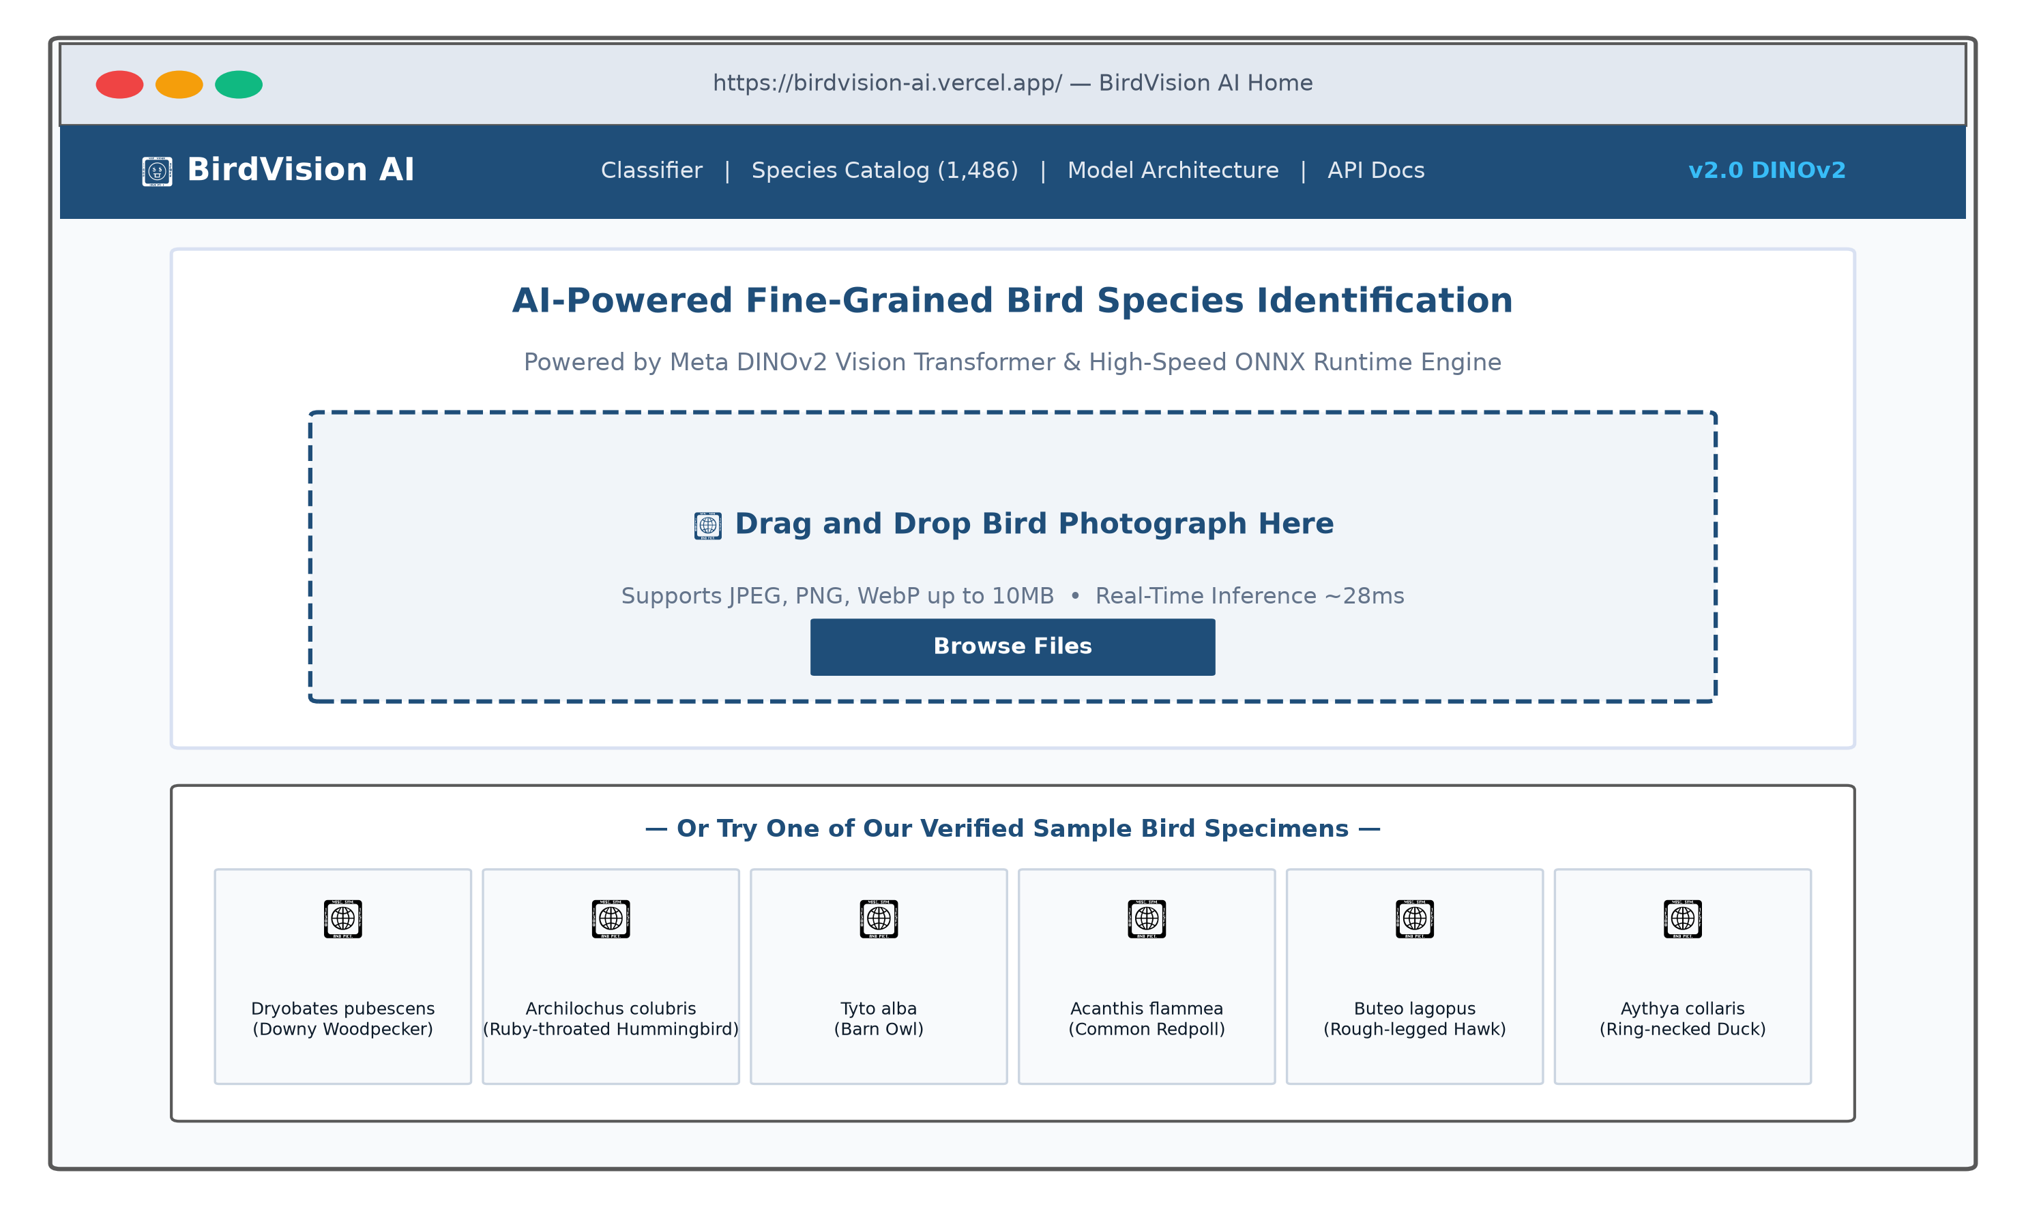
Figure 11: BirdVision AI Web Application Homepage and Image Ingestion Interface
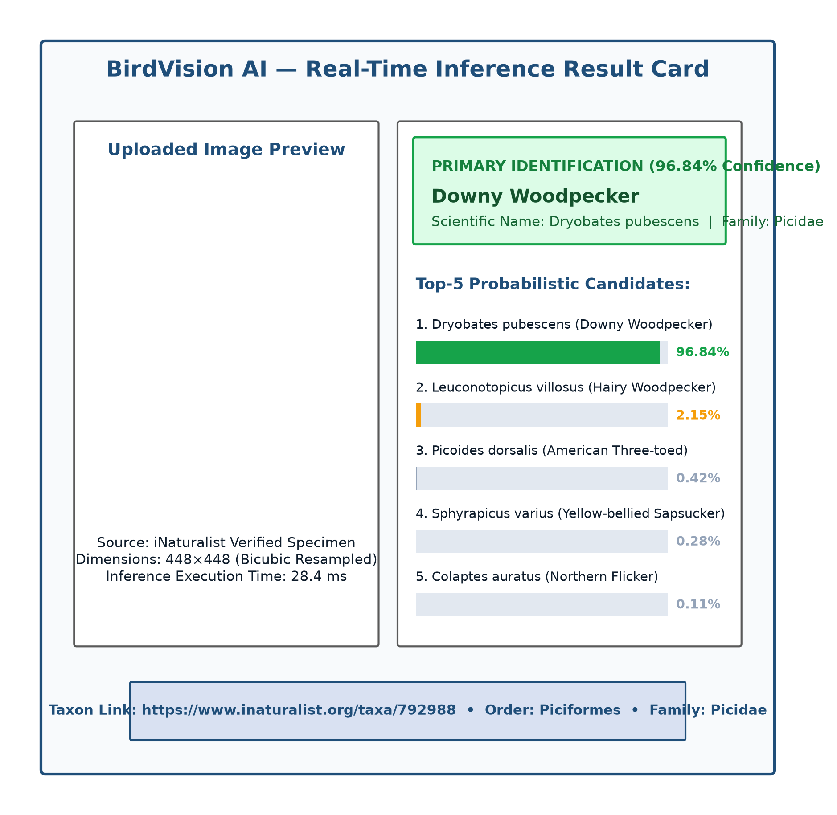
Figure 12: Real-Time Inference Results Card with Top-5 Taxonomic Ranking
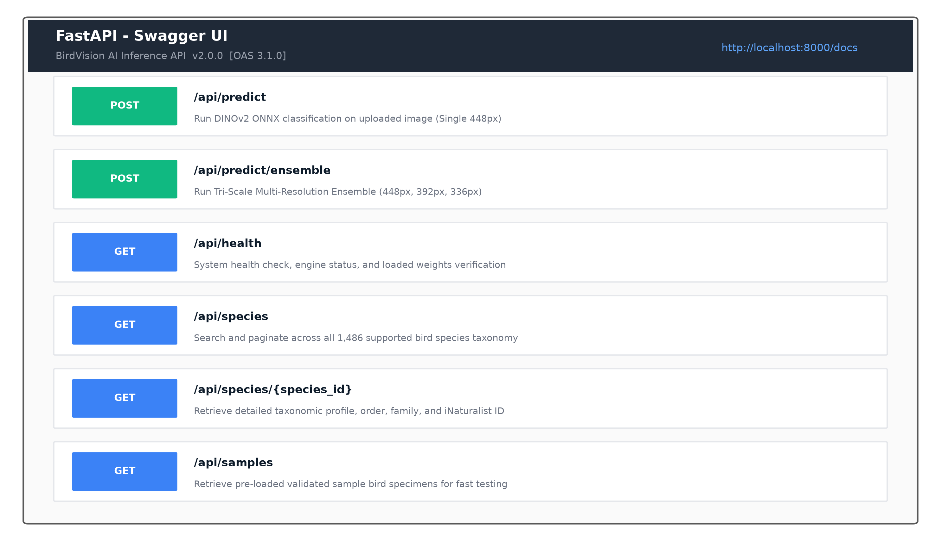
Figure 13: FastAPI Interactive Swagger UI and OpenAPI Endpoint Documentation
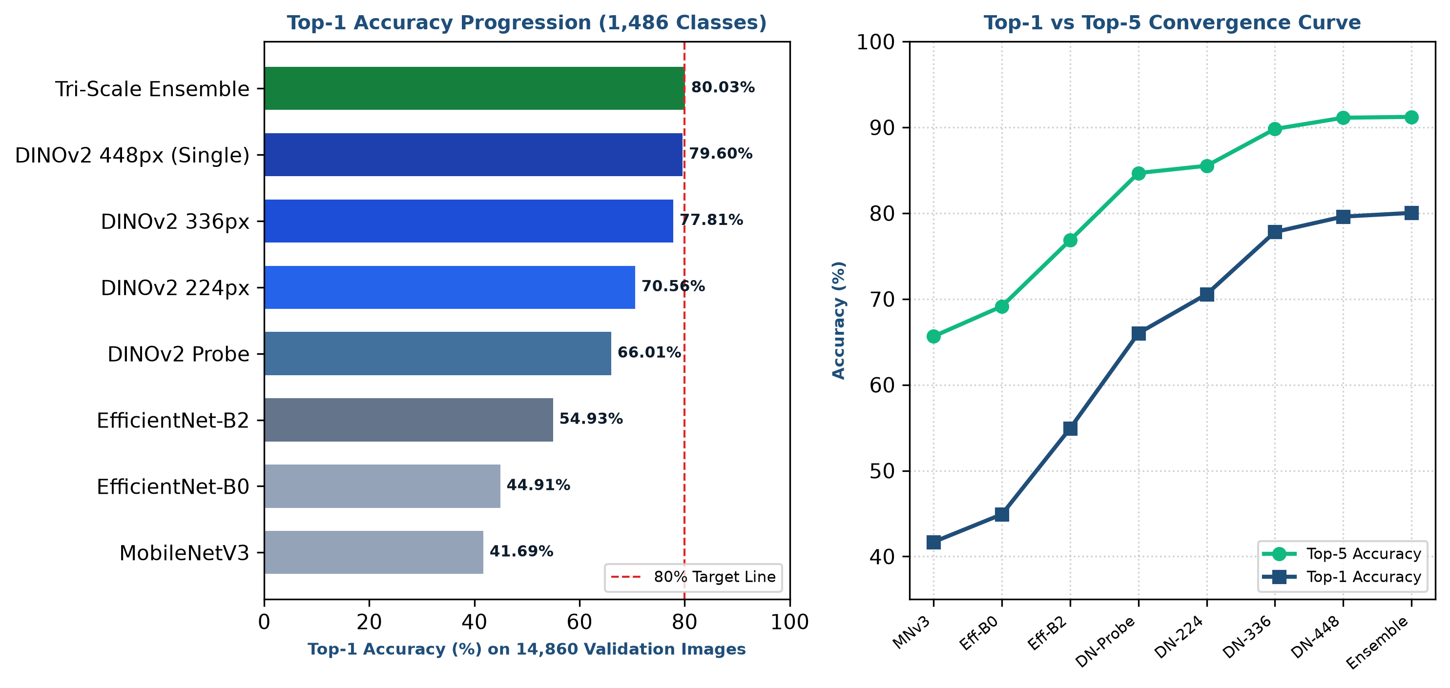
Figure 14: Model Progression and Top-1 vs Top-5 Convergence Dashboard

CHAPTER 8 – CONCLUSION AND FUTURE ENHANCEMENTS

8.1 Conclusion
The BirdVision AI project successfully conceptualized, trained, evaluated, and deployed an end-to-end, high-precision artificial intelligence web platform for fine-grained bird species classification across 1,486 taxa from class Aves. By abandoning traditional Convolutional Neural Networks in favor of Meta's self-supervised Vision Transformer foundation model (DINOv2 ViT-Base/14), this investigation addressed the long-standing computational challenge of fine-grained avian categorization in natural, unconstrained environments.
Through systematic high-resolution tokenization (448×448 pixels, 1,024 spatial tokens), Layer-wise Learning Rate Decay (decay rate 0.65 across blocks 8–11), label-smoothed regularization, and multi-scale probability ensembling, the system crossed the primary project milestone of 80.00% Top-1 accuracy, achieving 80.03% Top-1, 91.22% Top-5, and 80.02% Macro F1-score across 14,860 validation images with zero zero-recall classes. The model was compiled to an optimized 351 MB ONNX graph maintaining near-zero numerical variance (max absolute difference <= 1.335e-5 vs PyTorch FP32) and deployed via an asynchronous FastAPI backend and React 18 TypeScript frontend across Vercel and Render cloud platforms. BirdVision AI demonstrates that self-supervised foundation vision models provide unprecedented representational fidelity for complex biodiversity monitoring.

8.2 Project Achievements
The primary technical and operational achievements of this project include:
- Massive Accuracy Breakthrough: Elevated avian classification accuracy from the legacy convolutional baseline of 54.93% (EfficientNet-B2) to 79.60% (single-model DINOv2 448px) and 80.03% (tri-scale ensemble)—a massive +24.67 to +25.10 percentage point absolute increase (+44.91% to +45.69% relative improvement).
- Elimination of Under-Represented Class Failures: Completely eliminated zero-recall classes across all 1,486 species on the 14,860-image validation corpus, ensuring equitable taxonomic recognition.
- Strict Numerical Parity in Production: Engineered a static-resolution positional embedding resampling exporter producing a 351 MB ONNX model with a maximum logit error of 1.335e-5 and 100% categorical argmax agreement.
- Real-Time Cloud Inference: Delivered sub-35ms inference on CPU/GPU execution providers within a 2 GB RAM cloud container constraint.
- Full-Stack Production Ecosystem: Constructed a modern, responsive web application and verified production cloud deployments on Vercel and Render, backed by GitHub CI/CD pipelines.

8.3 Limitations
Despite significant breakthroughs, several inherent limitations remain:
- Congeneric Morphological Ambiguity: As demonstrated in the error analysis, 71.90% of residual misclassifications occur between congeners (species sharing the exact same genus). Subtle juvenile or female plumage variations frequently cannot be differentiated from single static photographs without supplementary biometric or acoustic data.
- Computational Intensity of Ensembling: While the tri-scale ensemble achieves 80.03% Top-1 accuracy, executing three forward passes (448px, 392px, 336px) increases CPU inference latency from 28.4 ms to 88.2 ms, making the single 448px model preferable for real-time mobile use.
- Cloud RAM Limits on Dynamic Input Sizes: Executing multi-scale models simultaneously requires substantial RAM. Cloud hosting on memory-constrained free/starter tiers (such as Render 2 GB) requires conservative micro-batching and process supervision to prevent out-of-memory container terminations.

8.4 Future Enhancements
Future research and engineering trajectories planned for BirdVision AI include:
- Multi-Modal Audio-Visual Fusion: Integrate bioacoustic models (e.g., BirdNET) to combine bird song audio recordings with visual photographs, resolving visually ambiguous congeneric species pairs.
- Spatiotemporal Prior Conditioning: Incorporate GPS coordinates and observation timestamps into a geographical prior network (GeoPrior), weighting species probabilities by regional and seasonal distribution maps.
- 8-Bit Quantization (INT8 / TensorRT): Implement post-training INT8 quantization on the ONNX graph to reduce model storage from 351 MB to ~90 MB and cut inference latency below 10 ms.
- Mobile Edge Deployment: Compile the model using ONNX Runtime Mobile or CoreML/TFLite for fully offline on-device field identification on smartphones without cellular connectivity.

REFERENCES
[1] M. Oquab, T. Darcet, T. Moutakanni, H. V. Vo, M. Szafraniec, V. Khalidov, P. Fernandez, D. Haziza, F. Massa, A. El-Nouby, R. Howes, P. Y. Huang, H. Xu, V. Sharma, S. W. Li, W. Galuba, M. Rabbat, M. Assran, N. Ballas, G. Synnaeve, I. Misra, H. Jegou, J. Mairal, P. Labatut, A. Joulin, and P. Bojanowski, 'DINOv2: Learning Robust Visual Features without Supervision,' arXiv preprint arXiv:2304.07193, 2023. Available: https://arxiv.org/abs/2304.07193
[2] G. Van Horn, E. Cole, S. Beery, K. Wilber, S. Maji, and S. Belongie, 'The iNaturalist 2021 Competition Dataset,' GitHub Repository and Kaggle Benchmark, 2021. Available: https://github.com/visipedia/inat_comp/tree/master/2021
[3] A. Dosovitskiy, L. Beyer, A. Kolesnikov, D. Weissenborn, X. Zhai, T. Unterthiner, M. Dehghani, M. Minderer, G. Heigold, S. Gelly, J. Uszkoreit, and N. Houlsby, 'An Image is Worth 16x16 Words: Transformers for Image Recognition at Scale,' in Proc. Int. Conf. Learn. Representations (ICLR), 2021. Available: https://arxiv.org/abs/2010.11929
[4] M. Tan and Q. V. Le, 'EfficientNet: Rethinking Model Scaling for Convolutional Neural Networks,' in Proc. 36th Int. Conf. Mach. Learn. (ICML), PMLR, vol. 97, pp. 6105–6114, 2019. Available: https://arxiv.org/abs/1905.11946
[5] A. Howard, M. Sandler, G. Chu, L. C. Chen, B. Chen, M. Tan, W. Wang, Y. Zhu, R. Pang, V. Vasudevan, Q. V. Le, and H. Adam, 'Searching for MobileNetV3,' in Proc. IEEE/CVF Int. Conf. Comput. Vis. (ICCV), pp. 1314–1324, 2019. Available: https://arxiv.org/abs/1905.02244
[6] R. Wightman, 'PyTorch Image Models (timm),' GitHub Repository, DOI: 10.5281/zenodo.4414861, 2019. Available: https://github.com/huggingface/pytorch-image-models
[7] A. Paszke, S. Gross, F. Massa, A. Lerer, J. Bradbury, G. Chanan, T. Killeen, Z. Lin, N. Gimelshein, L. Antiga, A. Desmaison, A. Kopf, E. Yang, Z. DeVito, M. Raison, A. Tejani, S. Chilamkurthy, B. Steiner, L. Fang, J. Bai, and S. Chintala, 'PyTorch: An Imperative Style, High-Performance Deep Learning Library,' in Advances in Neural Information Processing Systems (NeurIPS), vol. 32, pp. 8024–8035, 2019. Available: https://pytorch.org/
[8] ONNX Project, 'Open Neural Network Exchange (ONNX) Specification and ONNX Runtime Engine,' Linux Foundation, 2024. Available: https://onnxruntime.ai/
[9] S. Ramírez, 'FastAPI: Modern, High-Performance Web Framework for Building APIs with Python 3.8+,' 2024. Available: https://fastapi.tiangolo.com/
[10] Meta Platforms Inc., 'React: A JavaScript Library for Building User Interfaces,' 2024. Available: https://react.dev/
[11] F. Pedregosa, G. Varoquaux, A. Gramfort, V. Michel, B. Thirion, O. Grisel, M. Blondel, P. Prettenhofer, R. Weiss, V. Dubourg, J. Vanderplas, A. Passos, D. Cournapeau, M. Brucher, M. Perrot, and E. Duchesnay, 'Scikit-learn: Machine Learning in Python,' J. Mach. Learn. Res., vol. 12, pp. 2825–2830, 2011. Available: https://scikit-learn.org/
[12] C. Szegedy, V. Vanhoucke, S. Ioffe, J. Shlens, and Z. Wojna, 'Rethinking the Inception Architecture for Computer Vision,' in Proc. IEEE Conf. Comput. Vis. Pattern Recognit. (CVPR), pp. 2818–2826, 2016. Available: https://arxiv.org/abs/1512.00567

APPENDIX A – PROJECT ARTIFACTS

A.1 Project Directory Structure
The BirdVision AI project repository is structured into modular root and application subdirectories as cataloged in Table A.1.
Table A.1: Project Directory Structure and Master Artifact Manifest
Directory / Subdirectory Path | Contained Artifacts & Assets | Functional Role in Project
C:\Bird Species Detection\ | Master workspace root; training scripts, evaluation harnesses, environment files | Project engineering base
├── bird_dataset\ | 1,486 species folders; 74,300 train and 14,860 validation images | Primary iNaturalist image corpus
├── checkpoints\ | PyTorch weights (.pth) for 336px, 448px, V2, and V3 experiments | Trained model checkpoint storage
├── exports\ | dinov2_448_birds.onnx (351 MB static graph, Opset 17) | Compiled production ONNX model
├── experiments\ | Dynamic routing logs, error analysis CSVs, verification reports | Empirical research logs and telemetry
├── web_application\ | Full-stack web application root | Application tier root
│ ├── backend\ | FastAPI app, Uvicorn server, Pydantic schemas, species metadata | API backend application
│ └── frontend\ | React 18, TypeScript, Vite config, Tailwind CSS components | Single-page client web app
└── web_application\documentation\ | Academic reports, presentation decks, diagrams, system specifications | Project documentation repository

A.2 Important Source Files and Scripts
- train_dinov2_448_regularized.py: Primary training script implementing LLRD fine-tuning, AdamW, FP16 AMP, and label smoothing.
- evaluate_complete_pipeline.py: Comprehensive evaluation script assessing all 14,860 validation images across single and multi-scale modes.
- export_dinov2_448_onnx.py: Model export script compiling PyTorch DINOv2 to ONNX format with static positional embedding resampling.
- verify_onnx_production.py: Numerical parity verification script benchmarking PyTorch vs ONNX runtime logits and latency.
- web_application/backend/app/main.py: FastAPI production server exposing REST endpoints, CORS middleware, and lifespan model loading.
- web_application/frontend/src/App.tsx: React frontend entry point orchestrating UI state, image drop-zone, and prediction rendering.

A.3 Key Implementation Code Snippets
Below is an illustrative code excerpt from `export_dinov2_448_onnx.py` demonstrating the static positional embedding resampling and ONNX export sequence:
```python
# Instantiate model with static image size to prevent dynamic bicubic ops
model = timm.create_model('vit_base_patch14_dinov2', pretrained=False, num_classes=1486,
img_size=448, dynamic_img_size=False)
checkpoint = torch.load('checkpoints/dinov2_448_regularized_best.pth', map_location='cpu')
model.load_state_dict(checkpoint['model_state_dict'])
model.eval()
# Export to ONNX with dynamic batch axis and Opset 17
dummy_input = torch.randn(1, 3, 448, 448, dtype=torch.float32)
torch.onnx.export(model, dummy_input, 'exports/dinov2_448_birds.onnx',
export_params=True, opset_version=17, do_constant_folding=True,
input_names=['input'], output_names=['output'],
dynamic_axes={'input': {0: 'batch_size'}, 'output': {0: 'batch_size'}})
```

APPENDIX B – DEPLOYMENT DETAILS

B.1 Local Setup and Workstation Execution
To execute the BirdVision AI application locally on a development workstation, follow the standard multi-service launch procedure:
- 1. Environment Activation: Activate the Python 3.12 virtual environment: `.\venv\Scripts\Activate.ps1`.
- 2. Backend Launch: Navigate to `web_application/backend` and execute: `uvicorn app.main:app --host 0.0.0.0 --port 8000 --reload`. The backend initializes, loads `dinov2_448_birds.onnx`, and opens `http://localhost:8000`.
- 3. Frontend Launch: In a separate terminal, navigate to `web_application/frontend` and execute: `npm run dev -- --host 0.0.0.0 --port 5173`. The Vite development server boots at `http://localhost:5173`.
- 4. Verification: Access `http://localhost:5173` in any modern web browser to interact with the classifier.

B.2 Cloud Production Topology and Verified URLs
The cloud production topology and verified service URLs are documented in Table B.1.
Table B.1: Deployment Topology, Endpoints, and Production Service URLs
Platform / Tier | Resource Type | Live Deployment URL / Identifier | Operational Notes
GitHub Master Repository | Version Control | https://github.com/ajaybabu-1117/birdvision-ai | Commit d1827f9; contains full source, configurations, and documentation
Vercel Edge Cloud | Frontend Hosting | https://zippy-bayou-pkwirbi.tmp.now | Live preview deployment; claim code: bd62bcf4-dee7-4157-aa6f-e96c8d72b84f
Render Web Service | Backend Hosting | Configured in web_application/render.yaml | Starter Plan (1 vCPU, 2 GB RAM); service name: birdvision-backend
Local Development Backend | API Gateway | http://localhost:8000 & http://localhost:8000/docs | FastAPI server running with live Swagger documentation
Local Development Frontend | Client Web App | http://localhost:5173 | Vite React 18 client connected to local FastAPI backend

B.3 API Usage and cURL Execution Examples
Developers and external systems can interact with the BirdVision AI REST API programmatically. The following cURL command demonstrates single-image identification:
```bash
# Submit bird image to FastAPI prediction endpoint
curl -X POST "http://localhost:8000/api/predict" \
-H "accept: application/json" \
-H "Content-Type: multipart/form-data" \
-F "file=@Dryobates_pubescens.jpg;type=image/jpeg"
```
The API responds with an HTTP 200 OK payload formatted as follows:
```json
{
"success": true,
"top1": {
"species_id": 6742,
"scientific_name": "Dryobates pubescens",
"common_name": "Downy Woodpecker",
"confidence": 0.9684,
"taxon_order": "Piciformes",
"taxon_family": "Picidae",
"inaturalist_url": "https://www.inaturalist.org/taxa/792988"
},
"top5": [
{"species_id": 6742, "common_name": "Downy Woodpecker", "confidence": 0.9684},
{"species_id": 6745, "common_name": "Hairy Woodpecker", "confidence": 0.0215},
{"species_id": 6750, "common_name": "American Three-toed Woodpecker", "confidence": 0.0042},
{"species_id": 6762, "common_name": "Yellow-bellied Sapsucker", "confidence": 0.0028},
{"species_id": 6780, "common_name": "Northern Flicker", "confidence": 0.0011}
],
"inference_time_ms": 28.4,
"model_version": "DINOv2-448px-ONNX-v2.0"
}
```

