JAVA APPLETS

INTRODUCTION:
Java can be used to create two types of programs:
1.Applications
2.Applets.

An application is a program that runs on your computer, under the operating system of that computer.

An applet is an application designed to be transmitted over the Internet and executed by a Java-compatible Web browser. An applet is actually a tiny Java program, dynamically ownloaded across the network, just like an image, sound file, or video clip.

Applet Fundamentals
The fundamentals connected to the creation of an applet are presented here
import java.awt.*;
import java.applet.*;
public class SimpleApplet extends Applet {
public void paint(Graphics g) {
g.drawString("A Simple Applet", 20, 20);
}
}

This applet begins with two import statements.
- The first imports the Abstract Window Toolkit (AWT) classes. Applets interact with the user through the AWT, not through the console-based I/O classes. The AWT contains support for a window-based, graphical interface.
- The second import statement imports the applet package, which contains the class Applet. Every applet that you create must be a subclass of Applet.

The next line in the program declares the class SimpleApplet. This class must be declared as public, because it will be accessed by code that is outside the program.

Inside SimpleApplet, paint( ) is declared. This method is defined by the AWT and must be overridden by the applet. paint( ) is called each time that the applet must redisplay its output. The paint( ) method has one parameter of type Graphics. This parameter contains the graphics context, which describes the graphics environment in which the applet is running.

Inside paint( ) is a call to drawString( ), which is a member of the Graphics class. This method outputs a string beginning at the specified X,Y location. It has the following general form:
void drawString(String message, int x, int y)
Here, message is the string to be output beginning at x,y. In a Java window, the upper-left

corner is location 0,0. The call to drawString( ) in the applet causes the message “A Simple Applet” to be displayed beginning at location 20,20.

Notice that the applet does not have a main( ) method. Unlike Java programs, applets do not begin execution at main( ). In fact, most applets don’t even have a main( ) method. Instead, an applet begins execution when the name of its class is passed to an applet viewer or to a network browser.

Running SimpleApplet involves a different process. In fact, there are two ways in which you can run an applet:
■ Executing the applet within a Java-compatible Web browser.
■ Using an applet viewer, such as the standard SDK tool, appletviewer. An applet viewer executes your applet in a window. This is generally the fastest and easiest way to test your applet.

In general, you can quickly iterate through applet development by using these three steps:
1. Edit a Java source file.
2. Compile your program.
3. Execute the applet viewer, specifying the name of your applet’s source file. The applet viewer will encounter the APPLET tag within the comment and execute your applet.

The window produced by SimpleApplet, as displayed by the applet viewer, is shown in the following illustration:
Here are the key points that you should remember now:
■ Applets do not need a main( ) method.
■ Applets must be run under an applet viewer or a Java-compatible browser.
■ User I/O is not accomplished with Java’s stream I/O classes. Instead, applets use the interface provided by the AWT.
■ The Applet class is contained in the java.applet package

An Applet Skeleton
// An Applet skeleton.
import java.awt.*;
import java.applet.*;
/*
<applet code="AppletSkel" width=300 height=100>
</applet>
*/
public class AppletSkel extends Applet {
// Called first.
public void init() {
// initialization
}
/* Called second, after init(). Also called whenever
the applet is restarted. */
public void start() {
// start or resume execution
}
// Called when the applet is stopped.
public void stop() {
// suspends execution
}
/* Called when applet is terminated. This is the last
method executed. */
public void destroy() {
// perform shutdown activities
}
// Called when an applet's window must be restored.
public void paint(Graphics g) {
// redisplay contents of window
}
}

Applet Initialization and Termination
It is important to understand the order in which the various methods shown in the skeleton are called. When an applet begins, the AWT calls the following methods, in this sequence:
1. init( )
2. start( )
3. paint( )
When an applet is terminated, the following sequence of method calls takes place:
1. stop( )
2. destroy( )
Let’s look more closely at these methods.
init( )
The init( ) method is the first method to be called. This is where you should initialize variables. This method is called only once during the run time of your applet.

start( )
The start( ) method is called after init( ). It is also called to restart an applet after it has been stopped. Whereas init( ) is called once—the first time an applet is loaded—start( ) is called each time an applet’s HTML document is displayed onscreen. So, if a user leaves a web page and comes back, the applet resumes execution at start( ).

paint( )
The paint( ) method is called each time your applet’s output must be redrawn.The paint( ) method has one parameter of type Graphics. This parameter will contain the graphics context, which describes the graphics environment in which the applet is running. This context is used whenever output to the applet is required.

stop( )
The stop( ) method is called when a web browser leaves the HTML document containing
the applet—when it goes to another page, for example

destroy( )
The destroy( ) method is called when the environment determines that your applet needs to be removed completely from memory. At this point, you should free up any resources the applet may be using. The stop( ) method is always called before destroy( ).

Event Handling Mechanisms

The Delegation Event Model
Its concept is quite simple: A source generates an event and sends it to one or more listeners. In this scheme, the listener simply waits until it receives an event. Once received, the listener processes the event and then returns. The advantage of this design is that the application logic that processes events is cleanly separated from the user interface logic that generates those events. In the delegation event model, listeners must register with a source in order to receive an event notification. This provides an important benefit: notifications are sent only to listeners that want to receive them

Events
In the delegation model, an event is an object that describes a state change in a source.

Event Source
A source is an object that generates an event. Sources may generate more than one type of event. A source must register listeners in order for the listeners to receive notifications
about a specific type of event. Each type of event has its own registration method.
Here is the general form:
public void addTypeListener(TypeListener el)
Here, Type is the name of the event and el is a reference to the event listener.
A source must also provide a method that allows a listener to unregister an interest
in a specific type of event. The general form of such a method is this:
public void removeTypeListener(TypeListener el)
Here, Type is the name of the event and el is a reference to the event listener. For example, to remove a keyboard listener, you would call removeKeyListener( )

Event Listeners
A listener is an object that is notified when an event occurs. It has two major requirements.
First, it must have been registered with one or more sources to receive notifications about specific types of events. Second, it must implement methods to receive and process these notifications.

Event Classes
At the root of the Java event class hierarchy is EventObject, which is in java.util.
It is the superclass for all events. Its one constructor is shown here:
EventObject(Object src)
Here, src is the object that generates this event.
EventObject contains two methods:
getSource( ) and
toString( ).
The getSource( ) method returns the source of the event. Its general form is shown here:
Object getSource( )
As expected, toString( ) returns the string equivalent of the event.

Event Class Description
ActionEvent Generated when a button is pressed, a list item is double-clicked,
or a menu item is selected.
AdjustmentEvent Generated when a scroll bar is manipulated.
ComponentEvent Generated when a component is hidden, moved, resized, or
becomes visible.
ContainerEvent Generated when a component is added to or removed from a
container.
FocusEvent Generated when a component gains or loses keyboard focus.

InputEvent Abstract super class for all component input event classes.

ItemEvent Generated when a check box or list item is clicked; also occurs
when a choice selection is made or a checkable menu item is
selected or deselected.

KeyEvent Generated when input is received from the keyboard.

MouseEvent Generated when the mouse is dragged, moved, clicked, pressed, or
released; also generated when the mouse enters or exits a
component.
MouseWheelEvent Generated when the mouse wheel is moved

TextEvent Generated when the value of a text area or text field is changed.
WindowEvent Generated when a window is activated, closed, deactivated,
deiconified, iconified, opened, or quit.

Ex.No: 1(A) DEMONSTRATION OF AWT CONTROLS
DATE: 13.07.10

Aim:
To write a java program for demonstrating the following AWT controls
1. Button 2.Checkbox 3.Choice
4.List 5.TextField 6.Scrollbar

Hardware requirements:
Intel pentium Processor IV
128mb RAM

Software requirements:
Jdk1.6.0

Algorithm:
- Create a Button AWT control , select a suitable layout manager to place and demonstrate it’s use by clicking the Button.
- Create a Checkbox AWT control , select a suitable layout manager to place and demonstrate it’s use by selecting the Checkbox.
- Create a Choice AWT control , select a suitable layout manager to place and demonstrate it’s use by selecting a item.
- Create a List AWT control , select a suitable layout manager to place and demonstrate it’s use by selecting items.
- Create a TextField and TextArea AWT control , select a suitable layout manager to place and demonstrate it’s use by editing the TextField.
- Create a Scrollbar AWT control , select a suitable layout manager to place and demonstrate it’s use by clicking the thumb.

DEMONSTRATION OF AWT CONTROLS

PROGRAMS:

(i)Text Fields:

import java.awt.*;
import java.awt.event.*;
import java.applet.*;
/* <applet code="TextFieldDemo" width=500 height=150>
</applet>
*/
public class TextFieldDemo extends Applet implements ActionListener
{
TextField name,pass;
public void init()
{
Label namep=new Label("Name : ",Label.RIGHT);
Label passp=new Label("Password : ",Label.RIGHT);
name=new TextField(12);
pass=new TextField(8);
pass.setEchoChar('*');
add(namep);
add(name);
add(passp);
add(pass);
name.addActionListener(this);
pass.addActionListener(this);
}
public void actionPerformed(ActionEvent ae)
{
repaint();
}
public void paint(Graphics g)
{
g.drawString("Name : "+name.getText(),6,60);
g.drawString("Password : "+pass.getText(),6,80);
}
}

OUTPUT:

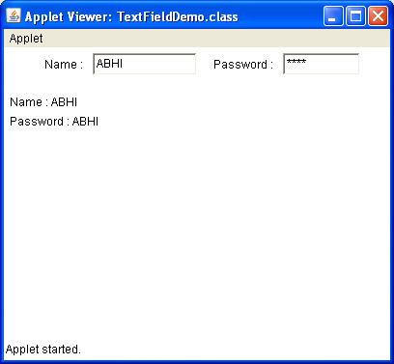

RESULT:
Thus the program to demonstrate text field was successfully executed and the output was verified.
(ii) Buttons:

import java.awt.*;
import java.awt.event.*;
import java.applet.*;
/* <applet code="ButtonDemo" width=350 height=150>
</applet>
*/
public class ButtonDemo extends Applet implements ActionListener
{
Button yes,no;
String msg=" ";
public void init()
{
yes=new Button("Yes");
no=new Button("No");
add(yes);
add(no);
yes.addActionListener(this);
no.addActionListener(this);
}
public void actionPerformed(ActionEvent ae)
{
String str=ae.getActionCommand();
if(str.equals("Yes"))
{
msg="Pressed Yes";
}
else
{
msg="Pressed No";
}
repaint();
}
public void paint(Graphics g)
{
g.drawString(msg,6,100);
}
}

OUTPUT:

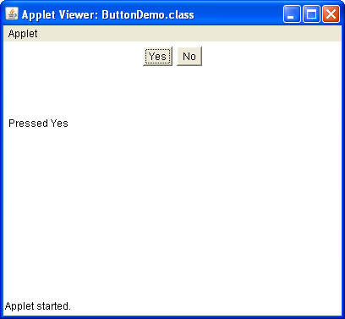

RESULT:
Thus the program to demonstrate button was successfully executed and the output was verified.
(iii) Choice:

import java.awt.*;
import java.awt.event.*;
import java.applet.*;
/* <applet code="ChoiceDemo" width=500 height=150>
</applet>
*/
public class ChoiceDemo extends Applet implements ItemListener
{
Choice os,br;
public void init()
{
os=new Choice();
br=new Choice();
add(os);
add(br);
os.add("Windows XP");
os.add("Windows Vista");
os.add("Solaris");
os.add("Mac OS");
br.add("Internet Explorer");
br.add("FireFox");
br.add("Opera");
os.addItemListener(this);
br.addItemListener(this);
}
public void itemStateChanged(ItemEvent ie)
{
repaint();
}
public void paint(Graphics g)
{
g.drawString("Current OS: "+os.getSelectedItem(),6,100);
g.drawString("Current Browser: "+br.getSelectedItem(),6,120);
}
}

OUTPUT:

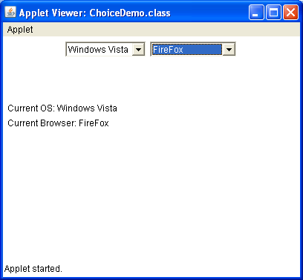

RESULT:
Thus the program to demonstrate choice was successfully executed and the output was verified.

(iv) List:

import java.awt.*;
import java.awt.event.*;
import java.applet.*;
/* <applet code="ListDemo" width=500 height=150>
</applet>
*/
public class ListDemo extends Applet implements ActionListener
{
List os,br;
String msg=" ";
public void init()
{
os=new List(4,true);
br=new List(4,true);
add(os);
add(br);
os.add("Windows XP");
os.add("Windows Vista");
os.add("Solaris");
os.add("Mac OS");
br.add("Internet Explorer");
br.add("Firefox");
br.add("Opera");
os.addActionListener(this);
br.addActionListener(this);
}
public void actionPerformed(ActionEvent ae)
{
repaint();
}
public void paint(Graphics g)
{
int index[],i;
msg="Current OS: ";
index=os.getSelectedIndexes();
for(i=0;i<index.length;i++)
{
msg+=os.getItem(index[i])+" ";
}
g.drawString(msg,6,100);
msg="Current Browser: ";
index=br.getSelectedIndexes();

for(i=0;i<index.length;i++)
{
msg+=br.getItem(index[i])+" ";
}
g.drawString(msg,6,120);
}
}

OUTPUT:

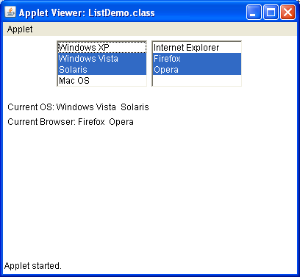

RESULT:
Thus the program to demonstrate list was successfully executed and the output was verified.
(v) Check box:

import java.awt.*;
import java.awt.event.*;
import java.applet.*;
/* <applet code="CBDemo" width=500 height=150>
</applet>
*/
public class CBDemo extends Applet implements ItemListener
{
Checkbox winXP,winVis,sol,mac;
public void init()
{
winXP=new Checkbox("Windows XP",null,false);
winVis=new Checkbox("Windows Vista",null,false);
sol=new Checkbox("Solaris",null,false);
mac=new Checkbox("Mac OS",null,false);
add(winXP);
add(winVis);
add(sol);
add(mac);
winXP.addItemListener(this);
winVis.addItemListener(this);
sol.addItemListener(this);
mac.addItemListener(this);
}
public void itemStateChanged(ItemEvent ie)
{
repaint();
}
public void paint(Graphics g)
{
g.drawString("Windows XP: "+winXP.getState(),6,80);
g.drawString("Windows Vista: "+winVis.getState(),6,100);
g.drawString("Solaris: "+sol.getState(),6,120);
g.drawString("Mac OS: "+mac.getState(),6,140);
}
}

OUTPUT:

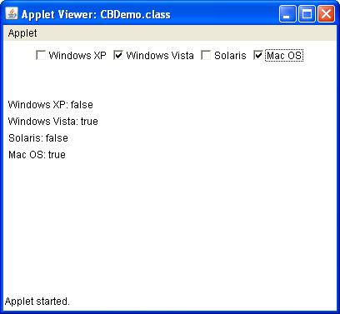

RESULT:
Thus the program to demonstrate check box was successfully executed and the output was verified.

(vi) Scroll bar:

import java.awt.*;
import java.awt.event.*;
import java.applet.*;
/* <applet code="SBDemo" width=500 height=150>
</applet>
*/
public class SBDemo extends Applet implements AdjustmentListener,MouseMotionListener
{
String msg=" ";
Scrollbar vertsb,horzsb;
public void init()
{
int width=Integer.parseInt(getParameter("width"));
int height=Integer.parseInt(getParameter("height"));
vertsb=new Scrollbar(Scrollbar.VERTICAL,0,1,0,height);
horzsb=new Scrollbar(Scrollbar.HORIZONTAL,0,1,0,width);
add(vertsb);
add(horzsb);
vertsb.addAdjustmentListener(this);
horzsb.addAdjustmentListener(this);
addMouseMotionListener(this);
}
public void adjustmentValueChanged(AdjustmentEvent ae)
{
repaint();
}
public void mouseDragged(MouseEvent me)
{
int x=me.getX();
int y=me.getY();
vertsb.setValue(y);
horzsb.setValue(x);
repaint();
}
public void mouseMoved(MouseEvent me) { }
public void paint(Graphics g)
{
msg="Vertical: "+vertsb.getValue();
msg+=" , Horizontal: "+horzsb.getValue();
g.drawString(msg,6,120);
g.drawString("*",horzsb.getValue(),vertsb.getValue());
}
}

OUTPUT:

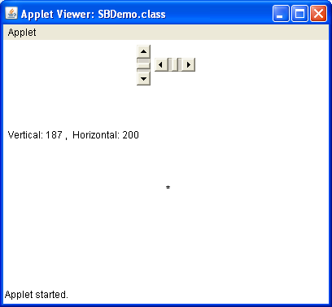

RESULT:
Thus the program to demonstrate scroll bar was successfully executed and the output was verified.
Ex.No: 1(b) APPLICATION OF AWT CONTROLS (BIO-DATA)
DATE: 20.07.10

Aim:
To write a java program for demonstrate the application of AWT controls.

Hardware requirements:
Intel pentium Processor IV
128mb RAM

Software requirements:
Jdk1.6.0

Algorithm:
- Create a Button AWT control , select a suitable layout manager to place and demonstrate it’s use by clicking the Button.
- Create a Checkbox AWT control , select a suitable layout manager to place and demonstrate it’s use by selecting the Checkbox.
- Create a Choice AWT control , select a suitable layout manager to place and demonstrate it’s use by selecting a item.
- Create a List AWT control , select a suitable layout manager to place and demonstrate it’s use by selecting items.
- Create a TextField and TextArea AWT control , select a suitable layout manager to place and demonstrate it’s use by editing the TextField.
- Create a Scrollbar AWT control , select a suitable layout manager to place and demonstrate it’s use by clicking the thumb.
- Use all these controls to design a bio-data form.

APPLICATION OF AWT CONTROL(BIO-DATA)

PROGRAM:

import java.awt.*;
import java.awt.event.*;
import java.applet.*;

/* <applet code="Biodata" width=500 height=500>
</applet>
*/

public class Biodata extends Applet implements ActionListener,ItemListener
{
String msg=" ";
Label namel,dobl,genderl,intl;
TextField name;
Choice date,month,year;
Checkbox male,female;
CheckboxGroup cbg;
List interest;
Button submit;
String str;
public void init()
{
setLayout(null);

//Create Labels
namel= new Label("Name : ",Label.LEFT);
namel.setBounds(50,50,50,25);
dobl= new Label("DOB : ",Label.LEFT);
dobl.setBounds(50,90,50,25);
genderl= new Label("Gender : ",Label.LEFT);
genderl.setBounds(50,130,60,25);
intl= new Label("Areas of Interest : ",Label.LEFT);
intl.setBounds(50,170,100,25);

//Create TextField
name= new TextField(20);
name.setBounds(170,50,80,25);

//Create Choices
date= new Choice();
date.setBounds(170,90,40,25);
month= new Choice();
month.setBounds(220,90,50,25);
year= new Choice();
year.setBounds(280,90,60,25);

//Add items to choices
year.add("1985");
year.add("1986");
year.add("1987");
year.add("1988");
year.add("1989");
year.add("1990");
month.add("Jan");
month.add("Feb");
month.add("Mar");
month.add("Apr");
month.add("May");
month.add("Jun");
month.add("Jul");
month.add("Aug");
month.add("Sep");
month.add("Oct");
month.add("Nov");
month.add("Dec");
date.add("1");
date.add("2");
date.add("3");
date.add("4");
date.add("5");
date.add("6");
date.add("7");
date.add("8");
date.add("9");
date.add("10");
date.add("11");
date.add("12");
date.add("13");
date.add("14");
date.add("15");
date.add("16");
date.add("17");
date.add("18");
date.add("19");
date.add("20");
date.add("21");
date.add("22");
date.add("23");
date.add("24");
date.add("25");
date.add("26");
date.add("27");
date.add("28");
date.add("29");
date.add("30");
date.add("31");

//Create CheckboxGroup to use RadioButton
cbg= new CheckboxGroup();

//Create RadioButtons
male= new Checkbox("Male",false,cbg);
male.setBounds(170,130,50,25);
female= new Checkbox("Female",false,cbg);
female.setBounds(220,130,60,25);

//Create a List
interest= new List(4,true);
interest.setBounds(170,170,80,70);

//add items to list
interest.add("C");
interest.add("C++");
interest.add("Java");
interest.add("C#");

//Create a button
submit= new Button("Submit");
submit.setBounds(150,270,80,25);

//Add the controls to the window
add(namel);
add(name);
add(dobl);
add(date);
add(month);
add(year);
add(genderl);
add(male);
add(female);
add(intl);
add(interest);
add(submit);

//Register the source events to the EventListener
name.addActionListener(this);
date.addItemListener(this);
month.addItemListener(this);
year.addItemListener(this);
male.addItemListener(this);
female.addItemListener(this);
interest.addActionListener(this);
submit.addActionListener(this);
}

public void actionPerformed(ActionEvent ae)
{
str=ae.getActionCommand();
if(str.equals("Submit"))
{
repaint();
}
}

public void itemStateChanged(ItemEvent ie)
{
repaint();
}

public void paint(Graphics g)
{
int idx[];

//To display Name
g.drawString("Name : "+name.getText(),50,320);

//To display DOB
msg="DOB : ";
msg+= date.getSelectedItem()+" ";
msg+= month.getSelectedItem()+" ";
msg+= year.getSelectedItem()+" ";
g.drawString(msg,50,340);

//To display Gender
msg="Gender : ";
msg+=cbg.getSelectedCheckbox().getLabel();
g.drawString(msg,50,360);

//To display Areas of Interest
msg="Areas of Interest : ";
idx=interest.getSelectedIndexes();
for(int i=0;i<idx.length;i++)
msg+=interest.getItem(idx[i])+" ";
g.drawString(msg,50,380);

}
}

OUTPUT:

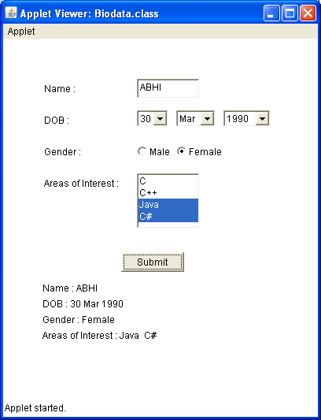

RESULT:
Thus the program to design a Biodata form was successfully executed and the output was verified.

