INVOKING SERVLET FROM HTML
DATE:21.9.10

Aim:
To create a java server side application using servlet and invoke it from a HTML client .

Hardware requirements:
Intel pentium Processor IV
128mb RAM

Software requirements:
Jdk1.6.0

Algorithm:
- Create a client using HTML It get the username and password from the user. When you submit the form it invoke the servlet.
- Create a server using servlet It receive the data from client and display the result to the client.
- Deploy the servlet in to the server.
- Run the client and server application . When you submit the client form it invoke the servlet and the server display the result to the client.

INVOKING SERVLET FROM HTML

HTML CODING:

<html>
<head><title>WELCOME TO MY SERVLET</title></head>
<body>

<form action="C:\jdk1.3\bin\HelloServlet" method="post">
<center>
<br><br><br><br><br>
Name : <input type="text" name="name"><br><br>
Password: <input type="password" name="pwd"><br><br>
<input type="SUBMIT" name="submit" value="submit">
</center>
</form>
</body>
</html>

SERVLET CODING:

import java.io.*;
import javax.servlet.http.*;
import javax.servlet.*;
public class HelloServlet extends HttpServlet
{
public void doPost(HttpServletRequest req,HttpServletResponse res)throws ServletException,IOException
{
PrintWriter out=res.getWriter();
res.setContentType("text/html");
String name=req.getParameter("name");
String pwd=req.getParameter("pwd");
out.println("<html>");
out.println("<body>");
out.println("WELCOME!!!!!!" + name);
out.println("</html>");
out.println("</body>");
out.close();
}
}

OUTPUT:

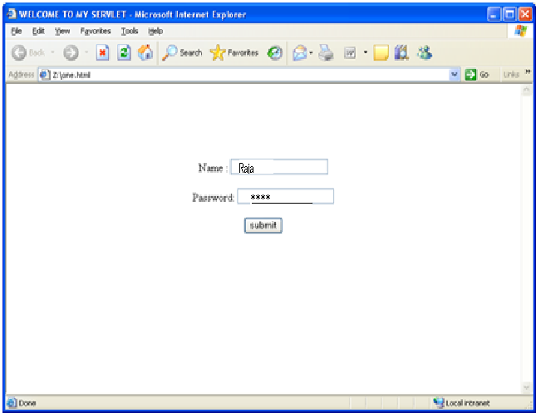

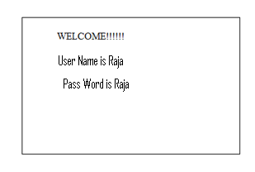

RESULT:
Thus the servlet has been deployed and invoked from the HTML client.

