DEMONSTRATION OF LAYOUT MANAGERS
DATE:27.07.10

Aim:
Write a java program to demonstrate the use of following layouts.
1.FlowLayout 2.BorderLayout 3.GridLayout
4.GridBagLayout 5.CardLayout

Hardware requirements:
Intel pentium Processor IV
128mb RAM

Software requirements:
Jdk1.6.0

Algorithm:
- Create bunch of AWT controls and arrange them one after other by setting the layout as Flow.
- Create bunch of AWT controls and place them in North, South, East, West and Center by setting the layout as Border.
- Create bunch of AWT controls and arrange them equal in size in matrix by setting the layout as Grid
- Create bunch of AWT controls and arrange them within a Grid of cells, allowing some components to span more than one cell by setting the layout as GridBag
- Create bunch of AWT controls and let the area to contain different components as different times by setting the layout as Card.

DEMONSTRATION OF LAYOUT MANAGERS

PROGRAMS:

(i) FlowLayout:

import java.awt.*;
import java.awt.event.*;
import java.applet.*;
/* <applet code="FlowDemo" width=500 height=150>
</applet>
*/
public class FlowDemo extends Applet implements ItemListener
{
Checkbox winXP,winVis,sol,mac;
public void init()
{
setLayout(new FlowLayout(FlowLayout.LEFT));
winXP=new Checkbox("Windows XP",null,false);
winVis=new Checkbox("Windows Vista",null,false);
sol=new Checkbox("Solaris",null,false);
mac=new Checkbox("Mac OS",null,false);
add(winXP);
add(winVis);
add(sol);
add(mac);
winXP.addItemListener(this);
winVis.addItemListener(this);
sol.addItemListener(this);
mac.addItemListener(this);
}
public void itemStateChanged(ItemEvent ie)
{
repaint();
}
public void paint(Graphics g)
{
g.drawString("Windows XP: "+winXP.getState(),6,80);
g.drawString("Windows Vista: "+winVis.getState(),6,100);
g.drawString("Solaris: "+sol.getState(),6,120);
g.drawString("Mac OS: "+mac.getState(),6,140);
}
}

OUTPUT:

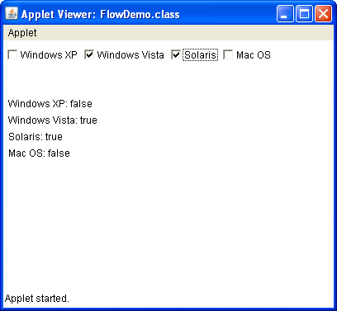

RESULT:
Thus the program to demonstrate flow layout was successfully executed and the output was verified.

(ii) BorderLayout:

import java.awt.*;
import java.awt.event.*;
import java.applet.*;
import java.util.*;
/* <applet code="BorderDemo" height=500 width=500>
</applet>
*/
public class BorderDemo extends Applet
{
public void init()
{
setLayout(new BorderLayout());
add(new Button("This is across the top."),BorderLayout.NORTH);
add(new Label("The footer msg might go here."),BorderLayout.SOUTH);
add(new Button("Right"),BorderLayout.EAST);
add(new Button("Left"),BorderLayout.WEST);
String msg="The reasonable man adapts himself to the world;\n"+
"the reasonable one persists in trying to adapt the world\n"+
"to himself.\n"+"Therefore all progress depends on the "+
"reasonable man.\n\n"+
" -George Bernard Shaw\n\n";
add(new TextArea(msg),BorderLayout.CENTER);
}
}

OUTPUT:

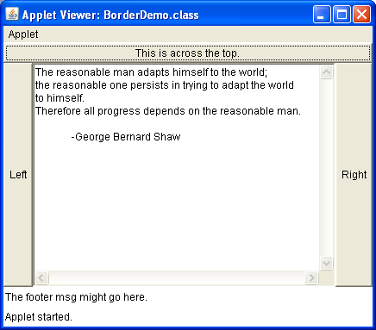

RESULT:
Thus the program to demonstrate border layout was successfully executed and the output was verified.
(iii) GridLayout:

import java.awt.*;
import java.applet.*;
/* <applet code="GridDemo" height=500 width=500>
</applet>
*/
public class GridDemo extends Applet
{
static final int n=4;
public void init()
{
setLayout(new GridLayout(n,n));
setFont(new Font("SansSerif",Font.BOLD,24));
for(int i=0;i<n;i++)
{
for(int j=0;j<n;j++)
{
int k=i*n+j;
if(k>0)
add(new Button(" "+k));
}
}
}
}

OUTPUT:

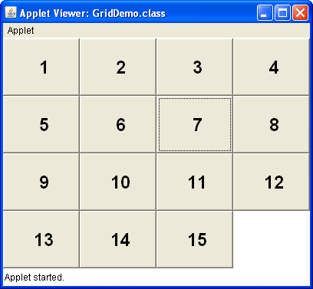

RESULT:
Thus the program to demonstrate grid layout was successfully executed and the output was verified.
(iv) CardLayout:

import java.awt.*;
import java.awt.event.*;
import java.applet.*;
/* <applet code="CardDemo" height=500 width=500>
</applet>
*/
public class CardDemo extends Applet implements ActionListener,MouseListener
{
Checkbox winxp,winvis,sol,mac;
Panel osCards;
CardLayout cardlo;
Button win,other;
public void init()
{
win=new Button("Windows");
other=new Button("Others");
add(win);
add(other);

cardlo=new CardLayout();
osCards=new Panel();
osCards.setLayout(cardlo);

winxp=new Checkbox("WindowsXP",null,true);
winvis=new Checkbox("Windows Vista");
sol=new Checkbox("Solaris");
mac=new Checkbox("Mac OS");

Panel winpan=new Panel();
winpan.add(winxp);
winpan.add(winvis);

Panel otherpan=new Panel();
otherpan.add(sol);
otherpan.add(mac);

osCards.add(winpan,"Windows");
osCards.add(otherpan,"Others");
add(osCards);

win.addActionListener(this);
other.addActionListener(this);
addMouseListener(this);
}
public void mousePressed(MouseEvent me)
{
cardlo.next(osCards);
}
public void mouseClicked(MouseEvent me){}
public void mouseEntered(MouseEvent me){}
public void mouseExited(MouseEvent me){}
public void mouseReleased(MouseEvent me){}
public void actionPerformed(ActionEvent ae)
{
if(ae.getSource()==win)
{
cardlo.show(osCards,"Windows");
}
else
{
cardlo.show(osCards,"Others");
}
}
}

OUTPUT:

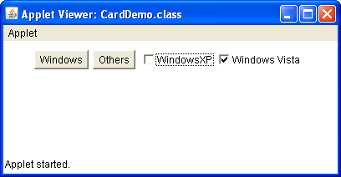

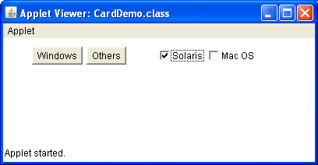

RESULT:
Thus the program to demonstrate card layout was successfully executed and the output was verified.

(v) GridBagLayout:

import java.awt.*;
import java.awt.event.*;
import java.applet.*;
/* <applet code="Gbag" width=400 height=200>
</applet>
*/
public class Gbag extends Applet
{
public void init()
{
GridBagLayout gb=new GridBagLayout();
setLayout(gb);

GridBagConstraints Cons1=new GridBagConstraints();
Cons1.fill=GridBagConstraints.BOTH;
Cons1.gridwidth=1;
Cons1.gridheight=1;
Cons1.gridx=0;
Cons1.gridy=0;

GridBagConstraints Cons2=new GridBagConstraints();
Cons2.fill=GridBagConstraints.BOTH;
Cons2.gridwidth=1;
Cons2.gridheight=1;
Cons2.gridx=1;
Cons2.gridy=0;

GridBagConstraints Cons3=new GridBagConstraints();
Cons3.fill=GridBagConstraints.BOTH;
Cons3.gridwidth=2;
Cons3.gridheight=2;
Cons3.gridx=0;
Cons3.gridy=1;

Button b1=new Button("one");
Button b2=new Button("two");
Button b3=new Button("three");
gb.setConstraints(b1,Cons1);
add(b1);
gb.setConstraints(b2,Cons2);
add(b2);
gb.setConstraints(b3,Cons3);
add(b3);
} }
OUTPUT:

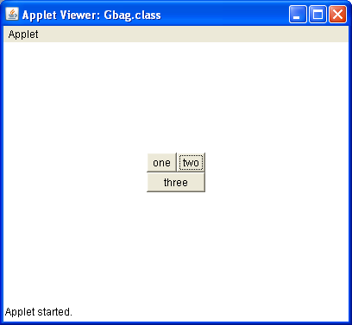

RESULT:
Thus the program to demonstrate gridbag layout was successfully executed and the output was verified.

