JAVA URL
DATE:10.8.10

Aim:
To write a java program to demonstrate the use of URL.

Hardware requirements:
Intel pentium Processor IV
128mb RAM

Software requirements:
Jdk1.6.0

Algorithm:
- Using the URL class locate the server with the help of URL specified in the command prompt.
- Using the appropriate streams and open the home page of the server.
- Display the contents of the homepage in the console.
- Using the methods getDate() , getContentType(), getExpiration(), getLastmodified() and getLength() display the above said information of the homepage on the console.

JAVA URL

PROGRAM:

(i) UrlDemo.java:

import java.net.*;
import java.util.*;
import java.io.*;
class UrlDemo
{
public static void main(String[] arg)throws MalformedURLException,IOException
{
try
{
URL u= new URL("file:\\z:\\hai.html");
URLConnection uc=u.openConnection();
InputStream in=uc.getInputStream();
int c;
while(( c=in.read())!= -1)
System.out.print((char)c);
System.out.println("content length:"+uc.getContentLength());
System.out.println("content type:"+uc.getContentType());
System.out.println("content encoding:"+uc.getContentEncoding());
System.out.println("date:"+new Date(uc.getDate()));
System.out.println("modified date:"+new Date(uc.getLastModified()));
System.out.println("expired date:"+new Date(uc.getExpiration()));
}
catch(MalformedURLException e)
{
System.out.println("exception caught:"+e);
}
catch(IOException e1)
{
System.out.println("exception caught:"+e1);
}

}
}

HAI.HTML

<html>
<head>
<title> MY HTML </title>
</head>
<body>
<center>WELCOME</center>
</body>
</html>

OUTPUT:

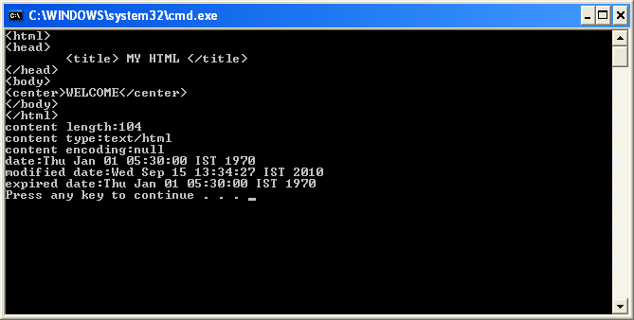

RESULT:
Thus the program to read data and header information from an URL was successfully executed and the output was verified

