IMPLEMENTATION OF FTP
DATE:24.08.10

Aim
To write a java program to demonstrate a simple FTP operation

Hardware requirements:
Intel pentium Processor IV
128mb RAM

Software requirements:
Jdk1.6.0

Algorithm

FTP Client:

Step 1: Establish a connection with the server at a particular port
Step 2: Specify the name of the file to be read
Step 3: Receive the contents of the file from the server

FTP Server:

Step 1: Accept the connection with the client
Step 2: Listen to the port for the name of the file to be sent
Step 3: Send the file character by character
Step 4: Terminate the connection

IMPLEMENTATION OF FTP

SERVER PROGRAM:

import java.io.*;
import java.net.*;
public class FtpServer
{
public static void main(String args[])
{
try
{
ServerSocket ss=new ServerSocket(1000);
Socket s=ss.accept();
FileInputStream fin=new FileInputStream("Z:\\source.txt");
OutputStreamWriter out=new OutputStreamWriter(s.getOutputStream());
int i;
while(true)
{
i=fin.read();
out.write(i);
out.flush();
if(i==-1)
break;
}
s.close();
fin.close();
System.out.println("file sent successfully");
}
catch(IOException e)
{
System.out.println("exception"+e);
}
}
}

CLIENT PROGRAM:

import java.io.*;
import java.net.*;
class FTPClient
{
public static void main(String args[])
{
try
{
Socket s=new Socket(InetAddress.getLocalHost(),1000);
FileOutputStream fout=new FileOutputStream("Z:\\destn.txt");
InputStreamReader in=new InputStreamReader(s.getInputStream());
int i;
while(true)
{
i=in.read();
if(i==-1|| i==63)
break;
fout.write(i);
}
s.close();
fout.close();
System.out.println("file received successful");
}
catch(IOException io)
{
System.out.println(io);
}
catch(Exception ex)
{
System.out.println("Exception"+ex);
}
}
}

OUTPUT:

SERVER:

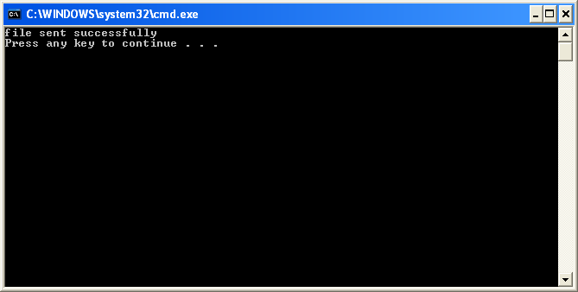

CLIENT:

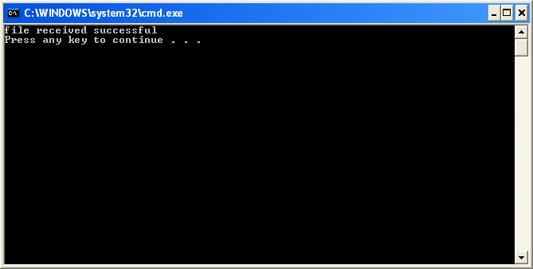

SOURCE.TXT

hi... welcome...

DESTN.TXT

hi... welcome...

RESULT:
Thus the file transfer protocol was implemented using TCP.
EX.NO:6(B) REMOTE METHOD INVOCATON
DATE:24.8.10

AIM:
To write a client-server application using RMI.

Hardware requirements:
Intel pentium Processor IV
128mb RAM

Software requirements:
Jdk1.6.0

ALGORITHM:

Step 1: define a remote interfece.
Step 2: write the client that uses the remote objects.
Step 3: generating stubs(client proxies) and skeletons(server entities).
Step 4: starting the registry and registering the object.
Step 5: run the server and client.

REMOTE METHOD INVOCATION

PROGRAMS:

(i) Interface program:

import java.rmi.*;
public interface HelloInterface extends Remote
{
public String sayHello()throws RemoteException;
}

(ii) Implementation program:

import java.rmi.*;
import java.rmi.server.*;
public class HelloImpl extends UnicastRemoteObject implements HelloInterface
{
public HelloImpl()throws RemoteException
{
super();
}
public String sayHello()throws RemoteException
{
return "Hello RMI";
}
}

(iii) Server program:

import java.rmi.*;
import java.rmi.server.*;
import java.net.*;
public class HelloServer
{
public static void main(String[] args)
{
try
{
HelloImpl remob=new HelloImpl();
Naming.rebind("/HelloServer",remob);
}
catch(MalformedURLException mue)
{
System.out.println("Exception caught : "+mue);
}
catch(RemoteException re)
{
System.out.println("Exception caught : "+re);
}
}
}

(iv) Client program:

import java.rmi.*;
import java.net.*;
public class HelloClient
{
public static void main(String[] args)
{
try
{
HelloInterface ref=(HelloInterface)Naming.lookup("/HelloServer");
String str=ref.sayHello();
System.out.println(str);
}
catch(RemoteException re)
{
System.out.println("Exception caught : "+re);
}
catch(NotBoundException nbe)
{
System.out.println("Exception caught : "+nbe);
}
catch(MalformedURLException mue)
{
System.out.println("Exception caught : "+mue);
}
}
}

OUTPUT:

SERVER SIDE:

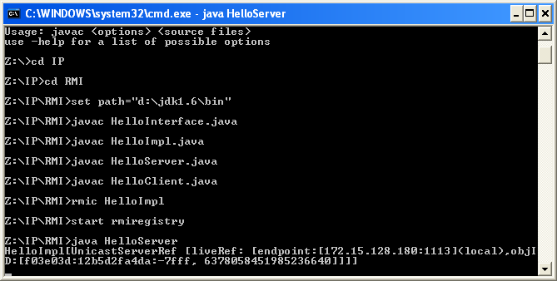

CLIENT SIDE:

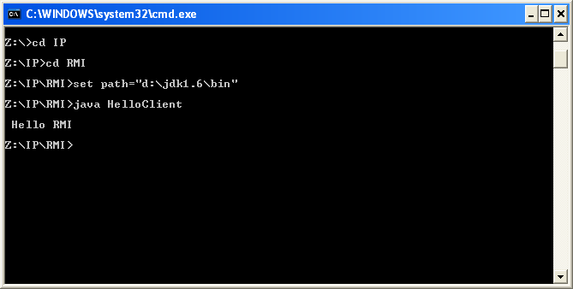

RESULT:
Thus the program to demonstrate RMI was successfully executed and the output was verified.

