***FlowChart🡺***

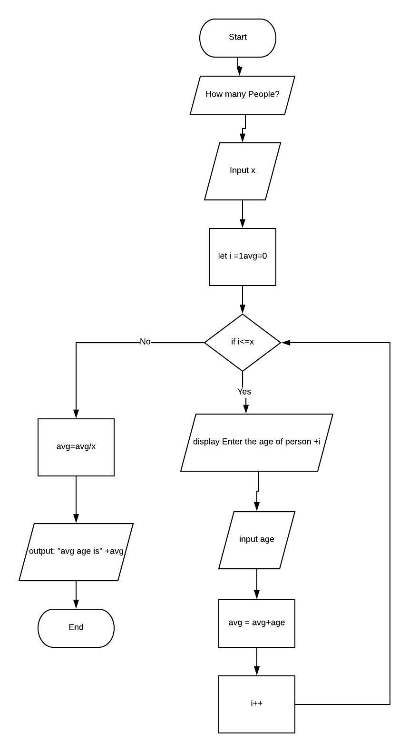

***Pseudocode🡺***

1.Declare x

2.Declare i

3.Declare avg

4.Declare age

5.”how many people?”

6.input x

7.set i =1

8.set avg = 0

9.for(i = 1; i<=x;)

10.then “enter the age of person”+i

11.input age

12.avg = avg+age

13.i++

14.if statement false

15.then avg= avg/x

16.display:”avg age is”+age

17.End

***Trace1🡺***

|  |  |  |  |  |  |  |
| --- | --- | --- | --- | --- | --- | --- |
| No. | input buffer | x | i | avg | age | output buffer |
| 1. | - | - | x | x | x | - |
| 2. | - | - | - | x | x | - |
| 3. | - | - | - | - | x | - |
| 4. | - | - | - | - | - | - |
| 5. | - | - | - | - | - | “How many people” |
| 6. | 4 | 4 | - | - | - | - |
| 7. | - | 4 | 1 | - | - | - |
| 8. | - | 4 | 1 | 0 | - | - |
| 9. | - | 4 | 1 | 0 | - | - |
| 10. | - | 4 | 1 | 0 | - | “Enter age of person “ + i |
| 11. | - | 4 | 1 | 0 | 28 | - |
| 12. | - | 4 | 1 | 28 | 28 | - |
| 13. | - | 4 | 2 | 28 | 28 | - |
| 9. | - | 4 | 2 | 28 | - | - |
| 10. | - | 4 | 2 | 28 | - | “Enter age of person “ + i |
| 11. | - | 4 | 2 | 28 | 24 | - |
| 12. | - | 4 | 2 | 52 | 24 | - |
| 13. | - | 4 | 3 | 52 | 24 | - |
| 9. | - | 4 | 3 | 52 | - | - |
| 10. | - | 4 | 3 | 52 | - | “Enter age of person “ + i |
| 11. | - | 4 | 3 | 52 | 25 | - |
| 12. | - | 4 | 3 | 77 | 25 | - |
| 13. | - | 4 | 4 | 77 | 25 | - |
| 9. | - | 4 | 4 | 77 | - | - |
| 10. | - | 4 | 4 | 77 | - | “Enter age of person “ + i |
| 11. | - | 4 | 4 | 100 | 23 | - |
| 12. | - | 4 | 4 | 100 | 23 | - |
| 13. | - | 4 | 5 | 100 | 23 | - |
| 14. | - | 4 | 5 | 100 | 23 | - |
| 15. | - | 4 | 5 | 25 | 23 | - |
| 16. | - | 4 | 5 | 25 | 23 | “Average age is” + avg |
| 17. | - | 4 | 5 | 25 | 23 | “Average age is” + avg |