RISC-V MYTH PROGRAM
Day-3

Transaction-Level Verilog (TL-Verilog) is an emerging extension to SystemVerilog that supports transaction-level design methodology. In transaction-level design, a ​transaction is an entity that moves through a microarchitecture. It is operated upon and steered through the machinery by flow components such as pipelines, arbiters, and queues. A transaction might be a machine instruction, a flit of a packet, or a memory read/write. The flow of a transaction can be established independently from the logic that operates on the transaction.

Features of TL-Verilog :
1. Pipeline-Centric Design:
- TL-Verilog introduces implicit pipelines using |pipe, making sequential logic more structured and readable.
- It eliminates the need for explicit clocking and always blocks.
2. Concise and Readable Syntax:
- Reduces boilerplate code compared to traditional Verilog/SystemVerilog.
- Uses hierarchical scoping (| notation) for better organization.
3. Automatic Signal Propagation:
- Variables automatically flow across pipeline stages (@0, @1, etc.).
- No need for manually coding registers or delays.
4. Modular and Reusable Design:
- Encourages reuse of pipeline structures, reducing redundancy.
- Scoped signals prevent naming conflicts and improve clarity.
5. Enhanced Debugging and Simulation:
- Provides built-in visualization tools like Makerchip for interactive debugging.
- Debugging is simpler and more intuitive due to structured pipeline stages.
6. Clock and Reset Abstraction:
- No need to explicitly define clocks and resets; TL-Verilog handles them automatically.
- Reduces errors related to clock-domain crossings.
7. Integration with Existing Tools:
- TL-Verilog can be translated to standard Verilog, making it compatible with traditional FPGA and ASIC toolchains.
- Works with open-source tools like Yosys, Verilator, and Makerchip.

These features make TL-Verilog a modern, efficient alternative for hardware design, particularly in complex pipeline-based architectures.

Makerchip IDE: A Cloud-Based IDE for TL-Verilog

Makerchip is a cloud-based integrated development environment (IDE) designed specifically for TL-Verilog, enabling efficient digital hardware design, simulation, and debugging. It simplifies RISC-V, FPGA, and ASIC development by providing an interactive and user-friendly environment.

Key Features of Makerchip IDE
🔹 Web-Based and Accessible:
- No installation required; accessible via any web browser.
- Supports real-time collaboration and sharing.
🔹 Support for TL-Verilog:
- Built-in support for TL-Verilog syntax and hierarchical design.
- Reduces complexity by automatically handling pipelining and clocking.
🔹 Integrated Simulation and Debugging:
- Provides real-time waveform visualization for debugging.
- Supports interactive simulation to verify designs efficiently.
🔹 Seamless Verilog Integration:
- Converts TL-Verilog to standard Verilog for FPGA/ASIC synthesis.
- Works with open-source tools like Yosys, Verilator, and OpenROAD.
🔹 M4 Macro Preprocessor Support:
- Enables parameterized design and macro-based code generation.
- Helps in modularizing large designs efficiently.

Why Use Makerchip IDE?
- Reduces development time with automated pipelines.
- Enhances readability compared to traditional Verilog.
- Ideal for RISC-V and complex digital designs.

Combinational logic in TL-Verilog :
1. Logic Gates :
\m5_TLV_version 1d: tl-x.org
\m5
\SV
m5_makerchip_module
\TLV
$out_and = $in1 & $in2;
$out_or = $in1 | $in2;
$out_not = !$in1;
$out_nand = !($in1 & $in2);
$out_nor = !($in1 | $in2);
$out_xor = $in1 ^ $in2;
$out_xnor = !($in1 ^ $in2);
\SV
endmodule

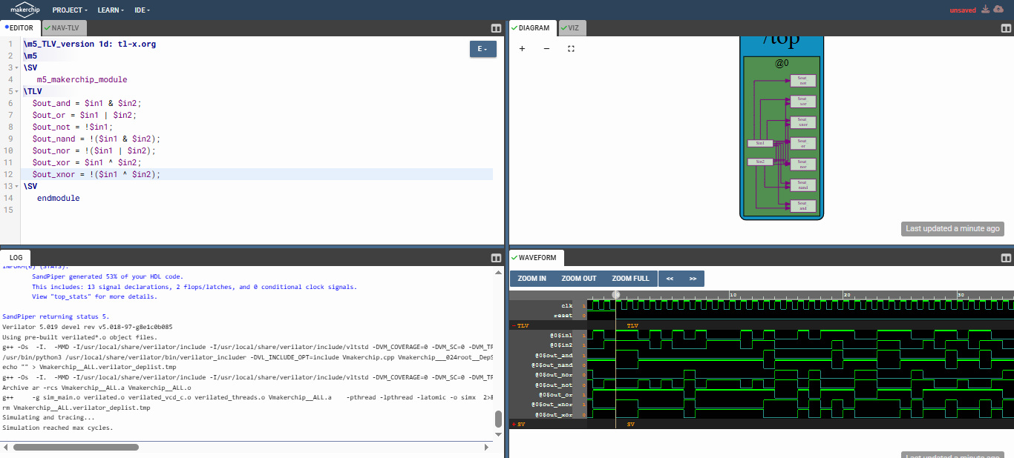

Makerchip : https://makerchip.com/sandbox/0lYfohqE9/03lhpRr

2. 2X1 MUX :
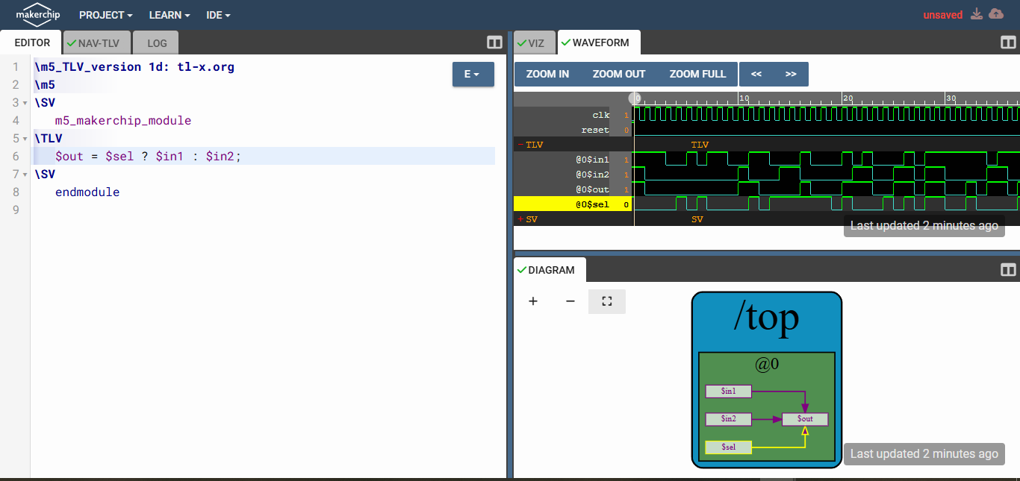
\m5_TLV_version 1d: tl-x.org
\m5
\SV
m5_makerchip_module
\TLV
$out = $sel ? $in1 : $in2;
\SV
endmodule
Makerchip : https://makerchip.com/sandbox/073fmhN5r/0Mjhqxm

3. 4X1 MUX :
\m4_TLV_version 1d: tl-x.org
\SV
m5_makerchip_module
\TLV
$out = $sel[0] ? $in1 : $sel[1] ? $in2 : $sel[2] ? $in3 : $in4;
*passed = *cyc_cnt > 40;
*failed = 1'b0;
\SV
endmodule

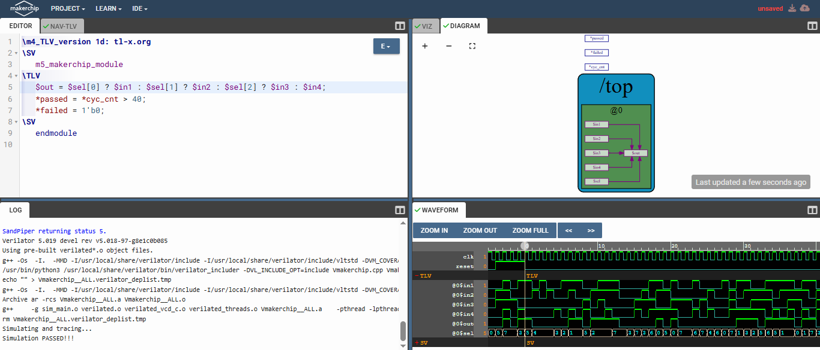
Makerchip : https://makerchip.com/sandbox/0rkfAhy2Z/08qh6wO
4. Ripple Carry Adder :
\m5_TLV_version 1d: tl-x.org
\m5
\SV
m5_makerchip_module
\TLV
{$cout, $sum[3:0]} = $a[3:0] + $b[3:0] + $cin;
\SV
endmodule

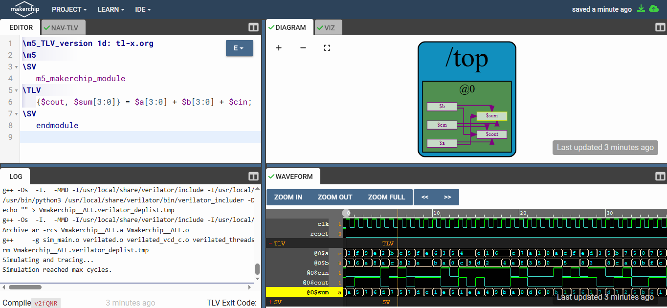
Makerchip : https://makerchip.com/sandbox/073fmhN5r/0Nxh0Vm
5. Combinational Pythogorean Theorm :
\m4_TLV_version 1d: tl-x.org
\SV
`include "sqrt32.v"
m5_makerchip_module
\TLV
$aa_sq[7:0] = $aa[3:0] ** 2;
$bb_sq[7:0] = $bb[3:0] ** 2;
$cc_sq[8:0] = $aa_sq + $bb_sq;
$cc[4:0] = sqrt($cc_sq);
*passed = *cyc_cnt > 40;
*failed = 1'b0;
\SV
endmodule

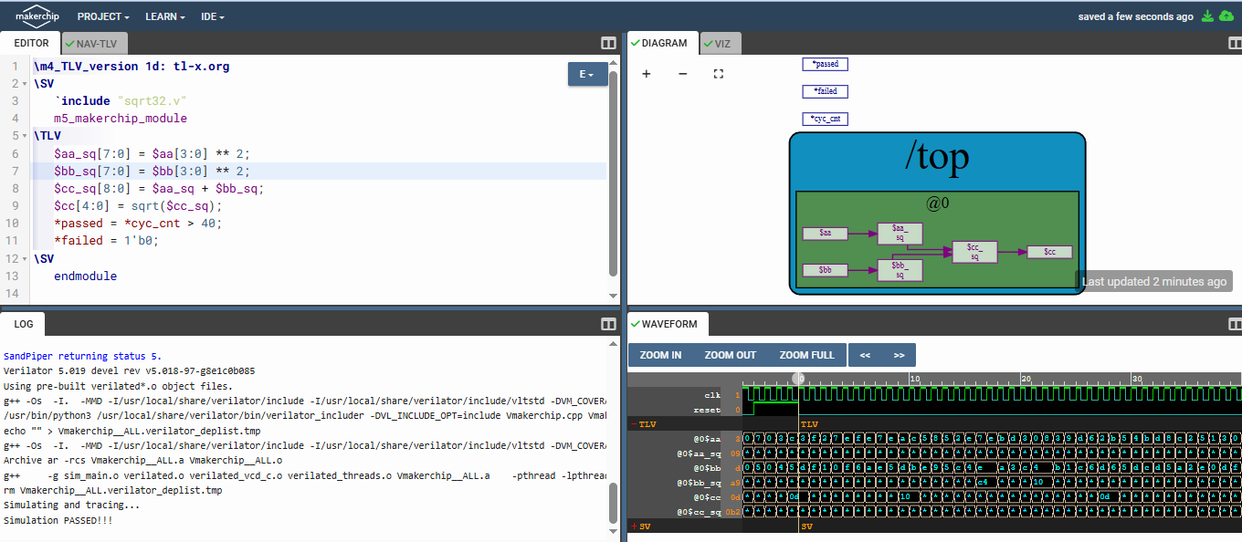
Makerchip : https://makerchip.com/sandbox/0rkfAhy2Z/076hAWz
6. Combinational Calculator :
\m5_TLV_version 1d: tl-x.org
\m5
\SV
m5_makerchip_module
\TLV
$mul[3:0] = $a[1:0] * $b[1:0];
$div[3:0] = $a[1:0] / $b[1:0];
$sub[3:0] = $a[1:0] - $b[1:0];
$add[3:0] = $a[1:0] + $b[1:0];
$result = $sel[0] ? $add : $sel[1] ? $sub : $sel[2] ? $mul : $div;
*passed = *cyc_cnt > 40;
*failed = 1'b0;
\SV
endmodule

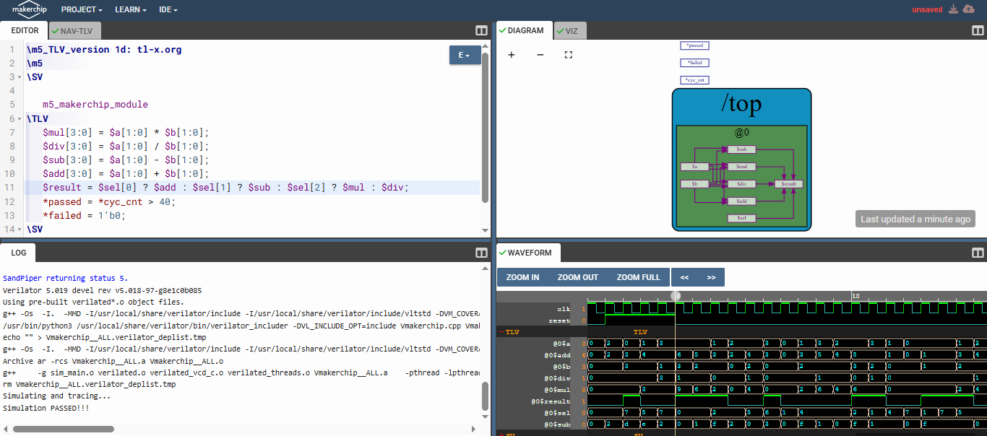
Makerchip : https://makerchip.com/sandbox/0rkfAhy2Z/098hkYY
Sequential logic in TL-Verilog :
1. Fibinacci Sequence :
\m5_TLV_version 1d: tl-x.org
\m5
\SV
m5_makerchip_module
\TLV
$num[15:0] = *reset ? 1 : >>1$num + >>2$num;
*passed = cyc_cnt > 30;
\SV
endmodule

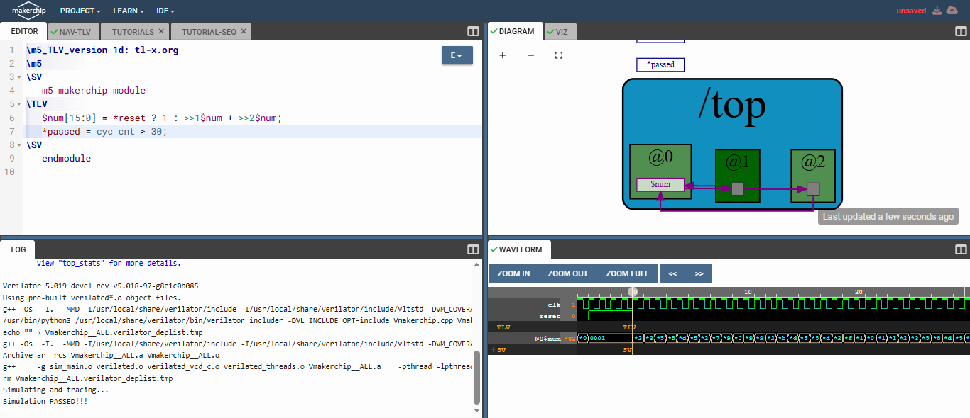
Makerchip : https://makerchip.com/sandbox/0rkfAhy2Z/00ghGrm
2. Counter :
\m5_TLV_version 1d: tl-x.org
\m5
\SV
m5_makerchip_module
\TLV
$num[15:0] = *reset ? 1 : >>1$num + 1;
*passed = cyc_cnt > 30;
\SV
endmodule

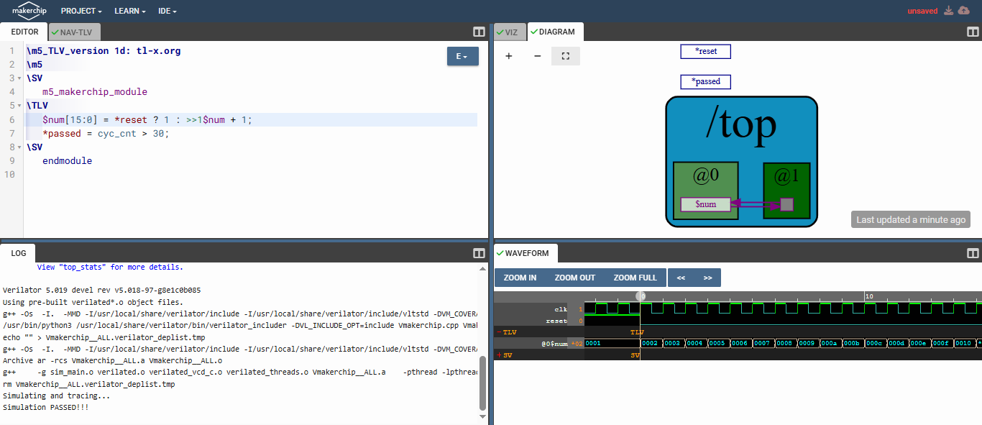
Makerchip : https://makerchip.com/sandbox/0rkfAhy2Z/0g5hAYw
3. Sequential Calculator :
\m5_TLV_version 1d: tl-x.org
\m5
\SV
m5_makerchip_module
\TLV
$mul[3:0] = $val1[1:0] * $val2[1:0];
$div[3:0] = $val1[1:0] / $val2[1:0];
$sub[3:0] = $val1[1:0] - $val2[1:0];
$add[3:0] = $val1[1:0] + $val2[1:0];
$result[3:0] = $sel[0] ? $add : $sel[1] ? $sub : $sel[2] ? $mul : $div;
$val2[1:0] = *reset ? 0 : >>1$result;
*passed = cyc_cnt > 30;
*failed = 1'b0;
\SV
endmodule

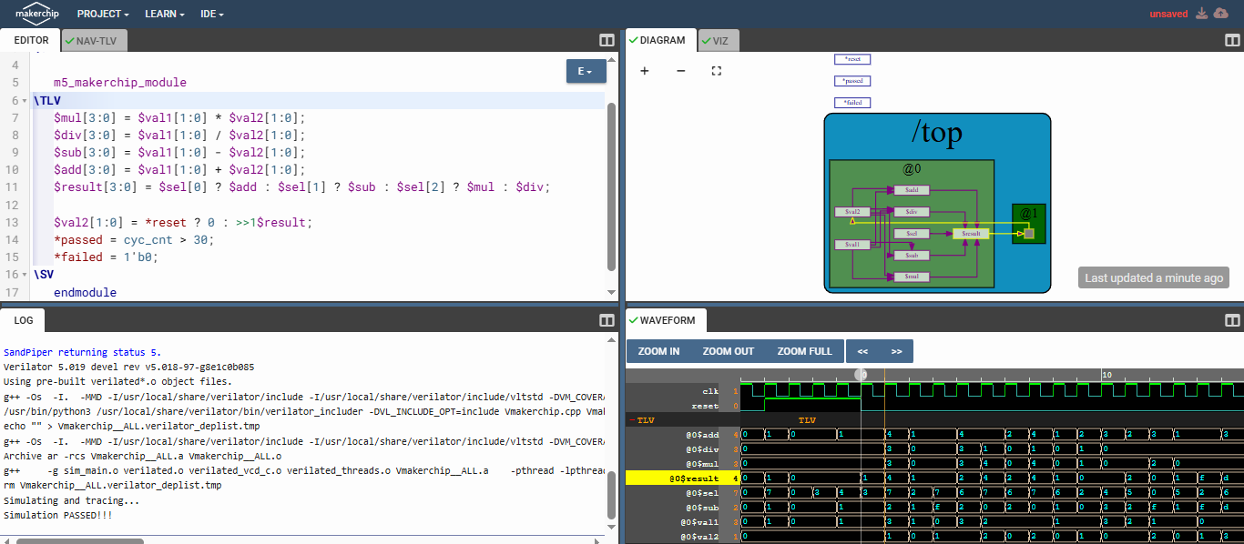
Makerchip : https://makerchip.com/sandbox/0rkfAhy2Z/0k5hOq4

Pipelining Logic in TL-Verilog :
1. Pipelined Pythogorean Theorm :
\m4_TLV_version 1d: tl-x.org
\SV
`include "sqrt32.v"
m5_makerchip_module
\TLV
|calc
@1
$aa_sq[7:0] = $aa[3:0] ** 2;
$bb_sq[7:0] = $bb[3:0] ** 2;
@2
$cc_sq[8:0] = $aa_sq + $bb_sq;
@3
$cc[4:0] = sqrt($cc_sq);
\SV
endmodule

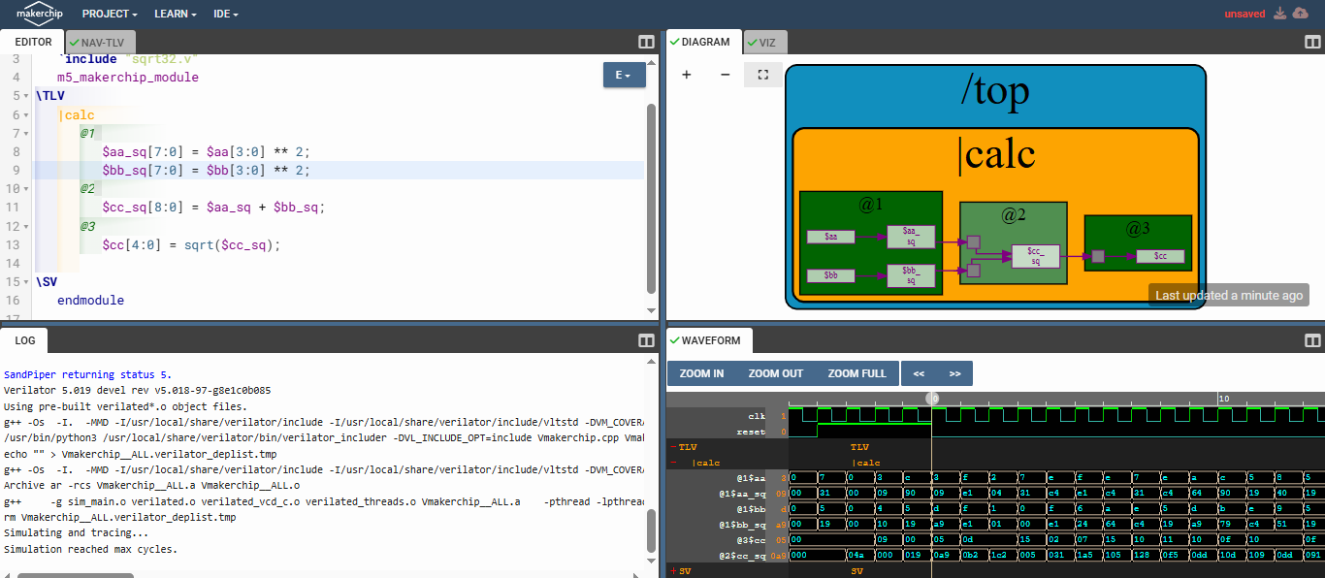
Makerchip : https://makerchip.com/sandbox/0rkfAhy2Z/0lOh2z6
2. Pipelined Fibonacci Sequence :
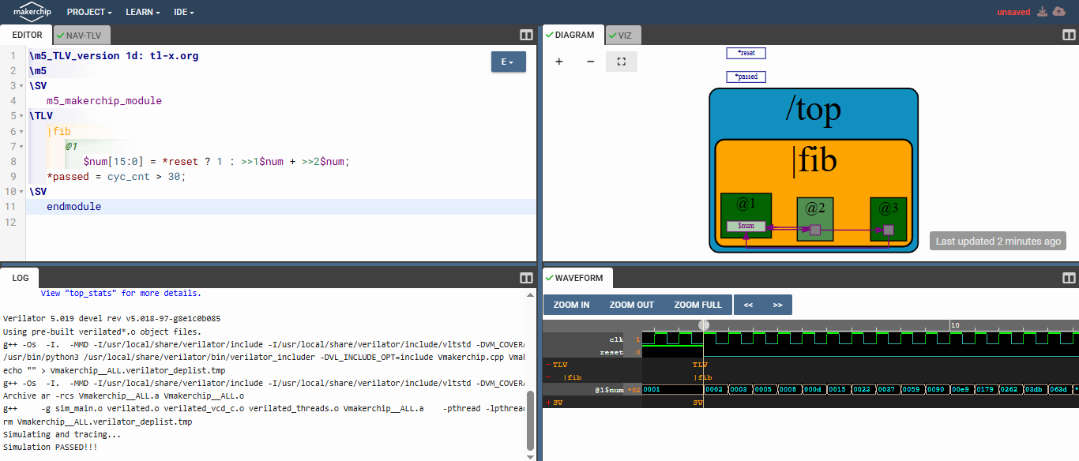
\m5_TLV_version 1d: tl-x.org
\m5
\SV
m5_makerchip_module
\TLV
|fib
@1
$num[15:0] = *reset ? 1 : >>1$num + >>2$num;
*passed = cyc_cnt > 30;
\SV
endmodule
Makerchip : https://makerchip.com/sandbox/0rkfAhy2Z/0mwhjR8

3. Error Conditions within Computational Pipeline :

\m5_TLV_version 1d: tl-x.org
\m5
\SV
m5_makerchip_module
\TLV
|comp
@1
$err1 = $illegal_op | $bad_input;
@2
$err1
@3
$err2 = $err1 | $over_flow;
@4
$err2
@5
$err2
@6
$err3 = $err2 | $div_by_zero;
\SV
endmodule

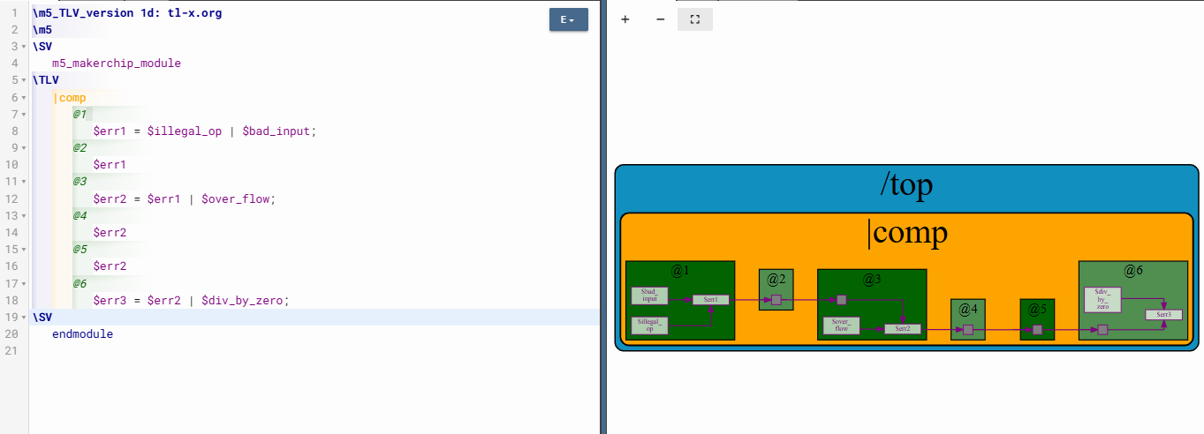

Makerchip : https://makerchip.com/sandbox/0rkfAhy2Z/0nZh76n

4. Single Cycle Counter Pipeline for Sequential Calculator :
\m5_TLV_version 1d: tl-x.org
\m5
\SV
m5_makerchip_module
\TLV
|calc
@0
$reset = *reset;
$mul[3:0] = $val1[1:0] * $val2[1:0];
$div[3:0] = $val1[1:0] / $val2[1:0];
$sub[3:0] = $val1[1:0] - $val2[1:0];
$add[3:0] = $val1[1:0] + $val2[1:0];
$result[3:0] = $reset ? 0 : $sel[0] ? $add : $sel[1] ? $sub : $sel[2] ? $mul : $div;
$val2[1:0] = >>1$result;
$cnt[15:0] = $reset ? 0 : >>1$cnt + 1;
*passed = *cyc_cnt > 30;
*failed = 1'b0;
\SV
endmodule
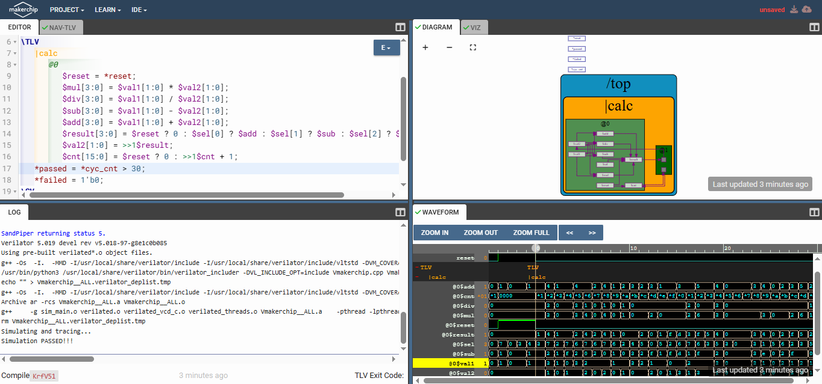
Makerchip : https://makerchip.com/sandbox/0rkfAhy2Z/0oYhrKJ

5. 2-cycle pipelined Calculator :
\m5_TLV_version 1d: tl-x.org
\m5
\SV
m5_makerchip_module
\TLV
|calc
@1
$reset = *reset;
$op[2:0] = $rand1[2:0];
$mul[3:0] = $val1[1:0] * $val2[1:0];
$div[3:0] = $val1[1:0] / $val2[1:0];
$sub[3:0] = $val1[1:0] - $val2[1:0];
$add[3:0] = $val1[1:0] + $val2[1:0];
$val2[1:0] = >>2$result;
$cnt[15:0] = $reset ? 0 : >>1$cnt + 1;
@2
$valid = $reset | (!$cnt);
$result[3:0] = ($valid) ? 0 : $op[0] ? $add : $op[1] ? $sub : $op[2] ? $mul : $div;
*passed = *cyc_cnt > 30;
*failed = 1'b0;
\SV
endmodule

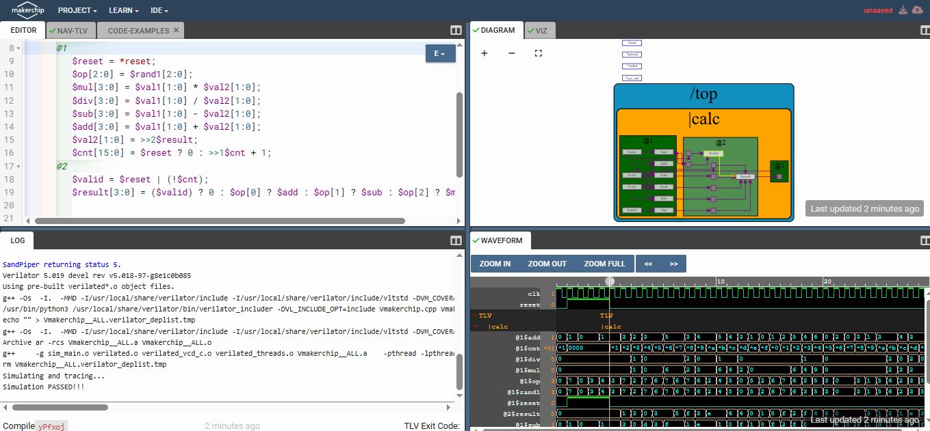
Makerchip : https://makerchip.com/sandbox/0rkfAhy2Z/0qjh874

Validity in TL-Verilog :
1. Computation of Total Distance with Validity :
\m4_TLV_version 1d: tl-x.org
\SV
`include "sqrt32.v"
m5_makerchip_module
\TLV
|calc
@1
$reset = *reset;
?$valid
@1
$aa_sq[31:0] = $aa[3:0] ** 2;
$bb_sq[31:0] = $bb[3:0] ** 2;
@2
$cc_sq[31:0] = $aa_sq + $bb_sq;
@3
$cc[31:0] = sqrt($cc_sq);
@4
$tot_dist[63:0] = $reset ? 0 : $valid ? >>1$tot_dist + $cc : >>1$tot_dist;
\SV
endmodule

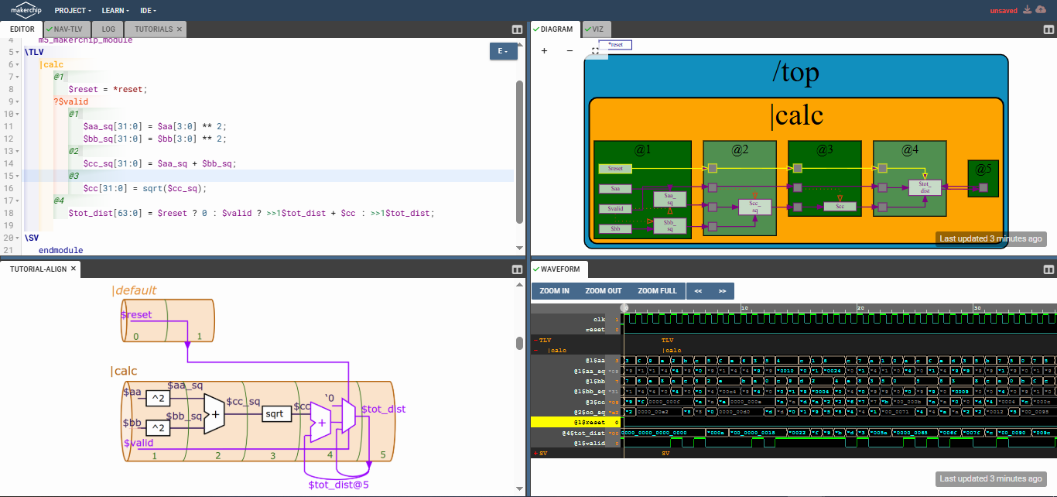

Makerchip : https://makerchip.com/sandbox/073fmhNyx/0vgh7yK

2. 2-cycle Calculator with Validity :
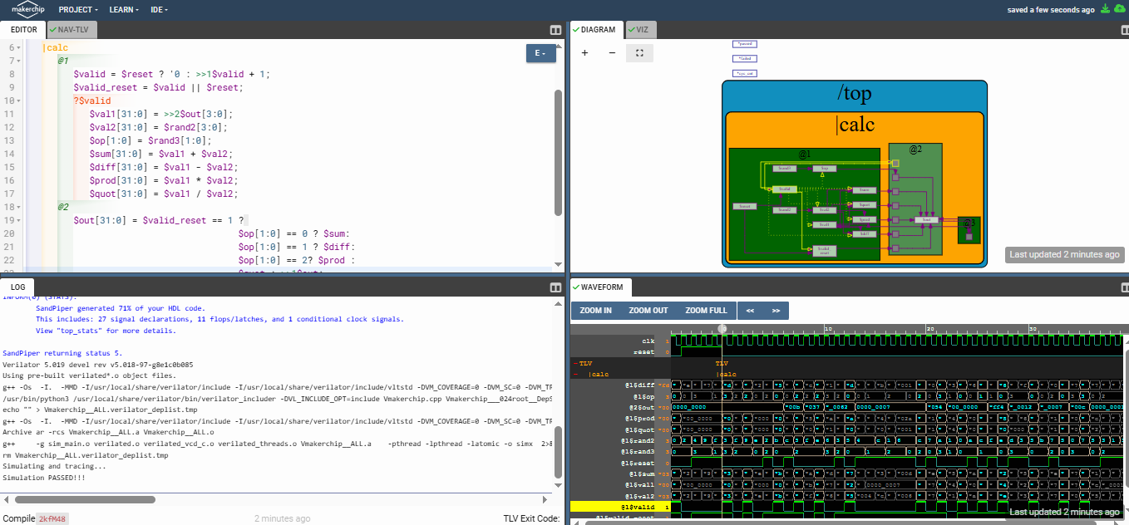
\m5_TLV_version 1d: tl-x.org
\m5
\SV
m5_makerchip_module
\TLV
|calc
@1
$valid = $reset ? '0 : >>1$valid + 1;
$valid_reset = $valid || $reset;
?$valid
$val1[31:0] = >>2$out[3:0];
$val2[31:0] = $rand2[3:0];
$op[1:0] = $rand3[1:0];
$sum[31:0] = $val1 + $val2;
$diff[31:0] = $val1 - $val2;
$prod[31:0] = $val1 * $val2;
$quot[31:0] = $val1 / $val2;
@2
$out[31:0] = $valid_reset == 1 ?
$op[1:0] == 0 ? $sum:
$op[1:0] == 1 ? $diff:
$op[1:0] == 2? $prod :
$quot : >>1$out;
*passed = *cyc_cnt > 40;
*failed = 1'b0;
\SV
endmodule
Makerchip : https://makerchip.com/sandbox/073fmhNyx/0AnhN18

