Overview of Data Theft Detector Project:
Data theft detection involves monitoring memory access patterns, identifying suspicious activity, and flagging unauthorized or anomalous access. This is crucial in preventing security breaches in embedded systems, FPGAs, and ASICs.
The Data Theft Detector project is designed to monitor and detect suspicious activity or anomalies in read/write bus traffic within a system. It aims to identify potential data theft by analyzing patterns in how data is accessed, written, and manipulated.

Key Features:

Real-Time Monitoring | Continuously tracks memory accesses to detect anomalies in real-time.
Threshold-Based Detection | Flags suspicious activity if a memory address is accessed excessively.
Low-Latency Operation | Implemented in hardware (FPGA/ASIC) for instant response without software overhead.
Read & Write Tracking | Separately monitors read and write operations for potential data leakage.
Configurable Thresholds | Users can set thresholds based on security needs to minimize false positives.
Minimal Resource Usage | Designed to be lightweight, requiring only a few registers and counters.
Reset & Self-Adjusting | Resets counters periodically or when a new address is accessed to maintain accuracy.
Hardware Security Enhancement | Provides an additional security layer for embedded systems, preventing unauthorized access.
Scalability | Can be expanded to track multiple addresses and implement more advanced detection methods.

FSM Implementation:

┌───────────┐
┌───►│ IDLE │
│ └────▲─────┘
│ │ (read/write detected)
│ ▼
│ ┌──────────────┐
│ │ MOVE_TO_TRACK│
│ └─────▲────────┘
│ │ (same address)
│ ▼
│ ┌──────────────┐
│ │INCREMENT_CNT │
│ └─────▲────────┘
│ │ (threshold exceeded)
│ ▼
│ ┌───────────┐
│ │ ALERT │
│ └─────▲─────┘
│ │ (new address)
│ ▼
│ ┌──────────────┐
└────│ RESET_COUNTER│
└──────────────┘

Threshold based Theft detection:

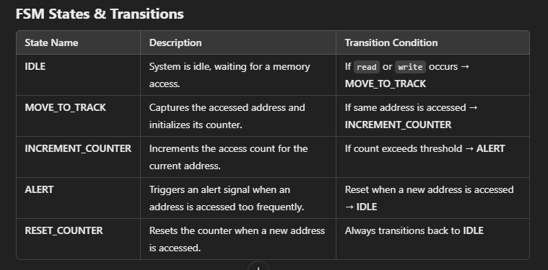

┌───────────┐
┌───►│ IDLE │
│ └────▲─────┘
│ │ (read/write detected)
│ ▼
│ ┌───────────┐
│ │ TRACK │
│ └────▲──────┘
│ │ (same address)
│ ▼
│ ┌──────────────┐
│ │ INCREMENT │
│ └────▲─────────┘
│ │ (threshold exceeded)
│ ▼
│ ┌───────────┐
│ │ ALERT │
│ └────▲─────┘
│ │ (timeout/reset)
│ ▼
│ ┌──────────────┐
└────│ RESET_COUNTER│
└──────────────┘

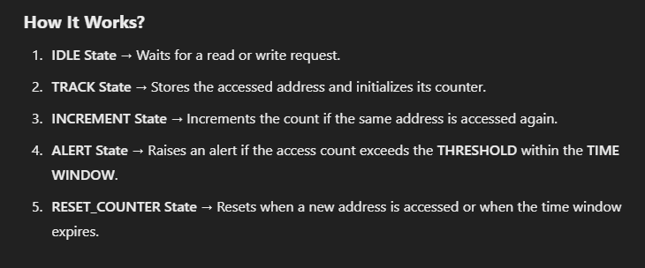

Threshold-Based Data Theft Detection Approach
This approach tracks how frequently an address is accessed and raises an alert if the number of accesses exceeds a predefined threshold within a given time window.

FSM States & Transitions
State Name | Description | Transition Condition
IDLE | System is idle, waiting for a memory access. | If read or write occurs → TRACK
TRACK | Starts monitoring the accessed address and increments its counter. | If the same address is accessed → INCREMENT
INCREMENT | Increments the access count. | If count exceeds the THRESHOLD within the TIME WINDOW → ALERT
ALERT | Raises an alert flag for potential data theft. | If time expires or reset occurs → IDLE
RESET_COUNTER | Resets the count after a time window or new address. | Always transitions back to IDLE

FSM Diagram
bash
CopyEdit
┌───────────┐
┌───►│ IDLE │
│ └────▲─────┘
│ │ (read/write detected)
│ ▼
│ ┌───────────┐
│ │ TRACK │
│ └────▲──────┘
│ │ (same address)
│ ▼
│ ┌──────────────┐
│ │ INCREMENT │
│ └────▲─────────┘
│ │ (threshold exceeded)
│ ▼
│ ┌───────────┐
│ │ ALERT │
│ └────▲─────┘
│ │ (timeout/reset)
│ ▼
│ ┌──────────────┐
└────│ RESET_COUNTER│
└──────────────┘

Verilog Implementation
verilog
CopyEdit
module threshold_data_theft_detector (
input clk, reset, read, write,
input [15:0] addr,
output reg alert
);
parameter THRESHOLD = 5;
parameter TIME_WINDOW = 100000; // Example: Number of clock cycles

reg [15:0] prev_addr;
reg [3:0] access_count;
reg [31:0] timer;

typedef enum reg [2:0] {IDLE, TRACK, INCREMENT, ALERT, RESET_COUNTER} state_t;
state_t current_state, next_state;

// State Transition Logic
always @(posedge clk or posedge reset) begin
if (reset)
current_state <= IDLE;
else
current_state <= next_state;
end

// Next State Logic
always @(*) begin
case (current_state)
IDLE: next_state = (read || write) ? TRACK : IDLE;
TRACK: next_state = (addr == prev_addr) ? INCREMENT : RESET_COUNTER;
INCREMENT: next_state = (access_count >= THRESHOLD) ? ALERT : INCREMENT;
ALERT: next_state = (timer >= TIME_WINDOW) ? RESET_COUNTER : ALERT;
RESET_COUNTER: next_state = IDLE;
default: next_state = IDLE;
endcase
end

// Counter and Timer Logic
always @(posedge clk) begin
if (current_state == TRACK)
prev_addr <= addr;
else if (current_state == INCREMENT)
access_count <= access_count + 1;
else if (current_state == RESET_COUNTER)
access_count <= 0;

if (current_state == TRACK || current_state == INCREMENT)
timer <= timer + 1;
else
timer <= 0;
end

// Alert Logic
always @(posedge clk) begin
alert <= (current_state == ALERT);
end
endmodule

How It Works?
- IDLE State → Waits for a read or write request.
- TRACK State → Stores the accessed address and initializes its counter.
- INCREMENT State → Increments the count if the same address is accessed again.
- ALERT State → Raises an alert if the access count exceeds the THRESHOLD within the TIME WINDOW.
- RESET_COUNTER State → Resets when a new address is accessed or when the time window expires.

How to Approach These Features?
Feature | Implementation Approach
Threshold-based Detection | Use a counter to track access frequency.
Time Window | Use a timer to reset the count periodically.
Address Tracking | Store previous accessed addresses in a register.
Real-time Monitoring | Check every memory transaction at clock edges.
Alert Mechanism | Raise a flag when threshold is exceeded.

Advantages of Threshold-Based Detection
✅ Works in Real-Time: Alerts are triggered as soon as access patterns exceed the limit.
✅ Customizable: The threshold and time window can be adjusted based on security requirements.
✅ Low Overhead: Requires minimal hardware, making it feasible for FPGA/ASIC implementation.
✅ Effective for Insider Threats: Can detect unauthorized memory accesses by internal processes.
Would you like to add multiple address tracking or dynamic threshold adjustment? 🚀

Detailed explanation of the DATA THEFT SYSTEM Architecture:

🔹 Module 1: Address Tracking Module (FSM)
🛠 Function: Detects repeated memory accesses to the same address, which may indicate data theft.

FSM States:
- IDLE:
  - The system waits for a memory access event (read or write).
  - If an access occurs, the FSM transitions to the STORE state.
- STORE:
  - The accessed address is stored in a register.
  - FSM transitions to COMPARE.
- COMPARE:
  - Compares the new access address with the stored address.
  - If different, FSM goes back to IDLE.
  - If same, FSM moves to REPEATED_ACCESS.
- REPEATED_ACCESS:
  - If the same address is accessed multiple times within a short period, FSM triggers a warning signal.
  - After a predefined limit, FSM signals potential data theft and moves to ALERT.
- ALERT:
  - The system raises an alert signal (theft_detected = 1).
  - FSM stays here until reset.

Module 2: Threshold-Based Detection Module (FSM)
🛠 Function: Monitors how frequently an address is accessed and flags theft if the count exceeds a threshold.

FSM States:
- IDLE:
  - System waits for a memory access.
- COUNT:
  - Increments a counter when an address is accessed.
  - If count reaches threshold, FSM transitions to ALERT.
- ALERT:
  - Triggers theft detection when the threshold is exceeded.
  - FSM waits for reset before returning to IDLE.

Module 3: Time-Window Monitoring Module (FSM)
🛠 Function: Detects if an address is accessed too many times within a given time frame.

FSM States:
- IDLE:
  - System is in an idle state, waiting for an access event.
- START_TIMER:
  - Starts a countdown timer.
- ACCESS:
  - Increments a counter each time the address is accessed within the time window.
  - If access count exceeds the limit, FSM moves to ALERT.
- ALERT:
  - Triggers theft detection due to rapid accesses in a short time.
  - FSM stays here until reset.

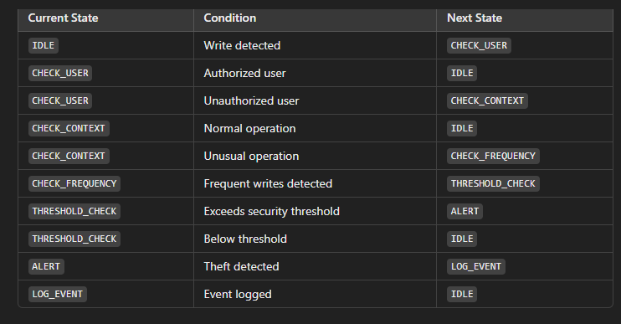
Legitimate Write Handling:

+------------------+
| Write Monitor |
+------------------+
|
v
+------------------+
| User Checker |
+------------------+
| |
(Valid) (Invalid)
| v
| +------------------+
| | Context Checker |
| +------------------+
| |
| (Normal) (Unusual)
| v
| +------------------+
| | Frequency Checker|
| +------------------+
| |
| (Safe) (High-Freq)
| v
| +------------------+
| | Threshold Check |
| +------------------+
| |
| (Safe) (Theft Detected)
| v
| +------------------+
| | Alert Module |
| +------------------+
| |
| (Log Event & Reset)
| v
| +------------------+
| | Log Storage |

FSM for Unauthorized Address Space Access Detection

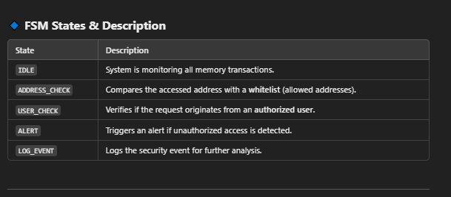

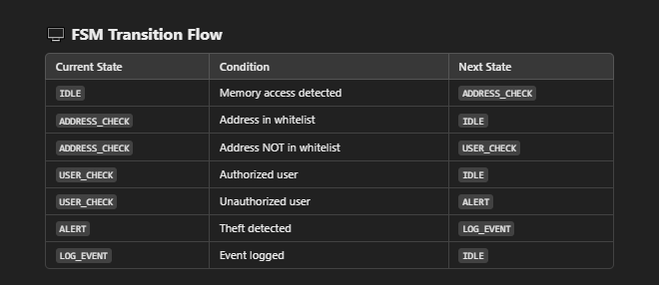

+------------------+
| Memory Monitor |
+------------------+
|
v
+------------------+
| Address Checker |
+------------------+
| |
(Valid) (Invalid)
| v
| +------------------+
| | User Checker |
| +------------------+
| |
| (Authorized) (Unauthorized)
| v
| +------------------+
| | Alert Module |
| +------------------+
| |
| (Log Event & Reset)
| v
| +------------------+
| | Log Storage |
| +------------------+

