Restroom Pass Kiosk: Teacher Guide
The kiosk is a restroom pass on a classroom computer. Students type their ID to sign out, get in line, and sign back in. You see who is out, for how long, and every trip in a log. This guide covers setup (about 10 minutes, once) and what to expect every day after.

Before you start
Have these ready:
- The kiosk file, Restroom_Kiosk.html. Keep it in one place, such as your Documents folder, and open that same file every day.
- Google Chrome in a regular window. Not Incognito or Guest: those windows erase everything when they close.
- Your class roster as an Excel (.xlsx) or CSV file. It needs a student ID and a name for each student. A column with your name and one with the class section help too, when the file holds more than your own classes.
- A place to write down a recovery code, somewhere students can’t see it.
- Speakers turned on, if you want the kiosk to call students by name.
Everything stays on this computer. The kiosk doesn’t upload your roster or log anywhere, and it works without internet once the file is open.

Get your roster file
Export a roster from your gradebook or student information system as Excel (.xlsx) or CSV. The kiosk asks a few questions to read it, so the column names don’t matter. It works best with:
- Student ID: the number students will type at the kiosk.
- Student name: one column (“Last, First” is fine) or first and last in two columns.
- Teacher and class section (optional): when the file covers more than your own classes, the kiosk uses them to keep only your students and to match each section to a period.
No file? You can paste students instead: one per line, with ID number, name, and period, such as 1000101, Ava Rivera, 2.
After you import, delete the roster file from your Downloads folder and empty the trash. It holds student information.

Open the kiosk and start setup
Double-click Restroom_Kiosk.html, or drag it into a Chrome window. The first time, the kiosk shows a Welcome! card with the six setup steps. Click Start setup.
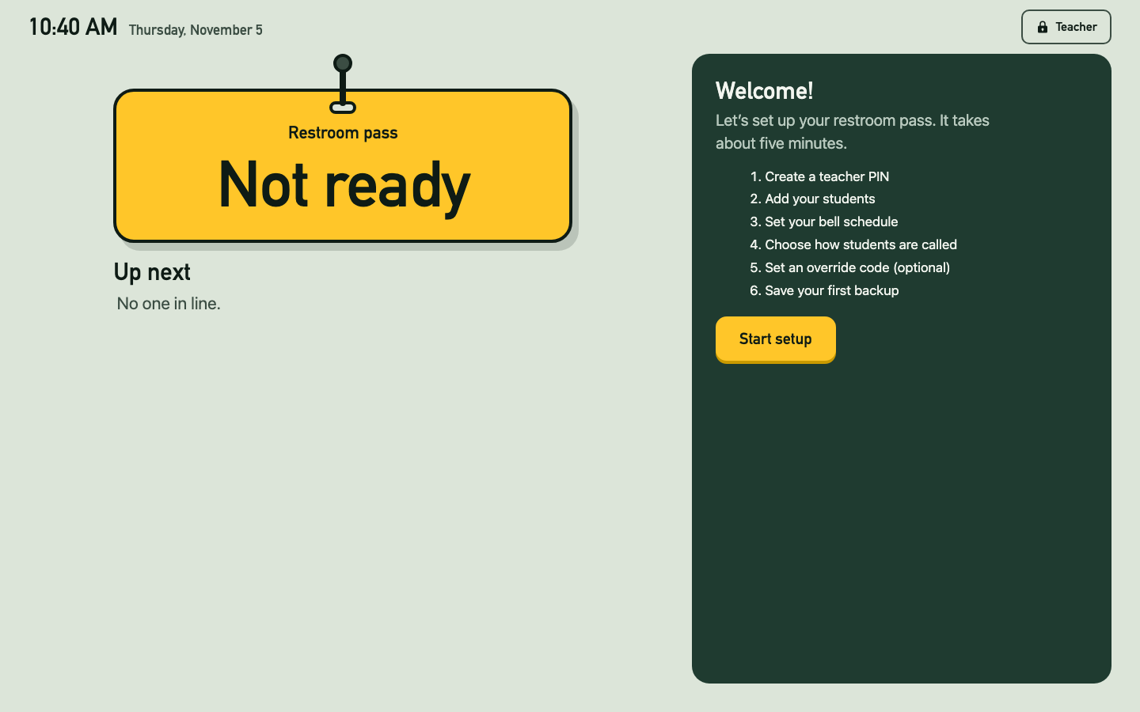
The kiosk before setup: the pass says Not ready and the Welcome card lists six steps
If a red note says “This might be a private or guest window,” stop and reopen the file in a regular Chrome window. If you stop partway, the card says Setup isn’t finished: click Continue setup, type your PIN, and you pick up at the same step.

Step 1: Create your teacher PIN
Your PIN opens Teacher view, where the roster, the log, and every setting live. Type 4 to 8 digits, click Next, then type the same PIN again and click Save PIN.
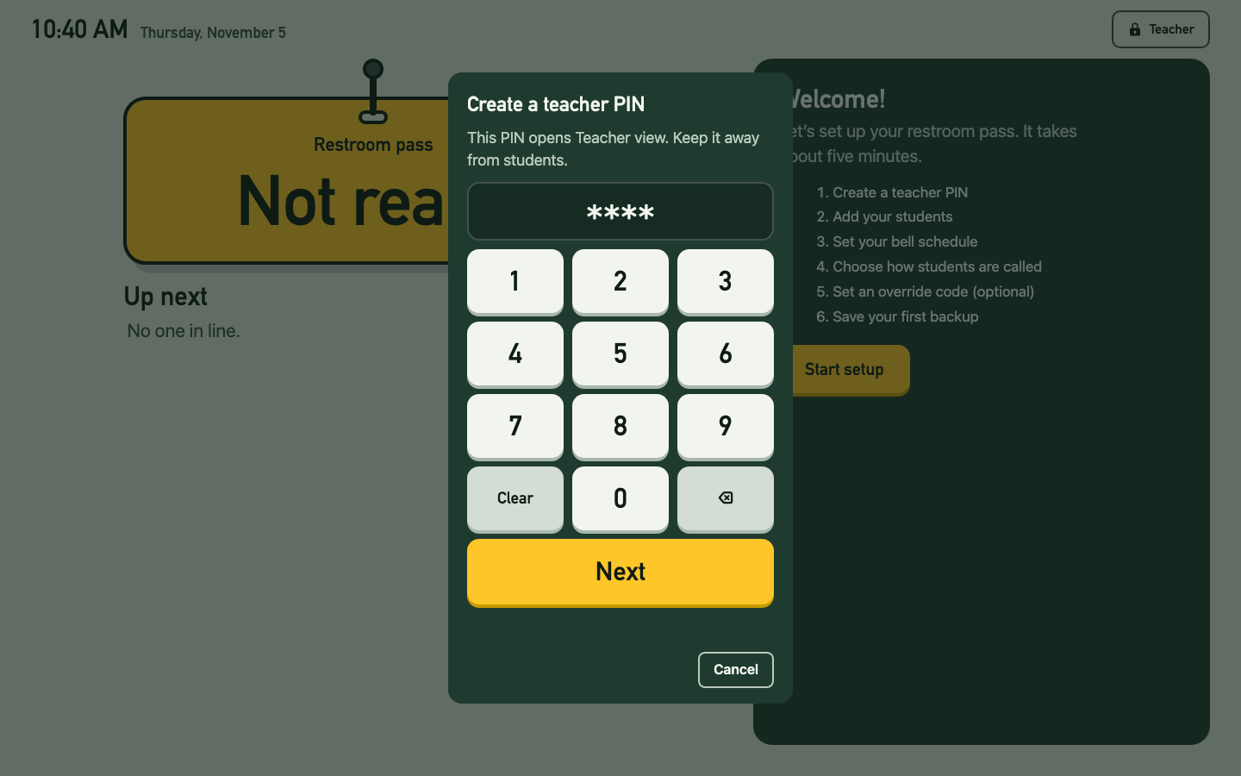
The Create a teacher PIN keypad
Next, the kiosk shows a recovery code. Write it down and keep it where students can’t see it. If you forget your PIN, this code sets a new one without losing any data. Click I wrote it down.
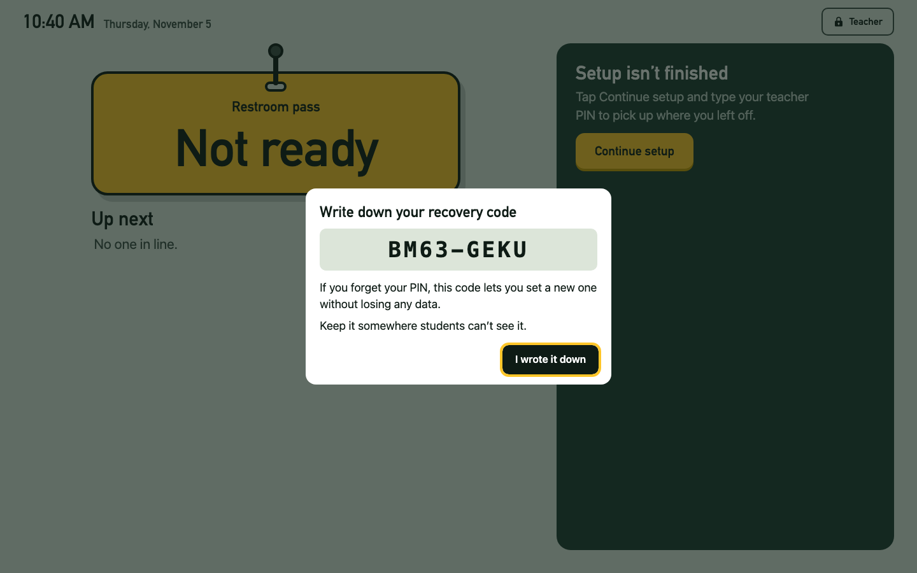
The recovery code screen
Teacher view locks itself after 3 minutes without activity. To open it again, click Teacher at the top right of the kiosk and type your PIN.

Step 2: Add your students
Setup opens the Roster tab with a dark banner that says what to do. The sections to use are outlined in yellow.
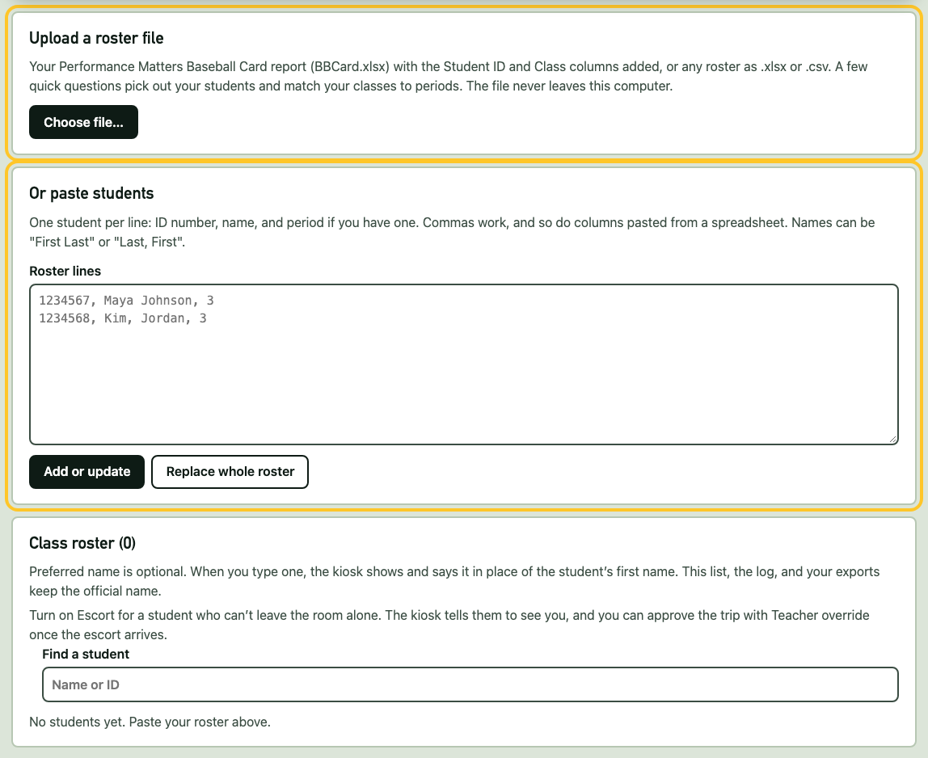
The Roster tab with the Upload a roster file and Or paste students sections outlined
Under Upload a roster file, click Choose file… and pick your roster file. The file stays on this computer. A few short questions follow; Cancel at any of them imports nothing.

Which column lists teachers?
The kiosk picks the column whose heading says “Teacher” and shows the names in it so you can check. If your file holds only your own classes, choose This file only has my classes, and the next question is skipped.
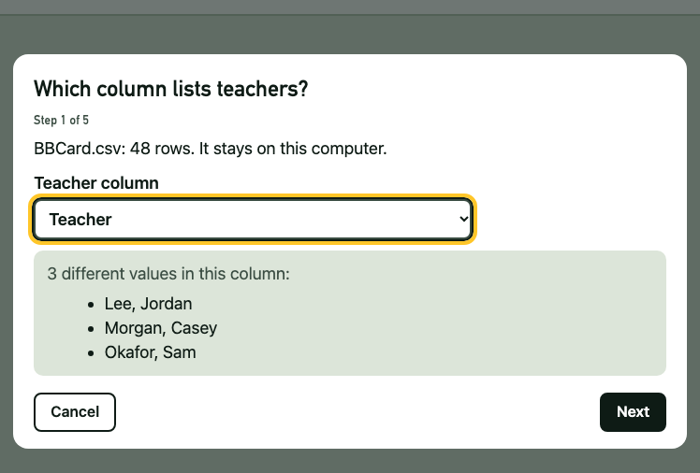
Which column lists teachers? with Teacher chosen

Which teacher are you?
Click your name. Each name shows how many students it has. When you click Next, every other teacher’s students are dropped. They are never shown or saved.
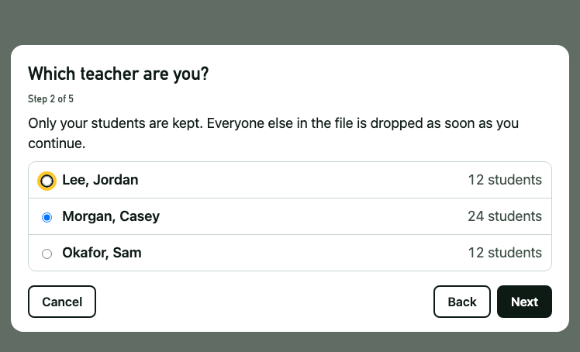
Which teacher are you? with Morgan, Casey chosen

Which column is the section?
From here on you see only your students. Each course and section is its own class: “Algebra 1 Honors - 02” and “Geometry Honors - 02” stay separate, while “- 07” and “- 7” of the same course are the same class.
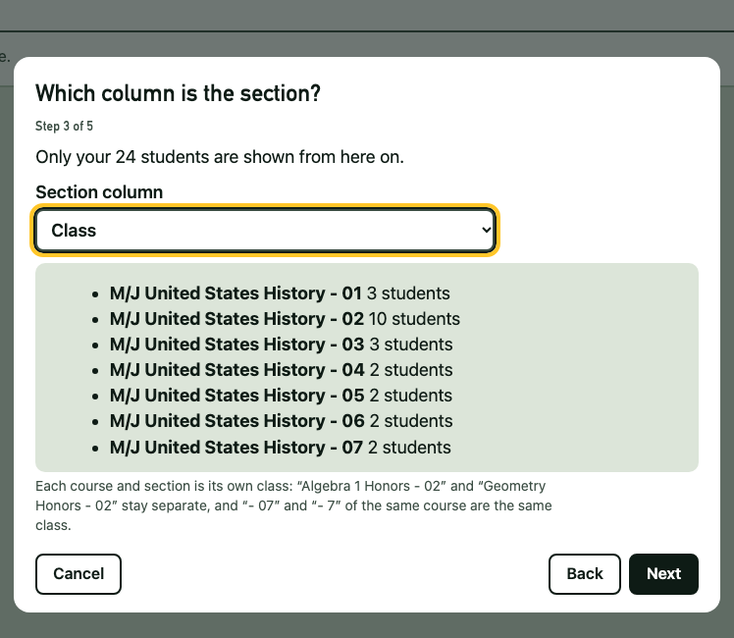
Which column is the section? listing seven sections

Which columns have student IDs and names?
The ID is the number students type on the keypad. Names can be in one column (“Last, First”) or two. The box shows your first few students so you can check. Rows the kiosk can’t use are listed with the reason, such as a missing ID.
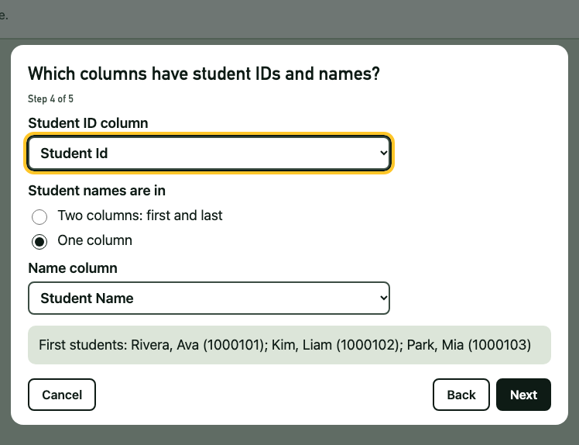
Which columns have student IDs and names?

Match each class to a period
Choose the period each class meets, or Leave out for a class you don’t want on the kiosk. Each class shows its first few students to help you recognize it. A student in two of your classes can sign out during either period. When every class has a choice, click Import.
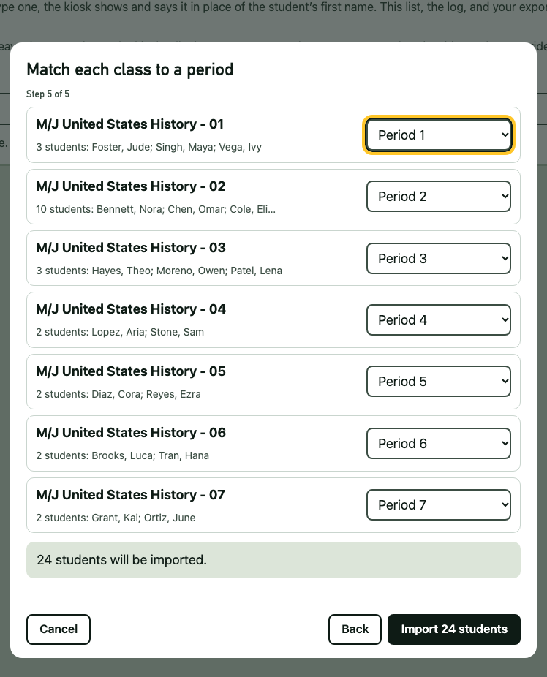
Match each class to a period, with Periods 1 to 7 chosen
The banner now lists how many students are in each period.
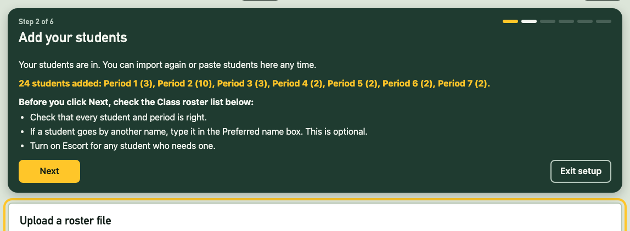
The banner after importing: 24 students added, by period

Check your list
Before you click Next, look over the Class roster list:
- Names and periods. To fix a period, import again or paste that student again with the right period. Click Remove for anyone who shouldn’t be on the kiosk.
- Preferred name (optional). If a student goes by another name, type it in the box. The kiosk shows and says that name instead of their first name. Blank means their first name is used.
- Escort. Click Off so it says On escort for a student who can’t leave alone. The kiosk tells them to see you instead of signing them out.
- No weekly limit. Turn it on for a student who should never be flagged for too many trips, such as one with a medical plan.
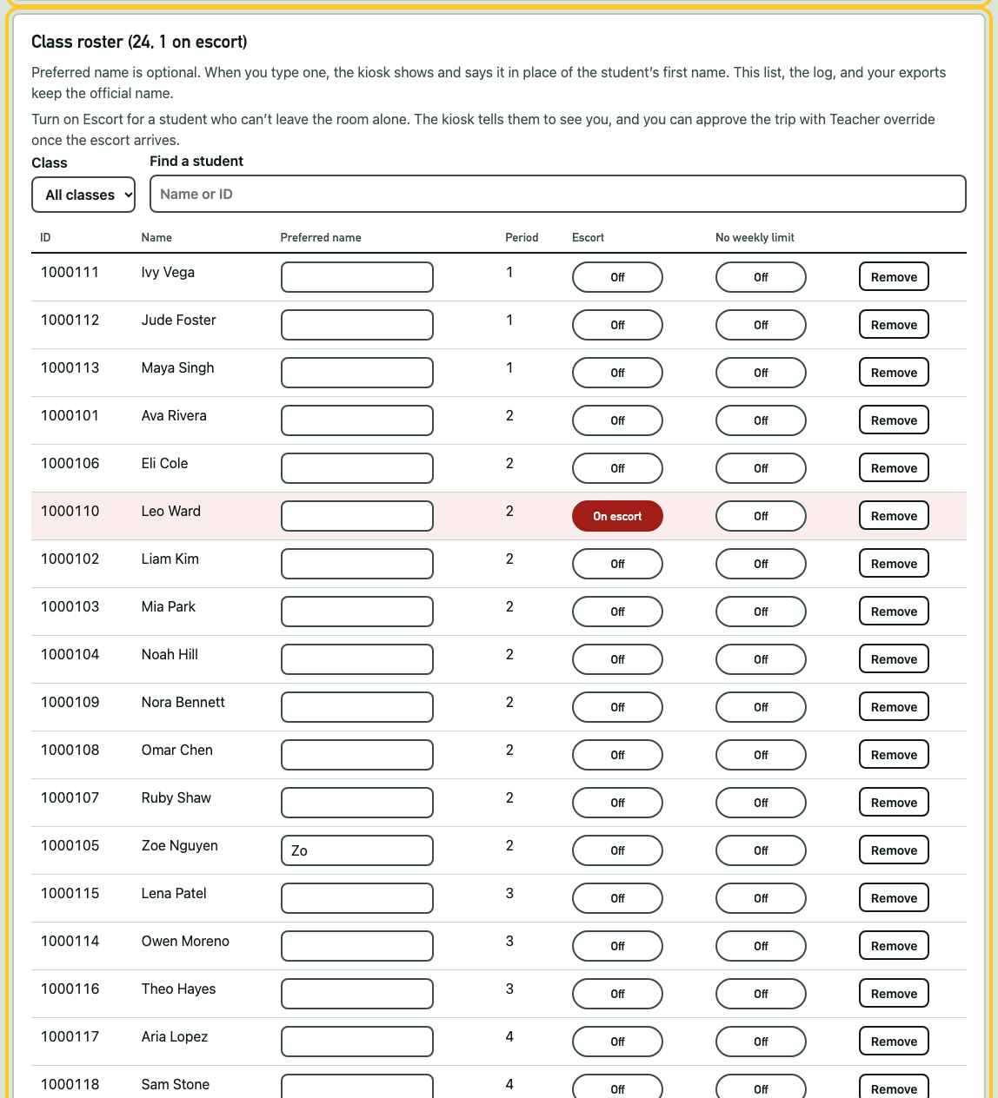
The Class roster list: Zoe has the preferred name Zo, and Leo is on escort
Click Next in the banner. Next time you import, the kiosk remembers your answers, including each class’s period.

Step 3: Set your bell schedule
With a bell schedule on, only students in the class now in session can sign out, and new sign-outs pause between classes.
Setup opens Edit the times for a weekday or a date. Type one day’s periods with their start and end times (Add period adds a row), then click Save schedule. To use the same times all week, choose Monday to Friday under Copy these rows to weekday and click Copy and save.
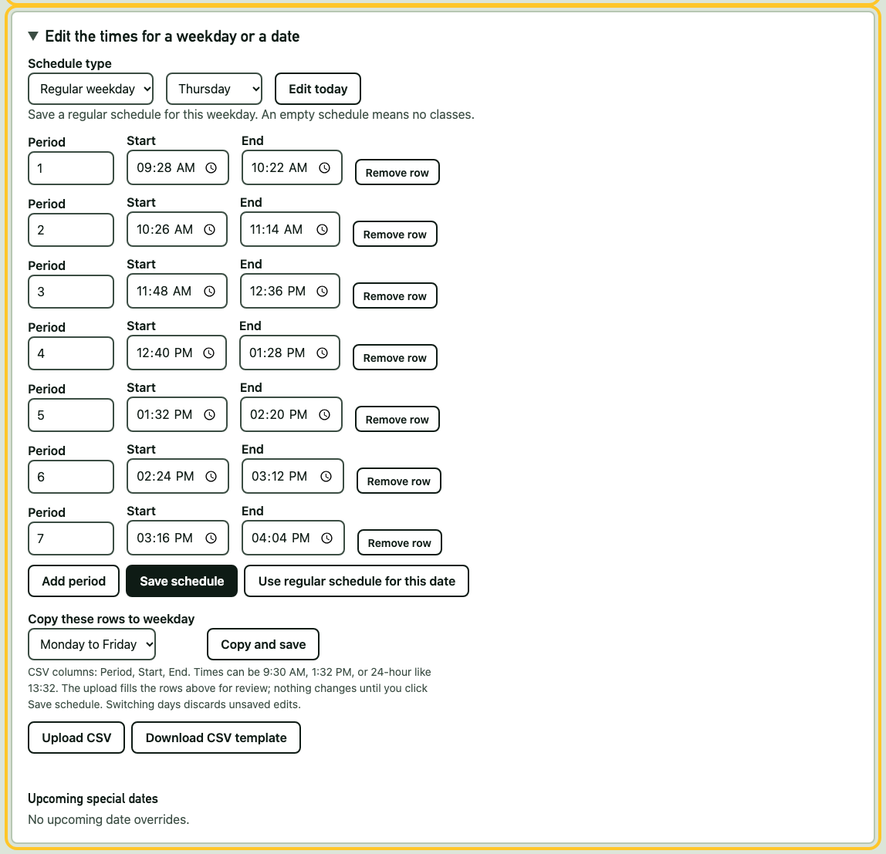
The time editor with Periods 1 to 7 typed in, and Monday to Friday chosen under Copy these rows
- A day that’s different, such as an early-release Wednesday: choose that weekday, change the times, and save.
- Prefer a spreadsheet? Download CSV template, fill in Period, Start, and End, then Upload CSV. The rows fill in for you to check before you save.
- The Bell schedule for the week table above shows what is saved for each day.
If your school doesn’t allow trips in the first and last minutes of class, check Hold the first and last 10 minutes of each class:
- First minutes: students can get in line, but nobody leaves until the time is up. Then the first student is called.
- Last minutes: nobody new can get in line. Choose what happens to students already waiting: let them all finish, let only the next student go, or cancel the line.
No bell schedule? Just click Next, and students can sign out any time.

Step 4: Choose how students are called
When the pass comes back, the kiosk plays a sound and says the next student’s first name. It never says a last name or the word “restroom.”
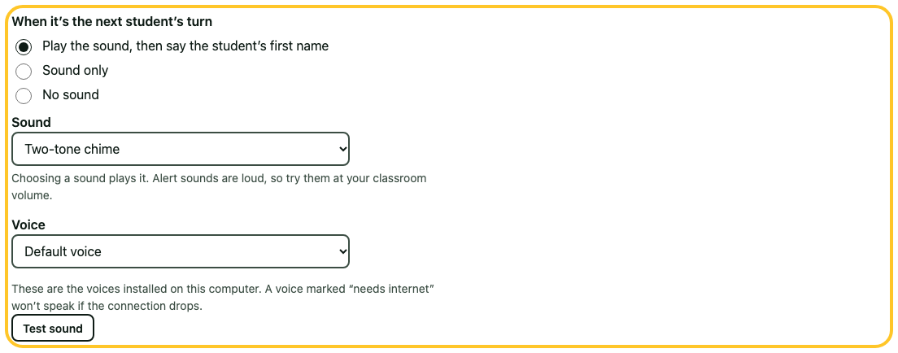
The calling settings: sound and name, the Two-tone chime, the default voice, and Test sound
- When it’s the next student’s turn: sound and name, sound only, or no sound.
- Sound: choosing one plays it. Alert sounds are loud, so try them at your classroom volume.
- Voice: the voices on this computer. A voice marked “needs internet” goes quiet if the connection drops, so a built-in voice is safer.
Click Test sound to hear it. Your choices save as you make them, here and everywhere in Settings.

Step 5: Set an override code (optional)
Teacher override approves a student the kiosk would turn away, or moves a waiting student to the front of the line. Your PIN works, but the student will be standing beside you as you type it. An override code approves overrides and nothing else, so it can’t open Teacher view.
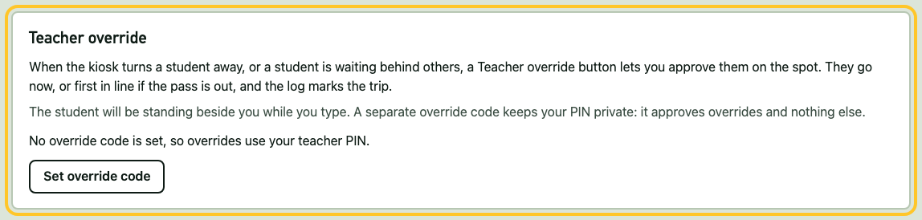
The Teacher override section with a Set override code button
Click Set override code, type 4 to 8 digits that differ from your PIN, and confirm. Or click Next to skip, and your PIN approves overrides.

Step 6: Save your first backup
Everything lives in Chrome on this one computer. Clearing browsing data or a new computer would erase it. Click Download backup and keep the file somewhere safe, such as your school drive. The Now tab reminds you when your last backup is a week old.
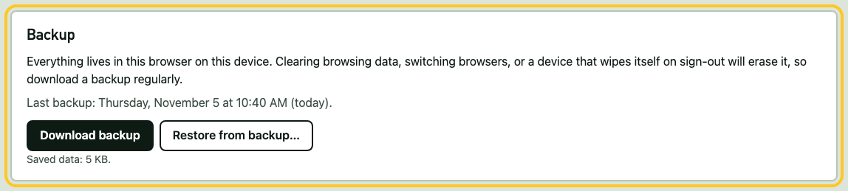
The Backup section with Download backup and Restore from backup
Click Finish setup. Teacher view closes and the kiosk is ready.
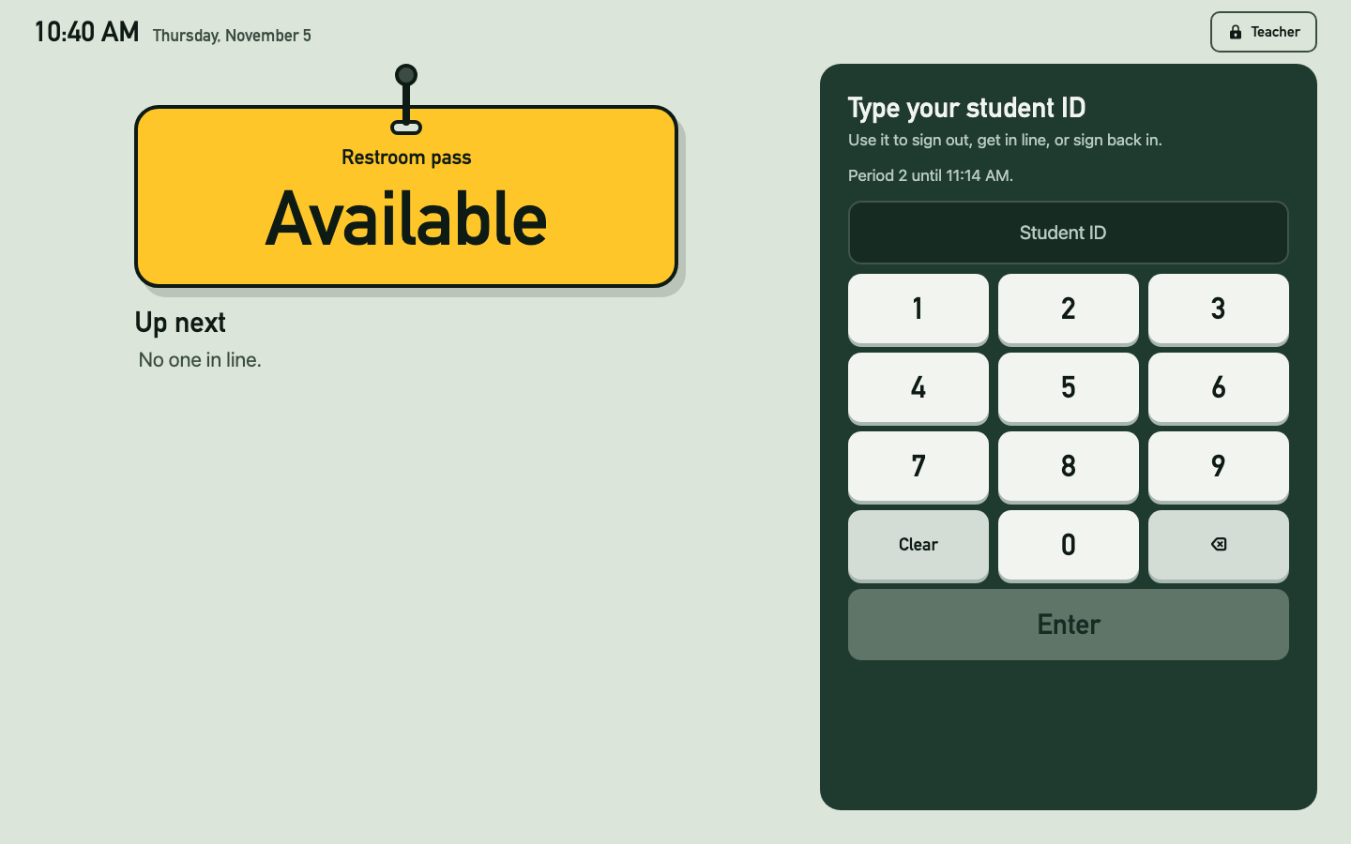
The finished kiosk: the pass says Available and the keypad says Type your student ID
Put the computer where students can reach the keypad and you can see the pass.

Every day
Students type their ID and press Enter, both to leave and to come back. If the pass is free, they go. If someone has it, they join the line. The pass shows who is out, with first name and last initial, and how many minutes they’ve been gone. Up next shows the line, large enough to read from a seat.
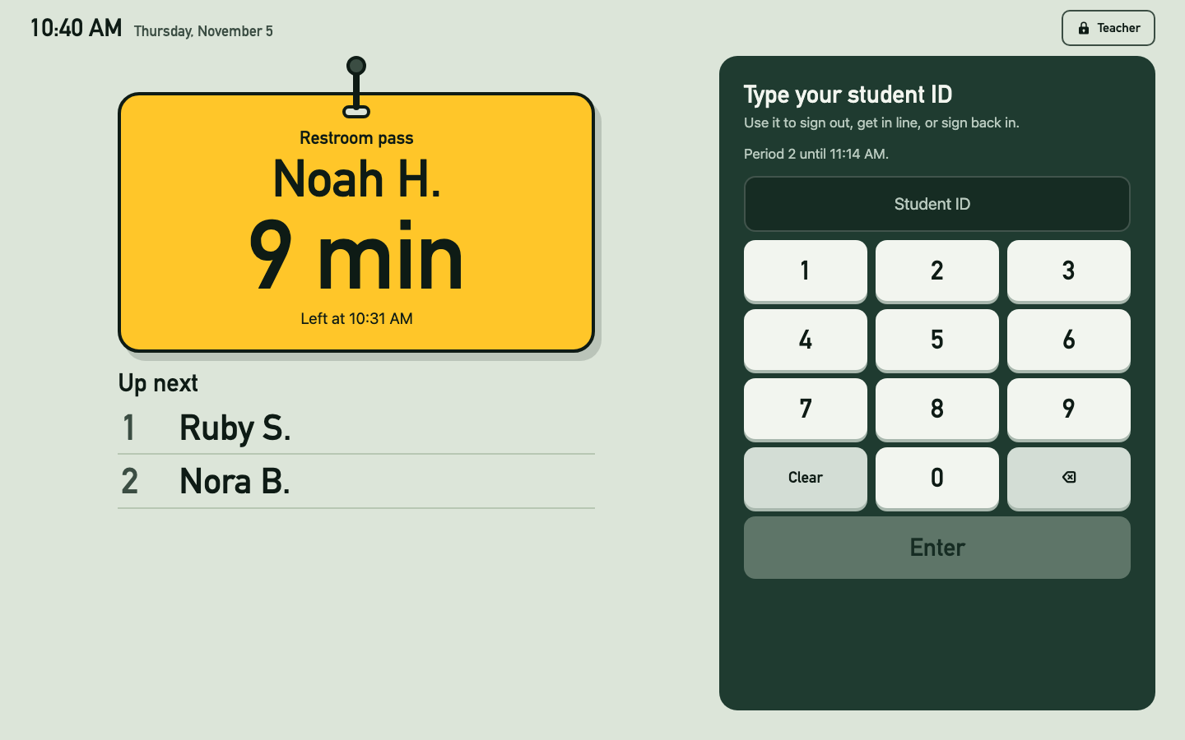
The kiosk in use: Noah H. has been out 9 minutes, and Ruby S. and Nora B. are next
When a student comes back and types their ID, a large card tells them who gets the pass next, and the kiosk calls that student by name.
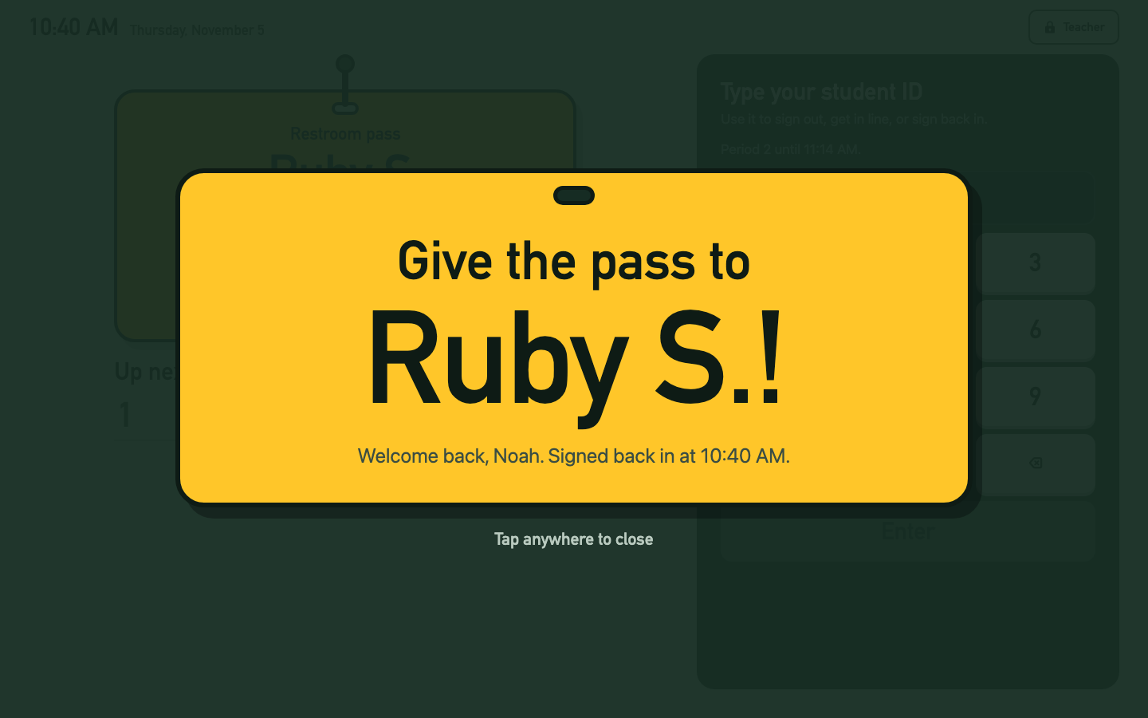
The handoff card: Give the pass to Ruby S.!

What students might see
- You’re #3 in line. They stay seated and listen for their name.
- Want to stay in line? A waiting student who types their ID again can choose Leave the line.
- You can’t sign out right now. It’s another period, between classes, or the student has no period on the roster. The message says which.
- See your teacher first. The student is on escort. The kiosk doesn’t name them or sign them out.
- Not yet and Line closed on the pass: the hold at the start or end of class, if you turned it on.
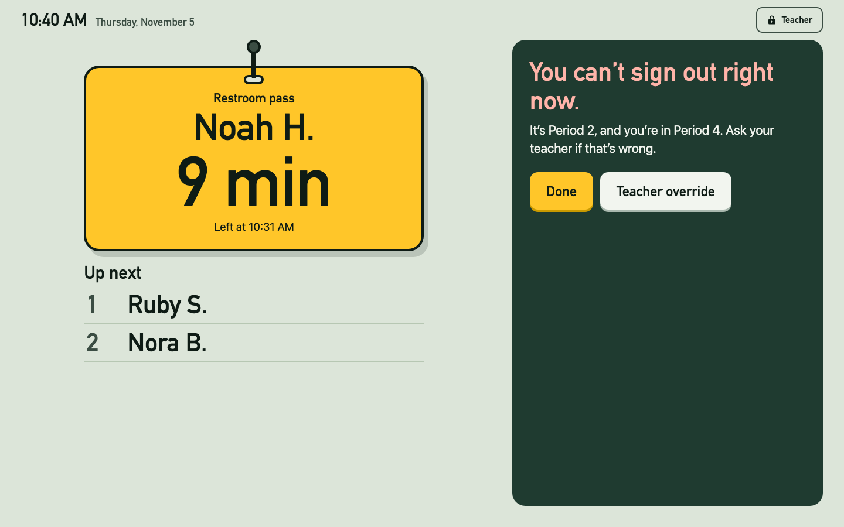
You can’t sign out right now: It’s Period 2, and you’re in Period 4
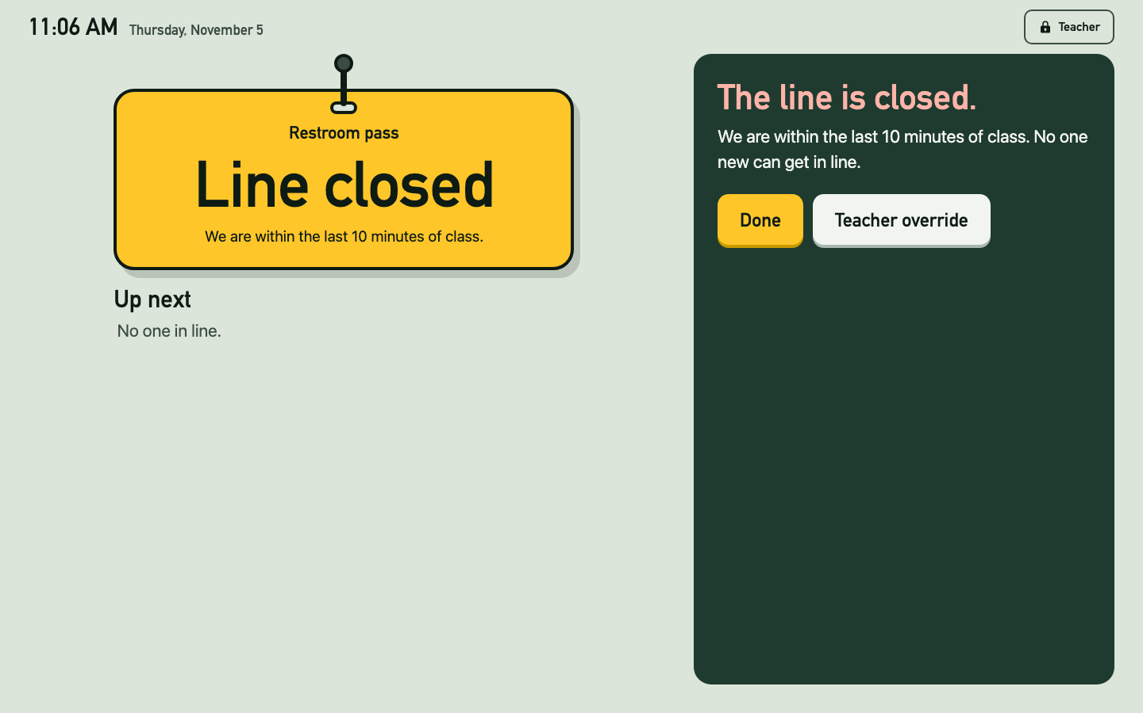
The pass says Line closed in the last 10 minutes of class

Teacher override
Teacher override appears whenever the kiosk turns a student away, and for a student waiting behind others. Click it and type your PIN or override code. The student goes now, or first in line if the pass is out, and the log marks the trip.
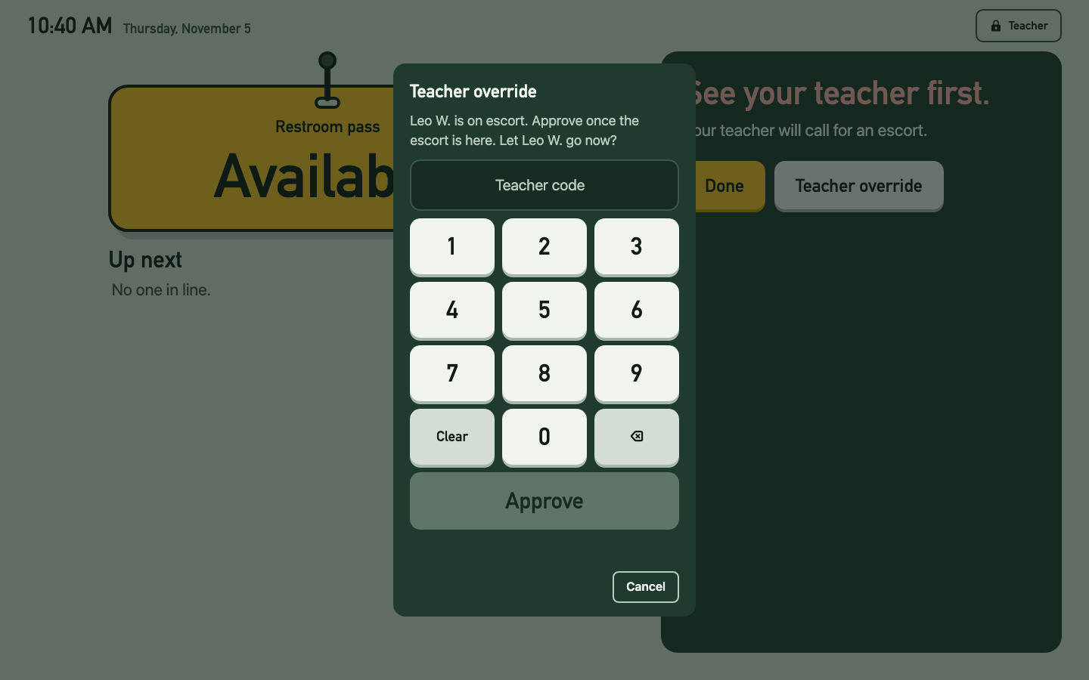
The Teacher override keypad: Leo W. is on escort. Let Leo W. go now?

Mistakes and long trips
- Typing the same ID again within a minute asks before signing the student back in, so a double tap doesn’t end a trip.
- Teacher view flags a trip after 10 minutes. After 45, the trip closes as Not signed back in and the pass goes to the next student. Change both in Settings.

Teacher view
Click Teacher and type your PIN. The tabs:
- Now: who has the pass and who is waiting. Mark a student returned, fix a return time, close a trip, or void one that didn’t happen. Move a student to the front of the line or remove them.
- Log: every trip, with when the student joined the line, left, and came back. Filter by day, period, or student.
- Weekly totals: trips per student for any week, with average and longest times.
- Roster, Schedule, and Settings: everything from setup. Settings save as you change them.
- Backup & export: download a backup, restore one, export the log as a spreadsheet, or erase.
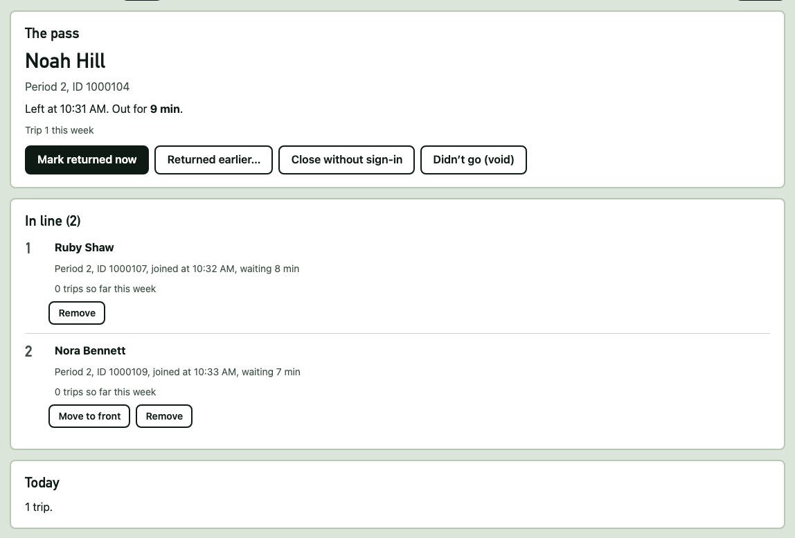
The Now tab: Noah Hill has the pass, with Ruby and Nora in line
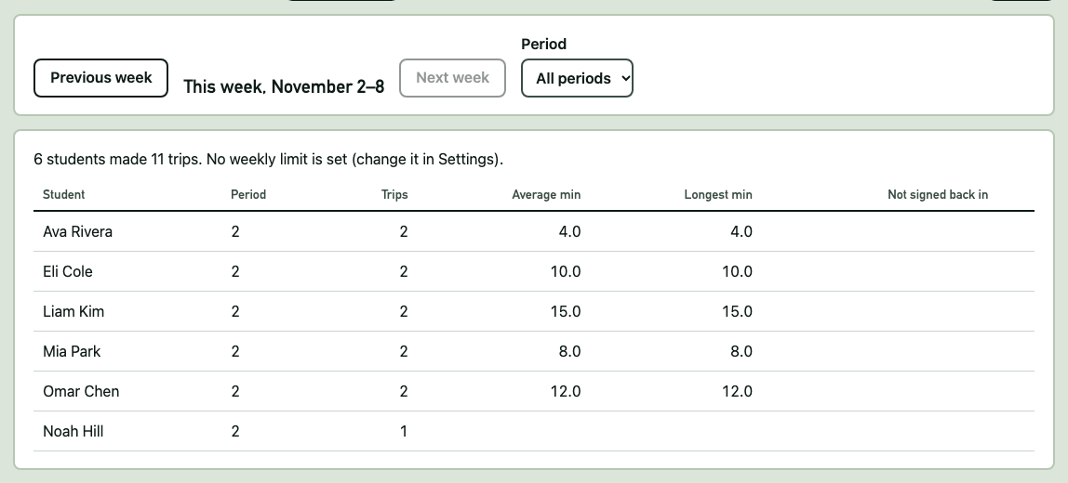
Weekly totals for November 2 to 8

A class outside the bell schedule
On the Schedule tab, under Today, open Run a different period for now. Type the period and the time it ends, and click Start this period. It ends on its own, or click Back to the bell schedule.

Special days
For a day with a different schedule, such as a testing day or an assembly, open Edit the times for a weekday or a date on the Schedule tab. Choose Specific date, pick the date, change the times, and click Save schedule. That date uses those times once, then the regular week takes over again. An empty schedule means no classes that day.

Change the colors
Open Settings and scroll to Look. Click a theme and the kiosk changes right away. The preview shows it before you leave the tab. Text colors are chosen for you, so everything stays readable. Back to the original look returns to hallway green.
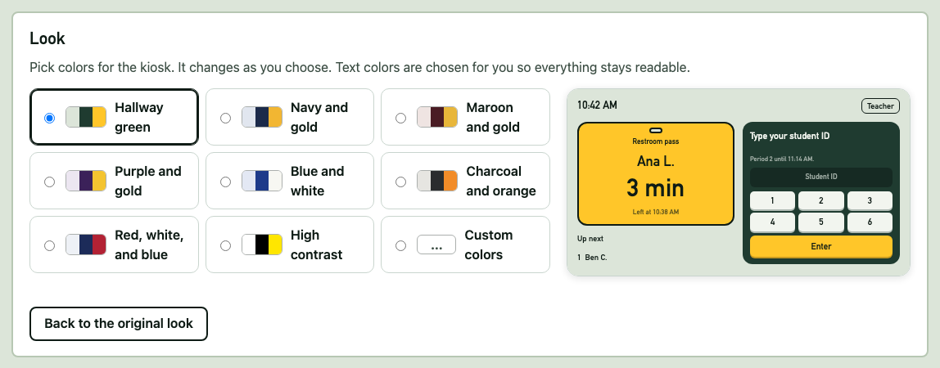
The Look section with nine themes and a preview

If something goes wrong
- Forgot your PIN: click Teacher, then Forgot PIN?, and type your recovery code.
- The kiosk is empty on a new computer, or after clearing Chrome: open Backup & export and Restore from backup….
- A student isn’t on the roster: paste them on the Roster tab: ID, name, period.
- Sign-outs are paused all day: check the Schedule tab. A day with nothing saved pauses sign-outs while schedules are on.

