MDRF / MLRF CONNECT
Meghalaya Research Fellows Platform
Launch Document

Version 1.0 | July 2026
Prepared for: Meghalaya Research Fellows Program — Government of Meghalaya
Bharti Institute of Public Policy, ISB

1. Executive Summary
The MDRF/MLRF Connect platform is a secure, web-based dashboard system developed for the Meghalaya Research Fellows program. It provides role-specific interfaces for Fellows, Coordinators, Directors, and Administrators to streamline field research management, log submissions, compliance tracking, and program oversight.
The platform serves two distinct programs:
- MDRF — Meghalaya District Research Fellows (supporting district administration with evidence-based planning)
- MLRF — Meghalaya Legislative Research Fellows (supporting MLAs with evidence-based public policy)

Built with modern web technologies (Next.js 14, TypeScript, Tailwind CSS, Firebase), the platform delivers a responsive, mobile-friendly experience with a professional navy-and-gold design language. All user interfaces have been designed to eliminate friction, with clear visual hierarchy, accessible typography, and context-appropriate navigation.
The platform includes key features such as: Firestore offline persistence for remote field areas, split activity/output logging, support request escalation, voice-to-text input, configurable LMS course links, and comprehensive coordinator alerting.

2. Platform Overview
The MDRF/MLRF Connect platform is a centralized digital workspace for the Meghalaya Research Fellows ecosystem. It connects field researchers with program coordinators, directors, and administrators through a unified, real-time dashboard interface.

2.1 Access Information
Item | Details
Platform URL | https://mdrf-dashboard.vercel.app
Supported Browsers | Chrome, Firefox, Safari, Edge (latest versions)
Mobile Support | Fully responsive — phones and tablets
Authentication | Google OAuth via Firebase Auth
Database | Cloud Firestore (real-time, offline-capable)

2.2 User Roles & Permissions
Role | Scope | Description
Fellow | Self | Field researcher — submits daily/weekly logs, tracks tasks, views deadlines, requests support
MDRF Coordinator | District | Oversees MDRF fellows in assigned districts — reviews logs, compliance management, alerts
MLRF Coordinator | Constituency | Oversees MLRF fellows assigned to constituencies
Director | Program-wide | Strategic oversight — cross-program compliance, case study review, support escalation
Administrator | System-wide | User management, approvals, LMS course configuration, system settings

3. Key Features by Role

3.1 Fellow Interface
The Fellow Dashboard is the primary workspace for field researchers. It provides:
- Quick stats: Total logs, streak count, active/stuck tasks
- Weekly progress tracker with compliance target
- Workload self-declaration meter
- Split activity/output log form with voice-to-text input
- File upload with 5MB client-side validation
- Task management (add, mark complete, flag stuck)
- Certificate Programme progress tracking
- Work history with week/category filters
- Support request submission and tracking
- Case study / policy brief submissions
- ISB LMS course links configured by admin

3.1.1 Login Page
The login page features a split layout with a branded hero panel (navy background with animated gradient orbs, geometric decorations, and Meghalaya hill silhouette) and a sign-in card with Google OAuth. Fully responsive for mobile with scrollable layout.
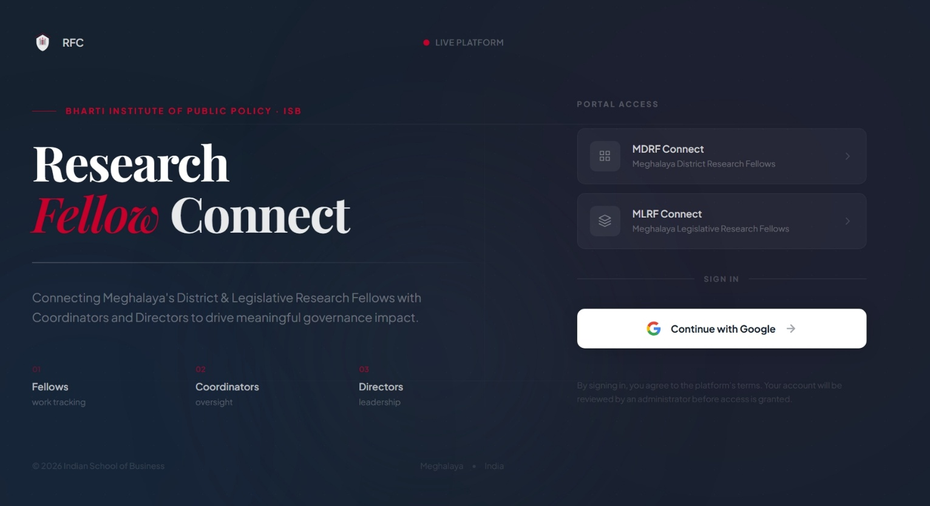
Figure 3.1: Login Page — Desktop View
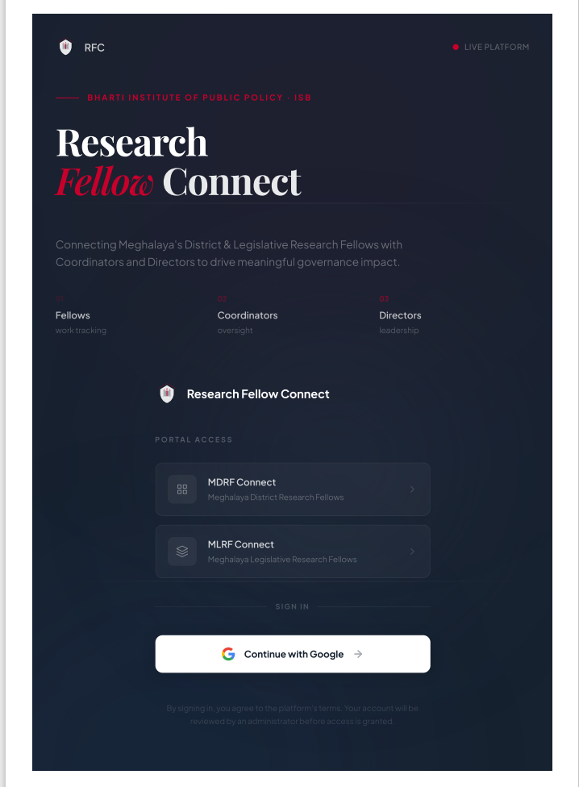
Figure 3.2: Login Page — Mobile View

3.1.2 Fellow Dashboard
The main dashboard shows stats cards, weekly progress, workload meter, work log form, tasks panel, recent activity, and quick links to support and LMS.
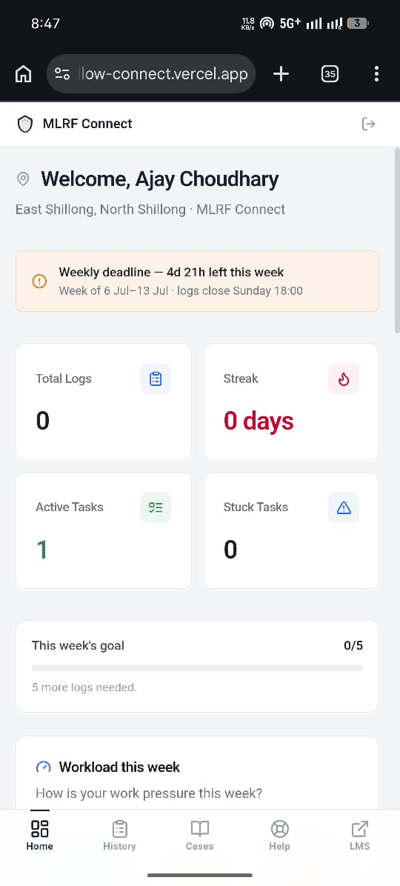
Figure 3.3: Fellow Dashboard

3.1.3 Work Log Form
The log form now separates activity description ("What did you do?") from output/deliverable ("What did you produce?"). Each textarea has a voice-to-text microphone button using the Web Speech API. An optional file attachment input validates files under 5MB.
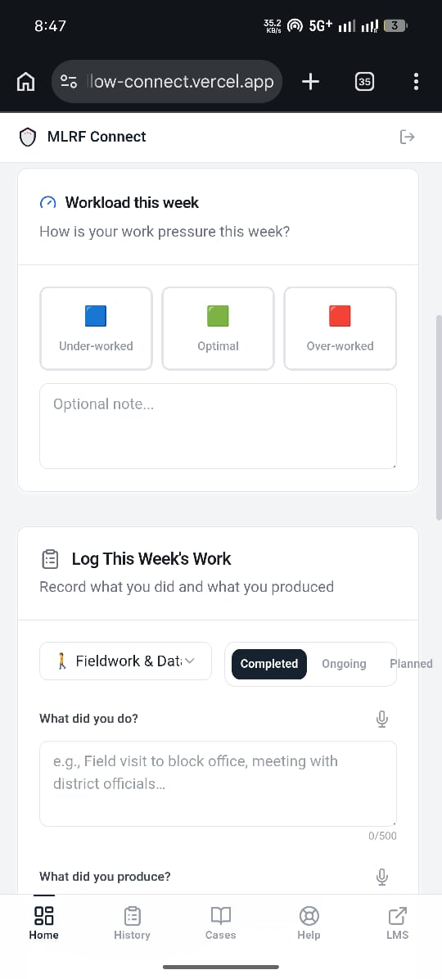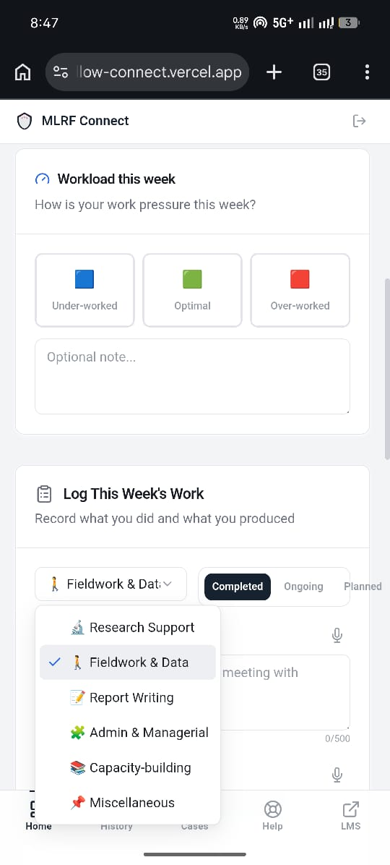
Figure 3.4: Work Log Form with Voice-to-Text

3.1.4 Tasks Panel
Fellows can add tasks, toggle status (ongoing/completed/stuck), and track progress directly from the dashboard.
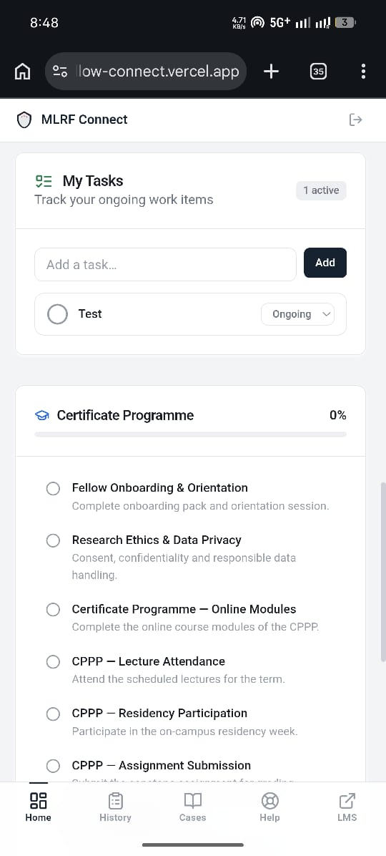
Figure 3.5: Tasks Panel

3.1.5 Work History
A filterable, week-grouped view of all past work logs showing both activity and output fields.
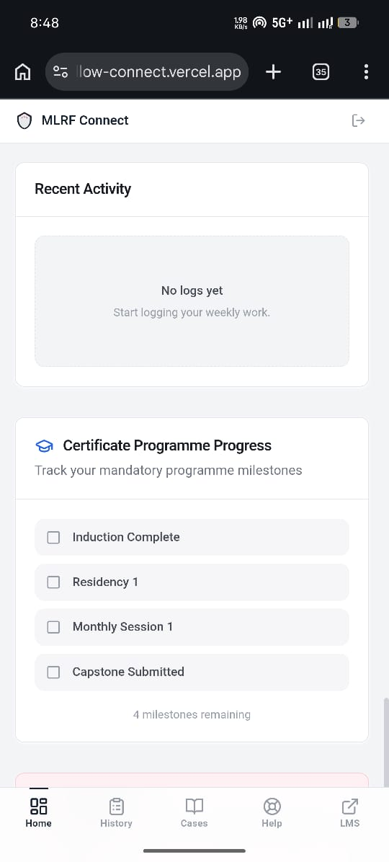
Figure 3.6: Work History

3.1.6 Support Requests
Fellows can submit support requests categorized by type (Data Analysis, Policy Drafting, Subject Matter Expert, Administrative) with urgency levels. All requests are saved to the supportRequests collection with status tracking.
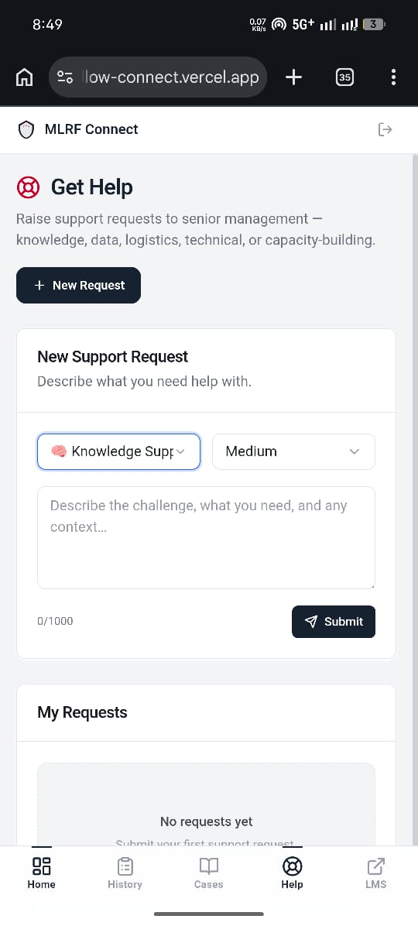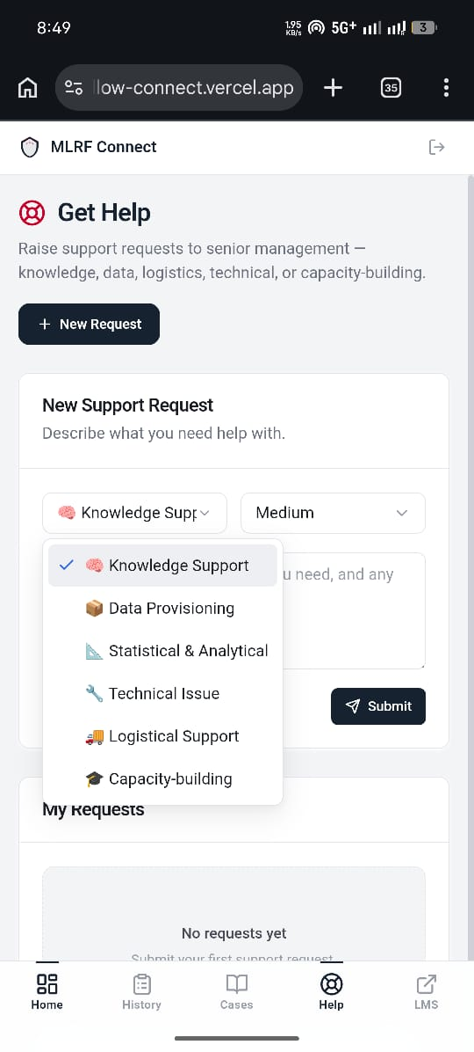
Figure 3.7: Submit Support Request

3.1.7 ISB LMS Courses
Administrators configure course links which fellows can access from a dedicated page. Courses open in new tabs and can be filtered by program.
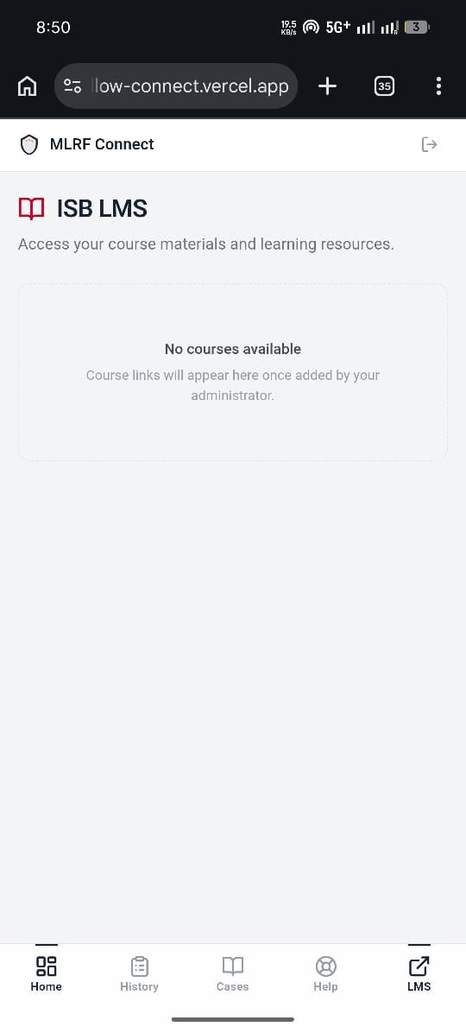
Figure 3.8: ISB LMS Courses

3.1.8 Case Studies
Fellows can document field breakthroughs, case studies, and policy briefs. Submissions go through draft/submitted/published workflow with comment-based discussion.
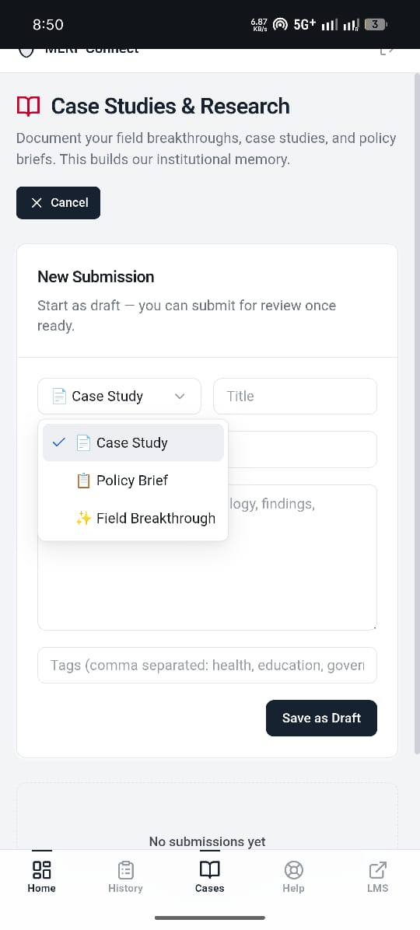
Figure 3.9: Case Studies

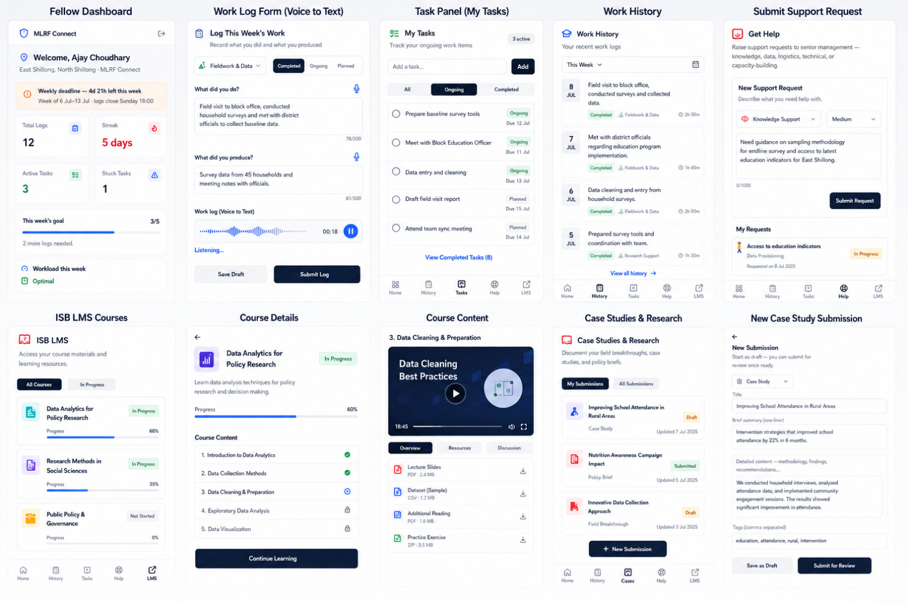
Figure 3.10: Demo

3.2 Coordinator Interface
The Coordinator dashboard provides oversight for assigned fellows:
- District/constituency overview with compliance metrics
- Alerts panel: silent fellows (configurable inactivity threshold), stuck tasks, urgent support requests, overdue deliverables
- Support request triage with status management
- Case study review and discussion

Figure 3.10: Coordinator Overview

Figure 3.11: Coordinator Alerts

3.3 Director Interface
Directors have program-wide visibility:
- Cross-program compliance dashboard
- Weekly compliance trends and category distribution
- Support request oversight across all districts
- Case study review across all programs

Figure 3.12: Director Dashboard

3.4 Administrator Interface
Administrators manage the platform:
- User management: approve, reject, assign roles, set districts/constituencies
- LMS course management: add/edit/delete course links with program filtering
- Bootstrap configuration

Figure 3.13: Admin — User Management

Figure 3.14: Admin — LMS Course Management

4. Technical Architecture

4.1 Technology Stack
Layer | Technology
Framework | Next.js 14 (App Router)
Language | TypeScript
Styling | Tailwind CSS 3 + CSS custom properties (HSL)
Authentication | Firebase Auth (Google OAuth)
Database | Cloud Firestore with offline persistence
UI Components | Radix UI primitives + Lucide icons + Recharts
Deployment | Vercel
Package Manager | pnpm

4.2 Offline Persistence
Firestore offline persistence is enabled via enableIndexedDbPersistence(). This allows fellows in remote areas of Meghalaya with poor internet connectivity to fill out forms offline. Data syncs automatically when connectivity returns. The implementation handles the failed-precondition error (multiple tabs) and unimplemented error (unsupported browser) gracefully.

4.3 Navigation Structure
The platform uses role-based navigation configured in nav-config.tsx. The desktop sidebar provides full navigation while a mobile bottom nav bar offers quick access to key sections. An "ISB LMS" link is available to all roles.

5. Security & Authentication
Authentication is handled entirely by Firebase Auth with Google OAuth. No passwords are stored in the application database.
Firestore security rules enforce role-based access at the database level:
- All authenticated users can read profiles, work logs, tasks, support requests
- Users can create their own profile and submit their own logs/requests
- Admin role required for user management, approvals, and LMS configuration
- Config collection readable by all authenticated users, writable only by admins

6. Deployment Information
The platform is deployed on Vercel with automatic deployments from the main branch of the GitHub repository (github.com/ajayc-iima/mdrf-dashboard).
Production URL: https://mdrf-dashboard.vercel.app
Environment: .env.local for local development; Vercel environment variables for production
Firebase Project: Configured via NEXT_PUBLIC_FIREBASE_* environment variables

7. Version History
Version | Date | Changes
1.0 | Jun 2026 | Initial launch: basic auth, work logging, task management, coordinator overview
2.0 | Jul 2026 | Offline persistence, split activity/output logging, voice-to-text, support request escalation, configurable LMS courses, coordinator alerts enhancement, mobile hero, Programme Progress card

8. Support & Contact
Platform Lead: Bharti Institute of Public Policy, ISB
Technical Inquiries: ISB IT Team (via internal channels)
Program Inquiries: Meghalaya Institute of Governance (MIG)

— End of Document —

