**Arduino-2**

**What is Arduino?**

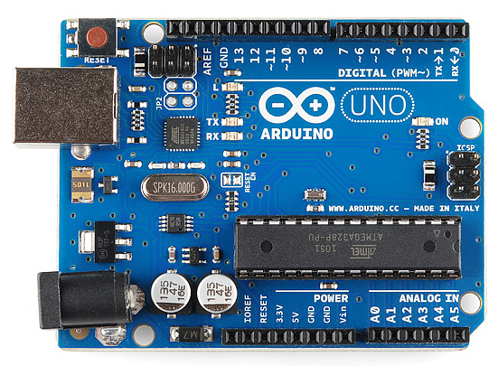Arduino is an open-source electronics platform based on easy-to-use hardware and software. [Arduino boards](https://www.arduino.cc/en/Main/Products) are able to read inputs - light on a sensor, a finger on a button, or a Twitter message - and turn it into an output - activating a motor, turning on an LED, publishing something online. You can tell your board what to do by sending a set of instructions to the microcontroller on the board.

**How to connect Arduino with laptop**

* First download the software arduino-1.6.12-windows.exe
* Connect Arduino with laptop by USB cable
* Open Arduino software
* Select Board: Click Tool and select board as Arduino as shown in figure 2.

Figure 1: Arduino

* Select port: Click Tool and select port as shown in figure 3, port number may be varying with device.

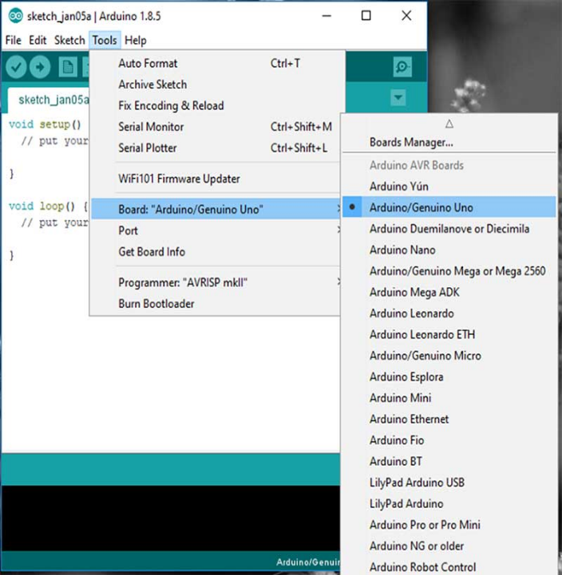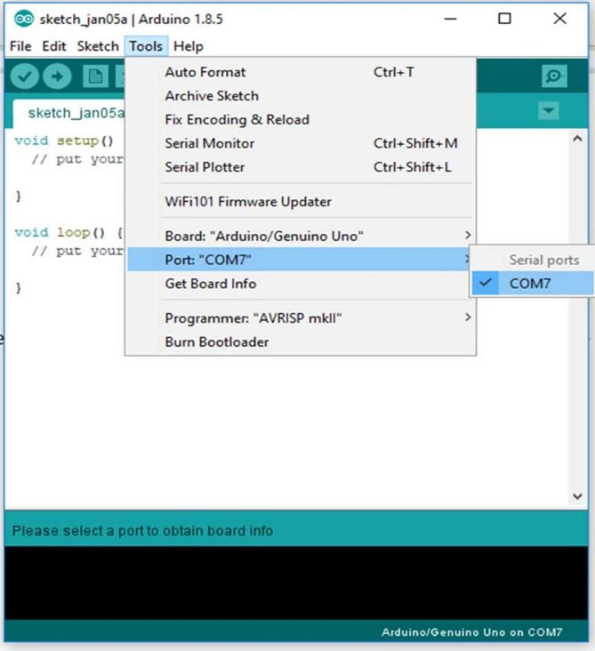

Figure 2

Figure 3

**Task 1:** Glow two LED (first LED five times then second LED five times)

**Hardware required:**

1. LED (Light Emitting Diode) 2. Power source (Arduino) 3. Resistor 4. Jumper wires 5. Breadboard

**Hardware connection:**

* Positive terminal of LEDs (longer leg) connected to 12 and 13 pins of Arduino.
* Negative terminal of LEDs (shorter leg) connected to 500-ohm resistor and another terminal of resistors connected to GND pins of Arduino.
* Always use resistors between the Arduino and LEDs to keep the LEDs from burning out due to too much current.
* Upload your code to Arduino and the led starts blinking.

**Code**

int redLEDPin=13; int yellowLEDPin=12; int waitTimeOn=200;// time in mili sec

int waitTimeOff=200;// time in mili sec

int I; int j;

void setup()

{

Serial.begin(9600);

pinMode(redLEDPin,OUTPUT);

pinMode(yellowLEDPin,OUTPUT);

}

void loop()

{

for(int j=1;j<=5;j=j+1)

{

Serial.println(j);

digitalWrite(redLEDPin,HIGH);

delay(waitTimeOn);

digitalWrite(redLEDPin,LOW);

delay(waitTimeOff);

}

for(int i=1;i<=5;i=i+1)

{

Serial.println(i);

digitalWrite(yellowLEDPin,HIGH);

delay(waitTimeOn);

digitalWrite(yellowLEDPin,LOW);

delay(waitTimeOff);

}

}

**Task 2:** Glow two LED (first LED five times then second LED five times) and print own name every time

**Connection:**

* Positive terminal of LEDs (longer leg) connected to 12 and 11 pins of Arduino.
* Negative terminal of LEDs (shorter leg) connected to 500-ohm resistor and another terminal of resistors connected to GND pins of Arduino.

**Code:**

int redLEDPin=12; int yellowLEDPin=11; int waitTimeOn=200;// time in mili sec

int waitTimeOff=200;// time in mili sec

int i; int j; int Priyesh;

void setup()

{

Serial.begin(9600);

pinMode(redLEDPin,OUTPUT);

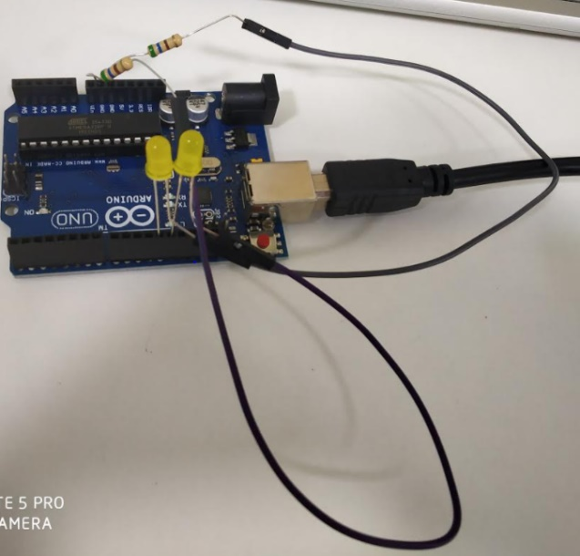pinMode(yellowLEDPin,OUTPUT);

}

void loop()

{

for(int j=1;j<=5;j=j+1)

{

Serial.print("Priyesh");

Serial.println(j);

digitalWrite(redLEDPin,HIGH);

delay(waitTimeOn);

digitalWrite(redLEDPin,LOW);

delay(waitTimeOff);

}

for(int i=1;i<=5;i=i+1)

{

Serial.print("Priyesh");

Serial.println(i);

digitalWrite(yellowLEDPin,HIGH);

delay(waitTimeOn);

digitalWrite(yellowLEDPin,LOW);

delay(waitTimeOff);

}

}

**Task 3:** Design the Arduino Circuit to measure the temperature by using temperature sensor (LM35)

**Hardware required:** Arduino board, USB cable, breadboard, LM 35 IC, LED’s

**Connection:**

* Connect the left pin of lm35 to the 5V of Arduino.
* Connect the center pin of lm35 to the A0 of Arduino.
* Connect the left pin of lm35 to the GND of Arduino.

**Code:**

float temp;

void setup()

{

Serial.begin(9600);

}

void loop()

{

temp = analogRead(A0);

temp = temp*0.48828125;

Serial.print("TEMPERATURE: ");

Serial.print(temp);

Serial.print("*C");

Serial.println();

delay(1000);

}

**Task 4:** Design the Arduino Circuit to measure the temperature by using temperature sensor (LM35) such that for temperature > 32 °C red led will glow and for temperature < 32 °C yellow led will glow.

**Component description LM 35 IC:** An LM35 is a 3-pin temperature sensor. It gives output in voltage according to the temperature, having an accuracy of 10mV per degree Celsius. It can measure temperatures in the range of **-55°C** to **150°C** and it operates from 4V to 20V. Its output voltage is proportional to the temperature i.e., higher the temperature, output voltage is also high. The output voltage of this sensor can be easily converted to digital form using an ADC so that a microcontroller can easily process it.

**Connection:**

* Connect the left pin of lm35 to the 5V of Arduino.
* Connect the center pin of lm35 to the A0 of Arduino.
* Connect the left pin of lm35 to the GND of Arduino.
* Connect the negative side of your LEDs (shorter leg) to ground.
* Connect the positive side (longer leg) of your LEDs to 1k Ohm resistors. Connect the other side of the resistors to digital pin 6 and 7 (you may put any digital pin, but don't forget to change the pin number in code).

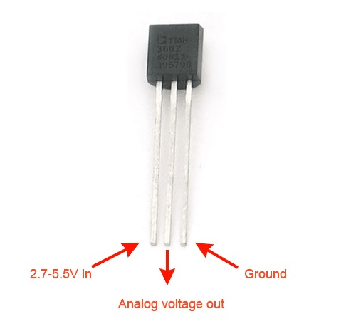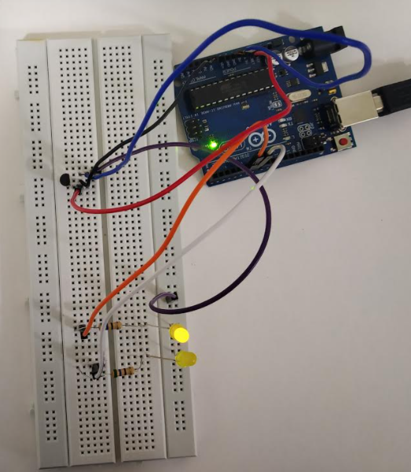**Circuit:**

**Code:**

#define LM35 A0

#define Red 7

#define yellow 6

float temp;

float value;

void setup()

{

Serial.begin(9600);

pinMode(Red,OUTPUT);

pinMode(yellow,OUTPUT);

}

void loop()

{

value = analogRead(LM35);

temp = value*0.48828125;

Serial.println(temp); // Temperature in celcius

//Condition

if(temp > 32)

{

digitalWrite(Red,HIGH);

digitalWrite(yellow,LOW);

}

else

{

digitalWrite(Red,LOW);

digitalWrite(yellow,HIGH);

}

delay(300);

}

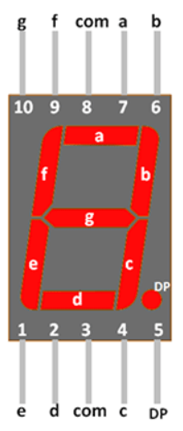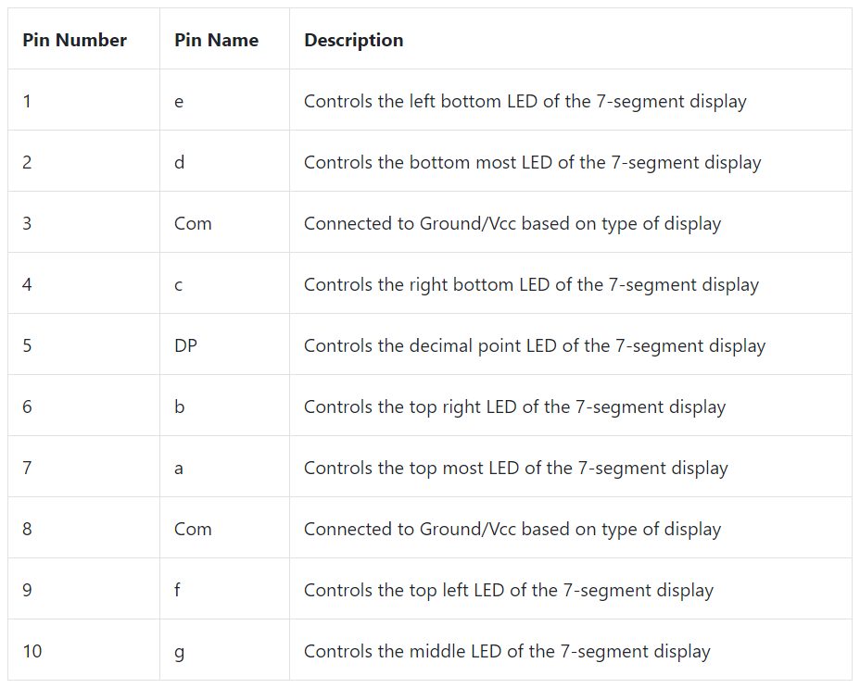**Task 5: Display 0 to 7 on 7 segment display**

**Connection:**

* Pin g connected to 5
* Pin f connected to 4
* com connected to 12
* Pin a connected to 3
* Pin b connected to 2
* Pin e connected to 7
* Pin d connected to 8
* Pin c connected to 6

**Code:**

#define A 3

#define B 2

#define C 6

#define D 8

#define E 7

#define F_SEG 4

#define G 5

// Pins driving common anodes

#define CA1 12

#define CA2 13

// Pins for A B C D E F G, in sequence

const int segs[7] = { A, B, C, D, E, F_SEG, G };

// Segments that make each number

const byte numbers[10] = { 0b1000000, 0b1111001, 0b0100100, 0b0110000, 0b0011001, 0b0010010,

0b0000010, 0b1111000, 0b0000000, 0b0010000 };

void setup() {

pinMode(A, OUTPUT);

pinMode(B, OUTPUT);

pinMode(C, OUTPUT);

pinMode(D, OUTPUT);

pinMode(E, OUTPUT);

pinMode(F_SEG, OUTPUT);

pinMode(G, OUTPUT);

pinMode(CA1, OUTPUT);

pinMode(CA2, OUTPUT);

}

void loop() {

for (int digit1=0; digit1 < 10; digit1++) {

for (int digit2=0; digit2 < 10; digit2++) {

unsigned long startTime = millis();

for (unsigned long elapsed=0; elapsed < 600; elapsed = millis() - startTime) {

lightDigit1(numbers[digit1]);

delay(5);

lightDigit2(numbers[digit2]);

delay(5);

}

}

}

}

void lightDigit1(byte number) {

digitalWrite(CA1, LOW);

digitalWrite(CA2, HIGH);

lightSegments(number);

}

void lightDigit2(byte number) {

digitalWrite(CA1, HIGH);

digitalWrite(CA2, LOW);

lightSegments(number);

}

void lightSegments(byte number) {

for (int i = 0; i < 7; i++) {

int bit = bitRead(number, i);

digitalWrite(segs[i], bit);

}

}

**Task 6:** Design the Arduino Circuit to measure the temperature by using temperature sensor (LM35) and display it on seven segment display (2 digits).

**Hardware required-** Arduino board, USB cable, breadboard, LM 35 IC, Lad’s, 500-ohm resistors, 7 segment display.

**Circuit:**

**Component description Seven segment:**



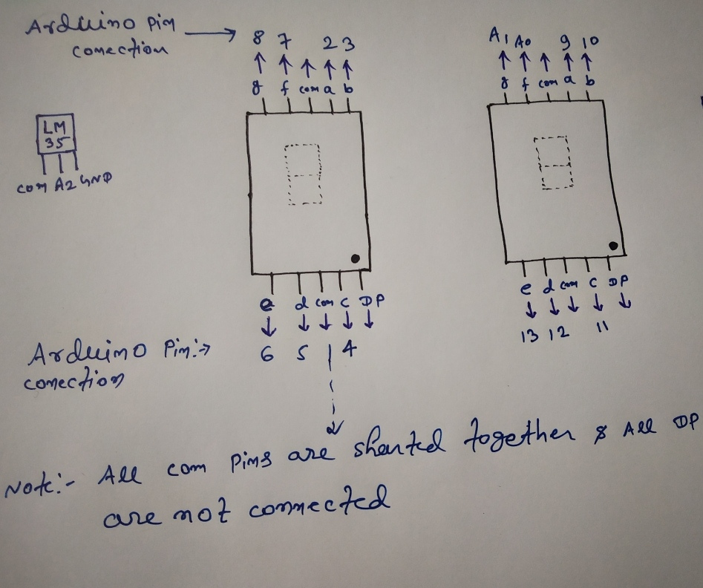**Connection:**

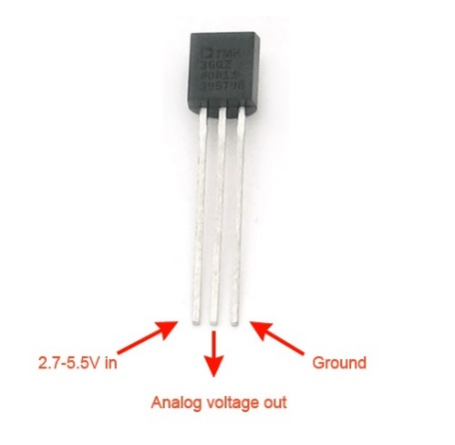

* Connect both 7 segments with Arduino as swan in above figure.
* All com pins are shorted together.
* Left pin of LM 35 connected to com pin of Arduino.
* Middle pin of LM 35 connected to A2 pin of Arduino.
* Right pin of LM 35 connected to GND pin of Arduino.
* Connect 500-ohm resistor, one terminal of resistor to 5 V of Arduino pin and another terminal of resistor connected to com pin of 7 segment.

**Code:**

int temp;

int tempPin = A2;

int x,y;

int bcd_array[10][7] = { { 0,0,0,0,0,0,1 }, // 0

{ 1,0,0,1,1,1,1 }, // 1

{ 0,0,1,0,0,1,0 }, // 2

{ 0,0,0,0,1,1,0 }, // 3

{ 1,0,0,1,1,0,0 }, // 4

{ 0,1,0,0,1,0,0 }, // 5

{ 0,1,0,0,0,0,0 }, // 6

{ 0,0,0,1,1,1,1 }, // 7

{ 0,0,0,0,0,0,0 }, // 8

{ 0,0,0,1,1,0,0 }}; // 9

void BCD0(int);

void BCD1(int);

void setup()

{

pinMode(2, OUTPUT);

pinMode(3, OUTPUT);

pinMode(4, OUTPUT);

pinMode(5, OUTPUT);

pinMode(6, OUTPUT);

pinMode(7, OUTPUT);

pinMode(8, OUTPUT);

pinMode(A2, INPUT);

pinMode(9, OUTPUT);

pinMode(10, OUTPUT);

pinMode(11, OUTPUT);

pinMode(12, OUTPUT);

pinMode(13, OUTPUT);

pinMode(14, OUTPUT);

pinMode(15, OUTPUT);

}

void loop()

{

temp = analogRead(tempPin);

temp = temp * 0.48828125;

x = (temp/10);

y = (temp -((temp / 10) * 10));

delay(1000);

BCD0(x);

BCD1(y);

}

void BCD0(int number)

{

int pin= 2;

for (int j=0; j < 7; j++) {

digitalWrite(pin, bcd_array[number][j]);

pin++;

}

}

void BCD1(int number)

{

int pin= 9;

for (int j=0; j < 7; j++) {

digitalWrite(pin, bcd_array[number][j]);

pin++;

}

}