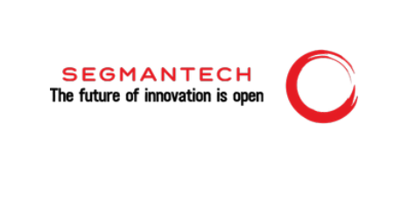

**Segman Technology India Pvt Ltd.**

**Technology | Consulting | Service | Product**

|  |
| --- |
|  |

# About Our Company



 **We are Committed to build trust, evolve and innovate the next gen secure software needs, which help to make an effective decision**.

 **Operating from 5+ years.** 

  **We are your innovating partner. Our motto is to serve you the best.**

 **One stop solution for all your business need**.

**Our Symbol of Stability & Credibility**



**15+**

**Years of**

**Experienced on**

**Tech Leads with Latest Technology**

**100+**

**Employee**

**Payroll Support**

**Delivered**

**30+**

**Successful**

**Projects**

**Delivered**

**10+**

**Happy**

**Clients**

**Worldwide**

**5+**

**Rapid**

**Deployment**

**Packages**

**6+**

**Core employee &**

**Consultant**

**strength**

**2+**

**Countries we are**

**serving**

**4+**

**Industries we are**

**serving**

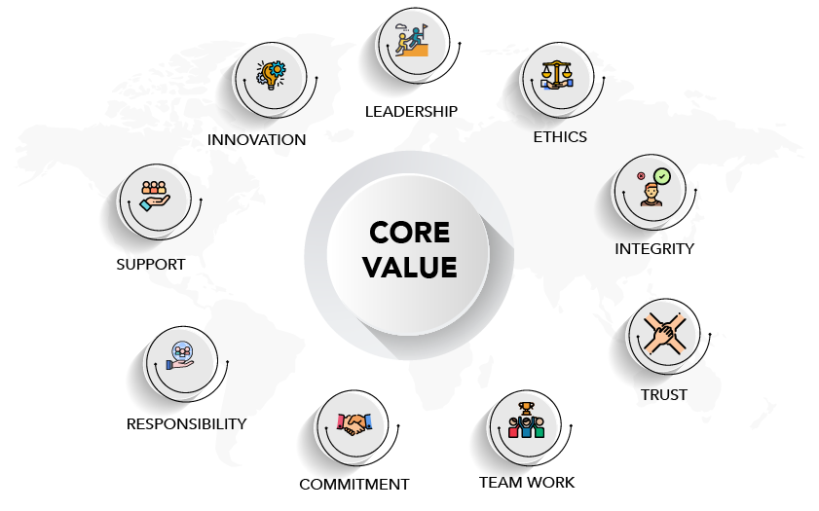

**Core Values**

# Our Products

* **Fusion Churn 360 Prediction Intelligence.**
* **Resource Capacity Planner.**
* **Quick Lender (Smart Loan Initiate System).**
* **Cosmic Inventory Tracking System.**
* **Nova Digital Banking System.**

# Our Services

* **Notification as a service.**
* **Banking as a service.**
* **Mobile, Software and Website Development.**
* **Computer Assembly and Re-design.**
* **Gem-Portal Accounting, E-commerce and Social Media Account Handling.**

# Why Choose Us

* **Put Customer First.**
* **Transparency.**
* **Open to Take Challenges.**
* **Purpose-Led to redefine innovation for good.**
* **Open to Collaborate.**

# Our Valuable Clients

* **Put Customer First.**
* **Transparency.**
* **Open to Take Challenges.**
* **Purpose-Led to redefine innovation for good.**
* **Open to Collaborate.**

# Domain Worked For

* **Fintech.**
* **Pharmacy.**
* **Hotels Billing and Customer Management.**
* **Manufacturing.**
* **Government and Private Projects.**



**Thank You.**

**+91-9871617066**

