Assignment 2.2
Create a sample dataset and implement the below Pig commands on the same dataset.
1) Concat
2) Tokenize
3) Sum
4) Min
5) Max
6) Limit
7) Store
8) Distinct
9) Flatten
10) IsEmpty

First of all loading the data in file student.txt
grunt> A= LOAD 'student.txt' using PigStorage(',');

grunt> A= LOAD 'student.txt' using PigStorage(',') AS(StdName:chararray, sec:chararray,DOB:chararray,qal:chararray,score:int,state:chararray,randname:chararray) ;
grunt> describe A ;
A: {StdName: chararray,sec: chararray,DOB: chararray,qal: chararray,score: int,state: chararray,randname: chararray}

- Concat
grunt> student_name_concat = foreach A Generate CONCAT (StdName, state);
dump student_name_concat;

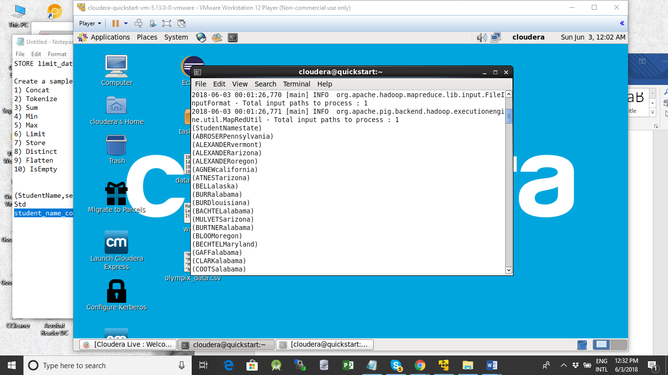

- Tokenize
The TOKENIZE() function of Pig Latin is used to split a string (which contains a group of words) in a single tuple and returns a bag which contains the output of the split operation.

grunt> Name= LOAD 'name.txt' using PigStorage(',') AS (name:chararray, age:int);
grunt> dump Name

O/P
(Ajay Chouksey,43)
(Abhijay Chouksey,15)
(Manmohan Shivhare,42)
(Gudiya Rai,37)
(Lakshmi Chouksey,40)
(Priya Menon,70)
(Ramesh Garg,35)

Tokenization

grunt> name_tokenize= forEach Name Generate TOKENIZE(name);
dume name_tokenize;
({(Ajay),(Chouksey)})
({(Abhijay),(Chouksey)})
({(Manmohan),(Shivhare)})
({(Gudiya),(Rai)})
({(Lakshmi),(Chouksey)})
({(Priya),(Menon)})
({(Ramesh),(Garg)})

- Sum
Dump Name;
(Ajay Chouksey,43)
(Abhijay Chouksey,15)
(Manmohan Shivhare,42)
(Gudiya Rai,37)
(Lakshmi Chouksey,40)
(Priya Menon,70)
(Ramesh Garg,35)

grunt> Name_group= Group Name all ;
grunt> dump Name_group ;

(all,{(Ramesh Garg,35),(Priya Menon,70),(Lakshmi Chouksey,40),(Gudiya Rai,37),(Manmohan Shivhare,42),(Abhijay Chouksey,15),(Ajay Chouksey,43)})

grunt> sumofAges= forEach Name_group Generate(Name.name), SUM(Name.age);
dump sumofAges;

({(Ramesh Garg),(Priya Menon),(Lakshmi Chouksey),(Gudiya Rai),(Manmohan Shivhare),(Abhijay Chouksey),(Ajay Chouksey)},282)

- Min
grunt> minofAges= forEach Name_group Generate(Name.name, Name.age), MIN(Name.age);

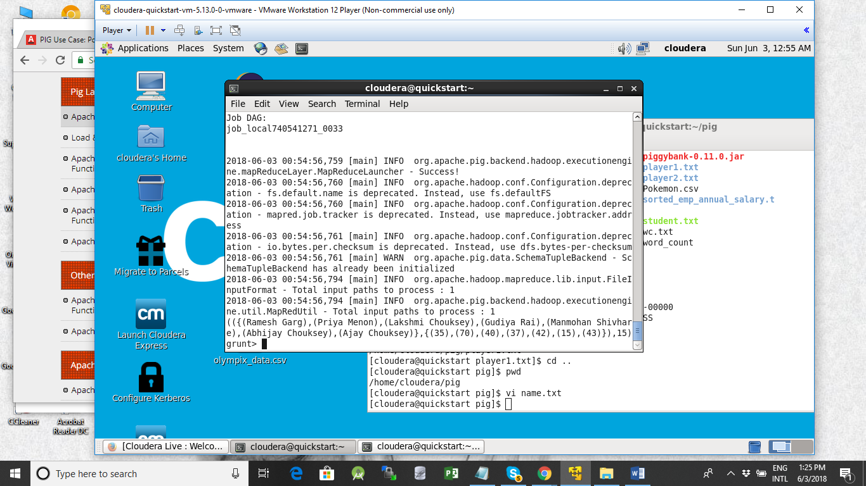

(({(Ramesh Garg),(Priya Menon),(Lakshmi Chouksey),(Gudiya Rai),(Manmohan Shivhare),(Abhijay Chouksey),(Ajay Chouksey)},{(35),(70),(40),(37),(42),(15),(43)}),15)
- Max

grunt> maxofAges= forEach Name_group Generate(Name.name, Name.age), MAX(Name.age);

(({(Ramesh Garg),(Priya Menon),(Lakshmi Chouksey),(Gudiya Rai),(Manmohan Shivhare),(Abhijay Chouksey),(Ajay Chouksey)},{(35),(70),(40),(37),(42),(15),(43)}),70)

- Limit

grunt> describe Name ;
Name: {name: chararray,age: int}
grunt> Name_limit= limit Name 3;
dump Name_limit ;
Output

(Ajay Chouksey,43)
(Abhijay Chouksey,15)
(Manmohan Shivhare,42)

- Store
Store Name_limit INTO ‘Lmtd_name.txt’ ;

grunt> Store Name_limit INTO 'a.txt' USING PigStorage(',');

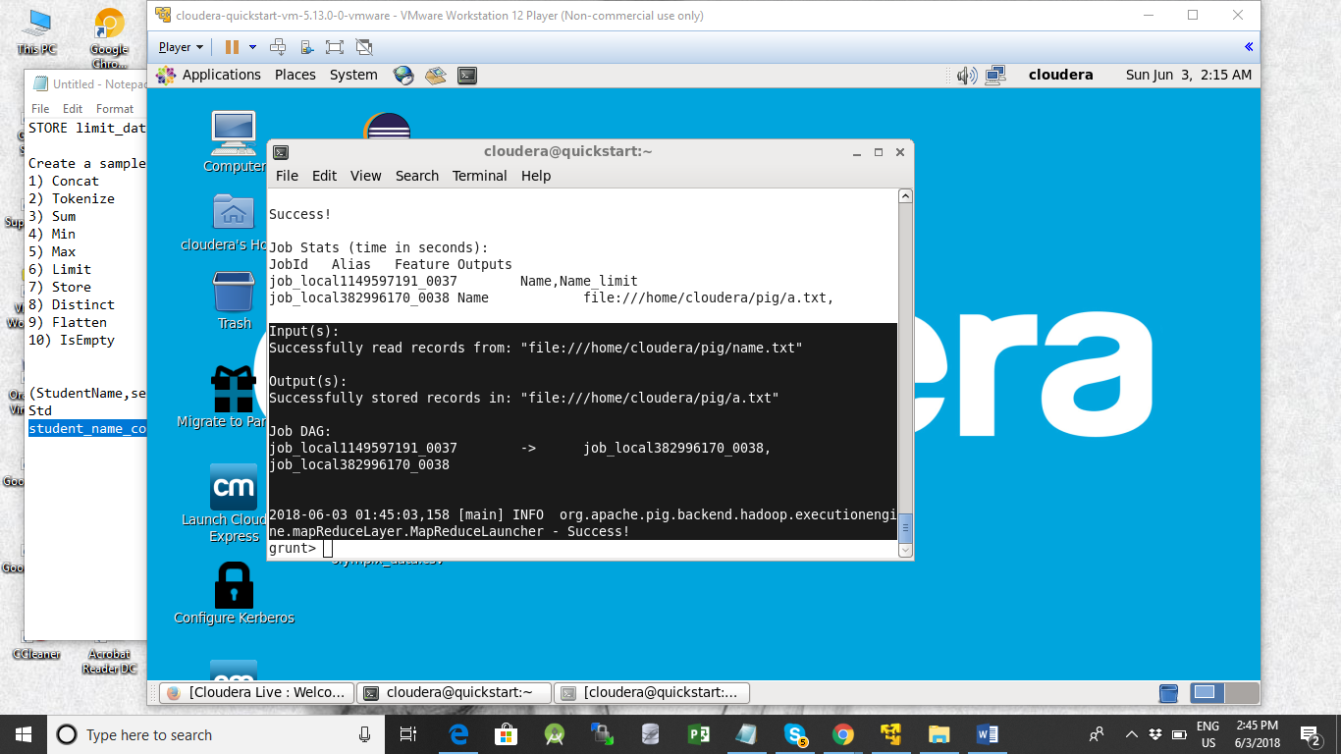

- Distinct

The DISTINCT operator is used to remove redundant (duplicate) tuples from a relation.

grunt> Name= LOAD 'name.txt' using PigStorage(',') AS (name:chararray, age:int);
grunt> dump Name ;

(Ajay Chouksey,43)
(Abhijay Chouksey,15)
(Manmohan Shivhare,42)
(Gudiya Rai,37)
(Lakshmi Chouksey,40)
(Priya Menon,70)
(Ramesh Garg,35)
(Ajay Chouksey,43)
(Lakshmi Chouksey,40)
(Abhijay,6)
(Rammohan,56)
(Ajay Chouksey,43)

grunt> distinct_Name= distinct Name ;
grunt> dump distinct_Name ;
Output :
(Abhijay,15)
(Rammohan,56)
(Gudiya Rai,37)
(Priya Menon,70)
(Ramesh Garg,35)
(Ajay Chouksey,43)
(Abhijay Chouksey,15)
(Lakshmi Chouksey,40)
(Manmohan Shivhare,42)

9)flatten
grunt> Name_flatten= FOREACH distinct_Name GENERATE FLATTEN(TOKENIZE(name));
grunt> dump Name_

Name_group Name_flatten Name_limit
grunt> dump Name_flatten ;

words = FOREACH lines GENERATE FLATTEN(TOKENIZE(line))

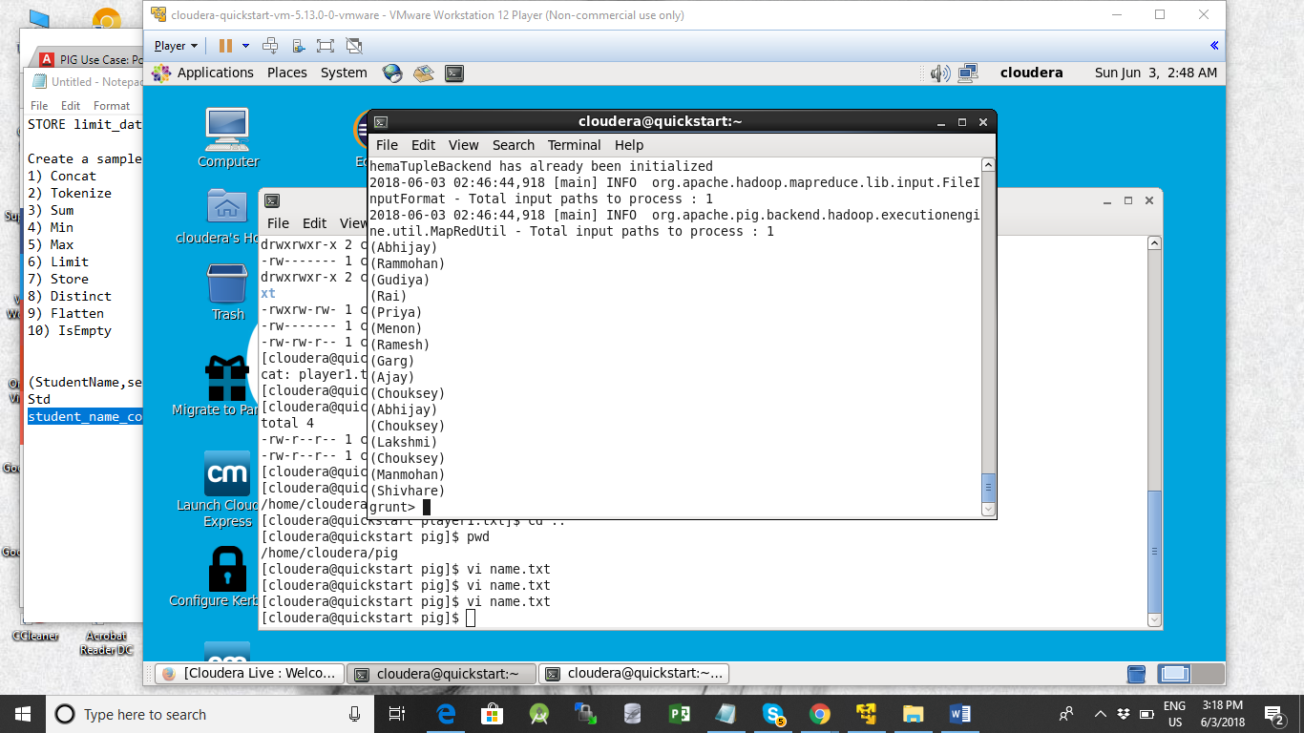

10)IsEmpty

The term "empty" refers to bags typically, and in particular you can use the isEmpty function to check if a bag is empty. You normally do this after a GROUP command:
grunt> sumofAges= forEach Name_group Generate(Name.name), SUM(Name.age);

c= filter Name_group by not isEmpty(group);

