**PIG Use Case: Pokemon Data Analysis**

<https://acadgild.com/blog/pig-use-case-pokemon-data-analysis>

Copying Data

[cloudera@quickstart pig]$ cd /home/cloudera/

[cloudera@quickstart ~]$ cd pig

[cloudera@quickstart pig]$ mv ../Desktop/Pokemon.csv .

grunt> Load_Data= LOAD 'Pokemon.csv' using PigStorage(',') ;

Load_Data = LOAD 'Pokemon.csv' using PigStorage(',') AS(Sno:int,Name:chararray,Type1:chararray,Type2:chararray,Total:int,HP:int,Attack:int,Defense:int,SpAtk:int,SpDef:int,Speed:int);

**Ques 1: Find the list of players that have been selected in the qualifying round (DEFENCE>55).**

selected_list = FILTER Load_Data BY Defense>55;

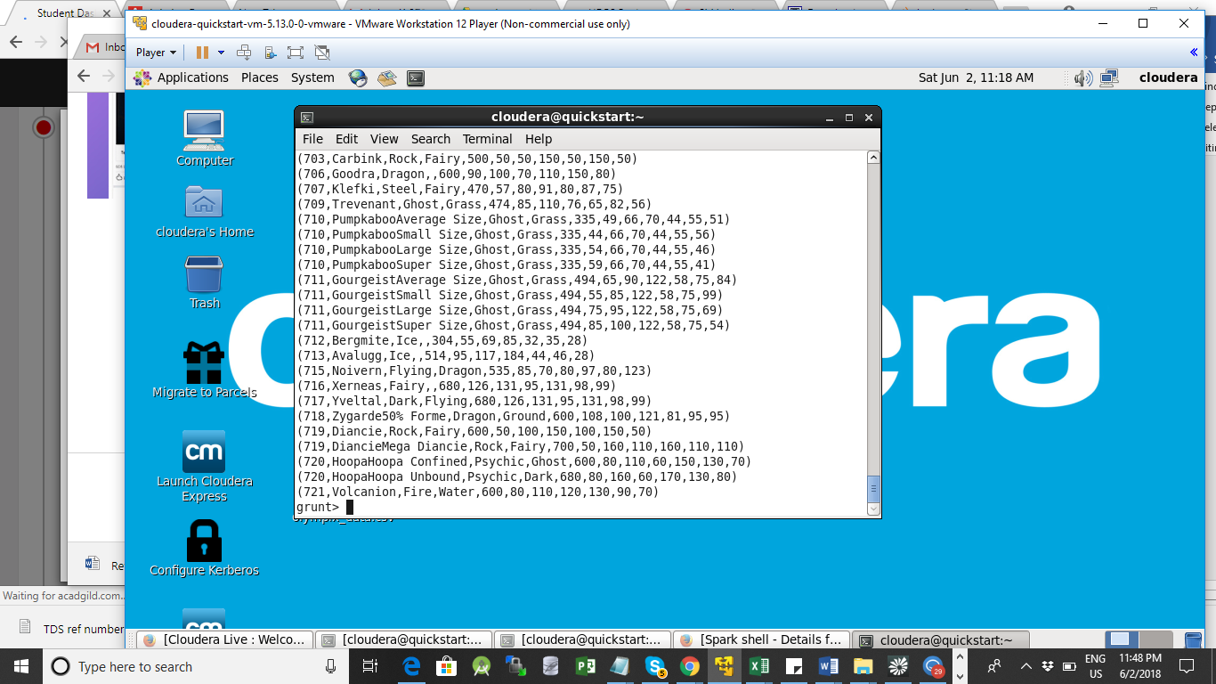

**Ques 2: State the number of players taking part in the competition after getting selected in the qualifying round.**

**Explanation**:  
*Command*  
gourp_selcted_list = Group selected_list All;

grunt> gourp_selcted_list = Group selected_list All;

grunt> count_selcted_list = foreach gourp_selcted_list GENERATE COUNT(selected_list);

dump count_selected_list;

ne.util.MapRedUtil - Total input paths to process : 1

**(544)**

**Ques 3: Using random() generate random numbers for each Pokémon on the selected list.**

**Explanation**:

grunt> random_include1 = foreach selected_list GENERATE RANDOM(),Name,Type1,Type2,Total,HP,Attack,Defense,SpAtk,SpDef,Speed;

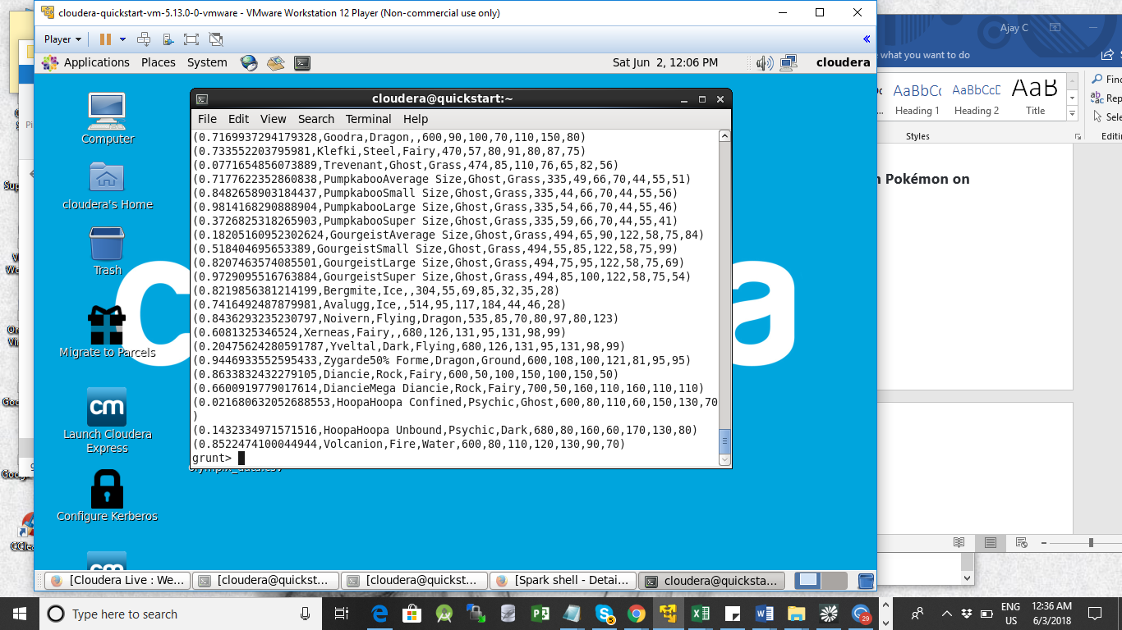

**Ques 4: Arrange the new list in a descending order according to a column randomly.**

**Explanation**: This will give us consequently a layer arranged to pick the random list which 1st player will choose.

random1_desending = ORDER random_include1 BY $0 DESC;

grunt> random1_desending = ORDER random_include1 BY $0 DESC;

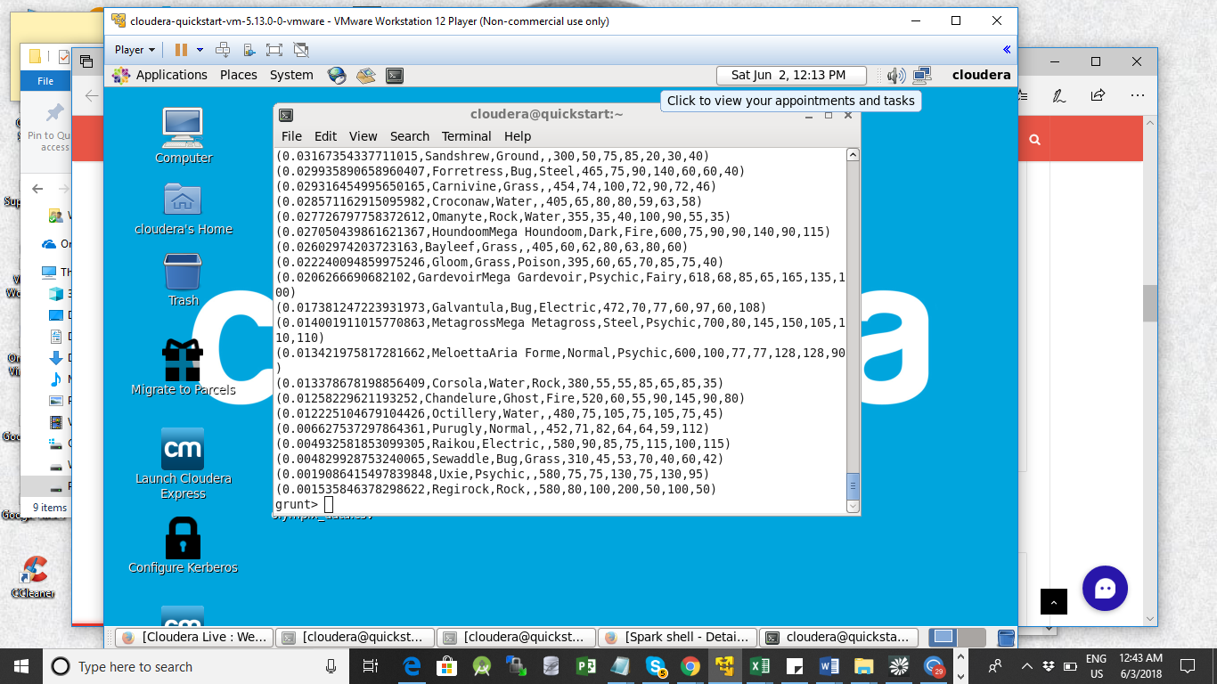

#### Ques 5: Now on a new relation again associate random numbers for each Pokémon and arrange in descending order according to column random.

**Explanation**: We will be repeating above two steps again to form the 2nd list.

grunt> random_include2 = foreach selected_list GENERATE RANDOM(),Name,Type1,Type2,Total,HP,Attack,Defense,SpAtk,SpDef,Speed;

grunt> random2_desending = ORDER random_include2 BY $0 DESC;

limit_data_random1_desending = LIMIT random1_desending 5 ;  
limit_data_random2_desending = LIMIT random2_desending 5 ;

grunt> limit_data_random1_desending = LIMIT random1_desending 5 ;

grunt> limit_data_random2_desending = LIMIT random2_desending 5 ;

dump limit_data_random1_desending;

**Output (Team 1)**

(0.99537203471002,Vanilluxe,Ice,,535,71,95,85,110,95,79)

(0.9902201348328671,Clawitzer,Water,,500,71,73,88,120,89,59)

(0.9883270270004234,Umbreon,Dark,,525,95,65,110,60,130,65)

(0.9865921172383645,Tirtouga,Water,Rock,355,54,78,103,53,45,22)

(0.9860283452341607,Avalugg,Ice,,514,95,117,184,44,46,28)

grunt> dump limit_data_random2_desending ;

**Output (Team 2)**

(0.9983620946620061,DiancieMega Diancie,Rock,Fairy,700,50,160,110,160,110,110)

(0.9922490177271954,Armaldo,Rock,Bug,495,75,125,100,70,80,45)

(0.97556306987006,Herdier,Normal,,370,65,80,65,35,65,60)

(0.9746247314268183,Eelektross,Electric,,515,85,115,80,105,80,50)

(0.9684402264337542,GroudonPrimal Groudon,Ground,Fire,770,100,180,160,150,90,90)

#### Ques: Store the data on a local drive to announce for the final match. By the name player1 and player2 (only show the NAME and HP).

**Explanation**:  
*Commands*  
filter_only_name1 = foreach limit_data_random1_desending Generate ($1,HP);

grunt> filter_only_name1 = foreach limit_data_random1_desending Generate ($1,HP);

grunt> filter_only_name2 = foreach limit_data_random2_desending Generate ($1,HP);

grunt> dump filter_only_name1 ;

((Tentacruel,80))

((Druddigon,77))

((Mesprit,80))

((Regice,80))

((KeldeoOrdinary Forme,91))

grunt> dump filter_only_name2 ;

((Slowking,95))

((Swadloon,55))

((GourgeistLarge Size,75))

((Gardevoir,68))

((Gligar,65))

In conclusion, let’s store this result in our local system  so we can use it as input to our next blog. Especially relevant where we will see UDF using PIG and calculations will be done through user-defined formulas.

STORE limit_data_random1_desending INTO ‘player1.txt’;

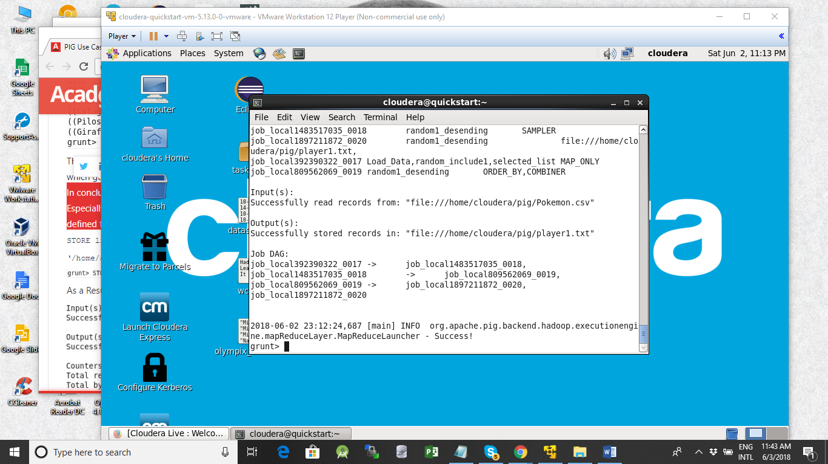

grunt> STORE limit_data_random1_desending INTO 'player2.txt' ;

