动态口令卡2000000000037477658

4518105120165265 贷记卡

6222001202199998001 灵通卡

6222081202899998007 理财金

9558801202107760812 灵通卡

6222001202199998001 E卡

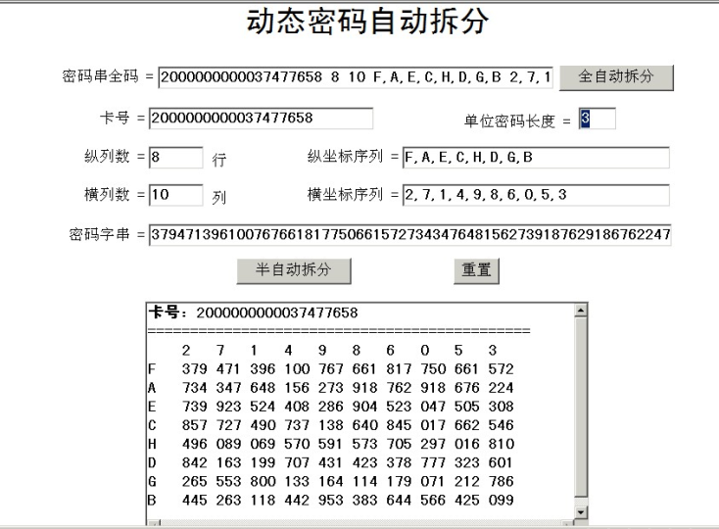

(Embedded image moved to file: pic01585.jpg)

国际卡4270208000351431 动态口令卡2000000000037477666

(Embedded image moved to file: pic14113.jpg)

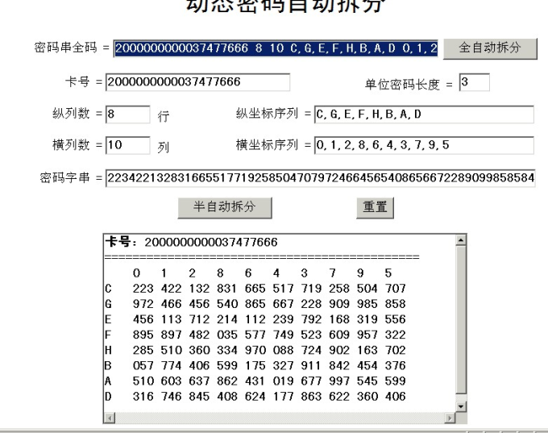

9558881202000120174

2000000000037477682

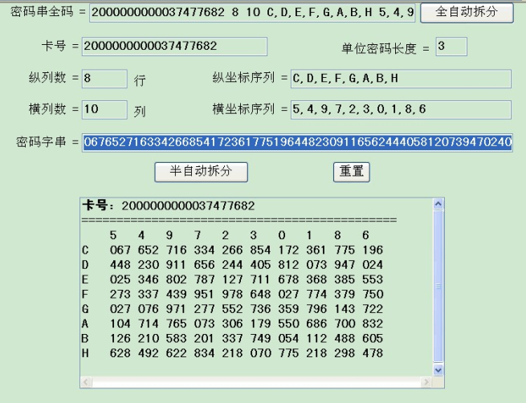

9558881202000091136

动态口令卡2000000000037477690

网银注册卡

45181051\*\*\*\*1860

95588012021\*\*\*\*2583

95588012021\*\*\*\*7327

95588812020\*\*\*\*1136

(Embedded image moved to file: pic27476.jpg)

