**OUTPUT SCREEN SHOTS WITH DESCRIPTION.**

**Home Page:**

Here user view the home page of cyber-attack detection web application.

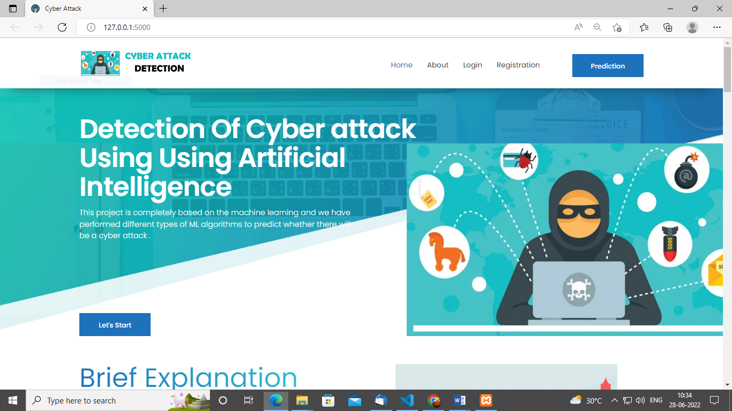

**Fig1**: Home Page

**ABOUT:**

Here we can read about our project.

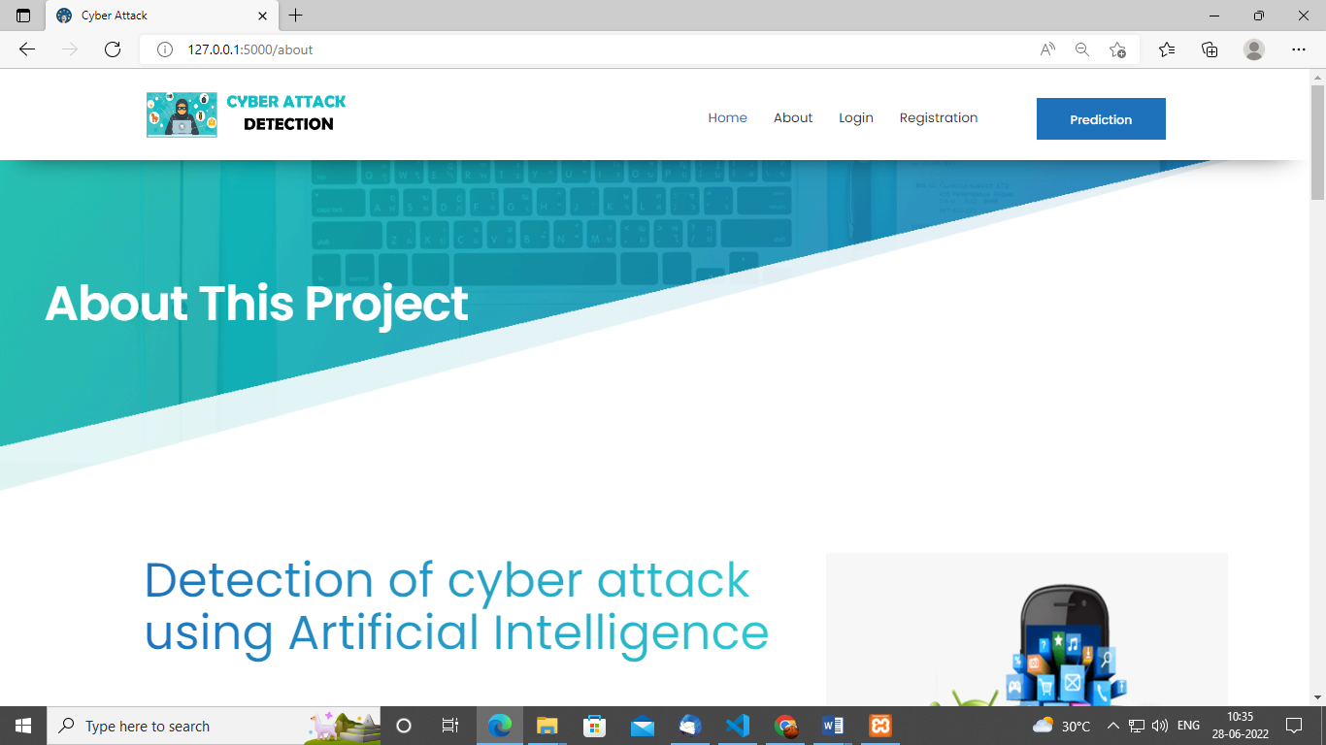

**Register:**

In the page, users need to register by entering his credentials.

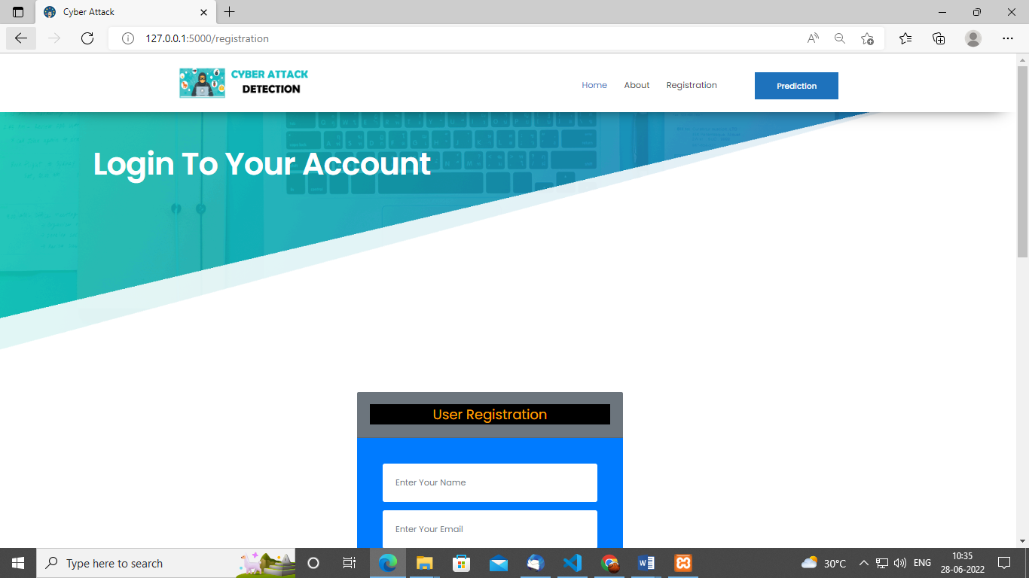

**Log in:**

In the page, users has to enter the credentials to enter into the cyber-attack prediction.

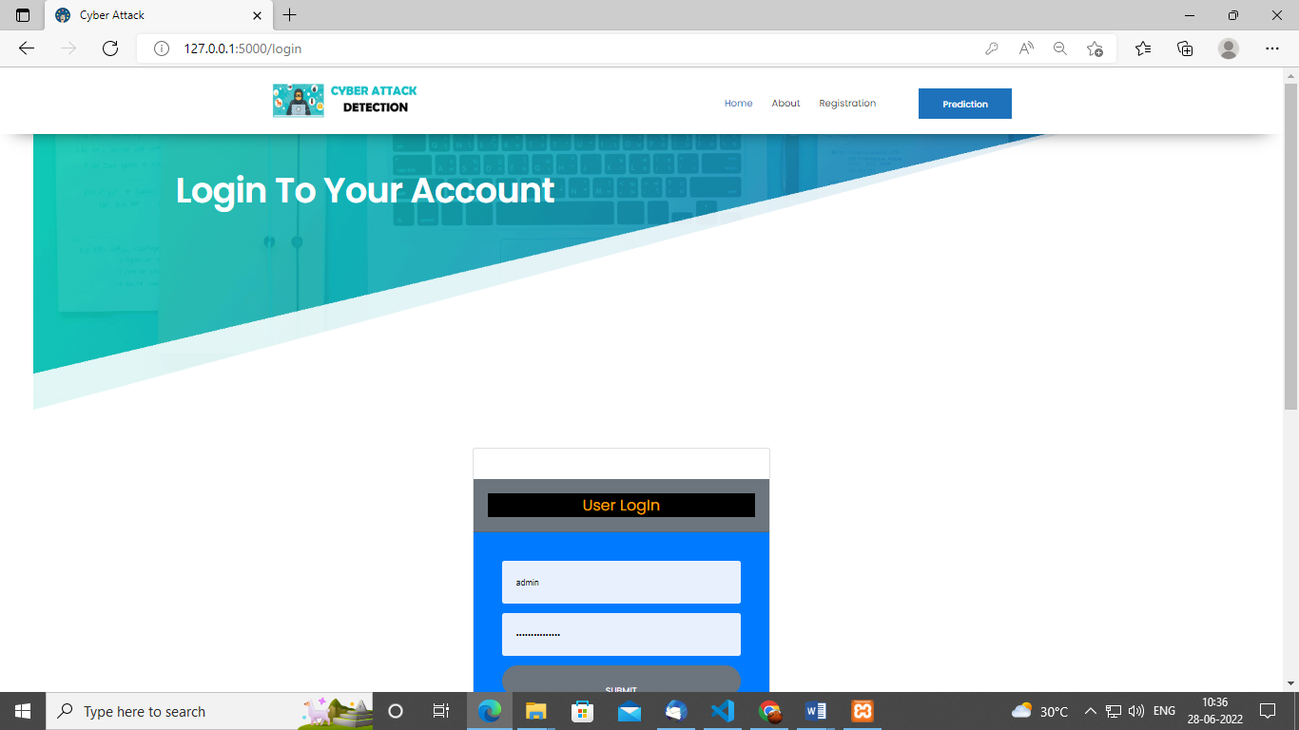

**Load:**

In the load page, users can load the cyber dataset.

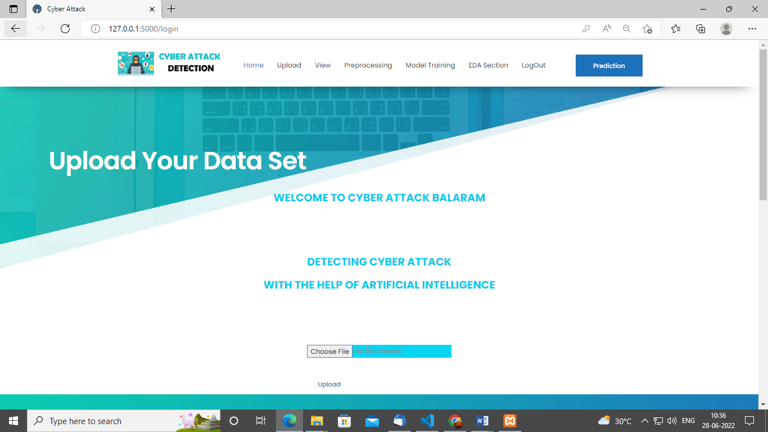

**View:**

Here we can see the uploaded data set.

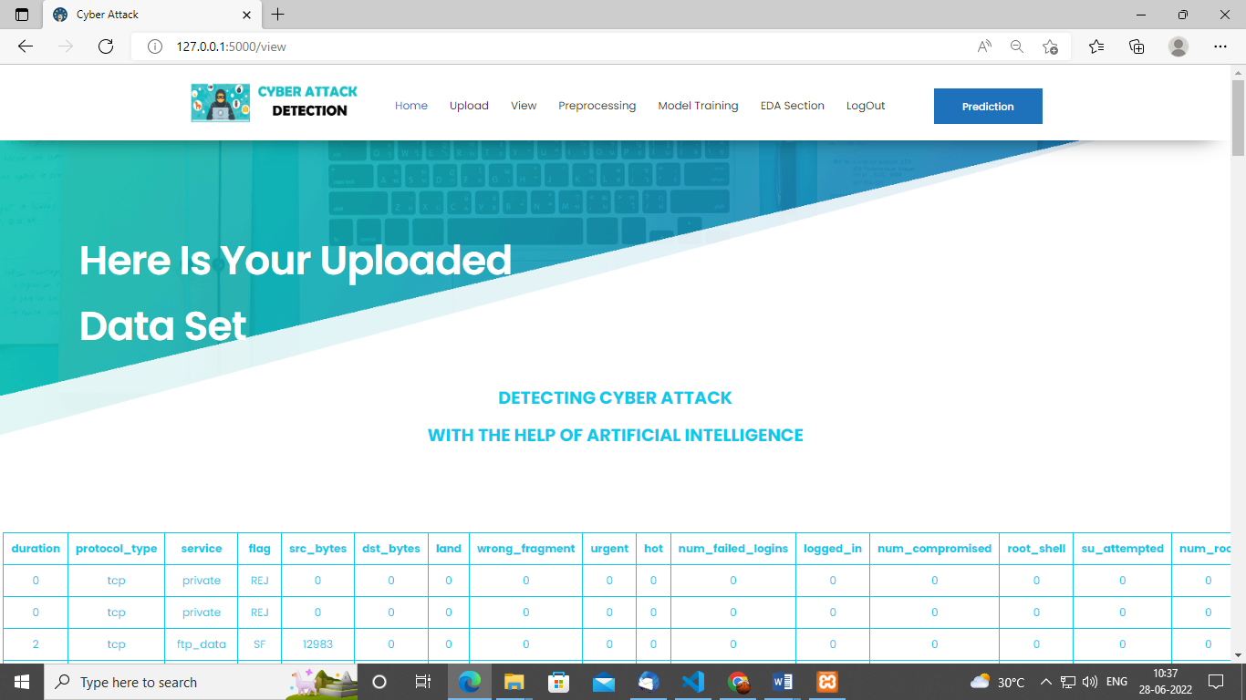

**Pre-process:**

Here we can pre-process and split our data into train and test.

`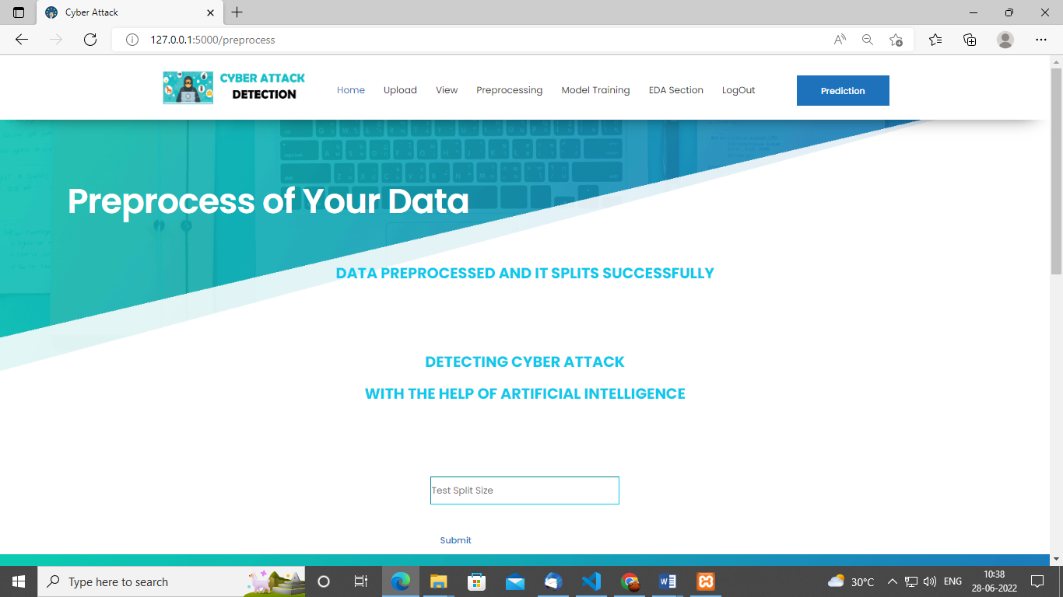

**Model:**

Here we train our data with different ML algorithms.

`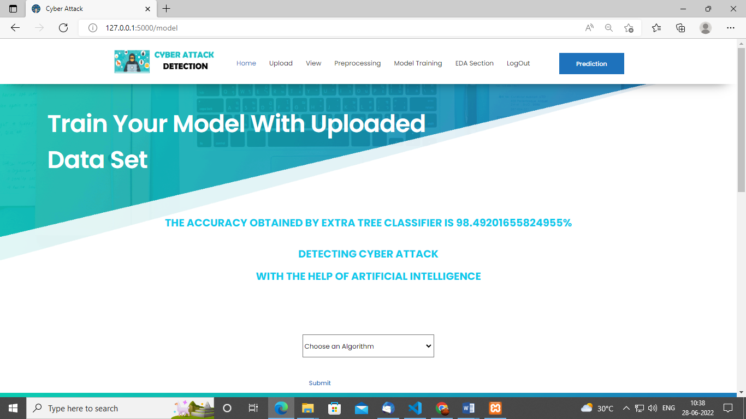

**Prediction:**

This page show the detection result of the cyber-attack detection data.

