**NETTUR TECHNICAL TRAINING FOUNDATION**

SUPPLY CHAIN MANAGAMENT TASK & ASSIGNMENT

***AMARJITH P***

***TTC0820035***

**CONTENTS**

|  |  |
| --- | --- |
| **Tasks** | **Page No** |
| Task 1 | **3-7** |
| Task 2 | **8-16** |
| Task 3 | **17-19** |
| Task 4 | **20-24** |
| Task 5 | **25-31** |

**Task 1:**

A: **What is meant by a supply chain?**

A supply chain is a system of organizations, people, activities, information, and resources involved in moving a product or service from supplier to customer. It includes the entire process of creating and delivering a product or service, from sourcing raw materials to delivering the finished product to the customer. The supply chain also includes the distribution channels and logistics systems that are used to move the product from one place to another.

There are many different components that make up a supply chain, including suppliers, manufacturers, distributors, retailers, and logistics providers. Each of these players has a role to play in ensuring that the product or service gets to the customer in a timely and cost-effective manner. The goal of the supply chain is to provide value to the customer by delivering the right product or service at the right time and place, while minimizing costs and maximizing efficiency.

**B: Name the functions that may be contained within a supply chain**

There are many different functions that may be contained within a supply chain. Some of the most common functions include:

* **Sourcing**: This involves identifying and selecting suppliers for raw materials, components, and other inputs that are needed to create the product or service.
* **Production**: This includes the activities required to manufacture or assemble the product, such as machining, assembly, and testing.
* Diagram

  Description automatically generated**Inventory management**: This involves deciding how much inventory to hold, where to store it, and how to move it through the supply chain.
* **Distribution:** This involves moving the product from the manufacturer to the customer, using various transportation and logistics systems.
* **Customer service**: This includes activities such as order processing, returns handling, and technical support.
* **Diagram

  Description automatically generatedProcurement:** This involves the process of purchasing materials, components, and other inputs that are needed to create the product or service.
* **Quality control**: This involves ensuring that the product or service meets the required quality standards and customer expectations.
* **Risk management**: This involves identifying and mitigating potential risks that could disrupt the supply chain, such as natural disasters, supplier issues, or transportation delays.
* **Logistics**: This involves coordinating the movement of materials and products through the supply chain, including transportation, warehousing, and distribution.

* **Information technology**: This involves the use of computer systems and software to manage and optimize the supply chain, including order processing, inventory management, and transportation scheduling.

**C: Describe supply chains that may be appropriate for the different types of goods within the case study:**

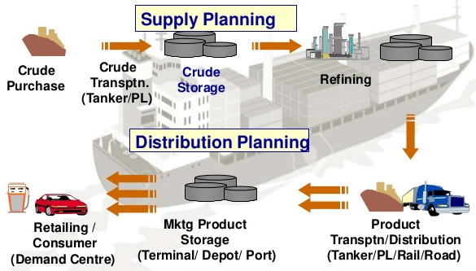An example is shown below of a simple supply chain process for oil from source to refinery:

**Task 2:**

**A: What do you think the advantages and disadvantages would be for not having a wholesaler involved in the supply chain process and instead, the company gets the ingredients directly from the supplier?**

There are potential advantages and disadvantages to not having a wholesaler involved in the supply chain process and instead getting ingredients directly from the supplier. Some potential advantages of this approach include:

* **Lower costs**: By eliminating the middleman, the company may be able to negotiate lower prices for the ingredients directly with the supplier.
* **Better quality:** By dealing directly with the supplier, the company may be able to ensure that the ingredients are of a higher quality and meet its specific requirements.
* **Stronger relationships**: By working directly with the supplier, the company may be able to build a stronger, more collaborative relationship, which could lead to more consistent and reliable sourcing in the future.

However, there are also potential disadvantages to this approach:

* **Limited bargaining power**: Without the wholesaler as a buffer, the company may have less bargaining power when negotiating prices with the supplier.
* **Lack of expertise**: Wholesalers often have a deep understanding of the market and can provide valuable insights and recommendations to the company. Without a wholesaler, the company may lack access to this expertise.
* **Increased risk**: By relying on a single supplier, the company may be more vulnerable to supply chain disruptions or quality issues.

Ultimately, whether eliminating the wholesaler and sourcing ingredients directly from the supplier is the right decision will depend on the specific needs and circumstances of the company. It may be worth considering a range of options and carefully weighing the potential advantages and disadvantages of each before deciding.

**B: Based on what you have read in the case study, read the options below and discuss in the space provided which option you feel would be the best for cost saving and efficiency and why? Discuss the advantages and disadvantages associated with your chosen option and briefly outline why you have not chosen the other two:**

**Option C: Do nothing. Continue to use the wholesaler and supplier, hope something improves soon.**

Wholesaler is an important chain of the channel of distribution because it is an agent between a manufacturer and retailers. A wholesaler purchases the goods from manufacturer in bulk quantity and re-sells it to retailers in small quantity. ... Wholesalers play an important part in the distribution of goods.

**Benefits of working with wholesaler to retailers**

There are several benefits to working with a wholesaler for retailers:

* **Cost** **savings**: Wholesalers often offer bulk purchasing discounts to retailers, which can help to lower the cost of goods and improve the retailer's profit margin.
* **Improved** **cash** **flow**: By working with a wholesaler, retailers can often take advantage of longer payment terms, which can help to improve cash flow and reduce the need for upfront capital.
* **Enhanced** **product** **selection**: Wholesalers often have a wider range of products available, which can give retailers access to a larger selection of goods to offer to their customers.
* **Reduced** **risk**: By working with a wholesaler, retailers can spread their risk across a larger number of products and suppliers, which can help to mitigate the impact of any issues that may arise with a particular product or supplier.
* **Improved** **logistics**: Wholesalers often have established logistics systems in place, which can help to improve the efficiency and reliability of the supply chain.
* **Expertise** **and** **support**: Wholesalers often have a deep understanding of the market and can provide valuable insights and recommendations to retailers, as well as support with things like product sourcing, order processing, and returns handling.

**Disadvantages of working with wholesaler to retailers**

There are also several potential disadvantages to working with a wholesaler for retailers:

* **Reduced bargaining power**: By working with a wholesaler, retailers may have less bargaining power when negotiating prices for goods, as the wholesaler may have more leverage due to their larger scale and relationships with suppliers.
* **Limited customization**: Retailers may have less control over the products and brands that are offered through the wholesaler, which can limit the ability to tailor the product selection to the needs and preferences of their customers.
* **Reduced** **margins**: Retailers may face pressure to maintain low prices in order to remain competitive, which can result in lower profit margins when working with a wholesaler.
* **Limited** **control** **over** **the** **supply** **chain**: By relying on a wholesaler, retailers may have less control over the supply chain and may be at the mercy of the wholesaler's decisions and practices.
* **Increased** **risk**: By working with a single wholesaler, retailers may be more vulnerable to supply chain disruptions or quality issues.
* **Complex** **relationships**: Managing relationships with wholesalers can be complex, and retailers may need to invest time and resources in order to build and maintain these relationships

**Reasons for not choosing the other two options:**

* **Option A:**

Option A is not the choice because changing the supplier which is another 120 miles farther away would only increase the expenses and probability of problems such as transportation, accidents, breakdown etc

* **Option B:**

Option B is again not the choice because changing wholesaler as well as the supplier and getting the product direct from the new supplier involves a lot of risk such as deal terms, experience in handling all the attributes, ownerships etc.

* **Option C:**

Do nothing. Continue to use the wholesaler and supplier, hope something improves soon.

**C: Evaluate the features of such chains which make them mutually beneficial to supplier and customer.**

Supply chain management refers to the process of coordinating and optimizing the various activities and resources involved in producing and distributing goods or services. A supply chain typically includes a range of activities, such as sourcing raw materials, manufacturing, transportation, storage, and distribution.

There are a few key features of supply chains that make them mutually beneficial to both suppliers and customers:

* **Efficiency**: Supply chains that are well-managed and optimized can help to reduce costs and improve efficiency by reducing waste and inefficiencies in the production and distribution process. This can benefit both suppliers and customers by reducing costs and increasing profits.
* **Visibility**: Supply chain management systems can provide real-time visibility into the flow of goods and materials, allowing both suppliers and customers to track orders and shipments, identify bottlenecks, and make informed decisions.
* **Collaboration**: Effective supply chain management requires close collaboration between suppliers, manufacturers, and customers. By working together, all parties can identify and address any issues or challenges that arise in a timely manner, leading to improved customer satisfaction and loyalty.
* **Responsiveness**: Supply chains that are agile and able to respond quickly to changes in demand or disruptions can help to ensure that customers receive the products or services they need in a timely manner. This can improve customer satisfaction and loyalty.

Overall, supply chain management can be a mutually beneficial relationship between suppliers and customers, as it can help to optimize the production and distribution of goods and services, improve efficiency, and increase customer satisfaction.

**7 Steps to Improve Supplier Performance & Quality Management :**

Here are seven steps that companies can take to improve supplier performance and quality management:

1. Define supplier performance expectations: Clearly communicate and document the performance expectations and requirements that suppliers need to meet. This can include things like delivery schedules, quality standards, and communication expectations.
2. Measure supplier performance: Use key performance indicators (KPIs) to track and measure supplier performance. This can help to identify areas for improvement and allow you to take corrective action if necessary.
3. Provide feedback: Regularly communicate with suppliers about their performance, both positive and negative. This can help to identify issues and opportunities for improvement, and build stronger relationships with your suppliers.
4. Establish a supplier development program: Consider implementing a supplier development program to help suppliers improve their performance and meet your requirements. This could include things like training, process improvement initiatives, and technical assistance.
5. Conduct supplier audits: Regularly audit your suppliers to assess their performance and identify areas for improvement. This can include both on-site audits and desk audits.
6. Encourage continuous improvement: Encourage a culture of continuous improvement among your suppliers. This can include implementing a suggestion system, encouraging the use of lean manufacturing principles, and promoting the adoption of new technologies.
7. Foster a culture of collaboration: Foster a culture of collaboration between your company and your suppliers. This can help to build stronger relationships, improve communication, and drive continuous improvement.

**Task 3:**

**A: Data Suggest ways in which improved data exchange between Toasty and its wholesaler might improve supply chain performance.**

**The Main Barrier Toasty and the Wholesaler faced are:**

Improved data exchange between Toasty and its wholesaler can potentially improve supply chain performance in several ways:

* **Improved** **forecasting** **and** **demand** **planning**: By sharing data on sales and customer demand, Toasty and its wholesaler can better forecast future demand and plan their inventory levels accordingly. This can help reduce excess inventory and stock-outs, which can improve efficiency and reduce costs.
* **Enhanced** **visibility**: By sharing data on inventory levels, production schedules, and shipping status, Toasty and its wholesaler can have a better understanding of the status of orders and the flow of goods through the supply chain. This can help identify and resolve bottlenecks or issues more quickly.
* **Improved** **communication** **and** **coordination**: By sharing data on orders, deliveries, and changes to production schedules, Toasty and its wholesaler can improve communication and coordination, leading to a more seamless and efficient supply chain.
* **Enhanced** **collaboration**: Improved data exchange can facilitate better collaboration between Toasty and its wholesaler, enabling them to work together more effectively to meet customer needs and optimize the supply chain
* **Increased** **efficiency**: By using data analytics to identify patterns and trends in the data shared by Toasty and its wholesaler, it may be possible to identify opportunities to streamline processes and improve efficiency in the supply chain.

**B: Explain the impact of effective and efficient data exchange between customers and suppliers on supply chain productivity**

|  |
| --- |
| **Customer**  • Physical damage from customer side  • In case of phone kept under the table  • Suddenly fall from your hand  • From customer side the product was deliver on time or before time they give good feedback  • Once the product was delivered without any issue is good  • If they got any issue and customer returns the product, then file a complaint about the issue. |
| **Supplier**  • The supplier supplies the low-quality display  • First, we want to identify the suppliers like milk, sugar, coffee powder etc.  • Then we also plan the design of the coffee shop area, near to the supplier to get the product easily.  • From the packer side the customer ordered was packed passed on the need.  • Once the product was check and qualified the product then the package was ready to deliver to the customer.  • The packer was delayed the product to pack.  • The supply chain get lag to the process of deliver. |

**Task 4:**

**A: Look at supply chain diagram below and on it circle all the areas in the chain that might benefit from the application of modern technology, In terms of improved performance, quality, customer service or some other factor.**



Wheat is harvested and

milled at flour mill, then

transported to

wholesalers (£2500 per

month)



Wholesalers makes up

new amount to order for

Toasty Bakery (£500 per

month)



Transport from

Wholesalers to bakery

(

£800 per month

)



Bakery makes up dough

for bulk orders (£1800

per month)



Dough gets baked in the

oven (£600 per month)



Bread is cooled and

packaged (£1100 per

month)



Bread is transported in

boxes to retailers

£1000 per month

)

(



Bread is displayed on

shelves (£400 per

month)

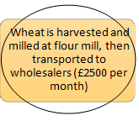**B: Briefly describe how the application of technology could influence the costs of the various steps you have just circled.**

* For harvesting the wheat, the manpower is required more, instead of having the manpower we can use the modern technology.
* Wheat harvesting machine can be used the cost will be approximately to £3,863.
* 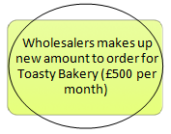Instead of spending £2500 per month there will be a one-time investment for the machine which harvests wheat.
* According to the case study given for the toasty bakery the wholesaler didn’t have the paperwork for taking orders from retailers.
* So, the orders should be taken digitally in a computer excel sheet.
* Then there will be no confusion with the products for whom it should be delivered.
* The computer costs around £561.



**C: Summarise ways in which modern technologies have impacted on supply chain productivity.**

Modern technologies have had a significant impact on supply chain productivity in several ways. Some of the keyways in which modern technologies have impacted supply chain productivity are:

* **Automation**: Modern technologies such as robotics and artificial intelligence have made it possible to automate many tasks in the supply chain, leading to increased efficiency and productivity.
* **Improved** **communication** **and** **collaboration**: Technologies such as cloud computing and collaboration software have made it easier for businesses to communicate and collaborate with their partners in the supply chain, leading to more efficient and effective decision-making and coordination.
* **Enhanced** **tracking** **and** **visibility**: Technologies such as GPS tracking and real-time monitoring systems have made it easier to track the movement of goods and materials through the supply chain, leading to more efficient and effective decision-making.
* **Predictive** **analytics**: Modern technologies such as machine learning and data analytics have made it possible to predict future demand and supply chain disruptions, allowing businesses to proactively plan and respond to potential issues.
* **E-commerce**: The widespread adoption of e-commerce platforms has revolutionized the way goods are bought and sold, making it easier for businesses to reach customers and streamlining the supply chain.

Overall, modern technologies have had a significant impact on supply chain productivity by enabling businesses to automate tasks, improve communication and collaboration, enhance tracking and visibility, and use predictive analytics to plan for the future

**Task5A:**

**You must create a project plan to improve the productivity of a supply chain, it must include staff training to improve performance with a minimum of one function of the supply chain where improved training will have a positive impact. You must explain the tools and techniques that you would adopt within the supply chain improvement project.**

**The project must include appropriate success criteria so improvements can be identified and measured and a tracking process to measure success. Please refer to the supply chain diagram and the costing where necessary**

**1. Inventory management**

Let’s say Toasty have only a two-hour worth of sitting stock in the bakery shop, with an aim to keep the storage costs low. But what will happen when the raw materials used for making bread are delivered an hour late? It could lead the tightly coupled production line to come to a standstill. Focusing solely on limiting stock is a myopic strategy, and in terms of the bottom line, the result is likely to be incurring more costs than the revenue it brings in. Thus Toasty have to strike the correct balance between minimizing the stock and the stomach to meet the customer demands. Threats to stock shortage must be contemplated well in advance before it actually strikes. Remember, we can say “no” to our customer only if the crisis is really big.

**2. Improve your distribution network**

The distribution network of the bakery is the operational fulcrum around which the supply chain management system is built. Distribution affects everything, including sales strategy and delivery tracking. Improving the distribution network should be the main aim, which Toasty can do with a cluster view or a holistic approach. In the latter, he have to review the essential parts of the distribution network and figure out how they work in tandem. For instance, look at the purchasing software and to see how it works with the delivery system. Does it communicate well with the warehouse manager and production foreman? If it’s not as efficient as you like it to be, identify the areas where the changes should be incorporated. On the other hand, the cluster view groups graphs, charts, and other details together and helps to keep watch on the process for a specific function.

**3. Devise a distribution strategy**

A good distribution strategy is integral to the supplier management framework. It reduces product decay while improving the customer service. Devising a good blueprint for distributing your products and services will help in achieving profitable growth, particularly when corporate managers strategically think about cost revenue and asset utilization.

While making the distribution strategy, keep a close watch on issues like production facilities, cross-docks, warehouses, and above all, customers, along with the number, location and the network of suppliers.

**4. Segregating your corporate and supply chain strategies**

Toasty must fetch leaders from all sections of his business to a common platform for defining the supply chain management system which would work for him to fetch possible feedbacks such as, what the customers demand, what sets his bakery apart from his peers. Toasty’s must identify the customers who justify the best service price, which can be served better using a greater standardized approach. He must come up with innovative products & services that cater to the demands of all customers, keeping the costs under control.

**5. Supplier cash control**

There are several elements to consider, including how to avoid buying unnecessary stock, avoid costs for correction in both orders and supplies and optimize the payment behaviour of suppliers. Partnerships with vendors usually contain many automatic processes that should be analysed and optimized carefully.

**6. Controlling operational expenses**

There could be reasons for incorrect supplies, but instead of just correcting the relevant order, it’s imperative to search for the particular point in the process where the discrepancy arose to prevent the recurrence of the same mistake.

**7. Creating a modern supply chain organization**

Managing the supply chain in discrete tiers is a dated process. Sophisticated data analyses have now enabled organizations to manage supply chains end-to-end. Toasty must ensure that the supply-chain system merges operational excellence with a strong analytical capability and data-driven, multifunctional decision making.

**8. Customer cash control**

While improving the profitability of customer relationships and orders, it’s important to measure order processing and to optimize the settlement of payments. Toasty have to constantly measure whether the right product is delivered to the right place in the right quantity as desired by the client. Supply processes can be optimized to avoid expensive errors. Settling payments with clients is equally important for saving costs. Reducing the time between orders and payment, resolving late payments, making a missing payment visible and invoicing them can greatly reduce costs.

**9. Set performance benchmarks for your company**

Giving incentives would deliver the biggest value for a company, and at the same time, secure against the biggest risks. The key performance indicators (KPIs) strongly depend on the demands of the business and the product or service, and the particular market segment. These include the production cost for value players, stable supply of critical products and staple items, agility to deal with fluctuating demand in volatile markets, and the perfect launch of a new product is essential.

**In order to plan and carry out a supply chain improvement project, we must first know where the problems lie and why they occur within the chain.**

It is very important to analyse every part of the supply chain. Therefore we, must first map the entire supply chain. Then we gather information about how the cost is increasing as the product moves from one stage to another. We can visualise the complete operation in terms of time, cost, and value addition. We can now budget the cost at each stage. This will help us in locating the problems and cutting down the cost and time.

We should analyse which process is inducing inefficiency in the supply chain. Then solve that problem of inefficiency to remain competitive in the market. DMAIC is one such tool used to identify and solve supply chain problems.

**DMAIC**

DMAIC is an acronym that stands for Define, Measure, Analyse, Improve, and Control. It is a problem-solving methodology commonly used in Six Sigma, a process improvement methodology designed to help organizations improve their business processes and eliminate defects.

The DMAIC process is designed to be a systematic and logical approach to problem-solving that follows the following five steps:

* **Define**: Identify the problem, define the objectives, and scope out the project.
* **Measure**: Collect and analyse data to understand the current state of the process.
* **Analyse**: Identify the root causes of the problem and generate potential solutions.
* **Improve**: Implement and test the selected solution(s) to determine their effectiveness.
* **Control**: Establish processes to maintain the improvements and monitor the results over time.

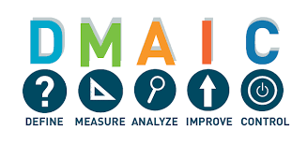The DMAIC process is often used in manufacturing and service industries to improve processes, reduce costs, and increase customer satisfaction. It is a highly structured and data-driven approach that relies on statistical analysis and the use of statistical tools to identify and eliminate the root causes of problems.

|  |
| --- |
| **Supply Chain, Improvement project**    **Task 5B.**  You must complete the project charter below; you must clearly outline the aims and how you will identify if there has been an improvement. Where you are unable to fill in a box in the project charter, you must suggest tools and techniques you could use to obtain the information you need. |

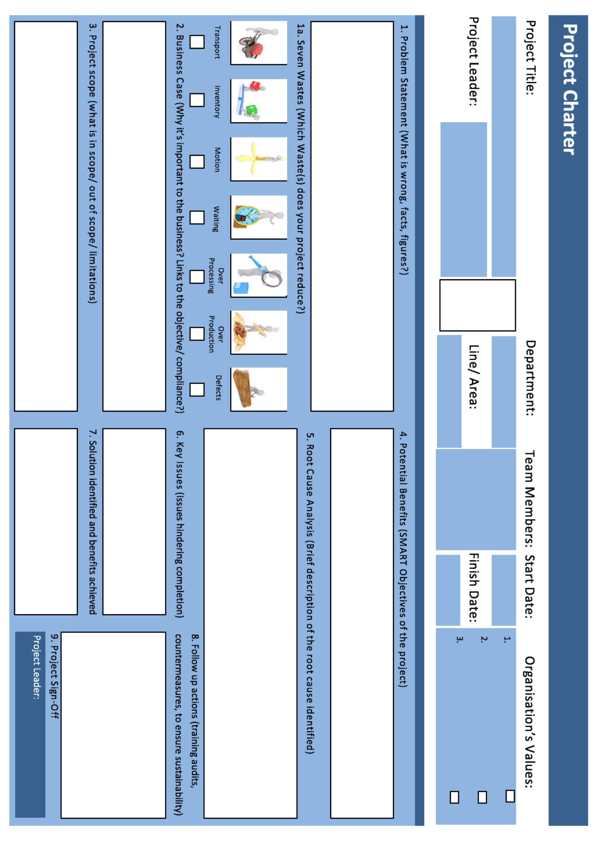

19/12/22

**Production**

AMARJITH P

**Improvement in supply chain**



1. Quality
2. Continual Improvement
3. Monitoring production
4. Result

AMARJITH P

Applying the inventory in ERP to do the work easily.

The scope of the project is to increase productivity, to give proper training for employees and gain the profit.

Maximum resources utilization, Proper instruction to be given for employees

Low in productivity

Delay in delivery

Trained employee can increase the productivity, quick delivery for customer satisfaction.

1. Wrong product delivered, 2.Late delivery, 3.Improper communication between supplier & Manufacturer.

KAIZEN, LEAN SIX SIGMA follow up to achieve the target.

Communication issue

Training provider is not sufficient

Due to late delivery

25/12/22

**Supply chain**

`

19/12/22

**Supply chain**

`

**Production**

AMARJITH P

**Improvement in supply chain**