**Three sample workout using array**

Sum of array elements!

**1.Takes an array of integers as input and returns the sum of its elements.**

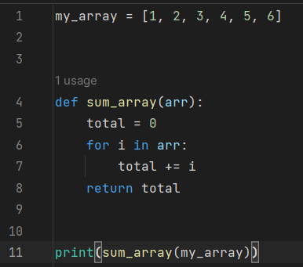

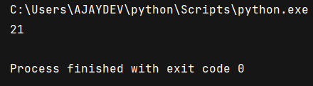

**2.Program that takes array of integer as input and returns the largest element.**

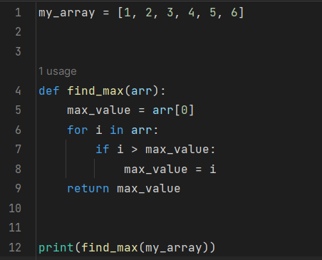

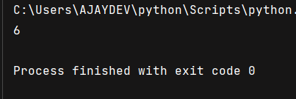

**3. program takes an array of integers as input and returns its average**

