Computer Fundamentals 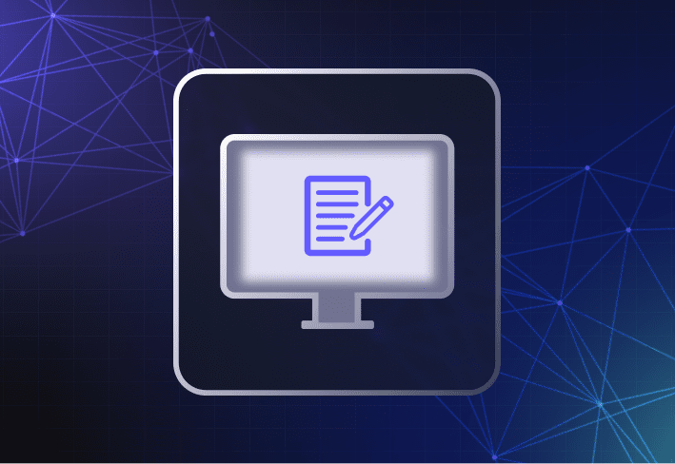

*Computers have become a necessity today. No matter what field, knowledge of computer fundamentals is very important. This article covers all the topics that you might need to know about computers.  
  
So without any delay let’s dive into computer fundamentals. Beginning from the very basic and then slowly moving forward.*

**Basics of Computers**

*Some examples of applications in which it is used:-*

[*Business*](https://www.tutorialspoint.com/computer_fundamentals/computer_applications.htm) *-* A computer has high speed of calculation, diligence, accuracy, reliability, or versatility which has made it an integrated part in all business organizations.

Computer is used in business organizations for −

* Payroll calculations
* Budgeting
* Sales analysis
* Financial forecasting
* Managing employee database
* Maintenance of stocks, etc.

[*Banking*](https://www.tutorialspoint.com/computer_fundamentals/computer_applications.htm) *-* Today, banking is almost totally dependent on computers.

Banks provide the following facilities −

* Online accounting facility, which includes checking current balance, making deposits and overdrafts, checking interest charges, shares, and trustee records.
* ATM machines which are completely automated are making it even easier for customers to deal with banks.

**Applications**