**NATIONAL INSTITUTE OF TECHNOLOGY KARNATAKA, SURATHKAL**

**A Summer Project Report**

**On**

**Attendance Management System**

**Submitted in partial fulfillment of the requirements for the degree of**

**MASTER OF TECHNOLOGY in**

**SYSTEMS ANALYSIS & COMPUTER APPLICATIONS ( SACA )**

**By**

**EERALLA AJAYKUMAR (09SY02F)**



**DEPARTMENT OF MACS**

**NATIONAL INSTITUTE OF TECHNOLOGY KARNATAKA**

**SURATHKAL, MANGALORE - 575025**

**June-July, 2010**

**NATIONAL INSTITUTE OF TECHNOLOGY KARNATAKA, SURATHKAL**

Contents

1. Introduction 1
2. Disadvantages of current working System 2
3. Characteristics of the proposed system 3
4. User Tables 4
5. Data Flow Diagrams 5
6. Screen Shots 8
7. Conclusion 12
8. References 13

**Introduction:**

Attendance Management System is a software developed for daily student attendance in institutes**.** It facilitates to access the attendance information of a particular student in a particular class. The information issorted by the operators, which will be provided by the clerk for a particular Department. This system will also help in evaluating stipend eligibility criteria of a student.

**Purpose:**

The purpose of developing attendance management system is to computerized the tradition way of taking attendance. Another purpose for developing this software is to generate the report automatically at the end of the month or in the between of the month.

**Scope:**

The scope of the project is the system on which the software is installed, i.e. the project is developed as a desktop application, and it will work for a particular institute.

**Technology Used:**

Language: C#.NET

Backend: MySql

**System Requirement:**

Minimum RAM:-256 MB

Hard Disk:-40 GB

Processor:-Intel core2Duo

Operating System:-Windows Vista

**Overview:**

Attendance Management System basically has two main modules for proper functioning.

* First module is admin which has right for creating space for new batch. Any entry of new user, Updation in record if necessary, and sending notice. Attendance can be taken on the basis of Class.
* Second module is handled by the user which can be a user or an operator. User

has a right of making daily attendance, generating report.

**Economically Feasibility:**

The system being developed is economic with respect to University point of view. It is cost effective in the sense that has eliminated the paper work completely.

The system is also time effective because the calculations are automated which are made at the end of the month or as per the user requirement.The result obtained contains minimum errors and are highly accurate as the data is required.

**Technical feasibility:**

The technical requirement for the system is economic and it does not use any other additional Hardware and software.

**Behavioral Feasibility:**

The system working is quite easy to use and learn due to its simple but attractive interface. User requires no special training for operating the system.

**Working Of Present System:**

In the present system all work is done on paper. The whole attendance is stored in register and at the and of the month the reports are generated. We are not interested in generating report in the middle of the month or as per the requirement because it takes more time in calculation.

**Disadvantages of current working System:**

• **Not User Friendly :** The existing system is not user friendly because the retrieval of data is very slow and data is not maintained efficiently.

• **Difficulty in report generating :** We require more calculations to generate the report so it is generated at the end of the month.

• **Manual control :** All calculations to generate report is done manually so there is greater chance of errors.

• **Lots of paperwork :** Existing system requires lot of paper work.

Loss of even a single register/record led to difficult situation because all the papers are needed

to generate the reports.

• **Time consuming :**  Every work is done manually so we cannot generate report in the middle of the session or as per the requirement because it is very time consuming.

**Characteristics of the proposed system:**

• **User Friendly:-** The proposed system is user friendly because the retrieval and storing of data is fast and data is maintained efficiently. Moreover the graphical user interface is provided in the proposed system, which provides user to deal with the system very easily.

• **Reports are easily generated:** reports can be easily generated in the proposed system so user can generate the report as per the requirement (monthly) or in the middle of the session. User can give the notice to the students so he/she become regular.

• **Very less paper work:** The proposed system requires very less paper work. All the data is feted into the computer immediately and reports can be generated through computers. Moreover work become very easy because there is no need to keep data on papers.

• **Computer operator control:** Computer operator control will be there so no chance of errors. Moreover storing and retrieving of information is easy. So work can be done speedily and in time.

User Tables:

User Table**:**

|  |  |  |  |
| --- | --- | --- | --- |
| S.No | Field Name | DataType | Description |
| 1. | userid | Char | Unique key for Every user |
| 2. | username | Char | Store username for every user |
| 3. | class | Char | Perticular class of the user |
| 4. | password | Char | Store password corresponding to usernames ,by default userid is the password |
| 5. | usertype | Char | User Type Administrator or User |

Holidays Table**:**

|  |  |  |  |
| --- | --- | --- | --- |
| S.No. | Field Name | DataType | Description |
| 1. | hdate | Date | Date of the holiday |
| 2. | description | Char | Description of the holiday |

Attendance Table**:**

|  |  |  |  |
| --- | --- | --- | --- |
| S.No. | Field Name | DataType | Description |
| 1. | userid | Char | ID of the user |
| 2. | attdate | Date | Date of the attendance given by the user |
| 3. | Time | Time | Time of the attendance given by the user |

DATA FLOW DIAGRAMS :

Level-0 DFD:

Userid,attandance

User

Login error

adminid

Administrator

Attendance report,login errror

Level-1 DFD:

Login error

Userid,attandance

Attendance report, login error

Adminid

2-level DFD:

2.1:

check

userid

user

error

error

Userid

Date,Time

Attendance

Attandance

2.2

User

check

holidays

error

Attendance report

Admin id

E-R DIAGRAM:

Attendance

Belongs

Department

Belongs

User/ Student

SCREEN SHOTS

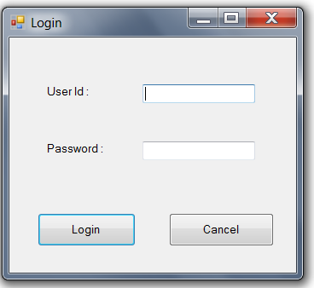

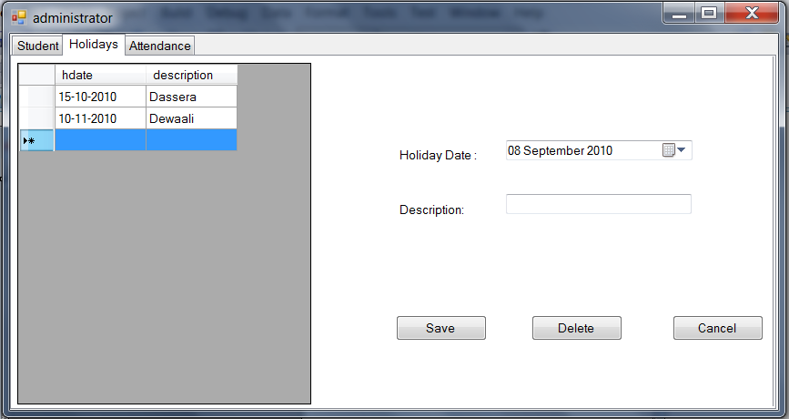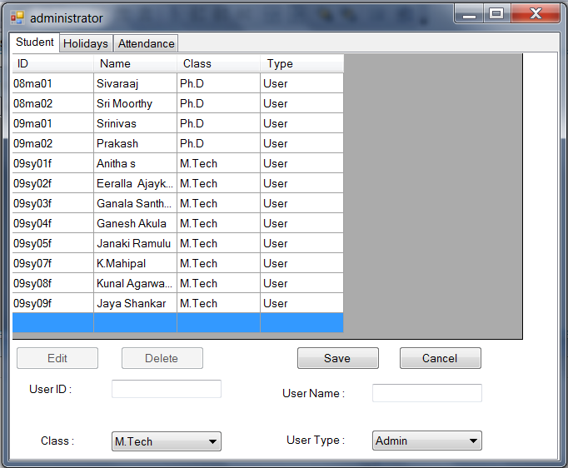

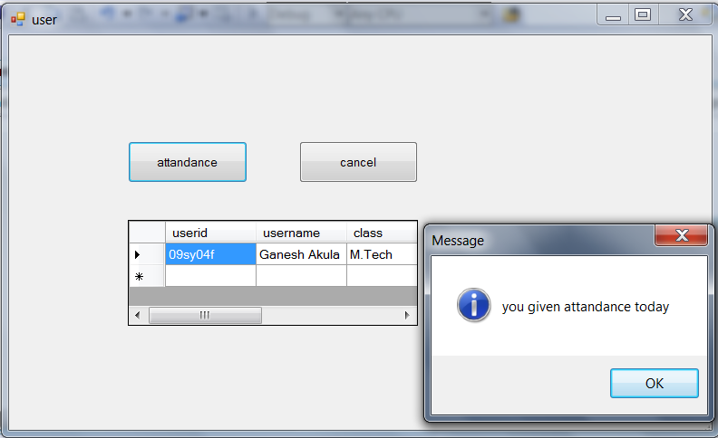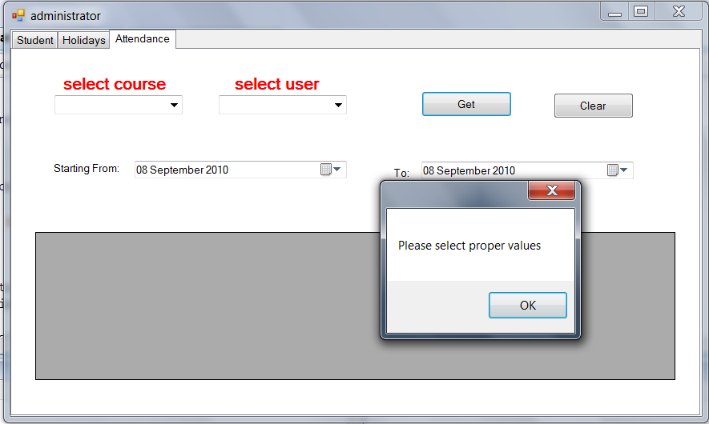

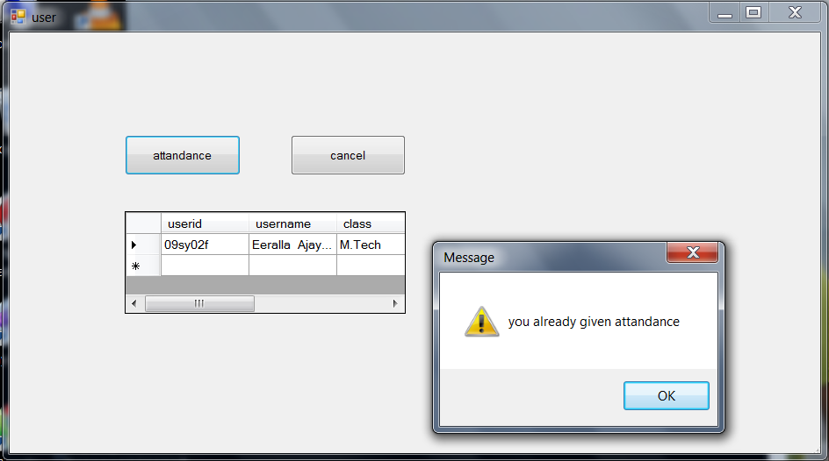

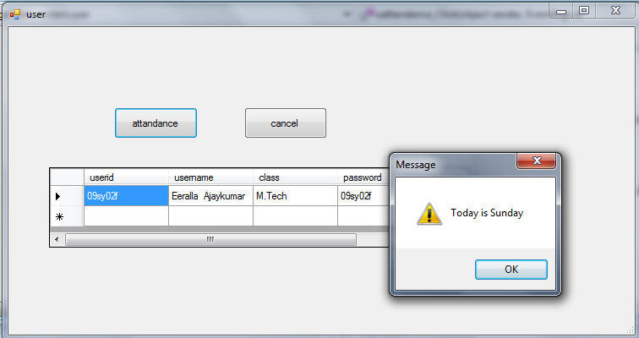

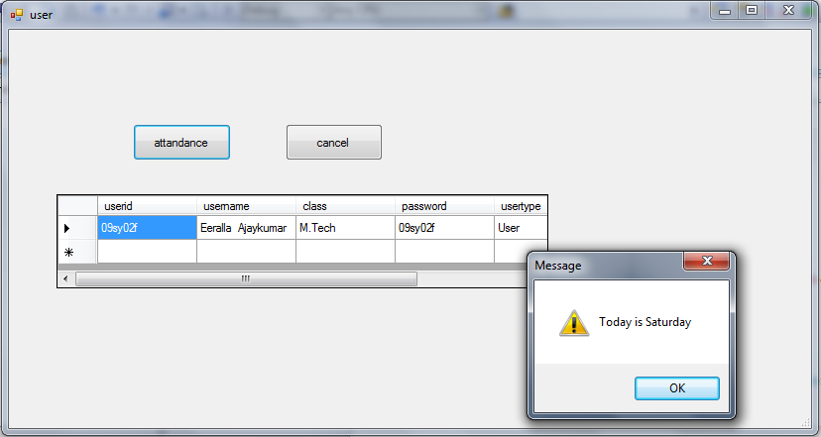

**Conclusion:**

The Attendance Management System is developed using Visual Basic.NET fully meets the objectives of the system which it has been developed. The system has reached a steady state where all bugs have been eliminated. The system is operated at a high level of efficiency and all the teachers and user associated with the system understands its advantage. The system solves the problem. It was intended to solve as requirement specification.

**References:**

1. <http://www.homeandlearn.co.uk/csharp/csharp.html>
2. <http://www.artfulsoftware.com/infotree/queries.php?&bw=994>

3. The complete reference C# by Herbert Schildt