| **Name of Student:** Ajay Karthikesan | | | |
| --- | --- | --- | --- |
| **Roll Number:** 57 | | **Assignment Number:** 4B | |
| **Aim of Assignment:** Build a simple angular application. | | | |
| **DOP:** 18.4.23 | | **DOS:** 25.5.23 | |
| **CO Mapped:**  CO1 | **PO Mapped:**  PO3, PO5, PSO1, PSO2 | **Faculty Signature:** | **Marks:** |

## 

## Practical No. 1

**Aim:** Build a simple angular web application.

**Theory:**

Angular is a development platform, built on

TypeScript. As a platform, Angular includes:

A component-based framework for building scalable

web applications

• A collection of well-integrated libraries that cover a

wide variety of features, including routing, forms

management, client-server communication, and more

• A suite of developer tools to help you develop, build,

test, and update your code

With Angular, you&#39;re taking advantage of a platform that

can scale from single developer projects to enterprise-

level applications. Angular is designed to make updating

as easy as possible, so you can take advantage of the

latest developments with a minimum of effort. Best of

all, the Angular ecosystem consists of a diverse group of

over 1.7 million developers, library authors, and content

creators.

Angular is a platform and framework for building single-

page client applications using HTML and TypeScript.

Angular is written in TypeScript. It implements core and

optional functionality as a set of TypeScript libraries that

you import into your applications.

The architecture of an Angular application relies on

certain fundamental concepts. The basic building blocks

of the Angular framework are Angular components that

are organized into NgModules. NgModules collect

related code into functional sets; an Angular application

is defined by a set of NgModules. An application always

has at least a root module that enables bootstrapping,

and typically has many more feature modules.

• Components define views, which are sets of screen

elements that Angular can choose among and modify

according to your program logic and data.

• Components use services, which provide specific

functionality not directly related to views. Service

providers can be injected into components as

dependencies, making your code modular, reusable,

and efficient.

**Code:**

File: WebForm1.aspx

﻿<%@ Page Language="C#" AutoEventWireup="true" CodeBehind="WebForm1.aspx.cs" Inherits="WebApplication2.WebForm1" %>

<!DOCTYPE html>

<html xmlns="http://www.w3.org/1999/xhtml">

<head id="Head1" runat="server">

<title>Practical 4-B</title>

<script type="text/javascript" src="angular.min.js"></script>

<style type="text/css">

.auto-style1 {

width: 49%;

height: 100%;

}

</style>

</head>

<body ng-app="myApp">

<div ng-controller="myCtrl">

<table class="auto-style1">

<tr>

<td>

<h3>

Un-Ordered</h3>

</td>

<td>

<h3>

Orderby Filter : Order by id</h3>

</td>

</tr>

<tr>

<td>

<table border="1" cellspacing="0" cellpadding="5">

<thead>

<th>

Id

</th>

<th>

Name

</th>

<th>

Salary

</th>

<th>

Date of joining

</th>

</thead>

<tr ng-repeat="x in emp">

<td>

{{x.id}}

</td>

<td>

{{x.name}}

</td>

<td>

{{x.sal}}

</td>

<td>

{{x.doj}}

</td>

</tr>

</table>

</td>

<td>

<table border="1" cellspacing="0" cellpadding="5">

<thead>

<th>

Id

</th>

<th>

Name

</th>

<th>

Salary

</th>

<th>

Date of joining

</th>

</thead>

<tr ng-repeat="x in emp | orderBy: 'id'">

<td>

{{x.id}}

</td>

<td>

{{x.name}}

</td>

<td>

{{x.sal}}

</td>

<td>

{{x.doj}}

</td>

</tr>

</table>

</td>

</tr>

</table>

<h3>

Number filter</h3>

<ul>

<li ng-repeat="x in emp">Salary of {{x.name}} is {{ x.sal | number:3}}</li>

</ul>

<h3>

Currency filter</h3>

<ul>

<li ng-repeat="x in emp">Salary of {{x.name}} is {{x.sal|currency:'Rs.'}}</li>

</ul>

</div>

<script>

var app = angular.module("myApp", []);

app.controller("myCtrl", function ($scope) {

$scope.emp = [{ id: '57', name: 'Ajay Karthikesan', sal: '90000', doj: '03-10-2000' }, { id: '103', name: 'James', sal: '60000', doj: '19-01-1999' }, { id: '120', name: 'August', sal: '10000', doj: '12-02-1996'}]

});

</script>

</body>

</html>

**Output:**

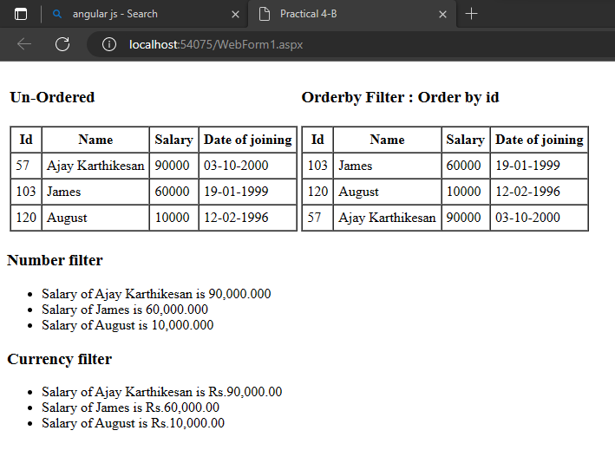

**Conclusion:**

I learnt how to build a simple angular application.