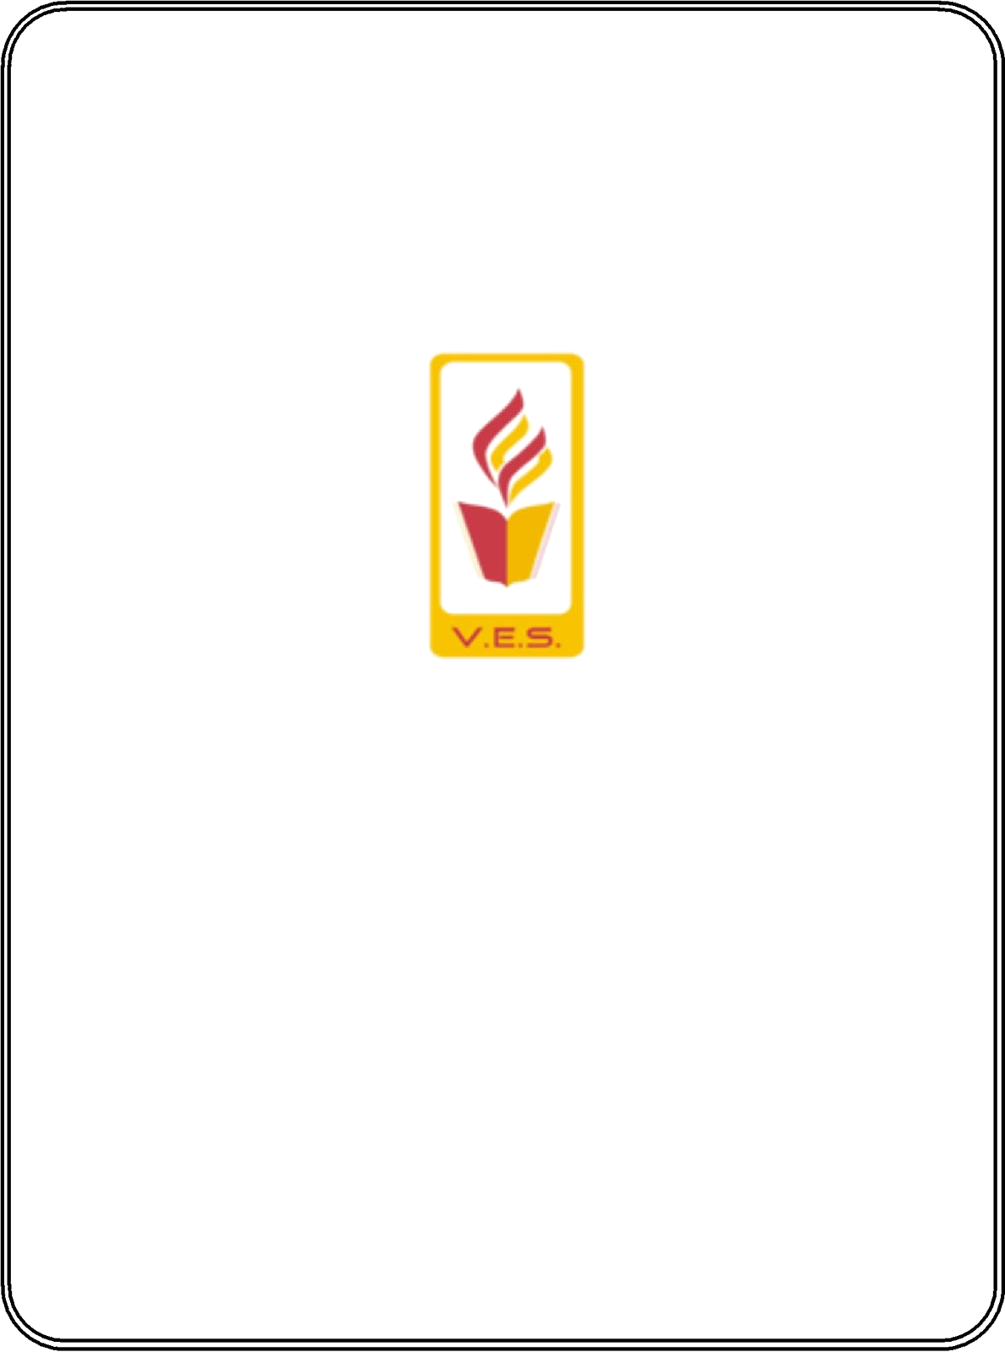

**Roll No: 57 Exam Seat No:**

VIVEKANAND EDUCATION SOCIETY’S INSTITUTE OF TECHNOLOGY

Hashu Advani Memorial Complex, Collector’s Colony, R. C. Marg, Chembur, Mumbai – 400074. Contact No. 02261532532

Since 1962

CERTIFICATE

Certified that Mr./Miss Ajay Karthikesan Thevar of FYMCA has satisfactorily completed a course of the necessary

experiments in Advanced Web Technologies Lab under my supervision in the Institute of Technology in the academic year 2022-2023.

Principal Head of Department

(Dr. Shiv kumar goel)

External Examiner Subject Teacher

(Miss. Bhavana Chaudhari)