| **Name of Student:** Ajay Karthikesan | | | |
| --- | --- | --- | --- |
| **Roll Number:** 57 | | **Assignment Number:** 1 | |
| **Aim of Assignment:** Installation of NS-3 in Linux, NetAnim,WireShark | | | |
| **DOP:** 3.4.23 | | **DOS:** 29.4.23 | |
| **CO Mapped:**  CO1 | **PO Mapped:**  PO2, PO5, PSO1 | **Faculty Signature:** | **Marks:** |

## 

## Practical No. 1

**Aim:** Installation of NS-3 in Linux, NetAnim,WireShark

**Theory:**

* What is NS-3?
  + ns-3 is a discrete-event network simulator, targeted primarily for research and educational use. ns-3 is free software, licensed under the GNU GPLv2 license, and is publicly available for research, development, and use.
  + The goal of the ns-3 project is to develop a free and open source simulation environment suitable for networking research: it should be aligned with the simulation needs of modern networking research and should encourage community contribution, peer review, and validation of the software. ns-3 is maintained by a worldwide team of volunteer maintainers.
  + NS-3 PyViz is a live simulation visualizer, meaning that it uses no trace files. It can be most useful for debugging purposes, i.e. to figure out if mobility models are what you expect, where packets are being dropped, etc. There's also a builtin interactive python console that can be used to debug the state of the running objects. Although it is mostly written in Python, it works both with Python and pure C++ simulations.
* What is NetAnim?
  + NetAnim is an offline animator based on the Qt toolkit. It animates a previously executed simulation using an XML trace file generated during a simulation. The first version was developed by George F Riley. The current version was largely developed by John Abraham. NetAnim has not been actively maintained/improved since 2017.
* What is WireShark?
  + Wireshark is a free and open-source packet analyzer. It is used for network troubleshooting, analysis, software and communications protocol development, and education. Originally named Ethereal, the project was renamed Wireshark in May 2006 due to trademark issues.

**Installation Steps:**

1. Installing Dependencies of ns-3, ns-3 PyVis and NetAnim.

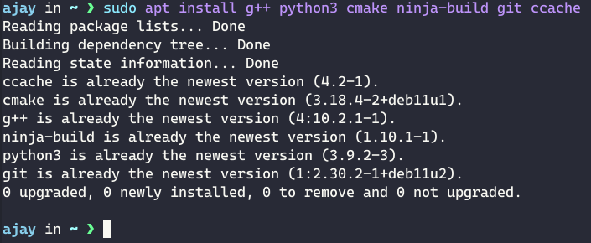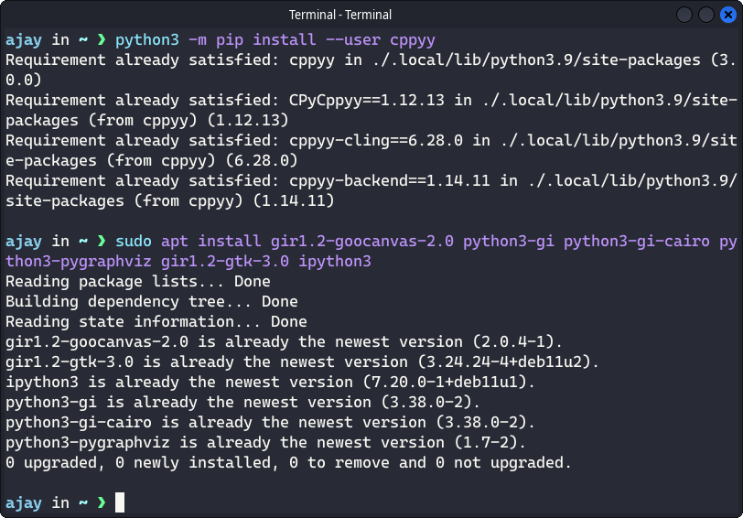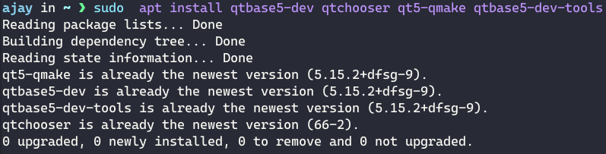

1. Getting the source of ns-3 and NetAnim.

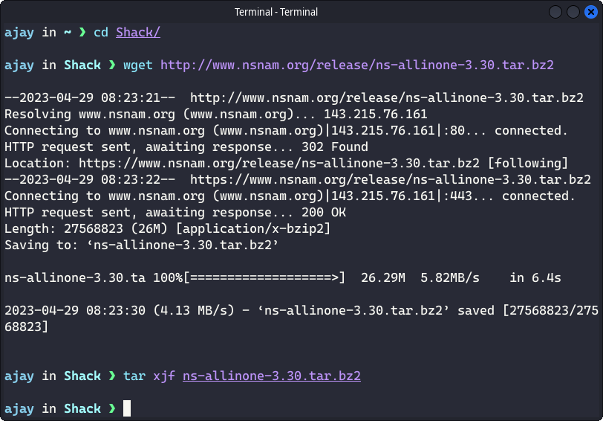

1. Building ns-3(with PyVis) and Netanim.

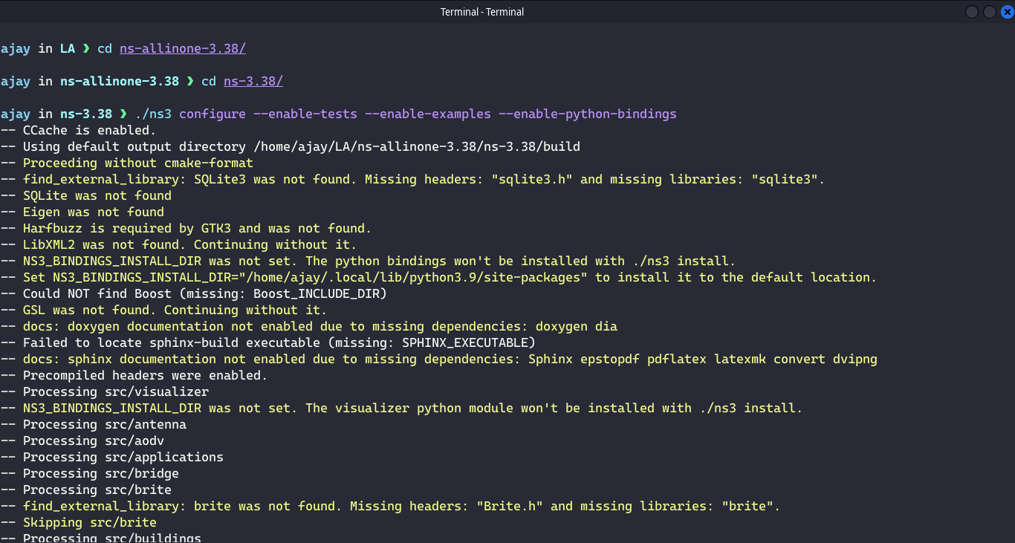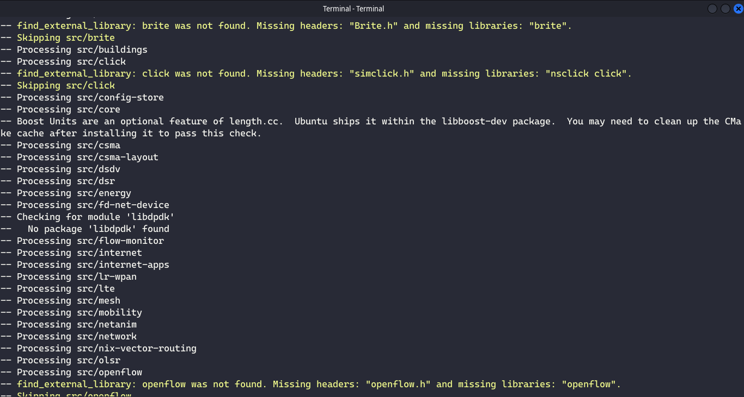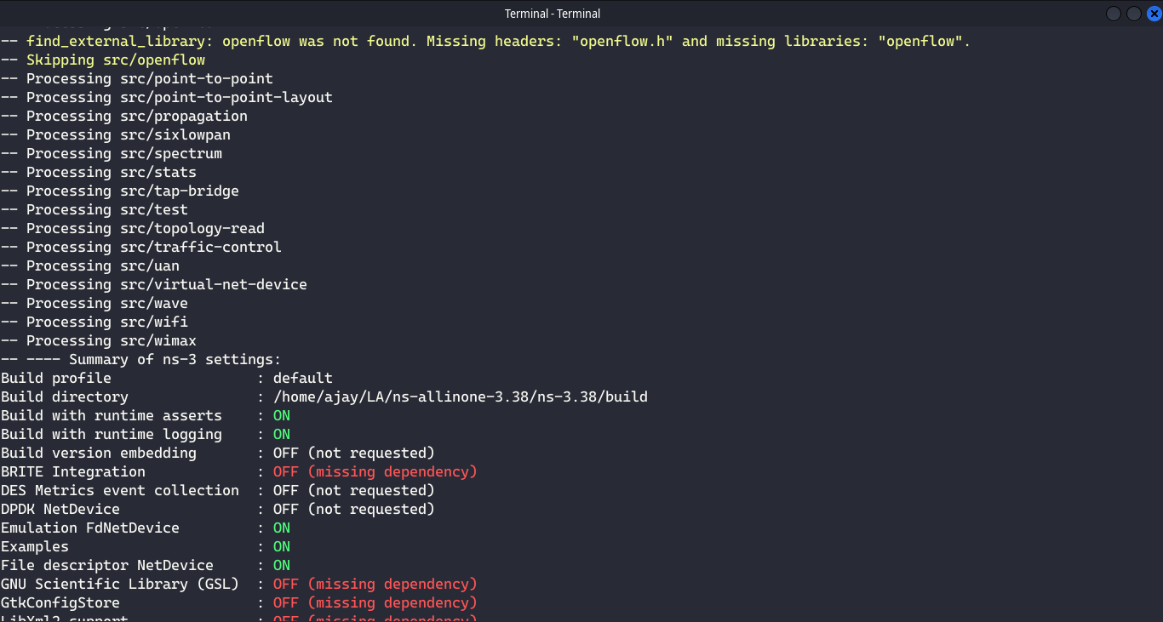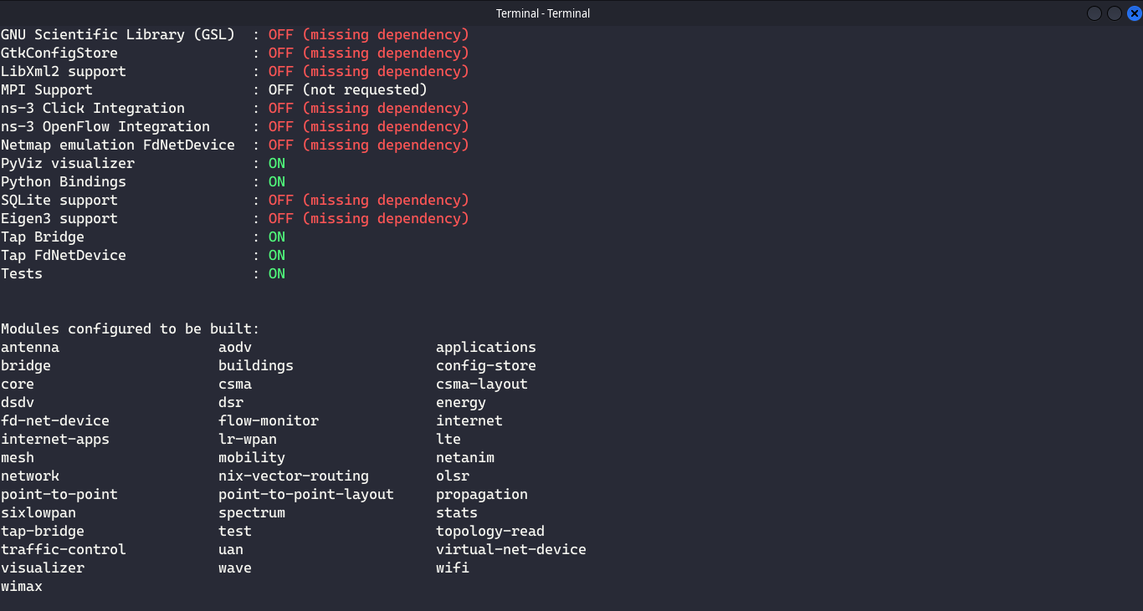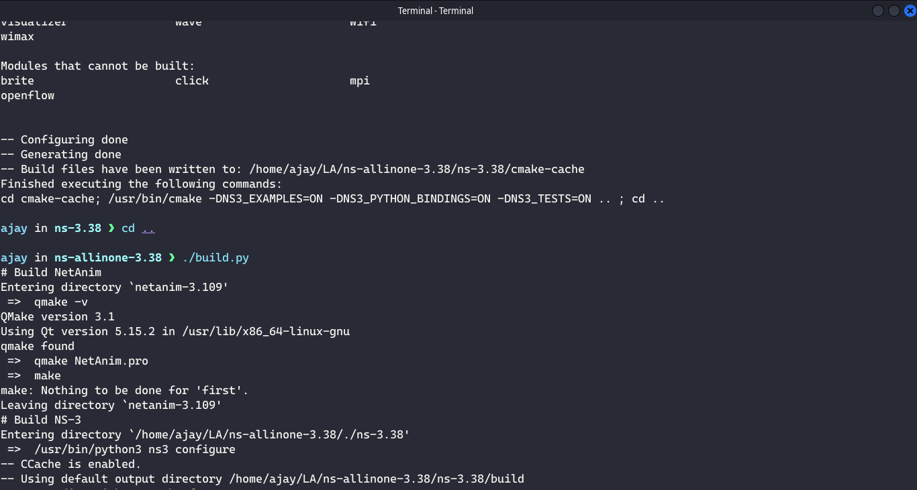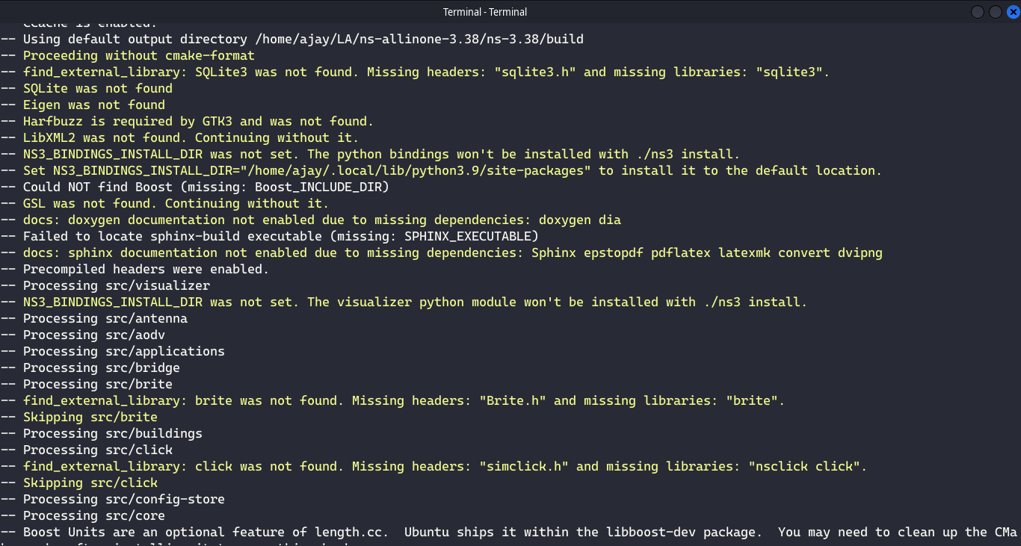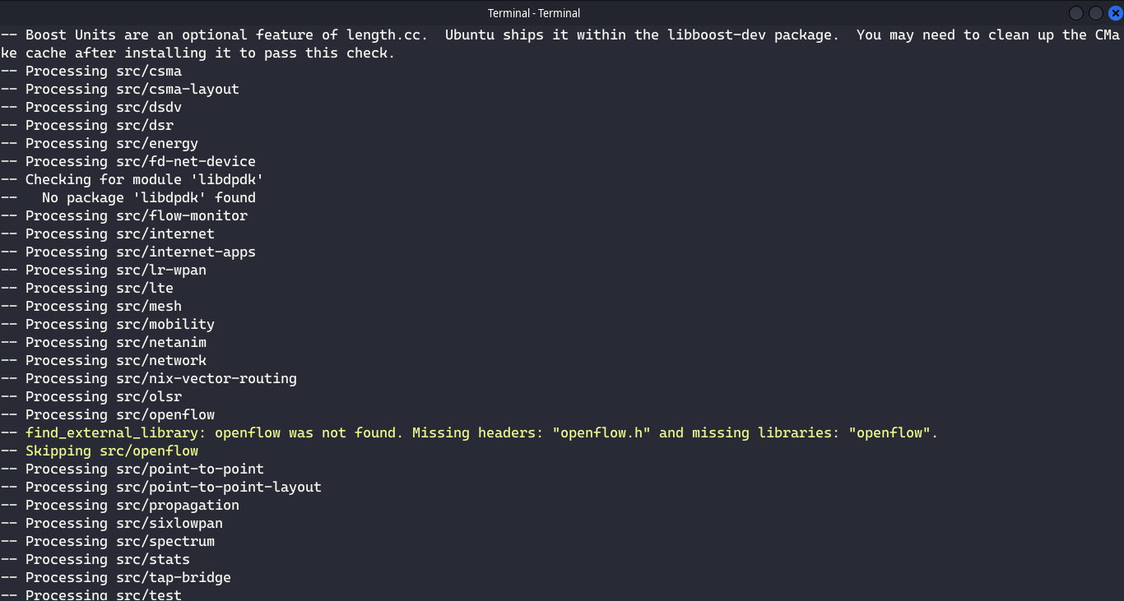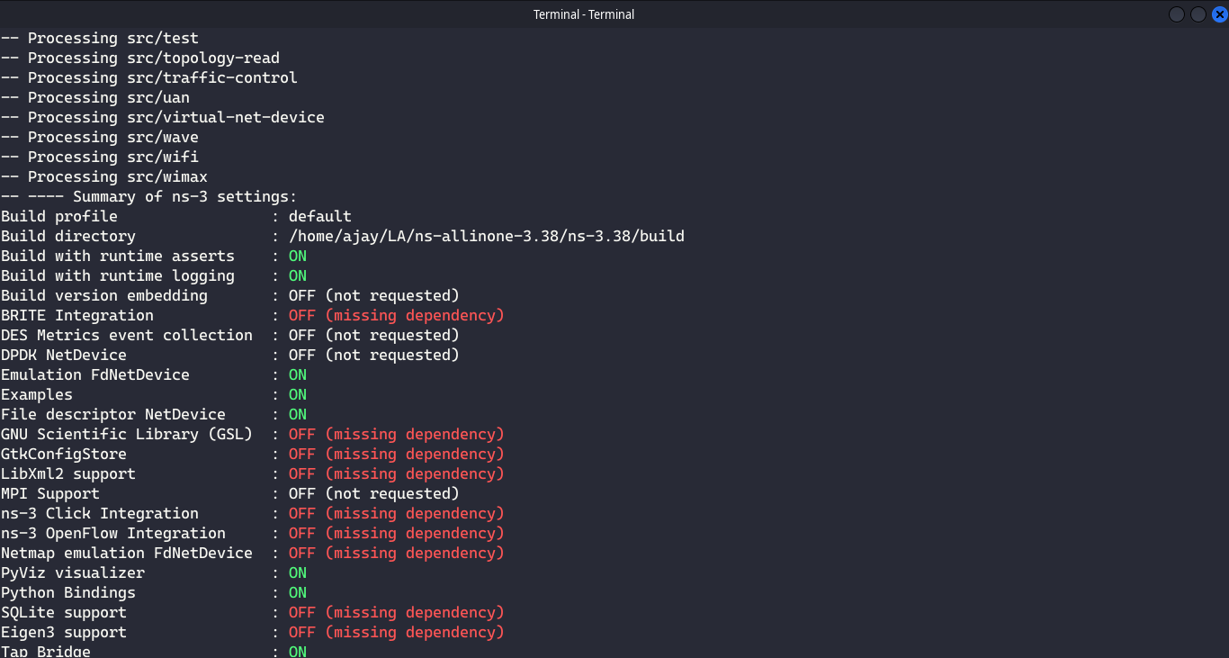

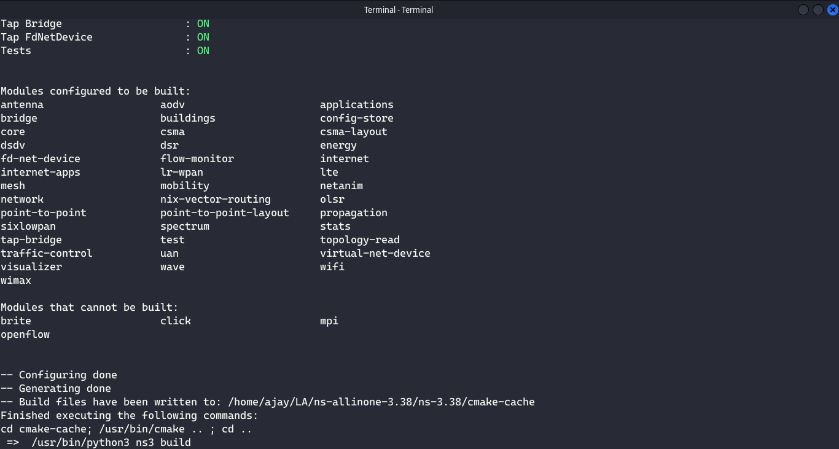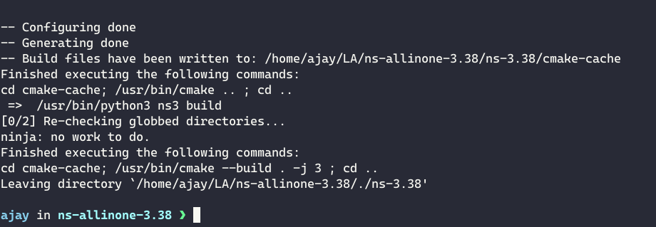

1. Testing if ns-3(with PyVis) is built properly.

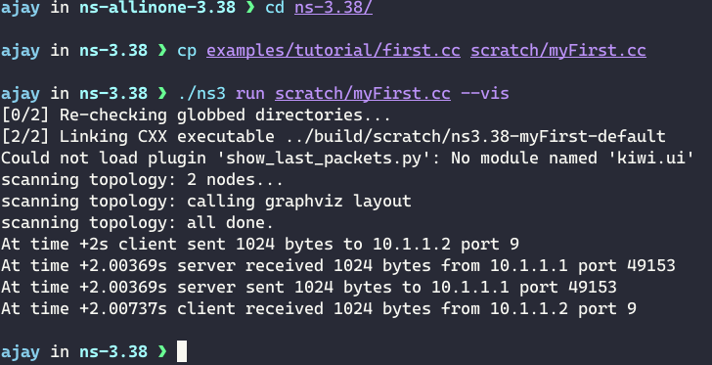

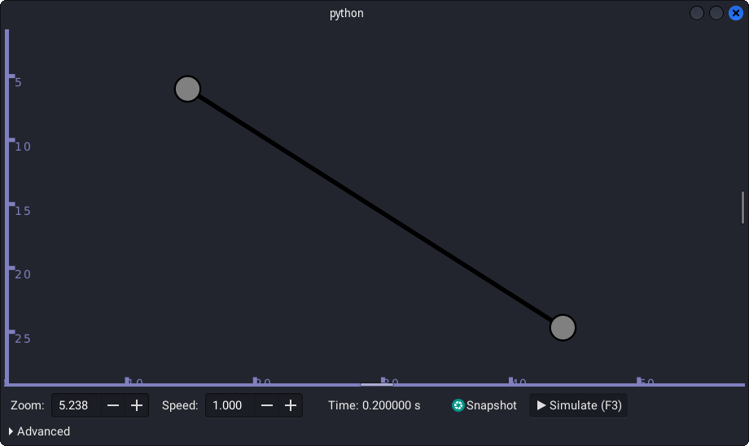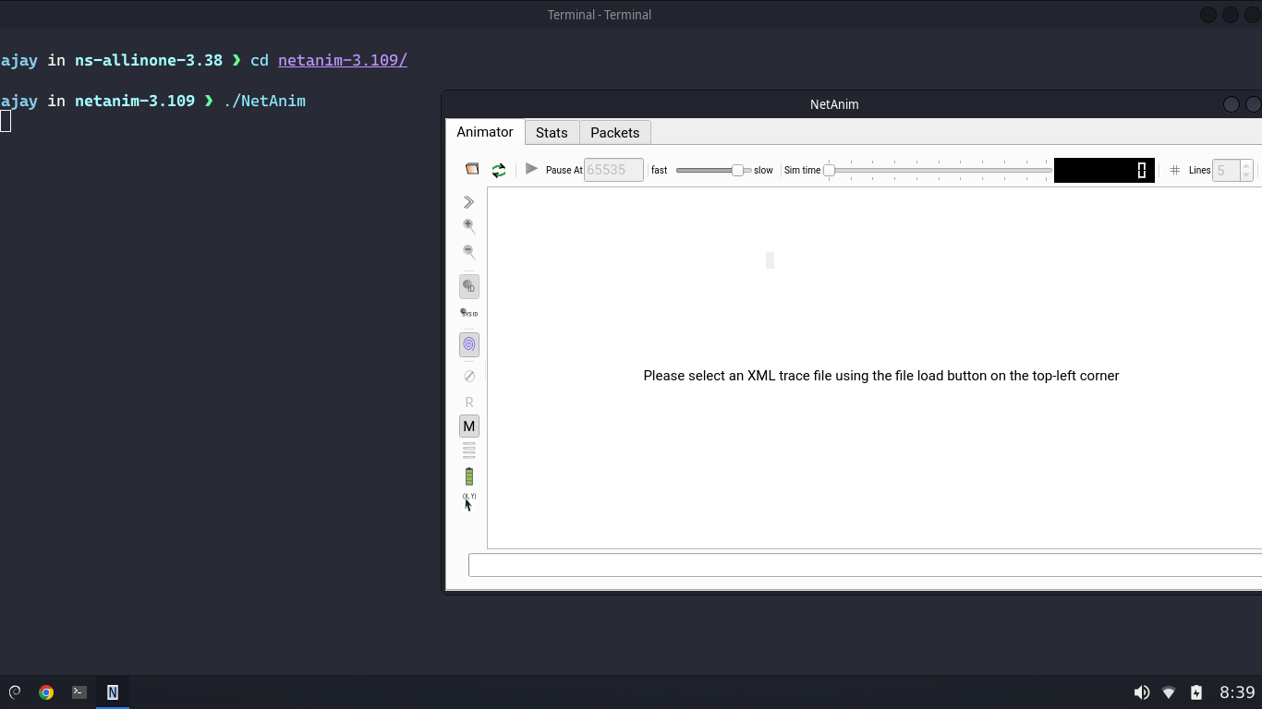

1. Installing WireShark.

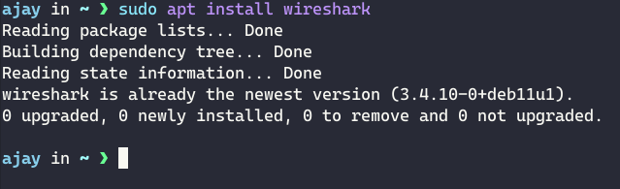

1. Running WireShark.

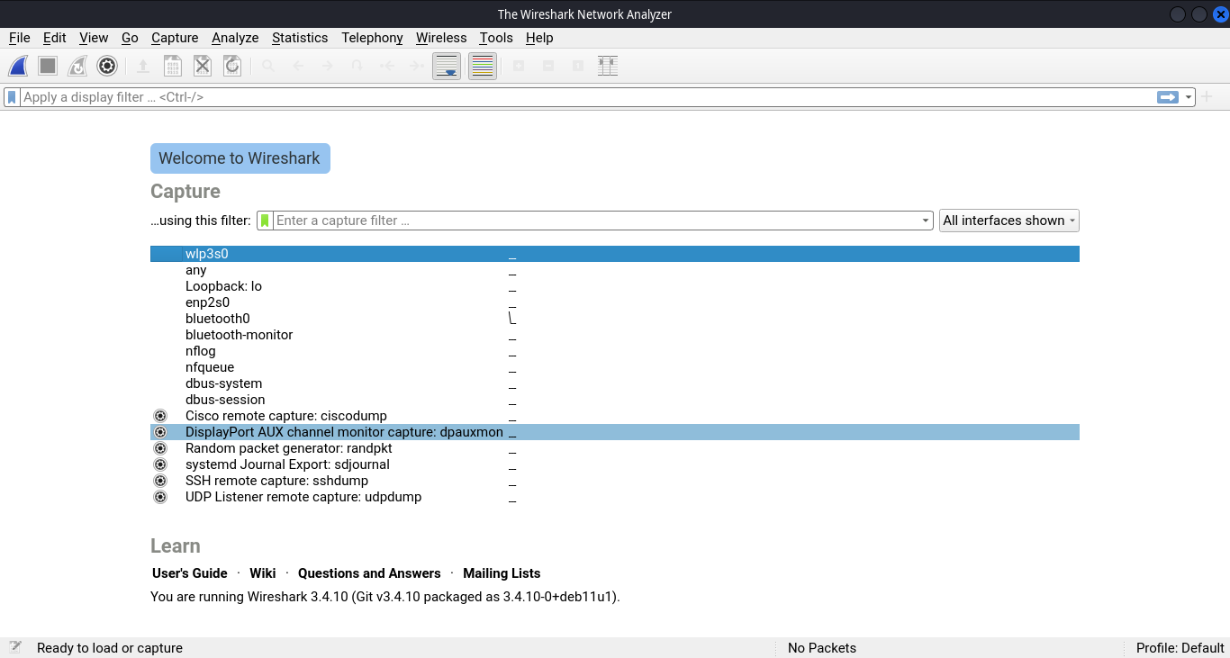

**Conclusion:**

I learnt how to build ns-3(with pyvis) and NetAnim in a Linux Distribution. I also learnt how to install WireShark in a Linux Distribution.