PROBLEM STATEMENT:
Given graph shows the hierarchy of employees in a company.
Write an SQL query to split the hierarchy and show the employees corresponding to their team.

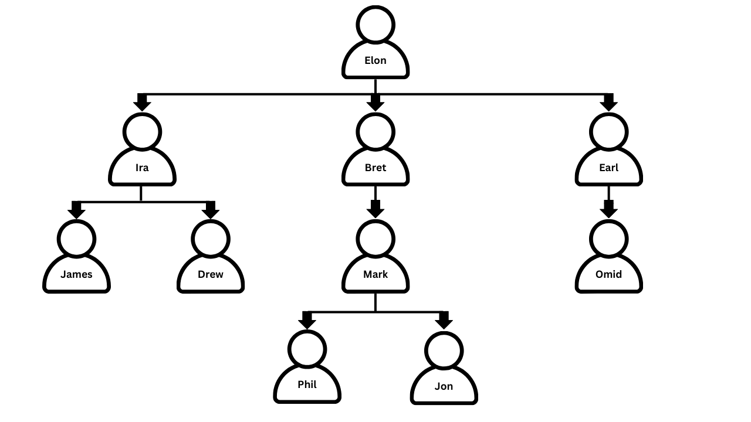

EXPECTED OUTPUT:
TEAMS | MEMBERS
Team 1 | Elon, Bret, Mark, Phil, Jon
Team 2 | Elon, Earl, Omid
Team 3 | Elon, Ira, James, Drew

