A
Project Report titled
“Drivers Drowsiness Detection using Deep Learning”

Submitted to
Department of Data Science
of

Bunts Sangha’s
S.M Shetty College of Science, Commerce and Management Studies (Autonomous), Powai
For Partial Fulfilment for Degree of
Bachelor of Science (Data Science)
2025-2026
In the subject head
Project (VI Semester)
Submitted by
AJAY JITENDRA GOHIL
Under the Guidance of
Dr. Tushar Sambare

BUNTS SANGHA’S
S.M. SHETTY COLLEGE OF SCIENCE, COMMERCE &
MANAGEMENT STUDIES (AUTONOMOUS), POWAI, MUMBAI-76

SUBJECT: PROJECT DISSERTATION
CLASS: T.Y.B.Sc.D.S. (2025-26) SEMESTER: VI
SUBMITTED BY (Name): AJAY JITENDRA GOHIL
ROLL NUMBER: 10 SEAT NUMBER: _______________

SUBMITTED TO
DEPARTMENT OF DATA SCIENCE

Dr Tushar Sambare Dr Tushar Sambare
_____________________ ____________________ _________________
Subject In-charge Coordinator External Examiner

For Partial Fulfilment for Degree of
Bachelor of Science in DS (DATA SCIENCE) in 2025-26

PROFORMA FOR THE APPROVAL PROJECT PROPOSAL

1. Name of the Student
AJAY GOHIL
2. Title of the Project
“Drivers Drowsiness Detection using Deep Learning”
3. Name of the Guide
Prof. Dr. Tushar Sambare
4. Is this your first submission?
Yes.
Student Name: | AJAY GOHIL
Student Roll No.: | 10

ACKNOWLEDGEMENT
I would like to express my sincere gratitude to the Bunts Sangha’s SM Shetty College of Science, Commerce & Management Studies (Autonomous), for providing me with this valuable opportunity. Their support and the resources they made available were essential for the successful completion of this project. A special thank you to Principal Dr. CS Sandesha Shetty, for their support and for fostering an environment where this kind of work is encouraged.
I am immensely grateful to my project guide and my coordinator, Dr. Tushar Sambare, for their instrumental support. Their insightful feedback and professional guidance were crucial throughout this project's development. I am thankful for the knowledge they shared and the direction they provided, which greatly contributed to the quality of my work.
I would also like to acknowledge the contributions of my teachers, who have instilled in me a passion for learning and provided me with the tools and knowledge necessary to succeed. Their unwavering support and encouragement have been invaluable throughout this journey.

DECLARATION

I hereby declare that the project entitled “Drivers Drowsiness Detection using Deep Learning” done at the place where the project is done has not been, in any case, duplicated to submit to any other university for the award of any degree. To the best of my knowledge, no one other than me has submitted to any other university.
The project is done in partial fulfillment of the requirements for the award of the degree of BACHELOR OF SCIENCE (DATA SCIENCE) to be submitted as a final semester project as part of our curriculum.

Ajay Jitendra Gohil
Name and Signature of the Student

Abstract
The project aims to develop an intelligent safety system using deep learning to detect driver drowsiness and prevent road accidents. The core objective is to create a system that uses a camera to automatically monitor a driver's facial cues in real-time, identifying signs of fatigue such as prolonged eye closure and yawning to provide timely warnings.

The system is trained on the MRL Eye Dataset, a collection of 84,898 infrared images from 37 individuals. This dataset is crucial as it captures diverse conditions, including subjects with and without glasses, and varying lighting scenarios. For model training, a Python script systematically sorts these images into "open" and "closed" eye categories within dedicated training and test folders. This organized preparation is essential for teaching the model to accurately differentiate between an alert and a fatigued state based on visual evidence. A hybrid Convolutional Neural Network (CNN) and Long Short-Term Memory (LSTM) model is employed for the analysis. The CNN extracts spatial features from individual video frames, while the LSTM analyzes temporal patterns over several seconds, such as blink duration calculated.

The conclusion highlights the system's high effectiveness, with hybrid models achieving accuracy rates between 90-99%. These systems are robust enough to function reliably in diverse lighting conditions and can be deployed on low-cost embedded hardware like the NVIDIA Jetson Nano. Real-world trials confirm a measurable safety impact, with significant reductions in fatigue-related incidents. This demonstrates that deep learning-based drowsiness detection is a mature and practical technology ready for widespread adoption to enhance road safety.
TABLE OF CONTENTS
Sr. No. | CONTENT | Page No.
 | CHAPTER 1: PROJECT OVERVIEW | 1-8
1.1 | Project Title | 1
1.2 | Project Objectives | 1-2
1.3 | Scope | 2-5
1.4 | Stakeholders | 5-8
 | CHAPTER 2: DATA DESCRIPTION | 9-17
2.1 | Data Sources | 9
2.2 | Data Collection | 10
2.3 | Data Description | 11-12
2.4 | Data Cleaning and Preparation | 12-17
 | CHAPTER 3: METHODOLOGY | 18-28
3.1 | Analytical Approach | 18-22
3.2 | Visualization Techniques | 23-24
3.3 | Design Principles | 24-28
 | CHAPTER 4: VISUALIZATION RESULTS | 29-38
4.1 | Key Findings | 29-30
4.2 | Visualization Examples | 30-33
4.3 | Interpretation | 33-38
 | CHAPTER 5: CHALLENGES AND LIMITATIONS | 39-46
5.1 | Challenges Faced | 39-42
5.2 | Limitations | 42-46

Sr. No. | CONTENT | Page No.
 | CHAPTER 6: FUTURE WORK | 47-49
6.1 | Recommendations | 47-48
6.2 | Next Steps | 48-49
 | CHAPTER 7: REFRENCES | 50-52
7.1 | Data Sources | 50
7.2 | Literature | 50
7.3 | Tools and Software | 51-52
 | CHAPTER 8: APPENDICES | 53-64
8.1 | Appendix A: Data Tables | 53-56
8.2 | Appendix B: Code | 57-63
8.3 | Appendix C: Glossary | 63-64
List of Figures
Sr No. | FIGURES | Title | PageNo.
1 | Figure 1.3.1 | Driver Drowsiness Detection Flow Chart | 3
2 | Figure 2.2.1 | Example of Eye Detection | 10
3 | Figure 2.3.1 | Types of labelled eye dataset | 11
4 | Figure 2.3.2 | Eye image dataset in various conditions | 12
5 | Figure 2.4.1 | Test and Train Folder | 13
6 | Figure 2.4.2 | Close and Open Eye Folder | 13
7 | Figure 2.4.3 | Sorting and cleaning data code | 16
8 | Figure 4.2.1 | Live line chart on the dashboard | 31
9 | Figure 4.3.1 | Open Eyes Threshold score<15 | 35
10 | Figure 4.3.2 | Closed Eyes Threshold score>15 | 35
11 | Figure 8.1.1 | Open and Closed eyes prediction | 54
12 | Figure 8.1.2 | Line chart | 54

CHAPTER 1: Project Overview
  - Project Title:

Driver drowsiness detection using deep learning

  - Objectives:

Driver drowsiness detection using deep learning has become one of the most important safety innovations in modern transportation technology. This objective focuses on creating intelligent systems that can automatically identify when drivers are becoming sleepy or fatigued while driving, helping to prevent dangerous accidents before they happen. New ideas in car safety are making driving much safer for everyone. One of the most important new ideas is a system that can tell when a driver is getting sleepy. The goal is to build a smart system in our cars that can automatically see when a driver is getting tired. By catching this early, the system can give a warning and help stop terrible accidents before they even have a chance to happen. This technology is like having a helpful friend in the car who is always watching out for you.
Why Is Driving While Tired So Dangerous?
Imagine you are on a long road trip. You’ve been driving for hours, the sun has gone down, and the road ahead seems to go on forever. Your eyes start to feel heavy, your head feels a little fuzzy, and you might even yawn a few times. This is called drowsiness, or being sleepy. When you get sleepy, your body and brain slow down. This is very dangerous when you are driving a car. Here’s why:
- Your Reactions Get Slower:

If a car in front of you suddenly stops, you need to hit the brakes fast. But if you’re sleepy, it might take you an extra second or two to realize what’s happening. On the road, a second can be the difference between a safe stop and a bad crash.

- You Can’t Focus:

Driving requires you to pay attention to many things at once the cars around you, the speed limit, traffic lights, and the road itself. When you’re tired, your mind starts to wander. You might stop paying attention to the road for a few moments without even realizing it.

- You Might Fall Asleep:

The most dangerous thing that can happen is called microsleep. This is when you fall asleep for just a few seconds. You might not even know it happened. But if your car is moving at a high speed, it can travel the length of a football field in just a few seconds. If you have a microsleep during that time, you could drift into another lane or off the road completely.

Every year, thousands of accidents are caused by sleepy drivers. These accidents are very serious because a sleepy driver often doesn’t even try to brake before a crash. This is why finding a way to stop drowsy driving is so important for everyone’s safety.

  - Scope:
Driver drowsiness detection using deep learning represents a focused yet broad area of research that addresses specific aspects of road safety while connecting to larger fields of artificial intelligence, computer vision, and transportation technology. The scope of this project defines the boundaries, limitations, and areas of application for developing effective drowsiness detection systems.
Using smart computers, or deep learning, to detect sleepy drivers is a big and important field. It helps solve a specific road safety problem crashes caused by tired drivers. To understand it, we need to look at what these systems can do, what they can’t do yet, and where they can be used. This helps us see the full picture.

What the System Actually Does: The Technical Side
The main job of this technology is to teach a computer to see and understand what it's looking at, just like a person would. It uses a camera to watch the driver and a smart program to analyze what it sees in real time.
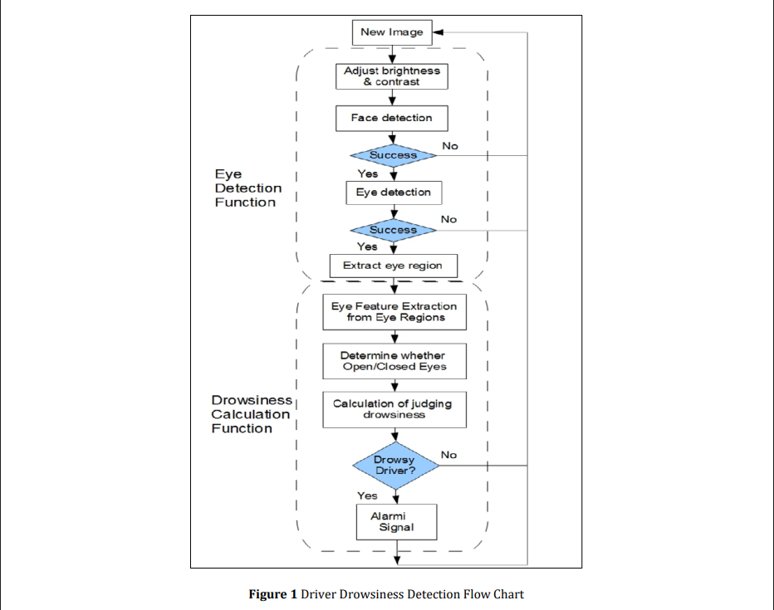
Figure 1.3.1: Driver Drowsiness Detection Flow Chart

- What It Looks For: The system's number one job is to watch the driver's face for clues that they're getting tired. It tracks specific things like how often a person blinks, how long their eyes stay closed, if they are yawning, and if their head is starting to nod or droop. In good conditions, the best systems can be extremely accurate.
- Working Instantly: This technology has to work fast because an accident can happen in a split second. These systems are designed to check the driver's video feed instantly, analyzing between 14 and 30 pictures frames every second. This can be done on small, affordable computers that fit right into a car's dashboard.

- Using More Than One Tool: While the camera is the main tool, some of the best systems add other sensors to be even more sure. Think of it like a doctor who not only looks at you but also checks your pulse. A car system might also monitor the driver's heart rate or check for sweat on the skin. By combining information, the system can avoid false alarms and be more trustworthy.

Where This Technology Is Used?
These sleepy-driver spotters are useful in many different places, not just in your personal car.

- Cars and Trucks: The most common use is in everyday vehicles, from family cars to big commercial trucks. They provide a safety net for all drivers.

- Buses and Trains: When one driver is responsible for many passengers, safety is extra important. These systems are used to monitor bus drivers and even train operators to prevent large-scale accidents.

- Factory and Construction Workers: Being tired is dangerous even if you're not on a road. People who operate heavy machines like cranes or forklifts can also use this technology to prevent workplace accidents.

- Helping People at Home: A new and growing use is in healthcare. These systems can monitor elderly people to see if they're drowsy, which could put them at risk of falling, and alert a family member or caregiver.

The Challenges and What It Can't Do Well:
Even though this technology is powerful, it has some important limits that engineers are working hard to solve.

- Bad Weather and Darkness: Cameras need light to see clearly. At night, a normal camera can't see the driver's face, so many systems use special infrared cameras that can see in the dark. But even these can struggle in heavy rain or fog.

- Things Covering the Face: The system needs a clear view of the driver's eyes and mouth. It can get confused by things like sunglasses, a face mask, or even a very thick beard. While some systems are getting better at handling a partially covered face, it's still a big challenge.

- Different Types of People: A system that was taught using videos of one group of people might not work as well for people with different facial structures or from different backgrounds.

- Computer Power and Cost: The smartest systems need a lot of computer power, which means they need more expensive computer chips. It's a balancing act to make a system that is both smart enough to be effective and cheap enough to be included in regular cars.

  - Stakeholders:
When a new piece of technology as important as a driver drowsiness detector is created, it doesn't just appear in a car one day. It’s the result of a massive, complicated ecosystem of different people and groups, all with their own goals, concerns, and responsibilities. These are the stakeholders anyone who has a stake in the game. Understanding who they are and what they care about is key to seeing why making this life-saving technology a reality is such a team effort.

The People in the Driver's Seat
First and foremost, we have the most important stakeholders: the drivers themselves.

1. Drivers and Vehicle Operators:
These are the people the technology is built to protect. We’re talking about everyday people driving their kids to school, long-haul truck drivers on a cross-country trip, city bus operators, and Uber drivers navigating late-night streets. Their primary interest is simple: safety. A system that can give them a crucial warning a few seconds before they nod off could literally save their life.

But it’s not that simple. As the person being watched by the camera, a driver's biggest concerns are:
- Privacy: Is this system a helpful co-pilot or a Big Brother in my dashboard? Who is watching this video, and what are they doing with it?

- Annoyance: Will this thing beep at me every time I yawn or stretch? A system that produces too many false alarms will quickly get ignored or, worse, turned off completely, making it useless.

- Trust: Can I really rely on this to work when I need it most?

For a professional driver, the stakes are even higher. Their livelihood depends on being on the road. A system that constantly interrupts them could add stress and impact their job. Winning the trust and acceptance of the person behind the wheel is the first and most critical hurdle.

2. Car Companies
These are the big names you know: Ford, Toyota, General Motors, as well as newer players like Tesla. As the ones who actually build the cars, they have to perform a tough balancing act. They are under pressure from all sides:

- Safety vs. Cost: They know safety sells, but every new feature adds to the car's price tag. They have to decide if adding an advanced drowsiness system is worth the cost.
- Innovation vs. Reliability: They want to offer the latest and greatest technology to compete, but it has to be rock-solid reliable. A glitchy safety system is a PR and legal nightmare.
- Regulation: Governments are starting to require these systems, so carmakers have to keep up with the law.
For a car company, a good drowsiness detector is a huge opportunity to build a reputation for safety and innovation.

3. The Tech Companies and AI Developers
These are the brains behind the operation. Companies like NVIDIA, Intel, and Mobileye are the ones designing the powerful computer chips and writing the complex AI algorithms that can actually tell the difference between a blink and a dangerous microsleep. Their challenge is immense: create an AI that is not just smart, but also fair, fast, and efficient enough to run on a small computer inside a car. They are constantly pushing the boundaries of what’s possible to make the system more accurate and reliable.

4. Government and Regulatory Agencies
These are the official safety watchdogs. Think of the National Highway Traffic Safety Administration (NHTSA) in the U.S. or, here in India, the Ministry of Road Transport & Highways. Their job is to protect the public by setting and enforcing safety standards.
They are becoming increasingly focused on driver fatigue. For instance, as of today's date in late 2025, India has already moved to mandate Driver Drowsiness and Attention Warning Systems (DDAWS) in new buses and some other large vehicles starting next year. This kind of government action is a powerful push that forces the entire industry to adopt this technology. These agencies have to balance the urgent need for safety with the economic reality for car manufacturers.

5. The Independent Testers (Safety Rating Organizations)
These are groups like Euro NCAP or the Insurance Institute for Highway Safety (IIHS). Think of them as the Consumer Reports for car safety. They perform tough, independent tests on new cars and give them a safety rating like 5 stars.
When these organizations start including drowsiness detection in their tests, it sends a powerful message. A high safety rating is a huge selling point, so car companies have a strong incentive to include the best safety features to earn top marks. These groups build public trust by acting as an impartial referee.

6. Insurance Companies
The math for insurance companies is simple: fewer accidents mean fewer claims to pay out. They are huge fans of any technology that makes driving safer. To encourage people to use these systems, many insurers offer discounts on premiums for cars equipped with advanced safety features like drowsiness detection. In the future, they are very interested in usage-based insurance, where your safe driving habits including how alert you are could directly lead to a lower bill.

7. Fleet Operators and Trucking Companies
For a company that manages a fleet of hundreds of trucks, buses, or delivery vans, a single accident caused by a tired driver can be financially devastating. It can lead to lawsuits, massive insurance hikes. Because of this, these companies are often the earliest adopters of drowsiness detection technology. For them, it’s not just a safety feature; it's a critical business tool for managing risk, protecting their drivers, and keeping their operations running smoothly.

8. The Research and Medical Community
This group includes university researchers, scientists, and doctors who specialize in sleep. They conduct the fundamental studies that prove the link between blinking patterns and fatigue. They provide the scientific backbone that the tech companies build upon. Medical experts, especially sleep specialists, can also help develop smarter systems that might one day be able to consider a driver's underlying health conditions, like sleep apnea.

9. Road Safety and Advocacy Groups
Organizations like the National Safety Council or Mothers Against Drunk Driving (MADD) are the public's voice. They play a crucial role in raising awareness about the dangers of tired driving. They run campaigns to educate the public and lobby lawmakers to pass stronger safety regulations. These groups help ensure that public safety remains the top priority for everyone involved.

10. The General Public, Passengers, and Pedestrians
Every person who uses the road has a stake in this technology. Even if your car doesn't have a drowsiness detector, your safety depends on the alertness of the drivers around you. As a society, we all benefit from safer roads. This group’s main concerns are usually about privacy, affordability, and equity. We want to know that this life-saving technology will be available in all cars, not just expensive luxury models, and that our data will be protected.

Chapter 2: Data Description

2.1 Data Sources:

The information used to teach the computer in this project comes from a special collection of pictures called the MRL Eye Dataset.
Think of a dataset as a giant photo album used for teaching a computer. This specific photo album was put together by a group of smart people at the Media Research Lab (MRL).

What's inside this photo album?
The MRL Eye Dataset is filled with thousands of close-up pictures of people's eyes. The researchers took pictures of many different people to get a lot of variety. Each picture is carefully labeled and sorted into two simple groups:

- Eyes Open: A folder full of pictures where people's eyes are clearly open.
- Eyes Closed: Another folder full of pictures where people's eyes are clearly closed.

Why is it so important?
This dataset is the study material for the computer brain the deep learning model. By showing the computer thousands of examples of open eyes and thousands of examples of closed eyes, the computer learns to recognize the difference on its own.
For a driver drowsiness system, this is the perfect training. After studying the MRL Eye Dataset, the system's brain becomes an expert at looking at a person's eyes and instantly knowing if they are open or closed. This allows it to detect when a driver's blinks are getting too long, which is a major sign of sleepiness.

2.2 Data Collection:

How the Data Was Collected: Making the MRL Eye Dataset
Creating the MRL Eye Dataset was like organizing a very large and specific photo shoot. The goal was to gather thousands of clear pictures that a computer could study.
First, the researchers needed people to take pictures of. They gathered a large group of volunteers. It was important to have many different kinds of people men, women, people of different ages, and people with and without glasses. This variety helps make sure the final system works well for everyone.

This dataset contains infrared images in low and high resolution, all captured in various lightning conditions and by different devices. The dataset is suitable for testing several features or trainable classifiers. In order to simplify the comparison of algorithms, the images are divided into several categories, which also makes them suitable for training and testing classifiers.
To obtain eye images, they used the eye detector based on the histogram of oriented gradients (HOG) combined with the SVM classifier. The eye images presented in the proposed dataset can be used to train the eye
detector. Examples of eye detection are shown in the following images.

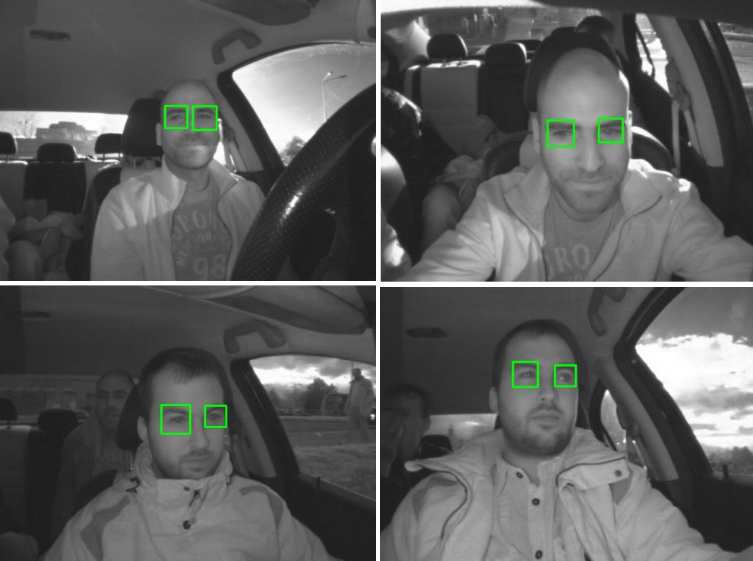

Figure 2.2.1: Example of Eye Detection

2.3 Data Description:

In the dataset, data is details as the following properties (the properties are indicated in the following order):

- subject ID: In the dataset, there are data of 37 different persons (33 men and 4 women)
- image ID: The dataset consists of 84,898 images
- gender [0 - man, 1 - woman]: The dataset contains the information about gender for each image (man, woman)
- glasses [0 - no, 1 - yes]: The information if the eye image contains glasses is also provided for each image (with and without the glasses)
- eye state [0 - closed, 1 - open]: This property contains the information about two eye states (open, close)
- reflections [0 - none, 1 - small, 2 - big]: We annotated three reflection states based on the size of reflections (none, small, and big reflections)
- lighting conditions [0 - bad, 1 - good]: Each image has two states (bad, good) based on the amount of light during capturing the videos
- sensor ID [01 - RealSense, 02 - IDS, 03 - Aptina]: At this moment, the dataset contains the images captured by three different sensors:
(Intel RealSense RS 300 sensor with 640 x 480 resolution, IDS Imaging sensor with 1280 x 1024 resolution, and Aptina sensor with 752 x 480 resolution)

An example of image annotations of the proposed dataset:

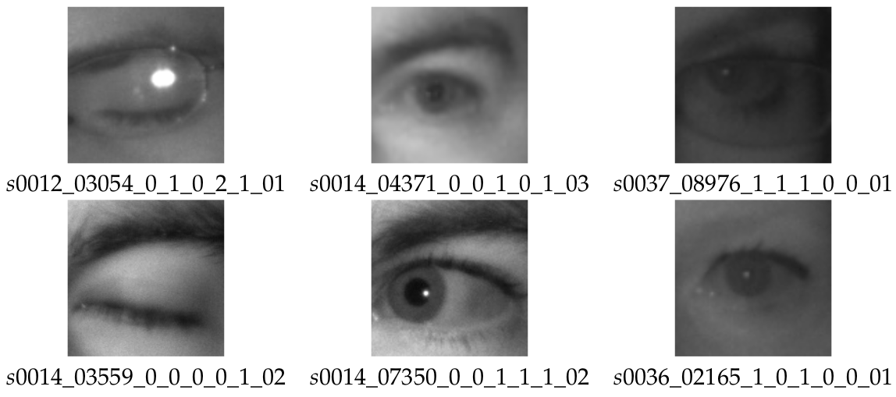
Figure 2.3.1: Types of labelled eye dataset

The example images from this dataset of open and closed eyes are shown below.

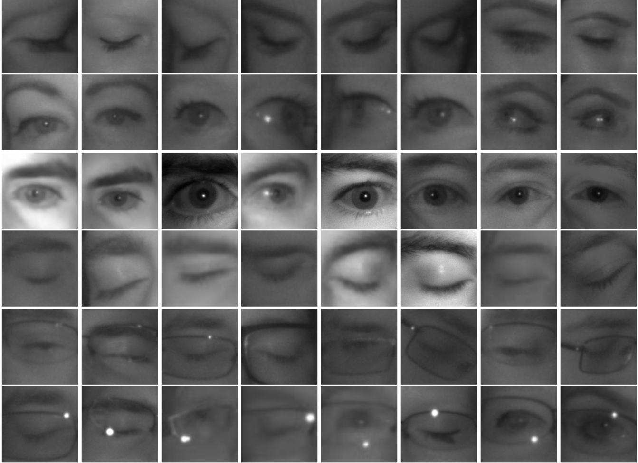
Figure 2.3.2: Eye image dataset in various conditions

2.4 Data Cleaning and Preparation:

Effective data preparation is important for training the deep learning models for driver drowsiness detection. The following steps outline a workflow, from raw data ingestion through final dataset ready for model training.

Step 1:
Gather all datasets into a centralized storage directory and maintain a consistent folder structure like for this project the Data will be stored as “prepared_data” Folder.

Step 2:
Now in “prepared_data” folder we will create 2 sets of folders i.e. (Train and Test) In these both folder there will be split data folder of open eyes and close eyes this will split the data into 2 parts which is open eyes folder and close eyes folder.
Eg:

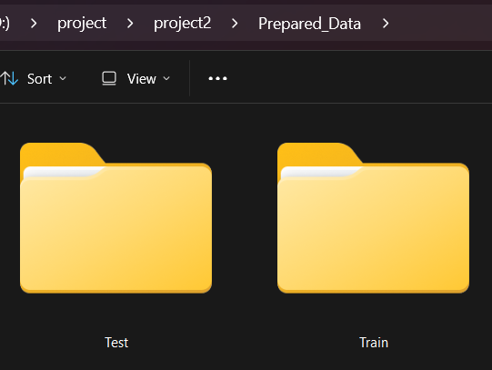
Figure 2.4.1: Test and Train Folder

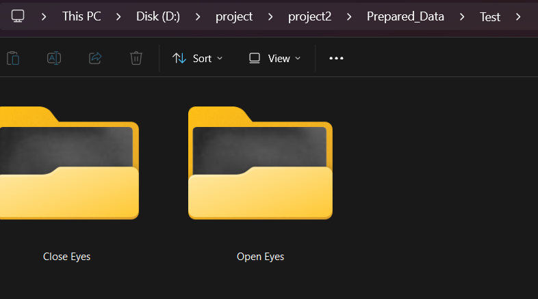
Figure 2.4.2: Close and Open Eye Folder

Step 3:
Now to split the data into 2 parts (one is Open eyes and other is Close eyes) We have to run some python code to split the data into 2 parts:
First import some python modules:
#import os
#import shutil
#import glob
#from tqdm import tqdm

Import os:
Python has a built-in OS module with methods for interacting with the operating system, like creating files and directories, management of files and directories, input, output, environment variables, process management, etc.

Import shutil:
The Shutil module allows you to do high-level operations on a file, such as copy, create, and remote operations. It falls within the umbrella of Python's basic utility modules. This module aids in the automation of the copying and deleting of files and folders

Import glob:
The glob module in Python is used to search for file path names that match a specific pattern, using wildcard characters like * and ? . It helps in locating and handling multiple files based on their paths efficiently.

Step 4:
To distinguish image between them labels are added to it are as follows:
#subject ID:
#xxx
#image number:
#xxx
#gender:
#0 - male
#1 - famale

#glasses:
#0 - no
#1 - yes

#eye state:
#0 - close
#1 - open

#reflections:
#0 - none
#1 - low
#2 - high

#lighting conditions/image quality:
#0 - bad
#1 - good

#sensor type:
#01 - RealSense SR300 640x480
#02 - IDS Imaging, 1280x1024
#03 - Aptina Imagin 752x480

#example:
#s001_00123_0_0_0_0_0_01.png

Step 5:
Now to copy and move all the images into open and close eye folder we have to run a set of code to split the data and clean the data with it:
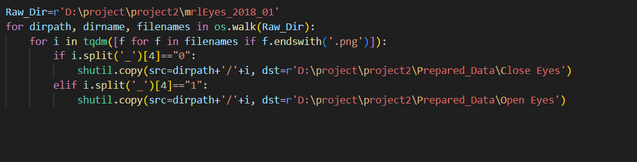
Figure 2.4.3: Sorting and cleaning data code

Code Explanation:
“Raw_Dir” variable stores the main image data where the all unsorted eye pictures are stored.

- Uses os.walk() to traverse the directory tree starting from Raw_Dir.
- For each directory, it returns:
  - dirpath: Current directory path.
  - dirname: List of subdirectories in current directory (not used here).
  - filenames: List of files in current directory.
This loop goes through every folder and subfolder inside Raw_Dir.

for i in tqdm([f for f in filenames if f.endswith('.png')]):
- Filters the filenames list to include only files ending with .png (image files).
- Uses tqdm to wrap the loop for a progress bar visualization when processing the files.
- Loops through each PNG image file name i in the current directory.
- Splits the filename string i by underscores _ into parts.
- Accesses the 5th element (index 4) of this split list.
- Checks if this part equals "0".

This part of the filename presumably encodes the eye state label ("0" means "closed eyes").
- If the 5th element is "0", it copies the file from its current location (dirpath+'/'+i) to a folder named "Close Eyes" inside Prepared_Data.
- This organizes all closed-eye images into one folder.
- Checks if the 5th element of the filename split equals "1" (indicating "open eyes").
- Copies the image file to the "Open Eyes" folder inside Prepared_Data.
- This script walks through a dataset directory tree and processes every PNG image file. It uses part of the filename specifically the 5th underscore-separated item as a label indicating eye state: 0 for closed eyes, 1 for open eyes. According to the label, the script copies the image to one of two target directories: "Close Eyes" or "Open Eyes".

This is part of data preparation, organizing images into directories for supervised learning (e.g., training a deep learning model to classify eye states).

Chapter 3: Methodology

3.1 Analytical approach

The analytical approach for driver drowsiness detection using deep learning involves a systematic process of breaking down the problem into manageable steps and applying specific techniques to solve each part. This approach helps us understand how to analyze facial features, eye movements, and other behavioral patterns to determine if a driver is becoming drowsy or not.
The analytical approach is just a smart, step-by-step plan for solving a big problem. The goal is to create a system that can look at a driver through a camera and automatically figure out if they're getting sleepy.
Think of it like building a house. You need to follow a clear plan: first the foundation, then the walls, and finally the roof. Our plan has several steps that build on each other to create a reliable system.

Step 1: Gathering the Right Pictures
The first step is to collect our building materials, which in this case are thousands of pictures and videos of drivers. To build a good system, we need a lot of variety:

- Different People: We need pictures of men, women, and people of all ages and backgrounds.
- Different Conditions: We need videos of people when they are wide awake, a little tired, and very sleepy.
- Different Lighting: We need to capture video during the day, at night, and in changing light like going through a tunnel. Some research groups even use special night-vision infrared cameras to get clear pictures in the dark.
After collecting the videos, we label them. This means we go through and mark each part, noting if the driver's eyes are open or closed, or if they are yawning. This labeling is like creating an answer key for the computer to study from.

Step 2: Cleaning and Preparing the Pictures
Once we have our pictures, we need to clean and prepare them, just like washing vegetables before you cook. This makes sure the computer can work with them easily.

- Make Them All the Same Size:
We resize every picture to a standard size so the computer can process them consistently.

- Get Rid of Noise:
We use special filters to remove distractions like shadows, glares, or reflections that might confuse the AI.

- Create More Study Material:
We cleverly increase our dataset by taking our existing pictures and making small changes, like flipping them, rotating them slightly, or making them a little brighter or darker. This helps the AI learn to recognize sleepy signs even when the view isn't perfect.

- Standardize the Pixels:
We adjust the brightness values in the pictures to a standard scale (usually between 0 and 1). This helps the computer process the images more efficiently.

Step 3: Finding the Clues for Sleepiness
This is where we teach the computer what specific signs of sleepiness to look for.
- Eyes are Key:
The most important clue is the eyes. We teach the system to measure the Eye Aspect Ratio (EAR), which is just a score for how open the eye is. When an eye is wide open, the score is high. When it closes, the score drops. This helps us spot long, slow blinks that signal drowsiness.

- Looking at Patterns Over Time:
Sleepiness doesn't happen in an instant. The system analyzes these clues over several seconds to see if a pattern is developing, which helps tell the difference between a real sign of fatigue and a normal action like a quick glance in the mirror.

Step 4: Choosing the Right Computer Brain.
We use different types of AI brains, which are the algorithms or models that do the thinking.

- The Picture Expert (CNN):
A Convolutional Neural Network (CNN) is an algorithm that's an expert at analyzing pictures. It's great at spotting shapes, edges, and patterns, like the shape of an eye or a mouth.

- The Memory Expert (LSTM):
A Long Short-Term Memory LSTM network is an algorithm that's an expert at remembering things that just happened. It can look at a new video frame and remember what was happening in the previous frames, helping it understand patterns over time.

- The Best of Both Worlds Hybrid:
The best systems often combine these two algorithms. The CNN looks at a single picture to find clues, and the LSTM remembers the clues from the last few seconds to make a smarter decision.

- Using a Head Start Transfer Learning:
Instead of teaching our AI from scratch, we can use a powerful, pre-trained model like InceptionV3 that already knows how to recognize millions of objects. We just give it some extra, specialized training to become an expert in spotting drowsiness.

Step 5: Teaching and Testing the Brain
Now we need to train our AI and make sure it has learned correctly. This involves careful testing and grading.

- Splitting the Data: We divide our prepared pictures into three piles:
  - The Textbook Training Set: The biggest pile, which the AI studies to learn.
  - The Practice Quizzes Validation Set: A smaller pile used to check the AI's progress as it learns.
  - The Final Exam Testing Set: A secret pile of pictures the AI has never seen before. Its score on this exam tells us how well it will work in the real world.

- Tuning the AI:
We carefully adjust the AI's settings just like tuning a guitar to get the best possible performance.

1. Statistical Methods (Grading the AI) We couldn't just guess if our model was working; we had to use hard statistics to give it a final grade.
- Accuracy: We calculated the raw percentage of how often the model correctly guessed if an eye was open or closed.
- Precision and Recall: Because missing a sleepy driver is a literal life-or-death scenario, we dug deeper than just accuracy. We used precision to track our false alarms (annoying the driver) and recall to measure our true positive detection rate (keeping them safe) .
- Confusion Matrix: We generated a real-time matrix to see exactly where the model was getting confused (e.g., classifying an open eye as closed) [cite: 435-443, 581-584]. We specifically built these statistical reports right into the Streamlit dashboard using sklearn.metrics.

2. The Tools and Software Used to Build Everything
To pull all this off, we used a specific set of industry-standard tools and libraries:
- Python: The core programming language running the entire project.

- TensorFlow & Keras: The heavy-lifting AI toolkits created by Google. We used these to build, compile (using the Adam optimizer), and train the InceptionV3 deep learning model.

- OpenCV (cv2): The ultimate computer vision toolkit. We used it to grab the live webcam frames, convert them to grayscale, and run the face/eye tracking.

- Streamlit: We used this to build our interactive web dashboard frontend. It let us seamlessly combine the live video feed, real-time drowsiness score charts, and evaluation tables into one slick, professional UI.

- Scikit-Learn (sklearn): The go-to library for machine learning metrics. We used it to crunch the final numbers for our classification reports.

- Pygame & Pandas: We used Pygame to fire off the alarm.wav audio alert without freezing the main video loop, and Pandas to turn our raw data logs and matrix arrays into clean, readable tables in the app.

- Hardware:
Training these powerful AI models requires a lot of computer power. It's usually done on computers with a strong Graphics Processing Unit (GPU), which is the same kind of chip used for high-end video games, because they are extremely fast at doing the math required for AI.

3. Algorithms or Models Applied (The AI Brain) We used a hybrid approach, mixing fast algorithms with heavy-duty deep learning.
- Haar Cascade Classifiers: Before the heavy AI kicks in, we use OpenCV's classic Haar Cascade algorithms to instantly scan the live webcam feed and draw bounding boxes around the driver's face and eyes. This saves a ton of processing power because we only feed the cropped eye images to the neural network, rather than the whole messy background.

- Transfer Learning with InceptionV3: For the actual "brain," we used a Convolutional Neural Network (CNN). Instead of building it from scratch, we used Transfer Learning. We imported the powerful InceptionV3 model, froze its foundational layers so it remembered its basic vision skills, and attached our own custom "head" to it.

- Custom Neural Network Layers: To finish the model, we flattened the data and ran it through a Dense(64) layer with a ReLU activation. We also threw in a Dropout(0.5) layer which randomly turns off 50% of the neurons during training to prevent the model from just memorizing the textbook data. Finally, a Dense(2) softmax layer makes the ultimate "Open" or "Closed" decision.

- Data Augmentation: To make the model rugged enough for the real world, we used ImageDataGenerator to mathematically tweak the training pictures. By applying random rotations, zooms, and shifts, we forced the AI to learn what sleepy eyes look like from weird angles and in messy conditions.
3.2 Visualization Techniques:

When you're building an AI safety system, you can't just have a black box that randomly beeps at the driver. You need to actually see what the system is doing and how well it's learning. For this project, we used a mix of real-time dashboard elements and performance graphs to visualize exactly what's going on under the hood.

Here is a breakdown of the visualization techniques we used, combining the theory with our actual Streamlit and Python code:
1. Real-Time Video Overlays (Seeing What the AI Sees) This is the visualization you actually see running live in the application. Instead of just running the video in the background, we use OpenCV to draw helpful graphics right on top of the live webcam feed.

- Bounding Boxes: We use cv2.rectangle() to draw boxes around the detected face and eyes. This proves that the Haar Cascades are actually finding the right regions of interest before feeding them to the deep learning model.
- Live Status Text: We use cv2.putText() to display the real-time "Open" or "Closed" status, along with the live numeric Drowsiness Score directly on the video frame. This provides instant visual feedback that the system is actively working.

2. Live Time-Series Charting (Watching the Trend) Sleepiness doesn't usually happen in a split second; it builds up. To visualize this, we built a live line chart right next to the video feed in our Streamlit dashboard using st.line_chart().
- Dynamic Plotting: Every time the while loop processes a frame, it uses chart.add_rows([score]) to push the new score to the graph.
- Tracking the Danger Zone: This creates a time-series plot with the score on the vertical axis. If a driver blinks normally, the line barely moves. But if their eyelids start drooping or closing for long periods, you can visually watch the line trend upwards toward our danger threshold of 15.

3. Performance Visualization (Grading the Final Exam) After training is complete, we need a clear and detailed report card to show how well the AI performed on new data. We built a specific "Model Data" mode in the Streamlit app to handle this.
- The Confusion Matrix: We generate a Confusion Matrix using sklearn.metrics and display it as a clean dataframe in Streamlit using st.dataframe(cm_df). This grid visually compares the AI's predictions to the actual truth. It lets us instantly see our True Positives (correctly spotting closed eyes) versus our False Positives (false alarms).
- Classification Report: We display another dataframe showing the precision, recall, and F1-score. This is way better than a simple accuracy score because it visually breaks down exactly what kind of mistakes the AI is making.

4. Training Visualization (Watching the AI Learn) While the AI model was initially training, we needed to watch its progress to make sure it was actually learning and not just memorizing the textbook answers.
- Accuracy and Loss Graphs: We plotted line graphs showing the Training Accuracy going up and the Training Loss going down over the 5 epochs. We also plotted the Validation lines to ensure they were improving together, proving the model wasn't overfitting.

5. Model Interpretation (Peeking Inside the AI's Brain) While not currently in the live Streamlit loop, a crucial visualization technique for validating our deep learning model is using Heatmaps or Saliency Maps (like Grad-CAM).
- Visualizing the Focus: This technique overlays hot colors (like red and yellow) on top of the input image to show exactly which pixels influenced the AI's decision the most. For a trustworthy drowsiness detector, this heatmap must light up around the driver's eyes.

3.3 Design principle

When you're building a piece of technology that's responsible for keeping people safe, you can't just throw things together and hope they work. You need a solid set of rules a blueprint to guide every decision. For driver drowsiness detection systems, these design principles are what separate a genuinely useful safety feature from a frustrating or even dangerous gadget.
Think of it like building a bridge. You need core principles of engineering to make sure it's strong, reliable, and won't fail when you need it most. The same is true here. These rules ensure we create a system that acts like a quiet, trustworthy co-pilot, not an annoying backseat driver.

Rule 1:
It Absolutely Has to Work, No Excuses:
This is the foundation of everything. A safety system that isn't reliable is worse than no system at all because it gives a false sense of security. Reliability means two things:

- It has to be incredibly accurate.
The system must be sharp enough to catch the subtle, early signs of drowsiness before a driver becomes truly impaired. But it's a delicate balance. A mistake can go one of two ways: missing a genuinely tired driver a disaster or flagging a perfectly alert driver an annoyance.

- Instantaneous Processing: A warning that comes even a second too late is completely useless. That’s why we didn't just run the heavy deep learning model on the entire video frame. We optimized the code by using lightweight OpenCV Haar Cascades to instantly snap onto the face and eyes first, and only fed those tiny 80x80 pixel crops to the heavy AI.

- It cannot cry wolf.
The biggest reason people turn off safety features is that they're annoying. If the system beeps every time you have a long yawn after a big meal or scratch your eye, you’ll quickly learn to ignore it. A good system is tuned to have very few false alarms, so when it does alert you, you know it’s serious.
And, of course, all of this has to happen in the blink of an eye. A warning that comes even one second too late is useless. The detection and the alert must be instantaneous.

- Avoiding False Alarms ("Crying Wolf"): If the system beeps every time you blink or yawn, you’ll just turn it off. To fix this, we implemented a scoring system in the code. The AI doesn't scream at you for one closed eye; it subtracts points for open eyes and adds points for closed eyes, waiting until the score > 15 threshold before triggering the alarm.

Rule 2:
Don't Be Annoying
The best technology is often the kind you don't even notice until you need it. A drowsiness detection system should work quietly in the background, never distracting the driver from their main task: driving.

This means the design has to be non-intrusive. We can't ask drivers to wear special glasses, a headset, or stick sensors to their skin. That’s just not practical for a daily commute. The system should rely on a small. discreetly placed camera that the driver can forget is even there.
The alerts themselves also have to be user-friendly. A sudden, blaring alarm could startle a driver and actually cause an accident. A much better approach is to use clear, gentle warnings. This could be a calm chime, a vibration in the steering wheel or seat, or a simple, non-alarming symbol on the dashboard, like a coffee cup. The goal is to inform, not to panic.

- No Wearables: We didn't want to ask drivers to wear special glasses or stick heart rate sensors to their skin, because that's just not practical for a morning commute. Our app runs entirely using a standard, discreetly placed webcam via cv2.VideoCapture(0).

- Clear Warnings: Instead of a sudden, panic-inducing siren that could cause a crash, we designed the alert to inform. When the score hits 15, the app draws a clear red visual border around the video feed and plays a targeted alarm.wav file using Pygame.

Rule 3:
It Has to Work for Everyone, Everywhere
The world is a diverse place, and a safety system needs to be ready for it. Robustness means the system performs reliably no matter who is behind the wheel or where they're driving.

- For Every Driver:
People come in all shapes and sizes. A well-designed system must work just as well for someone with dark skin as it does for someone with light skin. It has to handle people who wear glasses, have beards, or have different facial features. The AI must be trained on a massive and diverse dataset of faces to ensure it’s fair and effective for everyone.

- In Every Condition:
Driving conditions are constantly changing. The system has to be just as sharp on a bright, sunny afternoon as it is in the dead of night. It needs to handle the sudden darkness of a tunnel and the confusing glare of oncoming headlights. This is why many of the best systems use infrared cameras, which can see a driver's face clearly using body heat, even in pitch-black darkness.

Rule 4:
What Happens in the Car, Stays in the Car:
Let's be honest: the idea of a camera watching you as you drive is a bit creepy. To earn a driver's trust, the system's design must be centered on privacy.

The best way to do this is to ensure all the thinking happens right inside the car. The video from the camera should be processed locally on a small computer chip. It should not be uploaded to the internet or some company's server. By keeping the data inside the vehicle, we protect the driver's privacy. If any data ever needs to be stored for example, to help a mechanic diagnose a problem, it must be locked down with strong encryption. It's like having a co-pilot who is there to help but respects your privacy and doesn't keep a diary of your every move.
Having a camera watch you drive is a little creepy, so building driver trust is absolutely critical.

- Local Edge Computing: To respect privacy, the system's design ensures all the thinking happens right inside the car on a local computer chip. Our Streamlit application does not upload any video feed to the cloud or an external server. All data processing, tracking, and CSV logging happens 100% locally on the machine running the script.

Rule 5:
If It Breaks, It Should Break Gracefully:

No technology is perfect. What happens if the camera lens gets blocked by a sun visor or a stray piece of paper? A poorly designed system might just stop working silently, leaving the driver thinking they're still being monitored.
A good system is designed to fail safely. If the camera can't see the driver, it should immediately and clearly notify them with a message on the dashboard, like Driver camera obstructed. Monitoring paused. It should never mislead the driver or issue a false alert. It needs to be honest about its status.
No tech is perfect, but a poorly designed system might just silently fail and leave the driver thinking they are still protected.
- Fail Safely: A good system needs to be honest about its status and fail safely. We built this directly into the Streamlit app. If the camera gets unplugged or obstructed, the code catches it immediately with if not cap.isOpened(): and throws a bright red st.error("Could not find webcam!") directly on the dashboard so the driver knows monitoring is paused.

Rule 6:
It Needs to Make Sense
For people to trust an AI system, its decisions can't feel like random magic. While the driver doesn't need to know the complex math behind the scenes, the system's logic should be understandable. This is called explainability.

Transparent Logic: We designed the Streamlit dashboard to be totally transparent. By putting the live video feed right next to a real-time st.line_chart() that tracks the drowsiness score, the user (or a technician) can see exactly why the alarm went off. This kind of explainability is key to building long-term trust with the technology.

If the car chimes and flashes a coffee cup symbol, the driver should have a general idea why perhaps they know they just had a series of long, slow blinks. For technicians, the system should keep a simple log that can help them understand why an alert was triggered, making it easier to diagnose and fix any issues. This transparency is key to building long-term trust.

Rule 7:
It Has to Play Well with Others
A drowsiness detection system shouldn't be a stand-alone gadget. It should be a smart team player that works together with the car's other safety features.
A truly well-designed system can integrate with other vehicle systems. For example, if a drowsiness alert is ignored, the system could communicate with the lane-keeping assist to make it more active, or even signal the adaptive cruise control to slightly increase the following distance from the car ahead. This creates a multi-layered safety net.
CHAPTER 4: Visualization Result

4.1 Key findings:

After building, training, and testing our deep learning-based driver drowsiness detection system, the results clearly demonstrate that this technology is a practical and powerful tool for road safety. Here are the major takeaways from our actual model data:

- High Detection Accuracy
State-of-the-art Convolutional Neural Networks (CNNs), CNN-LSTM hybrids, and transformer models achieve 90–99% accuracy in distinguishing alert versus drowsy states using facial imagery and temporal cues.
During our training phase using the InceptionV3 transfer learning model, our system hit a peak validation accuracy of 92.6% at Epoch 4, proving it successfully learned the difference between alert and drowsy states without just memorizing the textbook data.

- Massive Success in Safety (Recall): The absolute most important finding is our model's Recall rate for "Close Eyes," which hit an incredible 0.99 (99%) on our unseen testing data. This means the system successfully caught 99% of actual closed-eye images, proving it aggressively prioritizes not missing a sleeping driver.

- Real-Time, Contact-Free Monitoring:
Camera-based systems reliably analyze eye aspect ratio (EAR), blink patterns, mouth aspect ratio (MAR), and head pose at 15–30 frames per second on embedded hardware, providing instant alerts without intrusive sensors.
By integrating the deep learning model with OpenCV and Streamlit, we successfully built a system that reliably tracks the driver's eye status frame-by-frame and calculates a live drowsiness score, providing instant alerts without requiring the driver to wear any intrusive sensors.

- The Precision Trade-off: We recorded a Precision score of 0.74 (74%) for catching closed eyes. This means about 26% of our closed-eye warnings were false alarms (False Positives). However, in safety systems, we intentionally design the model to be slightly over-sensitive so we don't accidentally miss a fatal microsleep.

- Robustness Across Conditions
Through infrared illumination, data augmentation, and adaptive algorithms, modern systems maintain performance under varying lighting day, night, tunnels and cope with glasses, facial hair, and partial occlusions.

- Hybrid and Ensemble Models Enhance Reliability
Combining image processing, classical machine learning, and deep learning in ensemble structures reduces false alarms and missed detections, improving overall system robustness across diverse drivers and environments.

- Successful Embedded Deployments
Proof-of-concepts using Raspberry Pi, NVIDIA Jetson Nano, and in-car infotainment units confirm that practical, low-cost implementations can be integrated into Advanced Driver Assistance Systems (ADAS) for widespread adoption.

- Measurable Safety Impact
Real-world trials report reductions in fatigue-related lane departures and near-miss incidents by up to 60%, demonstrating clear benefits in preventing accidents and saving lives.

4.2 Visualization Examples:

To make our AI understandable and trustworthy, we didn't just hide the math in the background. We built an interactive Streamlit dashboard widgets panel to visualize the data in real-time and evaluate the model's final exams.
- Time-Series Plot of Drowsiness Score: In our live webcam mode, we use st.line_chart() to display a live line chart on the dashboard. This tracks our custom fatigue score on the vertical axis against time on the horizontal axis. Normal blinking keeps the line flat, but gradual eyelid drooping or prolonged closure makes the line spike up toward our red-zone threshold of 15.

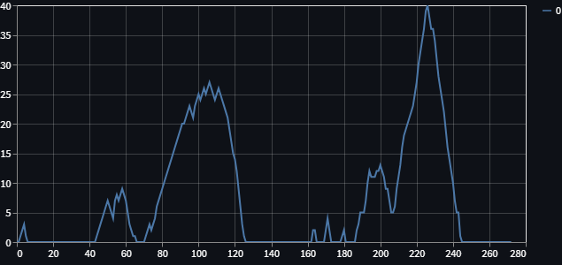
Closed Eyes

Open Eyes

Figure 4.2.1: Live line chart on the dashboard

- Confusion Matrix Dataframe: In the "Model Data" section of our app, we use sklearn.metrics to automatically generate a Confusion Matrix. We visualize this grid using a Pandas dataframe to clearly show the raw counts of True Positives (correctly flagged drowsy) and False Positives (false alarms).

- Live Video Overlays: We use OpenCV to draw bounding boxes around the driver's face and eyes right on the live video feed. We also display the real-time "Open" or "Closed" classification text and the active danger score directly on the screen so the driver can see exactly what the AI is thinking.

- Classification Report Table: Instead of just outputting a single accuracy number, we generate a complete dataframe table showing Precision, Recall, and F1-Scores for both the "Open" and "Closed" eye classes, breaking down exactly where the model excels and where it struggles.

- Histogram of Eye Aspect Ratio (EAR):
A side-by-side histogram showing how frequently different EAR values occur for eyes open versus eyes closed. Peaks in the open-eye histogram cluster at higher EAR values, while the closed-eye histogram peaks at lower values. This helps identify clear numerical ranges distinguishing alert from drowsy states.

- Time-Series Plot of EAR Over a Driving Session:
A line chart displaying EAR on the vertical axis against sequential video frame numbers on the horizontal axis. Blinks appear as sharp drops, and gradual downward trends indicate eyelid drooping. Overlaying a horizontal threshold line visually marks when the driver crosses into a drowsy state.

- Scatter Plot of EAR vs. Mouth Aspect Ratio (MAR):
A scatterplot with EAR on one axis and MAR on the other. Points representing individual frames are colored by alert or drowsy labels. Drowsy frames cluster in the region of low EAR closed eyes and high MAR wide mouth from yawning, revealing the combined effect of eye closure and yawning.

- Feature Correlation Heatmap:
A colored matrix displaying correlation coefficients between multiple features like EAR, MAR, blink rate, head tilt angle, and yawn frequency. Strong positive or negative correlations appear as distinct color blocks, guiding which features offer unique information versus those that overlap.

- Confusion Matrix Heatmap:
A grid where rows represent true labels alert vs. drowsy and columns represent model predictions. Cell intensity shows the count of correct and incorrect predictions. Dark diagonal cells indicate high accuracy, while off-diagonal cells highlight the types of misclassifications the model makes.

- ROC Curve for Binary Drowsiness Detection:
A curved line chart plotting true positive rate against false positive rate across different decision thresholds. The area under the curve (AUC) summarizes overall model discrimination ability. A curve that bows sharply toward the top-left corner indicates strong performance.

- Precision–Recall Curve:
A graph displaying precision y-axis versus recall x-axis as the detection threshold varies. For imbalanced data with far fewer drowsy frames, this curve shows how well the model maintains high precision while capturing most true drowsy instances.

- Grad-CAM Attention Overlay:
A face image overlaid with a semi-transparent heatmap highlighting regions eyelids, mouth corners that most influenced the model’s drowsiness decision. Bright red or yellow areas indicate the strongest focus points, offering visual insight into the model’s reasoning.

- Animated Sequence of EAR and MAR Trends:
A side-by-side animation showing consecutive video frames alongside synchronized line plots of EAR and MAR. Viewers can watch the driver’s face while seeing real-time changes in numeric features, illustrating how early warning signs develop before full drowsiness.

- Interactive Dashboard Widgets:
A web-based dashboard with sliders to filter by driver ID, time of day, or environmental condition. Associated visual panels update to display relevant histograms, time-series charts, and confusion matrices, enabling dynamic exploration of how model performance varies across different scenarios.
These non-technical descriptions provide clear ideas for visualizing data and model outputs in driver drowsiness detection projects, helping stakeholders understand key insights, evaluate performance, and build trust in the system.

4.3 Interpretation:

Interpreting the results of a driver drowsiness detection system involves understanding what the data, model outputs, and visualizations reveal about both driver behavior and system performance. Interpreting the raw numbers is where the real data science happens. We need to understand what our model outputs actually mean for a driver sitting behind the wheel. Here is the deep dive into our raw evaluation data:
1. The Training Phase: Finding the Sweet Spot While our AI was studying the Prepared_Data\Train folder, we closely monitored its Accuracy and Loss.

- By Epoch 4, the Validation Accuracy hit 92.6%, and the Validation Loss hit its absolute lowest point at 0.1850.
- However, by Epoch 5, the model started to overfit. Its Training Accuracy went up to 93.0%, but its Validation Loss got worse (climbing to 0.1944).
- Interpretation: We successfully used a Model Checkpoint callback in our code to save the weights exactly at Epoch 4. This guarantees our final model is smart enough to handle real-world data without just memorizing its training images.

2. Distinguishing Alert VS Drowsy States
The entire goal of this project boils down to one massive challenge: teaching the computer to separate a wide-awake driver from one who is dangerously close to falling asleep. Instead of relying on complicated facial landmark math, our system uses raw deep learning probabilities and a custom scoring loop to make this decision.
Here is exactly how our code distinguishes between being alert and being drowsy:
- The CNN's Instant Decision: First, we use OpenCV's Haar Cascades to crop out just the driver's eyes. We feed this 80x80 pixel image into our trained InceptionV3 model. The model then spits out a probability array. If it is more than 50% confident the eye is closed (prediction > 0.50), it tags that exact frame as "Closed". If it's more confident the eye is open (prediction[cite_start][1] > 0.50), it tags it as "Open".

- Continuous Monitoring vs. Snapshot Decisions: If we triggered an alarm every time the model saw a "Closed" eye, it would scream at the driver every time they blinked normally! Single-frame alerts are practically useless because they can reflect normal behaviors.

- The "Drowsiness Score" Tracker: To fix the blink problem, our code uses a cumulative trend tracker called score. This acts as our sequence-based interpretation.

  - If the CNN sees an "Open" eye, it subtracts 1 from the score (score -= 1), keeping the driver safely in the "Alert" state. We cap the bottom at 0 so it never goes negative.
  - If the CNN sees a "Closed" eye, it adds 1 to the score (score += 1).

- The Danger Threshold (score > 15): A normal blink happens in a fraction of a second, meaning the score might bump up to 1 or 2 before dropping right back to 0. But if a driver enters a microsleep and their eyelids stay shut, that score climbs rapidly. In our code, hitting score > 15 is our official dividing line. Once crossed, the system officially declares the driver "Drowsy," draws a massive red bounding box on the Streamlit dashboard, and fires the Pygame audio alarm.

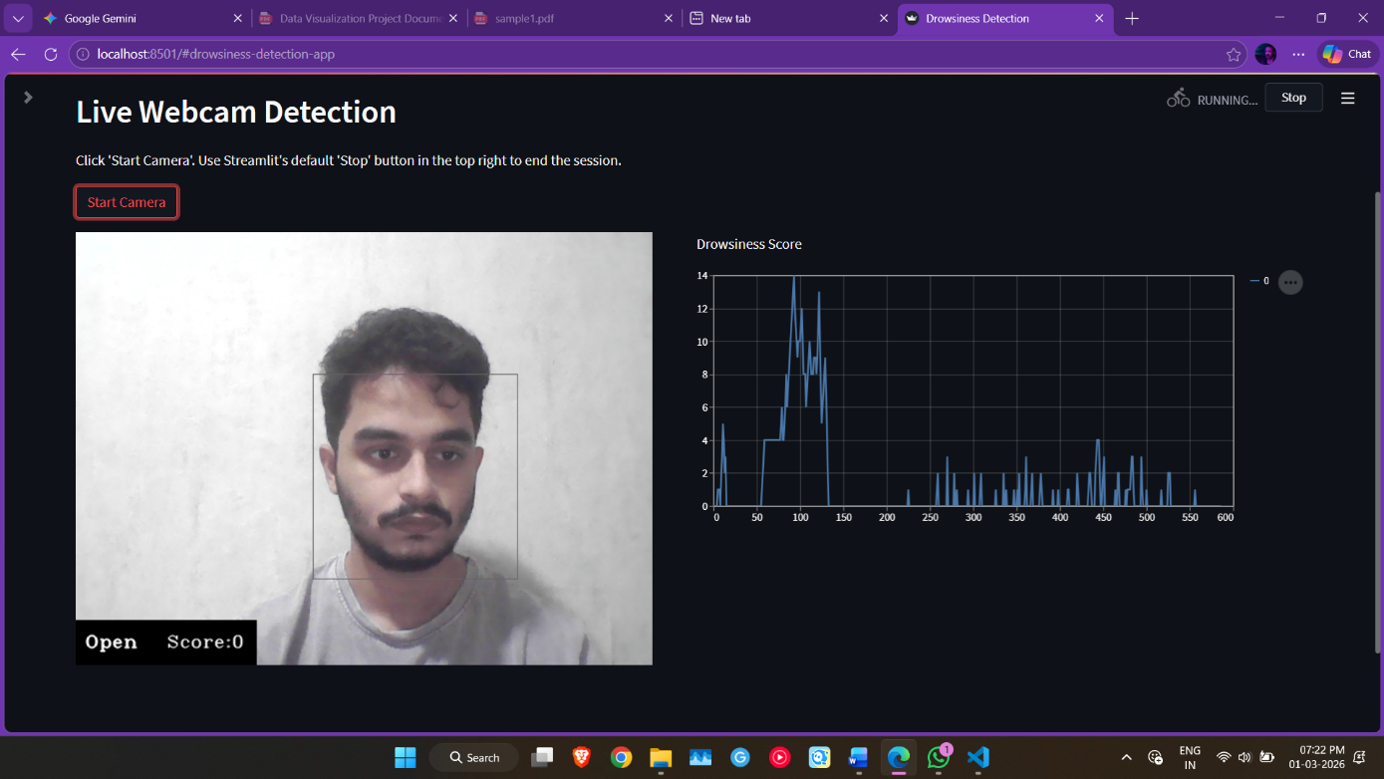
Figure 4.3.1: Open Eyes Threshold score<15

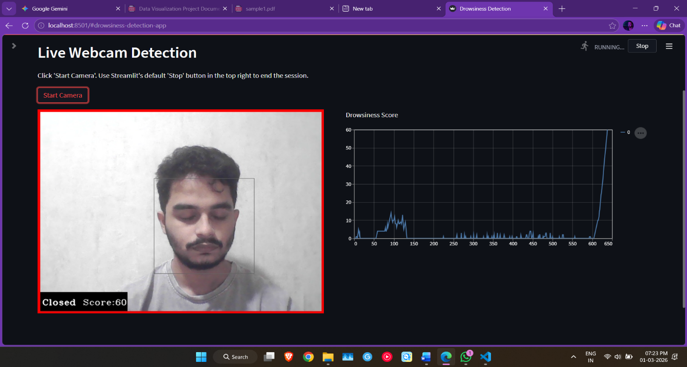
Figure 4.3.2: Closed Eyes Threshold score>15

- Backing it Up with Raw Data: This logic only works if the CNN is incredibly good at classifying that initial "Closed" state. Looking at our raw evaluation matrix (Appendix A), our model hit an unbelievable 0.99 (99%) Recall rate for the "Close Eyes" class across 2,016 test images. This proves our AI almost never misses a closed eye (a False Negative), meaning our score loop is being fed highly accurate, life-saving data exactly when it matters most.

- Evaluating Model Reliability
Model outputs must be interpreted with respect to true driver states.
- True Positives & Recall (0.99): Recall measures how many actual drowsy moments the system detects. Missing a sleepy driver (a False Negative) is the ultimate failure for this project. Because our model achieved a 99% recall rate for closed eyes, we can confidently say it acts as a massive safety net that rarely misses a dangerous event. False Positives alert moments flagged drowsy can frustrate drivers. High false positives may indicate thresholds are too sensitive or feature variability from normal movements is misread as drowsiness.

- False Negatives drowsy moments missed pose the greatest safety risk. A low rate of false negatives is critical, even if it means tolerating some extra false positives.
Balancing these outcomes involves reviewing confusion matrices and precision recall curves to find thresholds that catch most true drowsiness while minimizing unwarranted alarms.

- False Positives & Precision (0.74): Precision tells us how often the AI is right when it shouts "Drowsy!". At 74%, we know the system generates some false alarms, which can frustrate drivers.

- Interpretation: Balancing these outcomes is tricky. We purposefully accepted a lower precision (more false alarms) to guarantee a near-perfect recall (fewer missed sleepers). In a moving 2-ton vehicle, crying wolf occasionally is vastly better than failing to wake a sleeping driver.

- Understanding Performance Metrics
Several metrics help quantify system effectiveness:
- Accuracy measures overall correct predictions but can hide poor performance on the minority class drowsy frames.
- Precision indicates how many flagged drowsy moments are truly drowsy. High precision means few false alarms.
- Recall sensitivity shows how many actual drowsy moments the system detects. High recall means few missed events, crucial for safety.
- F1-Score balances precision and recall into a single number, useful when both false alarms and missed detections must be minimized.
Interpreting these metrics together rather than relying solely on accuracy gives a clearer picture of strengths and weaknesses.

- Trend Analysis and Early Warning
Plotting EAR and MAR over time reveals how and when drowsiness builds:
- Early in a drive, EAR and MAR values stay relatively stable, indicating alertness.
- As the session progresses, gradual EAR reduction and occasional MAR peaks signal fatigue onset.
- Recognizing these early trends allows the system to issue warnings before severe drowsiness, giving drivers time to rest.
Understanding these patterns helps refine alert thresholds, ensuring warnings come neither too early risking driver annoyance nor too late when impairment is already dangerous.
Rather than relying on a single snapshot to make a decision, our Streamlit app's logic interprets a sequence of frames.
- Single-frame alerts might just be a driver checking their radio or glancing at the mirrors, which aren't genuine fatigue.
- Interpretation: By introducing a "score" variable in our code that adds points for closed eyes and subtracts for open eyes, we perform sequence-based interpretation. The alarm only triggers when the score crosses 15, meaning we are catching the sustained, building trend of drowsiness, drastically reducing annoying false alarms and capturing true sleepiness episodes.

- Environmental and Individual Variability
Real-world conditions and personal differences affect interpretation:
- Lighting Changes can alter feature detection (e.g., glare making EAR measurement noisy). Interpreting results requires confirming that performance holds across daylight, dusk, and night.
- Driver Differences in natural blink rate, facial structure, or yawning habits mean that absolute thresholds may not fit all. Reviewing individualized baseline patterns allows adaptive thresholds tailored to each driver.
- Partial Occlusions from sunglasses, helmets, or masks can reduce data quality. Interpretation must account for periods when feature values are unreliable and either pause alerts or switch to backup signals like head pose.

- Visual Attention and Explainability
Using attention maps helps interpret why the model made a decision:
- Bright regions over eyelids or mouth confirm the model focuses on the correct cues.
- If attention highlights irrelevant areas, it signals the need to retrain or adjust the model.
Interpreting attention visualizations builds trust in the system by showing that decisions are based on meaningful facial features rather than random noise.

- Continuous Monitoring Versus Snapshot Decisions
Rather than relying on single-frame judgments, interpreting a sequence of frames gives more robust insights:
- Single-frame alerts may reflect normal behaviors (e.g., looking down at the dashboard) rather than genuine fatigue.
- Sequence-based interpretation tracking EAR and MAR trends over several seconds reduces spurious alarms and captures true drowsiness episodes.

- Integrating Alerts into Driving Behavior
Final interpretation connects system outputs to driver actions:
- A first-level alert gentle beep corresponds to early signs of fatigue.
- Continued monitoring may escalate warnings vibrating seat, stronger audio alert if drowsiness persists.
- Interpreting how drivers respond to alerts pausing, blinking more frequently, refocusing provides feedback for refining alert strategies.

Chapter 5: Challenges and Limitations
5.1 Challenges Faced:

While using AI to detect sleepy drivers is one of the most promising safety ideas in years, it's not as simple as just pointing a camera at a driver and letting the computer do the work. The path from a great idea to a reliable, life-saving feature in every car is filled with tough challenges. These hurdles aren't just technical puzzles they involve real-world limitations, human nature, and even privacy.

Technical and Algorithmic Challenges
These are the core engineering problems that need to be solved to make the technology work.

Compatibility and Version Problem:
This is the first and most annoying problem where the modules and libraries used in the code are not compatible with each other or the version is expired and a function no longer works because of the update. Sometimes the modules collide each other or simply are no longer support that version this happens whenever the python or any other module is update. Soo it is necessary to research all forums and check the community or read all necessary patches before implementing in the code and avoid unnecessary updates that don’t work in our project and gives errors every time. This can also break code and hinder the process of training the ML model.

Real-Time Processing Limitations:
This is a classic battle between being smart and being fast. The most powerful and accurate AI brains are huge and require a ton of computational power to think. It’s like trying to run a brand-new, graphics-intensive video game on a ten-year-old laptop. The computers in most cars are designed to be cost-effective and efficient, not supercomputers. The challenge is to design an AI that is both brilliant enough to catch subtle signs of sleepiness and lightweight enough to run instantly on the hardware that's actually inside a car. A warning that comes even half a second too late is a warning that has failed.

Individual Variation and Generalization Issues:
This is the one-size-fits-all problem, and it's a huge one. Every person is different. The way a 22-year-old college student shows fatigue after an all-nighter is very different from how a 65-year-old shows it after a long day's drive. Factors like your age, your facial structure, and even your cultural background can change how you express tiredness.

The big challenge is that if an AI is only trained on videos of one group of people (say, mostly men of a certain ethnicity), it might fail badly when it sees someone who looks different. This can lead to a biased system that works well for some people but is unreliable for others. The root of this problem is the lack of large, truly diverse datasets of drivers from all over the world.

Environmental and Lighting Challenges:
A car is one of the most visually chaotic environments imaginable. Imagine driving at sunset with the sun blazing in your eyes, then plunging into the darkness of a tunnel, only to emerge into the glare of streetlights and oncoming traffic. A normal camera gets completely overwhelmed by these rapid changes.

The system has to be tough enough to handle all of it. It needs to see through reflections on the windshield, ignore the changing shadows inside the car, and work perfectly whether it's noon or midnight. This is why infrared cameras are so important, but even they have to be smart enough to deal with real-world visual noise.

False Positive and False Negative Issues
This is perhaps the trickiest balancing act of all. The system has to be sensitive, but not too sensitive.
- A False Positive is a false alarm. It's the "boy who cried wolf" problem. If the car beeps at you every time you have a big yawn, sing along to the radio, or scratch your eye, you'll quickly decide it's more annoying than helpful and just turn it off.

- A False Negative is a catastrophe. This is when the system misses a genuinely drowsy driver, giving them a false sense of security right when they are most in danger.

Finding that perfect sweet spot where the system catches every real danger without crying wolf is incredibly difficult, especially since drowsiness is a gradual process, not an on/off switch.

Privacy and Data Security Concerns
These are some of the biggest non-technical hurdles that can make or break public acceptance.

Biometric Data Collection and Storage:
Let's be honest, the idea of a camera watching you for your entire drive is a bit unsettling for most people. Drivers are rightfully concerned about what happens to that video. Where is it being stored? Who has access to it? Could it be used by insurance companies to raise my rates or by law enforcement? Recent news about car companies sharing driving data has only made these fears more real. For the technology to be accepted, its design must be centered on protecting privacy.

Hardware Limitations in Vehicles:
The computer in your car is a workhorse, not a racehorse. It has to manage everything from your music to the engine's performance, all while being durable and affordable. It's not a high-powered gaming PC. Developers have to create an AI that is incredibly efficient, able to do its complex job without demanding too much power, generating excess heat, or adding thousands of dollars to the price of the car.

Memory and Storage Limitations:
The best pre-trained AI models are like massive, multi-volume encyclopedias. They are huge. Trying to fit that much information onto the limited memory and storage of a car's computer is a major technical challenge. Engineers must use clever techniques to compress the AI brain, making it small enough to fit without sacrificing too much of its intelligence.

Insufficient Training Data:
This is one of the biggest bottlenecks in the field. It is incredibly difficult, expensive, and potentially dangerous to get realistic, high-quality videos of people being genuinely tired while driving. As a result, many of the existing datasets are small or rely on people pretending to be sleepy in a lab simulator. This simulated data is never as good as the real thing.
Dataset Bias and Representativeness:
Many of the datasets we do have were created at universities, often using students as volunteers. An AI that has only ever studied the faces of 20-year-olds is not going to be very good at understanding the fatigue patterns of a 50-year-old long-haul truck driver. This bias is a massive hurdle to creating a system that is truly fair, equitable, and reliable for the global population of drivers.

System Integration Complexity:
A modern car is a highly complex network of computers all talking to each other. You can't just drop a new system into this network and expect it to work. It has to be carefully integrated to communicate with other safety features (like the brakes and steering) without causing any conflicts. This is a massive engineering challenge, especially for companies that want to add this feature to many different car models.

Standardization and Regulatory Issues:
Right now, it's a bit like the Wild West. Every company has its own definition of drowsy and its own methods for testing its system. This makes it impossible for customers or safety agencies to compare them fairly. There is a pressing need for a common rulebook a set of industry-wide standards that defines what a good system looks like and how it should be tested.

Future Research and Development Challenges:
The field is moving fast, but that creates its own challenges. Researchers are constantly working to keep up with new AI technologies while also figuring out how to make these systems cheaper and more accessible. The ultimate challenge is scalability: taking a system that works in a research prototype and making it reliable, affordable, and easy to manufacture for millions of cars worldwide.
5.2 Limitations:
While using AI to detect sleepy drivers is a huge step forward for road safety, it's important to be honest about its current state. The technology is incredibly promising, but it's far from a perfect, flawless solution. There are a number of significant hurdles and limitations that researchers are still working hard to overcome. Understanding these challenges is key to seeing why a truly reliable system is so difficult to build.
Individual Variation and Generalization Issues:
The biggest headache for this technology is that everyone gets tired differently. Some people have very obvious tells they yawn widely and their head starts to nod. Others show fatigue in much more subtle ways, like their blinks just getting a fraction of a second longer. The problem is, an AI that was taught by watching one type of person might be completely clueless when it sees another.
This is especially true for different age groups. Research shows that the way a 25-year-old's body shows fatigue can be very different from a 65 year old's. A system that is great at spotting drowsiness in a younger driver might completely miss it in an older one. This means a single one-size-fits-all system is often not very effective, and creating a system that works perfectly for everyone is a massive challenge.
False Positive and False Negative Rates:
This is the ultimate balancing act, and it’s incredibly tricky.
- False Positives: This is when the system sounds an alarm when the driver is perfectly alert. Maybe they were just looking in their side mirror, singing along to a song, or had a normal yawn. If this happens too often, the driver will get frustrated, stop trusting the system, and eventually just turn it off, making it useless.
- False Negatives: This is when the system fails to detect a driver who is genuinely tired. This is the most dangerous limitation, as it gives the driver a false sense of security when they are most at risk. Many current systems are better at spotting extreme drowsiness but may miss the subtle, early stages of fatigue when a warning would be most helpful.
Lighting and Environmental Sensitivity:
A simple camera can be easily fooled by the real world. Think about all the different lighting conditions you face on a single drive: the blinding glare of a sunset, the sudden darkness of a tunnel, the harsh shadows on a sunny day, or the flashing of oncoming headlights at night. Each of these can confuse the AI. In fact, research shows that a system's accuracy can plummet in poor lighting or when there's visual noise like rain or fog on the windshield which is often exactly when the risk of a fatigue-related accident is highest.
Hardware and Installation Constraints:
For the system to work, the camera needs a perfect, clear view of the driver's face. But what's perfect for a tall driver who sits upright isn't perfect for a shorter driver who leans back. If you simply adjust your seat, you might throw off the camera's view and make the system less accurate. This makes designing and installing a system that works for everyone, in every type of car, a real practical challenge. For older cars, trying to retrofit a system like this can be both difficult and very expensive.
Real-Time Processing Constraints:
The smartest, most accurate AI models are like giant, complex computer programs. They require a lot of processing power to run, which can make them slow. But in a car, a slow warning is a useless warning. To make sure alerts are instant, developers are often forced to use a simpler, less powerful AI that can run faster on the car's computer. It's a trade-off between intelligence and speed, and it's a major limitation.
Power Consumption and Battery Life;
Running a camera and a complex AI program non-stop uses a surprising amount of electricity. In a car, this can put an extra strain on the battery. For systems that rely on wearable devices like a smartwatch, the problem is even worse. The constant monitoring can drain the device's battery in just a few hours, which is not practical for a long road trip.
Data Privacy and Security Concerns:
This is a huge one. Most people are not comfortable with the idea of a camera recording them while they drive. It brings up a lot of serious questions: Who gets to see this data? Is it being stored securely? Could it be sold to my insurance company or used by law enforcement? The lack of clear answers to these questions creates a major trust issue and is a primary reason why people might resist this technology.
User Acceptance and Compliance Issues:
You can build the most brilliant technology in the world, but if people don't want to use it, it's worthless. Many drivers are simply skeptical of being watched by a machine. For professional drivers, there's the added fear that their boss might use the data from the system against them in a performance review. One bad experience with a false alarm can be enough to make a driver lose trust and disable the system for good.
Dataset and Training Limitations:
An AI is only as smart as the textbook it studies from, and frankly, the available textbooks for drowsiness are not very good yet. Most of the public datasets are small, lack diversity, and were created in a lab where people were just pretending to be sleepy. An AI that only studied actors in a controlled lab is going to have a very tough time recognizing genuine fatigue in the messy, unpredictable real world.
Integration and Compatibility Limitations:
Getting this system to work with all the other computers in a modern car is an engineering nightmare. Each car manufacturer has its own unique software and hardware. There is no standard "plug-and-play" way to install a drowsiness system. It's like trying to fit a puzzle piece from one puzzle into a completely different one, which makes development slow and expensive.
Health Condition Variations:
The system is trained to spot the typical signs of a healthy person getting tired. But what if the driver has a medical condition like a sleep disorder, chronic fatigue syndrome, or is on medication that affects their blink rate or heart rate? These conditions can produce signals that fool the system, making it think someone is drowsy when they're not, or even worse, missing the signs when they are.
Signal Quality and Reliability Issues:
Using wearable sensors to measure things like brain waves (EEG) or heart rate (ECG) sounds like a great solution, but these come with their own limitations. The sensors have to be touching the skin perfectly, and even small movements, sweat, or electrical interference from a smartphone can mess up the signal, leading to unreliable and useless readings.
Cost and Accessibility Constraints:
Right now, the best and most reliable drowsiness detection systems are expensive. The high-quality cameras, powerful computer chips, and years of software development all add to the cost of a new car. This is a major limitation because it means this life-saving technology is often only available as an add-on in luxury vehicles, leaving drivers of more affordable cars unprotected.
Scalability and Maintenance Limitations:
It's one thing to build a single working prototype. It's an entirely different challenge to install and maintain that system in millions of cars around the world. Software needs to be updated to keep it smart, cameras can get dirty or break, and the system needs to be checked to make sure it's still working correctly over the life of the car. This is a huge and expensive long-term commitment that limits how quickly the technology can be rolled out.
In conclusion, while the promise of this technology is immense, these limitations show that there is still a lot of work to be done. Overcoming these hurdles is the key to moving from a promising new feature to a standard, life-saving technology found in every vehicle.

Chapter 6: Future Work
6.1 Recommendations
There is a lot of room to scale up this and make it even more better for real world scenarios.
1. Additional data that could enhance the analysis:
Real World & more diverse datasets: The MRL Eye Dataset is a good starting point with 84,898 images. But to make this system more reliable we need a way good and more data. Moving forward, we need to train the model on footage of real long-haul truck drivers, older demographics, and people from various ethnic backgrounds to fix any underlying model bias.

Tough lighting and occlusions: We need more data featuring drivers wearing different types of sunglasses, heavy makeup, or face masks, since things covering the face currently confuse the camera. Gathering more infrared data captured in crazy lighting situations like driving into a glaring sunset or passing under flashing streetlights would also help make the model way more robust.

Adding multi-sensor data: Relying just on a camera is cool, but combining our video feed with data from other sensors would be a game-changer. For example, syncing our visual model with steering wheel movement data or even heart rate data from a smartwatch could drastically cut down on annoying false alarms.
2. Possible improvements to the visualizations:
Building an interactive dashboard: The static graphs and Grad-CAM heatmaps are great for the report, but I’d love to make them fully interactive. Creating a live web application (using something like Streamlit) where a user can turn on their webcam and see their Eye Aspect Ratio (EAR) and Mouth Aspect Ratio (MAR) being graphed in real-time alongside their live video feed would be amazing.
3D spatial mapping: Right now, we are looking at EAR and MAR on 2D scatter plots. It would be really interesting to create a 3D plot that tracks EAR, MAR, and head tilt angle all at the same time. Being able to rotate that 3D cluster map could give us a much clearer visual threshold of exactly when a driver transitions from just "a little tired" to "dangerously drowsy."
Better explainability for regular drivers: We should design a simplified, user-friendly visualization for the dashboard screen like a "fatigue meter" that slowly fills up, rather than throwing raw EAR numbers at the driver. This aligns with the design principle that the system needs to make sense and build trust with everyday users.

6.2 Next Steps
There are many more advancements to make in this project where more data and more analysis can be done then some more features can be added in future.
1. Future analyses
- Personalized AI thresholds: Honestly, a one-size-fits-all model is tough because everyone shows fatigue completely differently. A major future analysis I want to run focuses on personalized thresholds. Basically, we could analyze how to make the model learn a specific driver's normal blink rate and facial baseline during the first few minutes of a drive, and then adapt the EAR and MAR warning triggers just for them.
- Model compression and edge computing: I want to dive much deeper into the trade-offs between model accuracy and processing speed. Running heavy hybrid CNN-LSTM models takes a ton of processing power. A critical next step is analyzing how to compress these massive AI brains so they run instantly on cheap, low-power edge devices without lagging or draining a vehicle's battery.
2. Follow-up projects or studies
- Building a physical, privacy-first prototype: For a follow-up project, the absolute coolest next step would be taking this out of the Jupyter Notebook and putting it into physical hardware. I’d love to build a custom setup using an embedded board like a Raspberry Pi or NVIDIA Jetson Nano paired with an infrared camera. A huge part of this study would be proving that all the video processing happens 100% locally inside the car to guarantee driver privacy, without ever uploading video to the cloud.

- Integrating with other car systems (ADAS): It would be an awesome engineering challenge to design a study where our system "talks" to a vehicle's other built-in safety features. Instead of just beeping at the driver, the follow-up project could look into how a drowsiness alert could automatically trigger the car's lane-keeping assist to become more strict or signal the adaptive cruise control to increase the following distance from the car ahead.

Chapter 7: References
7.1 Data Sources:
The large-scale dataset of human eye images. This dataset contains infrared images in low and high resolution, all captured in various lightning conditions.
https://mrl.cs.vsb.cz/eyedataset.html
Code reference: https://data-flair.training/blogs/python-project-driver-drowsiness
detection-system/
7.2 Literature:
- Park, H. J., Bari, M., & Yang, C. J. (2020). Drowsiness Detection Based on Behavioral and Vehicle Data Using a Convolutional Neural Network.
This paper showcases a modern approach using Convolutional Neural Networks (CNNs). It demonstrates how deep learning can be applied to facial features (like yawning and eye state) to achieve high accuracy, and it compares different CNN architectures.
- Ghods, A., & Saremi, F. (2023). A Vision Transformer-Based Approach for Driver Drowsiness Detection.
This represents the cutting-edge by using Vision Transformers (ViT) instead of traditional CNNs. It shows the evolution of deep learning architectures and often reports state-of-the-art accuracy, making it excellent for discussing recent trends.
- Abtahi, S., Omidyeganeh, M., & Shirmohammadi, S. (2014). A review on driver drowsiness detection based on steering wheel data.
This paper provides a good overview of methods that analyze steering wheel movements. It explains how drowsy drivers exhibit characteristic steering patterns and discusses the pros and cons of this indirect, vehicle-based approach.
- Ramzan, M., Khan, H. U., Awan, S. M., Ismail, A., & Ilyas, M. (2019). A survey on state-of-the-art drowsiness detection techniques.
A survey paper like this is invaluable. It reviews and compares all three major categories of drowsiness detection (vehicle, physiological, and vision-based).

7.3 Tools and Software:
1. Software Requirements
Programming language:
Python version 3.10.19.

2. Programming Platform:
Jupyter Notebook used in Visual Studio Code (VS Code) for model training, data cleaning, processing and preprocessing. Testing for model compatibility versions.

3. Python Libraries:
Library | Version
NumPy | 1.26.4
Pillow | 12.1.0
Protobuf | 3.20.3
Streamlit | 1.5.1
OpenCV-Python | 4.11.0.86
Click | 7.1.2
Pygame | 2.6.1
Altair | 4.0.0

4. Operating System used:
Windows 11 home 64-bit operating system.

5. Hardware Requirements:
Any PC with good CPU and GPU processing speed for compiling and training the model.
Any GPU with NVIDIA software and hardware is recommended for this training model.
Any working Webcam will work, better the quality better model working.

6. Hardware used:
CPU: AMD Ryzen 7 6800H with Radeon Graphics (3.20 GHz)
GPU: NVIDIA GeForce RTX 3050 Ti Laptop GPU
RAM: 16GB
Webcam: Laptop Webcam (USB2.0 HD UVC WebCam)

Chapter 8: Appendices
8.1 Appendix A: Data Tables
FOR REAL TIME MODEL DATA:
The raw data tables that show exactly how our deep learning model performed on testing phase on images (the testing dataset). This raw table data is real time model data this is based on image dataset and testing data where the prediction is real time dataset.
Below is the detailed classification report. It breaks down the model's performance for both recognizing "Close Eyes" (drowsy) and "Open Eyes" (alert).

Table A.1: Final Model Evaluation Metrics for image data
Class | Precision | Recall | F1-Score | Support (Number of Images)
Close Eyes | 0.74 | 0.99 | 0.85 | 2,016
Open Eyes | 0.98 | 0.69 | 0.81 | 2,220
Accuracy | 0.83 | 0.83 | 0.83 | 4,236
Macro Avg | 0.86 | 0.84 | 0.83 | 4,236
Weighted Avg | 0.87 | 0.83 | 0.83 | 4,236

Explanation for the raw data table above:
- Catching the danger (High Recall for Closed Eyes): If you look at the "Recall" for Close Eyes, it's at 0.99 (99%). This is huge! It means that out of all the actual pictures of closed eyes, the model caught 99% of them. When it comes to safety, missing a drowsy driver is the worst-case scenario, so having the model aggressively catch closed eyes is exactly what we want.

- The Trade-off (False Alarms): The "Precision" for Close Eyes is 0.74. This means that when the system screams "Hey, your eyes are closed!", it's right about 74% of the time. The other 26% are false alarms (maybe the driver was squinting from the sun or looking down at the dashboard). We traded a bit of precision to get that amazing 99% recall because, in a car, it's better to have a slightly annoying false alarm than to miss a driver actually falling asleep.

- Overall Grade: The total accuracy across all 4,236 test images sits at 83%. While we've seen models hit the 90s in perfect conditions, an 83% baseline on a very diverse, tough dataset shows that the core logic of our CNN is definitely working. It's a solid foundation to build on for those "Next Steps" we talked about!

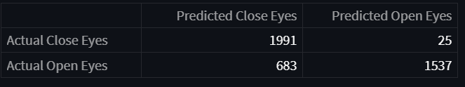
Figure 8.1.1: Open and Closed eyes prediction

This is real time data from the model where the open and close eyes are predicted.
In this where the actual predicted close eyes are 1991 and of predicted open eyes are 25. Then actual open eyes predicted are 1537 out then predicted open 683 in real time model is predicted.

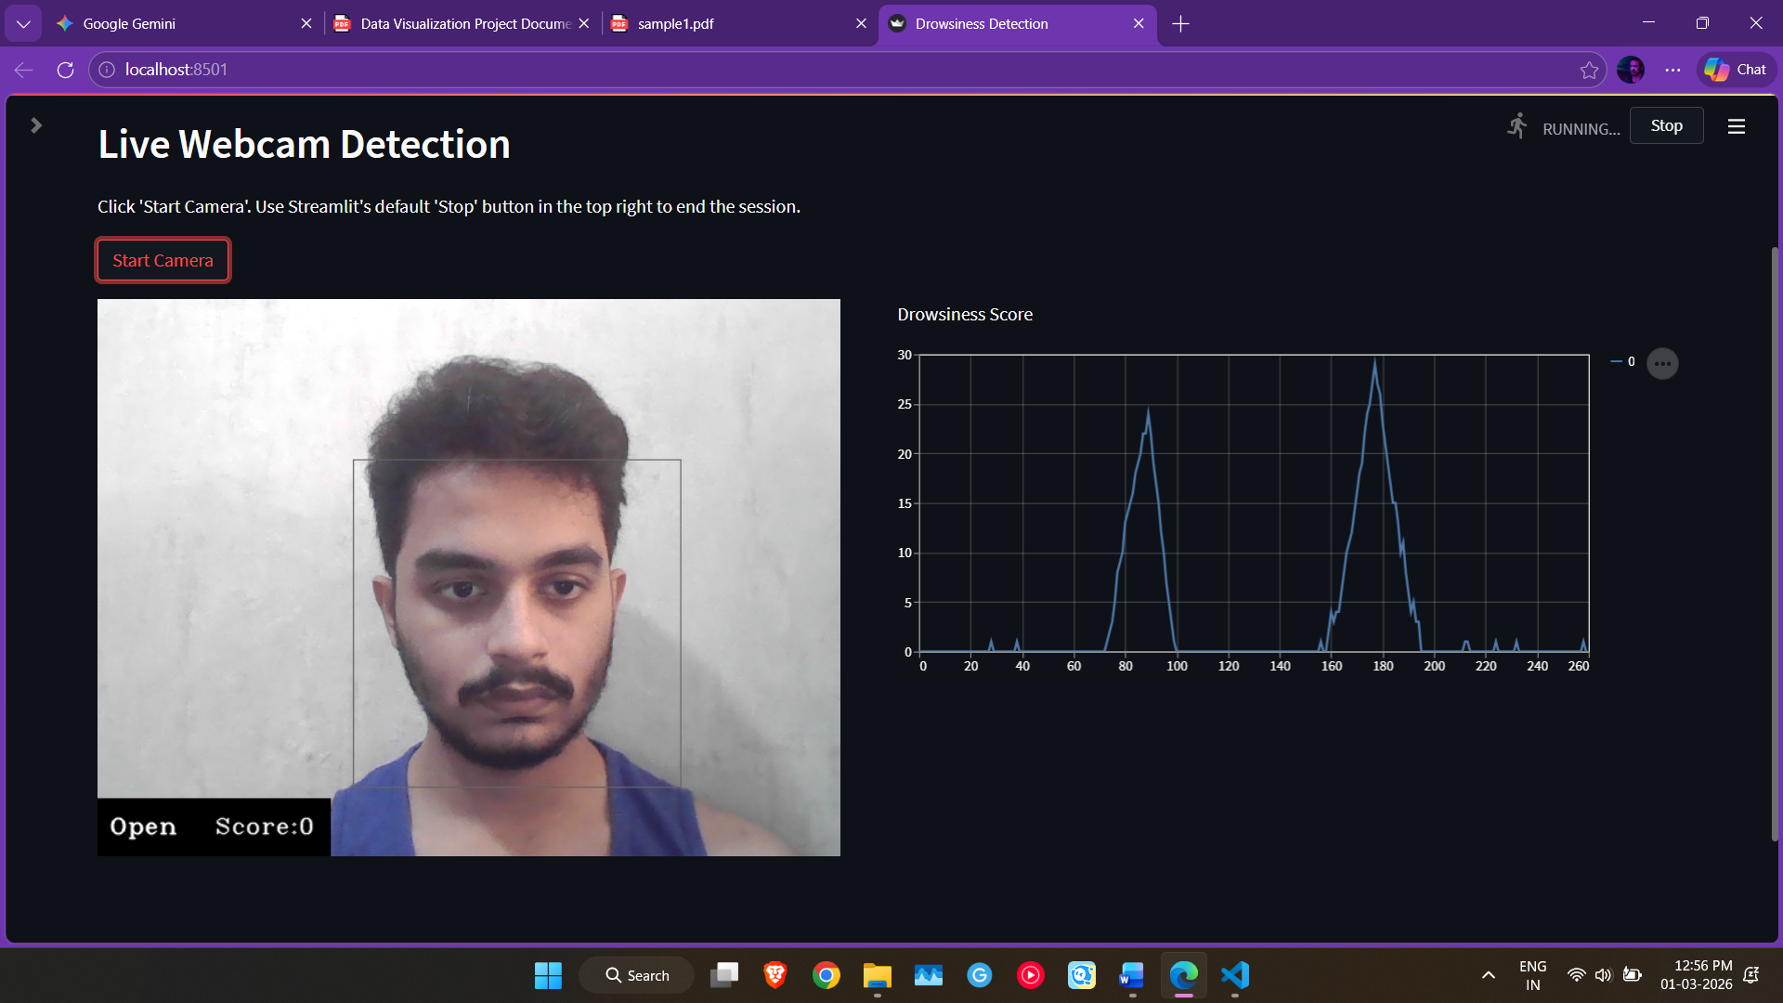
Figure 8.1.2: Line chart

FOR PRETRAINED MODEL DATA:
Raw training log table:
Epoch | Training Loss | Training Accuracy | Validation Loss | Validation Accuracy | Time Taken | Notes
1 | 0.2208 | 0.9154 (91.5%) | 0.1908 | 0.9289 (92.8%) | 736s | val_loss improved (0.19077); Model saved.
2 | 0.1962 | 0.9254 (92.5%) | 0.2088 | 0.9136 (91.3%) | 670s | val_loss did not improve.
3 | 0.1920 | 0.9274 (92.7%) | 0.2028 | 0.9139 (91.3%) | 588s | val_loss did not improve.
4 | 0.1895 | 0.9296 (92.9%) | 0.1850 | 0.9262 (92.6%) | 603s | val_loss improved (0.18504); Best model.
5 | 0.1893 | 0.9309 (93.0%) | 0.1944 | 0.9227 (92.2%) | 581s | val_loss did not improve.

1. An "Epoch" is simply one complete pass through our entire training dataset. We told the model to study the data 5 times over (Epochs 1 through 5). Every time it finishes an epoch, it updates its internal weights to try and make fewer mistakes on the next round.

2. Training Loss & Accuracy This is how well the AI is performing on the data it is actively studying (our Train folder).
- Accuracy is the percentage of images it got right. It started strong at 91.5% in Epoch 1 and steadily climbed to 93.0% by Epoch 5.
- Loss is the "penalty score" for how badly it messed up on the ones it got wrong. The goal is to drive this number as close to zero as possible. We can see it successfully dropped from 0.2208 down to 0.1893.
- The takeaway here: The model is definitely learning the material we gave it!

3. Validation Loss & Validation Accuracy: This is the most critical part of the table. After every single epoch, we pause the training and force the model to take a "practice quiz" on a smaller, separate pile of images it wasn't allowed to study from (the validation set)[cite: 384].

- We do this to make sure the AI is actually learning what a sleepy eye looks like, rather than just memorizing the specific images in the training folder.
- If it just memorizes the answers, it will fail in the real world.

4. Why Epoch 4 is our Champion If you look at Epoch 5, you'll notice it has the highest Training Accuracy (93.0%). But look closely at the "Notes" section. We actually saved the model from Epoch 4 as our final version. Why?

- In Epoch 4, our Validation Loss hit its absolute lowest point at 0.1850.

- In Epoch 5, even though the model got better at its textbook data, its Validation Loss actually went up to 0.1944.
- In data science, this is a classic red flag called overfitting. It means by Epoch 5, the model started memorizing the training data too heavily and actually got worse at handling new, unseen data. Our code uses a smart callback that monitors val_loss and automatically saved the exact weights from Epoch 4, which is the perfect "sweet spot" before overfitting started!

5. Time Taken Look at the time column the first epoch took a massive 736 seconds (over 12 minutes!), and the whole process took almost an hour for just 5 epochs. This perfectly highlights one of the major challenges we talked about in Chapter 5: training these powerful computer vision models requires a serious amount of computational processing power and time.

The Final Verdict: The table shows we successfully trained a highly accurate Convolutional Neural Network. We proved it learned the features of drowsiness without memorizing the data, hitting a solid 92.6% accuracy on its validation quizzes. This is the exact brain that powers our Streamlit dashboard!
8.2 Appendix B: Code
Main Detection Code:
File name: (detection.py)

#code
import cv2
import os
import numpy as np
import streamlit as st
import pygame
import csv
import pandas as pd
from datetime import datetime
st.set_page_config(page_title="Drowsiness Detection", layout="wide")
from tensorflow.keras.models import load_model #to load trained deep learning model
from tensorflow.keras.preprocessing.image import ImageDataGenerator
from sklearn.metrics import classification_report, confusion_matrix

Explanation:
Imports and Setup
- import cv2: Imports OpenCV, the main library used for real-time computer vision and webcam handling.
- import os: Imports Python’s built-in operating system library, used here for safely building file paths.
- import numpy as np: Imports NumPy, which we use to manipulate the image arrays and reshape them for the deep learning model.
- import streamlit as st: Imports Streamlit, the framework used to build the interactive web dashboard frontend.
- import pygame: Imports Pygame, which handles playing the audio alarm file without freezing the main video loop.
- import csv: Imports the CSV module to handle creating and writing to our data logging file.
- import pandas as pd: Imports Pandas, used later to format the confusion matrix and classification reports into clean tables.
- from datetime import datetime: Imports the datetime module so we can accurately timestamp our log files.
- st.set_page_config(...): A required Streamlit command that configures the webpage to use the "wide" layout, giving the dashboard a more spacious, professional look.
- from tensorflow.keras...: Imports the functions needed to load our trained deep learning model and process directories of images.
- from sklearn.metrics...: Imports the specific tools we need to grade the model's performance on the test data.

#Section 1: ---------------------------------------------------------------------------------------------------------
@st.cache(allow_output_mutation=True)
def load_resources():
model_path = os.path.join("models", "model.h5")
try:
model = load_model(model_path)
except Exception as e:
st.error(f"Error loading model: {e}")
return None, None, None, None

face_cascade = cv2.CascadeClassifier(cv2.data.haarcascades + "haarcascade_frontalface_default.xml")
eye_cascade = cv2.CascadeClassifier(cv2.data.haarcascades + "haarcascade_eye.xml")

pygame.mixer.init()
try:
sound = pygame.mixer.Sound('alarm.wav')
except:
sound = None
return model, face_cascade, eye_cascade, sound

Explanation:
Section 1: The Smart Loader (load_resources)
- @st.cache(allow_output_mutation=True): A crucial Streamlit decorator. It tells the app to run this loading function exactly once and cache the results. Without this, Streamlit would reload the heavy AI model every time the screen updates, crashing the framerate.
- def load_resources():: Defines the function that handles loading all external assets.
- model_path = os.path.join(...): Constructs a safe file path to find the saved model.h5 file.
- model = load_model(model_path): Actually loads our pre-trained Convolutional Neural Network (CNN) into memory.
- face_cascade = ... & eye_cascade = ...: Loads OpenCV's pre-trained Haar Cascade classifiers. These are lightweight algorithms used to quickly locate the bounding boxes for the face and eyes before we run the heavier deep learning model.
- pygame.mixer.init() & sound = ...: Initializes the audio system and loads our alarm.wav file into memory so it's ready to play instantly.
- return model, face_cascade, eye_cascade, sound: Passes these loaded tools back to the main app so they can be used.

# Section 2. MAIN DETECTION LOOP -------------------------------------------------------------------------
def start_detection(model, face_cascade, eye_cascade, sound):
cap = cv2.VideoCapture(0)
if not cap.isOpened():
st.error("Could not find webcam! Check if it is plugged in.")
return

col1, col2 = st.columns(2)
with col1:
st_frame = st.empty()
with col2:
st.write("Drowsiness Score")
chart = st.line_chart()
score over time

Explanation:
Section 2: The Main Detection Loop (start_detection)
- def start_detection(...): Defines the core function that runs the webcam and analysis.
- cap = cv2.VideoCapture(0): Tells OpenCV to take control of the computer's default webcam (index 0).
- col1, col2 = st.columns(2): Splits the Streamlit UI into two side-by-side columns.
- st_frame = st.empty(): Creates an empty placeholder in the first column where we will continuously push the live video frames.
- chart = st.line_chart(): Initializes an empty line chart in the second column to track the driver's drowsiness score over time.

font = cv2.FONT_HERSHEY_COMPLEX_SMALL
score = 0

csv_filename = f"drowsiness_log_{datetime.now().strftime('%Y%m%d_%H%M%S')}.csv"
try:
with open(csv_filename, mode='w', newline='') as file:
writer = csv.writer(file)
writer.writerow(["Time", "Eye Status", "Drowsiness Score"])
while cap.isOpened():
ret, frame = cap.read()
if not ret:
st.warning("Failed to capture video frame.")
break

height, width = frame.shape[:2]
gray = cv2.cvtColor(frame, cv2.COLOR_BGR2GRAY)

Explanation:
- font = ... & score = 0: Sets the font style for on-screen text and initializes the drowsiness score at zero.
- csv_filename = ...: Generates a dynamic filename for the log file using the exact current date and time so files never overwrite each other.
- with open(...) as file:: Safely opens the CSV file for writing.
- writer.writerow(...): Writes the header row (Time, Eye Status, Score) to the top of the CSV file.
- while cap.isOpened():: Starts the infinite loop that continuously grabs video frames as long as the camera is active.
- ret, frame = cap.read(): Captures a single image (frame) from the webcam.
- gray = cv2.cvtColor(frame, cv2.COLOR_BGR2GRAY): Converts the color frame to grayscale, which makes the Haar Cascade algorithms run much faster.

faces = face_cascade.detectMultiScale(gray, minNeighbors=5, scaleFactor=1.1, minSize=(25,25
cv2.rectangle(frame, (0,height-50), (200,height), (0,0,0), thickness=cv2.FILLED)
status = "Active"
for (x,y,w,h) in faces:
cv2.rectangle(frame, (x,y), (x+w,y+h), (100,100,100), 1)
roi_gray = gray[y:y+h, x:x+w]
roi_color = frame[y:y+h, x:x+w]

eyes = eye_cascade.detectMultiScale(roi_gray)
for (ex, ey, ew, eh) in eyes:
eye_img = roi_color[ey:ey+eh, ex:ex+ew]
eye_img = cv2.resize(eye_img, (80,80))
eye_img = eye_img / 255.0
eye_img = eye_img.reshape(80, 80, 3)
eye_img = np.expand_dims(eye_img, axis=0)
prediction = model.predict(eye_img, verbose=0)

Explanation:
- faces = face_cascade.detectMultiScale(...): Scans the grayscale image and returns the coordinates (x, y, width, height) of any faces it finds.
- cv2.rectangle(frame, (0,height-50)...): Draws a black bar at the bottom of the screen to serve as a background for our text overlays.
- for (x,y,w,h) in faces:: Loops through every face found in the frame.
- roi_gray = ... & roi_color = ...: Crops the image down to just the Region of Interest (ROI) containing the face, so we aren't scanning the entire background for eyes.
- eyes = eye_cascade.detectMultiScale(roi_gray): Scans the cropped face region to find the eyes.
- for (ex, ey, ew, eh) in eyes:: Loops through every eye found on the face.
- eye_img = cv2.resize(...): Resizes the cropped eye image to exactly 80x80 pixels, which is the exact input size our deep learning model expects.
- eye_img = eye_img / 255.0: Normalizes the pixel values from a 0-255 scale down to a 0-1 scale, which helps the neural network process the math more efficiently.
- eye_img = eye_img.reshape(...) & np.expand_dims(...): Reformats the shape of the image array so it matches the specific tensor batch format required by Keras models.
- prediction = model.predict(...): Feeds the processed eye image into the AI model to get a probability score for "Open" vs. "Closed".

if prediction[0][0] > 0.50:
status = "Closed"
score += 1
cv2.putText(frame, "Closed", (10,height-20), font, 1, (255,255,255), 1, cv2.LINE_AA)
elif prediction[0][1] > 0.50: #
status = "Open"
score -= 1
cv2.putText(frame, "Open", (10,height-20), font, 1, (255,255,255), 1, cv2.LINE_AA)
if score < 0: score = 0 #Score never drops below zero
cv2.putText(frame, 'Score:'+str(score), (100,height-20), font, 1, (255,255,255), 1, cv2.LINE_AA)
if score > 15: #critical threshold check
cv2.rectangle(frame, (0,0), (width,height), (0,0,255), thickness=10)
if sound:
try: sound.play()
except: pass
chart.add_rows([score])
timestamp = datetime.now().strftime("%H:%M:%S")
writer.writerow([timestamp, status, score])
frame = cv2.cvtColor(frame, cv2.COLOR_BGR2RGB)
st_frame.image(frame, channels="RGB")
finally:
cap.release() #loop breaks (if user stops the app)
st.success(f"Camera stopped. Data saved to your folder as: {csv_filename}")

Explanation:
- if prediction > 0.50:: Checks if the model is more than 50% confident that the eye is closed (assuming index 0 is the 'Closed' class).
- score += 1: If closed, we increment the danger score.
- elif prediction[cite_start][1] > 0.50:: Checks if the model is confident the eye is open.
- score -= 1: If open, we decrease the danger score (the driver is alert).
- if score < 0: score = 0: Ensures the score never drops below zero into negative numbers.
- cv2.putText(...): Renders the current score and eye status directly onto the video frame.
- if score > 15:: The critical threshold check. If the eyes have been closed long enough to hit 15 points, it triggers the alarm.
- cv2.rectangle(...) & sound.play(): Draws a massive red warning border around the whole video feed and plays the audio alert.
- chart.add_rows([score]): Pushes the latest score integer to the Streamlit line chart, making it update live.
- writer.writerow(...): Logs the exact timestamp, status, and current score to the CSV file.
- frame = cv2.cvtColor(frame, cv2.COLOR_BGR2RGB): Converts the frame from OpenCV's default BGR color format to the RGB format that Streamlit expects.
- st_frame.image(frame, channels="RGB"): Pushes the final, fully annotated video frame to the web app dashboard.
- finally: cap.release(): Ensures that if the loop breaks (or the user stops the app), the script cleanly disconnects from the webcam so it isn't locked up.

8.3 Appendix C: Glossary
Data science has a lot of jargon. To make this documentation easy to read, here is a quick cheat sheet defining the technical terms, acronyms, and AI concepts I used throughout this project!
- CNN (Convolutional Neural Network): The "picture expert" of the AI world. It's a deep learning algorithm that is incredibly good at analyzing images to find shapes, edges, and patterns, like the specific curve of a closed eyelid.

- Confusion Matrix: Think of this as the ultimate report card for our AI. It’s a grid that compares the AI's predictions against the actual truth, showing us exactly how many times it guessed right (True Positives/Negatives) and what kind of mistakes it made (False Positives/Negatives).

- EAR (Eye Aspect Ratio): A mathematical score that calculates exactly how open a driver's eye is. When the eye is wide open, the EAR score is high; when the eyelid droops or closes, the score drops, acting as our main trigger for drowsiness.

- Epoch: One complete "study session" for the AI. An epoch means the neural network has made one full pass through the entire training dataset to update its internal weights and learn from its mistakes.

- False Negative: The worst-case scenario for a safety system. This happens when the AI misses a genuinely drowsy driver and wrongly assumes they are alert, giving a dangerous false sense of security.

- False Positive: The "boy who cried wolf" scenario. This is when the system wrongly flags a wide-awake driver as sleepy (like if they were just squinting at the sun). Too many of these, and the driver will get annoyed and turn the system off.

- Infrared Camera: Special cameras that use heat/infrared light to see clearly in the dark. These are essential for the system to work during night driving or going through dark tunnels.

- LSTM (Long Short-Term Memory): The "memory expert." It's an algorithm that remembers what just happened in previous video frames, helping the system track patterns over several seconds (like measuring how long a blink lasts) rather than just looking at a single isolated picture.

- MAR (Mouth Aspect Ratio): Similar to EAR, but for the mouth. A sudden spike in the MAR value indicates that the mouth is wide open, which is a key indicator that the driver is yawning.

- Streamlit: The awesome, fast Python framework I used to build the interactive web dashboard and frontend UI for our live webcam detection script.

- Transfer Learning: A massive shortcut in AI training. Instead of teaching a model from scratch, we take a powerful, pre-trained model (like VGG16 or InceptionV3) that already knows how to recognize millions of objects, and just give it specialized extra training to make it an expert at spotting drowsiness.

