Monthly Rainfall Prediction Using Wavelet Neural Network Analysis

In this paper author is using wavelet signal dataset to train Multilayer Perceptron Neural Network which can predict rainfall accurately compare to existing algorithms. All existing algorithms were using plain satellite dataset to predict rainfall as this dataset may not contains present condition information so prediction may not be accurate. To overcome from this problem author is using wavelet digital signature dataset which contains present condition information so neural network can predict accurate rainfall. Wavelet based prediction has gain lots of popularity due to signals contains present information.

Author is combing Wavelet data with neural network to predict rainfall so author has given algorithm name as WNN. To train WNN algorithm we have used below dataset

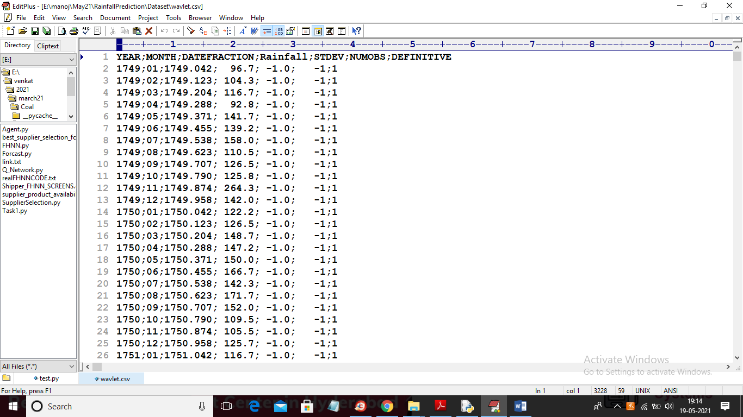

In above dataset first row contains dataset column names and remaining rows contains dataset values and we will used above dataset to train WNN algorithm and then predict rainfall for next 30 days (monthly).

SCREEN SHOTS

To run project double click on ‘run.bat’ file to get below screen

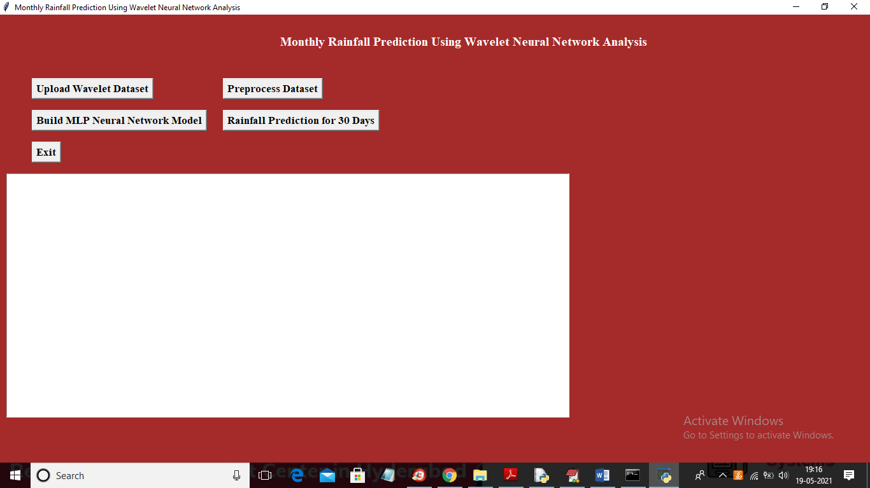

In above screen click on ‘Upload Wavelet Dataset’ button to load dataset

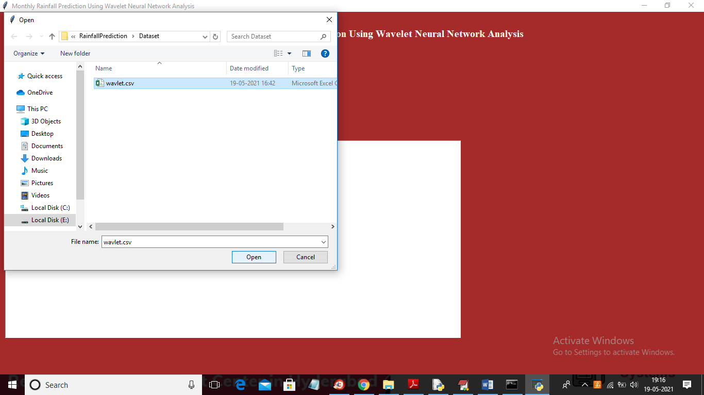

In above screen selecting and uploading ‘wavelet.csv’ file and then click on ‘Open’ button to load dataset and to get below screen

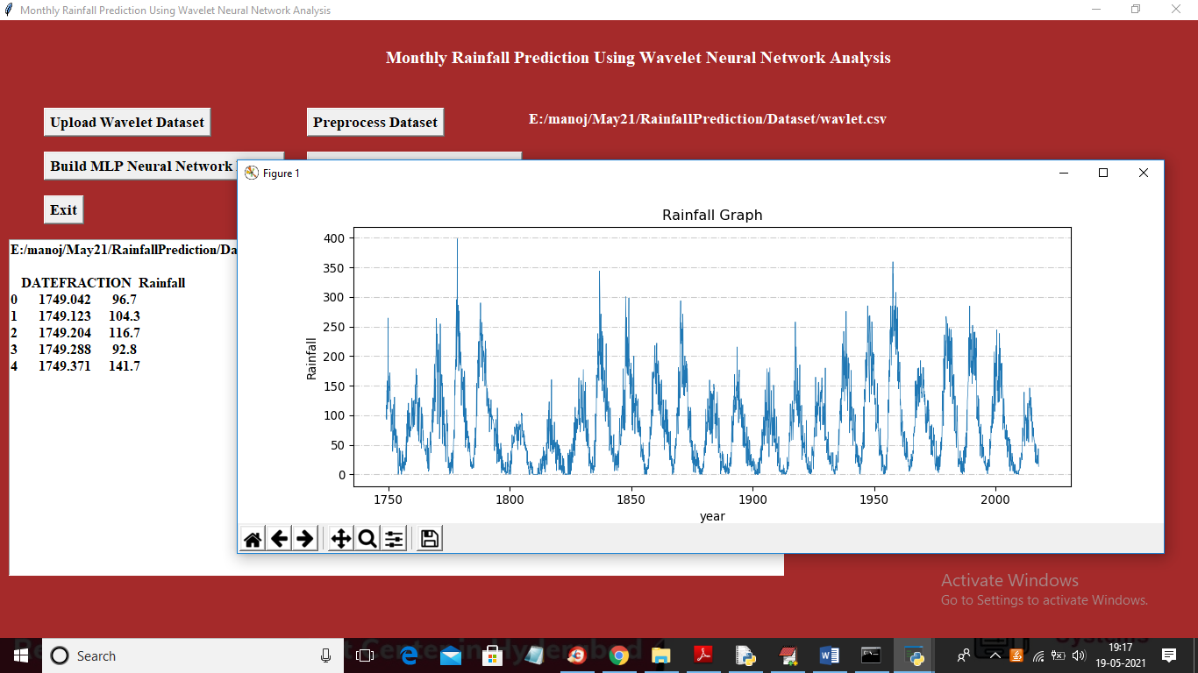

In above screen text area we can see year and rainfall from dataset and same thing we are plotting in graph where x-axis represents year and y-axis represents rainfall occurred in that year and now close above graph and then click on ‘Preprocess Dataset’ button to removing missing values and then split dataset into train and test part and then display wavelet rainfall graph from dataset like below screen

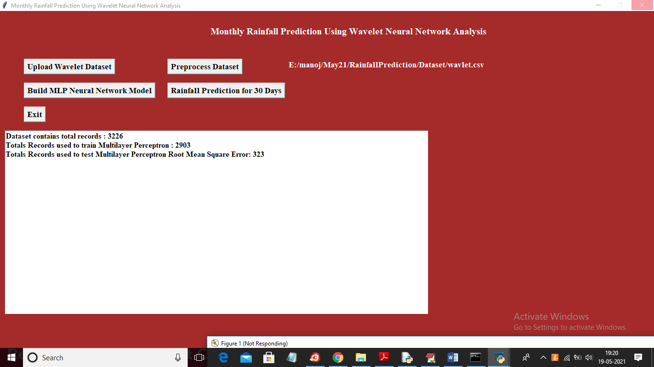

In above screen we can see dataset contains total 3226 records and application using 2903 (80%) records for training MLP and 323 records (20%) to test MLP prediction performance and then calculate RMSE (root mean square error). RMSE represents difference between actual and predicted values. If algorithm predict exact value then different will low and if predict wrong value then difference will be high

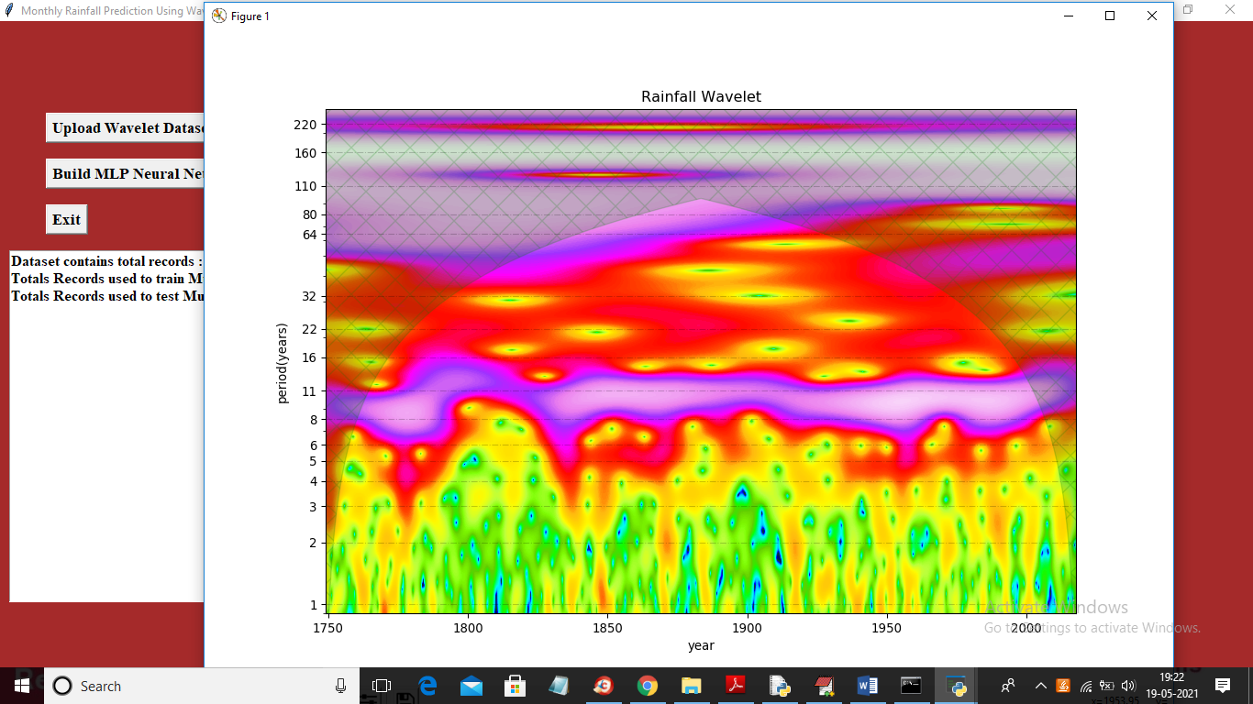

After preprocessing we got Wavelet rainfall graph where green dots represents rainfall and in above graph x-axis represents year and y-axis represents rate of receive rainfall.

Note: To get above graph output application may take 2 to 4 minutes time so please wait till graph appear correctly. Now close above graph and dataset train and test is also ready and now click on ‘Build MLP Neural Network Model’ button to generate WNN model on above dataset

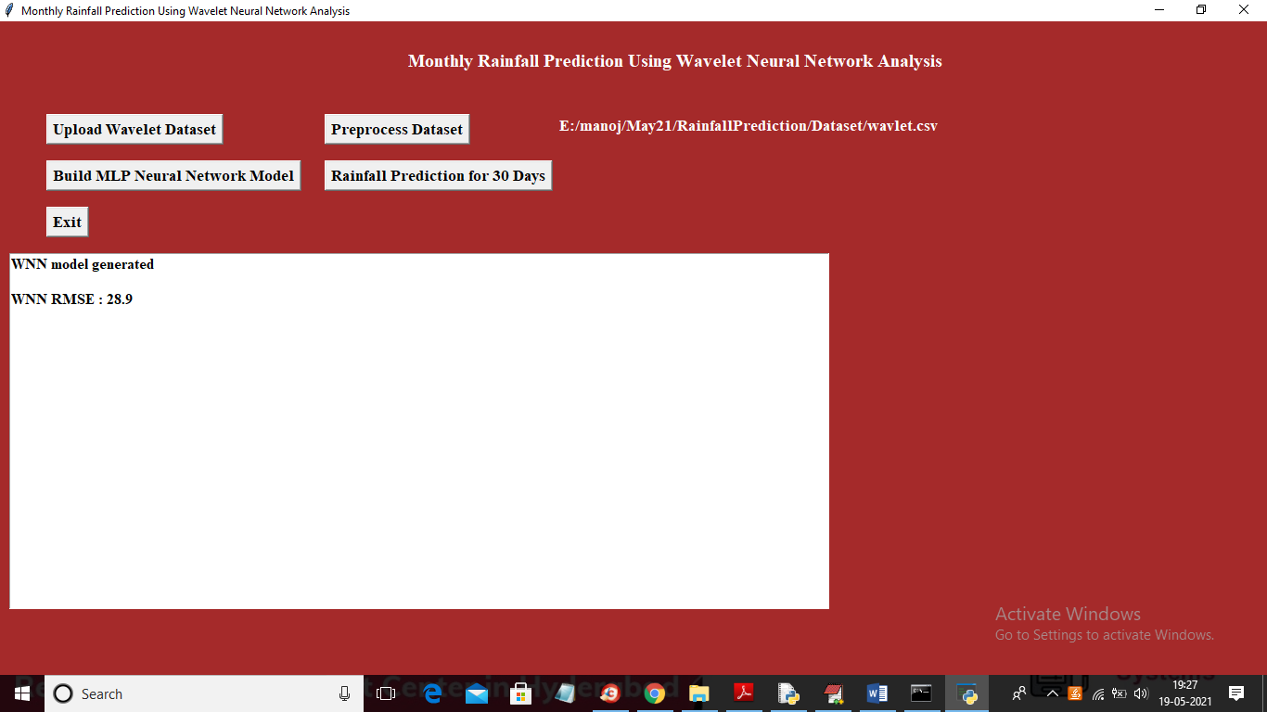

In above screen WNN model generated and we got RMSE error as 28% which is less than RMSE given in paper so model is accurate and now click on ‘Rainfall Prediction for 30 Days’ button to predict rainfall using WNN model

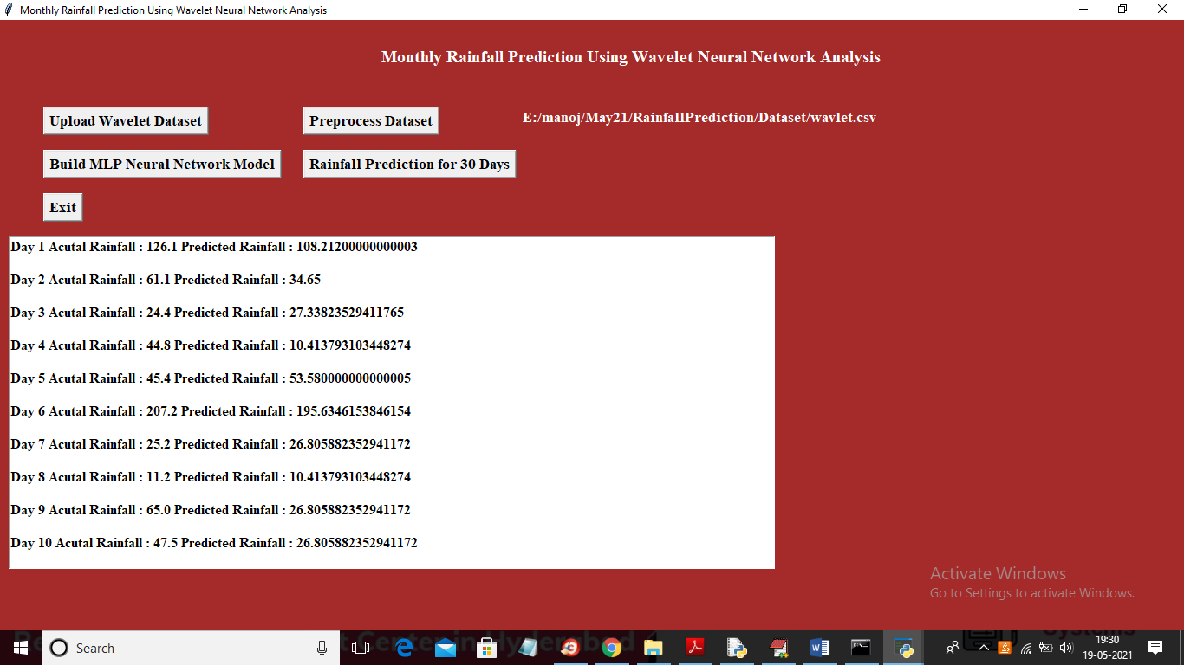

In above screen for each day we are printing actual rainfall from test data and predicted rainfall from WNN model and we can see difference between them is closed and you scroll down above text area to view all records

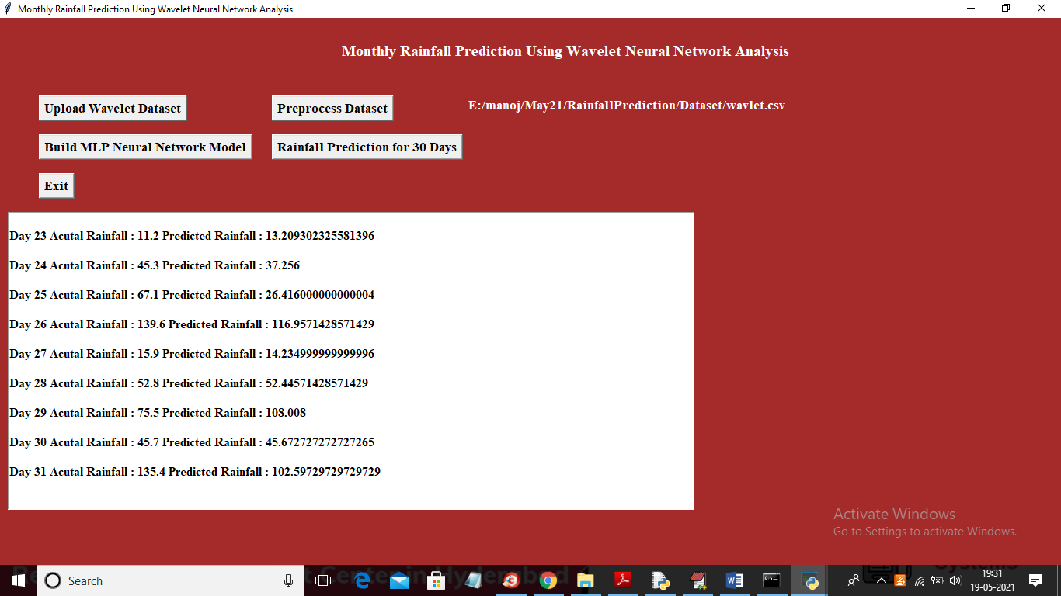

In above screen you can see for day 26, 27 and 28 prediction is closed to actual value and then will get below graph between actual and predicted rainfall

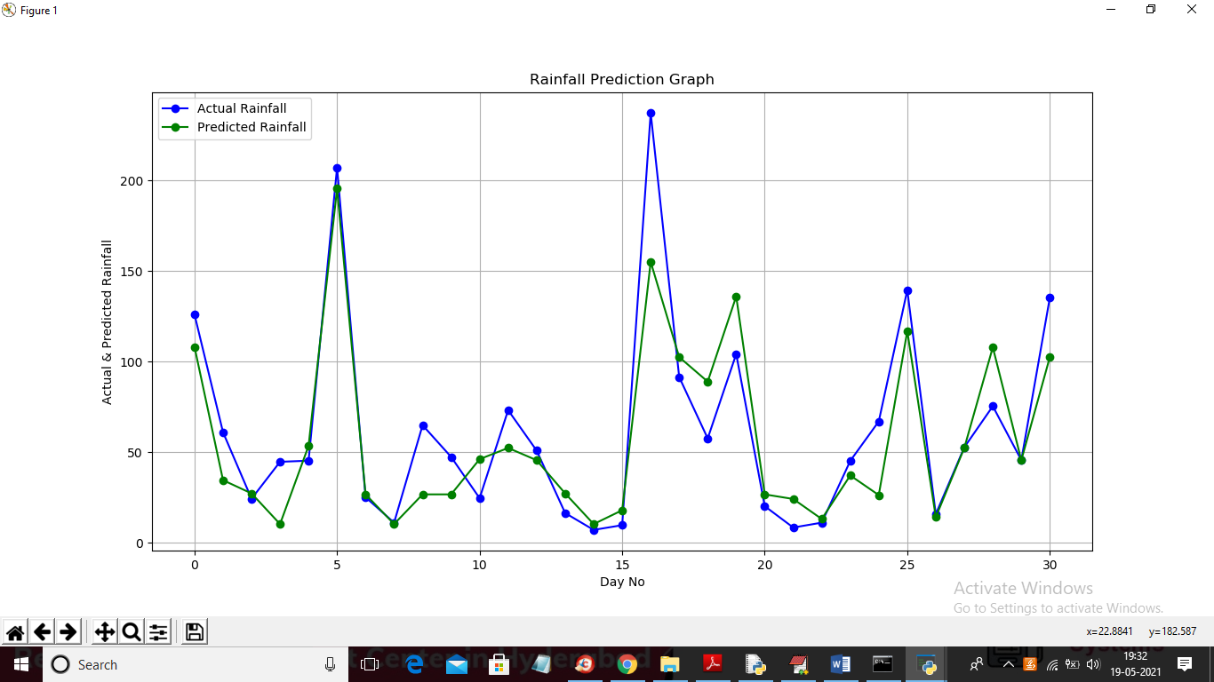

In above graph x-axis represents day and y-axis represents rainfall and in above graph blue line represents actual rainfall from test data and green line represents predicted rainfall and in above graph we can see difference between two lines are closed so we can conclude that prediction is accurate.