Executive Summary
Factory-to-Customer Shipping Route Efficiency — Nassau Candy Distributor

Purpose
This analysis was commissioned to give Nassau Candy Distributor visibility into which factory-to-customer shipping routes are efficient, which are not, and where operational bottlenecks exist — replacing reactive logistics decisions with data-driven ones.

What We Found
- Across 10,194 shipments and 196 active routes, shipping performance is broadly consistent — the difference between the fastest and slowest route is small (~5 days).
- The single biggest driver of delay is Ship Mode, not route: Standard Class shipments (60% of all volume) show a 22.5% delay rate, versus under 1% for all faster ship modes.
- Tennessee is the network's one bottleneck by a defined test (top 25% for both shipment volume and lead time): 183 shipments at a 178.0-day average lead time versus a 177.6-day network average, and a 16.9% delay rate. The gap is modest in absolute terms — this is a monitoring priority, not a severe outlier.
- A significant data quality issue was identified and corrected in the source Ship Date field during this analysis (see Technical Notes); this should be flagged to the systems team.

Recommendation
Prioritize fixing Standard Class handling first — it represents the majority of shipment volume and nearly all network-wide delay. This is likely to produce a larger, faster improvement in customer-facing delivery reliability than reassigning routes between factories.

At a Glance
Metric | Value
Total Shipments Analyzed | 10,194
Active Routes | 196
Overall Delay Rate | 13.6%
Standard Class Delay Rate | 22.5%
Fastest Ship Mode | Same Day
Key Bottleneck State | Tennessee

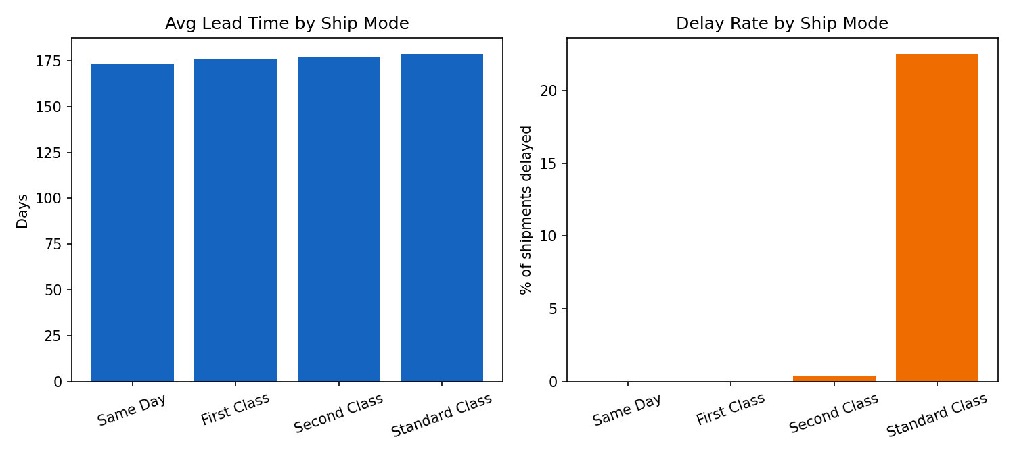

Technical Note
The raw Ship Date field contained a data quality defect (corrupted year values, unrelated to shipping method). This was identified through business-logic validation and corrected before analysis; see the full research paper for methodology. The corrected values are best read as a consistent, comparable index for ranking routes and ship modes — not as literal real-world shipping days. All figures in this summary reflect the corrected data on this comparative basis.

