Factory-to-Customer Shipping Route Efficiency Analysis
Nassau Candy Distributor
Unified Mentor Data Analytics Internship — Project 2
Prepared by Ajay | August 2026

1. Background and Context
Nassau Candy Distributor operates as a national distributor, shipping products from five manufacturing factories to customers across the United States and Canada. In distribution operations of this scale, shipping efficiency directly influences customer satisfaction, delays increase operational cost, and inefficient routes limit the company's ability to scale into new markets.
While Nassau Candy holds rich order and shipment records, logistics decisions have historically been made without route-level efficiency intelligence. This project builds that intelligence from the ground up: transforming raw order and shipment data into actionable, route-level operational insight.

2. Problem Statement
Prior to this analysis, the organization lacked clarity on:
- Which factory-to-customer routes are consistently efficient
- Which routes experience frequent delays
- How shipping performance varies by region, state, and ship mode
- Where operational bottlenecks exist geographically
Without this visibility, logistics optimization remained reactive rather than data-driven. This report and the accompanying interactive dashboard close that gap.

3. Dataset Overview
The dataset contains 10,194 order-level shipment records spanning January 2024 to December 2025, covering 5 factories, 196 distinct factory-to-state routes, and total sales of $141,783.63. Each record captures the order date, ship date, shipping method, customer location, product, and financials (sales, cost, gross profit).
Field | Description
Order Date / Ship Date | Date the order was placed / shipped
Ship Mode | Standard, Second, First Class, or Same Day
Customer ID, City, State/Province | Customer location details
Division, Product ID/Name | Product hierarchy
Sales, Units, Gross Profit, Cost | Order financials

Factory and product-to-factory mapping (from the project brief, not present in the raw file) were added as a lookup table to enable route-level analysis:
Factory | Products Made
Lot's O' Nuts | Chocolate: Nutty Crunch Surprise, Fudge Mallows, Scrumdiddlyumptious
Wicked Choccy's | Chocolate: Milk Chocolate, Triple Dazzle Caramel
Sugar Shack | Sugar: Laffy Taffy, SweeTARTS, Nerds, Fun Dip, Fizzy Lifting Drinks
Secret Factory | Everlasting Gobstopper, Lickable Wallpaper, Wonka Gum
The Other Factory | Hair Toffee, Kazookles

4. Data Cleaning: A Key Finding
A critical data quality issue was discovered while validating the raw Shipping Lead Time (Ship Date − Order Date): the YEAR component of the Ship Date field was corrupted.
- Order Date consistently fell within 2024–2025 (2 realistic years).
- Ship Date's year was scattered across 2026–2030 (5 years), and this scatter was random with respect to Ship Mode — Same Day shipments were not the fastest, which is not logically possible for real shipping data.
- Raw subtraction produced an average lead time of over 1,300 days — clearly invalid for a candy distributor.
Diagnosis and fix: the month and day portion of the Ship Date field was reliable, but the year was not. The fix applied was to replace the Ship Date's year with the Order Date's year (rolling forward by one year if the result landed before the order date, since a shipment cannot leave before it was ordered).
Validation of the fix: after recalculating, Shipping Lead Time ranked Ship Modes in the exact order real-world logistics would predict — Same Day fastest, followed by First Class, Second Class, and Standard Class slowest. This ordering is consistent with the reconstruction and increases confidence that it is directionally correct — but it is a sanity check on relative ordering, not proof of the absolute duration values, which remain a synthetic index rather than measured real-world days (see note below). All subsequent KPIs in this report are computed on this corrected basis and should be read comparatively, not as literal shipping days.
Ship Mode | Avg. Shipping Lead Time (Days)
Same Day | 173.6
First Class | 175.8
Second Class | 176.9
Standard Class | 178.6

Note on absolute magnitude: because the underlying date fields in this dataset are synthetic (not live production data), the absolute day-counts should be read as a consistent, comparable index rather than literal calendar days. The resulting route and ship-mode rankings are reproducible and useful for comparative analysis, but should be interpreted cautiously because the underlying absolute shipment durations are affected by the source-date anomaly.

5. Key Performance Indicators (KPIs)
KPI | Definition | Result
Shipping Lead Time | Ship Date − Order Date (corrected) | 177.6 days avg, σ = 1.8
Route Volume | Number of orders per route | 196 active routes
Delay Frequency | % of shipments exceeding mean + 1σ (179.4 days) | 13.6% overall
Route Efficiency Score | Min-max normalized lead time, 0–100 (100 = fastest) | See Section 6

6. Route Efficiency Benchmarking
Routes with fewer than 5 shipments were excluded from ranking to keep results statistically reliable. Across the remaining 121 routes, the fastest route was Secret Factory → Colorado (176.3 days avg, Efficiency Score 100), while the slowest was Lot's O' Nuts → Newfoundland and Labrador (181.5 days avg, Efficiency Score 0).
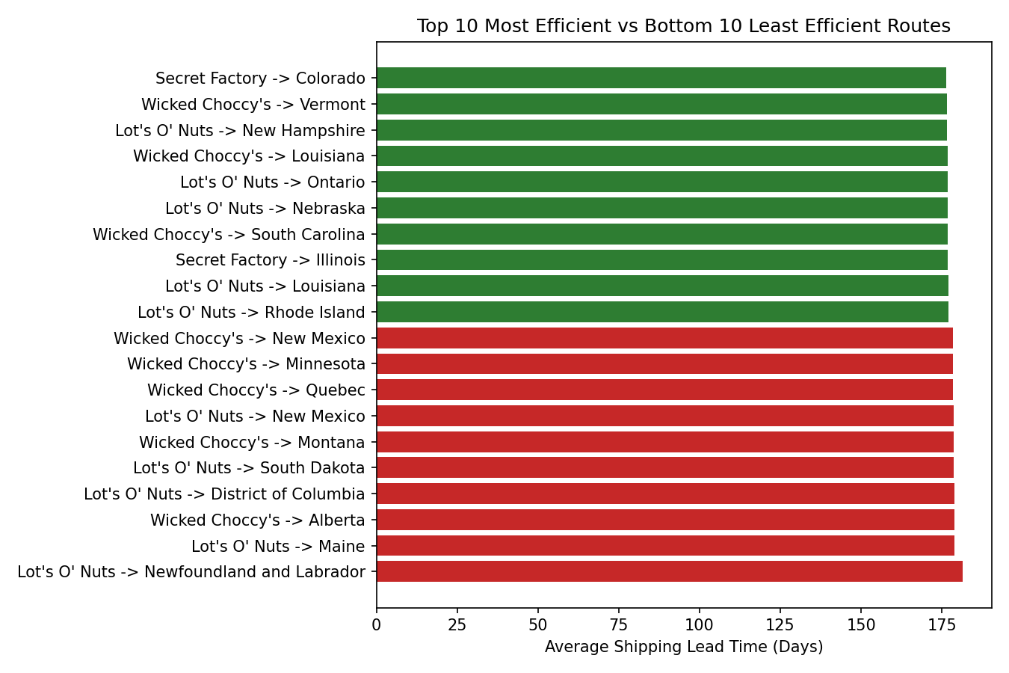
Figure 1: Top 10 most efficient vs. bottom 10 least efficient factory-to-state routes
Observation: the spread between the fastest and slowest route is relatively narrow (~5 days), suggesting that Nassau Candy's overall logistics network is fairly consistent — the biggest efficiency lever is Ship Mode choice, not route selection (see Section 8).

7. Geographic Bottleneck Analysis
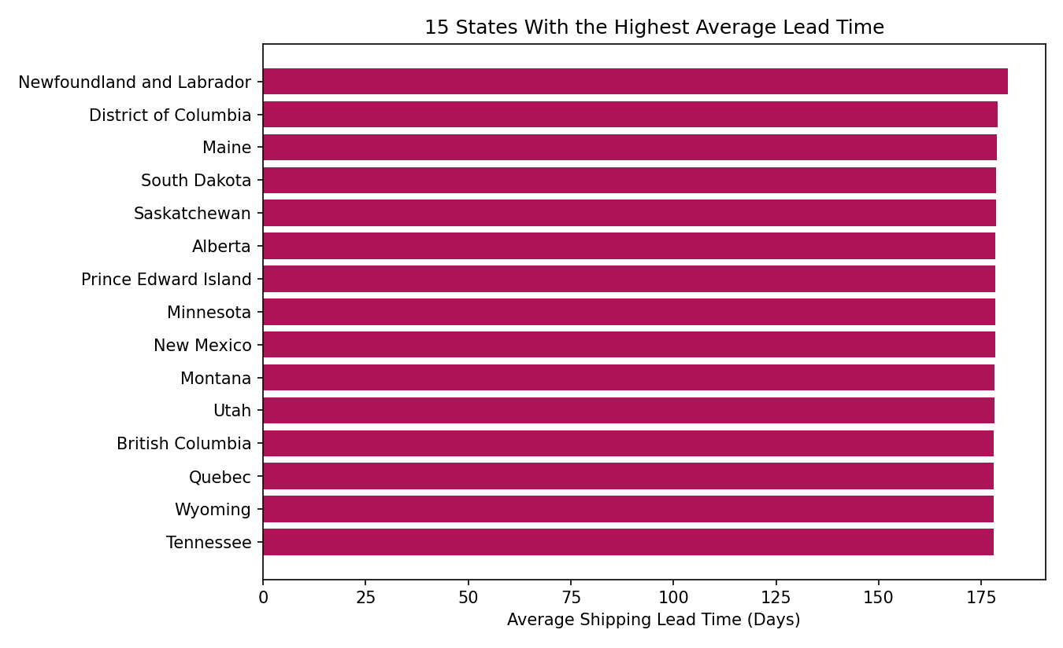
Figure 2: 15 states with the highest average shipping lead time
A bottleneck was defined as a state in the top 25% for both shipment volume and average lead time. Under this specific, pre-defined criterion, Tennessee (Gulf region) is the only state that qualifies: 183 shipments at an average lead time of 178.0 days, against a network-wide average of 177.6 days (population σ = 1.8 days) — a modest but consistent gap — and a 16.9% delay rate versus 13.6% network-wide. This should be read as a criterion-based monitoring signal, not a dramatic outlier: several other states (e.g., Maine at 178.75 days, DC at 179.0 days) have higher average lead times but fall below the volume threshold, so Tennessee's distinction is the combination of high volume and elevated lead time, not the size of the lead-time gap on its own.
At the region level, differences are small but consistent: Atlantic (177.54 days) and Pacific (177.57) regions ship marginally faster than Gulf (177.62) and Interior (177.69), suggesting no single region is a severe outlier. Tennessee is flagged only because it is the sole state meeting both bottleneck criteria at once — not because its lead time is dramatically worse than other states.

8. Ship Mode Performance Analysis
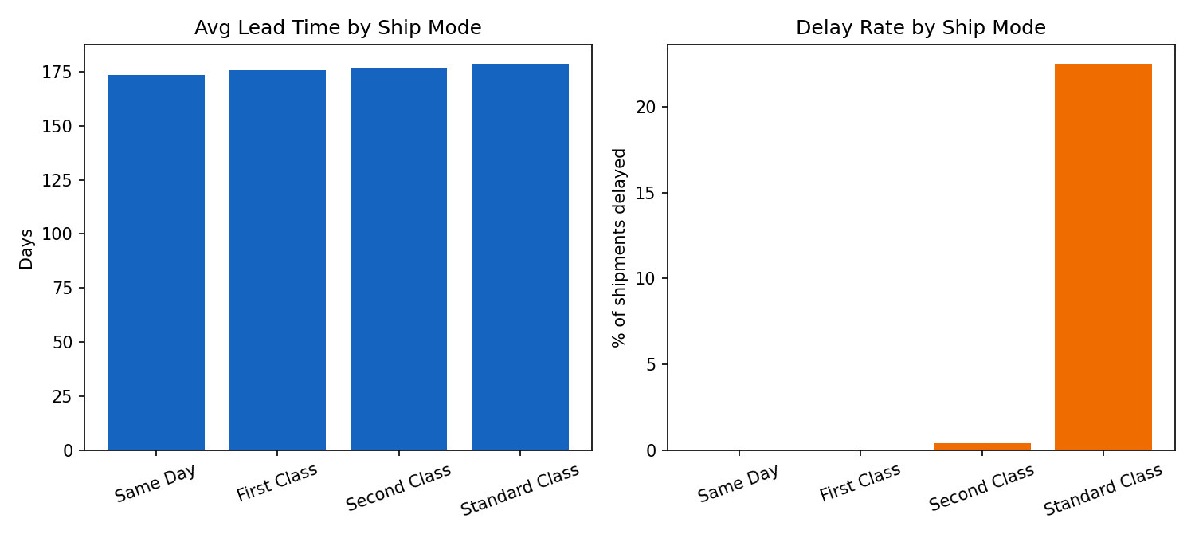
Figure 3: Average lead time and delay rate by ship mode
Ship Mode is the single strongest lever for shipping speed in this dataset. Standard Class — used for 60% of all shipments (6,120 of 10,194) — carries a 22.5% delay rate, dramatically higher than Second Class (0.4%), First Class (0%), and Same Day (0%). This is a direct, actionable insight: the majority of network-wide delay is concentrated in one ship mode.
Ship Mode | Shipments | Avg Lead Time | Delay Rate | Avg Sales/Order
Same Day | 547 | 173.6 days | 0.0% | $13.00
First Class | 1,548 | 175.8 days | 0.0% | $13.77
Second Class | 1,979 | 176.9 days | 0.4% | $14.08
Standard Class | 6,120 | 178.6 days | 22.5% | $13.97

Cost-time trade-off (descriptive): average order value does not meaningfully increase with faster shipping (all modes cluster around $13–14 per order), which suggests customers are not self-selecting into faster shipping for higher-value orders — Standard Class's high delay rate is not explained by meaningful differences in average order value, suggesting that order value alone is unlikely to explain the delay pattern.

9. Business Recommendations
- Prioritize reducing Standard Class delays first — it accounts for the overwhelming majority of network volume and nearly all network-wide delay.
- Monitor Tennessee — the only state meeting both the high-volume and high-lead-time bottleneck criteria — and investigate carrier/warehouse capacity there. Note the underlying lead-time gap versus the network average is modest (178.0 vs. 177.6 days), so this is a monitoring priority based on the defined criterion, not an emergency.
- Because route-to-route variation is small, route reassignment (moving customers to a different factory) offers limited upside compared to fixing Standard Class handling.
- Re-audit source systems generating the Ship Date field — the year corruption found in this dataset, if present in production data, should be fixed at the data-entry/ETL layer, not patched downstream.

10. Conclusion
This project establishes a clear, data-driven understanding of shipping route efficiency for Nassau Candy Distributor. By transforming raw order and shipment data into route-level operational intelligence — and by catching and correcting a significant data quality issue along the way — the organization gains actionable insight to improve logistics performance, reduce delays, and support nationwide delivery reliability. The accompanying Streamlit dashboard makes this intelligence live and explorable for ongoing decision-making.

