Equant - CSI Refactor Technical Review Document
Submitted by IonIdea, Inc.
11/19/2002

Basic Architecture
The existing architecture is being retained. The only difference is that JDBC will be used for queries instead of JDO. The reason for this is explained later in the document. As shown in the diagram, the components are:
- MDB EJB
- Session EJB
- JAXB utils and classes
- Managers
- JAXB -> JDO conversion classes.
- JDO utils and classes
- Oracle DB

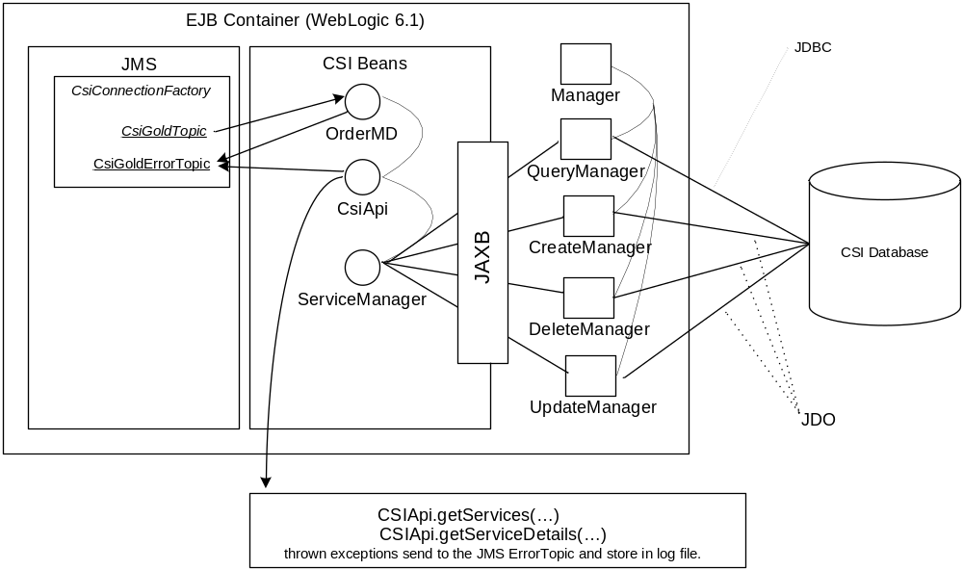

Query
As stated earlier, the JDO queries are causing a lot of latency. The reason is because of the way the queries are generated for the database structure. Another reason is that the database structure is currently not conducive to getting the required information using simple SQL selects.
The main reason is incorrect and non-optimal SQL queries generation. Currently, a lot of iterations are necessary to get the required information, which results in poor response times. Thus, with greater the amount of data and versions, the greater the retrieval time.
A sample of the query generated is:
SELECT TO_NUMBER(null),TO_NUMBER(null),C573_1_0.A_574,C573_1_0.A_575,
C573_1_0.A_576,C573_1_0.A_577,C573_1_0.A_578,C573_1_0.A_579,C573_1_0.A_580,
C573_1_0.A_581,C573_1_0.A_582,C573_1_0.A_583,C573_1_0.A_584,C573_1_0.A_585,
C573_1_0.A_586,C573_1_0.A_858
FROM
(SELECT TO_NUMBER(null) C573_N0,TO_NUMBER(null) C573_N1,
T1709_1_0.serviceElementId A_574,T1709_1_0.usid A_575,
T1709_1_0.serviceElementClass A_576,T1709_1_0.serviceElementName A_577,
T1709_1_0.description A_578,T1709_1_0.creationDate A_579,
T1709_1_0.grandFatherDate A_580,T1709_1_0.startBillingDate A_581,
T1709_1_0.endBillingDate A_582,T1709_1_0.prodId A_583,T1709_1_0.createDate
A_584,T1709_1_0.lupdDate A_585,T1709_1_0.lupdBy A_586,T1709_1_0.createdBy
A_858 FROM csi2.CServiceElement T1709_1_0) C573_1_0 WHERE (C573_1_0.A_574)
IN (SELECT serviceElementId FROM csi2.CVersionServiceElement WHERE
versionServiceElementId = :1 )
This is just one among approximately 500 queries which are performed currently to get details of just one service element. Some of such queries require full table scan.
Proposal: We recommend that JDBC be used, because amount and complexity of queries needed to do the same will be reduced 10-fold. JDBC also gives us flexibility in query construction to minimize execution time. We recommend that we build additional indexes and/or use the previous/next version pointers to directly fetch the latest version of an attribute. Note that this will increase the time to update a little as the previous record too will have to be updated, but the overall benefit outweighs this.

Exception handling
In QueryManager (and ServiceManagerEJB), lots of methods do log exception when it happens, ignore it, and return empty or incomplete result. In the case of getServiceDetails(), when an exception is encountered, the result is invalid (empty string, which is not a valid XML).
For persistence services, the only mechanism, which indicates that an error has been occurred in the system, is JMS notifications via error topic. And the only place it is used is InterimCreate.
Proposal: When system failure or data inconsistence is detected, throw an appropriate exception to be handled by an EJB. The EJB, in turn, should return valid result (instead of empty string, it should return valid XML with as much of the XML built as possible and in the worst case, the root element only. GOLD should handle this return condition). This result, in case of exception, will contain an error message in the notes section. All exceptions will be logged in a file error.log and the JMS error topic. The log in both cases will contain the XML, a description of the error, the date and time when it occurred and the exception trace. An email notification will be sent to a mailing list address that will be set as a configuration item, by the application listening to this error topic. Note that unlike queries, where the result may be partial, persistence will be all or nothing.

Transaction management.
Right now all EJBs have transaction NotSupported setting. JDO transactions are handled manually.
Proposal: The application server should handle Transactions. The advantage of doing so will allow integration to other system’s transactions into one distributed transaction, provided the other systems use XA transactions.
According to Frontier JDO documentation, Frontier can be configured to use WebLogic transaction manager, and then JDO transaction will be committed as soon as WebLogic EJB transaction is committed.

Dead code
There is at least one not implemented method in UpdateManager which is invoked from the ServiceManagerEJB class, modifyService method. This method is declared in remote interface and thus can be used by programs outside of CSI (e.g., GOLD).
Proposal: For the Manager classes, there will be
- CreateManager for creating new versions
- UpdateManager for updating existing (current) version
- DeleteManager for deleting (hard delete)
Only 3 call interfaces are provided for external applications (such as GOLD):
- XML-JMS input from GOLD, which is handled by CsiApi.handleOrder
- CsiApi.getServices
- CsiApi. getServiceDetails

Database
The following are empty fields in the DB:
CSERVICEELEMENT.GRANDFATHER
CSERVICECHANGEITEM.CHANGETYPECODE
CSERVICECHANGEITEM.SERVICEELEMENTID
CSERVICECHANGEITEM.SERVICEELEMENTID_1
CCHARGECHANGEITEM.CHANGETYPECODE
CCHARGECHANGEITEM.DISCCODE
CRECURRINGCHARGE.DISCCODE
CRECURRINGCHARGE.CHGATID
Clarification required: is this normal, or this is a result of a bug or not implemented functionality. Whatever the answer, do we write code in CSI to populate them, or leave them alone or drop them?
Clarification given: These are fields meant for future use.

Failover
It has been stated that messages from GOLD can get lost in the event of the CSI application and or database going down. There are alternatives to handle this situation.
The proposal is to use a highly available JMS server outside the CSI. IonIdea will investigate options and make recommendations after prototyping. IonIdea will make every endeavor to deliver this addition to the Statement of Work as per the required deadline. If this is not possible, we will be able to give Equant a solution by 12/13/2002, when the QA of the CSU application is underway.

Final Deliverable
Our final deliverable will be single zip file containing everything to run CSI application. A script will do startup of the CSI application. The files of WebLogic installation on the machine will be not modified. Rather, weblogic configuration directory will be provided with the deliverable. Along with source packages we will provide javadoc and other documents as stated in the Statement of Work.
We also recommend the following installation process:
- Unzip deliverable.
- Check file paths and Oracle settings.
- Run startup script.
Note: We are going to provide detail, step-by-step instructions for deployment of the CSI application. IonIdea’s engineers will provide all assistance in transferring knowledge about the CSI application to Equant’s engineers.

