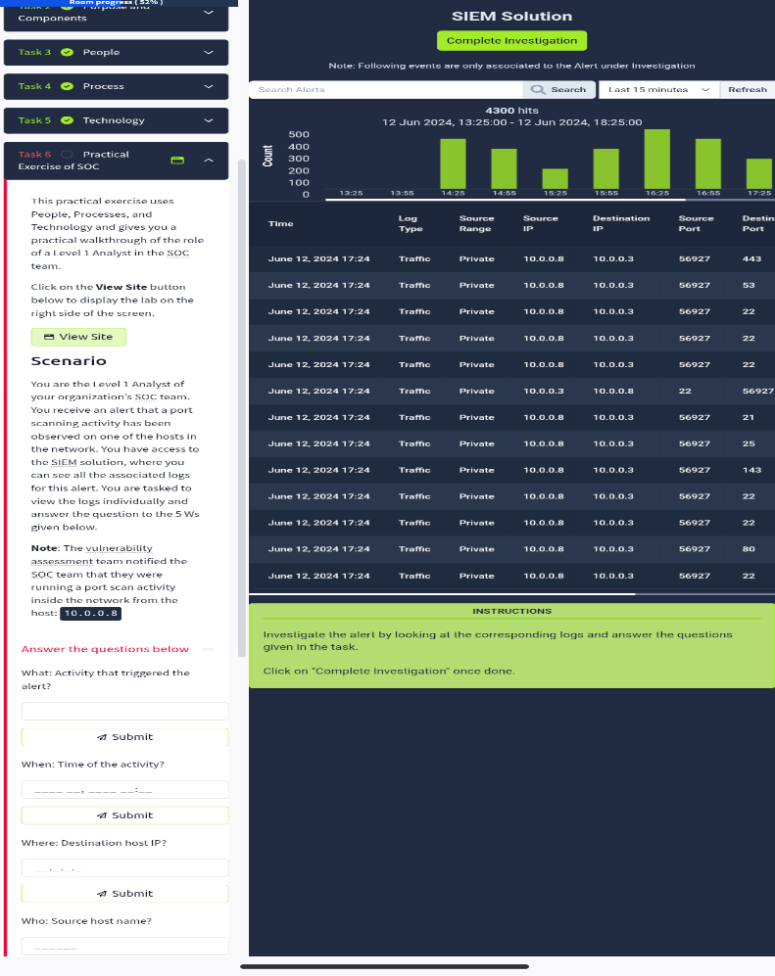
Opening up my SIEM tool on the virtual box, to investigate the alert by looking at the corresponding logs and locate the alert that trigged the alarm.

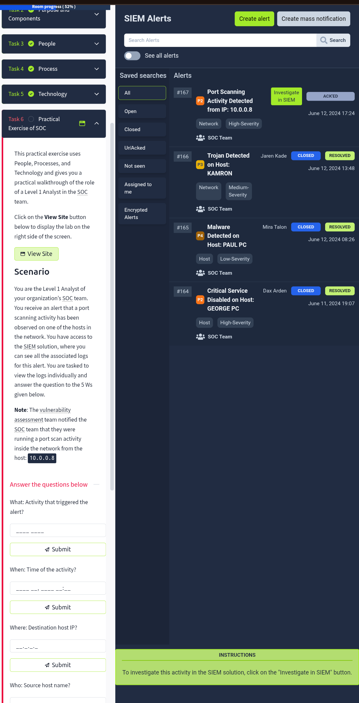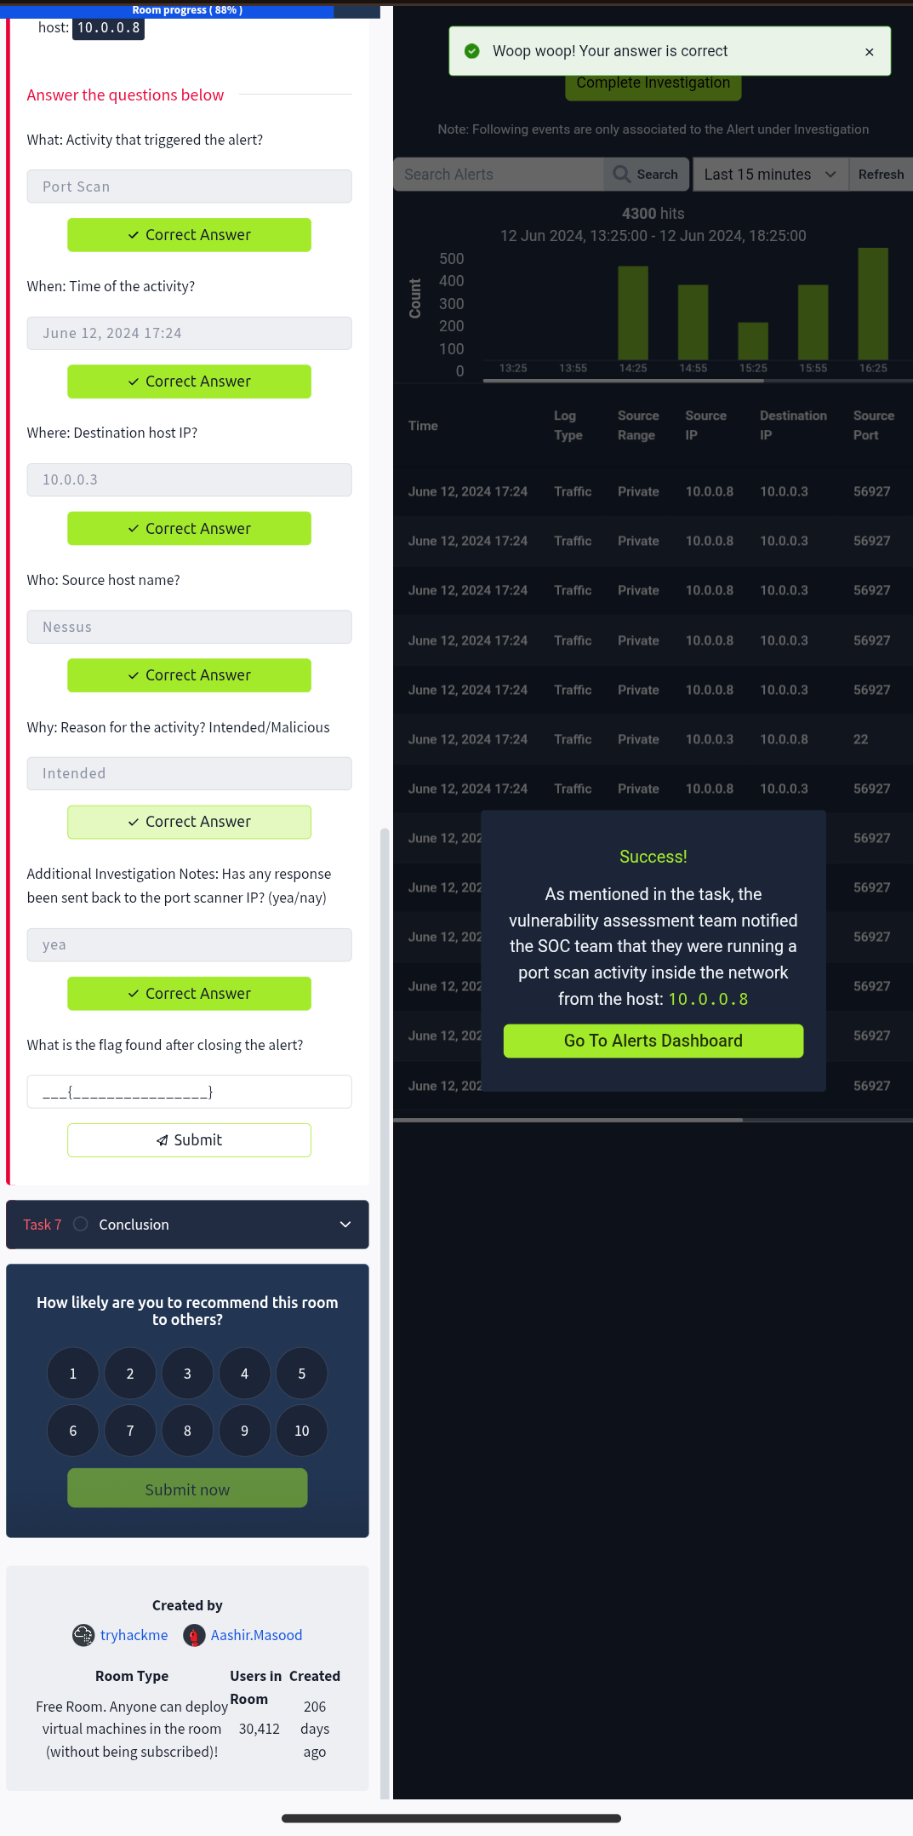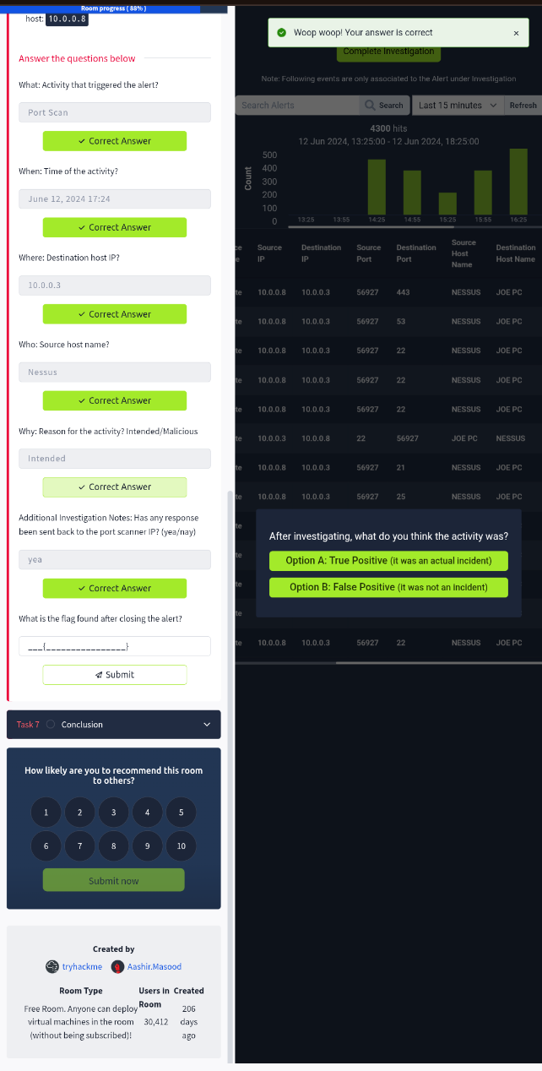
After analyzing the log, it was discovered that it was a port scanning from the IP: 10.0.0.8 at 05:24pm June 12, 2024 that trigged the alarm.
After analyzing the alert, it was discovered that the vulnerability assessment team trigged the alert when they run a port scan inside the network
After a thorough analysis, it could be deduced that it was a true positive alert

