RESULTS
Synthetic appendicitis reporting validation

4.1 Objective 5
Research objective: test the ease of diagnosis of acute appendicitis among resident doctors and medical officers using the combined MAS and hsCRP

4.1.1 Descriptive
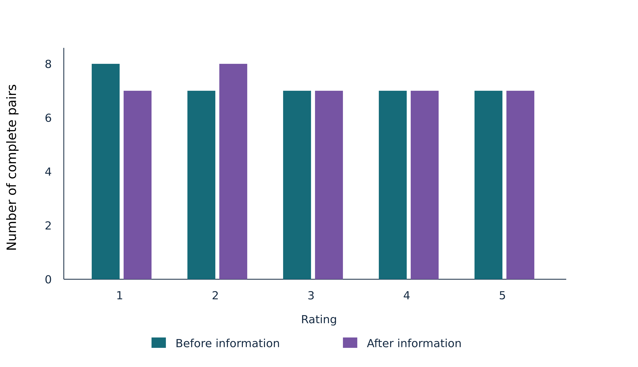
Figure 1. Before and after diagnostic-confidence rating distributions. Grouped bar graphs illustrate Rating and Number of complete pairs. Analysis included 36 eligible records; row-specific denominators take precedence. Before and after counts refer to the same complete pairs. Not confident at all: before, 8; after, 7. Descriptive paired-complete marginal distributions.
Statistical analysis: Descriptive paired-complete marginal distributions. Analysis n = 36.
Complete paired ordinal ratings: 36; incomplete/invalid pairs: 0.
Before: independent clinical confidence without MAS/hsCRP. After: confidence after receiving both. Same clinician within each patient pair is confirmed.
Clinician identity/repeated-case clustering and resident/medical-officer group are unavailable; no independence across cases or professional-group inference is assumed.
Confidence is a proxy, not a direct ease-of-diagnosis item or proof of improved diagnostic accuracy.
Loaded records: 36; result-level analysis n: 36. Row-specific denominators take precedence where shown.
CI = confidence interval; SD = standard deviation; Q1–Q3 = first to third quartile (IQR limits); n = number of observations. Not estimable/Not estimated identifies unavailable evidence; Not applicable identifies an irrelevant field.
Figure sample size and axis units follow the actual plotted observations and stated source definitions.
These results address recorded confidence after MAS/hsCRP information; confidence does not establish diagnostic accuracy. Not confident at all: before 8, after 7, using the same 36 complete pairs. Slightly confident: before 7, after 8, using the same 36 complete pairs. Moderately confident: before 7, after 7, using the same 36 complete pairs. Further series are displayed in the figure; the examples above are in display order and are not a ranking. Before and after distributions use the same complete pairs.
Table 1. Diagnostic-confidence ratings before and after MAS and hsCRP information
Rating | Before n (%) | After n (%) | Complete-pair denominator
1 · Not confident at all | 8 (22.2%) | 7 (19.4%) | 36
2 · Slightly confident | 7 (19.4%) | 8 (22.2%) | 36
3 · Moderately confident | 7 (19.4%) | 7 (19.4%) | 36
4 · Very confident | 7 (19.4%) | 7 (19.4%) | 36
5 · Extremely confident | 7 (19.4%) | 7 (19.4%) | 36
The table summarises Rating; Before n (%); After n (%); Complete-pair denominator. Analysis included 36 eligible records; row-specific denominators take precedence. 1 · Not confident at all — Before n (%): 8 (22.2%); After n (%): 7 (19.4%); Complete-pair denominator: 36. Ordinal frequency distribution using complete pairs; no mean-score or inferential test.
Statistical analysis: Ordinal frequency distribution using complete pairs; no mean-score or inferential test. Analysis n = 36.
Complete paired ordinal ratings: 36; incomplete/invalid pairs: 0.
Before: independent clinical confidence without MAS/hsCRP. After: confidence after receiving both. Same clinician within each patient pair is confirmed.
Clinician identity/repeated-case clustering and resident/medical-officer group are unavailable; no independence across cases or professional-group inference is assumed.
Confidence is a proxy, not a direct ease-of-diagnosis item or proof of improved diagnostic accuracy.
Loaded records: 36; result-level analysis n: 36. Row-specific denominators take precedence where shown.
CI = confidence interval; SD = standard deviation; Q1–Q3 = first to third quartile (IQR limits); n = number of observations. Not estimable/Not estimated identifies unavailable evidence; Not applicable identifies an irrelevant field.
These results address recorded confidence after MAS/hsCRP information; confidence does not establish diagnostic accuracy. 1 · Not confident at all: Complete-pair denominator = 36; Before n (%) = 8 (22.2%); After n (%) = 7 (19.4%). 2 · Slightly confident: Complete-pair denominator = 36; Before n (%) = 7 (19.4%); After n (%) = 8 (22.2%). The distribution shows recorded confidence before and after information; it does not identify effects by clinician group.

