RESULTS
Synthetic appendicitis reporting validation

4.1 Objective 2
Research objective: determine the diagnostic value of hsCRP in simple acute appendicitis and complicated appendicitis

4.1.1 Comparative
This table presents Comparison of hsCRP between simple and complicated appendicitis. The recorded variables are CRP, histology. The analysis uses 30 eligible records; row-specific denominators apply where shown.
Table 1. Comparison of hsCRP between simple and complicated appendicitis
Method / effect | Estimate / statistic | df | 95% interval | Two-sided p
Mann–Whitney U, two-sided asymptotic tie correction and continuity correction · sensitivity comparison | 105.500 | Not applicable | Not applicable | 0.932
Rank-biserial · complicated minus simple | -0.023 | Not applicable | -0.454 to 0.412 | Not applicable
Welch t · primary exploratory comparison | -0.194 | 22.557 | Not applicable | 0.848
Mean difference | -0.750 | 22.557 | -8.743 to 7.243 | Not applicable
Median difference | -1.500 | Not applicable | -13.500 to 10.500 | Not applicable
The table summarises Method / effect; Estimate / statistic; df; 95% interval; Two-sided p. Analysis included 30 eligible records; row-specific denominators take precedence. Mann–Whitney U, two-sided asymptotic tie correction and continuity correction · sensitivity comparison — Estimate / statistic: 105.500; df: Not applicable; 95% interval: Not applicable; Two-sided p: 0.932. Rank comparison selected conservatively for either n<10 or |skewness|>1; otherwise Welch. Both comparisons retained with distinct estimands. Welch t · primary exploratory comparison — df: 22.557.
Statistical analysis: Rank comparison selected conservatively for either n<10 or |skewness|>1; otherwise Welch. Both comparisons retained with distinct estimands. Analysis n = 30.
Histology 1–5 reference-positive; code 6 negative under isolated reactive lymphoid hyperplasia assumption.
Histological severity 1–3 simple, 4–5 complicated; code 6 not applicable. Operative rupture remains independent.
All supplied records retained; full clinical eligibility remains unverified. Missing and unrecognised codes are not negative.
Unit: mg/L. Included 30; excluded not applicable/missing/invalid 6.
Small complicated group; asymptotic rank test includes tie and continuity correction. Independence across recruited patients assumed.
Within-group percentile bootstrap intervals are exploratory; no causal claims.
Loaded records: 36; result-level analysis n: 30. Row-specific denominators take precedence where shown.
CI = confidence interval; SD = standard deviation; Q1–Q3 = first to third quartile (IQR limits); n = number of observations. Not estimable/Not estimated identifies unavailable evidence; Not applicable identifies an irrelevant field.
Retained reporting convention α = 0.05. P-values are displayed to three decimals, or <0.001 when justified by the calculated value; unrounded inferential values remain in the calculation log where available. Statistical evidence alone does not establish clinical importance. Multiplicity treatment is stated in the methods; unadjusted exploratory comparisons require cautious interpretation.
Complicated: n=12; mean (SD) 15.250 (10.635); median (Q1–Q3) 14.500 (8.500–21.250); observed range 1.000–31.000. Units are those of the measured variable in the title/source notes.
Simple: n=18; mean (SD) 16.000 (9.923); median (Q1–Q3) 16.000 (7.000–25.000); observed range 1.000–31.000. Units are those of the measured variable in the title/source notes.
The retained primary/sensitivity label uses sample size and skewness as a heuristic; it does not establish independence, distributional assumptions or protocol approval. Test choice/prespecification remains a methodological review item. Rank-biserial intervals are percentile bootstrap; the mean-difference interval is Welch-based; the median-difference interval is percentile bootstrap.
Additional recorded statistical details: Mann–Whitney comparison U statistic = 105.500. Mann–Whitney comparison p-value = 0.932. Mann–Whitney comparison effect estimate = -0.023. Welch comparison difference = -0.750. Welch comparison t = -0.194. Welch comparison degrees of freedom = 22.557. Welch comparison p-value = 0.848. Welch comparison recorded interval = -8.743 to 7.243. effect interval = -0.454 to 0.412.
Results. Mann–Whitney U, two-sided asymptotic tie correction and continuity correction · sensitivity comparison: Estimate / statistic = 105.500; Two-sided p = 0.932. Rank-biserial · complicated minus simple: Estimate / statistic = -0.023; 95% interval = -0.454 to 0.412. Welch t · primary exploratory comparison: Estimate / statistic = -0.194; df = 22.557; Two-sided p = 0.848.
Mean difference: Estimate / statistic = -0.750; df = 22.557; 95% interval = -8.743 to 7.243. Median difference: Estimate / statistic = -1.500; 95% interval = -13.500 to 10.500.
Interpretation. These results address the relationship between histological severity and hsCRP. For complicated minus simple, rank-biserial effect -0.023 (95% interval -0.454 to 0.412); Mann–Whitney (sensitivity comparison) p = 0.932. The unadjusted rank test does not provide evidence of a distributional difference at the 5% level; this does not establish equivalence. The retained primary exploratory Welch comparison estimates a mean difference of -0.750 (95% interval -8.743 to 7.243), t=-0.194, df=22.557, p = 0.848. This does not meet the retained 5% criterion and does not establish equivalence. Mann–Whitney compares distributions and is not automatically a median test. The estimated group difference is associative.

4.2 Objective 1
Research objective: compare the accuracy of modified Alvarado score (MAS) alone versus MAS plus high sensitivity c-reactive protein (hsCRP) in the diagnosis of acute appendicitis

4.2.1 Descriptive
This table presents Demographic and baseline characteristics of included participants. The recorded variables are age, sex. The analysis uses 36 eligible records; row-specific denominators apply where shown.
Table 2. Demographic and baseline characteristics of included participants
Characteristic | Value | Denominator
Age, years · median (Q1–Q3) | 27.500 (18.750–36.250) | 36
Age range, years | 10–45 | 36
Children <16 years | 6 (16.7%) | 36
Adults ≥16 years | 30 (83.3%) | 36
Male | 18 (50.0%) | 36
Female | 18 (50.0%) | 36
The table summarises Characteristic; Value; Denominator. Analysis included 36 eligible records; row-specific denominators take precedence. Age, years · median (Q1–Q3) — Value: 27.500 (18.750–36.250); Denominator: 36. Descriptive frequencies and median/quartiles; no demographic hypothesis tests.
Statistical analysis: Descriptive frequencies and median/quartiles; no demographic hypothesis tests. Analysis n = 36.
Age missing/invalid: 0; sex missing/invalid: 0.
Loaded records: 36; result-level analysis n: 36. Row-specific denominators take precedence where shown.
CI = confidence interval; SD = standard deviation; Q1–Q3 = first to third quartile (IQR limits); n = number of observations. Not estimable/Not estimated identifies unavailable evidence; Not applicable identifies an irrelevant field.
Results. Age, years · median (Q1–Q3): Value = 27.500 (18.750–36.250); Denominator = 36. Age range, years: Value = 10–45; Denominator = 36. Children <16 years: Value = 6 (16.7%); Denominator = 36.
Adults ≥16 years: Value = 30 (83.3%); Denominator = 36. Male: Value = 18 (50.0%); Denominator = 36. Female: Value = 18 (50.0%); Denominator = 36.
Synthetic validation data are used for this example.
Interpretation. These characteristics describe the cohort in which the research objectives are evaluated. Age, years · median (Q1–Q3): Value = 27.500 (18.750–36.250); Denominator = 36. Age range, years: Value = 10–45; Denominator = 36. Age and sex describe the included cohort; age grouping follows the approved 16-year boundary.

4.3 Objective 5
Research objective: test the ease of diagnosis of acute appendicitis among resident doctors and medical officers using the combined MAS and hsCRP

4.3.1 Descriptive
This table presents Diagnostic-confidence ratings before and after MAS and hsCRP information. The recorded variables are diagnostic_confi1, diagnostic_confi2. The analysis uses 36 eligible records; row-specific denominators apply where shown.
Table 3. Diagnostic-confidence ratings before and after MAS and hsCRP information
Rating | Before n (%) | After n (%) | Complete-pair denominator
1 · Not confident at all | 8 (22.2%) | 7 (19.4%) | 36
2 · Slightly confident | 7 (19.4%) | 8 (22.2%) | 36
3 · Moderately confident | 7 (19.4%) | 7 (19.4%) | 36
4 · Very confident | 7 (19.4%) | 7 (19.4%) | 36
5 · Extremely confident | 7 (19.4%) | 7 (19.4%) | 36
The table summarises Rating; Before n (%); After n (%); Complete-pair denominator. Analysis included 36 eligible records; row-specific denominators take precedence. 1 · Not confident at all — Before n (%): 8 (22.2%); After n (%): 7 (19.4%); Complete-pair denominator: 36. Ordinal frequency distribution using complete pairs; no mean-score or inferential test.
Statistical analysis: Ordinal frequency distribution using complete pairs; no mean-score or inferential test. Analysis n = 36.
Complete paired ordinal ratings: 36; incomplete/invalid pairs: 0.
Before: independent clinical confidence without MAS/hsCRP. After: confidence after receiving both. Same clinician within each patient pair is confirmed.
Clinician identity/repeated-case clustering and resident/medical-officer group are unavailable; no independence across cases or professional-group inference is assumed.
Confidence is a proxy, not a direct ease-of-diagnosis item or proof of improved diagnostic accuracy.
Loaded records: 36; result-level analysis n: 36. Row-specific denominators take precedence where shown.
CI = confidence interval; SD = standard deviation; Q1–Q3 = first to third quartile (IQR limits); n = number of observations. Not estimable/Not estimated identifies unavailable evidence; Not applicable identifies an irrelevant field.
Results. 1 · Not confident at all: Before n (%) = 8 (22.2%); After n (%) = 7 (19.4%). 2 · Slightly confident: Before n (%) = 7 (19.4%); After n (%) = 8 (22.2%). 3 · Moderately confident: Before n (%) = 7 (19.4%); After n (%) = 7 (19.4%).
4 · Very confident: Before n (%) = 7 (19.4%); After n (%) = 7 (19.4%). 5 · Extremely confident: Before n (%) = 7 (19.4%); After n (%) = 7 (19.4%).
Interpretation. These results address recorded confidence after MAS/hsCRP information; confidence does not establish diagnostic accuracy. 1 · Not confident at all: Complete-pair denominator = 36; Before n (%) = 8 (22.2%); After n (%) = 7 (19.4%). 2 · Slightly confident: Complete-pair denominator = 36; Before n (%) = 7 (19.4%); After n (%) = 8 (22.2%). The distribution shows recorded confidence before and after information; it does not identify effects by clinician group.
This figure presents Before and after diagnostic-confidence rating distributions. The recorded variables are diagnostic_confi1, diagnostic_confi2. The analysis uses 36 eligible records; row-specific denominators apply where shown.
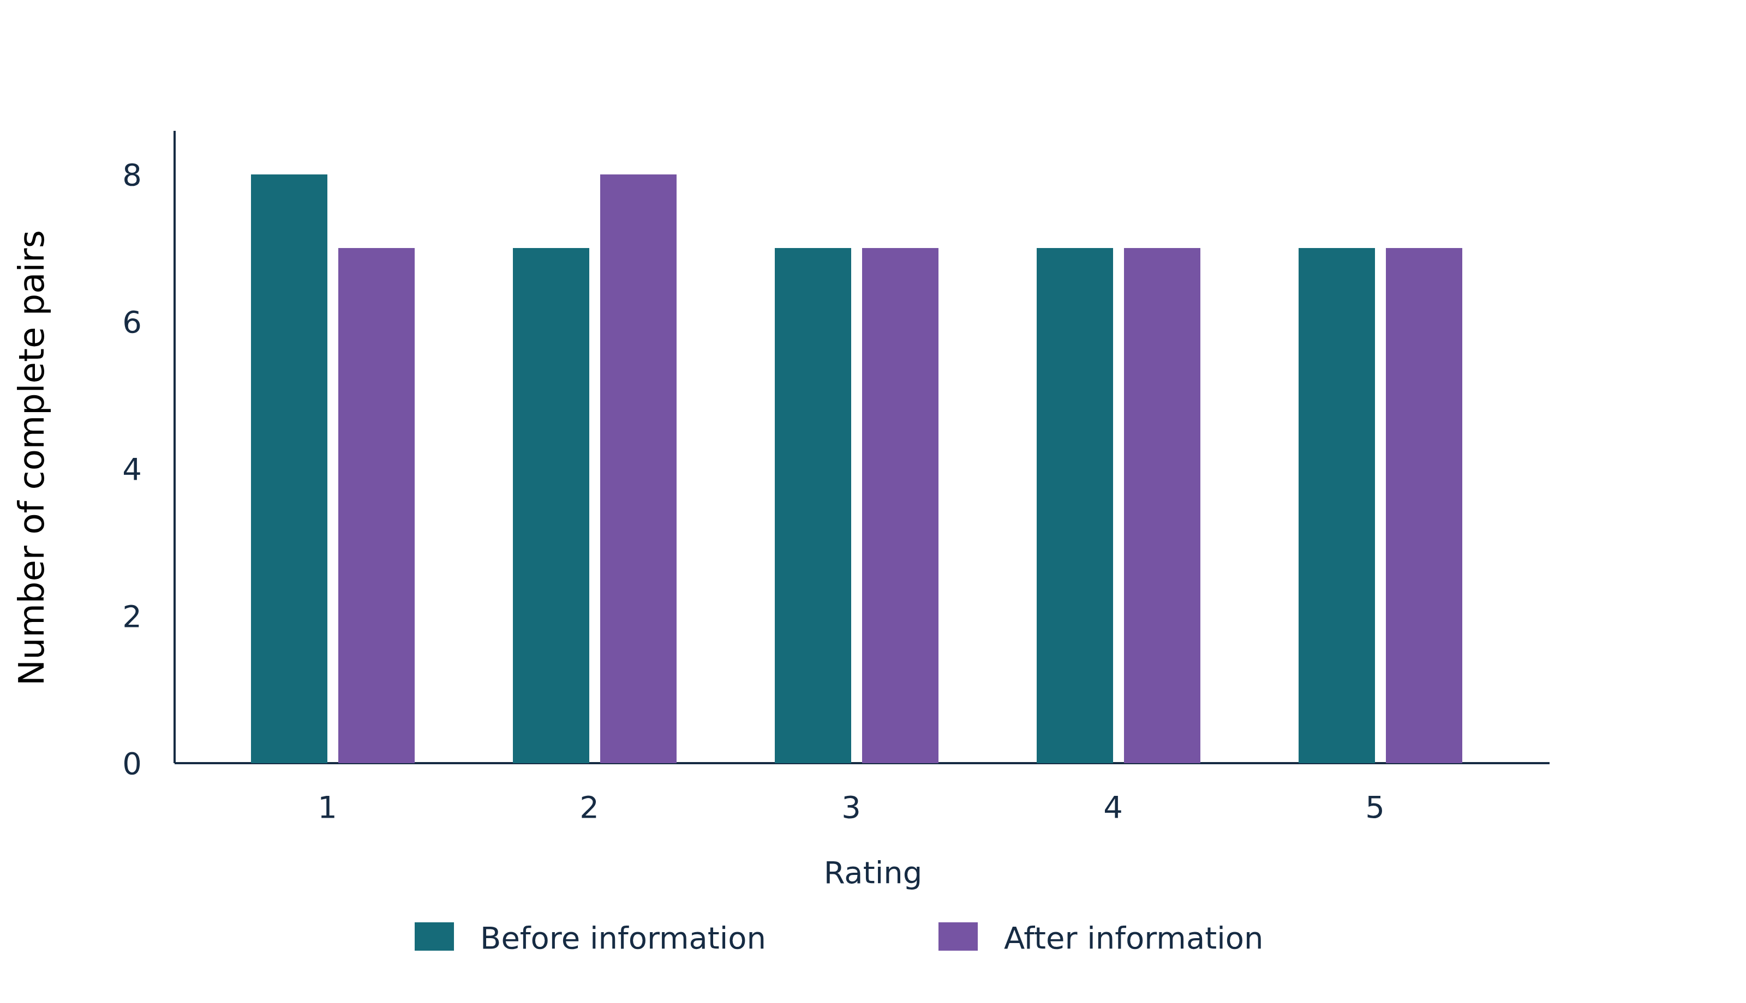
Figure 1. Before and after diagnostic-confidence rating distributions. Grouped bar graphs illustrate Rating and Number of complete pairs. Analysis included 36 eligible records; row-specific denominators take precedence. Before and after counts refer to the same complete pairs. Not confident at all: before, 8; after, 7. Descriptive paired-complete marginal distributions.
Statistical analysis: Descriptive paired-complete marginal distributions. Analysis n = 36.
Complete paired ordinal ratings: 36; incomplete/invalid pairs: 0.
Before: independent clinical confidence without MAS/hsCRP. After: confidence after receiving both. Same clinician within each patient pair is confirmed.
Clinician identity/repeated-case clustering and resident/medical-officer group are unavailable; no independence across cases or professional-group inference is assumed.
Confidence is a proxy, not a direct ease-of-diagnosis item or proof of improved diagnostic accuracy.
Loaded records: 36; result-level analysis n: 36. Row-specific denominators take precedence where shown.
CI = confidence interval; SD = standard deviation; Q1–Q3 = first to third quartile (IQR limits); n = number of observations. Not estimable/Not estimated identifies unavailable evidence; Not applicable identifies an irrelevant field.
Figure sample size and axis units follow the actual plotted observations and stated source definitions.
Results. Not confident at all: before = 8; after = 7. Slightly confident: before = 7; after = 8. Moderately confident: before = 7; after = 7.
Very confident: before = 7; after = 7. Extremely confident: before = 7; after = 7.
Interpretation. These results address recorded confidence after MAS/hsCRP information; confidence does not establish diagnostic accuracy. Not confident at all: before 8, after 7, using the same 36 complete pairs. Slightly confident: before 7, after 8, using the same 36 complete pairs. Moderately confident: before 7, after 7, using the same 36 complete pairs. Further series are displayed in the figure; the examples above are in display order and are not a ranking. Before and after distributions use the same complete pairs.

