CHROMOSOME 9 VARIANT ANNOTATION PROFILES ACROSS PUBLIC ACUTE LEUKEMIA SEQUENCING DATASETS
Progress Ajayi¹, Aanuoluwa Temitayo Iyiola², Mehwish Fatima³, Samson Oluwasefunmi Ejigbo⁴, Lilian Chinonso Okoro⁵, Oluomachi Nancy Uchenna⁶, Enoch Oluwaseun Aderemi⁷, Angella Namuyanja⁸, Blessing Opeyemi Afolabi⁹
¹ Department of Biological Sciences, Lead City University, Ibadan
² Federal University of Technology, Minna
³ Muhammad Ali Jinnah University, Pakistan
⁴ Adekunle Ajasin University, Akungba-Akoko
⁵ Department of Laboratory Services, Iwosan Lagoon Hospitals, Lagos, Nigeria
⁶ Department of Biochemistry, Michael Okpara University of Agriculture, Umudike, Abia State, Nigeria
⁷ Federal University, Oye-Ekiti
⁸ MRC/UVRI and LSHTM Uganda Research Unit, Entebbe, Uganda
⁹ Genomac Labs, Institute of Biochemistry, Molecular Biology and Biotechnology
Corresponding author: Blessing Opeyemi Afolabi
Keywords: Acute leukemia; genomic annotation; gene-set overlap; REH cell line; sequencing provenance; reference coverage; comparative genomics

ABSTRACT
Chromosome 9 contains loci implicated in acute leukemia, but interpreting public sequencing data requires attention to biological provenance and reference coverage. This study compared chromosome 9 variant annotation profiles across six sequencing runs associated with acute myeloid leukemia (AML) or acute lymphoblastic leukemia (ALL). Three ALL runs represented one REH BioSample; AML-associated inputs comprised ML-2, an HL-60 apoptotic DNA-fragment library and bone-marrow DNA analyzed by sparse sequencing. Sequences were aligned to GRCh38.p14 chromosome 9 (NC_000009.12) using Geneious, followed by reference annotation transfer and descriptive comparison of gene assignments, coding annotations, set overlap and hierarchical clustering. AML-associated annotation counts had a higher central value and wider spread, with overlapping group distributions. Predicted protein substitutions predominated in both groups; truncations were more prominent in ALL. Proline-to-leucine led the ALL-associated top-ten amino-acid-change summary, whereas glycine-to-arginine led the AML-associated summary. Gene-label overlap comprised 196 AML-only labels, 41 ALL-only labels and 15 shared labels; variant annotation-record overlap comprised 742 AML-only entries, 551 ALL-only entries and 4 shared entries. PAX5-associated records occurred in both groups. Run-level clustering intermixed leukemia labels, with ALL-3 and AML-2 forming the closest pair. ALL-1 had 0.8% chromosome 9 reference coverage. These findings characterize heterogeneous gene and coding-annotation patterns in this collection. Repeated sequencing of one ALL source, differing assay designs and sparse reference coverage limit disease-level interpretation; group-restricted annotations do not establish leukemia-specific mutations or clinical biomarkers.

1. INTRODUCTION
Genomic alterations contribute to the biological heterogeneity of acute leukemia. Their interpretation depends on the type of alteration and its biological context. In B-cell precursor acute lymphoblastic leukemia (B-ALL), genomic profiling combines sequence variants and chromosomal abnormalities with variant classification and orthogonal validation to identify potentially relevant lesions (Martínez Anaya et al., 2026). Whole-genome sequencing can also evaluate several classes of alterations in myeloid cancers, provided that detection performance has been established for each relevant variant class (Abel et al., 2025). Accurate characterization of genomic variation is therefore essential for interpreting sequencing results biologically.
Chromosome 9 contains loci implicated in leukemia development. Combined heterozygous loss of Pax5 and Cd72 can promote B-ALL experimentally, linking alterations in neighbouring genes to a defined leukemogenic phenotype (Ruiz-Corzo et al., 2026). Multiomic analysis of the REH leukemia cell line has also characterized alterations affecting PAX5 and CDKN2A using complementary short-read, long-read and transcriptomic measurements (Lysenkova Wiklander et al., 2024). These findings support chromosome-focused analysis. They also illustrate the distinction between assigning an annotation to a gene and establishing the function of a specific alteration.
Public sequencing datasets provide complementary measurements of leukemia genomes. The REH resource, for example, includes several library types and sequencing technologies from the same cell-line model (Lysenkova Wiklander et al., 2023). Comparing these inputs can reveal differences in the annotation profiles recovered by different approaches. However, platform, caller and genomic context influence variant detection (Eveleigh et al., 2026). Local coverage can also vary substantially despite acceptable overall sequencing quality (Lan et al., 2026). Between-group comparisons must therefore account for the biological sources of the data and the genomic regions represented by the reads.
How chromosome 9 annotation profiles compare across heterogeneous public leukemia sequencing datasets remains an important question. We examined six runs associated with acute myeloid leukemia (AML) or ALL, comparing gene-associated distributions, predicted protein effects, sequence-change classes, amino-acid and coding-position patterns, annotation-set overlap and run-level clustering. Our objective was to characterize shared and group-restricted patterns in this collection and interpret them in relation to biological provenance and chromosome coverage.

2. BACKGROUND AND LITERATURE REVIEW
Variant annotation assigns sequence differences to genomic features and predicts their consequences against a specified reference. The assignments depend on annotation software and transcript selection. A comparison of pathogenic ClinVar variants found discrepancies in coding and protein nomenclature across annotation tools (Chen et al., 2025). A genome-wide benchmark likewise showed that differences in tools and gene models can affect protein- and pathway-level interpretation (Queme et al., 2026). Transcript expression also matters: the interpretation of a variant assigned to a canonical coding transcript may change if that transcript is not expressed in the affected tissue (De Groote et al., 2025). Gene assignments and predicted effects therefore need to be considered at the allele and transcript levels.
Sequencing design also affects which variants are available for annotation. Cancer cell-line mixture standards show that sequence depth and normal-reference information influence somatic variant detection (Zhang et al., 2026). Tumor-only analysis adds the challenge of distinguishing somatic changes from germline variation and artifacts (Krishnamachari et al., 2026). Low-pass sequencing designed to quantify copy-number alterations addresses a different detection task from dense small-variant profiling (Eriksson & Lakatos, 2026). These differences are relevant when comparing archived leukemia datasets from different experiments.
Annotation-set overlap identifies similarities within a chromosome-focused comparison. An entry restricted to one group is a useful descriptive observation, but establishing biological exclusivity requires adequate coverage of the corresponding locus in the other group. This distinction is particularly relevant here. The collection combines repeated sequencing of REH with AML-associated inputs that differ in biological origin and library design. We therefore compared annotation profiles at the sequencing-run level, rather than estimating mutation prevalence in independent AML and ALL populations.

3. MAIN BODY

3.1. Materials and Methods
3.1.1. Study design and sequencing datasets: We conducted a secondary, descriptive analysis of human acute leukemia DNA sequencing data from the National Center for Biotechnology Information Sequence Read Archive (SRA) and the European Nucleotide Archive. Database searches combined terms for human acute leukemia, REH, AML and whole-genome sequencing. We analyzed six sequencing runs with accession, BioSample and sequencing-platform metadata: three associated with ALL and three with AML (Table 1). The sequencing run was the analytical unit; this was not a recruited patient cohort.
The three ALL runs represented REH and shared BioSample SAMN13831871. They comprised Oxford Nanopore PromethION, PacBio Sequel II and Illumina HiSeq X sequencing of the same biological source (Lysenkova Wiklander et al., 2023). The AML inputs comprised ML-2, HL-60 and AML-associated bone-marrow DNA. ML-2 sequencing originated from a study comparing control and decitabine-exposed leukemia cells. The HL-60 input was an apoptotic DNA-fragment library collected after 24 hours at room temperature, within a fragmentomics study (Zhu et al., 2023). The bone-marrow input used sparse whole-genome sequencing for somatic copy-number quantification (European Nucleotide Archive, 2026). Group labels were retained for descriptive comparison; sequencing runs sharing a BioSample were treated as repeated measurements of that source rather than independent biological replicates.
Table 1. Sequencing datasets included in the chromosome 9 analysis. AML, acute myeloid leukemia; ALL, acute lymphoblastic leukemia. The three ALL runs share one REH BioSample
Run label and accession | BioSample | Biological material | Sequencing platform
ALL-1  SRR22444744 | SAMN13831871 | REH | PromethION
ALL-2  SRR22805329 | SAMN13831871 | REH | PacBio Sequel II
ALL-3  SRR23704824 | SAMN13831871 | REH | Illumina HiSeq X
AML-1  SRR1207242 | SAMN02709918 | ML-2 | Illumina HiSeq 2000
AML-2  SRR24350313 | SAMN34434777 | HL-60 apoptotic DNA fragments | Illumina NovaSeq 6000
AML-3  SRR13483248 | SAMN17383328 | AML-associated bone-marrow DNA | Illumina HiSeq 2000
3.1.2. Sequence processing and reference alignment: Sequence data were retrieved using the SRA Toolkit or the European Nucleotide Archive. FastQC in Galaxy was used to assess sequence quality, guanine–cytosine (GC) content, sequence composition and duplication (Andrews, 2010). Adapters and low-quality sequences were trimmed using Trimmomatic, with quality filtering described by a Phred quality score of 30 (Q30) and a minimum read length of 50 base pairs (Bolger et al., 2014). Sequences were assembled using SPAdes, retaining contigs of at least 500 base pairs (Bankevich et al., 2012). Assembly statistics were assessed using QUAST (Gurevich et al., 2013).
Reads and assembly-derived sequences were imported into Geneious and aligned to human reference chromosome 9, GRCh38.p14 accession NC_000009.12. Geneious Mapper was used at medium sensitivity. Reference annotations were transferred to aligned sequences to assign genes, coding sequences and other genomic features. We examined alignment statistics to assess chromosome coverage before interpreting the annotation profiles.
3.1.3. Variant calling and annotation: Variant calling in Geneious used an approximate minimum variant-frequency setting of 0.6, a maximum variant P-value threshold below 0.001 and a strand-bias P-value threshold of 10⁻⁶. Strand bias above 65% was flagged. These thresholds were used for variant detection and filtering, not for testing differences between leukemia groups.
Variant annotations included gene assignment, polymorphism class, predicted protein effect, nucleotide and amino-acid changes, reference and alternate alleles, coding positions and coverage-related attributes. Protein-effect categories included substitutions, frameshifts and truncations. We use the term variant annotation record to denote an annotated entry included in the descriptive summaries. These records were considered separately from clinically classified somatic variants. Gene-associated annotations were compared within the chromosome 9 reference context.
3.1.4. Descriptive analysis: Annotation records were organized by run and leukemia group and analyzed using Python in JupyterLab version 4.2.0. We compared overall annotation counts, gene-associated frequencies, polymorphism classes, predicted protein effects, amino-acid changes and coding positions. Gene-set and variant annotation-record overlap were summarized across the AML-associated and ALL-associated groups. Hierarchical clustering examined similarities among the six run-level profiles. A clustered heat map displayed the run-by-gene annotation matrix, with dendrograms for both runs and genes. The heatmap workflow used row-wise unit-variance scaling, missing-value imputation, correlation distance and average linkage. Coding-position categories were summarized across coding sequences and were not treated as genomic coordinates.
All comparisons were descriptive. We did not estimate patient-level mutation prevalence, clinical performance or between-group statistical significance, and no clinical outcome results are reported. Polymorphism categories were interpreted as annotation labels, while predicted coding consequences were distinguished from experimentally established effects.

3.2. Results
3.2.1. Dataset composition and reference representation: The six sequencing runs represented four BioSample identifiers (Table 1). The three ALL-associated runs measured the same REH source on different sequencing platforms. The AML-associated inputs represented ML-2, HL-60 apoptotic DNA fragments and bone-marrow DNA. The collection thus included repeated sequencing of one ALL source and three distinct AML-associated inputs.
In ALL-1, 328,321 reads entered the alignment analysis: 326 were assigned to the assembled component and 327,995 remained unassembled. Pairwise identity was 91.4%, chromosome 9 reference coverage was 0.8% and maximum coverage was 3. Mean ungapped sequence length was 3,507.1 base pairs, with a range of 173–16,444 base pairs. Agreement within the aligned sequences was high, although they covered only a small proportion of the chromosome reference.
The chromosome 9 reference annotation layer contained 2,487 gene features, 5,514 coding-sequence features, 5,505 messenger RNA features, 1,636 noncoding RNA features and 6,270 regulatory features. These reference-derived features provided genomic context for the aligned sequences. The counts do not represent variant-bearing genes or experimentally measured transcripts.
3.2.2. Overall and gene-associated annotation distributions: Run-level annotation counts ranged from 4 to 4,943 in the ALL-associated group and from 25 to 8,117 in the AML-associated group. Median counts were 92 and 1,822, respectively (Figure 1). Counts were higher and more dispersed in the AML-associated group, although the group ranges overlapped. Gene-associated counts also varied across runs, with high counts concentrated in a subset of genes.
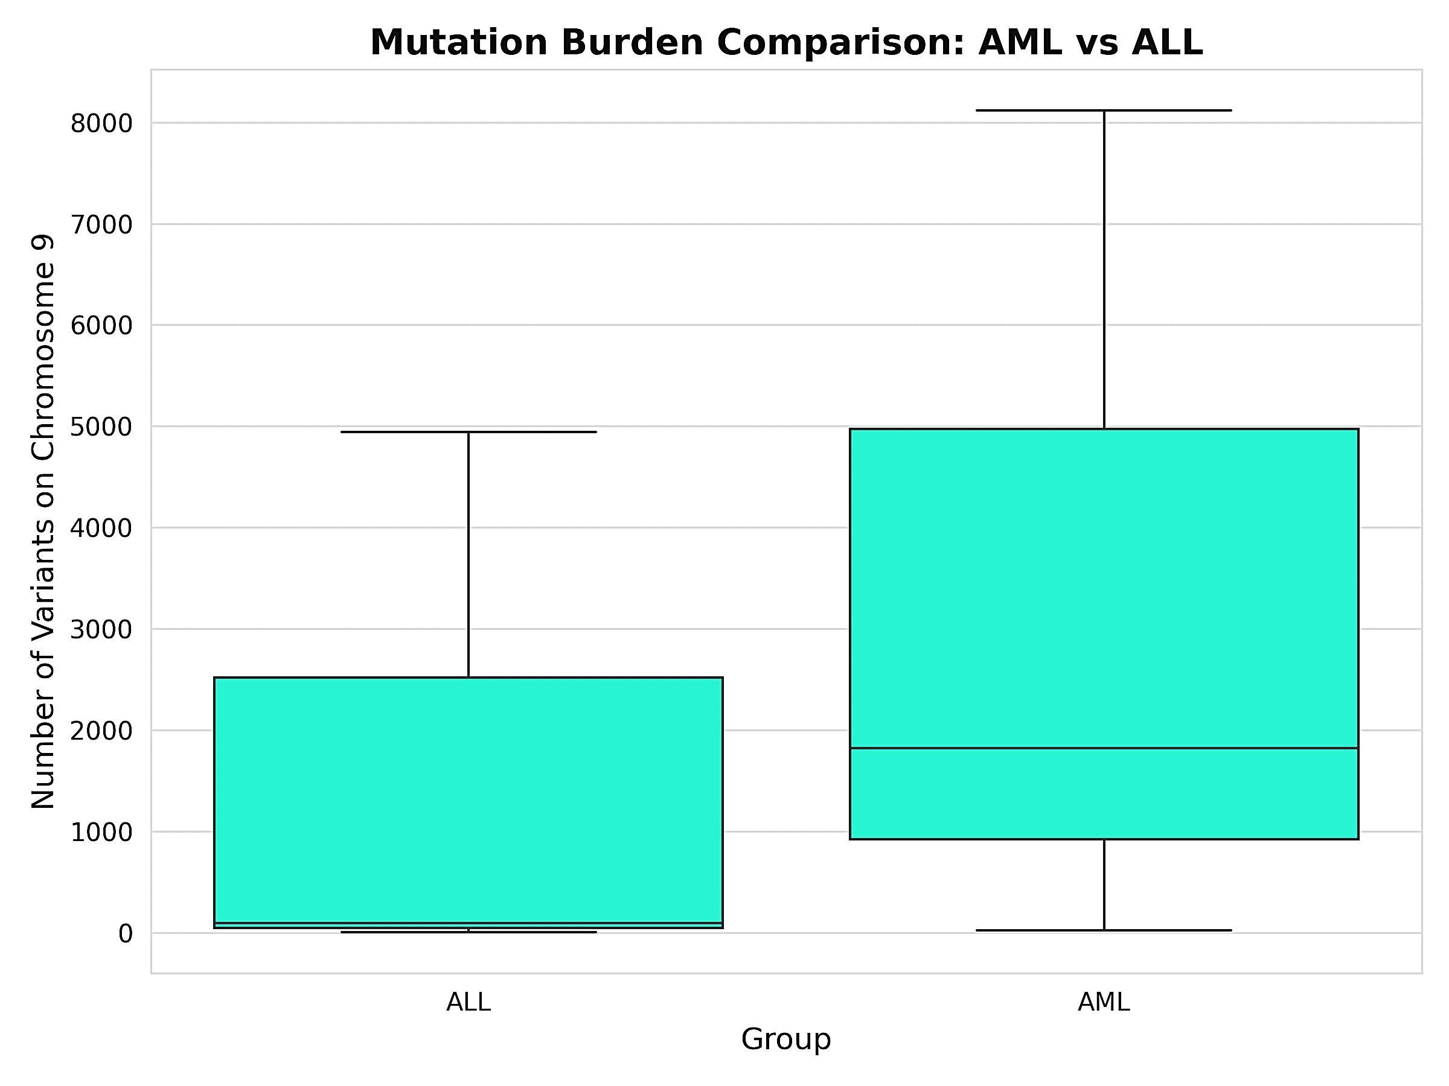
Figure 1. Run-level chromosome 9 annotation-record counts by leukemia group. Boxes show interquartile ranges; horizontal lines indicate medians. Three runs contribute to each group, with the ALL runs sharing one REH BioSample. Counts are annotation records rather than validated distinct somatic mutations. AML, acute myeloid leukemia; ALL, acute lymphoblastic leukemia
Frequently represented gene labels included GOLGA2, WASHC1, CDC14B and DNM1 in the AML-associated summary, and UNC13B, ADAMTSL1 and TEK in the ALL-associated summary. Table 2 lists additional gene labels and the coding-position categories. These summaries report frequencies of gene-associated annotation records.
Among the selected leukemia-associated genes, PAX5 records occurred in both groups and were more prominent in the ALL-associated summary. NUP214 records occurred in the ALL-associated summary, whereas NOTCH1 records occurred in the AML-associated summary (Figure 2). These results describe gene assignments; they do not identify a shared allele, fusion or validated pathogenic alteration.
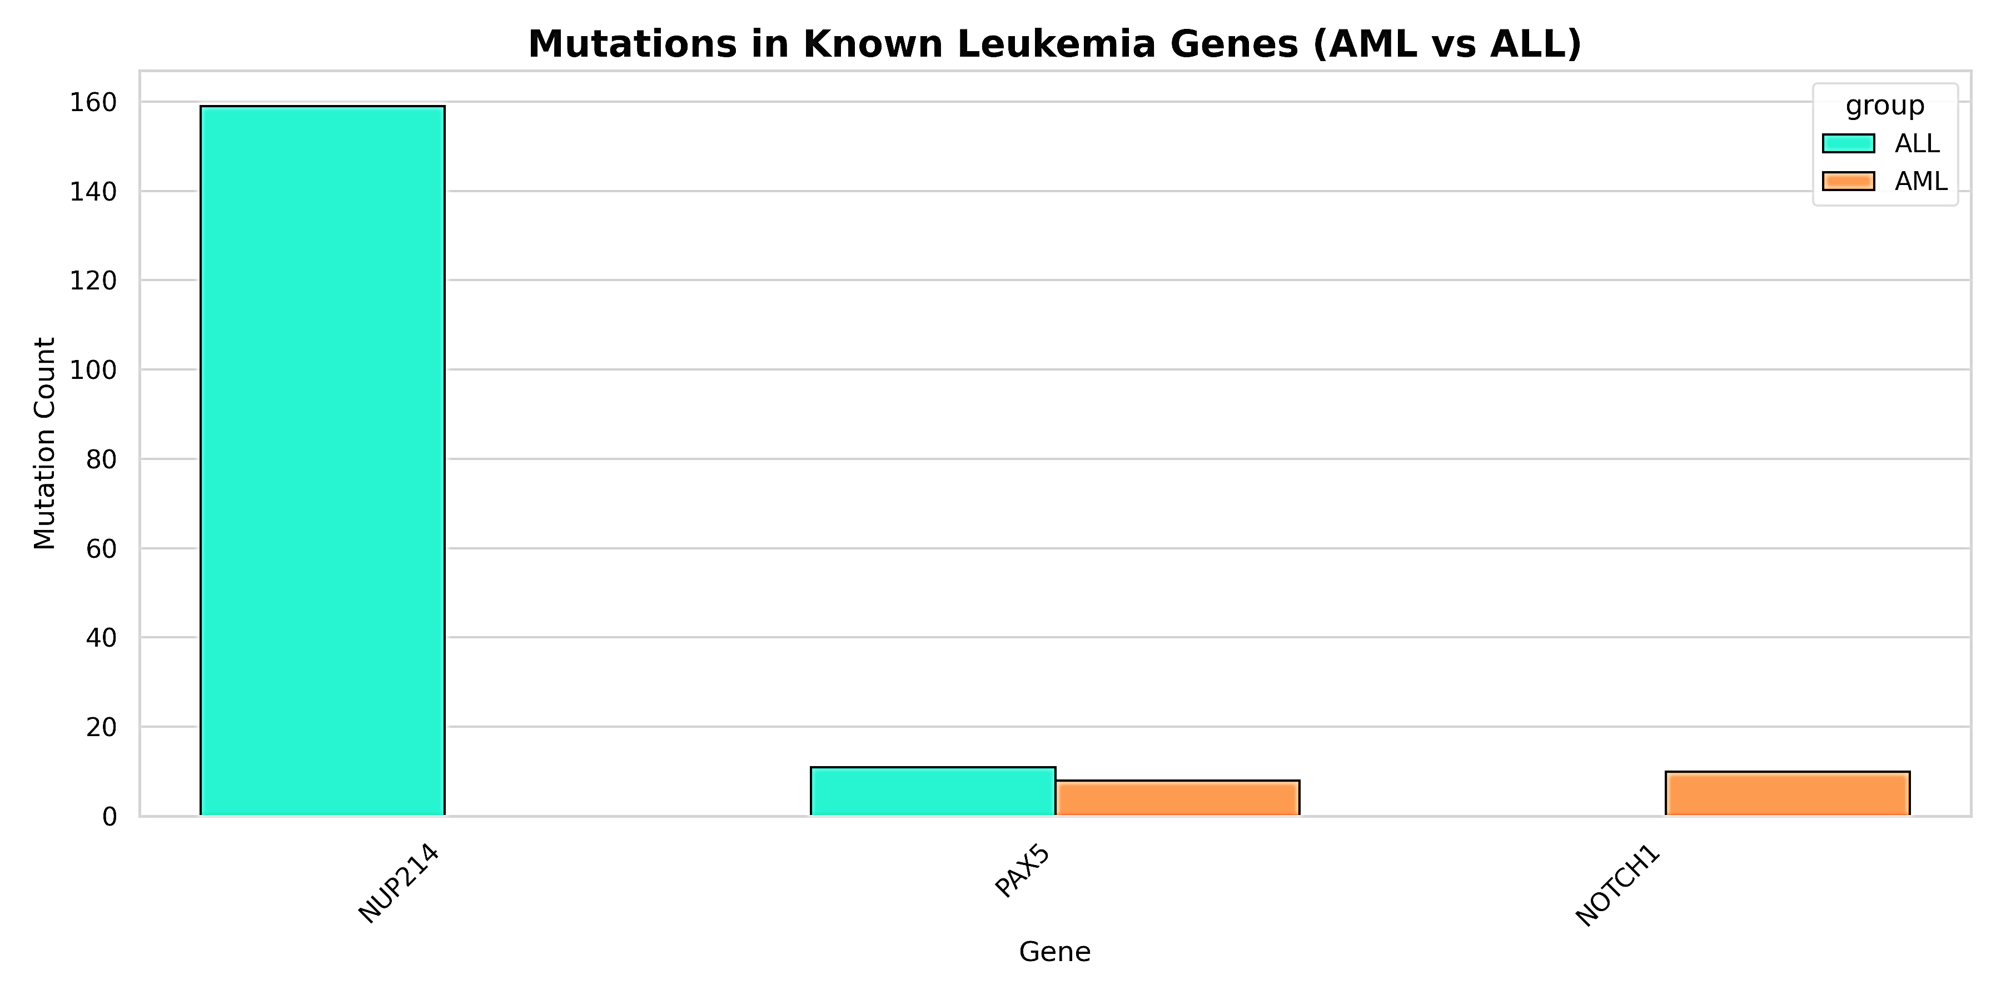
Figure 2. Annotation records assigned to selected leukemia-associated chromosome 9 genes. PAX5 entries occur in both groups, NUP214 in ALL and NOTCH1 in AML. Counts do not establish pathogenicity, fusions or biological absence. AML, acute myeloid leukemia; ALL, acute lymphoblastic leukemia
3.2.3. Sequence-change classes and predicted protein effects: Predicted protein substitutions predominated in both groups. Truncations and frameshifts accounted for smaller proportions of the protein-effect distributions. Truncations were more prominent in the ALL-associated profile than in the AML-associated profile (Figure 3).
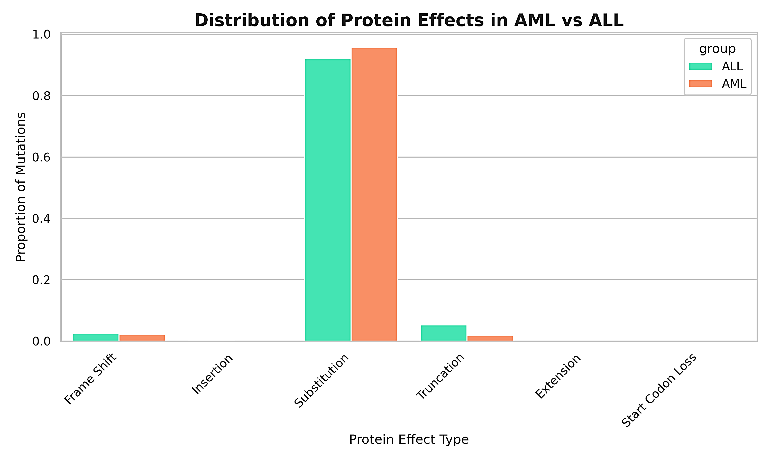
Figure 3. Predicted protein-effect annotation profiles. Bars show within-group proportions of the plotted categories. Substitutions predominate in both groups; truncations are more prominent in ALL. Effects are computational annotations rather than experimentally validated changes. AML, acute myeloid leukemia; ALL, acute lymphoblastic leukemia
Polymorphism-class distributions differed between groups. Transition labels were more prominent than transversion labels or entries labelled substitution in the AML-associated summary. In the ALL-associated summary, substitution labels predominated, followed by transversion and transition labels. Insertion labels accounted for a smaller proportion, while deletion and tandem-repeat categories were not prominent. These are descriptive differences in annotation categories, rather than statistically established enrichment.
3.2.4. Amino-acid changes and coding-position patterns: Proline-to-leucine was the most frequent category in the ALL-associated top-ten amino-acid-change summary, whereas glycine-to-arginine was the most frequent in the AML-associated summary (Figure 4). Proline-to-leucine, glutamate-to-lysine, alanine-to-valine and alanine-to-threonine appeared in both top-ten lists. Other categories differed between groups. The amino-acid heatmap also showed higher AML-associated record frequencies in several categories.
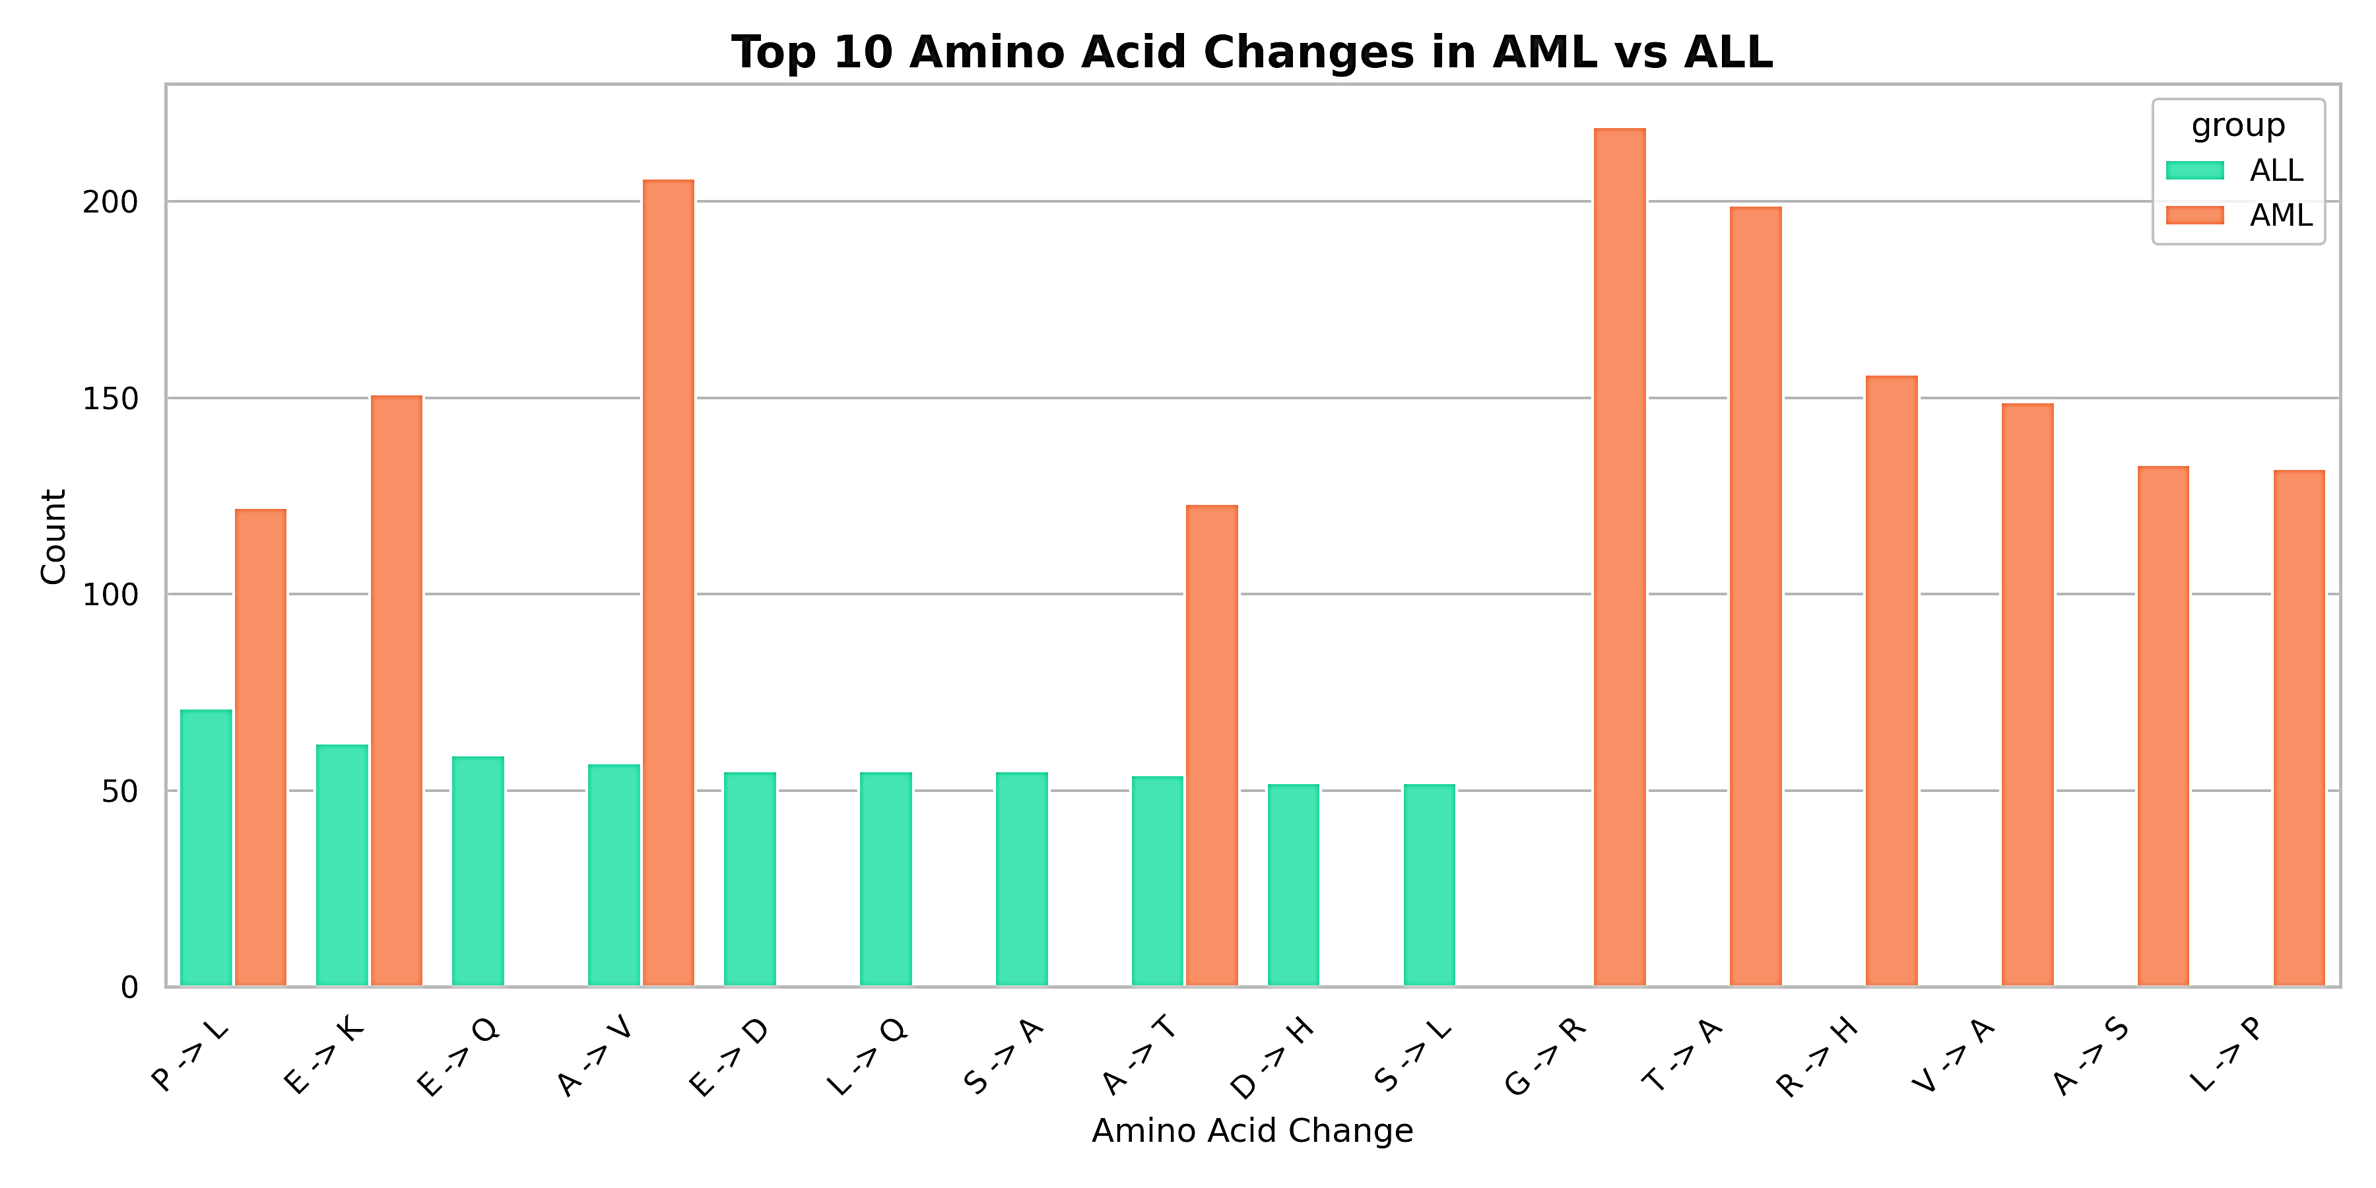
Figure 4. Frequently represented amino-acid-change annotation categories. The chart compares the top-ten category lists for ALL-associated and AML-associated records; overlapping categories appear in both groups. Arrows connect annotated reference and alternate residues. Codes: A, alanine; D, aspartate; E, glutamate; G, glycine; H, histidine; K, lysine; L, leucine; P, proline; Q, glutamine; R, arginine; S, serine; T, threonine; V, valine. Counts are pooled across coding sequences and do not define gene-specific recurrence
The top-ten codon-number lists differed between groups. Codon labels 151 and 539 were most prominent in the ALL-associated and AML-associated summaries, respectively. The corresponding coding-sequence-position summaries were led by labels 1074 in ALL and 1327 in AML. Table 2 lists all of these position labels. They are pooled across coding sequences and do not represent chromosome coordinates or recurrence at a single gene–transcript position.
Table 2. Selected gene labels and coding-position annotation patterns by leukemia group
Annotation category | AML-associated profile | ALL-associated profile
Selected frequently represented gene labels | GOLGA2; WASHC1; CDC14B; DNM1; KANK1; PHF2; FAM120A; HNRNPK | UNC13B; ADAMTSL1; TEK; ZNF618; DDX31; HAUS6; NUP214; PAPPA; ANKRD18B
Top-ten codon-number labels | 114; 118; 237; 434; 440; 443; 539; 980; 992; 994 | 44; 115; 129; 142; 146; 147; 150; 151; 159; 358
Top-ten coding-sequence-position labels | 340; 354; 1301; 1319; 1327; 1855; 2939; 2976; 2982; 2985 | 132; 358; 386; 451; 469; 484; 496; 508; 520; 1074
Gene labels summarize frequently represented annotations. Coding-position labels are pooled across coding sequences and are listed in ascending numerical order; they are not chromosome coordinates. AML, acute myeloid leukemia; ALL, acute lymphoblastic leukemia.
3.2.5. Shared and group-restricted annotation sets: Both the gene-label and variant annotation-record comparisons contained substantially more group-restricted than shared entries (Figure 5). Gene-label overlap comprised 196 AML-only labels, 41 ALL-only labels and 15 shared labels. Variant annotation-record overlap comprised 742 AML-only entries, 551 ALL-only entries and 4 shared entries. These sets describe the recovered profiles; they do not establish biological absence from other AML or ALL genomes.
A  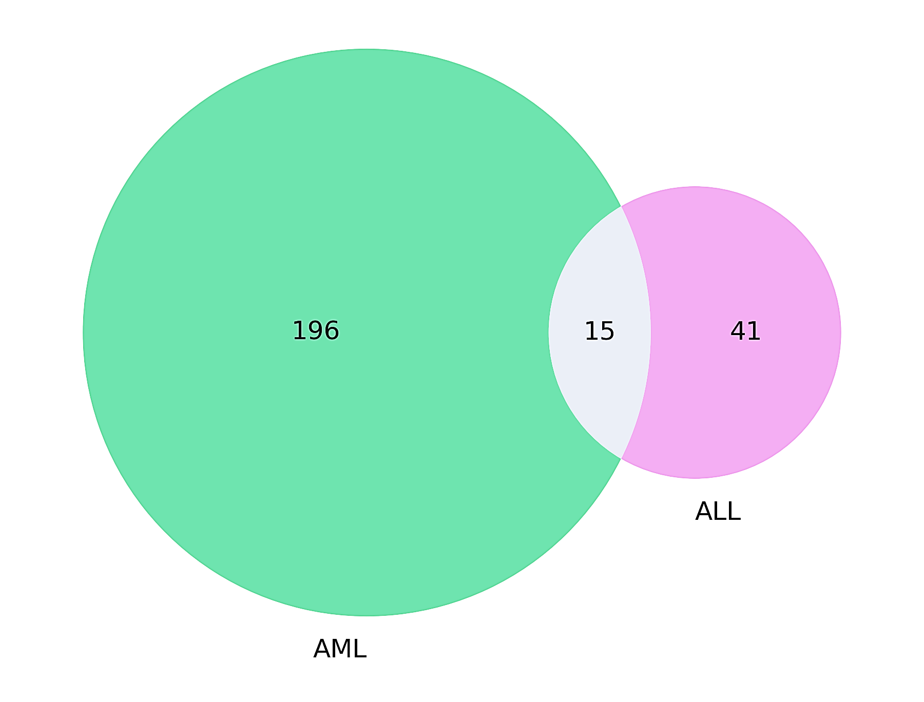 | B  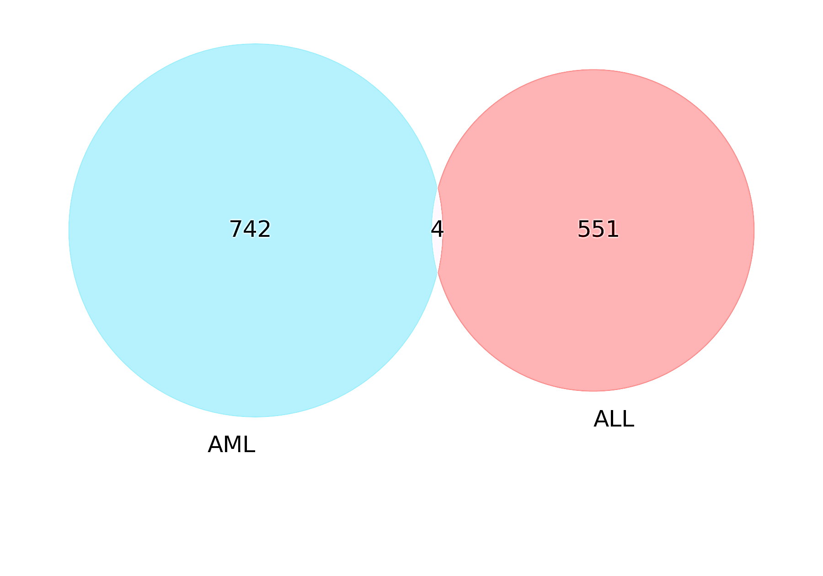
Figure 5. Shared and group-restricted chromosome 9 annotation sets. Panel A shows gene labels; panel B shows variant annotation records. Numbers indicate entries restricted to AML, shared between groups or restricted to ALL. Group-restricted membership refers to the recovered annotation sets and does not establish biological absence. AML, acute myeloid leukemia; ALL, acute lymphoblastic leukemia
3.2.6. Similarity among run-level profiles: Hierarchical clustering intermixed AML-associated and ALL-associated runs (Figure 6). ALL-3 and AML-2 formed the closest pair. ALL-1, ALL-2 and AML-3 joined this cluster successively, while AML-1 joined last.
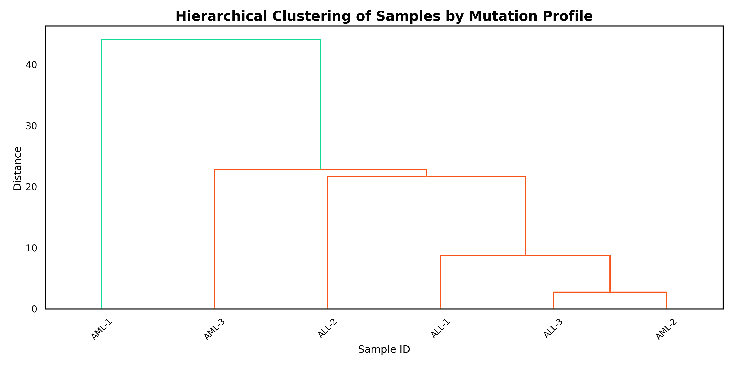
Figure 6. Hierarchical clustering of six chromosome 9 annotation profiles. ALL-3 and AML-2 form the closest pair, with leukemia labels intermixed. Branch heights indicate clustering distance rather than statistical support or diagnostic discrimination. AML, acute myeloid leukemia; ALL, acute lymphoblastic leukemia
The clustered run-by-gene heat map also intermixed AML and ALL labels (Figure 7). ALL-3 and AML-2 were paired in the row dendrogram. Higher plotted values were concentrated in subsets of gene–run combinations. The heat map and the separate dendrogram both showed incomplete separation by leukemia label.
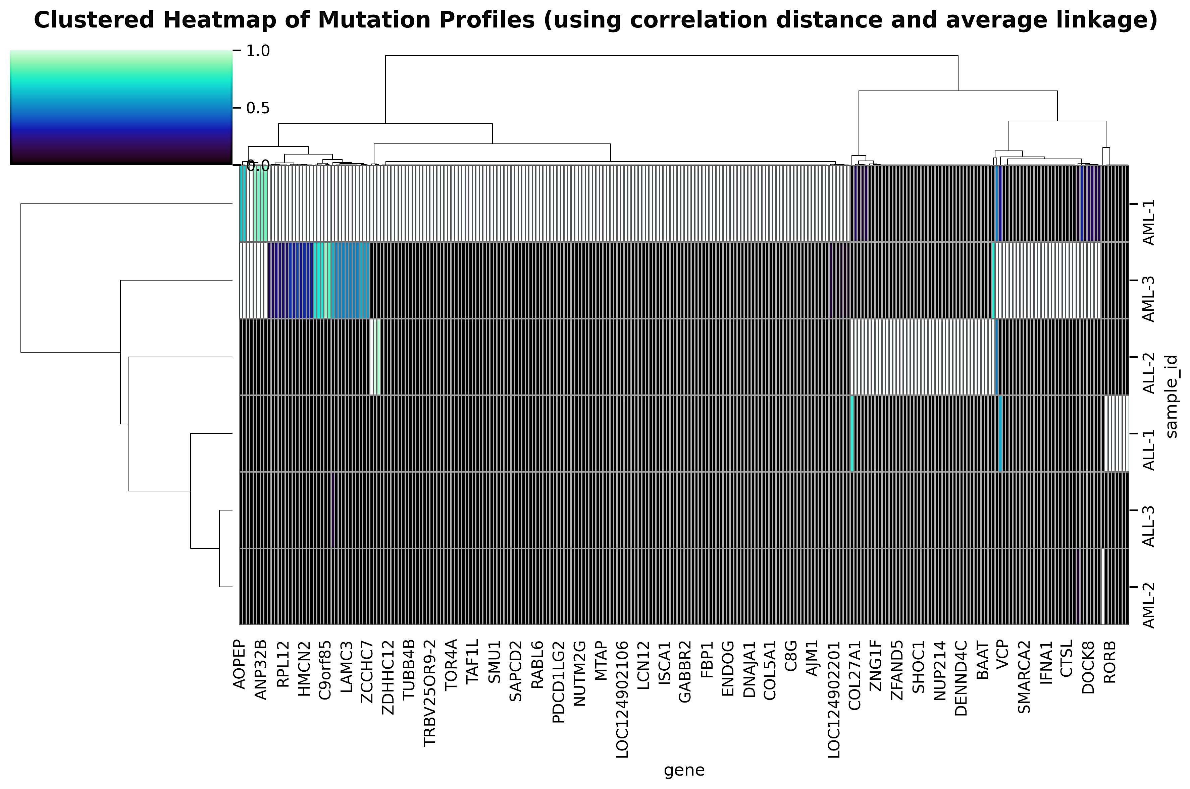
Figure 7. Clustered heat map of chromosome 9 gene-associated annotation profiles. Rows represent six sequencing runs and columns represent genes. Dendrograms show hierarchical clustering on both axes using correlation distance and average linkage. Colours follow the displayed 0–1 scale, from dark lower values to green higher values. AML and ALL run labels are interspersed; ALL-3 and AML-2 are paired in the row dendrogram. AML, acute myeloid leukemia; ALL, acute lymphoblastic leukemia.

3.3. Discussion
We found heterogeneous chromosome 9 gene and coding-annotation profiles across six acute leukemia sequencing runs. Annotation counts were higher and more dispersed in the AML-associated group, but the group distributions overlapped. Predicted substitutions predominated in both groups, whereas truncations were more prominent in ALL. Frequently represented gene labels, leading amino-acid changes and pooled coding-position patterns also differed. Despite limited annotation-set overlap, clustering did not clearly separate the leukemia groups. Group-restricted set membership therefore did not correspond to a distinct partition of the run-level profiles.
The reference-annotation counts describe the genomic features available for assigning context to aligned sequences. They do not measure transcript expression, gene dosage or the number of altered loci. Similarly, a high gene-associated count may reflect several annotations assigned to the same locus rather than independent lesions. Software and gene-model differences can affect these assignments and their interpretation (Queme et al., 2026). The gene profiles are therefore useful for describing this chromosome 9 comparison, but do not establish that the loci are drivers of AML or ALL.
The protein-effect and amino-acid summaries capture different aspects of coding annotation. Substitutions predominated in both groups, while truncation labels contributed more to the ALL profile. Proline-to-leucine and glycine-to-arginine led the ALL-associated and AML-associated summaries, respectively, and four categories appeared in both top-ten lists. These patterns suggest categories for closer examination, but pooled amino-acid changes do not identify the affected protein, domain or allele. Differences in coding and protein nomenclature between annotation tools (Chen et al., 2025), as well as transcript-expression context (De Groote et al., 2025), further limit functional interpretation. Category frequencies alone cannot establish a protein-level mechanism.
The codon and coding-sequence-position lists also differed between groups. Their leading labels warrant examination within specific genes and transcripts before they can be interpreted as mutational hotspots. The same codon number can occur in unrelated coding sequences, and a pooled coding-sequence position does not define a genomic locus. Establishing recurrence would require the same normalized alteration in a specified gene and transcript across independent samples. For the same reason, transition/transversion and substitution-label profiles cannot be interpreted as mechanistic mutation signatures without consistent category definitions and allele-level information.
PAX5 links these chromosome 9 annotations to established leukemia research. Combined Pax5 and Cd72 losses promote B-ALL experimentally (Ruiz-Corzo et al., 2026), and multiomic analysis of REH has characterized alterations affecting PAX5 and CDKN2A (Lysenkova Wiklander et al., 2024). The PAX5-associated records in both groups are compatible with the relevance of this locus, but do not demonstrate the lesions or effects reported in those studies. Likewise, the ALL-associated NUP214 and AML-associated NOTCH1 assignments identify annotated genes, not pathogenic fusions or functionally validated mutations. Interpreting them requires the specific alteration and its molecular context.
Limited overlap may partly reflect differences in chromosome coverage. Platform, caller and genomic context influence variant recovery (Eveleigh et al., 2026), while regional quality assessment helps distinguish callable sites from insufficiently observed regions (Lan et al., 2026). In ALL-1, pairwise identity was 91.4%, but reference coverage was only 0.8%. High identity describes agreement within the aligned sequences, not adequate coverage of the rest of chromosome 9. An annotation restricted to one group may therefore reflect differences in sequence representation as well as biological variation.
Differences in experimental design may also contribute to the mixed clustering. The ALL runs measured the same REH source, consistent with the published resource (Lysenkova Wiklander et al., 2023), whereas the AML-associated inputs differed in biological origin and assay purpose. The HL-60 library came from an apoptotic DNA fragmentomics study (Zhu et al., 2023). The sparse bone-marrow assay was designed for copy-number quantification, a task addressed by low-pass approaches (Eriksson & Lakatos, 2026). These differences can affect the feature matrix used for clustering. The mixed profiles do not imply that AML and ALL are genomically indistinguishable. Long-read myeloid sequencing studies evaluate performance within defined workflows (Abel et al., 2025), and cell-line mixture standards show how depth and normal-reference information affect somatic detection (Zhang et al., 2026).
A strength of this study is the use of publicly identifiable sequencing inputs and a defined chromosome reference, alongside complementary summaries of gene assignments, predicted effects, coding labels, set overlap and run-level similarity. The main limitations are the small collection, the shared biological source of the three ALL runs, heterogeneous library designs and sparse coverage in ALL-1. Annotation records may not represent independent alleles. The analysis also lacks a matched normal comparison, functional validation and clinical outcomes. Tumor-only calling requires specific treatment of germline variation and artifacts (Krishnamachari et al., 2026), while clinical genomic studies use molecular classification and validation to assess potentially important alterations (Martínez Anaya et al., 2026). These limitations restrict our conclusions to descriptive annotation profiles.
Further studies should use independent biological samples, processing suited to each sequencing platform and comparisons within justified callable regions. Allele normalization and annotation at the gene and transcript levels would help determine whether the observed gene, amino-acid and position-label patterns represent distinct recurrent alterations. Functional and clinical validation would be needed before any candidate could be evaluated as a biomarker. Our results provide a chromosome-focused description to guide these more controlled comparisons.

4. CONCLUSION
Chromosome 9 annotation profiles varied across six acute leukemia sequencing runs. The groups differed in gene assignments and coding-pattern summaries, while predicted substitutions predominated in both. Annotation-set overlap was limited, but run-level clustering intermixed leukemia labels. PAX5-associated records occurred in both groups. These findings support further chromosome-focused investigation in biologically controlled datasets with adequate coverage. They do not establish leukemia-specific mutations or clinical biomarkers.

REFERENCES
Abel, H. J., Mahgoub, M., Davarapalli, N., Kodgule, R., Miller, C. A., Fulton, R. S., Fronick, C., Markovic, C., Heath, S., Payton, J. E., Jacoby, M. A., Link, D. C., Walter, M. J., Duncavage, E. J., Ley, T. J., & Spencer, D. H. (2025). Evaluation of long-read genome sequencing for genomic profiling of myeloid cancers. The Journal of Molecular Diagnostics, 27(12), 1242–1254. https://doi.org/10.1016/j.jmoldx.2025.09.001
Andrews, S. (2010). FastQC: A quality control tool for high throughput sequence data [Computer software]. Babraham Bioinformatics. https://www.bioinformatics.babraham.ac.uk/projects/fastqc/
Bankevich, A., Nurk, S., Antipov, D., Gurevich, A. A., Dvorkin, M., Kulikov, A. S., Lesin, V. M., Nikolenko, S. I., Pham, S., Prjibelski, A. D., Pyshkin, A. V., Sirotkin, A. V., Vyahhi, N., Tesler, G., Alekseyev, M. A., & Pevzner, P. A. (2012). SPAdes: A new genome assembly algorithm and its applications to single-cell sequencing. Journal of Computational Biology, 19(5), 455–477. https://doi.org/10.1089/cmb.2012.0021
Bolger, A. M., Lohse, M., & Usadel, B. (2014). Trimmomatic: A flexible trimmer for Illumina sequence data. Bioinformatics, 30(15), 2114–2120. https://doi.org/10.1093/bioinformatics/btu170
Chen, Y. A., Yuan, T. H., Huang, J. H., Wang, Y. B., Hung, T. M., Chen, C. Y., Chen, P. L., & Hsu, J. S. (2025). Toward streamline variant classification: Discrepancies in variant nomenclature and syntax for ClinVar pathogenic variants across annotation tools. Human Genomics, 19(1), Article 70. https://doi.org/10.1186/s40246-025-00778-x
De Groote, D., Pepe, D., Janssens, X., & De Keersmaecker, K. (2025). To be or not to be a protein coding mutation, that's the question! NAR Genomics and Bioinformatics, 7(4), lqaf168. https://doi.org/10.1093/nargab/lqaf168
Eriksson, L., & Lakatos, E. (2026). Sensitive detection of copy number alterations in low-pass liquid biopsy sequencing data. Briefings in Bioinformatics, 27(2), bbag111. https://doi.org/10.1093/bib/bbag111
European Nucleotide Archive. (2026). European Nucleotide Archive [Database]. EMBL–EBI. Retrieved October 4, 2026, from https://www.ebi.ac.uk/ena/browser/
Eveleigh, R. J. M., Reiling, S. J., Galvez, J. H., Bourgey, M., Ragoussis, J., & Bourque, G. (2026). Benchmarking of sequencing technologies defines optimal strategies for genetic variants detection in a human genome. Genome Biology, 27(1), Article 129. https://doi.org/10.1186/s13059-026-04048-4
Gurevich, A., Saveliev, V., Vyahhi, N., & Tesler, G. (2013). QUAST: Quality assessment tool for genome assemblies. Bioinformatics, 29(8), 1072–1075. https://doi.org/10.1093/bioinformatics/btt086
Krishnamachari, K., Bui Nguyen, H. A., Kadioglu, S., Ong Tze, J., & Jacobsen Skanderup, A. (2026). Improved tumor-only variant calling and mutation burden estimation with VarNet-T. Nature Communications, 17(1), Article 5019. https://doi.org/10.1038/s41467-026-71705-4
Lan, F., Wang, Y., Lu, Y., Wu, B., Wang, X., Li, C., Liu, B., & Dong, X. (2026). TargetQC: A targeted quality control framework for clinical genomic testing. iScience, 29(9), Article 117393. https://doi.org/10.1016/j.isci.2026.117393
Lysenkova Wiklander, M., Arvidsson, G., Bunikis, I., Lundmark, A., Raine, A., Marincevic-Zuniga, Y., Gezelius, H., Bremer, A., Feuk, L., Ameur, A., & Nordlund, J. (2024). A multiomic characterization of the leukemia cell line REH using short- and long-read sequencing. Life Science Alliance, 7(8), e202302481. https://doi.org/10.26508/lsa.202302481
Lysenkova Wiklander, M., Övernäs, E., Lagensjö, J., Raine, A., Petri, A., Wiman, A. C., Ramsell, J., Marincevic-Zuniga, Y., Gezelius, H., Martin, T., Bunikis, I., Ekberg, S., Erlandsson, R., Larsson, P., Mosbech, M. B., Häggqvist, S., Hellstedt Kerje, S., Feuk, L., Ameur, A., … Nordlund, J. (2023). Genomic, transcriptomic and epigenomic sequencing data of the B-cell leukemia cell line REH. BMC Research Notes, 16(1), Article 265. https://doi.org/10.1186/s13104-023-06537-2
Martínez Anaya, D., Juárez-Velázquez, M. D. R., Juárez Figueroa, U., Dean, M., Salas Labadía, C., Valladares Coyotecatl, M., Reyes León, A., López Santiago, N., Juárez Villegas, L., Zapata Tarrés, M., & Pérez-Vera, P. (2026). Genomic profiling of Mexican patients with B-cell precursor acute lymphoblastic leukemia reveals clinically significant somatic and potential germline variants. The Journal of Pathology: Clinical Research, 12(5), e70107. https://doi.org/10.1002/2056-4538.70107
Queme, B., Muruganujan, A., Ebert, D., Mushayahama, T., Gauderman, W. J., & Mi, H. (2026). From SNPs to pathways: A genome-wide benchmark of annotation discrepancies and their impact on protein- and pathway-level inference. BMC Genomics, 27(1), Article 499. https://doi.org/10.1186/s12864-026-12824-6
Ruiz-Corzo, B., Casado-García, A., Oak, N., Somoza-Cotillas, P., López-Álvarez de Neyra, A., Martínez-Cano, J., Pérez-Pons, A., Sánchez, E. G., Blanco, O., Alonso-López, D., De Las Rivas, J., Riesco, S., Prieto-Matos, P., García Criado, F. J., García Cenador, M. B., Orfao, A., Ramírez-Orellana, M., Cobaleda, C., Vicente-Dueñas, C., … Sánchez-García, I. (2026). Deletion of 9p drives B-ALL through heterozygous inactivation of Pax5 and Cd72 in preleukemic cells. JCI Insight, 11(7), e199464. https://doi.org/10.1172/jci.insight.199464
Zhang, J., Wong, H. Y., Liu, L., Koufariotis, L. T., Wood, S., Fitzpatrick, N., Quiatchon, J., Collins, P., Pearson, J. V., & Waddell, N. (2026). Cancer genome standards for long-read sequencing using cancer cell line mixtures. GigaScience, 15, giag037. https://doi.org/10.1093/gigascience/giag037
Zhu, D., Wang, H., Wu, W., Geng, S., Zhong, G., Li, Y., Guo, H., Long, G., Ren, Q., Luan, Y., Duan, C., Wei, B., Ma, J., Li, S., Zhou, J., & Mao, M. (2023). Circulating cell-free DNA fragmentation is a stepwise and conserved process linked to apoptosis. BMC Biology, 21(1), Article 253. https://doi.org/10.1186/s12915-023-01752-6

Corresponding author: afolabless11@gmail.com

