Contents

Composite Design Pattern 1

Applicability 2

Pros and Cons 2

https://refactoring.guru/design-patterns/composite 2

Real World Example: 2

Behavioral design patterns: 3

Behavioral design patterns are concerned with algorithms and the assignment of responsibilities between objects 3

Chain of Responsibility 3

https://refactoring.guru/design-patterns/chain-of-responsibility 3

Diagram 3

Code Implementation: 3

Pros and Cons 4

Single Responsibility Principle. 4

Open/Closed Principle. 4

Cons: 4

Some requests may end up unhandled. 4

Observer design Pattern: 4

https://refactoring.guru/design-patterns/observer 4

Code Implementation: 4

Abstract Factory 5

Intent 5

Main code implementation: 5

Strategy 6

Intent 6

Code Implementation Main 6

Applicability 6

# Composite Design Pattern

**Also known as:**Object Tree

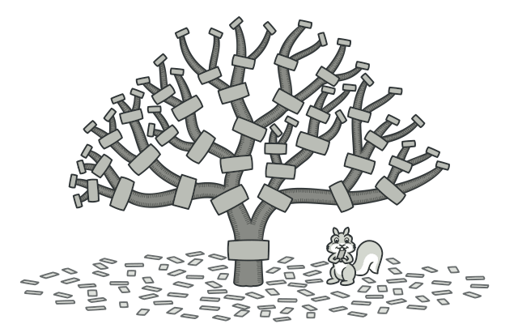

## **Applicability**

 Use the Composite pattern when you have to implement **a tree-like object structure.**

a **common interface: simple leaves and complex containers.**

**A container can be composed of both leaves and other containers.** This lets you construct a nested recursive object structure that resembles a tree.

**Use the pattern when you want the client code to treat both simple and complex elements uniformly.**

 All elements defined by the Composite pattern share a **common interface.**

## **Pros and Cons**

* You can work with complex tree structures more conveniently**: use polymorphism and recursion to your advantage.**
* **Open/Closed Principle**. You can introduce new element types into the app without breaking the existing code, which now works with the object tree.

## <https://refactoring.guru/design-patterns/composite>

## Real World Example:

**Interface IEmployee**

Director’s vector<IEmployee>

|

Managers vector<IEmployee>

|

Employees

# Behavioral design patterns:

## Behavioral design patterns are concerned with **algorithms and the assignment of responsibilities between objects**

# Chain of Responsibility

## https://refactoring.guru/design-patterns/chain-of-responsibility

Chain of Responsibility is a behavioral design pattern that lets you pass requests **along a chain of handlers**. Upon receiving a request, each handler decides either to **process the request or to pass it to the next handler** in the chain.

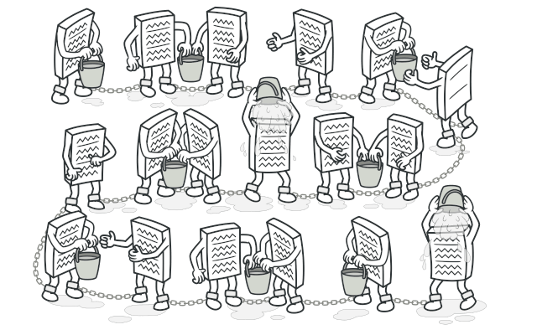

## Diagram

## Code Implementation:

    int request[13] = {1, 3, 23, 12, 5, 6, 16, 13, 11, 23, 22, 27, 3};

    Handler *h1 = new ConcreteHandle1();

    Handler *h2 = new ConcreteHandle2();

    Handler *h3 = new ConcreteHandle3();

    h1->SetSuccessor(h2);

    h2->SetSuccessor(h3);

    for (int i = 0; i < 13; i++)

    {

        h1->HandleRequest(request[i]);

    }

## Pros and Cons

You can control the order of request handling.

Single Responsibility Principle. You can decouple classes that invoke operations from classes that perform operations.

Open/Closed Principle. You can introduce new handlers into the app without breaking the existing client code.

## Cons:

### Some requests may end up unhandled.

# Observer design Pattern:

Observer is a behavioral design pattern that allows some objects to notify other objects about changes in their state.

## https://refactoring.guru/design-patterns/observer

## Code Implementation:

    Stock *ibm = new IBM("IBM", 120);

    IInvestor *i1 = new Investor("Ajay");

    IInvestor *i2 = new Investor("Gopal");

    IInvestor *i3 = new Investor("Vinita");

    ibm->attach(i1);

    ibm->attach(i2);

    ibm->attach(i3);

    ibm->setPrice(120.50);

    ibm->setPrice(112.50);

    ibm->setPrice(125.50);

    ibm->detach(i3);

    ibm->setPrice(125.50);

# ****Factory Method**** in C++

**Factory method** is a creational design pattern which solves the problem of **creating product objects without specifying their concrete classes.**

class Creater // Factory class

{

public:

    virtual Product *FactoryMethod() = 0;

    virtual ~Creater()

    {

    }

};

# Abstract Factory

## Intent

**Abstract Factory** is a creational design pattern that lets you **produce families of related objects without specifying their concrete classes.**

## Main code implementation:

    // Icar is the first level abstraction but IVehicleCompany is

// the 2nd level abstraction.

    IVehicleCompany *comp = new tata();

    Icar *cars = comp->GetCar(); // we don’t know concrete subclass

    cars->GetCar();

    Itruck *trucks = comp->GetTruck();

    trucks->GetTruck();

    IVehicleCompany *comp2 = new Mahindra();

    Icar *cars2 = comp2->GetCar(); // we don’t know concrete subclass

    cars2->GetCar();

    Itruck *trucks2 = comp2->GetTruck();

    trucks2->GetTruck();

    /* conclusion:

    design pattern that lets us produce families of

    related objects (Mahindra, tata) without specifying their concrete

classes (Cars, Trucks).

    */

# Strategy

## Intent

Strategy is a behavioral design pattern that lets you define a family of algorithms, put each of them into a separate class, and make their objects interchangeable.

## Code Implementation Main

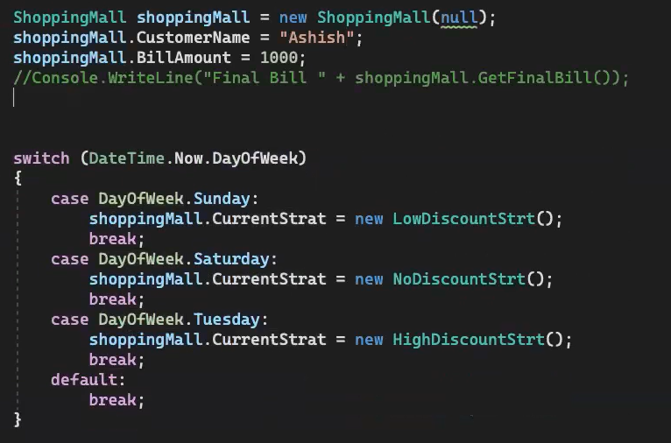

## Applicability

Use the Strategy pattern when you want to use **different variants of an algorithm within an object and be able to switch from one algorithm to another during runtime.**

**Shell**

**$name**

**Echo name**

**read name -> accept name from user as an input.**

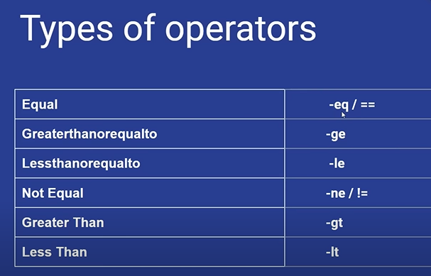

**___________________________________________________**

**For loop**

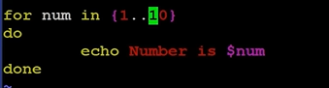

**For tasks in read write watch listen eat sleep**

**Do**

**Task is $tasks**

**Done**

**______________________________**

**If $num -ge 10**

**Fi**

**While loop**

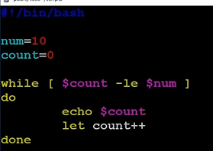

**Count =0**

**Num = 10**

**While [$count -le $Num]**

**Do**

**Echo count is**

**Let count++;**

**Done**

**1860 4250 255/1**