Engineering Project Detailed Research Plan
Please complete the information/questions begun/seen below in red ink. Save this document to your computer, and add a printed hardcopy to your application.

Date: January 3, 2024
Student Name: Ajay Jagadish
Project Title: A Low-Cost, AI-Powered Safety Device to Prevent Child Hot Car Deaths
Engineering Goal: PROBLEM BEING ADDRESSED: All engineering projects solve a problem or fill a need. This goal should be a simple statement that describes the product being designed, the customer it is for and the problem or need it satisfies. Example” “The goal is to design a solar powered lawn mower for inexpensive automated lawn care for homeowners”
The goal is to design a low-cost safety device that can detect when a child is left alone in an overheated car and produce a sound alert, preventing child death.
Design Criteria: Design criteria define the product’s required performance . Examples: “ It will have a minimum speed of 10 KPH”, The output will be within 15% of the mean of the experimental data”. “It must withstand 15 repetitions of a 10N impact” The International System of units (SI) required.
The device must detect one or more children in the car within 135 degrees field-of-view with at least 90% accuracy. It must also monitor when the temperature goes beyond 30 degrees Celsius. When both conditions are detected or when children are detected alone in a car, the device should produce a loud sound alert of at least 90 decibels.
Constraints: Constraints are factors that limit the engineer’s flexibility such as size, cost, and time limitations. Examples: “It must fit in a box no larger than 10x20x50 cm” “The maximum cost is $50” “The software must run in real time on a Raspberry Pi”
The device must fit in a box no larger than 10 cm x 20 cm x 6 cm, it must cost no more than $100, it should not require any network connection in order to operate, and the software must run in real-time on a Raspberry Pi. The device must also run on a battery for at least 8 hours.

Provide your chosen design. For hardware, provide a sketch. For software, provide a flowchart. Indicate the components you will develop, and the libraries you are using.
The components of my device are shown in the architectural diagram below:
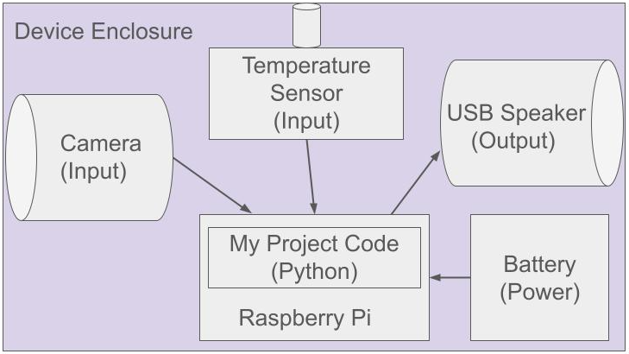
The software algorithm and its steps are shown below:
- Initialize the variables child_threshold_met and temperature_threshold_met each to FALSE
- Initialize the variable temperature_threshold to a value (such as 30 – for 30 degrees celsius)
- Start a loop that continuously runs forever until the device is switched off.
Within the loop, execute the following operations:
  - Capture the video stream frame using Raspberry Pi camera-module routines
  - Read the temperature from the sensor using circuitpython-dht routines
  - Run openCV and coco object detection routines to detect object(s) in the captured video stream frame
  - If the detected object(s) are only one or more “children”, then set the variable child_threshold_met = TRUE
  - If the detected temperature exceeds the temperature_threshold, then set the variable temperature_threshold_met = TRUE
  - If either child_threshold_met is TRUE or both child_threshold_met and temperature_threshold_met are TRUE, use picotts routines to convert an alert text to a loud sound announcement audio stream and play it through the connected speaker
  - Sleep for 5 seconds
- Go back to the beginning of the loop in Step 3
Test and evaluate your prototypes against the design criteria listed above to show how well the product meets the need/goal. Provide a test plan describing how you will test the design criteria and constraints you listed above., How will you analyze the data? If the product requires human testing please fill out and append https://science-fair.org/wp/wp-content/uploads/2015/10/Research-Plan-Human-Participants.docx
I will test my device using the following setup:
I will place a child look-alike doll (decoy) in a car seat to simulate a real-life scenario, so that the device can detect the child using its AI-powered object detection algorithm.
I will then perform the following tests to validate my device:
- Place one child decoy in the car, increase the heat in the car to at least 30 degrees Celsius, and step out of the car. Validate that the device produces a sound alert.
- Place two child decoys in two separate car seats in the car, increase the heat in the car to at least 30 degrees Celsius, and step out of the car. Validate that the device produces a sound alert.
- Place one child decoy in the car, increase the heat in the car to at least 30 degrees Celsius, and stay in the car. Validate that the device does not produce a sound alert.
- Place one child decoy in the car, keep the temperature in the car to a comfortable 22 degrees Celsius, and step out of the car. Validate that the device does produce a sound alert.
- Place one child decoy in the car, keep the temperature in the car to a comfortable 22 degrees Celsius, and do not step out of the car. Validate that the device does not produce a sound alert.
- Place two child decoys in the car, keep the temperature in the car to a comfortable 22 degrees Celsius, and step out of the car. Validate that the device does produce a sound alert.

Bibliography: List at least five (5) major references (e.g. science journal articles, books, internet sites & dates of review) from your literature review. If you plan to use vertebrate animals, one of these references must be an animal care reference.
- Pratt, Michelle. How to Prevent Hot Car Deaths. Safe in the Seat. Published 13 Dec. 2023, https://safeintheseat.com/how-to-prevent-hot-car-deaths/. Accessed 3 Jan. 2024.
- The Carlson Law Firm. Forgotten Baby Syndrome: What it is and How to Avoid it. Published 6 June 2023, https://www.carlsonattorneys.com/news-and-update/forgotten-baby-syndrome. Accessed 2 Jan. 2024.
- Collins, Chris. Set up temperature sensors in your home with a Raspberry Pi. Published 12 July 2021, https://opensource.com/article/21/7/temperature-sensors-pi.
Accessed 1 Jan. 2024.

- Initial State. Build an Inexpensive Network of Web-Connected Temperature Sensors using Pi Zeros. Mar. 22, 2019, https://medium.com/initial-state/build-an-inexpensive-network-of-web-connected-temperature-sensors-using-pi-zeros-730a40f1fb60. Accessed 2 Jan. 2024.
- Tim. Object and Animal Recognition With Raspberry Pi and OpenCV. Published 16 Feb. 2023, https://core-electronics.com.au/guides/object-identify-raspberry-pi/. Accessed 1 Jan. 2024.

