*Internationalization
- Add support for Internationalization in your application allowing messages to be shown in English, German and Swedish, keeping English as default.
Ans:

In controller class;

@GetMapping("/Internationalisation")
public String helloInternationalisation(@RequestHeader(name = "Accept-Language",required =false) Locale locale){
return messageSource.getMessage("Good.Morning.message",null,locale);
}
In Resource Buldle “messages” files added named are:
1.messages.proerties
2.messages_de.proerties
3.messages_es.proerties
4.messages_fr.proerties

File Name | Content | Comment
messages.proerties | Good.Morning.message=Good Morning | Default message
messages_de.proerties | Good.Morning.message=guten Morgen | Content in german language
messages_es.proerties | Good.Morning.message=Buenos Dias | Content in Spanish language
messages_fr.proerties | Good.Morning.message=Bonjour | Content in french language

In Application context class:

@Bean
public LocaleResolver localeResolver(){
SessionLocaleResolver localeResolver=new SessionLocaleResolver();
localeResolver.setDefaultLocale(Locale.US);
return localeResolver;
}

@Bean
public ResourceBundleMessageSource resourceBundleMessageSource(){
ResourceBundleMessageSource messageSource= new ResourceBundleMessageSource();
messageSource.setBasename("message");
return messageSource;
}
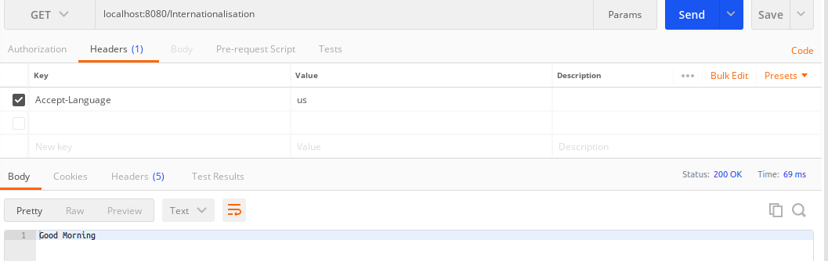

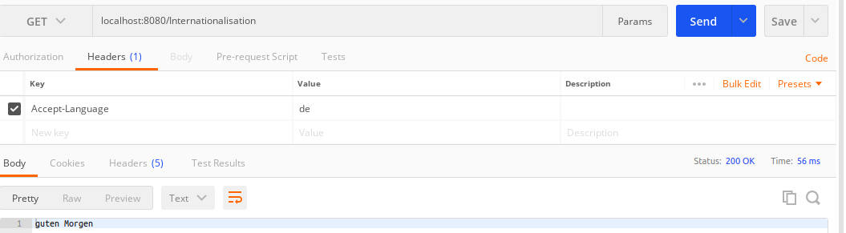

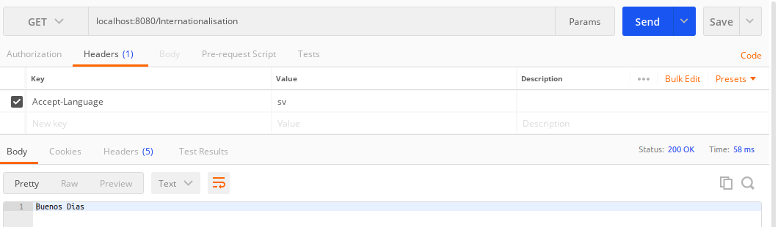
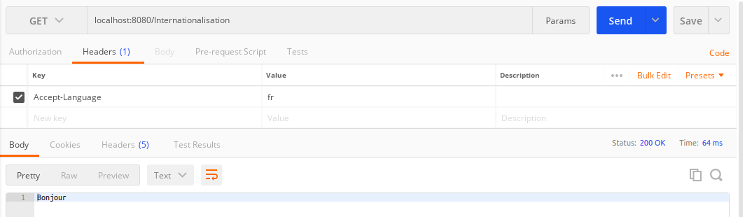

Ques3.Create a GET request which takes "username" as param and shows a localized message "Hello Username". (Use parameters in message properties).

@GetMapping("/HelloUser/{username}")
public String returnHelloUserName(@PathVariable String username){
return "Hello "+username+", Welcome to TTN.";
}

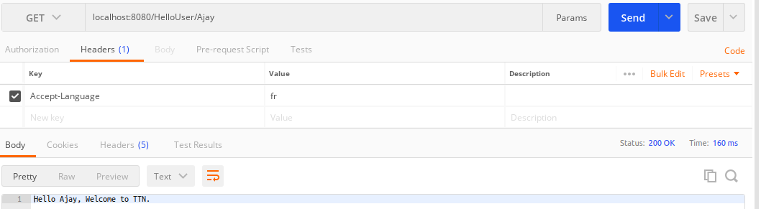

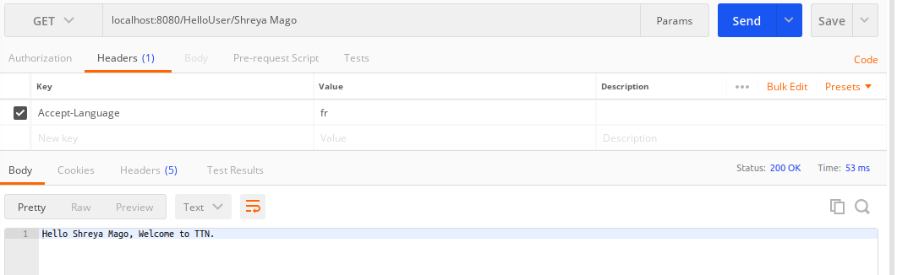

*Content Negotiation
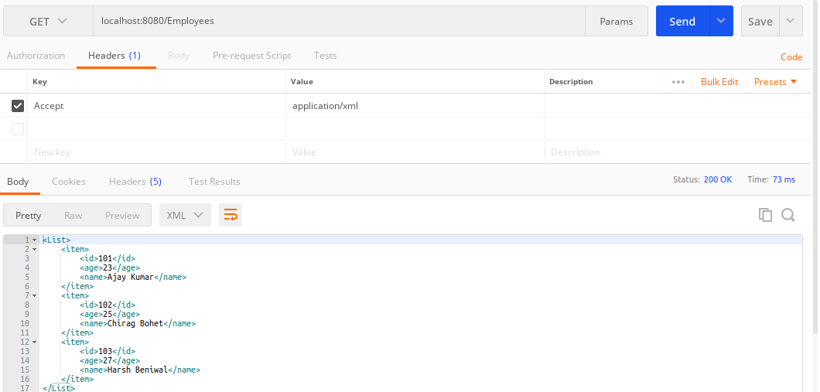
3.Create GET Method to fetch the list of users in XML format.

4. Create POST Method to create user details which can accept XML for user creation.

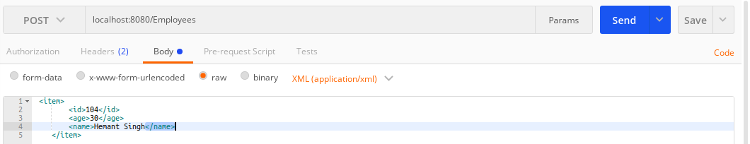
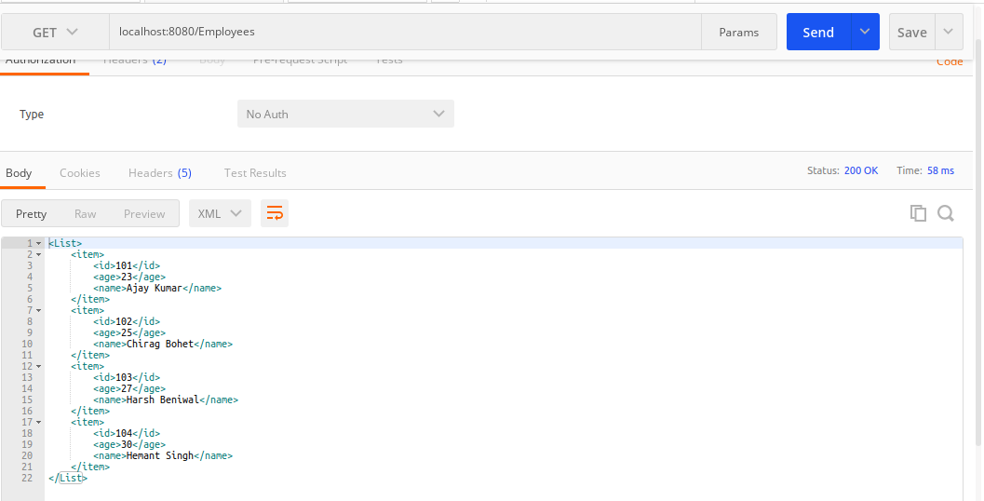

*Swagger
5. Configure swagger plugin and create document of following methods:
Get details of User using GET request.
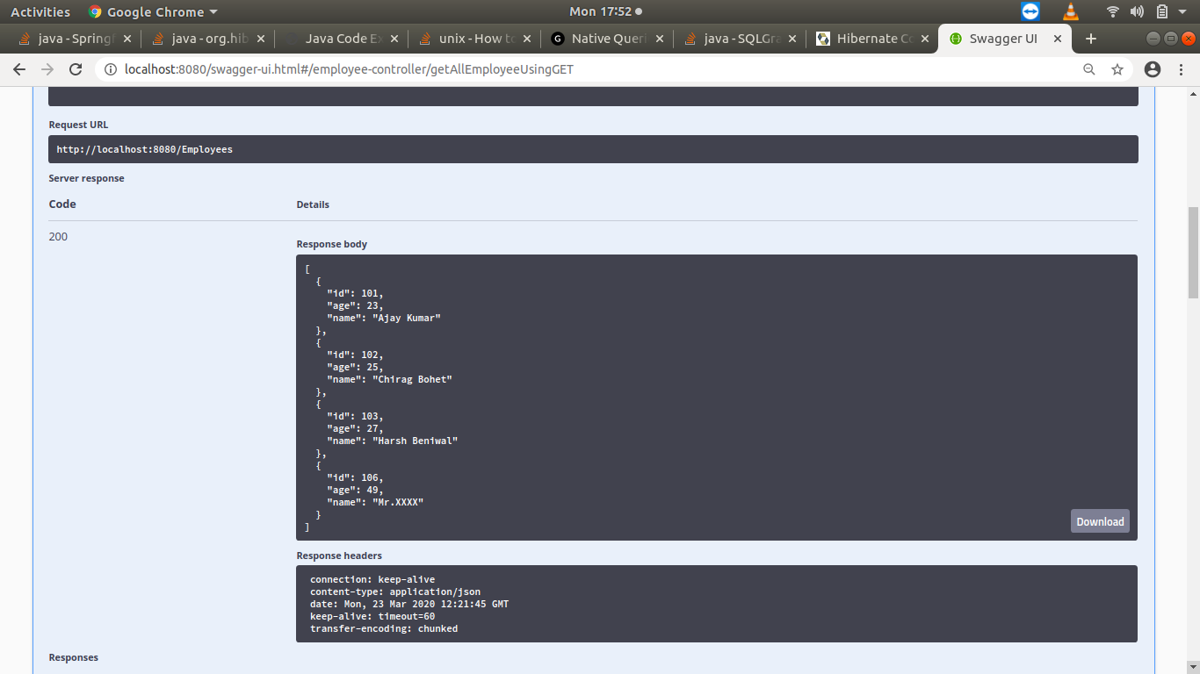
Save details of the user using POST request.
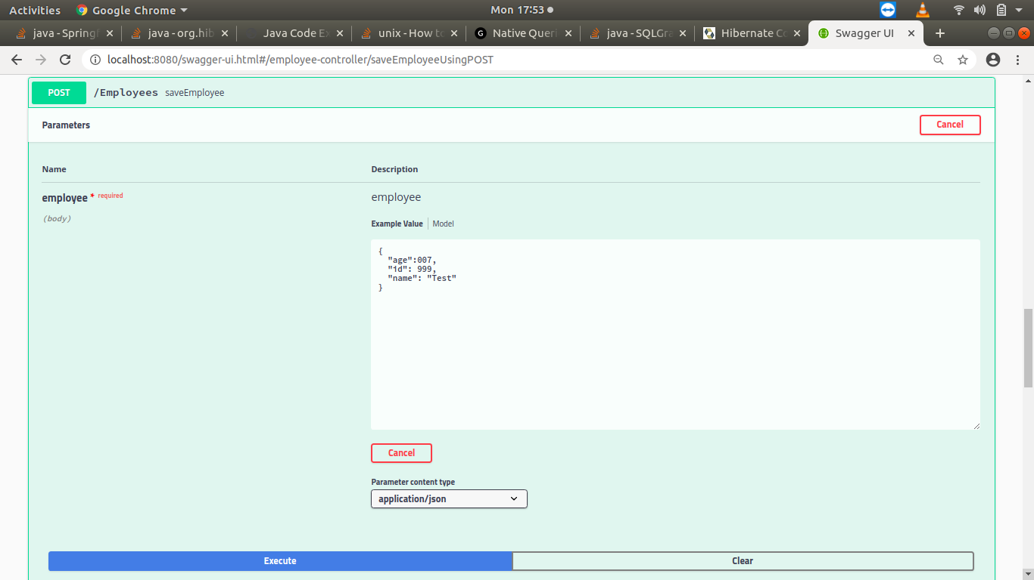

Delete a user using DELETE request.
>>>>NotWorking, I am working on that.

Chances made in different files/classes:
1.Created a new class named as “SwaggerConfig”
package com.ajaykumar.RestfullWebServices;
import org.springframework.context.annotation.Configuration;
import springfox.documentation.spi.DocumentationType;
import springfox.documentation.spring.web.plugins.Docket;
import springfox.documentation.swagger2.annotations.EnableSwagger2;
//configuration
@Configuration
//enable Swagger
@EnableSwagger2
public class SwaggerConfig {
//bean-docket
private Docket api(){
return new Docket(DocumentationType.SWAGGER_2);
}
}
2.Added following dependecies in bulid.gradle:

compile group: 'io.springfox', name: 'springfox-swagger2', version: '2.9.2'
compile group: 'io.springfox', name: 'springfox-swagger-ui', version: '2.9.2'
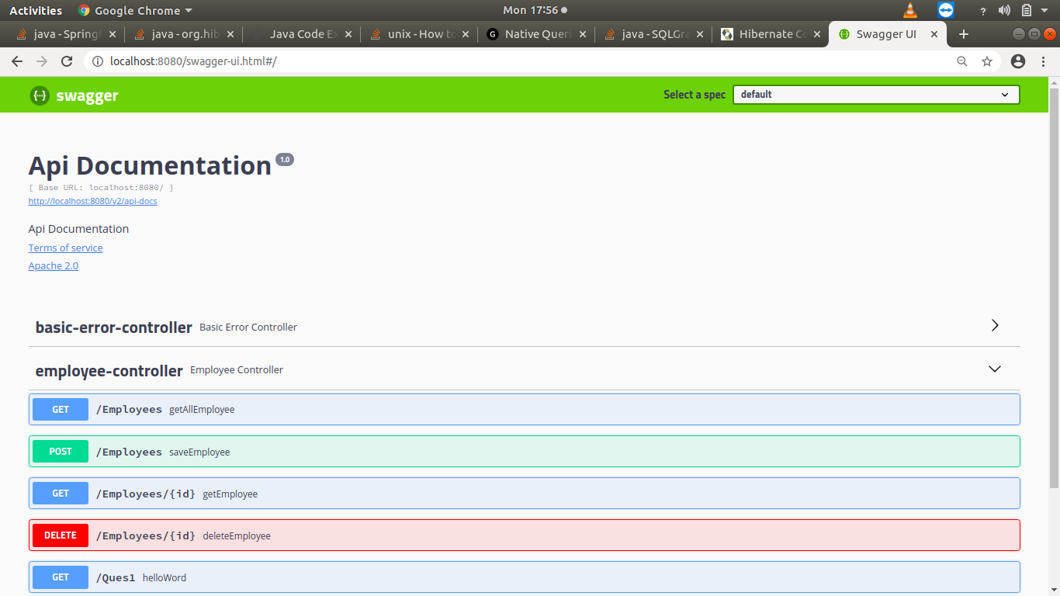
6. In swagger documentation, add the description of each class and URI so that in swagger UI the purpose of class and URI is clear.
package com.ajaykumar.RestfullWebServices.Entity;
import io.swagger.annotations.ApiModel;
import io.swagger.annotations.ApiModelProperty;
import javax.validation.constraints.Size;
@ApiModel(description = "All details about Employees")
public class Employee {
@ApiModelProperty(notes = "Id of employee must be unique.")
int id;
@ApiModelProperty(notes = "Age should be in past.")
int age;
//Question:9
@Size(min=3,message = "Should have length of name greater than 3")
String name;
}

7.Create API which saves details of User (along with the password) but on successfully saving returns only non-critical data. (Use static filtering).
package com.ajaykumar.RestfullWebServices.filtering.controllers;
import com.ajaykumar.RestfullWebServices.filtering.User;
import org.springframework.web.bind.annotation.GetMapping;
import org.springframework.web.bind.annotation.RestController;
//Static Filtering Controller
import java.util.Arrays;
import java.util.List;
@RestController
public class StaticFilterController {
@GetMapping("/staticFiltering1")
public User returnStaticFiltering(){
return new User(1,23,"Ajay Kumar","Ajay@123");
}
@GetMapping("/staticFiltering2")
public List<User> returnStaticFilteringResult(){
return Arrays.asList(new User(2,25,"Harshit","Harshit@123")
,new User(3,33,"vijay Kumar","Vijay@123"));
}
}

package com.ajaykumar.RestfullWebServices.filtering;
import com.fasterxml.jackson.annotation.JsonFilter;
import com.fasterxml.jackson.annotation.JsonIgnoreProperties;
//@JsonFilter("NewFilter")
@JsonIgnoreProperties(value = {"password"})
public class User {
private int id;
private int age;
private String name;
//we can also use @JsonIgnore
private String password;
//constructors ,getters and setters
}

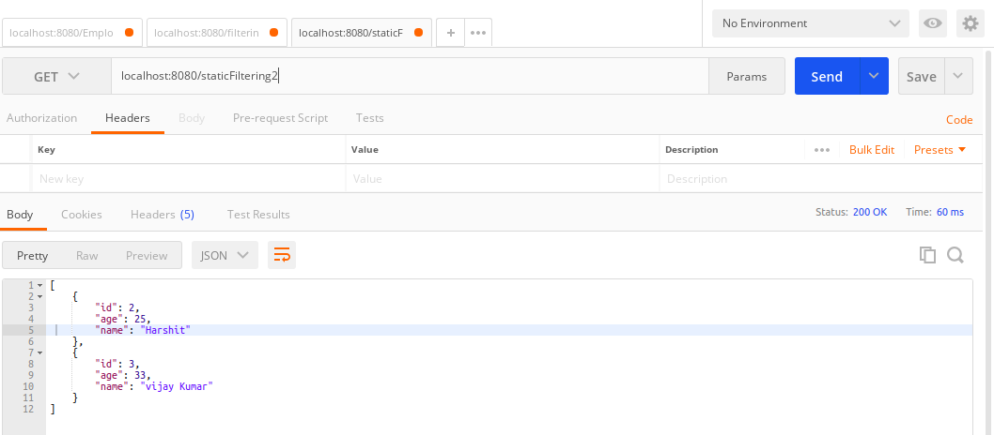

8.Create another API that does the same by using Dynamic Filtering.
package com.ajaykumar.RestfullWebServices.filtering;
import com.fasterxml.jackson.annotation.JsonFilter;
import com.fasterxml.jackson.annotation.JsonIgnoreProperties;
//@JsonFilter("NewFilter")
@JsonIgnoreProperties(value = {"password"})
public class User {
private int id;
private int age;
private String name;
//we can also use @JsonIgnore
private String password;
//constructors,getter and setters
}

package com.ajaykumar.RestfullWebServices.filtering.controllers;
//Dynamic Filtering Controller
import com.ajaykumar.RestfullWebServices.filtering.User;
import com.fasterxml.jackson.databind.ser.FilterProvider;
import com.fasterxml.jackson.databind.ser.impl.SimpleBeanPropertyFilter;
import com.fasterxml.jackson.databind.ser.impl.SimpleFilterProvider;
import org.springframework.http.converter.json.MappingJacksonValue;
import org.springframework.web.bind.annotation.GetMapping;
import org.springframework.web.bind.annotation.RestController;
@RestController
public class DynamicFilterController {
@GetMapping("DynamicFiltering")
public MappingJacksonValue returnDynamicFilteringResult(){
User user=new User(1,23,"Ajay Kumar","Ajay@1234");
SimpleBeanPropertyFilter simpleBeanPropertyFilter = SimpleBeanPropertyFilter.
filterOutAllExcept("username","id","age");
FilterProvider filterProvider = new SimpleFilterProvider().
addFilter("NewFilter",simpleBeanPropertyFilter);
MappingJacksonValue mappingJacksonValue = new MappingJacksonValue(user);
mappingJacksonValue.setFilters(filterProvider);
return mappingJacksonValue;
}
}
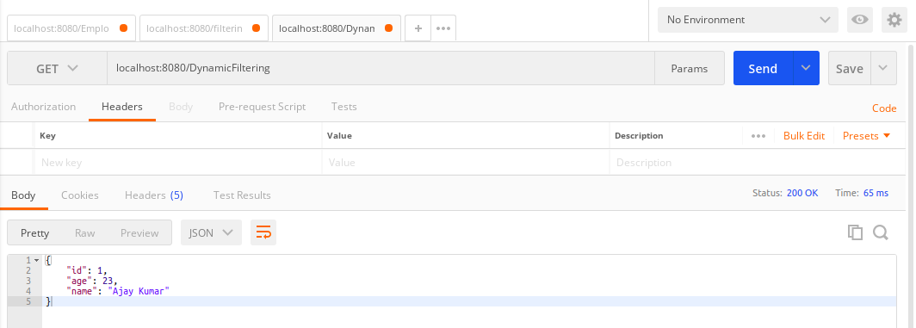

9.Create 2 API for showing user details. The first api should return only basic details of the user and the other API should return more/enhanced details of the user,
Now apply versioning using the following methods:
- Request Parameter versioning
- URI versioning
- Custom Header Versioning
- MimeType Versioning

- Request Parameter versioning:

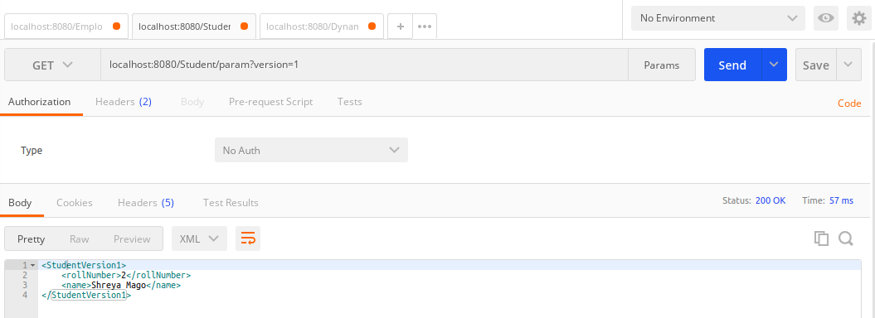
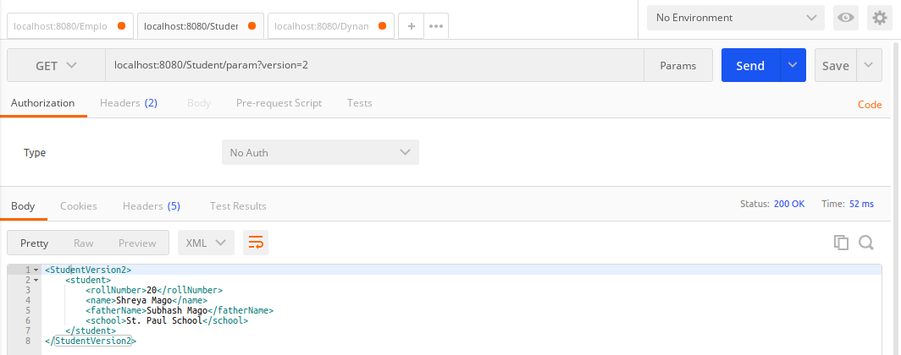

- Custom Header Versioning:

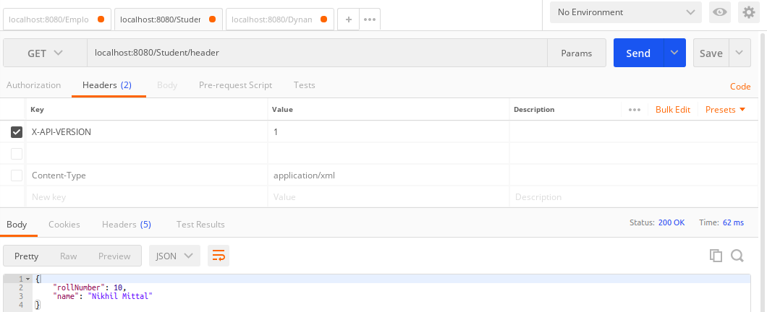
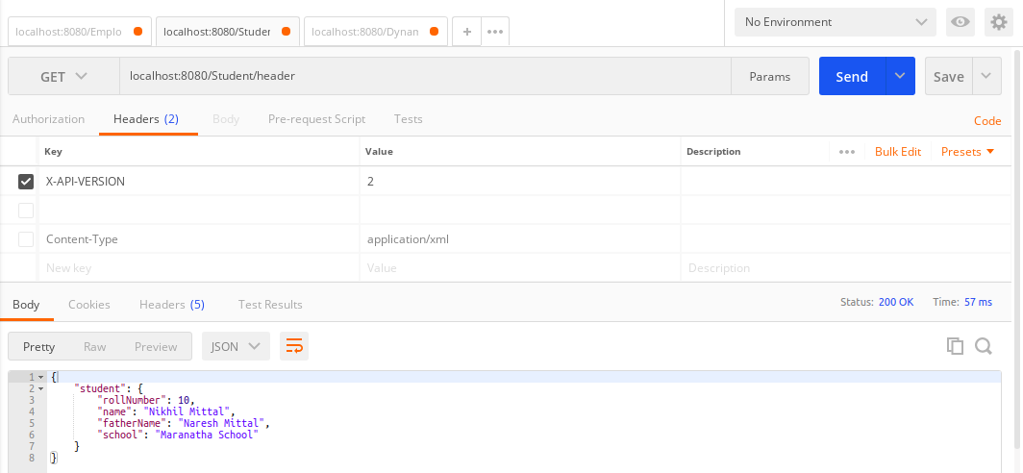

- MimeType Versioning:
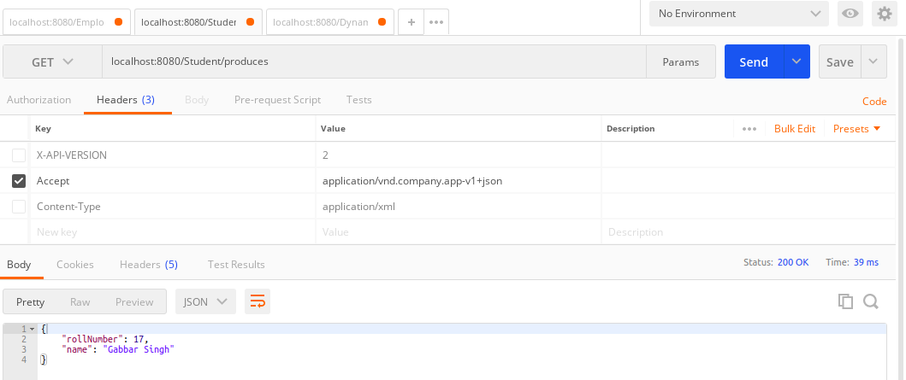

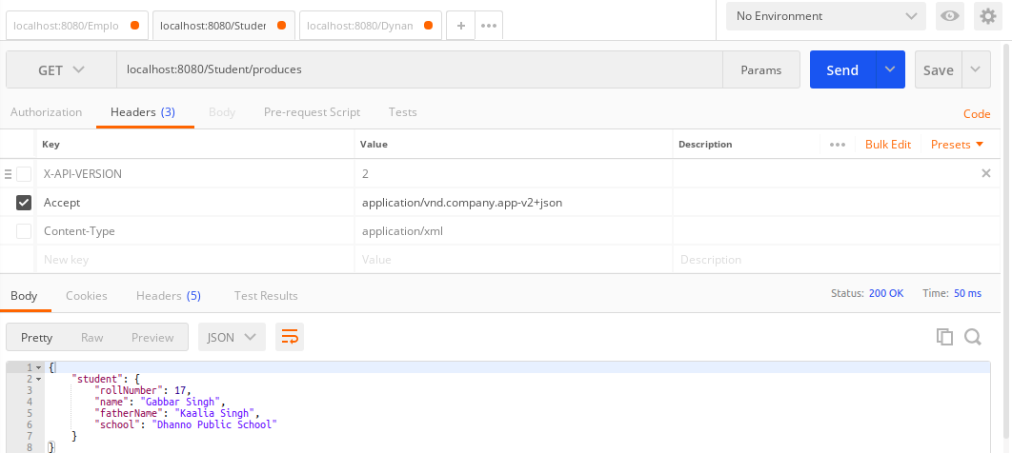

Code:
package com.ajaykumar.RestfullWebServices.Versioning.VersionController;
import com.ajaykumar.RestfullWebServices.Versioning.Entity.Student;
import com.ajaykumar.RestfullWebServices.Versioning.Entity.StudentVersion1;
import com.ajaykumar.RestfullWebServices.Versioning.Entity.StudentVersion2;
import org.springframework.web.bind.annotation.GetMapping;
import org.springframework.web.bind.annotation.RestController;
@RestController
public class StudentVersionController {
@GetMapping("/StudentVersion1")
public StudentVersion1 getStudentVersion1(){
StudentVersion1 studentVersion1=new StudentVersion1(1,"Ajay");
return studentVersion1;
}
@GetMapping("/StudentVersion2")
public StudentVersion2 getStudentVersion2(){
Student student=new Student(1,"Ajay kumar","Ramesh Chandra","St. Xaviers School");
StudentVersion2 studentVersion2=new StudentVersion2(student);
return studentVersion2;
}
@GetMapping(value = "Student/param",params = "version=1")
public StudentVersion1 getStudentVersion1UsingParam(){
StudentVersion1 studentVersion1=new StudentVersion1(2,"Shreya Mago");
return studentVersion1;
}
@GetMapping(value = "Student/param",params = "version=2")
public StudentVersion2 getStudentVersion2UsingParam(){
Student student=new Student(20,"Shreya Mago","Subhash Mago","St. Paul School");
StudentVersion2 studentVersion2=new StudentVersion2(student);
return studentVersion2;
}
@GetMapping(value = "Student/header",headers = "X-API-VERSION=1")
public StudentVersion1 getStudentVersion1UsingHeader(){
StudentVersion1 studentVersion1=new StudentVersion1(10,"Nikhil Mittal");
return studentVersion1;
}
@GetMapping(value = "Student/header",headers = "X-API-VERSION=2")
public StudentVersion2 getStudentVersion2UsingHeader(){
Student student=new Student(10,"Nikhil Mittal","Naresh Mittal","Maranatha School");
StudentVersion2 studentVersion2=new StudentVersion2(student);
return studentVersion2;
}
@GetMapping(value = "Student/produces",produces = "application/vnd.company.app-v1+json")
public StudentVersion1 getStudentVersion1UsingMimetype(){
StudentVersion1 studentVersion1=new StudentVersion1(17,"Gabbar Singh");
return studentVersion1;
}
@GetMapping(value = "Student/produces",produces= "application/vnd.company.app-v2+json")
public StudentVersion2 getStudentVersion2UsingMimetype(){
Student student=new Student(17,"Gabbar Singh","Kaalia Singh","Dhanno Public School");
StudentVersion2 studentVersion2=new StudentVersion2(student);
return studentVersion2;
}
}
Entites:
Student entity:
package com.ajaykumar.RestfullWebServices.Versioning.Entity;
public class Student {
private int rollNumber;
private String name;
private String fatherName;
private String school;
//constructors,getters and setters
}
Student Version1 entity:
package com.ajaykumar.RestfullWebServices.Versioning.Entity;
public class StudentVersion1 {
private int rollNumber;
private String name;
//constructors,getters and setters
}

Student Version2 entity:
package com.ajaykumar.RestfullWebServices.Versioning.Entity;
public class StudentVersion2 {
private Student student;
public Student getStudent() {
return student;
}
public void setStudent(Student student) {
this.student = student;
}
public StudentVersion2(Student student) {
this.student = student;
}
@Override
public String toString() {
return "StudentVersion2{" +
"student=" + student +
'}';
}
}

