Ques1.Create an Employee Entity which contains following fields
Name,Id,Age,Location.
Ans.
package com.tothenew.bootcamp.springdata.SpringDataJPA.entity;
import javax.persistence.Entity;
import javax.persistence.GeneratedValue;
import javax.persistence.GenerationType;
import javax.persistence.Id;
@Entity
public class Employee {
@Id
@GeneratedValue(strategy=GenerationType.IDENTITY)
private int id;
private int age;
private String name;
private String location;
//Default Constructor
public Employee(){
}
//parameterized constructor
public Employee(int id, int age, String name, String location) {
this.id = id;
this.age = age;
this.name = name;
this.location = location;
}
//Getters
public int getId() {
return id;
}
public int getAge() {
return age;
}
public String getName() {
return name;
}
public String getLocation() {
return location;
}
//Setters
public void setId(int id) {
this.id = id;
}
public void setAge(int age) {
this.age = age;
}
public void setName(String name) {
this.name = name;
}
public void setLocation(String location) {
this.location = location;
}
}

Ques2.Set up EmployeeRepository with Spring Data JPA.

Ans.

package com.tothenew.bootcamp.springdata.SpringDataJPA.repository;
import com.tothenew.bootcamp.springdata.SpringDataJPA.entity.Employee;
import org.springframework.data.repository.CrudRepository;
public interface EmployeeRepository extends CrudRepository<Employee,Integer> {

}

Ques3. Perform Create Operation on Entity using Spring Data JPA.
Ans.
@Test
void createTest(){
Employee employee = new Employee();
employee.setAge(21);
employee.setName("Ajay Kumar");
employee.setLocation("Rajasthan");
employeeRepository.save(employee);

Employee employee1 = new Employee();
employee1.setAge(20);
employee1.setName("Vijay Kumar");
employee1.setLocation("Bihar");
employeeRepository.save(employee1);

Employee employee2 = new Employee();
employee2.setAge(19);
employee2.setName("Himanshi Gupta");
employee2.setLocation("Gurugram");
employeeRepository.save(employee2);
}
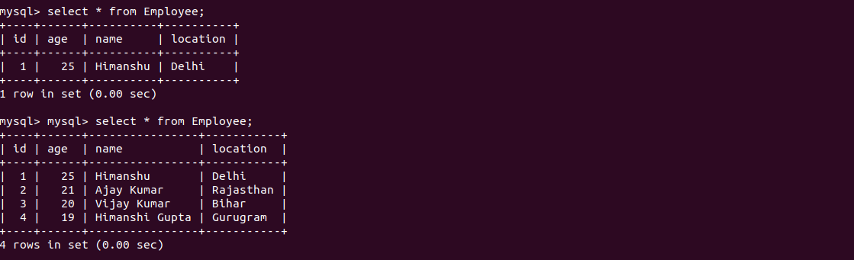

Ques4.Perform Update Operation on Entity using Spring Data JPA.
Ans

.
@Test
void updateTestEmployee(){
Optional<Employee> optionalEmployee=employeeRepository.findById(2);
assertNotNull(optionalEmployee);
assertEquals(2,optionalEmployee.get().getId());
optionalEmployee.get().setLocation("Jammmu");
employeeRepository.save(optionalEmployee.get());
}

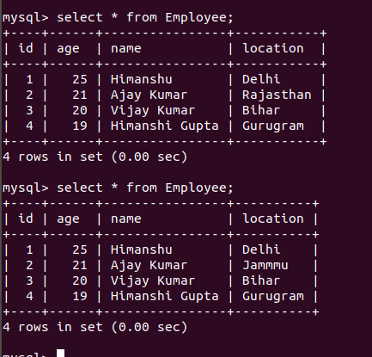

Ques5.Perform Delete Operation on Entity using Spring Data JPA.
Ans.

@Test
void deleteTestEmployee(){
employeeRepository.deleteById(4);
}
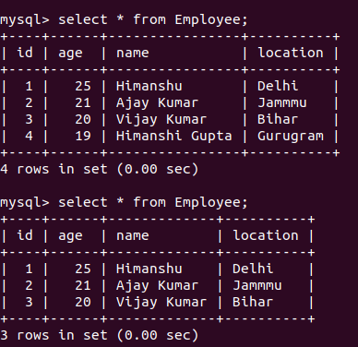

Ques6.Perform Read Operation on Entity using Spring Data JPA.
Ans.

@Test
void readByIdTestEmployee(){
Optional<Employee> optionalEmployee=employeeRepository.findById(1);
assertNotNull(optionalEmployee);
assertEquals(1,optionalEmployee.get().getId());
System.out.println(optionalEmployee.get().toString());
}
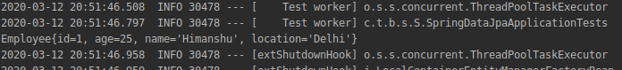

Ques7.Get the total count of the number of Employees.
Ans.
@Test
void countTestEmployee(){
long count=employeeRepository.count();
System.out.println("+++++++++++++++++++++++++++++++++++++++++++++++++");
System.out.println("Total records in Employee Table are : "+count);
System.out.println("++++++++++++++++++++++++++++++++++++++++++++++++++");
}
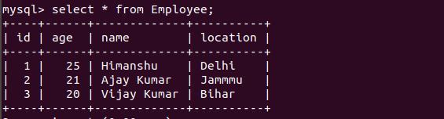

Ques8.Implement Pagination and Sorting on the bases of Employee Age.

Ques9.Create and use finder to find Employee by Name.

@Test
void readByNameTestEmployee(){
Optional<Employee> optionalEmployee =employeeRepository.findByName("Ajay Kumar");
assertNotNull(optionalEmployee);
assertEquals("Ajay Kumar",optionalEmployee.get().getName());
System.out.println("+++++++++++++++++++++++++++++++++++++++++++++++++++");
System.out.println(optionalEmployee.get().toString());
System.out.println("++++++++++++++++++++++++++++++++++++++++++++++++++++");

}

Ques10.Create and use finder to find Employees starting with A character
Ans.
@Test
void nameStartsFromATestEmployee(){
List<Employee> employeeList=employeeRepository.findByNameLike("A%");
System.out.println("++++++++++++++++++++++++++++++++++++++++++++++++++++++++");
System.out.println(employeeList.toString());
System.out.println("+++++++++++++++++++++++++++++++++++++++++++++++++++++++++");
}
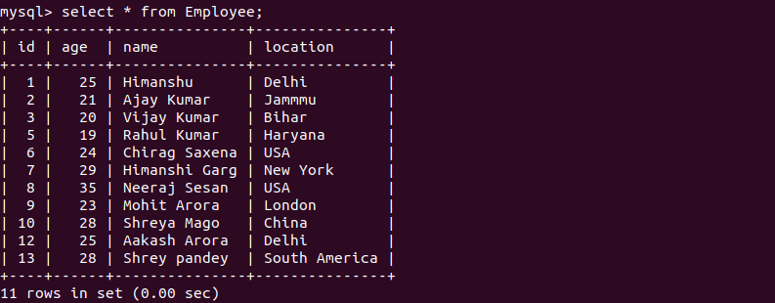

Ques11.Create and use finder to find Employees Between the age of 28 to 32.
Ans.
@Test
void findEmployeeAgeBetweenTestEmployee(){
List<Employee> employeeList = employeeRepository.findByAgeBetween(28,32);
employeeList.forEach(emp-> System.out.println(emp.toString()));
// employeeList.forEach(emp-> System.out.println(emp.getId()));
// employeeList.forEach(emp-> System.out.println(emp.getName()));
// employeeList.forEach(emp-> System.out.println(emp.getAge()));

}
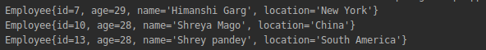

EmployeeRepository interface:

package com.tothenew.bootcamp.springdata.SpringDataJPA.repository;
import com.tothenew.bootcamp.springdata.SpringDataJPA.entity.Employee;
import org.springframework.data.repository.CrudRepository;
import java.util.List;
import java.util.Optional;
public interface EmployeeRepository extends CrudRepository<Employee,Integer> {
Optional<Employee> findByName(String name);
List<Employee> findByNameLike(String character);
List<Employee> findByAgeBetween(int age1,int age2);
}

SpringDataJpaApplication :

package com.tothenew.bootcamp.springdata.SpringDataJPA;
import org.springframework.boot.SpringApplication;
import org.springframework.boot.autoconfigure.SpringBootApplication;
@SpringBootApplication
public class SpringDataJpaApplication {
public static void main(String[] args) {
SpringApplication.run(SpringDataJpaApplication.class, args);
}
}

Application.properties:

spring.jpa.hibernate.ddl-auto=update
spring.datasource.url = jdbc:mysql://localhost:3306/JPADatabase1
spring.datasource.username = root
spring.datasource.password = PASSWORD
spring.jpa.hibernate.naming.physical-strategy = org.hibernate.boot.model.naming.PhysicalNamingStrategyStandardImpl
#logging.level.root=OFF

