SQL> create table suppliers

2 (

3 id number(10),

4 nmae varchar(30)

5 );

Table created.

SQL> desc suppliers;

Name Null? Type

----------------------------------------- -------- ----------------------------

ID NUMBER(10)

NMAE VARCHAR2(30)

SQL> alter table suppliers add(country_name varchar(20),

2 city_name varchar(20),

3 date_of_supply DATE,

4 address varchar(40),

5 quantity number(5),

6 price number(4,2)

7 );

Table altered.

SQL> desc suppliers;

Name Null? Type

----------------------------------------- -------- ----------------------------

ID NUMBER(10)

NMAE VARCHAR2(30)

COUNTRY_NAME VARCHAR2(20)

CITY_NAME VARCHAR2(20)

DATE_OF_SUPPLY DATE

ADDRESS VARCHAR2(40)

QUANTITY NUMBER(5)

PRICE NUMBER(38)

SQL> insert into supplier values(&supplier_id,'&supplier_name','&country_name','&city_name','&date_o

f_supply','&address',&quantity,&price);

Enter value for supplier_id: 100

Enter value for supplier_name: google

Enter value for country_name: USA

Enter value for city_name: DC

Enter value for date_of_supply: 11-jan-2019

Enter value for address: yyy,xxx

Enter value for quantity: 12

Enter value for price: 20

old 1: insert into supplier values(&supplier_id,'&supplier_name','&country_name','&city_name','&da

new 1: insert into supplier values(100,'google','USA','DC','11-jan-2019','yyy,xxx',12,20)

1 row created.

SQL> /

Enter value for supplier_id: 101

Enter value for supplier_name: audi

Enter value for country_name: USA

Enter value for city_name: FC

Enter value for date_of_supply: 12-jan-2019

Enter value for address: yy,zzz

Enter value for quantity: 23

Enter value for price: 23

old 1: insert into supplier values(&supplier_id,'&supplier_name','&country_name','&city_name','&da

new 1: insert into supplier values(101,'audi','USA','FC','12-jan-2019','yy,zzz',23,23)

1 row created.

SQL> /

Enter value for supplier_id: 102

Enter value for supplier_name: store

Enter value for country_name: INDIA.

Enter value for city_name: Erode

Enter value for date_of_supply: 9-aug-2019

Enter value for address: aaa,kkk

Enter value for quantity: 15

Enter value for price: 25

old 1: insert into supplier values(&supplier_id,'&supplier_name','&country_name','&city_name','&da

new 1: insert into supplier values(102,'store','INDIA.','Erode','9-aug-2019','aaa,kkk',15,25)

1 row created.

SQL> /

Enter value for supplier_id: 103

Enter value for supplier_name: aravind

Enter value for country_name: France

Enter value for city_name: GV

Enter value for date_of_supply: 25-jan-2013

Enter value for address: lll

Enter value for quantity: 23

Enter value for price: 12

old 1: insert into supplier values(&supplier_id,'&supplier_name','&country_name','&city_name','&da

new 1: insert into supplier values(103,'aravind','France','GV','25-jan-2013','lll',23,12)

1 row created.

SQL> /

Enter value for supplier_id: 104

Enter value for supplier_name: Doramon

Enter value for country_name: Japan

Enter value for city_name: bellwood

Enter value for date_of_supply: 11-jan-2013

Enter value for address: Near smoothyie

Enter value for quantity: 12

Enter value for price: 23

old 1: insert into supplier values(&supplier_id,'&supplier_name','&country_name','&city_name','&da

new 1: insert into supplier values(104,'Doramon','Japan','bellwood','11-jan-2013','Near smoothyie'

1 row created.

SQL> select * from supplier;

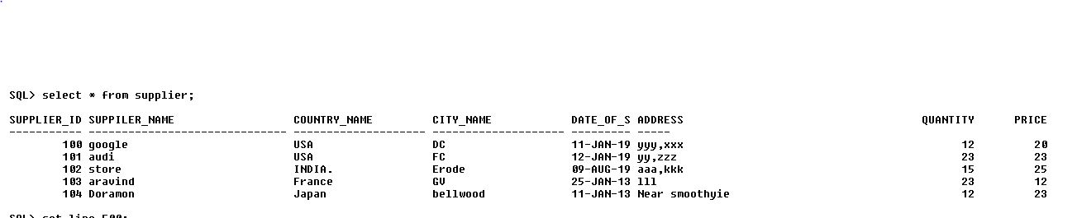

SQL> select price from supplier where price BETWEEN 10 AND 20;

PRICE

----------

12

SQL> select * from supplier where price BETWEEN 10 AND 20;

table2.JPG

SQL> SELECT DISTINCT COUNTRY_NAME FROM supplier;

COUNTRY_NAME

--------------------

USA

France

INDIA.

Japan

SQL> select price from supplier where price>20;

PRICE

----------

23

25

23

select * from supplier where country_name='USA';



table4.JPG



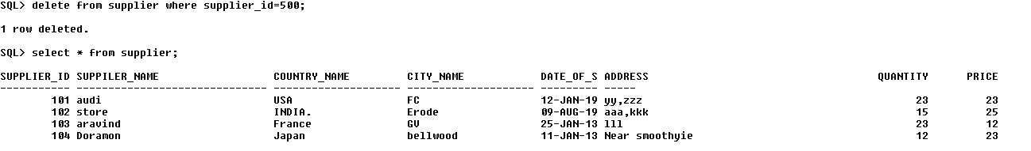

SQL> SELECT COUNT(country_name) from supplier where price>20;

COUNT(COUNTRY_NAME)

-------------------

3

SQL> update supplier set supplier_id=500,suppiler_name='ajay',country_name='China',city_name='ER',qu

antity=9,price=20 where supplier_id=100;

1 row updated.

