**PHASE:03**

**Environmental Monitoring[temperature gradient in different places]**

**Places Selected for placing the sensors so that it is connected to the ESP8266**

* **Mani Mangalam**
* **Mudichur**
* **Tambaram**

**Python code for the getting the temperature from the selected locations**

import paho.mqtt.client as mqtt

import Adafruit_DHT

import time

# Define sensor type and GPIO pin

DHT_SENSOR = Adafruit_DHT.DHT22

DHT_PIN = 4 # Replace with the actual GPIO pin you're using

# MQTT Broker information

MQTT_BROKER = "mqtt.example.com" # Replace with your MQTT broker address

MQTT_PORT = 1883

MQTT_TOPIC = "environmental_data"

# Create an MQTT client

client = mqtt.Client()

# Connect to the MQTT broker

client.connect(MQTT_BROKER, MQTT_PORT, 60)

try:

while True:

# Read data from the DHT22 sensor

humidity, temperature = Adafruit_DHT.read_retry(DHT_SENSOR, DHT_PIN)

if humidity is not None and temperature is not None:

# Format the data

data = f"Temperature={temperature:.2f}°C, Humidity={humidity:.2f}%"

# Publish the data to the MQTT topic

client.publish(MQTT_TOPIC, data)

print(f"Published: {data}")

else:

print("Failed to retrieve data from the sensor")

**time.sleep(60) # Send data every 60 seconds (adjust as needed)**

**except KeyboardInterrupt:**

**print("Script terminated by user")**

**client.disconnect()**

**OUTPUT for the above program**

1. **If the script successfully reads the data from the sensor it will print the temperature and humidity values like this :**

***Published: temperature in mani Mangalam=31.76 C,Humidity=65.98%***

***Published: temperature in Mudichur =28.76 C,Humidity=51.98%***

***Published: temperature in Tambaram=29.65 C,Humidity=54.26%***

1. **If there are any issuesnwith reading the sensor,it will print an error message,such as:**

***FAILED TO RETRIVE DATA FROM THE SENSORS***

**3. If the script successfully connects to the MQTT broker and publishes the data, you'll see the MQTT topic and the data being published*:***

***Published: Temperature=35.60***

***The script will continue to run in a loop, reading and publishing data every 60 seconds (as specified in the time.sleep(60) line). The exact output you see will depend on the sensor's readings and the status of your MQTT broker and network connection.***

***Pictures related to the sensors:***

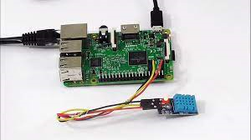

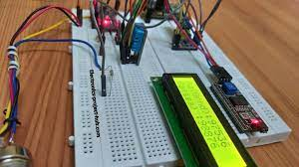

Environment monitoring has attracted more and more attention due to the growing concern about climate change. During the past couple of decades, advanced information and communication technologies have been applied to the development of various marine environment monitoring systems. Among others, the Internet of Things (IoT) has been playing an important role in this area. This paper presents a review of the application of the Internet of Things in the field of marine environment monitoring. New technologies including advanced Big Data analytics and their applications in this area are briefly reviewed. It also discusses key research challenges and opportunities in this area, including the potential application of IoT and Big Data in marine environment protection.