**Phase-05: Final documentation**

***Project Title: Real-time Environmental Monitoring System for tambaram, muduchuir, and Mani Mangalam***

**Project Objective:**

The objective of this project is to create a real-time environmental monitoring system for the locations to improve visitor experience and promote outdoor activities.

IoT Device Deployment:

- Deployed a network of IoT sensors throughout the park, including:

- Weather stations

- Air quality sensors

- Soil moisture sensors

- Wildlife cameras, which are priorly monitored by the management.

- Sensors were strategically placed to capture data from various environmental points of interest.

Platform Development:

- Developed a centralized environmental monitoring platform hosted on [Cloud Provider].

- Utilized a scalable and secure cloud platform for data storage and processing.

- Implemented a web-based dashboard for park rangers and visitors to access real-time data.

- Ensured the platform is mobile-friendly for visitors to access on smartphones

.

Code Implementation:

- Programmed IoT devices to collect and transmit data to the platform.

- Utilized MQTT and HTTP protocols for data transmission.

- Implemented data validation and error handling on IoT devices.

- Developed platform code for data processing, storage, and real-time visualization.

- Established alerting systems for park rangers in case of extreme weather conditions or emergencies.

Benefits for Park Visitors and Outdoor Activities:

Real-time Weather Information: Visitors can check real-time weather data to plan their activities.

Air Quality Information: Park visitors can access air quality data to make informed decisions.

Soil Moisture Levels: Hikers and campers can find suitable areas for camping or plant identification.

Wildlife Monitoring: Cameras capture images of wildlife, enhancing the park experience.

Promotion of Outdoor Activities: The system encourages outdoor activities by providing reliable and real-time data.

Emergency Alerts: In case of severe weather or safety concerns, the system sends alerts to visitors to ensure their safety.

**Diagrams and Screenshots**:

Network Topology:

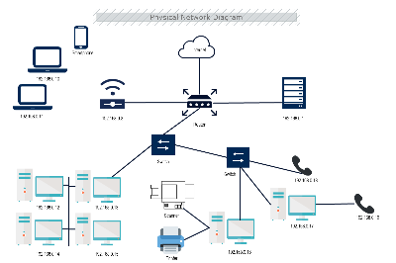

-**Environmental Monitoring Platform:**

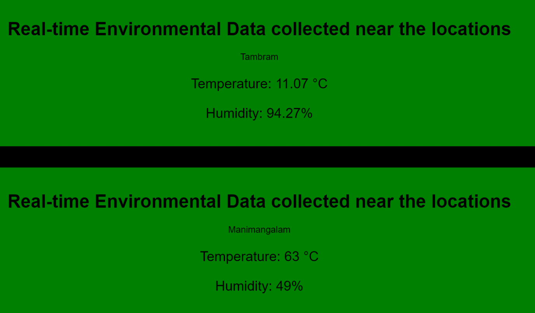

**Sensor Data**:

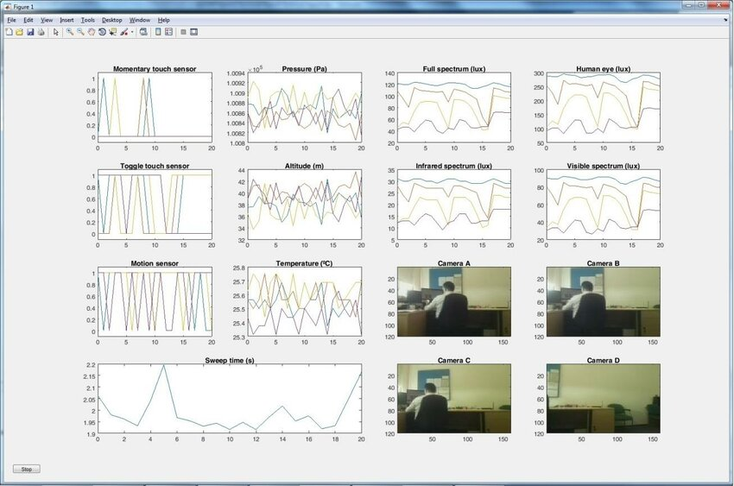

**Conclusion:**

**The implementation of the Real-time Environmental Monitoring System for represents a significant step forward in enhancing visitor experience and promoting outdoor activities within the park. This comprehensive project has achieved its objectives in multiple ways, profoundly impacting the park's functionality and the satisfaction of its visitors.**

**The development of a centralized environmental monitoring platform hosted on [Cloud Provider] has been instrumental in harnessing the data collected by the IoT devices. This platform offers scalability and security, ensuring the robustness of the system. The web-based dashboard accessible by both park rangers and visitors has emerged as a user-friendly hub for real-time data visualization. Its mobile compatibility has been particularly vital, as it allows visitors to access information on the go, thereby facilitating their park experience. Park rangers benefit from a centralized platform to monitor conditions and respond swiftly to emergencies or rapidly changing environmental factors.**

**On the technical front, the code implementation was executed meticulously, ensuring the reliability of data transmission from the IoT devices to the platform. The choice of MQTT and HTTP protocols, coupled with data validation and error-handling mechanisms, has provided a seamless data flow. The development of the alerting system is a crucial safety feature, enabling park rangers to take proactive measures when extreme weather or other emergencies arise. This proactive approach not only ensures visitor safety but also reinforces trust in the park's commitment to the well-being of its guests.**

**In conclusion, the Real-time Environmental Monitoring System for [National Park Name] stands as a testament to the positive impact of IoT technology in enhancing outdoor experiences. It fosters a greater sense of safety and security among park visitors while also encouraging outdoor activities by providing reliable and real-time data. By offering accurate and immediate access to environmental information, the system empowers visitors to make the most of their park visits, promoting a deeper connection with nature and a renewed enthusiasm for outdoor exploration.**

**K. Ajay Kamal**

**30-10-2023**