A Project Proposal Report on
C++ OOP Pomodoro Timer
A Project Report Submitted for the Course OOP with C++
Bachelor of Science in Computer Science
Under Westcliff University
Submitted by:
Ajay Karki, WU0258926
Date:

08/10/2026

King’s College Nepal
________________________________________
Bijulibazar, Kathmandu

ABSTRACT
The “C++ OOP Pomodoro Timer” is a console-based productivity application built to demonstrate the object-oriented programming concepts covered in the C++ course. The program helps a user manage focused work sessions using the Pomodoro technique, where a period of work is followed by a short break. The user can either use the standard default timing of twenty-five minutes of work and five minutes of break, or enter a custom work and break duration of their own choice. The system counts down each work and break period in the console, plays a sound alert using the Windows Beep function when a period ends, and keeps track of how many Pomodoro cycles the user completes in a session. When the user decides to stop, the session details are written to a CSV log file together with the date and time, so that a simple record of past sessions is kept. The project is composed of four classes (TimerMode, DefaultMode, CustomMode, PomodoroTimer, and SessionLogger) that together demonstrate encapsulation, abstraction, inheritance, and polymorphism. The project is developed in a single C++ source file using the Windows-specific Sleep and Beep functions for timing and sound.
Keywords: Pomodoro Technique, Timer, Object-Oriented Programming, UML, C++, Productivity

TABLE OF CONTENTS
Abstract i
Table of Contents ii
List of Figures iii
1 INTRODUCTION 1
1.1 PROBLEM STATEMENT 1
1.2 PROJECT OBJECTIVES 1
1.3 SCOPE AND LIMITATIONS 1
2 LITERATURE REVIEW 3
3 METHODOLOGY 3
3.1 SOFTWARE DEVELOPMENT LIFECYCLE 3
3.2 TOOLS TO BE USED 3
3.3 OOP CONCEPTS COVERAGE 5
4 SYSTEM DESIGN 6
4.1 UML CLASS DIAGRAM 6
4.2 SEQUENCE DIAGRAM 7
4.3 USE CASE DIAGRAM 9
5 PROPOSED DELIVERABLES 11
6 PROJECT TASK AND TIME SCHEDULE 12
7 CODE-TO-PROPOSAL VERIFICATION 13
8 BIBLIOGRPAHY 15

1. INTRODUCTION
This project applies the object-oriented programming concepts taught in the C++ course to a small, practical tool: a Pomodoro study and work timer. This section describes the problem being addressed, the objectives of the project, and its scope and limitations.

1.1 PROBLEM STATEMENT
Many students and workers struggle to stay focused for long, unbroken stretches of time, and often either work without any structured breaks or lose track of how much time has actually been spent working versus resting. Manually watching a clock to time work and break periods is distracting and easy to forget. A further gap is that a plain phone timer does not keep any record of how many focused sessions were actually completed, so there is no simple way to look back and see how a work day went. This project addresses both problems: the problem of manually tracking work and break periods, and the problem of having no record of completed sessions.

1.2 PROJECT OBJECTIVES
- Implement a functional Pomodoro timer that counts down a work period followed by a break period in the console.
- Allow the user to choose between a default timing mode (25 minutes work, 5 minutes break) and a custom mode where the user enters their own work and break durations.
- Notify the user with an audible sound when a work or break period ends.
- Count the number of completed Pomodoro cycles in a session and record the session to a CSV log file with the date and time when the session ends.
- Demonstrate the OOP concepts required by the course syllabus, including encapsulation, abstraction, inheritance, and polymorphism.

1.3 SCOPE AND LIMITATIONS
The scope of this project is:
- Run a work countdown timer and a break countdown timer in the console
- Choose between a default mode and a custom mode for work and break durations
- Play a sound alert when a work or break period finishes
- Count completed Pomodoro cycles within a session
- Ask the user after every cycle whether they want to continue or stop
- Save the completed session (work minutes, break minutes, and cycle count) to a CSV file with a timestamp when the session ends
The limitations of this project are:
- Console-based interface only; no graphical user interface
- Windows-only, since the timer sound and delay rely on the Windows-specific Beep and Sleep functions from windows.h
- No ability to pause a running timer once it has started, other than stopping the whole program
- The session log only records the work minutes, break minutes, and cycle count for a session; it does not log the individual start and end time of each cycle

2. LITERATURE REVIEW
Commercial focus and productivity applications such as Forest and Focus To-Do implement the Pomodoro technique with graphical interfaces, statistics dashboards, and cloud syncing across devices. These applications offer a polished user experience, but their internal design is not visible to a student, and they are far larger in scope than what can be built and understood within a single-course OOP project.
Academic treatments of object-oriented design commonly use timer and scheduling examples to illustrate abstraction and inheritance, because a timer naturally separates the general idea of “a timer mode with a work duration and a break duration” from the specific ways that duration can be decided, such as a fixed default or a value entered by the user. This project follows that convention: an abstract TimerMode class defines the shared idea of a timer mode, while DefaultMode and CustomMode provide two different ways of deciding the actual durations.
The gap this project addresses, within the scope of a course project, is a minimal, self-contained Pomodoro timer that is small enough to be fully understood and demonstrates the four core OOP principles clearly, rather than a full-featured commercial application whose internal structure a student cannot inspect or reproduce.

3. METHODOLOGY
The following methodology was used to develop the project in a controlled, verifiable manner.

3.1 SOFTWARE DEVELOPMENT LIFECYCLE
Development followed an incremental, dependency-ordered build process. Each stage builds only on classes that are already complete, so the project remains compilable and testable at every stage. The order is:
- TimerMode: abstract base class with a pure virtual setTime() method and protected workTime and breakTime attributes
- DefaultMode and CustomMode: classes that inherit from TimerMode and override setTime() to provide the fixed default durations or ask the user for custom durations
- PomodoroTimer: class that runs a single countdown, printing the remaining time each second and playing a beep when the countdown reaches zero
- SessionLogger: class that writes the completed session's work minutes, break minutes, and cycle count to a CSV log file with a timestamp
- Main program: menu for selecting the timer mode, the main work/break loop, the continue-or-stop prompt, and testing of the overall flow

3.2 TOOLS TO BE USED
The following tools were used throughout this project:
C++ Compiler / IDE:
A standard C++ compiler with support for the windows.h header (such as g++ under MinGW on Windows) was used to compile and run the project, since the program depends on the Windows-only Sleep and Beep functions.
Text Editor:
A code editor (VS Code) was used to write and organize the single C++ source file that makes up the project.
CSV / Spreadsheet Viewer:
A spreadsheet program was used to open and inspect the pomodoro_logs/session_log.csv file produced by the program, to confirm that sessions were being logged correctly.

3.3 OOP CONCEPTS COVERAGE
The following Object-Oriented Programming concepts are used in the project:
Encapsulation:
Private attributes are used with controlled access through public methods. In the PomodoroTimer class, the seconds attribute is private and is only used internally by runTimer(). In the SessionLogger class, the folderName and fileName attributes are private and are only used internally by logSession().
Abstraction:
The TimerMode class declares setTime() as a pure virtual function, which makes TimerMode an abstract class that cannot be instantiated directly. It exists only to be extended by a concrete mode. This is demonstrated in the TimerMode class.
Inheritance:
DefaultMode and CustomMode both derive from the abstract TimerMode class, inheriting its workTime and breakTime attributes and its getWorkTime() and getBreakTime() methods. This is demonstrated in the DefaultMode and CustomMode classes.
Polymorphism:
The setTime() method is overridden differently by DefaultMode and CustomMode, and is called through a TimerMode pointer in main(). Depending on whether the pointer actually points to a DefaultMode or a CustomMode object, the correct overridden version of setTime() runs. This is demonstrated where the timerMode pointer is created and setTime() is called on it in main().

4. SYSTEM DESIGN
This section presents three key design artifacts for the system: the UML class diagram, which models the static structure of the system; the sequence diagram, which models the order of interactions between objects during a Pomodoro session; and the use case diagram, which models how the user interacts with the system's functionality.

4.1 UML CLASS DIAGRAM
The UML class diagram below shows all five classes in the system and their relationships. It illustrates how DefaultMode and CustomMode inherit from the abstract TimerMode class, and how PomodoroTimer and SessionLogger exist independently as supporting classes used by the main program to run timers and record sessions. The diagram is expressed in PlantUML so that it can be generated directly in a diagram tool.
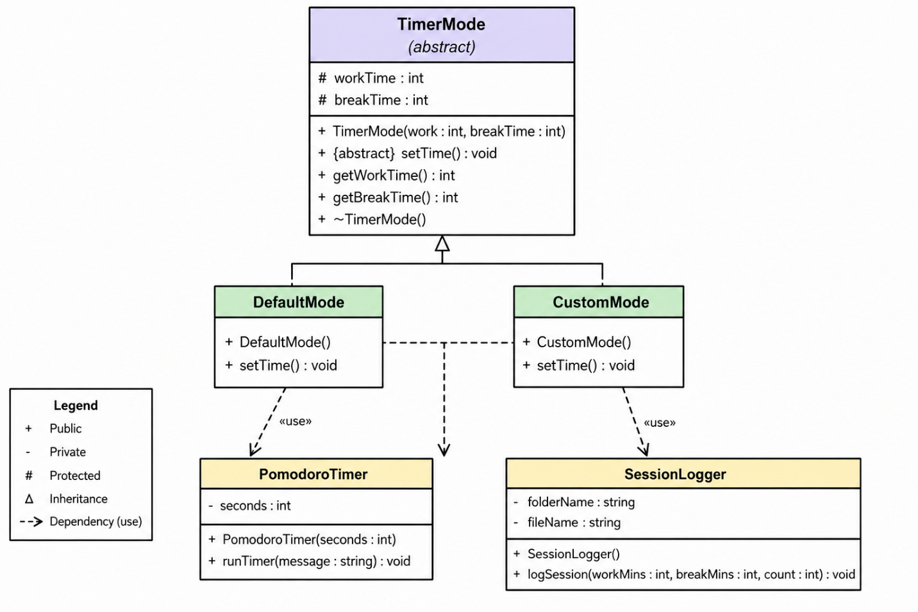
Figure 1: UML Class Diagram (PlantUML)
TimerMode is an abstract class because it declares setTime() as a pure virtual function; it cannot be instantiated on its own and only exists to be extended. DefaultMode and CustomMode both inherit the protected workTime and breakTime attributes and the getWorkTime() and getBreakTime() methods from TimerMode, and each overrides setTime() in its own way: DefaultMode fixes the values at 25 and 5, while CustomMode reads them from the user. PomodoroTimer and SessionLogger do not inherit from any class and are not related to TimerMode by inheritance; they are created and used directly inside main() to run a countdown and to write the session log respectively. There is no formal association arrow between PomodoroTimer, SessionLogger, and TimerMode in the diagram because, in the code, main() only reads the work and break minutes from the TimerMode object through getWorkTime() and getBreakTime() and passes those plain integers into PomodoroTimer and SessionLogger; the classes do not hold references to each other as attributes.

4.2 SEQUENCE DIAGRAM
The sequence diagram illustrates the order of interactions that occur during a single Pomodoro session, focusing on the messages exchanged between the User, the main() program, the TimerMode object, the PomodoroTimer objects, and the SessionLogger object over time. It begins when the user selects a mode, continues through the repeated work and break timers, and ends when the user chooses to stop and the session is logged. This diagram highlights the exact point where polymorphism is used, when setTime() is called through the TimerMode pointer.
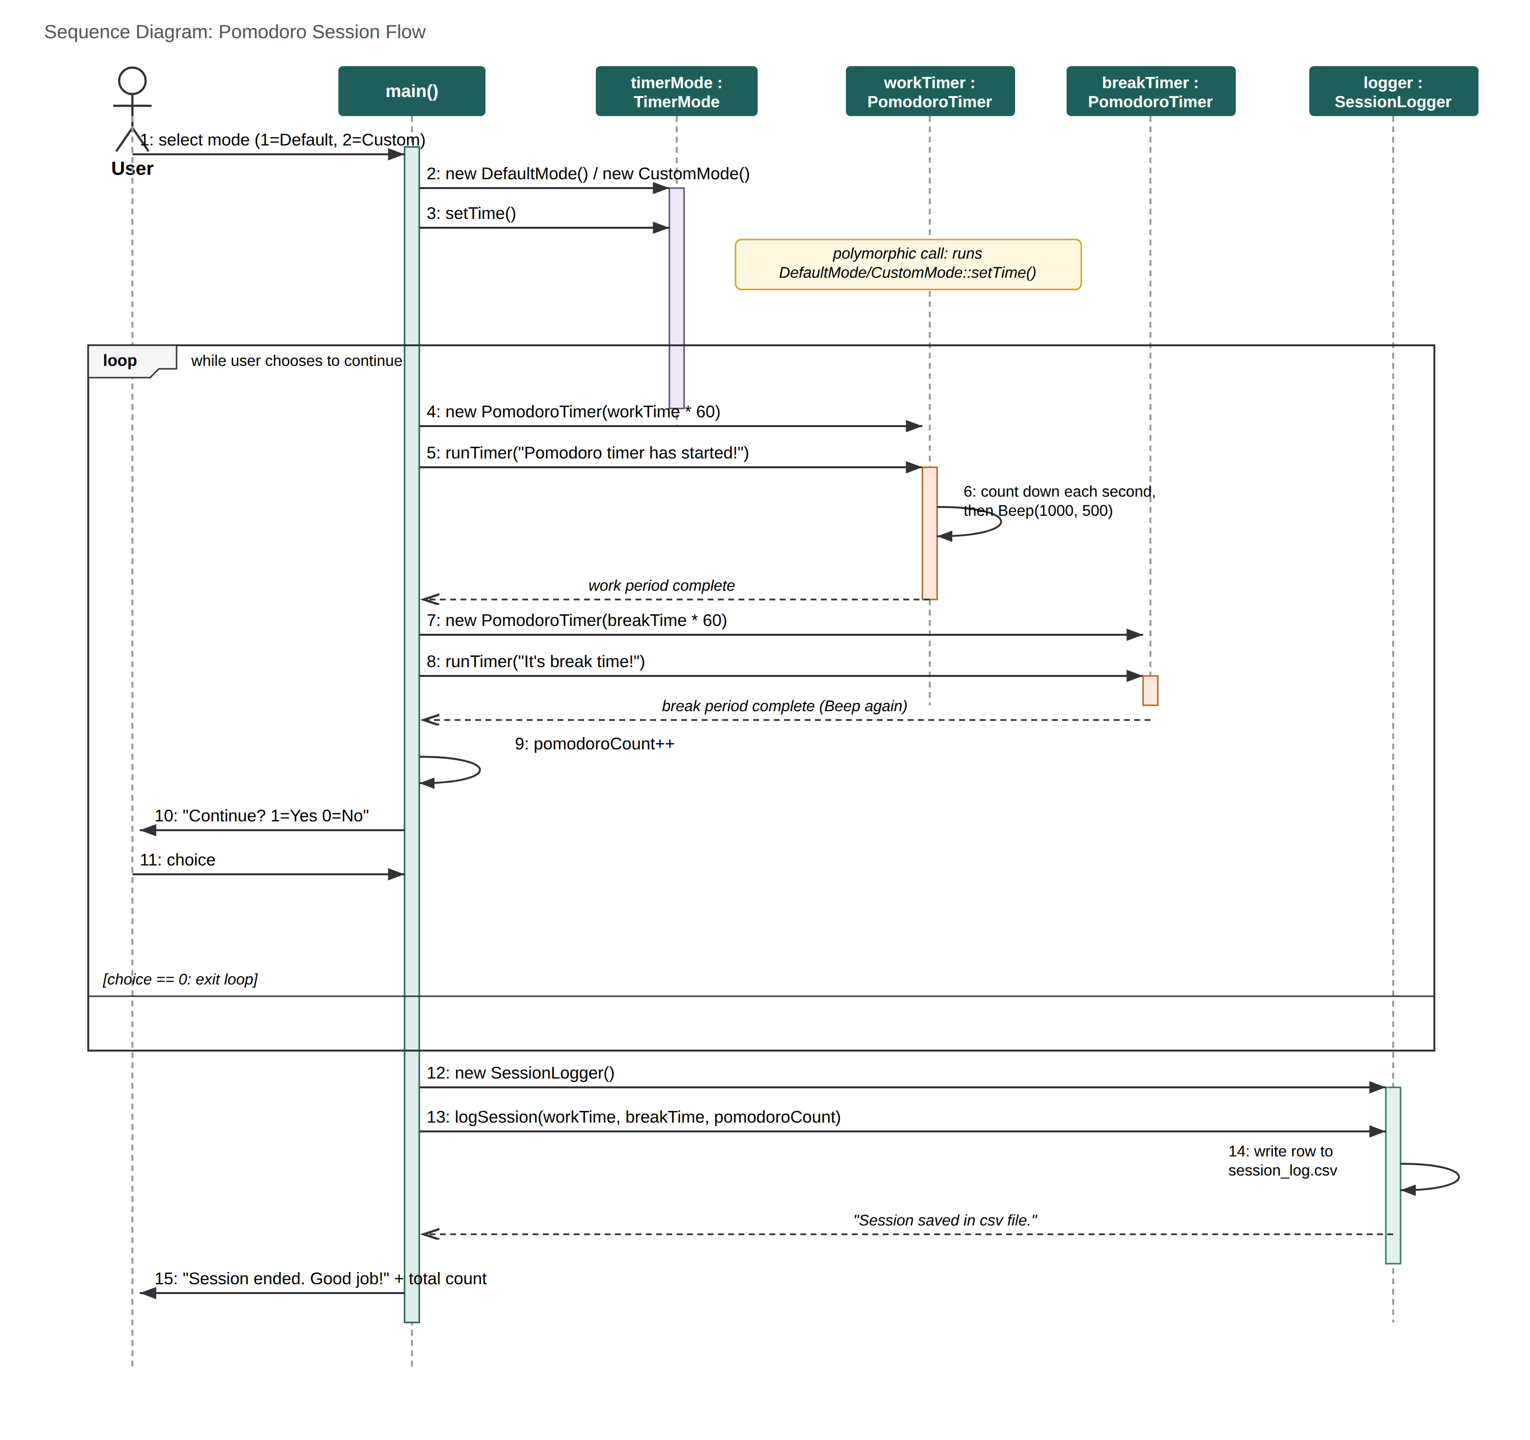
Figure 2: Sequence Diagram (PlantUML)
The session begins when the user selects a mode, and main() creates either a DefaultMode or a CustomMode object and calls setTime() on it through a TimerMode pointer, which is where polymorphism is demonstrated. Inside the main pomodoro loop, main() creates a new PomodoroTimer for the work period using getWorkTime() from the timer mode, runs it, then creates a new PomodoroTimer for the break period using getBreakTime(), and runs that as well; each call to runTimer() ends with a Beep(). After each work-break cycle, main() increments the pomodoro count and asks the user whether to continue. If the user enters 0, main() creates a SessionLogger object and calls logSession() with the work minutes, break minutes, and total cycle count, which writes a new row to the CSV log file with the current date and time before the program ends.

4.3 USE CASE DIAGRAM
The use case diagram identifies the single actor who interacts with the system, the User, and the key functionalities available to them. The user's use cases include selecting a timer mode, entering custom durations, running the work and break timers, choosing whether to continue after a cycle, and, when stopping, having the session saved to the log. The “Enter Custom Durations” use case extends “Select Timer Mode” because it only occurs when the user chooses the custom mode option.
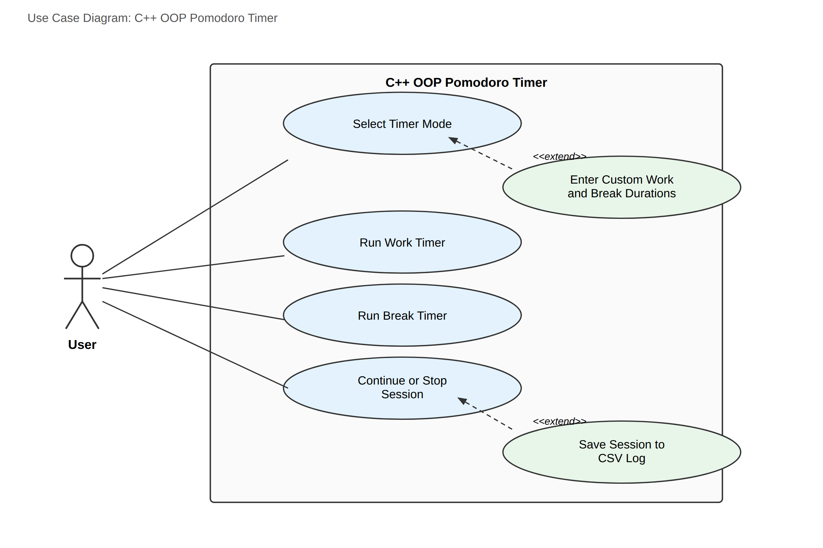
Figure 3: Use Case Diagram (PlantUML)
There is a single actor in this system: the User, since the program has no separate administrator or staff role. Selecting the timer mode is the entry point of the program; entering custom durations is shown as an extension of it because it only happens when the user picks the custom mode. Running the work timer and running the break timer are separate use cases that repeat every cycle. Continuing or stopping the session is a use case the user performs after every cycle, and saving the session to the CSV log is shown as an extension of stopping the session, because logging only happens when the user chooses to stop rather than continue.

5. PROPOSED DELIVERABLES
The project delivers a complete source code implementation contained in a single C++ source file, as reflected in the current implementation.
Three UML diagrams are provided as part of this proposal, expressed in PlantUML so that they can be regenerated in any PlantUML-compatible diagram tool: a class diagram showing the structure and inheritance relationship between the five classes, a sequence diagram showing the order of interactions during a Pomodoro session, and a use case diagram showing how the user interacts with the system.
The program itself produces a session log file, pomodoro_logs/session_log.csv, as a runtime deliverable each time a session is completed and the user chooses to stop.

6. PROJECT TASK AND TIME SCHEDULE
The project time schedule below reflects the actual work involved in a small, single-file console project of this size.
TASK | APPROX DURATION IN DAYS
Requirements analysis | 1
System Design (UML) | 1
Coding | 3
Testing and Debugging | 1
Documentation | 1
Table 1: Time Schedule

7. CODE-TO-PROPOSAL VERIFICATION
The table below lists the major claims and features described in this proposal alongside the exact class or function in the C++ source code that implements them, so that every claim can be checked directly against the code.
Proposal Claim / Feature | Corresponding Class / Function in Code
Default mode: 25 min work, 5 min break | DefaultMode::DefaultMode() constructor (TimerMode(25, 5)) and DefaultMode::setTime()
Custom work and break durations | CustomMode::setTime(), which reads workTime and breakTime from cin
Abstract timer mode / abstraction | TimerMode class, pure virtual setTime() = 0
Inheritance | class DefaultMode : public TimerMode and class CustomMode : public TimerMode
Polymorphism | TimerMode* timerMode in main(); timerMode->setTime() calls the overridden version
Encapsulation | private int seconds in PomodoroTimer; private folderName and fileName in SessionLogger
Work and break countdown timers | PomodoroTimer::runTimer(), called once for work and once for break each cycle in main()
Sound notification | Beep(1000, 500) at the end of PomodoroTimer::runTimer()
Counting completed Pomodoro cycles | int pomodoroCount, incremented once per loop iteration in main()
Saving sessions to a CSV file | SessionLogger::logSession(), writing to pomodoro_logs/session_log.csv
Session logging with date and time | time(NULL) and localtime() used inside SessionLogger::logSession()
Note: The program currently has no way to pause a timer mid-countdown; this is a limitation of the current implementation and is not described as a feature above.

8. BIBLIOGRAPHY

* Robert Sedgewick and Kevin Wayne, Algorithms, 4th Edition, Addison-Wesley, 2011.

* Bjarne Stroustrup, The C++ Programming Language, 4th Edition, Addison-Wesley, 2013.

* William Stallings, Object Oriented Programming: Principles and Practice, 7th Edition, Pearson, 2017.

