SOCIAL MEDIA ANALYTICS PROJECT
SQL Data Analysis and Power BI Dashboard

1. Problem Statement
Social media platforms generate large volumes of data involving posts, views, likes, comments, shares, followers, content types, categories, sentiment, and influencer characteristics. Without structured analysis, it is difficult to identify which platforms, content types, categories, days, and time periods show stronger engagement. The project therefore focuses on analyzing social media performance and converting the results into clear business insights.

2. Proposed Solution
A two-stage analytical solution was developed. MySQL was used to audit, prepare, and analyze the social media dataset using SQL. Power BI was then used to present the most relevant findings through an interactive two-page dashboard with KPI cards, charts, a synchronized platform slicer, and multiple visualization types.

3. Project Objectives
- Assess engagement performance across social media platforms.
- Identify high-performing content types and categories.
- Analyze engagement patterns by day and hour.
- Compare follower/audience size across platforms.
- Examine engagement across influencer tiers and platforms.
- Understand the distribution of positive, neutral, and negative sentiment.
- Provide an interactive dashboard that supports exploration of the dataset.

4. Tools and Technologies
- MySQL / MySQL Workbench – database creation, data quality checks, cleaning/preparation, and SQL analysis.
- Power BI Desktop – data visualization, dashboard development, KPI cards, slicers, and interactive analysis.
- SQL – aggregation, grouping, filtering, calculated metrics, ranking, and exploratory analysis.
- CSV/social media dataset – source data for the analysis.

5. Dataset Overview
The project uses a social media dataset containing post-level information. The final Power BI dashboard shows approximately 5K posts in the default overall view. The dataset includes fields such as Post ID, timestamp, platform, content type, category, likes, comments, shares, views, saves, follower count, engagement rate, hour of day, day of week, hashtag count, content length, sentiment, influencer tier, media presence, and verification status.

6. Project Methodology
Data Import: Imported the raw social media dataset into MySQL and created the social_media_raw table.
Data Quality Audit: Checked record counts, table structure, missing values, duplicate Post IDs, date range, categorical values, invalid numeric values, engagement-rate consistency, hours, hashtags, content length, and timestamp/day consistency.
Data Preparation: Created the social_media_clean analysis table and performed additional checks for blank values, spaces, Boolean values, zero followers, and engagement-rate extremes.
SQL Analysis: Performed 43 analytical queries covering platform, content, category, time, views, engagement, followers, influencer tiers, sentiment, hashtags, content length, verification, media presence, and top-performing posts.
Power BI Dashboard: Created a two-page interactive dashboard with KPIs, platform/content/category/time analysis, influencer-tier analysis, sentiment distribution, follower analysis, and a synchronized platform slicer.
Validation: Tested the dashboard interactions and confirmed that the platform slicer filters both report pages.

7. SQL Analysis Areas
- Average and total engagement by platform.
- Average engagement and volume by content type and category.
- Engagement performance by day and hour.
- Views and average views by platform, category, and content type.
- Likes, comments, shares, and engagement-to-view analysis.
- Follower and engagement relationships by platform.
- Verification and media-presence comparisons.
- Influencer-tier engagement and follower analysis.
- Sentiment-based engagement analysis.
- Hashtag and content-length analysis.
- Platform/content/day combinations.
- Top-performing and high-engagement posts.
- Overall social media performance summary.

8. Power BI Dashboard

Page 1 – Overall Social Media Performance
- Engagement Rate by Platform
- Engagement Rate by Content Type
- Engagement Rate by Day of Week
- Engagement Rate by Category
- Total Posts, Total Views, Total Engagement, and Average Engagement Rate KPI cards
- Platform slicer synchronized with Page 2

Page 2 – Detailed Social Media Insights
- Total Engagement by Influencer Tier and Platform – Treemap
- Sentiment Distribution – Donut chart
- Engagement Rate by Hour of Day – Line chart
- Follower Count by Platform – Column chart
- The same KPI cards and synchronized Platform slicer

9. Key Dashboard Observations
- The default dashboard view summarizes approximately 5K posts, 555M total views, 44M total engagement, and an average engagement rate of 11.96.
- The platform comparison shows substantial differences in average engagement rate, with TikTok visibly higher than the other platforms in the dashboard.
- Engagement varies considerably across content types, with a small number of content types showing much higher average engagement than others.
- Engagement also varies by day of week and hour of day, allowing potential timing patterns to be explored.
- Follower counts differ substantially across platforms, providing context for interpreting platform-level engagement.
- The influencer-tier treemap shows how total engagement is distributed across influencer tiers and platforms.
- The sentiment donut shows approximately 50% positive, 35% neutral, and 15% negative posts in the overall dashboard view.

9.1 Power BI Dashboard – Page 1
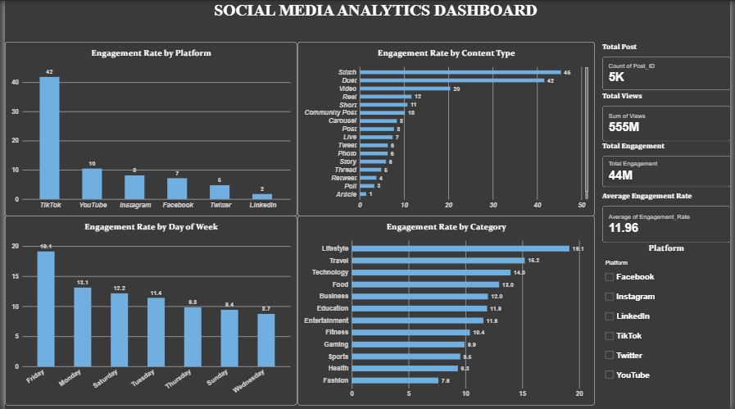
Figure 1: Social Media Analytics Dashboard – Page 1

9.2 Power BI Dashboard – Page 2
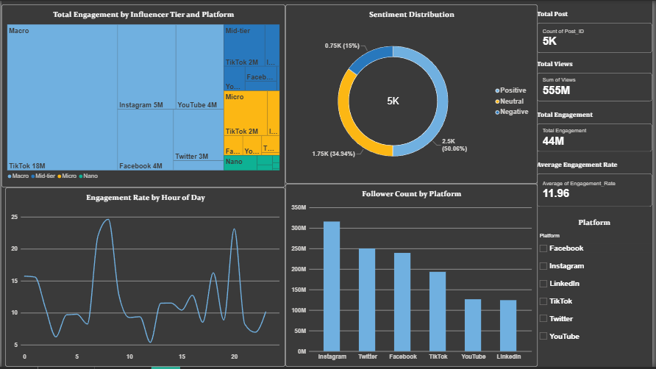
Figure 2: Social Media Analytics Dashboard – Page 2

10. Business Insights & Recommendations

10.1 Key Business Insights
- Platform Performance: TikTok records the highest engagement rate among the platforms shown in the dashboard, indicating stronger engagement efficiency within this dataset.
- Content Type Performance: Engagement rates vary substantially across content types, with some content formats generating considerably higher average engagement than others.
- Day-of-Week Pattern: Engagement differs by day of the week. Friday records the highest engagement rate in the dashboard, while some other days show lower average engagement.
- Category Performance: Lifestyle records the highest engagement rate among the categories shown in the dashboard.
- Influencer Tier and Platform: The treemap shows how total engagement is distributed across influencer tiers and platforms. Macro-tier content accounts for a large share of the engagement represented in the dashboard.
- Sentiment Distribution: Approximately 50% of posts are positive, 35% are neutral, and 15% are negative in the overall dataset.
- Time-of-Day Pattern: Engagement varies across hours of the day, with noticeable differences between higher- and lower-performing periods. This provides a basis for evaluating posting-time patterns.
- Audience Size: Follower counts vary considerably between platforms. Follower count therefore provides useful context when interpreting platform-level engagement.

10.2 Business Recommendations
- Prioritize analysis of high-engagement platforms and content types when planning future social-media campaigns, while continuing to monitor performance rather than assuming that past results will remain constant.
- Use the day-of-week and hour-of-day patterns as inputs when testing different posting schedules.
- Evaluate influencer partnerships by considering both influencer tier and platform, rather than looking at influencer tier alone.
- Monitor sentiment regularly so that changes in positive, neutral, and negative content can be identified over time.
- Use engagement rate together with follower count and total engagement to avoid relying on a single metric when evaluating social-media performance.
- Continue using the Power BI slicer to compare platform-specific performance and support more focused analysis.

11. Conclusion
The Social Media Analytics project combines SQL-based data analysis with Power BI visualization to transform post-level social media data into an interactive analytical dashboard. The SQL stage provides detailed analysis across multiple dimensions, while the Power BI dashboard presents the most relevant findings in a concise format. The final dashboard can be filtered by platform, enabling users to compare overall performance and explore platform-specific patterns.

12. Submission Deliverables
- Final SQL analysis script.
- Power BI .pbix dashboard file.
- Project documentation.
- Dashboard screenshots for documentation

