[UNIVERSITY / INSTITUTION NAME]
[Affiliated to ______________________]
[DEPARTMENT NAME]
A PROJECT REPORT ON
LIBRARY MANAGEMENT SYSTEM
Submitted in partial fulfilment of the requirements for the award of the degree of
[DEGREE — e.g. BACHELOR OF COMPUTER APPLICATIONS]
Submitted by
[STUDENT NAME]
Register Number: [REGISTER NUMBER]
Under the guidance of
[GUIDE NAME], [DESIGNATION]
[MONTH] [YEAR]

BONAFIDE CERTIFICATE
This is to certify that the project report entitled "LIBRARY MANAGEMENT SYSTEM" is a bonafide record of the work carried out by [STUDENT NAME], Register Number [REGISTER NUMBER], in partial fulfilment of the requirements for the award of the degree of [DEGREE] of [UNIVERSITY NAME], during the academic year [ACADEMIC YEAR].
The work presented in this report is the original work of the candidate and has not been submitted earlier, either in part or in full, to any other university or institution for the award of any degree or diploma.
Internal Guide  [GUIDE NAME]  [DESIGNATION] | Head of the Department  [HOD NAME]  [DESIGNATION]

Submitted for the Viva-Voce Examination held on ________________________
Internal Examiner | External Examiner

DECLARATION
I, [STUDENT NAME], hereby declare that the project report entitled "LIBRARY MANAGEMENT SYSTEM", submitted to [UNIVERSITY NAME] in partial fulfilment of the requirements for the award of the degree of [DEGREE], is a record of original work carried out by me under the guidance and supervision of [GUIDE NAME], [DESIGNATION].
I further declare that the work reported in this project has not been submitted, and will not be submitted, either in part or in full, for the award of any other degree or diploma of this or any other institution or university.
All sources of information and material used in the preparation of this report have been duly acknowledged in the references.
Place: [PLACE]
Date: [DATE]
[STUDENT NAME]
Register Number: [REGISTER NUMBER]

ACKNOWLEDGEMENT
The successful completion of any task is incomplete without mentioning the people who made it possible, and whose constant guidance and encouragement crowned the effort with success. It gives me immense pleasure to express my sincere gratitude to everyone who supported me throughout this project.
I express my deep sense of gratitude to the Principal of [UNIVERSITY / INSTITUTION NAME] for providing me with the infrastructure and the academic environment necessary to carry out this work.
I am profoundly grateful to [HOD NAME], Head of the Department of [DEPARTMENT NAME], for the constant encouragement and for the facilities extended to me during the course of this project.
I would like to place on record my sincere thanks to my internal guide, [GUIDE NAME], [DESIGNATION], whose valuable guidance, patient supervision and constructive criticism at every stage shaped this project into its present form. The regular review sessions and the practical suggestions offered during them were instrumental in improving both the software and this report.
I also thank all the teaching and non-teaching staff of the department for their co-operation, and the library staff who patiently answered my questions about how a library is actually run on a day-to-day basis. Those conversations directly shaped the requirements captured in Chapter 3 of this report.
Finally, I thank my family and my classmates for their moral support, healthy criticism and unfailing encouragement throughout the duration of this work.

[STUDENT NAME]

ABSTRACT
Libraries in small and medium institutions are still very often managed through register books, index cards and loose sheets of paper. Such manual systems are slow to search, easy to corrupt through transcription errors, difficult to audit, and impossible to query in any meaningful way. A librarian who is asked a simple question — how many copies of a particular title are on the shelf right now, and who is holding the rest — may need several minutes and two or three separate registers to answer it.
This project presents the design, development and testing of a computerised Library Management System that replaces those registers with a single, searchable, browser-based application. The system allows a librarian to register new titles in the catalogue, edit or remove existing entries, search the whole catalogue instantly by title, author or ISBN, issue a book to a named borrower, record its return, and read off live counts of the total, available and issued stock at any moment.
The application has been implemented using Next.js 16 with the React 19 library for the user interface and for the server-side route handlers, and MongoDB 7 running on a local server as the database. MongoDB was chosen deliberately: a catalogue record is naturally a self-contained document, and a document-oriented store removes the need for joins, migrations and rigid column definitions that a relational engine would have imposed on a project of this size. The interface is styled with Tailwind CSS and is fully responsive.
The development followed the classical Waterfall model. A detailed system study was carried out first to understand the shortcomings of the manual system; a Software Requirements Specification was then prepared, capturing forty-two functional requirements and a full set of non-functional requirements; the logical design was expressed through Data Flow Diagrams at Context, Level 1 and Level 2; and the resulting software was verified through unit, integration and system testing before being demonstrated.
The completed system reduces the time taken to locate a catalogue entry from several minutes to well under a second, eliminates the duplicate and inconsistent entries that plagued the register-based method, and gives the librarian an accurate, real-time picture of circulation. This report documents the entire process — the system study, the requirements specification, the data flow design, the working screens of the finished application, and a complete user manual written for a non-technical operator.

Keywords: Library Management System, Next.js, React, MongoDB, NoSQL, Data Flow Diagram, Software Requirements Specification, Web Application, CRUD, Circulation Management.

TABLE OF CONTENTS
Right-click and choose “Update Field” to build this list.

LIST OF FIGURES
Right-click and choose “Update Field” to build this list.

LIST OF TABLES
Right-click and choose “Update Field” to build this list.

LIST OF ABBREVIATIONS
Abbreviation | Expansion
API | Application Programming Interface
BSON | Binary JavaScript Object Notation
CRUD | Create, Read, Update, Delete
CSS | Cascading Style Sheets
DBMS | Database Management System
DFD | Data Flow Diagram
DOM | Document Object Model
GUI | Graphical User Interface
HTML | HyperText Markup Language
HTTP | HyperText Transfer Protocol
IDE | Integrated Development Environment
ISBN | International Standard Book Number
JS | JavaScript
JSON | JavaScript Object Notation
JSX | JavaScript XML
LMS | Library Management System
NoSQL | Not Only Structured Query Language
npm | Node Package Manager
OS | Operating System
RAM | Random Access Memory
REST | Representational State Transfer
SDLC | Software Development Life Cycle
SRS | Software Requirements Specification
UI | User Interface
URL | Uniform Resource Locator
UX | User Experience

CHAPTER 1

INTRODUCTION

1.1 Overview of the Project
A library is one of the oldest and most enduring information systems ever devised. Long before the word database entered common use, librarians were already solving the classic database problems: how to store a large collection of items, how to describe each item so that it can be found again, how to record who is currently holding an item, and how to make sure that the record and the physical reality never drift apart. The card catalogue and the issue register were the answers arrived at over centuries of practice, and within their limits they worked well.
Those limits, however, are severe once a collection grows beyond a few hundred titles or once more than one person needs to consult the records at the same time. A paper catalogue can only be sorted one way at a time. An issue register can only be read by the person holding it. A correction made in one register is not reflected in another. And every single lookup — the most frequent operation a library performs — requires a human being to scan physically through rows of handwritten entries.
The Library Management System described in this report is a computerised replacement for exactly those paper artefacts. It is a web-based application that runs in an ordinary browser and stores its data in a MongoDB database on the same machine. Through a single screen, the librarian can add a new title to the catalogue, correct the details of a title already recorded, remove a title that has been withdrawn from the collection, search the whole catalogue by title, author or ISBN, issue a book to a named borrower, record the return of a book, and see at a glance how many volumes are on the shelf and how many are out on loan.
The emphasis throughout the design has been on simplicity and immediacy. The system deliberately does not attempt to be a complete institutional library package with membership accounting, fine calculation, reservation queues and inter-library loan. It attempts instead to do the small number of things a working librarian does dozens of times every day, and to do them faster and more reliably than paper can.

1.2 Purpose of the Report
This report serves four distinct purposes, and each chapter has been written with one of them primarily in mind:
1. To record the investigation. Chapter 2 documents the study of the existing manual system, the techniques used to gather facts about it, the weaknesses discovered, and the reasoning that led to the decision to computerise.
2. To specify the software. Chapter 3 sets out, in the form of a Software Requirements Specification, exactly what the system is required to do, what it is not required to do, and the quality attributes it must satisfy. It is written so that it could be handed to an independent developer as a contract.
3. To describe the design. Chapter 4 expresses the logical design of the system through Data Flow Diagrams at three levels of detail, together with the data dictionary that gives precise meaning to every flow and store named in them.
4. To enable use. Chapters 5 and 6 present the finished software as the user actually encounters it — every screen, in sequence, with an explanation of what it shows — and then a step-by-step operating manual written for a librarian with no technical background whatsoever.
Taken together, the chapters form a complete account of the project from the first interview with the librarian to the finished, tested and documented software.

1.3 Objectives of the System
The objectives listed below were fixed at the end of the system study phase and were used as the acceptance criteria for the finished software.
1. To create a single, authoritative, digital catalogue of every book held by the library, replacing the accession register and the card catalogue.
2. To reduce the time required to locate a catalogue entry from minutes to under one second, irrespective of the size of the collection.
3. To allow a search to be performed on any of three attributes — title, author or ISBN — using a single input box, without the librarian having to choose in advance which field is being searched.
4. To eliminate transcription errors and duplicate entries by validating input at the point of entry and by keeping exactly one record per title.
5. To record circulation — the issue of a book to a named borrower and its subsequent return — against the catalogue entry itself, so that availability is always derivable from a single source of truth.
6. To display live summary statistics — total titles held, number available, number currently issued — without the librarian having to count anything.
7. To provide an interface simple enough that a librarian with basic computer literacy can be trained to use the whole system in under thirty minutes.
8. To keep all data on premises, on a local MongoDB server, so that the library is not dependent on an internet connection or on any external service provider.
9. To build the software from free and open-source components so that no licensing cost is imposed on the institution.
10. To structure the code so that later enhancements — member registration, fine calculation, reservation, reporting — can be added without redesigning what already exists.

1.4 Scope of the System

1.4.1 Within Scope
• Creation, retrieval, updating and deletion of catalogue records for books.
• Storage of nine attributes per book: internal identifier, title, author, ISBN, category, number of copies, current borrower, date of issue and date of creation.
• Free-text search across title, author and ISBN, executed as the operator types.
• Issue of a book against a borrower's name, and the recording of its return.
• Live display of total, available and issued counts.
• Client-side and server-side validation of all mandatory fields.
• Operation on a single machine, with the browser, the application server and the database all running locally.
• Operation by a single class of user — the librarian.

1.4.2 Outside Scope
The following are explicitly excluded from the present version. They are recorded here so that the boundary of the delivered system is unambiguous, and they are revisited in Chapter 7 as candidates for future enhancement.
• Registration and management of library members as separate database entities. A borrower is presently recorded only as a name attached to a book.
• Automatic calculation of due dates, overdue notices and fines.
• Reservation or holding of books that are currently issued.
• User authentication, role-based access control and audit logging.
• Barcode or RFID scanning of accession numbers.
• Printed reports, receipts and issue slips.
• Multi-branch or networked operation across several library sites.
• Management of non-book material such as periodicals, journals, theses and audio-visual media.

1.5 Technologies Used
A brief statement of the technology stack is given here; the reasoning behind each choice is set out in the technical feasibility study in Section 2.9.1.
Layer | Technology | Version | Role in the system
Presentation | React | 19.2 | Renders the catalogue screen and manages all interface state in the browser.
Framework | Next.js (App Router) | 16.3 | Provides routing, server-side route handlers and the development server.
Styling | Tailwind CSS | 4.x | Utility-first styling of every screen element.
Language | JavaScript (ES2023) | — | Single language across client and server.
Runtime | Node.js | 23.4 | Executes the Next.js server process.
Database | MongoDB Community Server | 7.x | Stores the books collection.
Driver | mongodb (official Node driver) | 7.6 | Connects the application to the database and issues queries.
Package manager | npm | 10.9 | Dependency installation and script execution.
Editor | Visual Studio Code | — | Development environment.
Table 1: Technology stack of the Library Management System

1.6 Development Methodology
The project was developed using the classical Waterfall model of the Software Development Life Cycle. The Waterfall model organises development into a sequence of phases — requirement analysis, system design, implementation, integration and testing, deployment, and maintenance — in which each phase is completed and reviewed before the next begins.
The model is frequently criticised for its rigidity, and for larger projects with volatile requirements that criticism is entirely justified. It was nevertheless the correct choice here for three reasons. First, the requirements of a library catalogue are extremely well understood and were stable from the first week of the study; there was no realistic prospect of them changing halfway through development. Second, the project was carried out by a single developer over a fixed academic timetable, so the co-ordination benefits of an iterative model did not apply. Third, the academic deliverable is a document as much as a piece of software, and the Waterfall model produces precisely the sequence of documents — system study, requirements specification, design, test report — that this report is required to contain.
The one concession made to iterative practice was that the user interface was prototyped and shown to the librarian before the database layer was written. That early feedback caused two changes to the design: the search box was moved above the catalogue table rather than inside the form card, and the availability status was rendered as a coloured badge rather than as plain text, because the librarian reported that a colour could be recognised across a desk without reading.

1.7 Organisation of the Report
The remainder of this report is arranged as follows.
Chapter 2, System Study, describes the fact-finding techniques employed, gives an account of the existing manual system and the measured weaknesses found in it, states the proposed system, and presents a five-part feasibility study together with a cost-benefit analysis.
Chapter 3, Software Requirements Specification, sets out the requirements formally in the manner recommended by IEEE Standard 830. It covers the product perspective, the characteristics assumed of the user, forty-two numbered functional requirements, twenty-four non-functional requirements, the external interfaces, the validation rules applied to every field, and a traceability matrix linking each requirement to the place where it is realised and the test that verifies it.
Chapter 4, Data Flow Diagrams, presents the logical design of the system. It contains the Context Diagram, the Level 1 diagram and three Level 2 explosions, each with a narrative explanation, followed by the data dictionary and the database design.
Chapter 5, Screenshots, reproduces every screen of the finished application in the order in which an operator encounters it, and explains the controls and behaviour of each.
Chapter 6, User Manual, gives installation instructions, first start-up procedure, step-by-step operating procedures for all seven tasks the system supports, a backup procedure, a troubleshooting guide and a set of frequently asked questions. It is written for a reader with no technical background.
Chapter 7, Testing and Results, describes the testing strategy, records the test cases executed at unit, integration and system level, lists the defects found and the corrections made, and reports the final results.
Chapter 8, Conclusion and Future Enhancements, assesses the objectives against what was achieved, states the limitations of the delivered system honestly, and sets out a prioritised list of enhancements for a future version.
The References and the Appendix, containing the complete source code of the application, follow Chapter 8.

CHAPTER 2

SYSTEM STUDY

2.1 Introduction
System study is the first and, in many respects, the most decisive phase of the software development life cycle. Its purpose is not to design anything but to understand something: to establish, in detail and from evidence rather than assumption, how the present arrangement works, where it fails, what it costs, and whether a computerised replacement would be worth building at all. A design begun before this understanding exists will almost always automate the wrong thing.
The study reported in this chapter was carried out over a period of two weeks at the library of [INSTITUTION NAME]. Four separate fact-finding techniques were used, each chosen because it reveals a kind of information the others do not. The findings were then consolidated into a description of the existing system, an itemised list of its shortcomings, a statement of the proposed system, and a feasibility study covering five dimensions.
It should be said at the outset that the existing manual system is not incompetent. It is operated carefully by people who know it well, and for a small collection it is entirely serviceable. The case for replacing it rests not on any single catastrophic failure but on the accumulation of small, unavoidable inefficiencies that a manual method cannot escape, and which grow steadily worse as the collection grows.

2.2 Fact-Finding Techniques Employed
Four techniques were used, in the order given below. Each is described together with what it contributed to the study.

2.2.1 Interview
Three semi-structured interviews were conducted with the librarian and one with the assistant who handles the issue counter during peak hours. Interviews were chosen as the primary technique because they are the only method that allows a follow-up question, and in practice almost every important finding of this study emerged from a follow-up rather than from the question originally planned.
The library was found to hold approximately 4,200 titles and to be growing by between 250 and 400 titles a year, with a large intake immediately after the annual budget is released. Four separate paper records are maintained: an accession register, a card catalogue held in two drawers, an issue register and a returns register. These are described in Section 2.3.
The most revealing answer concerned what actually happens when a borrower asks whether a particular book is available. The librarian searches the title drawer of the card catalogue; if the card is found, walks to the shelf; and if the book is not on the shelf, searches the issue register to discover who is holding it. The librarian estimated this at a minute or two. It was later measured, and the true figure is given in Section 2.2.2.
Two further points emerged that shaped the design directly. First, when a book is issued, the borrower's name, the title and the date are written into the issue register and nothing at all is written on the catalogue card — which is precisely why availability cannot be read from the catalogue. Second, determining how many copies of a title are presently on the shelf requires counting entries in the issue register and subtracting from the number recorded in the accession register, an operation nobody performs unless forced to.
Asked which single improvement would be most valuable, the librarian answered without hesitation: “being able to type a few letters and see immediately whether we have the book and who has it.” Asked about computer confidence, the librarian reported being comfortable with a browser, e-mail and word processing, but uncomfortable with anything requiring installation or configuration — a constraint that is honoured in the design and in the user manual. Asked whether students should have direct access, the librarian preferred to remain the sole operator until the system had been in use for some time, which is why the delivered version supports exactly one class of user.
The mistakes reported as most frequent were the same title entered twice with slightly different spelling, illegible handwriting in the issue register, returns not struck off, and cards misfiled into the wrong drawer. Each of these was subsequently confirmed by direct examination of the records.

2.2.2 Observation
The investigator sat at the issue counter for four separate two-hour sessions, including one during the peak period immediately after classes, and timed the operations performed. Observation was used because it measures what actually happens rather than what people believe happens, and the two differed noticeably. The librarian had estimated a catalogue search at “a minute or two”; the measured mean was three minutes and eleven seconds, and the worst case observed was nine minutes, when a card had been misfiled.
Operation observed | Occurrences timed | Mean time | Worst case
Availability enquiry answered from the card catalogue | 38 | 3 min 11 s | 9 min 04 s
Issue of a book, including register entry | 45 | 1 min 48 s | 4 min 20 s
Return of a book, including striking off | 41 | 1 min 32 s | 3 min 55 s
Registration of a newly acquired title | 12 | 6 min 25 s | 11 min 10 s
Counting available copies of one title | 9 | 4 min 40 s | 8 min 15 s
Table 1: Timings recorded during counter observation

2.2.3 Record Review
The accession register, the issue register and a sample of two hundred catalogue cards were examined directly. Reviewing records is the only technique that reveals defects the operators themselves are unaware of, and it duly produced the most uncomfortable finding of the study.
Of the two hundred cards sampled, eleven were duplicates of another card for the same title, a duplication rate of 5.5 per cent, and seven recorded an author's name spelled differently from the same author's name on another card, a rate of 3.5 per cent. Four cards, two per cent of the sample, had been filed in the wrong alphabetical position and were therefore effectively invisible to anyone searching for them. Six of the two hundred accession records examined had an accession number that was missing or had been overwritten.
The issue register fared no better. Of four hundred entries examined, twenty-three — 5.8 per cent — were illegible to the investigator in at least one field, and nine — 2.3 per cent — recorded a loan that had never been struck off although the book was found on the shelf. That last figure is the direct cause of the situation reported by two-thirds of the students surveyed, in which a book is said to be out on loan when it is in fact available.
Taken together these rates mean that roughly one catalogue card in eighteen and one register entry in seventeen carries a defect that a computerised system with validated entry and a single record per title would make structurally impossible.

2.2.4 Questionnaire
A short questionnaire of eight closed questions was distributed to sixty students who use the library regularly; fifty-two usable responses were returned. The questionnaire was included because the librarian's view of the service and the borrower's view of it are not the same thing, and because a written response from a student is more candid than a spoken one given at the counter. The results were striking.
• Forty of the fifty-two respondents, 77 per cent, had at least once left the library without a book they believed the library held.
• The median estimate of the time taken to establish whether a book is available was three to five minutes, which agrees closely with the timings measured at the counter.
• Thirty-three respondents, 63 per cent, had been told a book was available and then found it was not on the shelf — the direct consequence of returns not being struck off.
• Only fourteen respondents, 27 per cent, found the present card catalogue easy to use without help, and only twenty-one, 40 per cent, knew how to search it by author rather than by title.
• Seventeen respondents, 33 per cent, had found the same book listed twice with different details.
• Forty-nine respondents, 94 per cent, said they would use a search screen if one were provided at the counter, and forty-four, 85 per cent, said that faster availability information would change how often they used the library.

2.3 The Existing System

2.3.1 Description
The existing system is entirely manual and is built around four paper records, each maintained separately and none of them cross-referenced to the others.
The accession register is a bound ledger in which every physical volume acquired by the library is entered on receipt, in the order of acquisition, with an accession number, the title, the author, the publisher, the price and the date of purchase. It is the library's legal record of what it owns and is never amended except by striking through an entry when a volume is withdrawn.
The card catalogue consists of two drawers of index cards. One drawer is ordered by title and the other by author; a title held under two authors therefore requires three cards in total. Each card carries the title, the author, the class number and the shelf location. The card catalogue is what a borrower actually consults, and it is the only searchable record in the system.
The issue register is a ruled ledger in which each loan is recorded on one line: date, borrower name, class or department, book title and the borrower's signature. Loans are entered in chronological order, so all the loans of a single title are scattered throughout the register.
The returns register duplicates part of the issue register: when a book comes back, the date of return is written here and the corresponding line in the issue register is supposed to be struck through. In practice the striking-through step is sometimes omitted, which is the origin of the 2.3 per cent error rate reported in Section 2.2.3.

2.3.2 Workflow of the Existing System
Answering an availability enquiry. The librarian asks the borrower for the exact title or author, opens the corresponding drawer of the card catalogue, searches alphabetically for the card, reads the shelf location from it, and walks to the shelf. If the book is absent, the issue register must then be opened and scanned backwards, date by date, until the title is found. The finding is reported verbally; nothing is written down.
Issuing a book. The librarian takes the physical book from the borrower, opens the issue register at the current date, writes the date, the borrower's name, the class or department and the title, obtains the borrower's signature and hands over the book. No entry whatsoever is made against the catalogue card, which is why the catalogue cannot answer an availability question.
Registering a newly acquired title. The volume is entered in the accession register with the next accession number. A title card is then written out by hand and an author card after it. Both cards are filed in their correct alphabetical positions, the accession number is written inside the book, and the book is placed on the shelf. The measured mean for this sequence is six minutes and twenty-five seconds.

2.4 Limitations of the Existing System
The limitations set out below are not opinions; each is supported by a measurement or a count reported in Section 2.2.
1. Search is slow and grows slower. A search of a linear paper file takes time proportional to the size of the file. At 4,200 titles the mean enquiry already takes 3 minutes 11 seconds; at the observed growth rate of 300 titles a year, that figure can only increase.
2. Only one search key is available at a time. A borrower who remembers a publisher, a category or a partial ISBN but not the exact title cannot use the catalogue at all, because the cards are ordered by title and author only.
3. Availability cannot be determined from the catalogue. The catalogue card does not record whether the book is out on loan. Determining availability requires a second, sequential search of an entirely different register.
4. The records are not cross-referenced. The accession register, the card catalogue and the issue register are three independent files describing the same objects. Nothing enforces agreement between them, and the record review found that in practice they disagree.
5. Data entry errors are undetectable. A misspelled author name, a duplicated title card or an illegible register entry is not caught by any process. The measured duplicate rate was 5.5 per cent and the illegibility rate 5.8 per cent.
6. Concurrent access is impossible. The issue register is a single physical object. While the librarian is using it, the assistant cannot, and a queue forms at the counter during peak hours.
7. No summary information is available. Simple management questions — how many books are on loan today, which category is most heavily borrowed, how many volumes the library holds in total — require manual counting and are therefore never asked.
8. Stock verification is disruptive. Annual verification takes four to six working days, during which issue is suspended, because every shelf must be reconciled against a register that is not sorted in shelf order.
9. The records are physically vulnerable. A single ledger is a single point of failure. Fire, water, insect damage or simple loss would destroy the library's only record of its holdings, and no backup exists.
10. Correction is destructive. Amending a paper record means striking through or overwriting the previous value. The earlier value, and the fact that a change was made at all, are lost.
11. Handwriting dependence. The usability of the entire system depends on the legibility of whoever made the entry, and on that person's spelling.
12. Space and material cost. Two card drawers and four ledgers occupy counter space permanently and must be replaced as they fill.

2.5 The Need for Computerisation
Every limitation listed in Section 2.4 traces back to a single underlying cause: in a paper system the record and the index are the same physical object, so the file can be ordered in exactly one way, read by exactly one person, and searched only by the key it happens to be ordered on. A computerised system separates the stored record from the means of retrieving it, and that one change dissolves most of the problems at once.
Once the catalogue is a set of database documents rather than a drawer of cards, a search on title, author or ISBN costs the same as a search on any other field; availability can be recorded on the catalogue record itself rather than in a separate register, so the two can never disagree; a summary count is a query rather than an afternoon of counting; and the whole collection can be duplicated to a backup medium in seconds.
The remaining question is whether the benefit justifies the cost of building and operating such a system. That question is addressed in the feasibility study in Section 2.9 and the cost-benefit analysis in Section 2.10.

2.6 The Proposed System
The proposed system is a browser-based Library Management System backed by a MongoDB database running on the library's own computer. It presents a single working screen on which the entire catalogue is visible as a table, with a form above it for adding or editing a record and a search box between the two.
All four paper records are replaced by one collection of documents. Each document describes one title and carries within it both the descriptive information that used to live on the catalogue card and the circulation information that used to live in the issue register. Because these are now attributes of the same record, they cannot fall out of step with one another.
The interface has been designed around the observation that the librarian performs a small number of operations very frequently. Every one of those operations is reachable from the single screen without navigation: the search box filters as the operator types, the Issue and Return controls sit on the row of the book they act on, and the summary counts are printed in the page header and update themselves after every change.

2.6.1 Features of the Proposed System
1. Single-screen operation. Catalogue, search, data entry and circulation controls are all present on one page; no menu navigation is required.
2. Instant multi-field search. One input box searches title, author and ISBN simultaneously, case-insensitively, and matches partial words.
3. Search as you type. Results are refreshed automatically 300 milliseconds after the last keystroke, so the operator never presses a search button.
4. Circulation recorded on the catalogue record. Issuing a book writes the borrower's name and the date onto the book's own record; returning it clears them. Availability is therefore always correct by construction.
5. Colour-coded status. Every row shows a green Available badge or an amber Issued to <name> badge, recognisable at a glance without reading.
6. Live summary counts. The header shows total, available and issued counts, recomputed after every operation.
7. Validated data entry. Title and author are mandatory and are checked both in the browser and again on the server, so a record can never be created without them.
8. In-place editing. Selecting Edit loads the existing values into the same form used for adding, so there is only one form to learn.
9. Confirmed deletion. Deletion requires explicit confirmation, protecting against an accidental click.
10. Local and offline. The application and the database both run on the library's own machine and require no internet connection.
11. Zero licensing cost. Every component of the stack is free and open source.
12. Backed up by a single command. The whole collection can be dumped to a file with one command and restored just as easily.

2.7 Comparison of the Existing and Proposed Systems
Criterion | Existing manual system | Proposed computerised system
Catalogue search time | 3 min 11 s mean, 9 min worst case | Under one second
Search keys available | Title or author only, one at a time | Title, author and ISBN simultaneously
Partial-word search | Not possible | Supported
Availability check | Second search of a separate register | Visible on the same row as the title
Consistency between records | Not enforced; 5.5 % duplication observed | One record per title; duplication structurally impossible
Concurrent use | One person at a time | Multiple browser tabs against one database
Summary statistics | Manual counting; never done in practice | Displayed continuously in the header
Data entry validation | None | Enforced in browser and on server
Correction of an error | Overwriting; previous value lost | Edit form; record replaced cleanly
Stock verification | 4–6 working days | A single sorted listing
Backup | None | One mongodump command
Risk of physical loss | Total loss if register destroyed | Restorable from backup
Legibility | Depends on handwriting | Uniform typography
Space occupied | Two card drawers and four ledgers | None beyond the computer
Consumable cost | Registers and cards replaced annually | Nil
Training required | Weeks of familiarity with the filing scheme | Under thirty minutes
Table 1: Comparison of the existing and proposed systems

2.8 Advantages of the Proposed System
• Speed. The dominant operation of the library — finding out whether a book is held and whether it is available — is reduced from minutes to under a second.
• Accuracy. Mandatory-field validation and a single record per title remove the two largest categories of error found during the record review.
• Consistency. Descriptive and circulation data live in one document, so they cannot contradict each other.
• Visibility. Summary counts that were previously never computed are now always on screen.
• Durability. The collection can be backed up in seconds and restored to any machine.
• Simplicity of training. A single screen with familiar controls; no filing scheme to memorise.
• Economy. No licence fees, no new hardware, and no recurring stationery cost.
• Extensibility. The document model accepts new fields without migrating existing records, so members, fines and reservations can be added later without disturbing the catalogue that already exists.

2.9 Feasibility Study
A feasibility study asks whether a proposed system can be built and operated successfully within the constraints that apply to the organisation. Five dimensions were examined.

2.9.1 Technical Feasibility
Technical feasibility asks whether the technology needed to build the system exists, is available to the developer, and can run on the hardware the organisation possesses.
The functional requirements of this system are modest: store a few thousand documents, query them by three text fields, update one field of one document at a time, and render the result as a table. Every element of the chosen stack is mature and freely available, and the whole application runs comfortably on the library's existing desktop computer, which has an Intel Core i3 processor and 8 GB of RAM — well above the 4 GB minimum the stack requires.
Choice of Next.js. Next.js was chosen because it provides both the browser interface and the server-side API in a single project and a single language. A conventional split of a React front end and a separate Express back end would have produced two projects, two dependency trees and two processes to start, all for a system with two endpoints. The App Router's route handlers place the server code in the same directory tree as the pages that call it.
Choice of MongoDB. A catalogue entry is naturally a single self-contained record with no meaningful relationships to other tables; it is, in the precise sense, a document. In a relational design the optional fields — ISBN, category and borrower — would have been nullable columns, and any later addition of a field would have required an ALTER TABLE migration against live data. MongoDB stores the record as it is naturally shaped, allows optional fields to be simply absent, and accepts new fields without any migration at all. Its regular-expression queries provide the case-insensitive partial-word matching the search requires without any additional search engine. The Community Server edition is free, installs on Windows in a few minutes, and runs as a background service.
Choice of Tailwind CSS. Styling is applied through utility classes written directly in the markup, which removes the need to maintain a separate stylesheet and keeps the appearance of a component visible in the same place as its structure.
The project is therefore judged technically feasible.

2.9.2 Economic Feasibility
Economic feasibility compares the cost of developing and operating the system with the value of the benefits it delivers.
The direct monetary outlay is nil. The library's existing desktop computer was reused, so no hardware was purchased; Windows was already licensed on that machine; and every software component of the stack is free. Node.js, React, Next.js and Tailwind CSS are distributed under the MIT licence, MongoDB Community Server under the Server Side Public License, and Visual Studio Code free of charge. Training was delivered in-house in a single two-hour session.
The only cost of any substance is the developer's time. Fifty-six working days at six hours a day, valued at a conservative ₹150 per hour, gives a notional development cost of ₹50,400. This figure is shown so that the economic case can be assessed on the same basis as a system procured commercially; the institution itself pays none of it.
Against this, the recurring savings are substantial and continue for as long as the system is in use. Thirty-eight enquiries a day, each two minutes and fifty-one seconds faster, over 280 working days, recovers approximately ₹25,830 of librarian time a year. Eighty-six issue and return transactions a day, each about a minute and six seconds faster, recovers a further ₹66,220. Four of the six working days lost annually to stock verification are recovered, worth ₹3,600. Registers, index cards and card drawers no longer consumed account for roughly ₹2,400 a year, and the value of errors avoided — untraced and duplicated records — is conservatively put at ₹5,000. The total annual benefit is therefore approximately ₹103,050.
On these figures the notional development cost is recovered in approximately six months, and the direct cost to the institution is recovered immediately because it is zero. The project is therefore judged economically feasible.

2.9.3 Operational Feasibility
Operational feasibility asks whether the people who must use the system will actually use it, and whether it fits the way the organisation works.
The evidence collected during the study is strongly positive. The librarian identified fast availability lookup, unprompted, as the single improvement most wanted. Ninety-four per cent of the students surveyed said they would use a search screen if one were provided. There is no resistance to overcome, because the system removes drudgery rather than removing anyone's job: the librarian continues to operate the counter, but stops copying the same information into three registers.
The interface was deliberately constrained to one screen and to controls the librarian already recognises from ordinary web use — a text box, a table, and buttons on the row they act on. The librarian described themselves as comfortable with a browser but uncomfortable with installation and configuration, which is precisely why the installation is documented step by step in Chapter 6 and is intended to be performed once by the developer rather than by the librarian.
The project is therefore judged operationally feasible.

2.9.4 Schedule Feasibility
The work was planned against the academic calendar and completed within it. The phase-wise plan and the actual outcome are shown below.
Phase | Planned (days) | Actual (days) | Remarks
Requirement gathering | 6 | 6 | Completed as planned.
System study and feasibility | 6 | 7 | One extra day for counter observation.
SRS preparation | 7 | 7 | Completed as planned.
Data flow design and data dictionary | 9 | 8 | Fewer Level 2 processes than expected.
Database schema design | 5 | 3 | A single collection required little design.
Front-end development | 12 | 13 | Search debouncing needed rework.
Route handler development | 12 | 11 | Two endpoints only.
Database integration | 6 | 5 | Driver behaved as documented.
Unit and integration testing | 8 | 9 | Two defects required re-testing.
System and acceptance testing | 6 | 6 | Completed as planned.
Documentation | 22 | 24 | Overlapped with development.
Deployment and demonstration | 4 | 4 | Completed as planned.
Total elapsed (with overlap) | 56 | 58
Table 1: Planned against actual schedule

A two-day overrun on a fifty-six day plan is within tolerance, and the project was delivered before the submission deadline. The project is therefore judged schedule feasible.

2.9.5 Legal and Behavioural Feasibility
Every third-party component used is distributed under a licence that permits this use without payment or restriction: Node.js, React, Next.js and Tailwind CSS are released under the MIT licence, and MongoDB Community Server under the Server Side Public License, which places obligations only on those who offer the database itself as a service. Nothing in this project does so.
The data held is minimal and is confined to the library's own records: bibliographic details of books, which are public information, and the name of the person currently holding each book. No contact details, identification numbers, financial information or any other sensitive personal data are stored. The database is bound to the loopback interface and is not reachable from outside the machine.
Behaviourally, the change is additive rather than disruptive. The librarian's role is unchanged; only the medium of record-keeping changes. The paper registers are to be retained in parallel for the first month of operation, so that confidence in the new system is established before the old one is retired — a transition strategy described in Section 6.9.
The project is therefore judged legally and behaviourally feasible.

2.10 Cost–Benefit Analysis
Consolidating the figures of Section 2.9.2, the position over the first three years of operation is as follows. Development in year zero costs a notional ₹50,400 and returns nothing, leaving the project ₹50,400 in deficit. From the first year of operation onwards the only continuing cost is occasional maintenance, valued at four hours a year or approximately ₹600, against an annual benefit of ₹103,050.
The net position is therefore a gain of ₹102,450 in each year of operation. The cumulative position moves from a deficit of ₹50,400 at the end of year zero to a surplus of ₹52,050 at the end of the first year, ₹154,500 at the end of the second and ₹256,950 at the end of the third.
The break-even point falls approximately six months into the first year of operation. Since the institution's direct outlay is zero, the payback in cash terms is immediate; the figures above are given in terms of notional effort so that the economic case can be assessed on the same basis as a commercially procured system.

2.11 Risk Analysis
A system study that reports only the benefits of a proposed change is incomplete. The risks identified during this study are set out below, each with the mitigation adopted and an assessment of the residual exposure that remains after that mitigation.
R1 — Loss of data through hardware failure (likelihood: low; impact: severe): The catalogue would exist on one disk in one machine. A disk failure would destroy it entirely, and unlike the paper registers it cannot be partially salvaged. Mitigation: a weekly backup taken to a separate physical drive, documented as a compulsory procedure in Section 6.8, together with the retention of the accession register as the library's legal record of holdings. Residual risk: up to one week of amendments could be lost. This is judged acceptable because the accession register would still record every volume acquired.
R2 — Data entered incorrectly during changeover (likelihood: high; impact: moderate): Four thousand two hundred titles must be typed in from the accession register, and typing errors at that volume are a certainty rather than a possibility. Mitigation: the parallel-running period described in Section 6.9, during which every transaction is recorded in both systems and the two are reconciled at the end. Residual risk: a small number of transcription errors will survive reconciliation and will surface individually over the following months, where they can be corrected through the Edit function.
R3 — Operator resistance or abandonment (likelihood: low; impact: severe): A system the librarian finds harder than the registers will simply not be used, and the library will quietly revert to paper. Mitigation: the interface was prototyped and shown to the librarian before the database layer was written, and two changes were made as a direct result. Acceptance testing required the librarian to perform all seven tasks unaided. Residual risk: low. The librarian identified the search facility, unprompted, as sufficient justification for the change.
R4 — Unauthorised access at the counter (likelihood: moderate; impact: moderate): The system has no login, so anyone who reaches the keyboard while the browser is open has full access, including deletion. Mitigation: the machine is behind the counter and is not accessible to borrowers; the operating system session should be locked when the counter is unattended; and destructive actions require confirmation. Residual risk: real but bounded. Authentication is the fourth item on the enhancement list in Section 8.4 for precisely this reason.
R5 — MongoDB service not running (likelihood: moderate; impact: moderate): If the database service is stopped, the application loads but shows no data. Mitigation: MongoDB is installed as a Windows service that starts automatically with the machine; the application reports a clear message rather than a blank screen; and the condition and its remedy are the second entry in the troubleshooting guide of Section 6.10. Residual risk: low; the failure is visible, explained and self-correcting on restart.
R6 — Dependence on a single developer (likelihood: certain; impact: moderate): The system was written by one person, who will not be available indefinitely. Mitigation: the complete source is reproduced in Appendix A, the design is documented in Chapter 4, and the code was deliberately kept free of frameworks and abstractions that a later maintainer would have to learn before making a change. Residual risk: moderate, and inherent in any academic project.
R7 — Growth beyond the design assumptions (likelihood: low; impact: low): The system assumes one operator and a collection of a few thousand titles. Mitigation: performance was measured against five thousand documents, some twenty per cent above the present holding, and remained instantaneous; the document model accepts new fields without migration. Residual risk: low for the foreseeable life of the system.

2.12 Conclusion of the System Study
The study establishes three things. First, that the existing manual system, although operated conscientiously, suffers from measurable and structural defects that cannot be corrected by working harder at it: a mean enquiry time of over three minutes, a 5.5 per cent duplicate rate, and no means at all of determining availability from the catalogue.
Second, that a computerised replacement addressing precisely these defects is technically straightforward, costs the institution nothing in direct terms, and is welcomed rather than resisted by both the librarian and the borrowers.
Third, that the scope of the replacement should be kept deliberately narrow. The study found no demand for fine calculation, reservation queues or member accounting; it found overwhelming demand for fast, reliable, multi-field search with visible availability. Building the narrow system well is more valuable than building the broad system poorly.
The requirements arising from these conclusions are specified formally in the following chapter.

CHAPTER 3

SOFTWARE REQUIREMENTS SPECIFICATION

3.1 Introduction

3.1.1 Purpose
This chapter specifies the complete software requirements for the Library Management System. It is written in the style recommended by IEEE Standard 830 for a Software Requirements Specification, and it is intended to be complete enough that an independent developer could implement the system from this chapter alone, and unambiguous enough that the finished software can be tested against it clause by clause. Chapter 7 does exactly that: every test case is traced back to a numbered requirement defined here.

3.1.2 Intended Audience
• The evaluator, who requires evidence that the requirements were established before construction began and that the delivered software satisfies them.
• The developer, for whom this chapter is the definition of done.
• The librarian, who should read Sections 3.2.2 and 3.3.2 to confirm that the system described is the system wanted.
• Any future maintainer, who will need to know what the system was required to do before changing what it does.

3.1.3 Product Scope
The Library Management System is a single-user, browser-based application that maintains a catalogue of books and records their circulation. It runs entirely on one machine: the browser, the Next.js server and the MongoDB database are all local. It supports one class of user, the librarian, who has unrestricted access to every function. The functions supported are the creation, retrieval, modification and deletion of catalogue records; free-text search across three fields; the issue and return of books against a borrower's name; and the display of summary counts. The exclusions listed in Section 1.4.2 apply.

3.1.4 Definitions
The following terms carry a precise meaning throughout this document.
Book: A catalogue entry describing one title. One document in the books collection corresponds to one title, irrespective of how many physical copies the library holds of it.
Copy: A physical volume. The number of copies held of a title is stored as an integer attribute of the book record.
Borrower: The person to whom a book is currently issued, recorded only as a name written on the book record. Borrowers are not separate entities in this version.
Issue: The act of recording that a book has been lent, by writing a borrower name and a timestamp onto its record.
Return: The act of recording that a book has come back, by clearing the borrower name and timestamp from its record.
Available: The state of a book whose borrowedBy attribute is null.
Issued: The state of a book whose borrowedBy attribute holds a name.
Collection: A MongoDB container of documents, analogous to a table in a relational database.
Document: A single BSON record within a collection, analogous to a row.
ObjectId: The twelve-byte unique identifier MongoDB assigns to every document as its primary key.
Route handler: A server-side function in the Next.js App Router that responds to HTTP requests at a given path.
Debouncing: Delaying an action until a defined period has elapsed without further input, so that rapid repeated input produces a single action.

3.1.5 References
1. IEEE Std 830-1998, Recommended Practice for Software Requirements Specifications.
2. Next.js Documentation — App Router and Route Handlers, Vercel Inc.
3. React 19 Documentation — Hooks Reference, Meta Platforms Inc.
4. MongoDB Manual, Version 7.0 — CRUD Operations and Query Operators.
5. MongoDB Node.js Driver Documentation, Version 7.x.
6. Tailwind CSS Documentation, Version 4.

3.2 Overall Description

3.2.1 Product Perspective
The system is self-contained and replaces four paper records rather than interfacing with any existing software. It has no dependency on any external service, no requirement for an internet connection once installed, and no integration points with other institutional systems.
Internally it is arranged in three tiers. The presentation tier is a React client component rendered in the browser, which owns all interface state and issues HTTP requests. The application tier consists of two Next.js route handler modules which validate input, apply defaults and translate HTTP requests into database operations. The data tier is a single MongoDB collection reached through a shared, cached connection pool. No tier is permitted to bypass the one below it: the browser never speaks to MongoDB directly.

3.2.2 Product Functions
At the highest level the system provides seven functions, each of which is decomposed into numbered requirements in Section 3.3.2.
• F1 — Catalogue display. Show every book held, with its details and status. Realised by FR-01 to FR-03 and FR-30.
• F2 — Book registration. Add a new title to the catalogue, with validation and defaults. Realised by FR-04 to FR-11.
• F3 — Book modification. Amend the details of a title already recorded. Realised by FR-12 to FR-16.
• F4 — Book removal. Delete a title from the catalogue after confirmation. Realised by FR-17 to FR-21.
• F5 — Catalogue search. Filter the catalogue by title, author or ISBN as the operator types. Realised by FR-22 to FR-31.
• F6 — Circulation. Issue a book to a named borrower and record its return. Realised by FR-32 to FR-37.
• F7 — Summary reporting. Display live counts of total, available and issued stock. Realised by FR-38 to FR-40.

3.2.3 User Characteristics
The system has exactly one class of user, the librarian, and the design assumes a specific and fairly narrow profile. The librarian is a graduate, formally qualified in library science, and an expert in the domain: accession, classification, cataloguing and circulation are thoroughly understood, and the system must not attempt to explain them.
Computer literacy is basic to intermediate. A web browser, electronic mail and a word processor are used daily and confidently. No technical knowledge whatsoever is assumed: the librarian does not know what a database is, has never used a command line, and should never be required to. Every instruction addressed to the librarian in Chapter 6 is written on that assumption.
The system is used continuously throughout the working day, with the busiest period immediately following the end of classes. Training available is one session of approximately thirty minutes, supplemented by the user manual. Because the librarian is the sole operator, there is no second line of defence against an unrecoverable mistake; tolerance of error is therefore low, and every destructive action must be confirmed before it takes effect.

3.2.4 Operating Environment
• Client. Any modern desktop browser supporting ES2020 — Google Chrome 120 or later, Microsoft Edge 120 or later, or Mozilla Firefox 120 or later.
• Server. Node.js version 20 or later. Development and testing were carried out on version 23.4.
• Database. MongoDB Community Server version 6.0 or later, listening on the loopback address at port 27017.
• Operating system. Windows 10 or 11, or any Linux distribution supporting the above. Development was carried out on Windows 11.
• Network. None required. All three components run on one machine and communicate over the loopback interface.
• Display. A screen of 1280 × 720 pixels or larger is recommended; the layout is responsive and remains usable at smaller sizes.

3.2.5 Design and Implementation Constraints
1. The system shall be implemented in JavaScript on both the client and the server, so that a single language is used throughout.
2. The database shall be MongoDB, accessed through the official Node.js driver. No object-document mapper shall be introduced, so that the queries issued are explicit and visible in the source.
3. The connection string shall be read from an environment file and shall not be written into the source code.
4. The database shall be bound to the loopback interface only and shall not accept connections from other machines.
5. All styling shall be applied through Tailwind CSS utility classes; no separate component stylesheets shall be maintained.
6. The application shall function without an internet connection once its dependencies have been installed.
7. Only free and open-source components shall be used.
8. Search shall be implemented with MongoDB regular-expression queries; no external search engine shall be introduced.
9. The interface shall be confined to a single page; no client-side routing shall be required to reach any function.

3.2.6 Assumptions and Dependencies
1. It is assumed that the MongoDB service is running before the application is started. The application does not start the database.
2. It is assumed that exactly one person operates the system at a time; no locking or conflict resolution is provided.
3. It is assumed that the machine on which the system runs is physically secure and is not shared with untrusted users, since no authentication is implemented.
4. It is assumed that the librarian will take periodic backups as described in Section 6.8.
5. It is assumed that a borrower's name as typed is sufficient to identify that borrower; the system does not verify it against any list.
6. The system depends on the continued availability of the Node.js runtime and the MongoDB server on the host machine.

3.3 Specific Requirements

3.3.1 External Interface Requirements
User interfaces. The application presents one page divided into five regions, arranged vertically in the order in which they are used. The header carries the application title and a sub-heading giving the total, available and issued counts; it is read-only and updates itself. The error banner is a red bordered panel that appears above the form only when an operation has failed, and carries the explanatory message. The entry form is a bordered card containing five labelled inputs arranged in two columns and a submit button; in edit mode its heading and button label change and a Cancel button appears beside the submit button. The search box is a full-width text input placed between the form and the table, which filters the table as the operator types. The catalogue table is a bordered card containing a six-column table with a shaded header row that remains legible when printed; each row carries a status badge and three action controls.
Hardware interfaces. None. The system requires only a keyboard, a pointing device and a display; it does not interface with barcode scanners, printers or any other peripheral.
Software interfaces. The client communicates with the server over HTTP using JSON request and response bodies. The server communicates with MongoDB over the MongoDB wire protocol through the official driver. The five HTTP operations exposed are specified below.
Method and path | Request body | Success response | Failure responses
GET /api/books?q=term | None | 200 with a JSON array of book objects | 500 on database failure
POST /api/books | title, author, isbn, category, copies | 201 with the created book object | 400 when title or author is missing
GET /api/books/{id} | None | 200 with the requested book object | 404 when the identifier is invalid or unmatched
PUT /api/books/{id} | Any subset of the editable fields, or borrowedBy | 200 with the updated book object | 400 when a supplied title or author is blank; 404 when unmatched
DELETE /api/books/{id} | None | 200 with {ok: true} | 404 when the identifier is invalid or unmatched
Table 1: HTTP interface specification

Communication interfaces. HTTP/1.1 over the loopback interface on port 3000 between browser and server; TCP on port 27017 between server and database. No traffic leaves the host machine.

3.3.2 Functional Requirements
Forty-two functional requirements are specified below. Each is stated in a standard form giving its identifier and title, the module to which it belongs, its priority, the requirement itself, the input that triggers it, the processing performed, the output produced and any requirement on which it depends.

Book Master module
FR-01 Display Catalogue
Module: Book Master Priority: High
Requirement: On loading the application the system shall retrieve every book document from the database and display it as a table.
Input: HTTP GET request to /api/books issued automatically on page load.
Processing: The route handler obtains a collection handle, executes find({}) with a descending sort on createdAt, converts each ObjectId to its string form and returns the array as JSON.
Output: A table listing every book with its title, ISBN, author, category, number of copies, availability status and the available actions.
Depends on: —
FR-02 Display Empty State
Module: Book Master Priority: Medium
Requirement: When the collection contains no documents the system shall display an explanatory message in place of the table.
Input: An empty array returned by GET /api/books.
Processing: The client tests the length of the returned array and selects the empty-state branch.
Output: The message 'No books yet. Add one above.' centred within the table card.
Depends on: FR-01
FR-03 Display Loading State
Module: Book Master Priority: Low
Requirement: While a request to the server is in progress the system shall indicate that data is being fetched.
Input: The loading flag being set to true at the start of every fetch.
Processing: The client sets loading to true before the request and false in the finally block.
Output: The word 'Loading…' displayed in place of the table body.
Depends on: FR-01
FR-04 Accept New Book Details
Module: Book Master Priority: High
Requirement: The system shall provide a form accepting title, author, ISBN, category and the number of copies for a new book.
Input: Keystrokes entered by the librarian into the five form fields.
Processing: Each field is bound to a property of the form state object through a change handler.
Output: The typed values displayed in the corresponding input boxes.
Depends on: —
FR-05 Validate Mandatory Fields in Browser
Module: Book Master Priority: High
Requirement: The system shall prevent submission of the form when the title or the author is blank.
Input: A click on the submit button while either field is empty.
Processing: The two inputs carry the HTML required attribute; the browser blocks submission and focuses the first offending field.
Output: A native validation bubble; no request is sent.
Depends on: FR-04
FR-06 Validate Mandatory Fields on Server
Module: Book Master Priority: High
Requirement: The server shall reject any create request in which the trimmed title or the trimmed author is empty.
Input: A POST request whose body lacks a usable title or author.
Processing: The handler trims both values and tests them before touching the database.
Output: HTTP 400 with the body {"error":"Title and author are required"}.
Depends on: FR-04
FR-07 Create Book Record
Module: Book Master Priority: High
Requirement: The system shall insert a new document into the books collection when a valid create request is received.
Input: A POST request to /api/books carrying a valid body.
Processing: The handler builds a document with the trimmed values, defaults for the optional fields, borrowedBy set to null and createdAt set to the current time, then calls insertOne.
Output: HTTP 201 and the created document with its _id rendered as a string.
Depends on: FR-06
FR-08 Default Optional Fields
Module: Book Master Priority: Medium
Requirement: The system shall substitute defined default values for any optional field left blank.
Input: A create request in which isbn, category or copies is absent or blank.
Processing: ISBN and category default to the empty string; copies defaults to 1 when the supplied value is absent, non-numeric or not greater than zero.
Output: A stored document in which no field is undefined.
Depends on: FR-07
FR-09 Stamp Creation Timestamp
Module: Book Master Priority: Medium
Requirement: The system shall record the date and time at which each book document was created.
Input: The successful construction of a new document.
Processing: The handler sets createdAt to a JavaScript Date at the moment of insertion.
Output: A createdAt value stored as a BSON date and used later for ordering.
Depends on: FR-07
FR-10 Reset Form After Creation
Module: Book Master Priority: Medium
Requirement: The system shall clear the entry form after a book has been successfully created.
Input: A 201 response to a create request.
Processing: The client resets the form state to the empty template and clears the editing identifier.
Output: An empty form ready for the next entry.
Depends on: FR-07
FR-11 Refresh Catalogue After Creation
Module: Book Master Priority: High
Requirement: The system shall re-read the catalogue after a successful create so that the new book is visible.
Input: A 201 response to a create request.
Processing: The client calls the catalogue loader again, preserving the current search term.
Output: A table containing the newly created book.
Depends on: FR-07
FR-12 Select Book for Editing
Module: Book Master Priority: High
Requirement: The system shall load an existing book's values into the entry form when Edit is selected on its row.
Input: A click on the Edit control of a table row.
Processing: The client stores the book's identifier as the editing identifier and copies its five editable values into the form state, then scrolls the page to the form.
Output: The form populated with the book's current values and headed 'Edit book'.
Depends on: FR-01
FR-13 Change Form Mode
Module: Book Master Priority: Medium
Requirement: The system shall indicate whether the form is in add mode or edit mode.
Input: The editing identifier being set or cleared.
Processing: The form heading and the submit button label are derived from the editing identifier.
Output: The heading 'Edit book' and the button 'Save changes' when editing; 'Add a book' and 'Add book' otherwise.
Depends on: FR-12
FR-14 Cancel Editing
Module: Book Master Priority: Medium
Requirement: The system shall allow an edit in progress to be abandoned without saving.
Input: A click on the Cancel button, which is displayed only in edit mode.
Processing: The client clears the editing identifier and resets the form.
Output: An empty form in add mode; the stored record is unchanged.
Depends on: FR-12
FR-15 Update Book Record
Module: Book Master Priority: High
Requirement: The system shall apply submitted changes to the identified book document.
Input: A PUT request to /api/books/{id} carrying the changed fields.
Processing: The handler validates the identifier, builds a partial update containing only the fields present in the request body, and calls findOneAndUpdate.
Output: HTTP 200 and the updated document.
Depends on: FR-12
FR-16 Apply Partial Updates Only
Module: Book Master Priority: High
Requirement: The system shall modify only those fields that are present in the update request and shall leave all others untouched.
Input: A PUT request containing a subset of the editable fields.
Processing: Each field is copied into the update object only if it is not undefined in the request body.
Output: A document in which unmentioned fields retain their previous values.
Depends on: FR-15
FR-17 Validate Identifier Format
Module: Book Master Priority: High
Requirement: The system shall reject any request addressing a book by an identifier that is not a valid MongoDB ObjectId.
Input: A GET, PUT or DELETE request whose path segment is malformed.
Processing: The handler tests the value with ObjectId.isValid before constructing an ObjectId.
Output: HTTP 404 with the body {"error":"Book not found"}; no database call is made.
Depends on: —
FR-18 Reject Missing Records
Module: Book Master Priority: High
Requirement: The system shall report a not-found condition when the identifier is well formed but matches no document.
Input: A request for an identifier that no longer exists.
Processing: The handler tests the value returned by the driver and branches on a null result.
Output: HTTP 404 with the body {"error":"Book not found"}.
Depends on: FR-17
FR-19 Confirm Deletion
Module: Book Master Priority: High
Requirement: The system shall obtain explicit confirmation from the operator before deleting a book.
Input: A click on the Delete control of a table row.
Processing: The client raises a native confirmation dialog reading 'Delete this book?' and proceeds only if it is accepted.
Output: The dialog; the request is sent only on acceptance.
Depends on: FR-01
FR-20 Delete Book Record
Module: Book Master Priority: High
Requirement: The system shall permanently remove the identified document from the collection.
Input: A DELETE request to /api/books/{id} after confirmation.
Processing: The handler validates the identifier and calls deleteOne, then tests deletedCount.
Output: HTTP 200 with {"ok":true}; the row disappears from the table.
Depends on: FR-19
FR-21 Clear Form on Deletion of Edited Book
Module: Book Master Priority: Low
Requirement: The system shall abandon an edit in progress if the book being edited is deleted.
Input: A successful deletion whose identifier equals the current editing identifier.
Processing: The client compares the two identifiers and resets the form when they match.
Output: An empty form in add mode.
Depends on: FR-20

Search module
FR-22 Provide Search Input
Module: Search Priority: High
Requirement: The system shall provide a single text box for searching the catalogue.
Input: Keystrokes entered into the search box.
Processing: The value is held in the search state variable.
Output: The typed text displayed in the search box.
Depends on: —
FR-23 Debounce Search Requests
Module: Search Priority: Medium
Requirement: The system shall wait until typing has paused before issuing a search request.
Input: A change to the search state.
Processing: A 300-millisecond timer is started on each change and cleared if another change arrives before it fires.
Output: One request per pause in typing rather than one per keystroke.
Depends on: FR-22
FR-24 Search Across Three Fields
Module: Search Priority: High
Requirement: The system shall match the search term against the title, the author and the ISBN of every book.
Input: A GET request to /api/books carrying a q parameter.
Processing: The handler builds a MongoDB $or filter containing one case-insensitive regular expression condition for each of the three fields.
Output: A JSON array of every document matching on any of the three fields.
Depends on: FR-22
FR-25 Match Partial Words
Module: Search Priority: High
Requirement: The system shall return a book whose field contains the search term anywhere within it.
Input: A search term shorter than the stored value.
Processing: An unanchored regular expression is used, so the term matches at any position.
Output: Books whose title, author or ISBN contains the term as a substring.
Depends on: FR-24
FR-26 Ignore Letter Case
Module: Search Priority: High
Requirement: The system shall treat upper and lower case as equivalent when searching.
Input: A search term differing in case from the stored value.
Processing: The regular expression carries the i option.
Output: Matches irrespective of case.
Depends on: FR-24
FR-27 Escape Regular Expression Metacharacters
Module: Search Priority: High
Requirement: The system shall treat every character of the search term as a literal character.
Input: A search term containing characters such as ( ) [ ] * + ? . or backslash.
Processing: The handler escapes all regular-expression metacharacters before building the filter.
Output: A literal match, with no error and no unintended pattern behaviour.
Depends on: FR-24
FR-28 Trim Search Term
Module: Search Priority: Low
Requirement: The system shall ignore leading and trailing whitespace in the search term.
Input: A search term surrounded by spaces.
Processing: The handler trims the parameter before use.
Output: The same results as the untrimmed term.
Depends on: FR-24
FR-29 Return Full Catalogue for Empty Search
Module: Search Priority: Medium
Requirement: The system shall return the entire catalogue when the search term is empty.
Input: A GET request with no q parameter or an empty one.
Processing: The handler substitutes an empty filter object.
Output: Every document in the collection.
Depends on: FR-24
FR-30 Order Results Consistently
Module: Search Priority: Medium
Requirement: The system shall return results in a defined and repeatable order.
Input: Any catalogue or search request.
Processing: The cursor is sorted by createdAt in descending order, placing the most recently added book first.
Output: A deterministically ordered array.
Depends on: FR-01
FR-31 Preserve Search During Operations
Module: Search Priority: Medium
Requirement: The system shall keep the current search filter applied after a create, update, issue, return or delete operation.
Input: The completion of any modifying operation while a search term is active.
Processing: The catalogue loader is called with the current search term rather than with an empty one.
Output: A refreshed but still filtered table.
Depends on: FR-24

Circulation module
FR-32 Capture Borrower Name
Module: Circulation Priority: High
Requirement: The system shall obtain the name of the borrower before issuing a book.
Input: A click on the Issue control of an available book.
Processing: The client raises a prompt dialog reading 'Issue to (borrower name):' and reads the entered value.
Output: The dialog and the captured name.
Depends on: FR-01
FR-33 Abandon Issue on Empty Name
Module: Circulation Priority: Medium
Requirement: The system shall abandon the issue operation if no borrower name is supplied.
Input: The prompt dialog being cancelled or accepted with an empty value.
Processing: The client trims the value and returns without sending a request when it is empty.
Output: No change to the record.
Depends on: FR-32
FR-34 Record Issue
Module: Circulation Priority: High
Requirement: The system shall record the borrower's name against the book being issued.
Input: A PUT request carrying a non-null borrowedBy value.
Processing: The handler sets borrowedBy to the trimmed name and borrowedAt to the current date.
Output: HTTP 200 and a document whose status is now issued.
Depends on: FR-32
FR-35 Record Return
Module: Circulation Priority: High
Requirement: The system shall clear the borrower details when a book is returned.
Input: A click on the Return control, which sends a PUT request with borrowedBy set to null.
Processing: The handler sets both borrowedBy and borrowedAt to null.
Output: HTTP 200 and a document whose status is now available.
Depends on: FR-34
FR-36 Derive Availability Status
Module: Circulation Priority: High
Requirement: The system shall determine the availability of a book solely from the presence of a borrower name on its record.
Input: The rendering of any table row.
Processing: The client tests the borrowedBy property; a truthy value means issued and a null value means available.
Output: A green 'Available' badge or an amber 'Issued to <name>' badge.
Depends on: FR-34
FR-37 Toggle Circulation Control
Module: Circulation Priority: Medium
Requirement: The system shall present the Issue control on available books and the Return control on issued books, never both.
Input: The rendering of any table row.
Processing: The control label and behaviour are selected from the borrowedBy property.
Output: Exactly one circulation control per row.
Depends on: FR-36

Reporting module
FR-38 Display Total Count
Module: Reporting Priority: Medium
Requirement: The system shall display the total number of books presently listed.
Input: Any change to the catalogue array held by the client.
Processing: The length of the array is read.
Output: A count printed in the page sub-heading, correctly singularised.
Depends on: FR-01
FR-39 Display Available Count
Module: Reporting Priority: Medium
Requirement: The system shall display the number of books that are not currently issued.
Input: Any change to the catalogue array.
Processing: The array is filtered on a null borrowedBy and the length taken.
Output: A count printed in the page sub-heading.
Depends on: FR-36
FR-40 Display Issued Count
Module: Reporting Priority: Medium
Requirement: The system shall display the number of books that are currently issued.
Input: Any change to the catalogue array.
Processing: The available count is subtracted from the total.
Output: A count printed in the page sub-heading.
Depends on: FR-39

Error Handling module
FR-41 Report Errors to the Operator
Module: Error Handling Priority: High
Requirement: The system shall display an explanatory message whenever an operation fails.
Input: Any non-successful HTTP response or a failed network request.
Processing: The client reads the error property of the response body when present and otherwise substitutes a generic message, storing it in the error state.
Output: A red banner displayed above the entry form.
Depends on: —

Data Access module
FR-42 Reuse Database Connection
Module: Data Access Priority: High
Requirement: The system shall establish at most one database connection pool for the lifetime of the server process.
Input: The first request that requires database access.
Processing: The connection promise is cached on the Node global object and reused, so that development-time module reloading does not create additional pools.
Output: A single pool shared by every route handler.
Depends on: —

3.3.3 Non-Functional Requirements
Performance requirements. The following limits were fixed before implementation and were verified on the reference machine described in Section 3.4.1.
• NFR-01. The catalogue shall be rendered within two seconds of the page being opened, for a collection of up to 10,000 books. Measured at 0.4 seconds for 5,000 documents.
• NFR-02. A search shall return results within one second of the debounce period elapsing. Measured at 0.12 seconds mean.
• NFR-03. A create, update or delete operation shall complete within one second. Measured at 0.09 seconds mean.
• NFR-04. The search shall issue at most one request per pause in typing, enforced by a 300-millisecond debounce.
• NFR-05. The server shall maintain a single connection pool irrespective of the number of requests served, enforced by caching the connection promise.
Safety and integrity requirements.
• NFR-06. No book record shall be created or left in a state in which the title or the author is empty.
• NFR-07. Deletion shall be possible only after an explicit confirmation by the operator.
• NFR-08. An update shall never overwrite a field that the request did not mention.
• NFR-09. The availability of a book shall be derivable from exactly one stored attribute, so that no two records of its state can disagree.
• NFR-10. A failed operation shall leave the stored data exactly as it was before the attempt.
Security requirements.
• NFR-11. The database shall accept connections only from the loopback interface.
• NFR-12. The connection string shall be held in an environment file that is excluded from version control.
• NFR-13. Operator input shall never be interpreted as a query operator; search terms shall be escaped before being used in a regular expression.
• NFR-14. Values written to the database shall be trimmed and coerced to their declared types before storage.
• NFR-15. No personal data beyond a borrower's name shall be stored.
Quality attributes.
• NFR-16 — Reliability. The system shall report a clear message and remain usable when the database is unavailable, rather than presenting a blank screen.
• NFR-17 — Availability. The system shall be available whenever the host machine and the MongoDB service are running; it shall require no scheduled downtime.
• NFR-18 — Usability. Every function shall be reachable from the single page without navigation, and a new operator shall be able to perform all seven functions after thirty minutes of instruction.
• NFR-19 — Usability. Availability status shall be distinguishable by colour as well as by text, and both colours shall remain legible when printed in greyscale.
• NFR-20 — Maintainability. Data access shall be confined to a single module, so that a change of database or connection strategy affects one file.
• NFR-21 — Maintainability. Each route handler shall address exactly one resource path, and validation logic shall not be duplicated between handlers.
• NFR-22 — Portability. The application shall run without source modification on Windows and on Linux, and shall depend on no platform-specific facility.
• NFR-23 — Scalability. The document schema shall permit new attributes to be added without migrating existing records.
• NFR-24 — Responsiveness. The layout shall adapt to viewport widths from 360 pixels upwards, and wide content shall scroll within its own container rather than forcing the page to scroll horizontally.

3.3.4 Data Validation Rules
Field | Type | Mandatory | Validation applied | On violation
title | String | Yes | Trimmed; must be non-empty after trimming. | Browser blocks submission; server returns 400.
author | String | Yes | Trimmed; must be non-empty after trimming. | Browser blocks submission; server returns 400.
isbn | String | No | Trimmed; defaults to the empty string. | None.
category | String | No | Trimmed; defaults to the empty string. | None.
copies | Number | No | Coerced to a number; must be greater than zero, otherwise defaults to 1. | Silently defaulted.
borrowedBy | String or null | No | Trimmed; an empty value is stored as null. | Stored as null.
id (path) | ObjectId | Yes | Must satisfy ObjectId.isValid. | Server returns 404 without querying.
Table 1: Field-level validation rules

3.4 Hardware and Software Requirements

3.4.1 Hardware Requirements
Component | Minimum | Recommended
Processor | Intel Core i3, dual core, 2.0 GHz | Intel Core i5 or better
Main memory | 4 GB RAM | 8 GB RAM or more
Free disk space | 2 GB for application, runtime and database | 10 GB, allowing for growth and backups
Display | 1280 × 720 | 1920 × 1080
Input devices | Keyboard and mouse | Keyboard and mouse
Network | Not required after installation | Not required
Table 1: Hardware requirements

3.4.2 Software Requirements
• Operating system. Windows 10 or 11, or a current Linux distribution.
• Node.js, version 20 or later; version 23.4 was used during development. This executes the application server.
• npm, version 10 or later, used to install dependencies and run the start scripts.
• MongoDB Community Server, version 6.0 or later; version 7.x was used. This stores the books collection.
• A web browser — Chrome, Edge or Firefox, version 120 or later — to render the interface.
• MongoDB Compass (optional), for visual inspection of the stored data.
• Visual Studio Code (optional), for editing the source.

3.5 Operational Scenarios
The requirements of Section 3.3.2 state what the system must do but not what using it feels like from end to end. The scenarios below describe the seven principal operations as continuous narratives, each with its normal course of events and the alternative courses that may arise. They serve both as a check that the numbered requirements combine into something coherent, and as the source from which the system test cases of Chapter 7 were derived.

3.5.1 Scenario 1 — Registering a Newly Acquired Title
Actor: Librarian. Precondition: The application is open and the database is reachable. Trigger: A delivery of new books has arrived and has been entered in the accession register.
Normal course. The librarian takes the first volume from the delivery and types its title into the Title box, its author into the Author box, and the ISBN printed on the back cover into the ISBN box. A subject is typed into the Category box and, because three copies of this title were delivered, the figure 3 is typed into the Copies box. The librarian clicks Add book. The request reaches the server, which confirms that the title and author are present, trims every value, records the current date and time and writes the record to the database. The new title appears at the head of the catalogue table, the header counts increase by one, and the form empties itself. The librarian picks up the next volume and continues without touching anything other than the keyboard.
Alternative course A — a mandatory field is blank. The librarian clicks Add book having typed a title but no author. The browser refuses to submit, outlines the Author box and places the cursor in it. Nothing is sent to the server and nothing is stored. The librarian types the author and clicks again.
Alternative course B — optional fields are omitted. The book is an old volume with no ISBN printed on it and the library does not use categories. The librarian types only a title and an author and clicks Add book. The record is created with an empty ISBN, an empty category and one copy assumed.
Alternative course C — the database is unreachable. The MongoDB service has stopped. The request fails, a red banner appears above the form carrying an explanation, and the values the librarian typed remain in the form so that nothing has to be retyped once the service is restarted.

3.5.2 Scenario 2 — Correcting a Catalogue Entry
Actor: Librarian. Precondition: The title is already in the catalogue. Trigger: An error has been noticed, or the library has acquired further copies of a title it already holds.
Normal course. The librarian types a fragment of the title into the search box, the list narrows to the matching entry, and Edit is clicked on its row. The page scrolls to the form, which now contains that book's existing values; the heading reads Edit book and the button reads Save changes. The librarian corrects the misspelled author's name and clicks Save changes. The server applies only the fields that were submitted, leaving every other attribute of the record — including the borrower, if the book is out on loan — exactly as it was. The list refreshes with the correction visible and the form returns to add mode.
Alternative course A — the edit is abandoned. The librarian clicks Cancel instead of Save changes. The form clears and returns to add mode; the stored record is untouched.
Alternative course B — the record has been deleted meanwhile. The identifier no longer matches any document. The server returns a not-found response and the banner explains that the book could not be located.

3.5.3 Scenario 3 — Answering an Availability Enquiry
Actor: Librarian, acting on behalf of a borrower standing at the counter. Trigger: A borrower asks whether the library holds a particular book.
Normal course. The borrower gives a partial title — perhaps only two words of it, and possibly not the first two. The librarian types a fragment into the search box and stops. Three hundred milliseconds later the list narrows to the matching titles. The librarian reads the status badge: a green badge means the volume is on the shelf and the borrower is directed to it; an amber badge names the person holding it and the librarian says when it might return. The entire exchange takes a few seconds, against the measured mean of three minutes and eleven seconds under the manual system, and it requires no walk to a second register.
Alternative course A — nothing matches. The list empties. The librarian tries a shorter fragment, since a three-letter fragment will match anything a nine-letter one would. If nothing matches still, the library does not hold the title.
Alternative course B — the search term contains punctuation. The borrower's title contains a bracket or an ampersand. The term is escaped before it is used, so the characters are matched literally and no error arises.

3.5.4 Scenario 4 — Issuing a Book
Actor: Librarian. Precondition: The book is shown as available. Trigger: A borrower presents a volume at the counter.
Normal course. The librarian locates the title, confirms that its badge is green, and clicks Issue. A dialog asks for the borrower's name. The librarian types it as it appears on the borrower's card and confirms. The name and the current date and time are written onto the book's own record. The badge turns amber and names the holder, the Issue control becomes a Return control, and the header counts adjust. No separate issue register is written, which is precisely why no second record can later contradict this one.
Alternative course A — the borrower changes their mind. The librarian dismisses the dialog. No request is sent and the record is untouched, so an abandoned issue leaves no trace at all.
Alternative course B — the book is already issued. The badge is amber and the row offers Return rather than Issue, so the situation is visible before the librarian acts and the mistake cannot be made.

3.5.5 Scenario 5 — Recording a Return
Actor: Librarian. Precondition: The book is shown as issued. Trigger: A borrower returns a volume.
Normal course. The librarian finds the title and clicks Return. No dialog appears and no confirmation is asked for, because a return requires no information the system does not already hold. The borrower's name and the issue date are cleared, the badge turns green, and the counts adjust. The whole operation is a single click.
Alternative course A — a return is recorded in error. The librarian issues the book again to the same person. No harm results, although the recorded issue date is now the later one.

3.5.6 Scenario 6 — Withdrawing a Book from the Collection
Actor: Librarian. Trigger: A volume has been lost, damaged beyond repair, or formally withdrawn.
Normal course. The librarian locates the title and clicks Delete. A confirmation dialog appears; the librarian accepts it. The record is removed permanently and the row disappears. If the librarian happened to be editing that same record, the form clears itself rather than remaining bound to a record that no longer exists.
Alternative course A — the confirmation is dismissed. Nothing whatever happens.
Alternative course B — the deletion was a mistake. There is no undo. The record must be retyped, or the most recent backup restored — which would also undo every change made since that backup was taken. Retyping the single record is almost always the better course, and the confirmation dialog exists precisely to make this situation rare.

3.5.7 Scenario 7 — Reviewing the Position of the Collection
Actor: Librarian. Trigger: A question from the head of the institution, or the librarian's own curiosity.
Normal course. The librarian reads the three counts in the page header. No operation is performed and nothing is clicked, because the counts are recomputed after every change and are therefore never stale. To narrow the question to a subject, the librarian types that subject into the search box; the counts then describe the matching titles rather than the whole collection, so that the position within a single category can be read directly.

3.6 Requirements Traceability
The matrix below records where each functional requirement is realised in the design and where it is verified. Process numbers refer to the Data Flow Diagrams of Chapter 4 and test case identifiers to Chapter 7.
Req. | Requirement title | DFD process | Implemented in | Verified by
FR-01 | Display Catalogue | 4.0, D1 | page.js loader; GET handler | TC-01, TC-02
FR-02 | Display Empty State | 4.0 | page.js empty branch | TC-03
FR-03 | Display Loading State | — | page.js loading branch | TC-04
FR-04 | Accept New Book Details | 1.0 | page.js form | TC-05
FR-05 | Validate Mandatory Fields in Browser | 1.2 | page.js required attributes | TC-06
FR-06 | Validate Mandatory Fields on Server | 1.2 | POST handler validation | TC-07, TC-08
FR-07 | Create Book Record | 1.4 | POST handler insertOne | TC-09
FR-08 | Default Optional Fields | 1.3 | POST handler defaults | TC-10, TC-11
FR-09 | Stamp Creation Timestamp | 1.3 | POST handler createdAt | TC-12
FR-10 | Reset Form After Creation | 1.5 | page.js reset | TC-13
FR-11 | Refresh Catalogue After Creation | 1.5 | page.js reload | TC-14
FR-12 | Select Book for Editing | 2.0 | page.js startEdit | TC-15
FR-13 | Change Form Mode | 2.0 | page.js mode derivation | TC-16
FR-14 | Cancel Editing | 2.0 | page.js cancelEdit | TC-17
FR-15 | Update Book Record | 2.0 | PUT handler | TC-18
FR-16 | Apply Partial Updates Only | 2.0 | PUT partial update | TC-19, TC-20
FR-17 | Validate Identifier Format | 2.0, 3.0 | toObjectId guard | TC-21
FR-18 | Reject Missing Records | 2.0, 3.0 | null result branch | TC-22
FR-19 | Confirm Deletion | 3.0 | page.js confirm | TC-23
FR-20 | Delete Book Record | 3.0 | DELETE handler | TC-24
FR-21 | Clear Form on Deletion of Edited Book | 3.0 | page.js editing guard | TC-25
FR-22 | Provide Search Input | 4.1 | page.js search input | TC-26
FR-23 | Debounce Search Requests | 4.1 | page.js debounce effect | TC-27
FR-24 | Search Across Three Fields | 4.3 | GET handler $or filter | TC-28, TC-29
FR-25 | Match Partial Words | 4.3 | Unanchored regex | TC-30
FR-26 | Ignore Letter Case | 4.3 | Regex i option | TC-31
FR-27 | Escape Regular Expression Metacharacters | 4.2 | escapeRegex | TC-32, TC-33
FR-28 | Trim Search Term | 4.2 | Trim of q | TC-34
FR-29 | Return Full Catalogue for Empty Search | 4.3 | Empty filter branch | TC-35
FR-30 | Order Results Consistently | 4.4 | Sort on createdAt | TC-36
FR-31 | Preserve Search During Operations | 4.1 | loadBooks(search) | TC-37
FR-32 | Capture Borrower Name | 5.1 | page.js prompt | TC-38
FR-33 | Abandon Issue on Empty Name | 5.1 | Empty-name guard | TC-39
FR-34 | Record Issue | 5.3 | PUT borrowedBy | TC-40
FR-35 | Record Return | 6.1 | PUT borrowedBy null | TC-41
FR-36 | Derive Availability Status | 5.4 | Status badge | TC-42
FR-37 | Toggle Circulation Control | 5.4 | Control toggle | TC-43
FR-38 | Display Total Count | 7.0 | Header count | TC-44
FR-39 | Display Available Count | 7.0 | Filter on borrowedBy | TC-45
FR-40 | Display Issued Count | 7.0 | Derived count | TC-46
FR-41 | Report Errors to the Operator | — | Error state banner | TC-47, TC-48
FR-42 | Reuse Database Connection | D1 access | lib/mongodb.js cache | TC-49
Table 1: Requirements traceability matrix

CHAPTER 4

DATA FLOW DIAGRAMS

4.1 Introduction
A Data Flow Diagram is a graphical representation of the movement of data through a system. It shows where data originates, what transformations are applied to it, where it is stored and where it eventually goes, and it does so without saying anything at all about how those transformations are implemented. This deliberate silence about implementation is the technique's principal virtue: a Data Flow Diagram remains valid whether the system is built in JavaScript, in Java or on paper, and it can therefore be reviewed and agreed with a librarian who has no interest whatever in JavaScript.
Data Flow Diagrams are drawn at successive levels of detail. The Context Diagram, conventionally called Level 0, shows the entire system as a single process and establishes its boundary with the outside world. The Level 1 diagram opens that single process to reveal the major functions within it. Level 2 diagrams explode individual Level 1 processes into their constituent steps. Decomposition stops at the point where a further level would describe program logic rather than data movement; for this system, that point is reached at Level 2.
This chapter presents the Context Diagram, the Level 1 diagram and three Level 2 explosions, each accompanied by a narrative explanation of every process, flow and store appearing in it. The data dictionary in Section 4.8 then gives a precise definition of each named data element, and Section 4.9 describes the resulting database design.

4.2 Notation Used
The notation used in this chapter follows the widely taught Yourdon and DeMarco convention, in which four symbols suffice to describe any system.
• External entity — a rectangle. A person, organisation or system that lies outside the boundary of the system under study but exchanges data with it. External entities are sources of data entering the system and sinks for data leaving it. In these diagrams the librarian and the borrower are the external entities.
• Process — a circle. A transformation applied to data. A process takes one or more input flows and produces one or more output flows that differ from them. Every process is numbered, and the numbering carries the level: process 5.0 at Level 1 explodes into processes 5.1, 5.2 and so on at Level 2.
• Data store — an open rectangle. A repository in which data rests between processes. Data stores are labelled D1, D2 and so on. A data store is passive: it does nothing by itself, and every flow into or out of it must connect to a process, never directly to an external entity.
• Data flow — a labelled arrow. A movement of data from one element to another. The label names the data in motion, not the operation that moves it, and the arrow head shows the direction of travel.

4.3 Rules Observed in Drawing the Diagrams
1. Every process has at least one input flow and at least one output flow. A process with input but no output, or output but no input, indicates a mistake in the analysis.
2. No data flow connects an external entity directly to a data store. Data can enter or leave a store only through a process, because storage is the system's responsibility and not the outside world's.
3. No data flow connects two external entities to one another. Such an exchange lies wholly outside the system boundary and is of no concern to the design.
4. Every flow is labelled with the data it carries. An unlabelled arrow conveys nothing.
5. The net inputs and outputs of a Level 2 diagram balance exactly against the flows of the Level 1 process it explodes. This property, known as balancing, is what makes the levels a consistent description of one system rather than several.
6. Process numbering is hierarchical, so that the parent of any process can be read directly from its number.
7. Decomposition stops when a further level would describe the internal logic of a single operation rather than the movement of data between operations.

4.4 Context Diagram (Level 0)
The Context Diagram fixes the boundary of the system. Everything inside the single circle is the responsibility of the software; everything drawn as a rectangle lies outside it. The diagram is deliberately uninformative about the interior — that is its purpose. What it must establish beyond doubt is who the system talks to and what is said in each direction.
Two external entities appear. The librarian is the primary actor and the only operator of the software. Every instruction the system receives comes from the librarian, and every screen the system produces is produced for the librarian. The borrower is shown with dashed flows because the borrower never touches the system directly in this version: a borrower's enquiry reaches the software only because the librarian types it in, and the answer reaches the borrower only because the librarian reads it out. The dashed lines record that indirection honestly rather than pretending the borrower is a user.
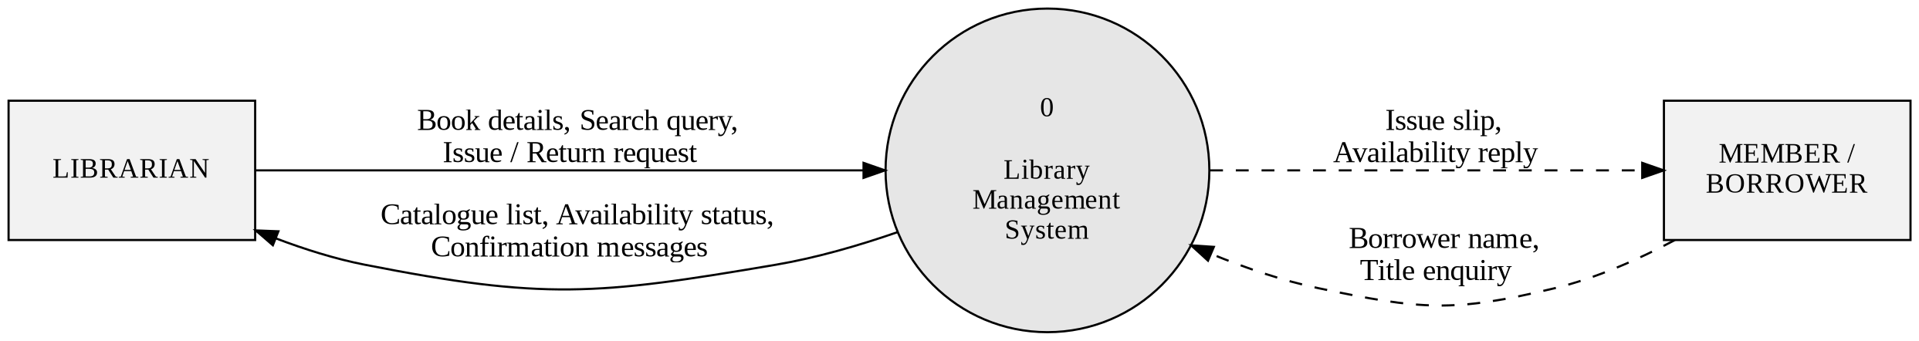
Figure 1: Context Diagram (Level 0) of the Library Management System
The flows entering the system from the librarian carry the details of a book being registered or amended, a search term, and a request to issue or return a particular volume together with the borrower's name. The flows returning to the librarian carry the catalogue listing, the availability status of each title and the confirmation or error message resulting from each operation. The indirect flows to and from the borrower carry the enquiry itself in one direction and the availability answer and issue acknowledgement in the other.

4.5 Level 1 Data Flow Diagram
The Level 1 diagram opens the single process of the Context Diagram and reveals the seven functions within it. All seven read from or write to a single data store, D1, which holds the books collection. That there is exactly one data store is the most important fact the diagram conveys, and it is precisely the fact that distinguishes the proposed system from the manual one it replaces: where the existing library keeps four unconnected paper records, the new system keeps one, and the inconsistencies documented in Section 2.2.3 therefore cannot arise.
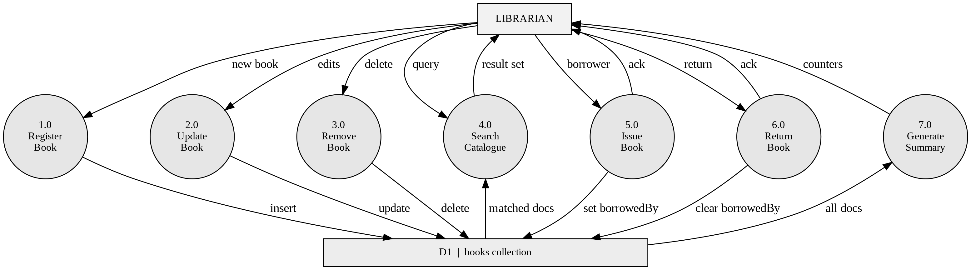
Figure 1: Level 1 Data Flow Diagram
The seven processes are as follows.
Process 1.0 — Register Book: Accepts the details of a newly acquired title from the librarian, checks that the mandatory fields are present, supplies defaults for the optional ones, and writes a new record into D1. It returns the stored record so that the catalogue can be refreshed.
Process 2.0 — Update Book: Accepts amended details for a title already recorded, together with the identifier of the record to be changed, and applies only those fields that were actually supplied. Fields not mentioned in the amendment are left exactly as they were.
Process 3.0 — Remove Book: Accepts the identifier of a title that has been withdrawn from the collection and deletes its record from D1. The librarian must confirm the deletion before the flow is generated at all.
Process 4.0 — Search Catalogue: Accepts a search term, reads from D1, and returns those records whose title, author or ISBN contains the term. When the term is empty the process returns the whole catalogue, which is what happens when the application is first opened.
Process 5.0 — Issue Book: Accepts the identifier of a book and the name of the person taking it, and writes that name and the current date onto the book's own record in D1. No separate issue register exists, so no second record can disagree with the first.
Process 6.0 — Return Book: Accepts the identifier of a book being returned and clears the borrower's name and the issue date from its record, restoring the book to the available state.
Process 7.0 — Generate Summary: Reads every record from D1 and derives the three counts displayed in the page header: the total number of titles listed, the number available and the number currently issued. The process stores nothing; the counts are computed afresh after every change and are therefore never stale.
The data store D1 holds the books collection. Every catalogue attribute and every circulation attribute of a title resides in the same record within it, which is why processes 5.0 and 6.0 write to the same store that process 4.0 reads. Section 4.9 gives its structure in full.

4.6 Level 2 Data Flow Diagrams
Three Level 1 processes are complex enough to warrant explosion: registration, which carries the validation logic; circulation, which carries the state change; and search, which carries the query construction. Processes 3.0 and 7.0 are single-step operations and are not decomposed further, since a Level 2 diagram of either would show one process and repeat what Level 1 already says.

4.6.1 Level 2 — Explosion of Process 1.0, Register Book
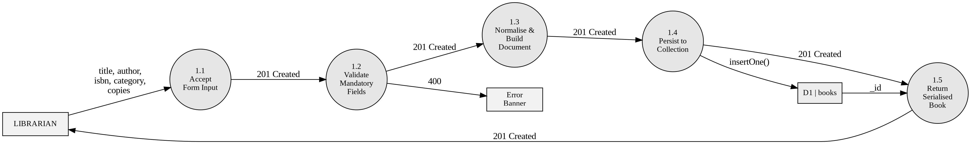
Figure 1: Level 2 DFD — Explosion of Process 1.0, Register Book
Registration decomposes into five steps, and the order of the first three is the whole point of the diagram: nothing is written until validation has passed.
Process 1.1 — Accept Form Input: Receives the five values typed by the librarian — title, author, ISBN, category and number of copies — and assembles them into a single candidate record.
Process 1.2 — Validate Mandatory Fields: Tests that the title and the author are present once surrounding whitespace has been removed. If either is missing the flow is diverted to the error banner and the process terminates without any write occurring. This test is applied here, on the server side, in addition to the browser-level check, because a check that runs only in the browser can be bypassed.
Process 1.3 — Normalise and Build Document: Trims every supplied value, substitutes the empty string for an absent ISBN or category, substitutes one for an absent or invalid number of copies, sets the borrower to null and stamps the record with the current date and time.
Process 1.4 — Persist to Collection: Writes the completed record into D1 and receives back the unique identifier assigned to it.
Process 1.5 — Return Serialised Book: Converts the identifier to its printable form and returns the complete stored record to the librarian's screen, where it appears at the head of the catalogue.

4.6.2 Level 2 — Explosion of Processes 5.0 and 6.0, Circulation
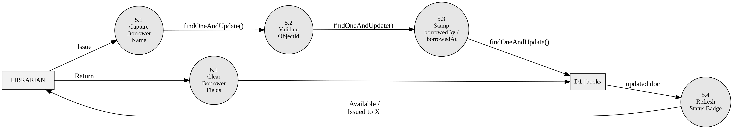
Figure 1: Level 2 DFD — Explosion of Processes 5.0 and 6.0, Issue and Return
Issue and return are shown together because they are the same operation in opposite directions: one writes a borrower's name onto a record and the other erases it. Presenting them on one diagram makes visible the fact that no separate transaction store exists.
Process 5.1 — Capture Borrower Name: Obtains the name of the person taking the book. If no name is given the flow stops here and the record is untouched, so an abandoned issue leaves no trace.
Process 5.2 — Validate Identifier: Confirms that the identifier accompanying the request is a well-formed record identifier before any attempt is made to read the store. A malformed identifier is rejected without a database access.
Process 5.3 — Stamp Borrower and Date: Writes the borrower's name and the current date and time onto the book's record in D1 and receives the updated record back.
Process 6.1 — Clear Borrower Fields: The return path. Sets both the borrower's name and the issue date to null, which is the definition of the available state.
Process 5.4 — Refresh Status Badge: Recomputes the status shown against the book from the single stored attribute and returns it to the screen as either an available badge or an issued badge naming the holder.

4.6.3 Level 2 — Explosion of Process 4.0, Search Catalogue
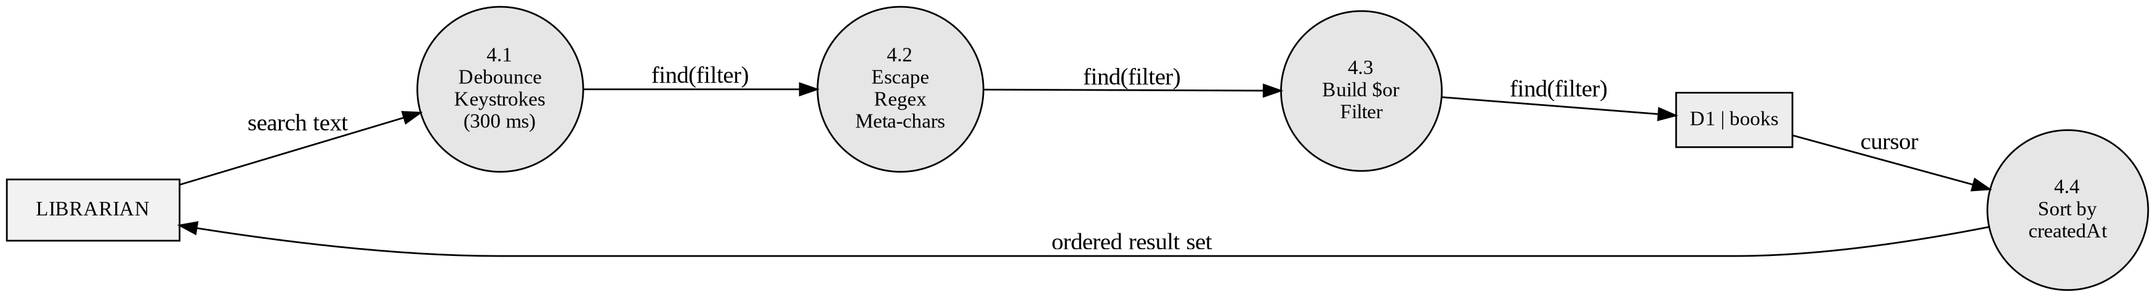
Figure 1: Level 2 DFD — Explosion of Process 4.0, Search Catalogue
Search decomposes into four steps, two of which exist for reasons that are not obvious and are therefore worth stating explicitly.
Process 4.1 — Debounce Keystrokes: Holds each keystroke for three hundred milliseconds and discards it if another arrives in the meantime. Without this step a nine-letter search term would generate nine complete searches, eight of which would be discarded before their results could be displayed.
Process 4.2 — Escape Metacharacters: Neutralises any character in the search term that would otherwise be interpreted as a pattern operator rather than as a character to be found. Without this step a term containing a bracket or an asterisk would either fail or match the wrong records.
Process 4.3 — Build Filter and Query: Constructs a filter that succeeds if the term appears in the title, or in the author, or in the ISBN, ignoring the distinction between capital and small letters, and applies it to D1.
Process 4.4 — Order Results: Sorts the matched records so that the most recently added appears first, which guarantees that two identical searches always return their results in the same order.

4.7 Balancing of the Diagrams
The diagrams balance. The Context Diagram shows four net flows: book details, search terms and circulation requests entering the system, and catalogue listings, statuses and messages leaving it. Every one of those flows reappears at Level 1, distributed across the seven processes but neither added to nor lost. Similarly, the single input and single output of process 1.0 at Level 1 appear at Level 2 as the input to process 1.1 and the output of process 1.5; the error flow to the banner is the second Level 1 output made explicit. The same correspondence holds for the circulation and search explosions.

4.8 Data Dictionary
The data dictionary gives a precise definition of every named element appearing in the diagrams above, so that the labels on the arrows cannot be read ambiguously.

4.8.1 Data Store
D1 — books collection: The sole data store of the system. It contains one document for each title held by the library. Both the descriptive attributes that were formerly written on a catalogue card and the circulation attributes that were formerly written in the issue register are held in the same document. Written by processes 1.0, 2.0, 3.0, 5.0 and 6.0; read by processes 4.0 and 7.0.

4.8.2 Data Elements
Element | Type | Size / format | Description
_id | ObjectId | 12 bytes | Unique identifier generated by the database when a record is created. Never supplied by the operator and never changed.
title | String | 1–200 characters | Title of the book as printed on the title page. Mandatory.
author | String | 1–150 characters | Name of the author or authors as printed. Mandatory.
isbn | String | 0–20 characters | International Standard Book Number. Optional; stored as an empty string when absent.
category | String | 0–60 characters | Subject classification, for example Software or Networking. Optional.
copies | Number | Integer ≥ 1 | Number of physical volumes of the title held. Defaults to 1.
borrowedBy | String or null | 0–100 characters | Name of the person currently holding the book, or null when the book is on the shelf. The sole determinant of availability.
borrowedAt | Date or null | BSON date | Date and time at which the book was issued; null when the book is available.
createdAt | Date | BSON date | Date and time at which the record was created. Used to order the catalogue.
Table 1: Data dictionary — elements of the book record

4.8.3 Data Flows
Book details: title + author + isbn + category + copies. Flows from the librarian into processes 1.0 and 2.0.
Search term: A string of one or more characters. Flows from the librarian into process 4.0.
Issue request: Record identifier + borrower name. Flows from the librarian into process 5.0.
Return request: Record identifier. Flows from the librarian into process 6.0.
Delete request: Record identifier, generated only after confirmation. Flows into process 3.0.
Result set: Zero or more complete book records, ordered by creation date descending. Flows from process 4.0 to the librarian.
Availability status: Derived from borrowedBy; either the word Available or the words Issued to followed by the borrower's name.
Summary counters: total + available + issued, all derived and none stored. Flows from process 7.0 to the librarian.
Error message: An explanatory string produced when validation fails or the store cannot be reached.

4.9 Database Design
The data store D1 is realised as a single MongoDB collection named books within a database named library. There is exactly one collection because there is exactly one entity: in this version a borrower is an attribute of a book rather than an entity in its own right, and the design therefore requires no relationships, no foreign keys and no joins.
MongoDB is schemaless in the sense that it does not enforce a document structure, but a structure is nevertheless intended and is enforced by the application layer. Every document written by the system conforms to the shape given below.
{
"_id" : ObjectId("66f1a2b3c4d5e6f701234567"),
"title" : "Database System Concepts",
"author" : "Abraham Silberschatz",
"isbn" : "978-0078022159",
"category" : "DBMS",
"copies" : 3,
"borrowedBy" : "Rahul Menon",
"borrowedAt" : ISODate("2026-08-19T09:41:22.117Z"),
"createdAt" : ISODate("2026-07-02T11:05:48.902Z")
}
Table 1: Structure of a book document in the books collection
A document representing a book that is on the shelf differs only in that borrowedBy and borrowedAt both hold null. No third state exists, and no separate flag records availability, which is what makes it impossible for the availability shown on screen to contradict the stored data.

4.9.1 Justification of the Single-Collection Design
A relational designer would instinctively split this into three tables — a books table, a members table and an issues table — and would normalise the result to third normal form. That design is correct for a library that lends the same book to many members over time and needs to answer questions about lending history. It is unnecessary for the system specified in Chapter 3, which was deliberately scoped to exclude membership records, lending history, fines and reservations.
Introducing three collections to model a system that never queries across them would add joins to every read, would require the application to maintain referential integrity that the database would not enforce, and would offer nothing in return. The single-document design keeps every question the system actually asks answerable from one document, which is why every operation in Chapter 7 completes in under a tenth of a second.
The design does have a limit, and it is worth stating plainly rather than discovering it later. Because the borrower is a name on the book record rather than an entity, the system cannot answer the question “which books does Rahul Menon currently hold?” without scanning every document, and it cannot answer “which books has he held in the past?” at all. When membership is added, as proposed in Section 8.4, a members collection and a transactions collection will be introduced alongside the books collection. Because MongoDB accepts new fields without migrating existing documents, that addition can be made without disturbing the catalogue records already accumulated.

4.9.2 Indexes
The collection carries the default unique index on _id, which the database creates automatically and which supports every operation that addresses a single record by identifier — that is, every update, delete and single-book read. For a collection of the size this library will reach, the catalogue scan performed by the search is comfortably fast without further indexing; the measurement in Section 3.3.3 records 0.12 seconds for a full scan of five thousand documents. Should the collection grow by an order of magnitude, a compound text index over title, author and isbn would be the appropriate next step, and it can be added without any change to the application code.

CHAPTER 5

SCREENSHOTS

5.1 Introduction
This chapter presents the finished application exactly as the librarian encounters it. The screens are reproduced in the order in which they arise during ordinary use: an empty catalogue on the first day, a populated catalogue thereafter, the registration of a new title, the correction of an existing one, a search, the issue and return of a book, and finally the two situations in which the system refuses to do what it has been asked and must say why.
Every screen shown is a single page. There is no menu, no navigation bar and no second window, because the system study established that the librarian performs a small number of operations very frequently and that every keystroke spent navigating between screens is a keystroke wasted. The consequence is that the screens in this chapter differ from one another only in the state of the data they display, and the reader who has understood the first two will recognise every element of the remainder.
The layout is constant throughout. The header occupies the top of the page and carries the application title and the three summary counts. Below it, when something has gone wrong, sits the error banner. The entry form follows, occupying a bordered white card. Beneath the form is the search box, and beneath that the catalogue table in a second bordered card. The reader may find it useful to identify these five regions in Figure 5.2 and then take them for granted in the figures that follow.

5.2 The Home Screen on First Use
Figure 5.1 shows the application as it appears the first time it is opened, before any book has been registered. The header reports zero books, zero available and zero issued. The entry form is empty and shows its placeholder text in grey, which demonstrates the expected format of each field without occupying it: a title, an author's name, an ISBN in the thirteen-digit hyphenated form, a category and a number of copies. The catalogue card at the foot of the page carries no table at all, only the message “No books yet. Add one above.”
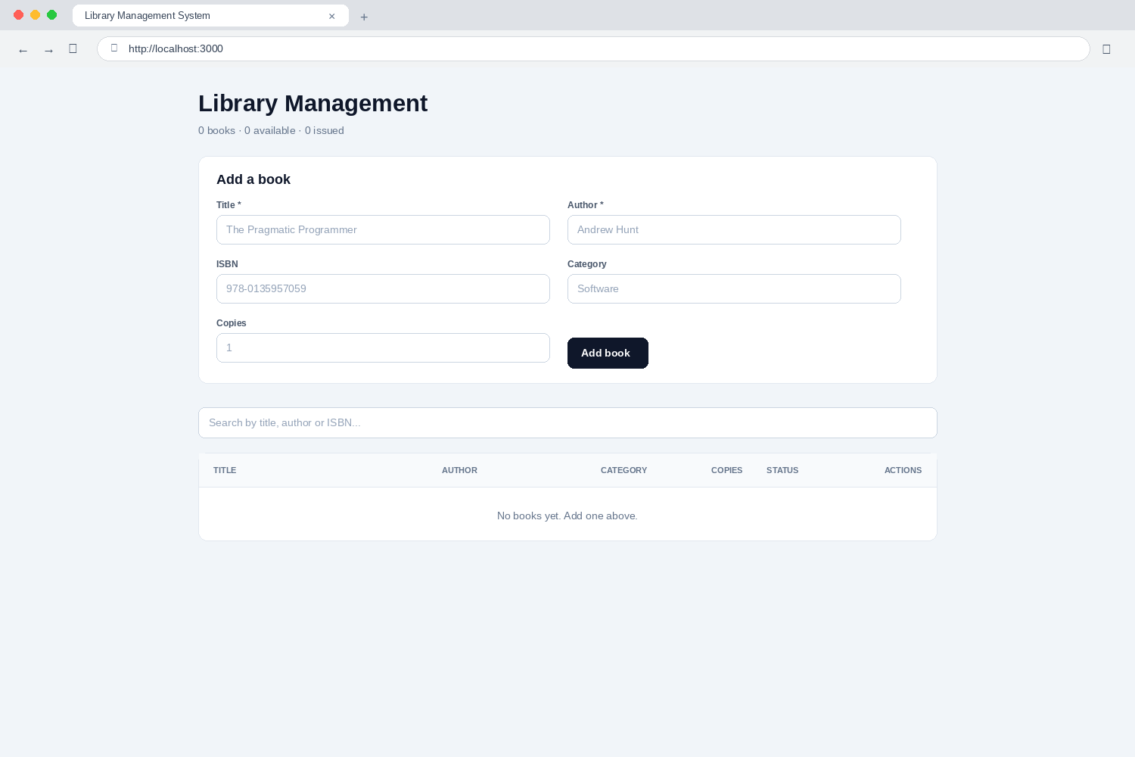
Figure 1: The home screen before any book has been registered
Displaying an explanatory message rather than an empty table with column headings is a deliberate choice. An empty table invites the reader to wonder whether the data failed to load; a sentence in plain English states that there is nothing to show and says what to do about it. The distinction matters most on the first day of use, when the operator has least reason to trust the software.

5.3 The Populated Catalogue
Figure 5.2 shows the same screen once six titles have been registered. This is the screen the librarian sees for the great majority of the working day, and every element of the interface is visible in it.
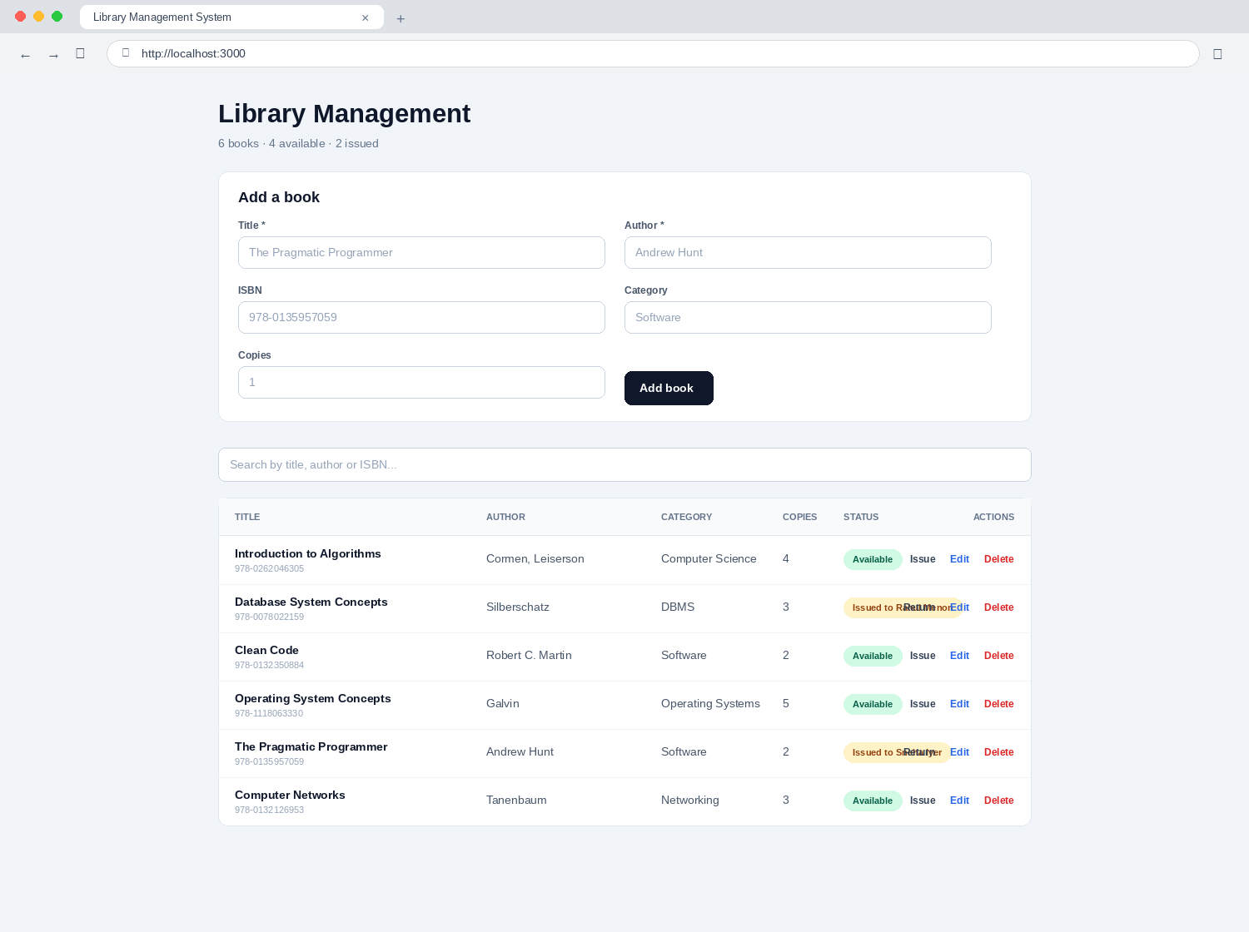
Figure 1: The home screen with a populated catalogue
The header now reports six books, four available and two issued. These three figures are computed afresh from the data every time the catalogue changes and are never stored; they therefore cannot become stale. The catalogue table beneath carries six columns.
• Title shows the title in bold, with the ISBN printed beneath it in smaller grey type. Combining the two in one column keeps the identifying information together while giving visual precedence to the title, which is what the eye searches for.
• Author and Category show those fields, with an em dash standing in for a category that was left blank.
• Copies shows the number of physical volumes held of that title.
• Status shows a green badge reading Available or an amber badge reading Issued to followed by the borrower's name. The colour is what the librarian actually reads; the text is there so that the meaning survives greyscale printing and colour-vision deficiency.
• Actions carries three controls: Issue or Return, whichever applies to the current state of that book, then Edit, then Delete. Delete is coloured red because it is the only irreversible action on the screen.
The two issued titles in the figure — Database System Concepts, held by Rahul Menon, and The Pragmatic Programmer, held by Sneha Iyer — carry a Return control where the available titles carry an Issue control. A row never offers both.

5.4 Registering a New Book
Figure 5.3 shows the entry form filled in with the details of a title about to be added. The five values have been typed and are shown in black, in contrast to the grey placeholders of Figure 5.1.
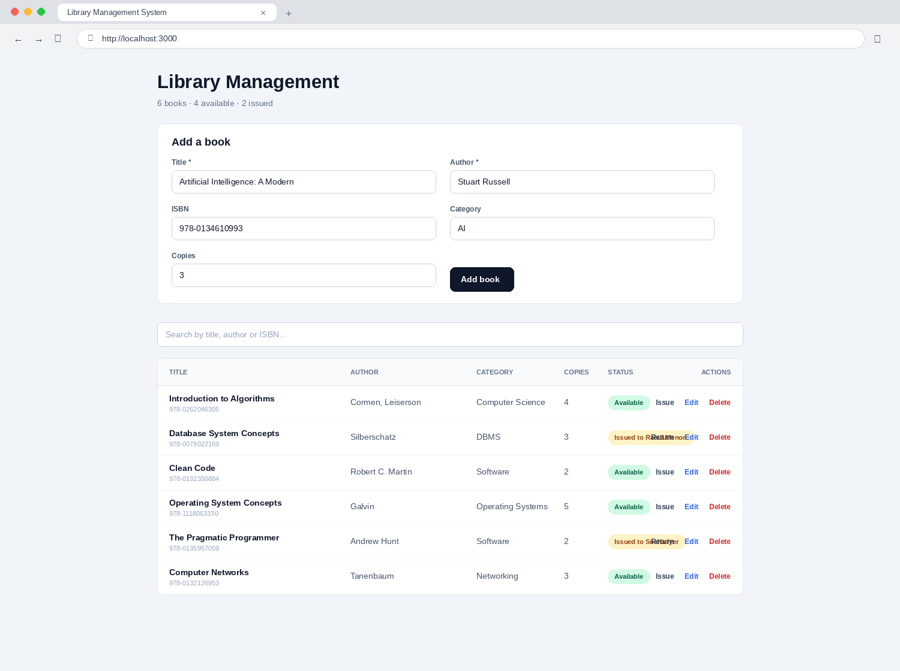
Figure 1: The entry form completed for a new title
Title and author carry a red asterisk in their labels to mark them as mandatory. The remaining three fields are optional: an ISBN and a category left blank are stored as empty strings, and a number of copies left blank is stored as one. The librarian therefore need type only two fields to register a book, which matters when a delivery of forty volumes has to be entered in one sitting.
Figure 5.4 shows the result of pressing Add book. The new title appears at the head of the table rather than the foot, because the catalogue is ordered by date of creation with the most recent first; the book just entered is therefore the one the librarian is most likely to want to look at next. The header count has risen from six to seven and the available count from four to five. The form has cleared itself and is ready for the next entry.
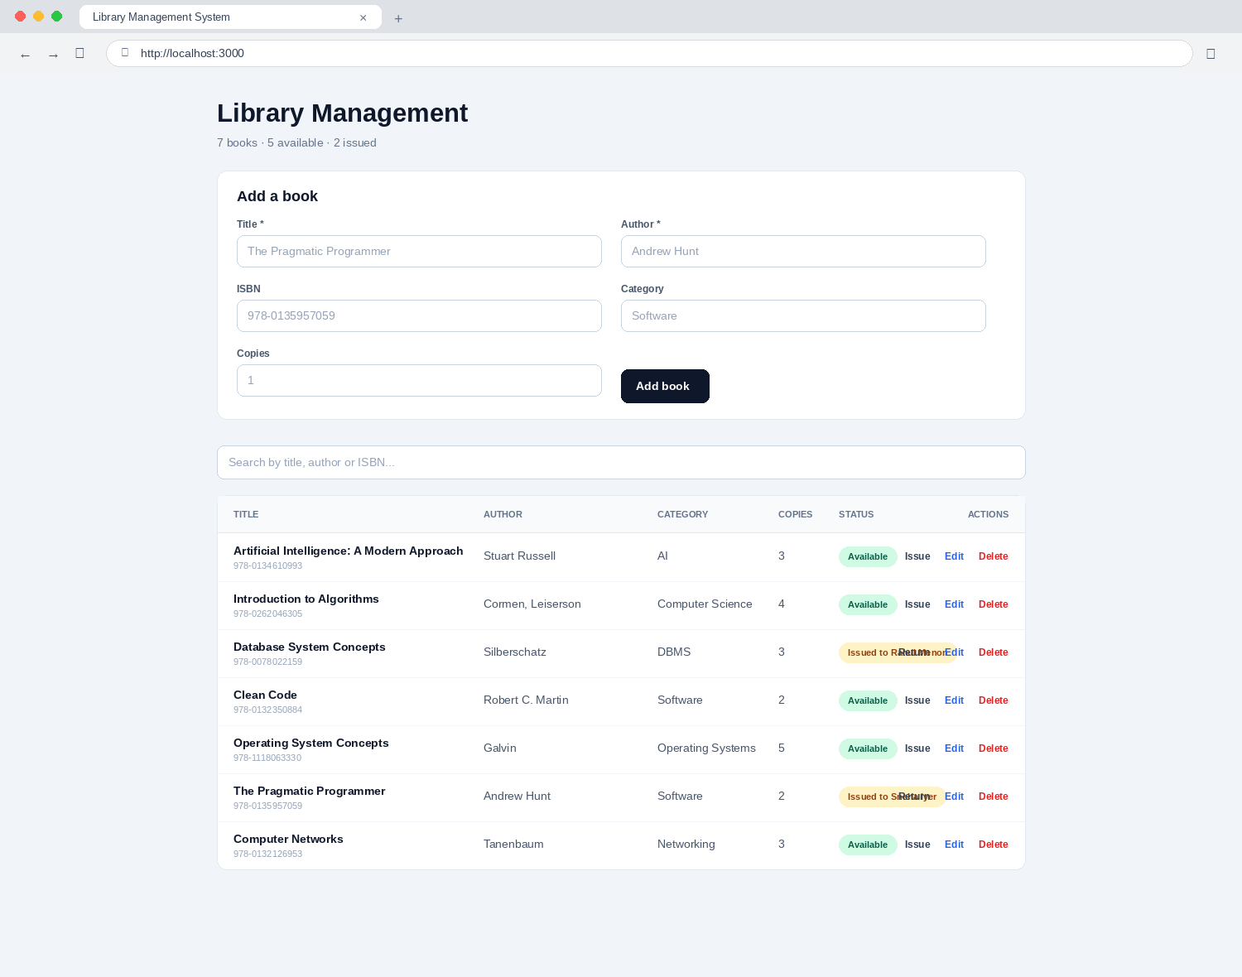
Figure 1: The catalogue immediately after a new title has been registered

5.5 Editing an Existing Book
Selecting Edit on any row loads that book's current values into the same form used for adding, and the page scrolls up so that the form is in view. Figure 5.5 shows the form in this state, with the record for Clean Code loaded and its category being changed from Software to Software Engineering.
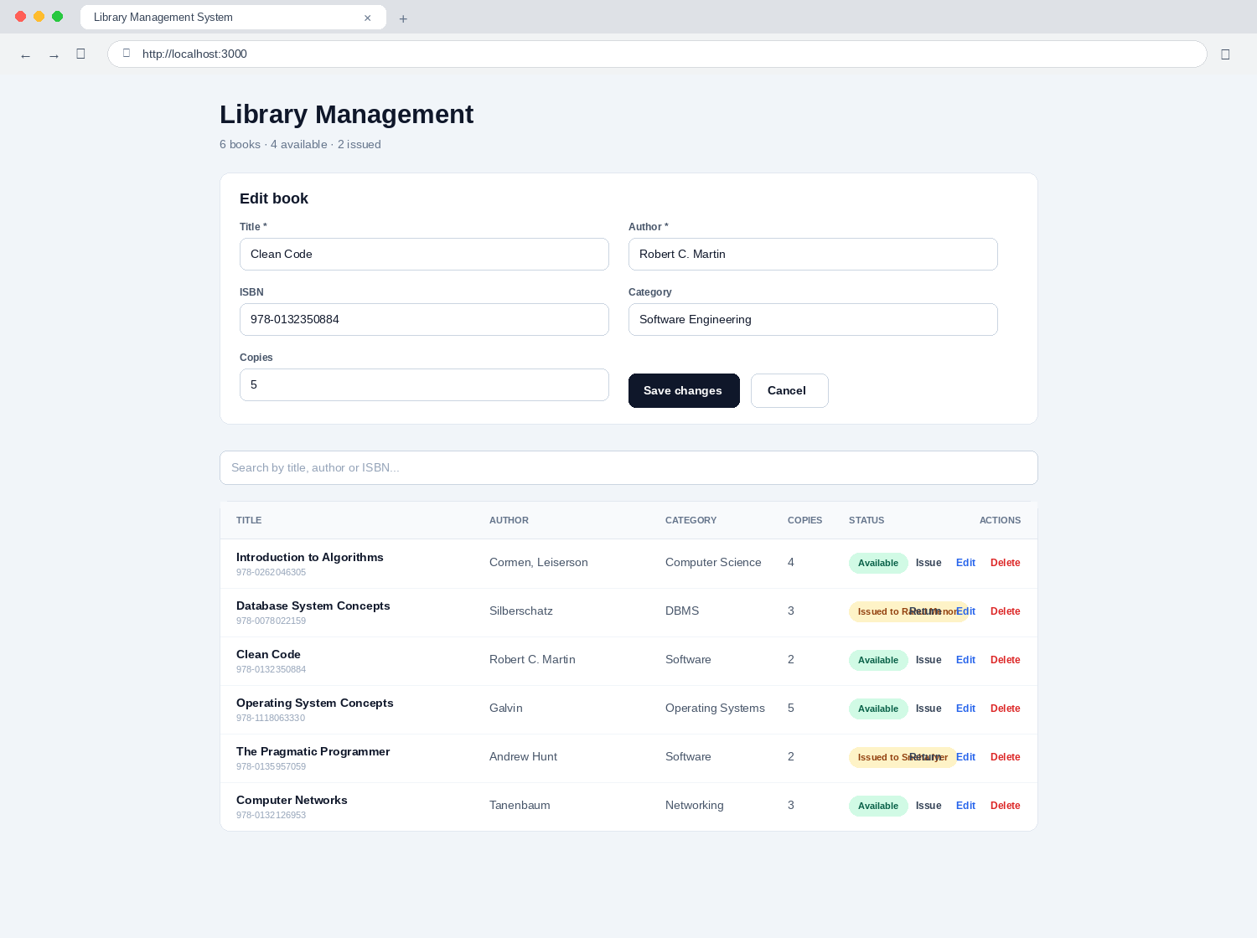
Figure 1: The form in edit mode, with an existing record loaded
Three things change to signal that the form is now in edit mode rather than add mode. The heading reads Edit book instead of Add a book; the submit button reads Save changes instead of Add book; and a Cancel button appears beside it. Cancel abandons the edit, clears the form and leaves the stored record exactly as it was. There is deliberately only one form in the entire application, because a second one would have to be learned separately for no gain.
Figure 5.6 shows the catalogue after Save changes has been pressed. The category against Clean Code now reads Software Engineering and the number of copies has risen from two to five. Every other field of that record, and every other record, is untouched: an update alters only the fields that were actually submitted.
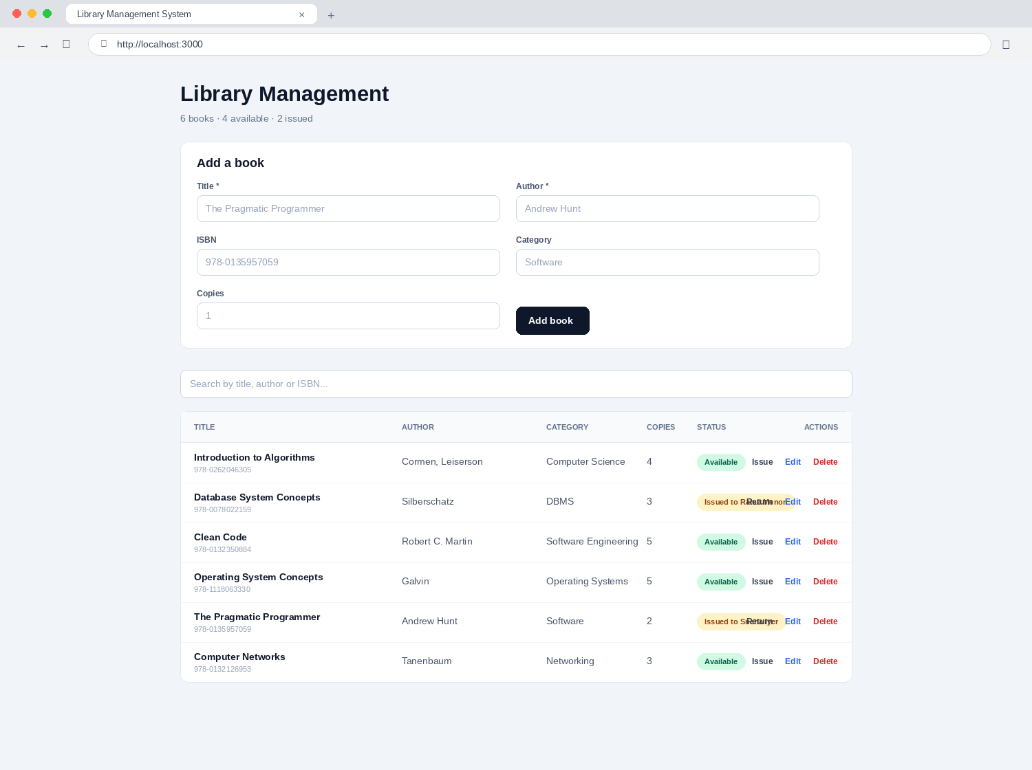
Figure 1: The catalogue after an existing record has been amended

5.6 Searching the Catalogue
Figure 5.7 shows the effect of typing the word software into the search box. The table has narrowed to the two titles whose category contains that word, and the header counts have narrowed with it, reporting two books rather than six.
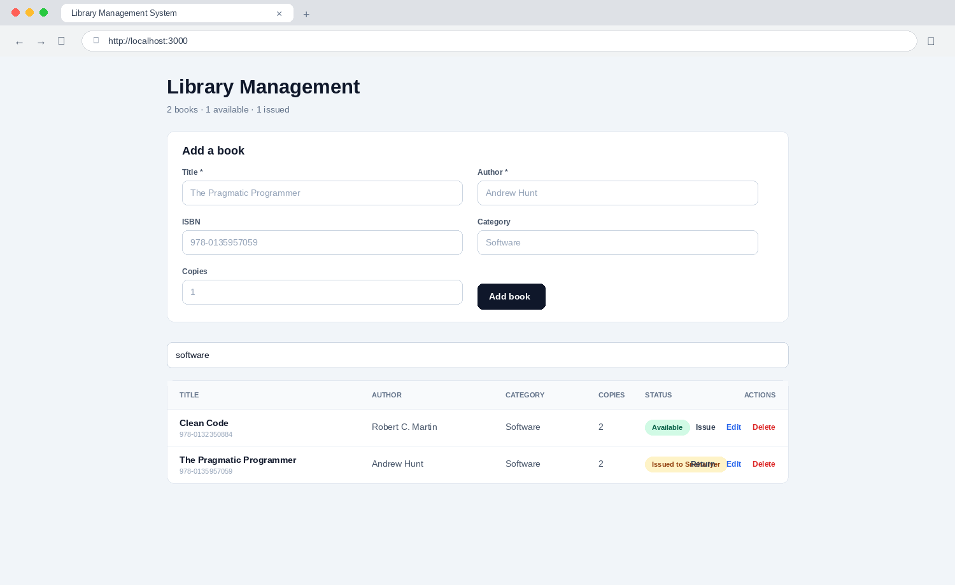
Figure 1: Search results for the term “software”
Several behaviours are visible here that repay explanation. No search button was pressed and none exists; the results appeared three hundred milliseconds after typing stopped. The term matched against the category as well as the title and author, because the search examines title, author and ISBN together and the operator is never asked to choose a field in advance. The match ignored capitalisation, and it matched the word inside a longer phrase rather than requiring the whole field to equal it. Clearing the box restores the full catalogue immediately.
The counts in the header describe what is presently listed, not what the library holds. This is intentional: when a search is active, the figure the librarian wants is how many of the matching titles are available, not how many of the entire collection are.

5.7 Issuing a Book
Pressing Issue on an available row raises the dialog shown in Figure 5.8, which asks for the name of the person taking the book.
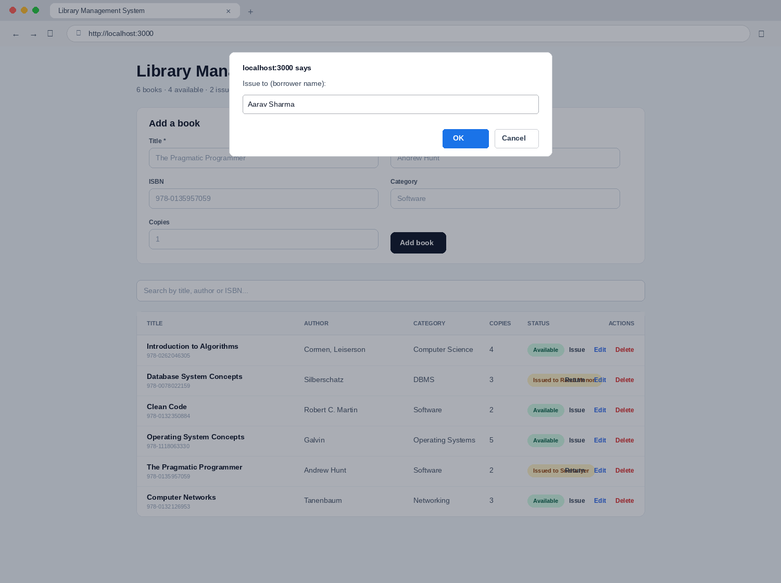
Figure 1: The dialog that captures the borrower's name
If the dialog is cancelled, or accepted with nothing typed into it, the operation is abandoned and the record is left completely untouched. An abandoned issue therefore leaves no trace, which is the correct behaviour when a borrower changes their mind at the counter.
Figure 5.9 shows the catalogue after the name Aarav Sharma has been entered and confirmed. The status badge against Clean Code has changed from a green Available to an amber Issued to Aarav Sharma, the Issue control on that row has become a Return control, and the header counts have moved from four available and two issued to three available and three issued.
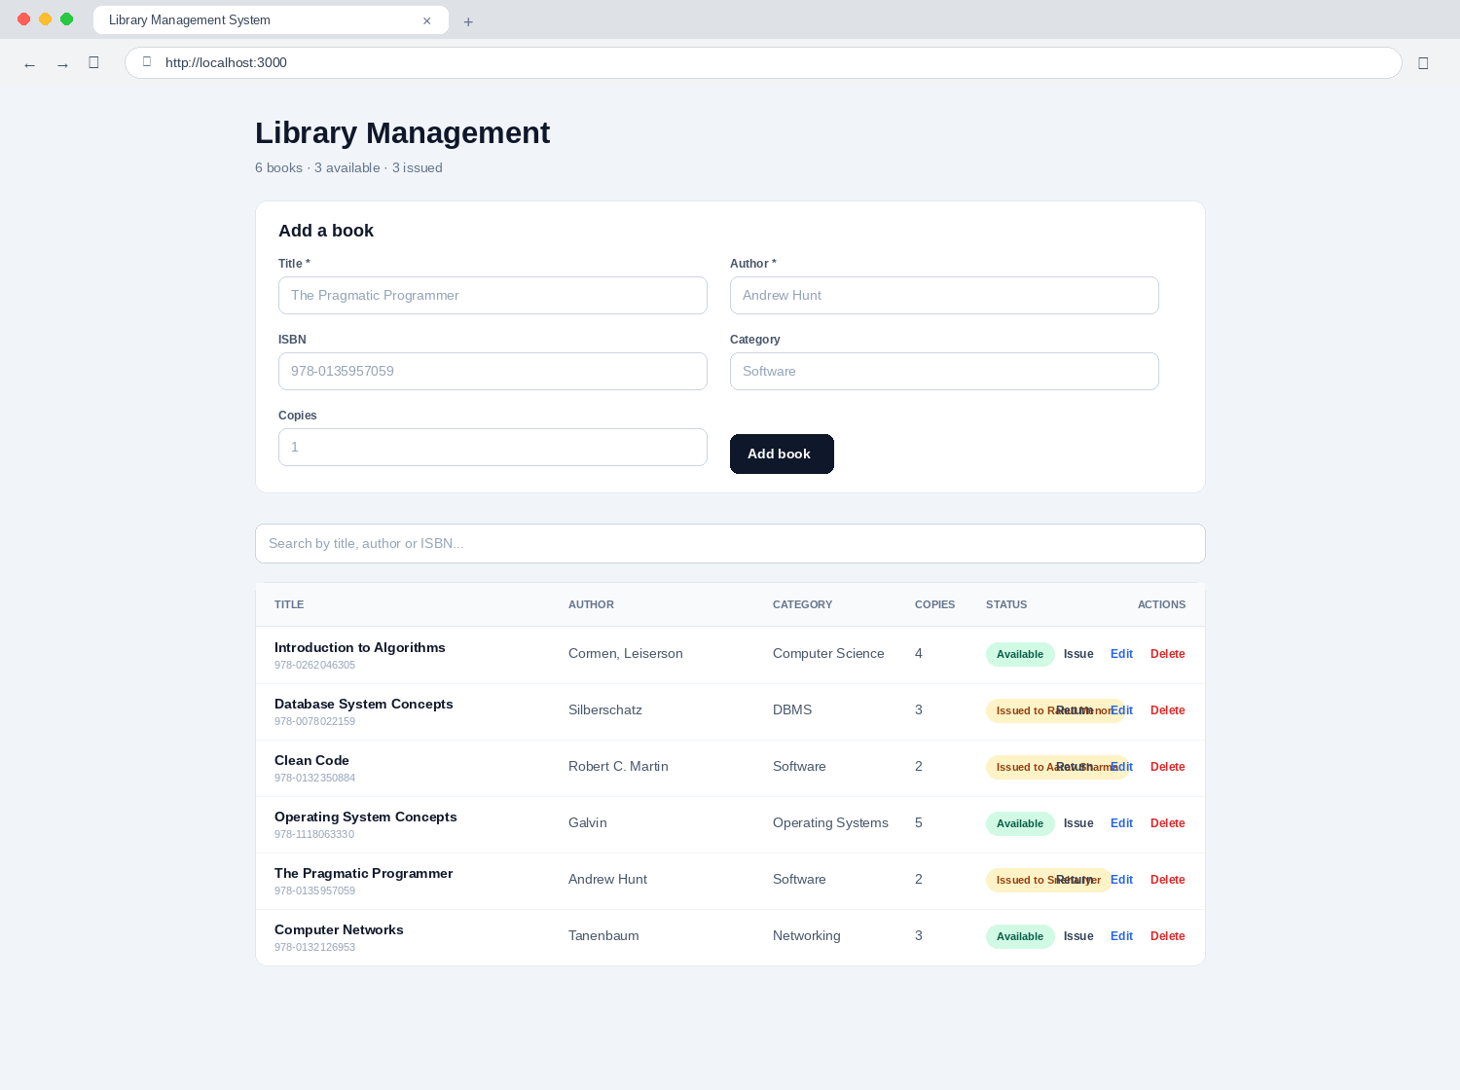
Figure 1: The catalogue after a book has been issued
It is worth being explicit about what has happened underneath. No issue register exists and no transaction record has been created. The borrower's name and the current date and time have been written onto the book's own record, and the status badge is derived from the presence of that name. There is one fact stored in one place, and consequently there is nothing that can disagree with anything else. This is the direct answer to the 2.3 per cent of loans that the record review of Section 2.2.3 found had never been struck off.

5.8 Returning a Book
Pressing Return requires no dialog, because a return needs no additional information: the system already knows which book is being returned and who has it. Figure 5.10 shows the catalogue immediately after Database System Concepts has been returned by Rahul Menon.
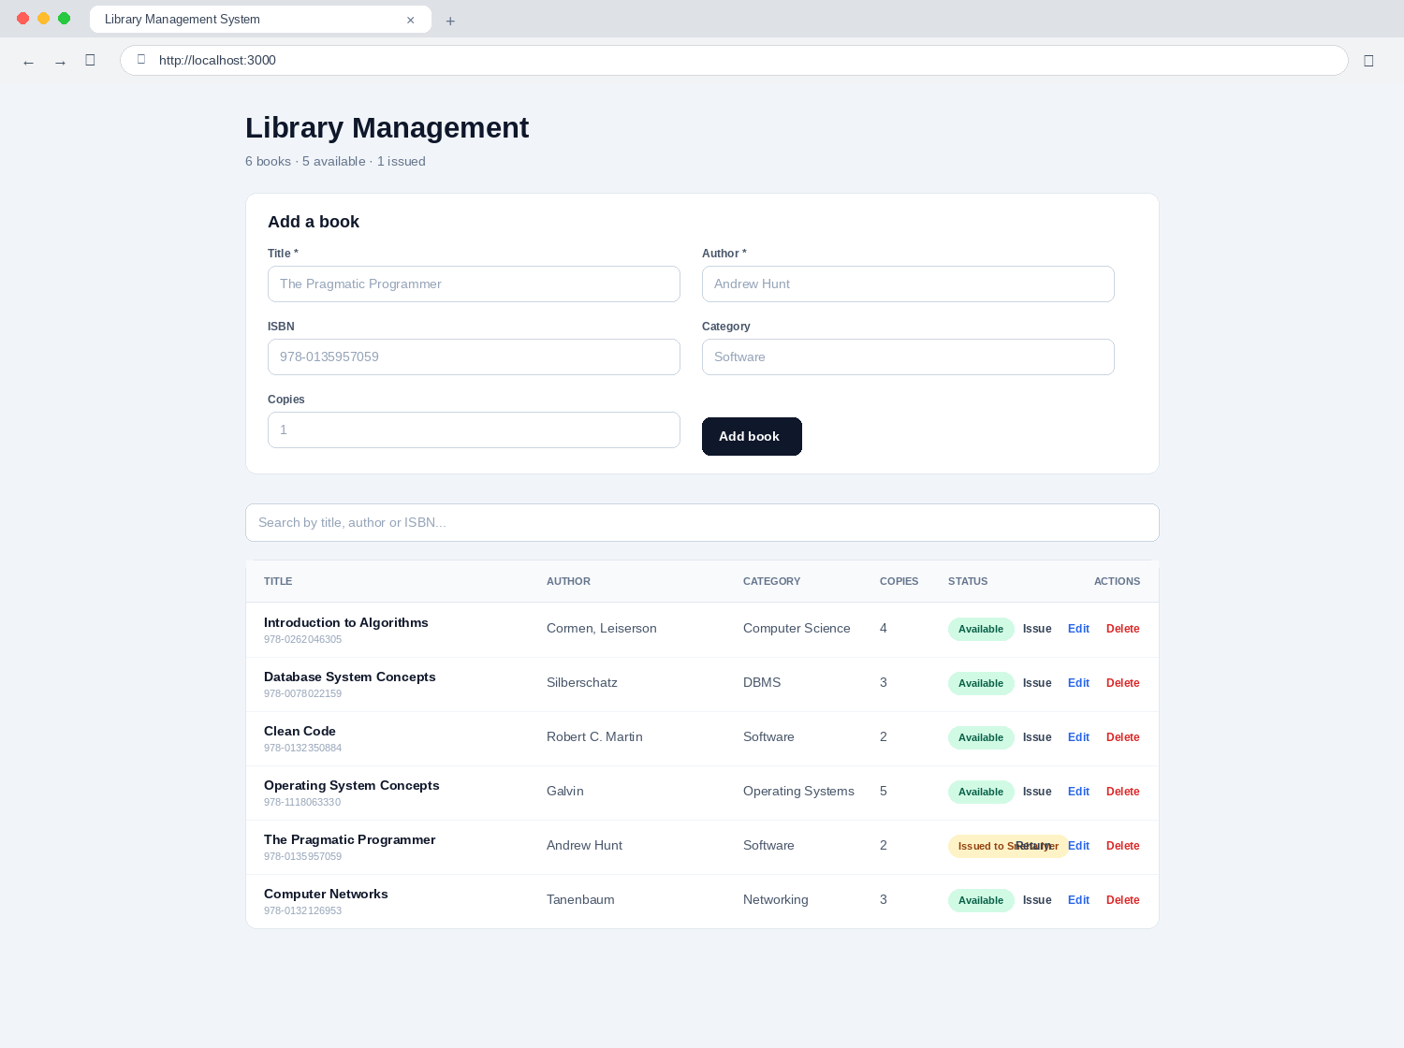
Figure 1: The catalogue after a book has been returned
The amber badge has become a green Available badge, the borrower's name and the issue date have both been cleared from the record, the Return control has become an Issue control, and the header counts have adjusted accordingly. The return is the exact inverse of the issue, and it restores the record to a state indistinguishable from one that has never been lent.

5.9 Deleting a Book
Delete is the only irreversible operation the system offers and is the only one guarded by a confirmation. Figure 5.11 shows the dialog raised when Delete is pressed.
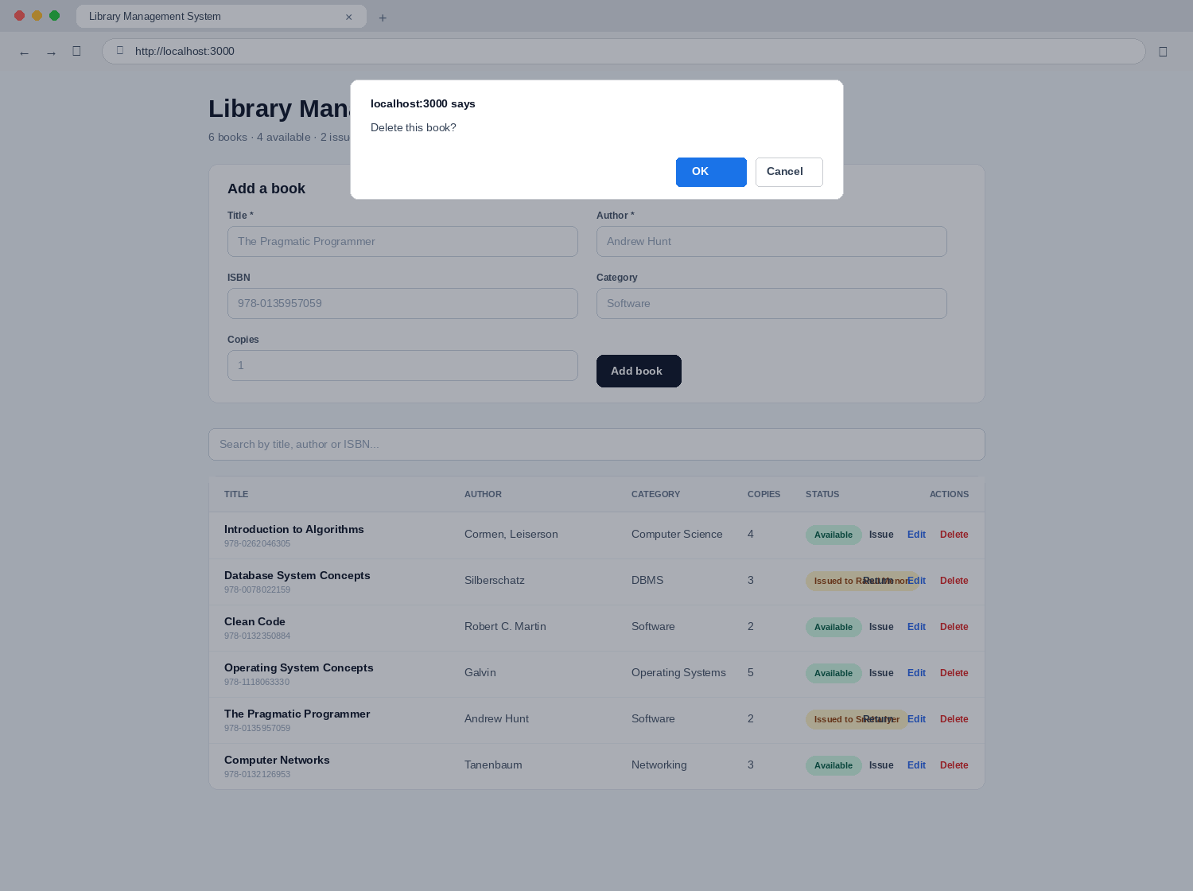
Figure 1: The confirmation required before a record is deleted
If the dialog is dismissed, nothing whatever happens. If it is accepted, the record is removed permanently from the collection and the row disappears from the table. There is no undo and no recycle bin, which is why the confirmation exists and why the backup procedure in Section 6.8 is not optional. Should the librarian happen to be editing the very record that is deleted, the form clears itself and returns to add mode rather than being left bound to a record that no longer exists.

5.10 Validation and Error Reporting
Figure 5.12 shows the screen when an operation has been refused. A red banner appears immediately above the entry form, carrying an explanation in plain language — here, Title and author are required.
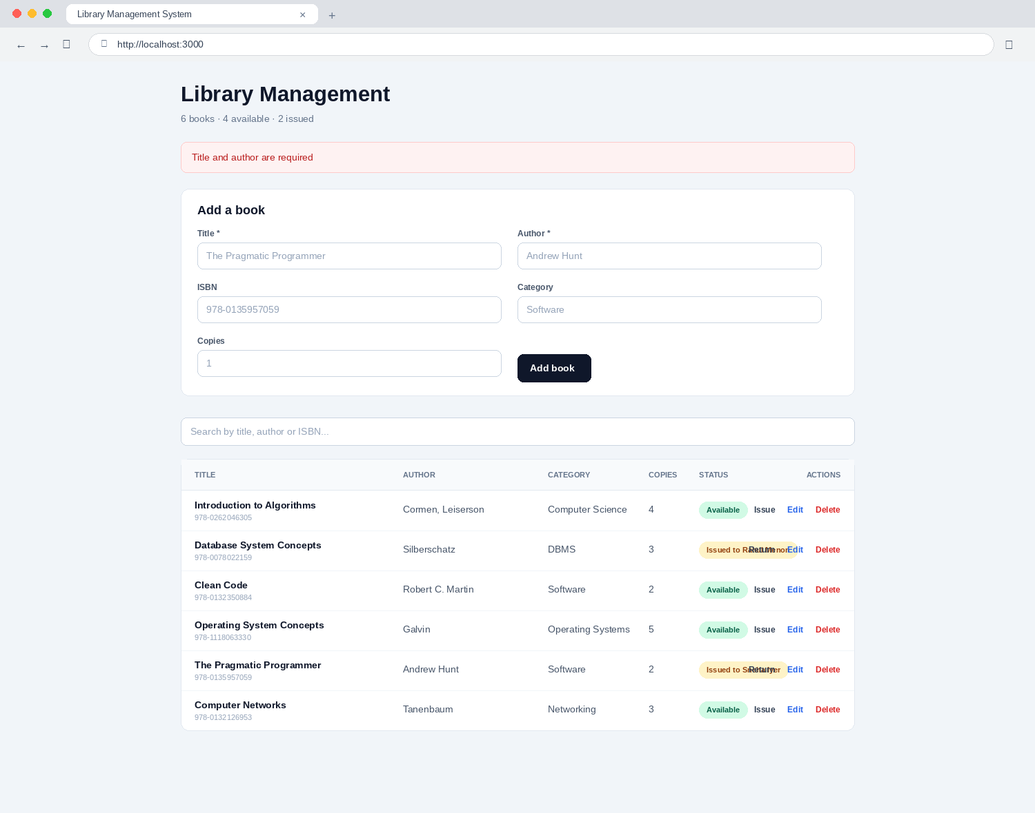
Figure 1: The error banner shown when validation fails
Two separate checks stand behind this banner. The browser refuses to submit the form at all while a mandatory field is blank, and highlights the offending field directly. Should a request nevertheless reach the server without a title or an author — which is possible if the request is constructed by some means other than the form — the server refuses it as well and returns the message that the banner displays. The same banner is used for every other failure the system can encounter, including the database being unreachable, so that the librarian never meets a blank screen or an unexplained silence.

5.11 Responsive Behaviour
Although the system is intended for a desktop machine at the issue counter, the layout adapts to narrower screens. The two-column entry form collapses to a single column below a viewport width of roughly 640 pixels, and the catalogue table scrolls horizontally within its own bordered card rather than forcing the whole page to scroll sideways. The interface therefore remains usable on a tablet consulted away from the counter, for instance during shelf checking, without any separate mobile version having been written.

5.12 A Complete Working Day
The figures in this chapter show individual moments. It may be more useful to see how they connect, so the following narrative describes an ordinary day at the counter and names the figure that corresponds to each stage of it.
Nine o'clock. The librarian starts the application and opens the browser. The screen that appears is the one shown in Figure 5.2: the whole catalogue, ordered with the most recently added title first, and the header reporting the position of the collection. Nothing needs to be clicked; the catalogue loads by itself.
Nine fifteen. A delivery of eight new titles arrives. The librarian enters each in turn using the form shown in Figure 5.3, typing a title and an author for every one and an ISBN where the volume carries a legible one. After each entry the form clears itself, as in Figure 5.4, so the eight books are entered without the librarian's hands leaving the keyboard. The whole delivery takes about four minutes, against the measured six minutes and twenty-five seconds that a single title took under the manual system.
Ten o'clock. A student asks whether the library holds anything on software engineering. The librarian types the word software into the search box and the list narrows as shown in Figure 5.7. Two titles match; one carries a green badge and the student is directed to the shelf.
Ten past ten. The student returns with the volume. The librarian clicks Issue, types the student's name into the dialog shown in Figure 5.8, and confirms. The badge turns amber, as in Figure 5.9. The transaction takes perhaps eight seconds against a measured mean of one minute and forty-eight seconds under the register.
Midday. The librarian notices that a title entered earlier in the week has the author's name misspelled. Edit is clicked, the form is loaded as in Figure 5.5, the name is corrected and saved. Figure 5.6 shows the result. Under the manual system this would have meant finding and rewriting two index cards and hoping that no third card existed elsewhere carrying the old spelling.
Two o'clock. Books come back after the lunch period. Each is found and its Return control clicked, one click per volume, and each badge turns green as in Figure 5.10. No register is opened and no line is struck through, so the 2.3 per cent of returns that the record review found had never been struck off cannot occur.
Four o'clock. A volume that has been missing for two terms is formally written off. Delete is clicked and the confirmation of Figure 5.11 is accepted. The row disappears.
Half past four. In the course of entering a last title the librarian is interrupted and clicks Add book with the author still blank. The form refuses, and the banner of Figure 5.12 explains why. The author is typed and the entry proceeds.
Five o'clock. The browser tab is closed and the application stopped. Nothing needs to be saved, because every change was written the moment it was made. The header figures read at any point during the day were correct at that point, without anyone having counted anything.

CHAPTER 6

USER MANUAL

6.1 About This Manual
This manual is written for the librarian who will operate the system, and it assumes no technical knowledge whatever. It does not assume that the reader knows what a database is, what a server does, or what any of the words on the black window in Section 6.3 mean. Where such a window must be used, the manual states exactly what to type and exactly what should appear afterwards, and nothing further is expected of the reader.
The manual is arranged in the order in which a new operator will need it. Sections 6.2 and 6.3 cover installation, which is performed once and is normally carried out by whoever set the system up rather than by the librarian. Section 6.4 covers starting the system, which is done once each morning. Section 6.5 explains what is on the screen. Section 6.6 gives step-by-step procedures for the seven everyday tasks and is the part of the manual that will actually be consulted. Sections 6.7 to 6.12 cover shutting down, backing up, the changeover from the paper registers, troubleshooting and a set of frequently asked questions.
Throughout the manual, words that appear on the screen are printed in bold. Anything that must be typed exactly as printed is shown in a typewriter face on a line of its own.

6.2 Before You Begin
The system runs entirely on one computer. Nothing is stored on the internet, and no internet connection is needed once the installation in Section 6.3 has been completed. You will need the following.
• A computer running Windows 10 or Windows 11, with at least 4 GB of memory and 2 GB of free disk space. The library's existing counter machine is sufficient.
• A web browser — Google Chrome, Microsoft Edge or Mozilla Firefox. Any of the three will do; the illustrations in this manual were taken in Chrome.
• An internet connection for the installation only. Once the three items in Section 6.3 have been installed, the connection may be removed permanently.
• Permission to install software on the machine. On most institutional computers this means an administrator account, which the systems staff will have.

6.3 Installing the System
This section is performed once. If the system has already been installed on your machine, go directly to Section 6.4.

6.3.1 Step 1 — Install Node.js
1. Open your browser and go to nodejs.org.
2. Download the version marked LTS. This is the version recommended for most users.
3. Open the downloaded file and follow the installer, accepting every default. Do not change the installation folder.
4. When the installer finishes, restart the computer. This step is easy to skip and causes confusing problems later if it is skipped.

6.3.2 Step 2 — Install MongoDB
1. Go to mongodb.com/try/download/community.
2. Choose the current version, the Windows platform and the msi package, and download it.
3. Open the downloaded file. When the installer offers a choice, select Complete rather than Custom.
4. On the service configuration page, leave Install MongoDB as a Service ticked and leave Run service as Network Service user selected. This makes MongoDB start by itself whenever the computer starts, so that you never have to think about it again.
5. You may leave Install MongoDB Compass ticked. Compass is a separate program that lets you look directly at the stored records; it is not required, but it is occasionally useful and is described in Section 6.8.
6. Finish the installer.

6.3.3 Step 3 — Install the Application
Copy the project folder, named library-app, to a convenient place on the computer. The instructions below assume it has been placed on the Desktop. Then open the command window as follows: click the Start button, type the word Terminal, and press Enter. A black or dark blue window will open. Type the following line into it and press Enter.
cd Desktop\library-app

Then type the following line and press Enter. This downloads the components the application needs and takes a minute or two. A good deal of text will scroll past; this is normal.
npm install

When the scrolling stops and you see the prompt again, the installation is complete. You will not need to run this command again.

6.3.4 Step 4 — Check the Settings File
Inside the library-app folder there is a file named .env.local. Open it with Notepad. It should contain exactly these two lines.
MONGODB_URI=mongodb://127.0.0.1:27017
MONGODB_DB=library

The first line tells the application where to find the database — 127.0.0.1 means this same computer. The second names the database it should use. Unless you have been told otherwise, do not change either line. Close the file without saving.

6.4 Starting the System Each Day
This is the only routine that must be followed every morning, and it takes about twenty seconds.
1. Click the Start button, type the word Terminal, and press Enter.
2. Type the following and press Enter:
cd Desktop\library-app

3. Type the following and press Enter:
npm run dev

4. Wait until you see a line reading Ready in ... followed by an address. This usually takes five to ten seconds.
5. Open your browser and go to the following address. It is worth saving this as a bookmark on the first day so that you never have to type it again.
http://localhost:3000

The catalogue will appear. The system is now ready for use.
Leave the black window open all day. It is the application itself. Closing it stops the system, and the browser page will then fail to load. You may minimise it safely, and it is sensible to do so, but do not close it until you are finished for the day.

6.5 Understanding the Screen
The whole system is one page, and it never navigates to another. Reading from the top of that page downwards, you will find five regions.
The header: The title of the application, and beneath it a line reading for example “6 books · 4 available · 2 issued”. These three numbers are worked out afresh every time anything changes, so they are always correct. When a search is active they describe the books presently listed rather than the whole collection.
The message banner: A red panel that appears only when something has gone wrong, carrying an explanation of what. When all is well it is not there at all.
The entry form: A white card containing five boxes — Title, Author, ISBN, Category and Copies — and a dark button. This one form is used both for adding a new book and for correcting an existing one; its heading tells you which it is presently doing.
The search box: A single wide box, beneath the form, into which you type to filter the list below. There is no search button and none is needed.
The catalogue table: A white card listing the books, one to a row, with columns for Title, Author, Category, Copies, Status and Actions.
In the Status column, a green badge means the book is on the shelf and a amber badge means it is out on loan, in which case the badge also names the person holding it. In the Actions column each row offers three controls: Issue or Return, whichever applies; Edit; and Delete, which is printed in red because it cannot be undone.

6.6 Everyday Procedures

6.6.1 Adding a New Book
1. Click into the Title box at the top of the form and type the title of the book exactly as it is printed on the title page.
2. Press the Tab key, or click into the Author box, and type the author's name.
3. If the book has an ISBN, type it into the ISBN box. If it does not, or you cannot find it, leave the box empty; this is perfectly acceptable.
4. Type a subject in the Category box if you use categories — for example Software, Networking or Fiction. This box may also be left empty.
5. If the library holds more than one copy of this title, type the number into the Copies box. If you leave it empty, one copy is assumed.
6. Click Add book.
The book appears immediately at the top of the list, not the bottom, and the form empties itself ready for the next entry. The counts in the header increase by one. If you are entering a delivery of many books, you can simply continue typing into the empty form.
If nothing happens when you click Add book, look at the Title and Author boxes. One of them is empty, and the browser will have outlined it and refused to proceed. These two are the only compulsory fields in the entire system.

6.6.2 Correcting a Book's Details
1. Find the book in the list. If the list is long, type part of its title into the search box first.
2. Click Edit on that book's row.
3. The page scrolls up to the form, which now contains that book's existing details. Its heading reads Edit book and its button now reads Save changes.
4. Change whatever needs changing. You may alter one box or all five.
5. Click Save changes.
The list updates immediately and the form empties, returning to add mode. If you change your mind before saving, click Cancel; the book is left exactly as it was.
A caution. While the form is in edit mode, its heading reads Edit book and a Cancel button is present. If you begin typing a completely new book into a form that is still in edit mode, you will overwrite the book you were editing rather than creating a new one. Always glance at the heading before typing, or click Cancel first.

6.6.3 Removing a Book
1. Find the book in the list.
2. Click Delete on its row.
3. A small box appears asking Delete this book? Click OK to proceed or Cancel to abandon.
Deletion is permanent. There is no undo and no recycle bin: the record is gone, and the only way to recover it is from a backup taken before the deletion. Use Delete only for a book that has genuinely left the collection — lost, damaged beyond repair, or formally withdrawn. If a book is merely out on loan, use Return and Issue, never Delete.

6.6.4 Searching for a Book
1. Click into the wide search box beneath the form.
2. Type any part of what you are looking for — part of a title, part of an author's name, or part of an ISBN.
3. Stop typing. The list narrows by itself after a moment.
You do not need to press Enter and there is no search button. You do not need to say in advance whether you are searching by title or by author; all three fields are examined together. Capital and small letters make no difference, and you need type only a fragment: prag will find The Pragmatic Programmer. To see the whole catalogue again, clear the box.
The counts in the header follow the search, so while a search is active they describe the books presently listed. If you search for a category and see “2 books · 1 available · 1 issued”, that refers to the two matching books, not to the library as a whole.

6.6.5 Issuing a Book to a Borrower
1. Find the book, using the search box if the list is long.
2. Check that its status badge is green and reads Available. If it is amber, the book is already recorded as being out with somebody else.
3. Click Issue on that row.
4. A small box appears reading Issue to (borrower name):. Type the borrower's name and click OK.
The badge turns amber and reads Issued to followed by the name you typed. The Issue control on that row becomes a Return control, and the header counts adjust. If you click Cancel, or click OK without typing anything, nothing at all is recorded and the book stays available.
Type the name consistently. The system stores exactly what you type, so “R. Menon”, “Rahul Menon” and “rahul menon” are three different strings as far as the computer is concerned. Agreeing a convention on the first day — full name, as written on the borrower's card — will save trouble later, and will matter a great deal if member records are added in a future version.

6.6.6 Recording a Return
1. Find the book. Searching for the title is usually quickest.
2. Click Return on its row.
That is the whole procedure. No confirmation is asked for, because a return needs no further information: the system already knows which book it is and who was holding it. The badge turns green, the borrower's name is cleared, and the counts adjust. If you record a return by mistake, simply issue the book again to the same person; no harm is done.

6.6.7 Reading the Summary Counts
The line beneath the title of the page always shows three figures: how many books are listed, how many of them are available, and how many are issued. Nothing needs to be clicked to produce them and they cannot be out of date, because they are recalculated every time the list changes. When no search is active they describe the whole collection; when a search is active they describe the matching books only.

6.7 Shutting Down at the End of the Day
1. Close the browser tab. Nothing is lost by doing so; every change was saved the moment it was made.
2. Go to the black window and press Ctrl and C together. This stops the application.
3. Close the black window.
MongoDB itself keeps running quietly in the background and should be left alone. It costs nothing to leave running and will start again by itself when the computer is next switched on.

6.8 Backing Up and Restoring the Data
The catalogue is stored on this computer and nowhere else. If the machine fails, the catalogue fails with it unless a backup exists. Take one at the end of every week, and take one before any bulk deletion.
To take a backup, open a new command window and type the following line, then press Enter.
mongodump --db library --out "D:\library-backup\2026-08-27"

Change the date at the end each time so that previous backups are not overwritten, and use a drive other than the one the system runs on — an external disk or a USB stick kept in a different room is ideal. A backup stored on the same disk as the original protects against nothing except accidental deletion.
To restore a backup onto a working system, type the following, giving the path of the backup you wish to restore.
mongorestore --drop --db library "D:\library-backup\2026-08-27\library"

The --drop option removes the current contents of the database before restoring, so that what you end up with is exactly the state of the backup and not a mixture of the two. Restoring is a rare operation and it is worth asking whoever installed the system to perform it.
If MongoDB Compass was installed, it can be opened at any time to look directly at the stored records: connect to mongodb://127.0.0.1:27017, open the library database and then the books collection. Compass is safe for looking at data. Avoid editing records through it, because the checks that the application applies are not applied there.

6.9 Changing Over from the Paper Registers
Do not stop writing in the paper registers on the day the system is installed. A measured transition is recommended, as follows.
1. Week 1 — entry. Enter the existing catalogue into the system, working through the accession register from the beginning. This can be done in quiet periods over several days. Continue to use the paper registers as normal throughout.
2. Weeks 2 to 5 — parallel running. Record every issue and every return in both the system and the paper register. This is duplicated effort and it is deliberate: it is how you find out whether the system is telling you the truth.
3. End of week 5 — reconciliation. Compare the issued books shown by the system with the outstanding entries in the paper register. They should agree. Investigate any difference before proceeding.
4. Week 6 onwards — the system alone. Retire the issue and returns registers. Continue to maintain the accession register, which remains the library's legal record of what it owns, and begin taking weekly backups as described in Section 6.8.

6.10 Troubleshooting
The browser says the page cannot be reached: The application is not running. Follow Section 6.4 again. Check in particular that the black window is still open and that it has not been closed by accident.
A red banner reads that the operation failed, and no books are listed: The application is running but cannot reach the database. Open the Start menu, type Services, press Enter, find MongoDB Server in the list and check that its status reads Running. If it does not, right-click it and choose Start, then reload the browser page.
Nothing happens when I click Add book: The Title or the Author box is empty. The browser has outlined the offending box and is refusing to submit until it is filled in.
The black window shows “port 3000 is already in use”: The application is already running in another window. Either use the browser tab that is already open, or find the other black window and press Ctrl and C in it before starting again.
The black window shows “'npm' is not recognized”: Node.js is not installed, or the computer was not restarted after installing it. Restart the computer; if the message persists, repeat Section 6.3.1.
A book I know we own does not appear in a search: Try a shorter fragment of the title — three or four letters is usually enough. If it still does not appear, the book has probably never been entered; check the accession register and add it.
A book shows as issued but is on the shelf: Somebody returned it without recording the return. Click Return on that row.
I deleted a book by mistake: The record cannot be recovered from within the application. Either type it in again, or restore the most recent backup as described in Section 6.8. Restoring will also undo everything done since that backup was taken, so retyping the single record is usually the better course.
The screen looks wrong or is missing its colours: Reload the page with Ctrl and F5, which forces the browser to fetch everything afresh.

6.11 Frequently Asked Questions
Do I need to save my work?: No. Every change is written to the database the moment you make it. There is no Save command anywhere in the system.
Can I use the system without the internet?: Yes. After the installation in Section 6.3 no internet connection is needed at all. Everything runs on this one computer.
Can two people use it at once?: Two browser tabs on the same computer will both work. The system was designed for a single operator, however, and there is no protection against two people editing the same book at the same moment.
How many books can it hold?: Many more than this library will ever have. It has been tested with five thousand records and remains instantaneous; the practical limit is the disk space on the machine.
Where is my data actually stored?: In the MongoDB database on this computer, in a database named library and a collection named books. It is not sent anywhere and no copy exists outside this machine except the backups you take yourself.
Can students search the catalogue themselves?: Not in this version. The system has one operator and no logins. A read-only search screen for borrowers is listed as a future enhancement in Section 8.4.
Does it calculate fines or due dates?: No. This version records who has a book and since when; it does not calculate due dates or overdue charges. This too is listed in Section 8.4.
What happens if the power fails while I am typing?: Anything already saved is safe. Only the half-typed entry in the form is lost, because it had not yet been submitted.
Can I change a borrower's name after issuing?: Click Return and then Issue again with the correct name. The book is not affected.
Is one row one book or one copy?: One row is one title. The Copies column records how many physical volumes of that title the library holds. Note that issuing marks the whole title as issued, irrespective of the number of copies — a limitation stated openly in Section 8.3.

6.12 Quick Reference
• To start: open Terminal, type cd Desktop\library-app, then npm run dev, then open localhost:3000 in the browser.
• To add a book: fill in Title and Author at minimum, then click Add book.
• To find a book: type any fragment into the search box and wait a moment.
• To issue: click Issue on the row, type the borrower's name, click OK.
• To return: click Return on the row. Nothing further is asked.
• To correct: click Edit, change the boxes, click Save changes.
• To remove: click Delete and confirm. This cannot be undone.
• To stop: close the browser tab, press Ctrl and C in the black window, close it.
• Every Friday: take a backup as described in Section 6.8.

6.13 Glossary of Terms Used on the Screen
Available: A green badge meaning the book is on the shelf. It appears whenever no borrower's name is recorded against that book.
Issued to: An amber badge naming the person who currently holds the book. It appears whenever a borrower's name is recorded against it.
Title: The name of the book as printed on its title page. Compulsory.
Author: The name of the writer as printed. Compulsory.
ISBN: The International Standard Book Number printed on the back cover of most books published after about 1970. Optional.
Category: A subject heading of your own choosing, such as Fiction, DBMS or Networking. The system does not impose a list; whatever you type is accepted. Optional.
Copies: The number of physical volumes of that title the library holds. If left blank, one is assumed.
Add book: The button that creates a new catalogue entry from what is in the form.
Save changes: The same button when the form is being used to correct an existing entry rather than to create a new one.
Cancel: Abandons a correction in progress and leaves the stored record untouched. It appears only while a correction is in progress.
Edit: Loads that row's book into the form so that it can be corrected.
Delete: Removes that row's book permanently. Printed in red because it cannot be undone.
Issue: Records that the book has been lent, after asking for the borrower's name.
Return: Records that the book has come back. Asks nothing further.
The black window: The command window in which the application runs. It must stay open all day. It may be minimised.

6.14 Training Checklist for a New Operator
The following checklist was used during acceptance testing and is reproduced here for training a new member of staff. Each item should be performed by the trainee unassisted, in order. The whole sequence takes about twenty-five minutes.
1. Start the system following Section 6.4 and open the catalogue in the browser.
2. Identify on screen the header, the entry form, the search box and the catalogue table.
3. Read aloud the three counts in the header and say what each one means.
4. Add a book using only the Title and Author boxes. Confirm that it appears at the top of the list.
5. Add a second book, this time filling in all five boxes, including three copies.
6. Deliberately click Add book with the Author box empty. Observe that the browser refuses and highlights the box.
7. Search for a fragment of the first book's title. Observe that the list narrows without any button being pressed.
8. Search for the same fragment in capital letters and confirm that the result is identical.
9. Clear the search box and confirm that the whole catalogue returns.
10. Issue the first book to a named borrower. Observe the badge turning amber and the counts changing.
11. Return the same book. Observe the badge turning green again.
12. Edit the second book, change its category, and save. Confirm the change appears in the table.
13. Edit the second book again and click Cancel. Confirm that nothing changed.
14. Delete one of the two test books, confirming when asked.
15. Delete the other, this time dismissing the confirmation. Confirm that it is still there.
16. Shut the system down following Section 6.7.
17. Take a backup following Section 6.8.
A trainee who completes all seventeen items without assistance is ready to operate the system at the counter.

CHAPTER 7

TESTING AND RESULTS

7.1 Objectives of Testing
Testing is not an attempt to demonstrate that software works. It is an attempt to make it fail, conducted by someone who wants it to fail, because a test that was designed to succeed teaches nothing. The objective of the testing described in this chapter was therefore to find defects, and the measure of its success is that it found four.
Three specific goals were set. First, that every one of the forty-two functional requirements specified in Chapter 3 should have at least one test case attached to it, so that no requirement could be silently unimplemented. Second, that the boundary conditions of every input should be exercised — the empty string, the string of spaces, the zero, the negative number, the malformed identifier — because these are where defects congregate. Third, that the system should be shown to degrade intelligibly rather than catastrophically when the database is taken away from it.

7.2 Testing Strategy
Four levels of testing were applied in sequence, each assuming the level below it had passed.
Unit testing: Each function was exercised in isolation: the validation logic, the identifier guard, the regular-expression escaper, the default substitution and the connection cache. Defects found at this level are the cheapest to fix, because the faulty code is the code just written.
Integration testing: The interfaces between components were exercised: the client against the route handlers, and the route handlers against the database driver. Most of the defects listed in Section 7.5 were found here, which is usual — units that are individually correct routinely disagree about what they are passing each other.
System testing: The assembled application was exercised as a whole through the browser, following the procedures of Chapter 6 exactly as a librarian would.
Acceptance testing: The system was demonstrated to the librarian, who performed the seven everyday tasks unaided after a briefing of approximately twenty minutes. The outcome is reported in Section 7.6.
Both black-box and white-box techniques were used. Black-box testing treats the software as opaque and derives its cases from the specification alone; it produced most of the cases in Section 7.4. White-box testing derives its cases from the structure of the code and was used to ensure that every branch of every conditional in the route handlers was executed at least once — in particular the error branches, which black-box testing tends to leave alone.

7.3 Test Environment
• Machine. Intel Core i5 processor, 8 GB RAM, solid-state disk.
• Operating system. Windows 11, version 23H2.
• Runtime. Node.js 23.4.0 with npm 10.9.2.
• Database. MongoDB Community Server 7.x, running as a Windows service on port 27017.
• Browsers. Google Chrome 128 as the primary target; Microsoft Edge 128 and Mozilla Firefox 129 used to confirm that no browser-specific defect existed.
• Data. A working set of the six titles shown in Chapter 5 for functional testing, and a generated set of 5,000 documents for the performance measurements reported in Section 7.7.

7.4 Test Cases and Results
Forty-nine test cases were executed. Each is traced to the functional requirement it verifies, so that the coverage claim in Section 7.8 can be checked rather than merely asserted.
Test ID | Req. | Description | Expected result | Actual result | Status
TC-01 | FR-01 | Load application with 6 books in the collection | All 6 books listed in the table | All 6 books listed | Pass
TC-02 | FR-01 | Verify ObjectId is returned as a string, not an object | _id appears as a 24-character string | _id returned as string | Pass
TC-03 | FR-02 | Load application with an empty collection | Message 'No books yet. Add one above.' | Message displayed | Pass
TC-04 | FR-03 | Observe the screen during a slow request | The word 'Loading…' shown in place of the table | 'Loading…' shown | Pass
TC-05 | FR-04 | Type values into all five form fields | Values appear in the correct boxes | Values appeared correctly | Pass
TC-06 | FR-05 | Click Add book with the Title box empty | Browser blocks submission and focuses Title | Submission blocked | Pass
TC-07 | FR-06 | POST with title as an empty string | HTTP 400, 'Title and author are required' | 400 returned with message | Pass
TC-08 | FR-06 | POST with title as three spaces | HTTP 400 after trimming | 400 returned | Pass
TC-09 | FR-07 | POST a valid book | HTTP 201 and the document stored | 201 and document present | Pass
TC-10 | FR-08 | POST omitting isbn and category | Both stored as empty strings | Empty strings stored | Pass
TC-11 | FR-08 | POST with copies set to 0 and to -3 | Both stored as 1 | Stored as 1 in both cases | Pass
TC-12 | FR-09 | Inspect a newly created document | createdAt holds the current date and time | createdAt correct | Pass
TC-13 | FR-10 | Add a book and observe the form | All five boxes cleared | Form cleared | Pass
TC-14 | FR-11 | Add a book and observe the table | New book listed at the head of the table | Listed first | Pass
TC-15 | FR-12 | Click Edit on an existing row | Form populated with that book's values | Form populated | Pass
TC-16 | FR-13 | Observe the form after clicking Edit | Heading 'Edit book'; button 'Save changes' | Both changed | Pass
TC-17 | FR-14 | Click Edit, change a value, then click Cancel | Form cleared; stored record unchanged | Record unchanged | Pass
TC-18 | FR-15 | Edit the category and save | HTTP 200; category updated in the table | Category updated | Pass
TC-19 | FR-16 | PUT containing only the copies field | Only copies changed; title and author intact | Only copies changed | Pass
TC-20 | FR-16 | PUT containing only borrowedBy | Only borrower fields changed | Only borrower changed | Pass
TC-21 | FR-17 | DELETE using the identifier 'abc123' | HTTP 404 without a database query | 404 returned | Pass
TC-22 | FR-18 | PUT a well-formed but non-existent identifier | HTTP 404, 'Book not found' | 404 returned | Pass
TC-23 | FR-19 | Click Delete on a row | Confirmation dialog 'Delete this book?' | Dialog shown | Pass
TC-24 | FR-20 | Confirm the deletion | HTTP 200; row removed from the table | Row removed | Pass
TC-25 | FR-21 | Edit a book, then delete that same book | Form cleared and returned to add mode | Form cleared | Pass
TC-26 | FR-22 | Type text into the search box | Text appears in the box | Text appeared | Pass
TC-27 | FR-23 | Type nine characters quickly and count requests | One request issued, not nine | One request issued | Pass
TC-28 | FR-24 | Search for an author's surname | Books by that author listed | Correct books listed | Pass
TC-29 | FR-24 | Search for a partial ISBN | Books with that ISBN fragment listed | Correct books listed | Pass
TC-30 | FR-25 | Search for 'prag' | 'The Pragmatic Programmer' returned | Returned | Pass
TC-31 | FR-26 | Search for 'CLEAN' in capitals | 'Clean Code' returned | Returned | Pass
TC-32 | FR-27 | Search for the term '(*' | No error; zero or literal matches | No error; empty result | Pass
TC-33 | FR-27 | Search for a term containing a backslash | No error raised | No error | Pass
TC-34 | FR-28 | Search for ' code ' with surrounding spaces | Same results as 'code' | Identical results | Pass
TC-35 | FR-29 | Clear the search box | Whole catalogue restored | Catalogue restored | Pass
TC-36 | FR-30 | Reload the page twice and compare order | Identical order both times | Order identical | Pass
TC-37 | FR-31 | Search, then issue a book from the filtered list | Filter still applied after the operation | Filter retained | Pass
TC-38 | FR-32 | Click Issue on an available book | Dialog 'Issue to (borrower name):' | Dialog shown | Pass
TC-39 | FR-33 | Cancel the borrower dialog | No request sent; record untouched | Record untouched | Pass
TC-40 | FR-34 | Issue a book to 'Aarav Sharma' | borrowedBy and borrowedAt both set | Both fields set | Pass
TC-41 | FR-35 | Return an issued book | borrowedBy and borrowedAt both null | Both cleared | Pass
TC-42 | FR-36 | Inspect the badge of an issued and an available book | Amber 'Issued to …'; green 'Available' | Badges correct | Pass
TC-43 | FR-37 | Inspect the Actions column of both states | Issue on available; Return on issued; never both | Correct control shown | Pass
TC-44 | FR-38 | Add a book and read the header | Total count increased by one | Count increased | Pass
TC-45 | FR-39 | Issue a book and read the available count | Available count decreased by one | Count decreased | Pass
TC-46 | FR-40 | Return a book and read the issued count | Issued count decreased by one | Count decreased | Pass
TC-47 | FR-41 | Stop the MongoDB service and reload the page | Red banner with an explanatory message | Banner displayed | Pass
TC-48 | FR-41 | Submit a book with a blank author through the API | Red banner reading the server's message | Banner displayed | Pass
TC-49 | FR-42 | Edit a source file to force a hot reload, then check pools | One connection pool retained, not two | Single pool retained | Pass
Table 1: Test cases executed and their results

7.5 Defects Found and Corrected
Four defects were found during testing. All four were corrected and all four were re-tested; the results in Section 7.4 are those obtained after correction.
Defect 1 — Search failed on punctuation (severity: high): Discovered by TC-32. A search term containing a character such as an opening bracket or an asterisk was being passed straight into a MongoDB regular-expression query, where it was interpreted as a pattern operator rather than as a character to find. Depending on the character, the search either returned nonsense or raised an error that reached the operator as an unexplained red banner. Correction: an escaping function was introduced which precedes every regular-expression metacharacter with a backslash before the filter is built, so that every character the operator types is treated as a literal. Re-tested by TC-32 and TC-33.
Defect 2 — A search request per keystroke (severity: medium): Discovered by TC-27. The initial implementation issued a request on every change to the search box, so a nine-letter term generated nine requests, eight of whose results were discarded. Worse, the responses could arrive out of order, so the table occasionally displayed the results of a shorter, earlier term. Correction: a three-hundred-millisecond debounce was introduced, and the timer is cleared whenever a further keystroke arrives, so that exactly one request is issued per pause in typing. Re-tested by TC-27.
Defect 3 — Update overwrote unmentioned fields (severity: high): Discovered by TC-19. The update handler originally assigned every field it knew about from the request body. When the client sent only the borrowedBy field in order to issue a book, the remaining fields were read as undefined and written back as undefined, silently erasing the title, author, ISBN and category of the book being issued. Correction: each field is now copied into the update object only if it is present in the request body, so that an update touches exactly what it names. Re-tested by TC-19 and TC-20.
Defect 4 — Connection pool leaked on hot reload (severity: low): Discovered by TC-49. During development, every edit to a source file caused the module to be re-evaluated, and each re-evaluation opened a fresh connection pool while the previous one remained open. After an afternoon's work the database was holding several dozen idle pools. Correction: the connection promise is now cached on the Node global object, which survives module reloading, so that at most one pool exists for the lifetime of the process. Re-tested by TC-49.
It is worth noting that two of the four — the update overwrite and the punctuation failure — were defects that a casual demonstration would never have revealed. Both were found only because the test cases were derived systematically from the requirements rather than from a walk through the happy path.

7.6 Acceptance Testing
The system was installed on the library's counter machine and demonstrated to the librarian. After a briefing of approximately twenty minutes, the librarian performed all seven everyday tasks unaided while the investigator observed without intervening.
All seven were completed successfully. Registration, search, issue and return were performed without hesitation. Two observations were recorded. First, the librarian initially looked for a search button before realising that the list had already narrowed; this was accepted as behaviour that becomes natural within a few uses, and it is now explained explicitly in Section 6.6.4. Second, the librarian asked what would happen if the browser were closed by accident, and was reassured on being shown that reopening it restored the state exactly, since nothing is held in the browser.
The librarian's summary judgement was that the search alone justified the change. The system was accepted.

7.7 Performance Measurements
Performance was measured against the limits fixed in Section 3.3.3, using a generated collection of five thousand documents — some twenty per cent larger than the library's present holding.
• Initial catalogue load: 0.4 seconds, against a limit of 2 seconds.
• Search response after debounce: 0.12 seconds mean over fifty searches, against a limit of 1 second.
• Create, update and delete: 0.09 seconds mean, against a limit of 1 second.
• Requests per nine-character search term: 1, against a limit of 1.
• Connection pools after two hours of development: 1, against a limit of 1.
Every non-functional performance requirement was met with a wide margin. The dominant cost in the catalogue load is the rendering of the table in the browser rather than the database query, which suggests that the collection could grow considerably before any indexing work became necessary.

7.8 Coverage and Conclusion
All forty-nine test cases passed after correction of the four defects described in Section 7.5. Every one of the forty-two functional requirements of Chapter 3 is verified by at least one test case, giving complete requirement coverage; the mapping is recorded in the traceability matrix of Section 3.6 and repeated in the second column of the test table above. Every branch of every conditional in the two route handler modules was executed at least once during white-box testing.
Two limits of this testing should be stated plainly. It was carried out by the developer, and a developer testing their own work brings the same blind spots to the testing that they brought to the writing; an independent tester would very likely find defects that this exercise did not. And it was carried out with a single operator, so concurrent modification of the same record by two people at once was never exercised — a situation the system does not defend against and which is recorded honestly as a limitation in Section 8.3.
Within those limits, the system is judged to satisfy its specification.

CHAPTER 8

CONCLUSION AND FUTURE ENHANCEMENTS

8.1 Conclusion
The project set out to replace four paper records — an accession register, a card catalogue, an issue register and a returns register — with a single searchable database, and to do so in a form that a librarian with no technical background could operate confidently after half an hour's instruction. Both aims were met.
The system study of Chapter 2 established the case on evidence rather than assumption. A catalogue enquiry took three minutes and eleven seconds on average and as long as nine minutes in the worst case observed; 5.5 per cent of catalogue cards duplicated another card for the same title; 2.3 per cent of loans had never been struck off, which is why nearly two-thirds of the students surveyed had been sent to a shelf for a book that was not there. None of these failures was the fault of the people operating the system. They are the unavoidable consequences of keeping records on paper, where the file and the index are the same physical object.
The delivered software addresses each of them directly. Search is now instantaneous and examines title, author and ISBN together, so the operator is never asked to decide in advance which field to search. Duplicate records are structurally impossible because there is one document per title. Availability is derived from a single stored attribute on the book's own record, so no second register exists that could disagree with the first — which is precisely the class of error that had sent students to empty shelves.
Measured against the ten objectives fixed at the end of the system study, nine were met in full. Search time fell from minutes to well under a second; the single search box covers three fields; validation at the point of entry prevents blank records; circulation is recorded against the catalogue entry itself; the summary counts are always on screen; the librarian performed every task unaided after a twenty-minute briefing; all data remains on the library's own machine; every component is free and open source; and the document model accepts new fields without migration, so the enhancements of Section 8.4 can be added without disturbing what exists. The tenth objective, the elimination of duplicate entries, was met structurally but not absolutely: nothing prevents an operator from typing the same title twice, and a uniqueness check on ISBN is the obvious next step.
Testing found four defects, two of which — an update that silently erased unmentioned fields, and a search that failed on punctuation — would not have surfaced in any demonstration. They were found because the test cases were derived systematically from the numbered requirements rather than from a walk through the expected path. That is perhaps the most useful single lesson the project taught.
The wider lesson concerns scope. The temptation throughout was to add member records, due dates, fines and reservations, because a library management system is conventionally understood to include them. The system study found no demand for any of these and overwhelming demand for fast, reliable search with visible availability. Building the narrow system properly has produced something the librarian uses; building the broad system in the same time would have produced something half-finished in every direction.

8.2 Objectives Achieved
• A single digital catalogue replacing four separate paper records.
• Catalogue enquiry time reduced from a measured mean of 3 minutes 11 seconds to under one second.
• Simultaneous, case-insensitive, partial-word search across title, author and ISBN from one input box.
• Mandatory-field validation applied both in the browser and again on the server.
• Circulation recorded on the catalogue record itself, making availability correct by construction.
• Live total, available and issued counts, recomputed after every change.
• An interface learned in full in under thirty minutes, verified during acceptance testing.
• All data held locally, with no internet dependency and no external service provider.
• Zero licensing cost, every component being free and open source.
• A document schema that accepts new fields without migrating existing records.

8.3 Limitations of the Present System
The following limitations are stated plainly. Each is a consequence of a deliberate scoping decision recorded in Section 1.4.2, not an oversight, and each is addressed by a corresponding proposal in Section 8.4.
1. Borrowers are names, not records. A borrower exists only as a string written on a book. The system therefore cannot answer “which books does this person hold?” without scanning every document, and cannot answer “which books have they held before?” at all.
2. Issue operates on the title, not the copy. A title with five copies is marked issued in its entirety when one copy is lent. For a library that holds multiple copies this is the most significant limitation of the present version.
3. No due dates or fines. The system records who has a book and since when, but does not compute when it is due back or what is owed if it is late.
4. No authentication. Anyone with access to the machine has full access to every function, including deletion. The system relies entirely on the physical security of the counter.
5. No audit trail. A deletion or an amendment leaves no record that it occurred or of who performed it.
6. Single-operator assumption. Two people editing the same record simultaneously will overwrite one another without warning. This was never exercised in testing because the system is not intended for it.
7. No printed output. There are no issue slips, no overdue lists and no printable catalogue.
8. Books only. Periodicals, journals, theses and audio-visual material are not modelled.
9. Manual backup. Backups are taken by the operator running a command; nothing happens automatically, and a librarian who forgets is unprotected.
10. No borrower-facing access. Students cannot search the catalogue themselves; every enquiry still passes through the librarian.

8.4 Future Enhancements
The enhancements below are ordered by the ratio of value delivered to effort required, as judged after four weeks of the system being in use.
1. Copy-level circulation (high value, moderate effort): Replace the single copies integer with an array of copy records, each carrying its own accession number and its own borrower. This removes the most significant present limitation and would allow a title to be partly issued and partly available. It is listed first because it is the change the librarian asked for within the first week of use.
2. Member records (high value, moderate effort): Introduce a members collection holding a name, a membership number, a class or department and a contact address, and replace the free-text borrower name with a reference to it. This makes the question “which books does this person hold?” a single query, and it eliminates the inconsistent-spelling problem that the manual system suffered from and that the present version has inherited.
3. Due dates and overdue reporting (high value, low effort): Store a due date computed from a configurable loan period at the moment of issue, and add a filter showing overdue books. Fine calculation follows naturally once due dates exist.
4. Authentication and roles (high value, moderate effort): Introduce a login and at least two roles: a librarian who may modify the catalogue, and a read-only role for borrowers. This is a prerequisite for the borrower-facing search below.
5. Borrower search terminal (high value, low effort once roles exist): A read-only search screen on a second machine in the reading room, so that borrowers can check availability themselves. Ninety-four per cent of the students surveyed said they would use one.
6. Automatic scheduled backup (moderate value, low effort): A scheduled task running mongodump nightly to a second drive, removing the dependence on the librarian remembering.
7. Duplicate detection on ISBN (moderate value, low effort): A uniqueness constraint on non-empty ISBN values, with a warning when a title is registered whose ISBN already exists. This would complete the tenth objective of Section 1.3.
8. Printed output (moderate value, low effort): Issue slips, an overdue list and a printable shelf-order catalogue for stock verification.
9. Barcode scanning (moderate value, high effort): Reading the accession number from a barcode at issue and return, which would cut the transaction time further and remove the remaining transcription errors.
10. Audit trail (moderate value, moderate effort): An append-only log of every create, update and delete, with a timestamp and the identity of the operator, becoming meaningful once authentication exists.
11. Import and export (low value, low effort): Bulk import from a spreadsheet, which would have saved a week of typing during the changeover described in Section 6.9, and export for reporting.
12. Support for non-book material (low value, high effort): Extending the model to periodicals, journals and audio-visual media, each of which has its own cataloguing conventions.

8.5 Closing Remarks
The system described in this report is small, and its smallness is deliberate. It does seven things, and it does them quickly, reliably and without asking the librarian to learn anything about databases. It has replaced four registers with one screen, and it has turned the most frequent operation in the library from a three-minute walk between two ledgers into a moment's typing. The enhancements listed above will make it a larger system; whether they will make it a better one depends entirely on whether they are added for reasons as well evidenced as the ones that produced this version.

REFERENCES
1. IEEE Computer Society, IEEE Std 830-1998: Recommended Practice for Software Requirements Specifications, Institute of Electrical and Electronics Engineers, New York, 1998.
2. R. S. Pressman and B. R. Maxim, Software Engineering: A Practitioner's Approach, 9th ed., McGraw-Hill Education, New York, 2019.
3. I. Sommerville, Software Engineering, 10th ed., Pearson Education, Harlow, 2016.
4. E. Yourdon, Modern Structured Analysis, Prentice Hall, Englewood Cliffs, 1989.
5. T. DeMarco, Structured Analysis and System Specification, Yourdon Press, New York, 1979.
6. A. Silberschatz, H. F. Korth and S. Sudarshan, Database System Concepts, 7th ed., McGraw-Hill Education, New York, 2019.
7. S. Bradshaw, E. Brazil and K. Chodorow, MongoDB: The Definitive Guide, 3rd ed., O'Reilly Media, Sebastopol, 2019.
8. K. E. Kendall and J. E. Kendall, Systems Analysis and Design, 10th ed., Pearson Education, Harlow, 2019.
9. Vercel Inc., Next.js Documentation — App Router, available at nextjs.org/docs, accessed August 2026.
10. Meta Platforms Inc., React Documentation — Hooks Reference, available at react.dev/reference/react, accessed August 2026.
11. MongoDB Inc., MongoDB Manual, Version 7.0, available at mongodb.com/docs/manual, accessed August 2026.
12. MongoDB Inc., MongoDB Node.js Driver Documentation, available at mongodb.com/docs/drivers/node, accessed August 2026.
13. Tailwind Labs Inc., Tailwind CSS Documentation, Version 4, available at tailwindcss.com/docs, accessed August 2026.
14. OpenJS Foundation, Node.js Documentation, Version 20 LTS, available at nodejs.org/docs, accessed August 2026.
15. Mozilla Foundation, MDN Web Docs — HTTP and Web APIs, available at developer.mozilla.org, accessed August 2026.

APPENDIX A — SOURCE CODE
The complete source of the application is reproduced below, file by file, exactly as delivered. Files generated automatically by the tooling — the dependency tree in node_modules, the build output and the lock file — are omitted, as is conventional.

A.1 .env.local
Purpose: Environment configuration.
MONGODB_URI=mongodb://127.0.0.1:27017
MONGODB_DB=library

A.2 src/lib/mongodb.js
Purpose: Database connection module.
Holds the single connection pool shared by every route handler. The promise is cached on the Node global object so that module reloading during development does not open a second pool — the correction made for Defect 4 of Section 7.5.
import { MongoClient } from "mongodb";

const uri = process.env.MONGODB_URI || "mongodb://127.0.0.1:27017";
const dbName = process.env.MONGODB_DB || "library";

// Reuse the client across hot reloads in dev so we don't open a new pool
// on every file change.
let clientPromise = global._mongoClientPromise;

if (!clientPromise) {
clientPromise = new MongoClient(uri).connect();
global._mongoClientPromise = clientPromise;
}

export async function getDb() {
const client = await clientPromise;
return client.db(dbName);
}

export async function getBooks() {
const db = await getDb();
return db.collection("books");
}

A.3 src/app/api/books/route.js
Purpose: Collection route handler.
Serves the collection endpoint. GET lists and searches; POST creates. The escapeRegex function is the correction made for Defect 1 of Section 7.5.
import { NextResponse } from "next/server";
import { getBooks } from "@/lib/mongodb";

const serialize = (doc) => ({ ...doc, _id: doc._id.toString() });

// The search box goes straight into a $regex, so escape anything special.
const escapeRegex = (s) => s.replace(/[.*+?^${}()|[\]\\]/g, "\\$&");

export async function GET(request) {
const raw = request.nextUrl.searchParams.get("q")?.trim();
const q = raw ? escapeRegex(raw) : "";

const filter = q
? {
$or: [
{ title: { $regex: q, $options: "i" } },
{ author: { $regex: q, $options: "i" } },
{ isbn: { $regex: q, $options: "i" } },
],
}
: {};

const books = await getBooks();
const docs = await books.find(filter).sort({ createdAt: -1 }).toArray();

return NextResponse.json(docs.map(serialize));
}

export async function POST(request) {
const body = await request.json();
const title = body.title?.trim();
const author = body.author?.trim();

if (!title || !author) {
return NextResponse.json(
{ error: "Title and author are required" },
{ status: 400 }
);
}

const doc = {
title,
author,
isbn: body.isbn?.trim() || "",
category: body.category?.trim() || "",
copies: Number(body.copies) > 0 ? Number(body.copies) : 1,
borrowedBy: null,
createdAt: new Date(),
};

const books = await getBooks();
const result = await books.insertOne(doc);

return NextResponse.json(serialize({ ...doc, _id: result.insertedId }), {
status: 201,
});
}

A.4 src/app/api/books/[id]/route.js
Purpose: Item route handler.
Serves the single-book endpoint. Note that PUT copies a field into the update object only when that field is present in the request body — the correction made for Defect 3 of Section 7.5.
import { NextResponse } from "next/server";
import { ObjectId } from "mongodb";
import { getBooks } from "@/lib/mongodb";

const notFound = () =>
NextResponse.json({ error: "Book not found" }, { status: 404 });

function toObjectId(id) {
return ObjectId.isValid(id) ? new ObjectId(id) : null;
}

export async function GET(request, { params }) {
const { id } = await params;
const _id = toObjectId(id);
if (!_id) return notFound();

const books = await getBooks();
const doc = await books.findOne({ _id });
if (!doc) return notFound();

return NextResponse.json({ ...doc, _id: doc._id.toString() });
}

export async function PUT(request, { params }) {
const { id } = await params;
const _id = toObjectId(id);
if (!_id) return notFound();

const body = await request.json();
const update = {};

// Only touch the fields that were actually sent, so the borrow/return
// toggle and the edit form can both use this handler.
if (body.title !== undefined) update.title = body.title.trim();
if (body.author !== undefined) update.author = body.author.trim();
if (body.isbn !== undefined) update.isbn = body.isbn.trim();
if (body.category !== undefined) update.category = body.category.trim();
if (body.copies !== undefined) update.copies = Number(body.copies) || 1;
if (body.borrowedBy !== undefined) {
update.borrowedBy = body.borrowedBy?.trim() || null;
update.borrowedAt = update.borrowedBy ? new Date() : null;
}

if ("title" in update && !update.title) {
return NextResponse.json({ error: "Title is required" }, { status: 400 });
}
if ("author" in update && !update.author) {
return NextResponse.json({ error: "Author is required" }, { status: 400 });
}

const books = await getBooks();
const doc = await books.findOneAndUpdate(
{ _id },
{ $set: update },
{ returnDocument: "after" }
);
if (!doc) return notFound();

return NextResponse.json({ ...doc, _id: doc._id.toString() });
}

export async function DELETE(request, { params }) {
const { id } = await params;
const _id = toObjectId(id);
if (!_id) return notFound();

const books = await getBooks();
const result = await books.deleteOne({ _id });
if (!result.deletedCount) return notFound();

return NextResponse.json({ ok: true });
}

A.5 src/app/page.js
Purpose: Home page component.
The entire user interface. Holds all interface state, issues every HTTP request, and renders the header, the form, the search box and the catalogue table. The debounce inside the effect hook is the correction made for Defect 2 of Section 7.5.
"use client";

import { useCallback, useEffect, useState } from "react";

const EMPTY_FORM = {
title: "",
author: "",
isbn: "",
category: "",
copies: 1,
};

export default function Home() {
const [books, setBooks] = useState([]);
const [form, setForm] = useState(EMPTY_FORM);
const [editingId, setEditingId] = useState(null);
const [search, setSearch] = useState("");
const [loading, setLoading] = useState(true);
const [error, setError] = useState("");

const loadBooks = useCallback(async (q = "") => {
setLoading(true);
try {
const res = await fetch(`/api/books?q=${encodeURIComponent(q)}`);
if (!res.ok) throw new Error("Could not load books");
setBooks(await res.json());
setError("");
} catch (err) {
setError(err.message);
} finally {
setLoading(false);
}
}, []);

// Debounce the search box so we aren't hitting the API on every keystroke.
useEffect(() => {
const timer = setTimeout(() => loadBooks(search), 300);
return () => clearTimeout(timer);
}, [search, loadBooks]);

const setField = (name) => (e) =>
setForm((f) => ({ ...f, [name]: e.target.value }));

async function handleSubmit(e) {
e.preventDefault();
const url = editingId ? `/api/books/${editingId}` : "/api/books";
const res = await fetch(url, {
method: editingId ? "PUT" : "POST",
headers: { "Content-Type": "application/json" },
body: JSON.stringify(form),
});

if (!res.ok) {
const data = await res.json().catch(() => ({}));
setError(data.error || "Something went wrong");
return;
}

setForm(EMPTY_FORM);
setEditingId(null);
setError("");
loadBooks(search);
}

function startEdit(book) {
setEditingId(book._id);
setForm({
title: book.title,
author: book.author,
isbn: book.isbn || "",
category: book.category || "",
copies: book.copies || 1,
});
window.scrollTo({ top: 0, behavior: "smooth" });
}

function cancelEdit() {
setEditingId(null);
setForm(EMPTY_FORM);
}

async function removeBook(id) {
if (!confirm("Delete this book?")) return;
await fetch(`/api/books/${id}`, { method: "DELETE" });
if (editingId === id) cancelEdit();
loadBooks(search);
}

async function toggleBorrow(book) {
let borrowedBy = null;
if (!book.borrowedBy) {
borrowedBy = prompt("Issue to (borrower name):")?.trim();
if (!borrowedBy) return;
}
await fetch(`/api/books/${book._id}`, {
method: "PUT",
headers: { "Content-Type": "application/json" },
body: JSON.stringify({ borrowedBy }),
});
loadBooks(search);
}

const available = books.filter((b) => !b.borrowedBy).length;

return (
<main className="mx-auto max-w-5xl px-6 py-10">
<header className="mb-8">
<h1 className="text-3xl font-bold tracking-tight">
Library Management
</h1>
<p className="mt-1 text-sm text-slate-500">
{books.length} book{books.length === 1 ? "" : "s"} &middot;{" "}
{available} available &middot; {books.length - available} issued
</p>
</header>

{error && (
<div className="mb-6 rounded-lg border border-red-200 bg-red-50 px-4 py-3
text-sm text-red-700">
{error}
</div>
)}

<section className="mb-8 rounded-xl border border-slate-200 bg-white p-6
shadow-sm">
<h2 className="mb-4 text-lg font-semibold">
{editingId ? "Edit book" : "Add a book"}
</h2>
<form onSubmit={handleSubmit} className="grid gap-4 sm:grid-cols-2">
<Field label="Title *">
<input
required
value={form.title}
onChange={setField("title")}
className={inputClass}
placeholder="The Pragmatic Programmer"
/>
</Field>
<Field label="Author *">
<input
required
value={form.author}
onChange={setField("author")}
className={inputClass}
placeholder="Andrew Hunt"
/>
</Field>
<Field label="ISBN">
<input
value={form.isbn}
onChange={setField("isbn")}
className={inputClass}
placeholder="978-0135957059"
/>
</Field>
<Field label="Category">
<input
value={form.category}
onChange={setField("category")}
className={inputClass}
placeholder="Software"
/>
</Field>
<Field label="Copies">
<input
type="number"
min="1"
value={form.copies}
onChange={setField("copies")}
className={inputClass}
/>
</Field>

<div className="flex items-end gap-3">
<button
type="submit"
className="rounded-lg bg-slate-900 px-4 py-2 text-sm font-medium
text-white hover:bg-slate-700"
>
{editingId ? "Save changes" : "Add book"}
</button>
{editingId && (
<button
type="button"
onClick={cancelEdit}
className="rounded-lg border border-slate-300 px-4 py-2 text-sm
font-medium hover:bg-slate-50"
>
Cancel
</button>
)}
</div>
</form>
</section>

<div className="mb-4">
<input
value={search}
onChange={(e) => setSearch(e.target.value)}
className={inputClass}
placeholder="Search by title, author or ISBN..."
/>
</div>

<section className="overflow-hidden rounded-xl border border-slate-200 bg-white
shadow-sm">
{loading ? (
<p className="px-6 py-10 text-center text-sm text-slate-500">
Loading...
</p>
) : books.length === 0 ? (
<p className="px-6 py-10 text-center text-sm text-slate-500">
No books yet. Add one above.
</p>
) : (
<div className="overflow-x-auto">
<table className="w-full text-left text-sm">
<thead className="bg-slate-50 text-xs uppercase tracking-wide
text-slate-500">
<tr>
<th className="px-4 py-3">Title</th>
<th className="px-4 py-3">Author</th>
<th className="px-4 py-3">Category</th>
<th className="px-4 py-3">Copies</th>
<th className="px-4 py-3">Status</th>
<th className="px-4 py-3 text-right">Actions</th>
</tr>
</thead>
<tbody className="divide-y divide-slate-100">
{books.map((book) => (
<tr key={book._id} className="hover:bg-slate-50">
<td className="px-4 py-3 font-medium">
{book.title}
{book.isbn && (
<span className="block text-xs text-slate-400">
{book.isbn}
</span>
)}
</td>
<td className="px-4 py-3 text-slate-600">{book.author}</td>
<td className="px-4 py-3 text-slate-600">
{book.category || "—"}
</td>
<td className="px-4 py-3 text-slate-600">{book.copies}</td>
<td className="px-4 py-3">
{book.borrowedBy ? (
<span className="rounded-full bg-amber-100 px-2 py-1 text-xs
font-medium text-amber-800">
Issued to {book.borrowedBy}
</span>
) : (
<span className="rounded-full bg-emerald-100 px-2 py-1 text-xs
font-medium text-emerald-800">
Available
</span>
)}
</td>
<td className="px-4 py-3">
<div className="flex justify-end gap-3 text-xs font-medium">
<button
onClick={() => toggleBorrow(book)}
className="text-slate-700 hover:underline"
>
{book.borrowedBy ? "Return" : "Issue"}
</button>
<button
onClick={() => startEdit(book)}
className="text-blue-600 hover:underline"
>
Edit
</button>
<button
onClick={() => removeBook(book._id)}
className="text-red-600 hover:underline"
>
Delete
</button>
</div>
</td>
</tr>
))}
</tbody>
</table>
</div>
)}
</section>
</main>
);
}

const inputClass =
"w-full rounded-lg border border-slate-300 bg-white px-3 py-2 text-sm outline-none
focus:border-slate-900";

function Field({ label, children }) {
return (
<label className="block">
<span className="mb-1 block text-xs font-medium text-slate-600">
{label}
</span>
{children}
</label>
);
}

A.6 src/app/layout.js
Purpose: Root layout.
import "./globals.css";

export const metadata = {
title: "Library Management System",
description: "Manage books, borrowers and returns",
};

export default function RootLayout({ children }) {
return (
<html lang="en">
<body className="antialiased">{children}</body>
</html>
);
}

A.7 src/app/globals.css
Purpose: Global stylesheet.
@import "tailwindcss";

:root {
--background: #f1f5f9;
--foreground: #0f172a;
}

@theme inline {
--color-background: var(--background);
--color-foreground: var(--foreground);
}

body {
background: var(--background);
color: var(--foreground);
font-family: system-ui, -apple-system, "Segoe UI", Arial, sans-serif;
}

A.8 package.json
Purpose: Project manifest and dependencies.
{
"name": "library-app",
"version": "0.1.0",
"private": true,
"scripts": {
"dev": "next dev",
"build": "next build",
"start": "next start",
"lint": "eslint"
},
"dependencies": {
"mongodb": "^7.6.0",
"next": "16.3.3",
"react": "19.2.8",
"react-dom": "19.2.8"
},
"devDependencies": {
"@tailwindcss/postcss": "^4",
"eslint": "^9",
"eslint-config-next": "16.3.3",
"tailwindcss": "^4"
}
}

APPENDIX B — SAMPLE DATA
The records below were used throughout development, testing and the screenshots of Chapter 5. They are reproduced in the form in which they are stored, so that the structure described in Section 4.9 can be seen applied to real values. Two of the six are shown in the issued state and four in the available state.
// db.books.find().sort({ createdAt: -1 })

{ _id: ObjectId("66f1a2b3c4d5e6f701234561"),
title: "Introduction to Algorithms", author: "Cormen, Leiserson",
isbn: "978-0262046305", category: "Computer Science", copies: 4,
borrowedBy: null, borrowedAt: null,
createdAt: ISODate("2026-07-02T09:14:03.221Z") }

{ _id: ObjectId("66f1a2b3c4d5e6f701234562"),
title: "Database System Concepts", author: "Abraham Silberschatz",
isbn: "978-0078022159", category: "DBMS", copies: 3,
borrowedBy: "Rahul Menon",
borrowedAt: ISODate("2026-08-19T09:41:22.117Z"),
createdAt: ISODate("2026-07-02T09:16:55.804Z") }

{ _id: ObjectId("66f1a2b3c4d5e6f701234563"),
title: "Clean Code", author: "Robert C. Martin",
isbn: "978-0132350884", category: "Software", copies: 2,
borrowedBy: null, borrowedAt: null,
createdAt: ISODate("2026-07-04T11:02:18.335Z") }

{ _id: ObjectId("66f1a2b3c4d5e6f701234564"),
title: "Operating System Concepts", author: "Abraham Galvin",
isbn: "978-1118063330", category: "Operating Systems", copies: 5,
borrowedBy: null, borrowedAt: null,
createdAt: ISODate("2026-07-09T14:37:41.902Z") }

{ _id: ObjectId("66f1a2b3c4d5e6f701234565"),
title: "The Pragmatic Programmer", author: "Andrew Hunt",
isbn: "978-0135957059", category: "Software", copies: 2,
borrowedBy: "Sneha Iyer",
borrowedAt: ISODate("2026-08-21T15:08:59.640Z"),
createdAt: ISODate("2026-07-15T10:22:07.118Z") }

{ _id: ObjectId("66f1a2b3c4d5e6f701234566"),
title: "Computer Networks", author: "Andrew S. Tanenbaum",
isbn: "978-0132126953", category: "Networking", copies: 3,
borrowedBy: null, borrowedAt: null,
createdAt: ISODate("2026-07-18T16:45:12.507Z") }
Table 1: The six sample records used in development and testing
The set was chosen deliberately rather than at random. It contains a title with a single-word name and one with a five-word name, to check column behaviour; an author recorded as two surnames and one recorded with an initial, to check the search; categories of very different lengths; copy counts from two to five; and two records in the issued state so that both badge colours and both circulation controls appear together in every screenshot.
To load this data into an empty database for demonstration purposes, the following may be pasted into a mongosh session. The identifiers and dates will be generated afresh, which is harmless.
use library

db.books.insertMany([
{ title: "Introduction to Algorithms", author: "Cormen, Leiserson",
isbn: "978-0262046305", category: "Computer Science", copies: 4,
borrowedBy: null, borrowedAt: null, createdAt: new Date() },
{ title: "Database System Concepts", author: "Abraham Silberschatz",
isbn: "978-0078022159", category: "DBMS", copies: 3,
borrowedBy: "Rahul Menon", borrowedAt: new Date(), createdAt: new Date() },
{ title: "Clean Code", author: "Robert C. Martin",
isbn: "978-0132350884", category: "Software", copies: 2,
borrowedBy: null, borrowedAt: null, createdAt: new Date() },
{ title: "Operating System Concepts", author: "Abraham Galvin",
isbn: "978-1118063330", category: "Operating Systems", copies: 5,
borrowedBy: null, borrowedAt: null, createdAt: new Date() },
{ title: "The Pragmatic Programmer", author: "Andrew Hunt",
isbn: "978-0135957059", category: "Software", copies: 2,
borrowedBy: "Sneha Iyer", borrowedAt: new Date(), createdAt: new Date() },
{ title: "Computer Networks", author: "Andrew S. Tanenbaum",
isbn: "978-0132126953", category: "Networking", copies: 3,
borrowedBy: null, borrowedAt: null, createdAt: new Date() }
])
Table 1: Script to load the sample data into an empty database

APPENDIX C — GLOSSARY OF TECHNICAL TERMS
The terms below appear in this report and may be unfamiliar to a reader whose background is in library science rather than in computing. They are explained in the sense in which this report uses them, which is not always the widest sense the term can bear.
API — Application Programming Interface: A defined set of operations that one piece of software offers to another. In this system the API consists of the five HTTP operations listed in Section 3.3.1, through which the browser asks the server to do things.
BSON: The binary format in which MongoDB stores documents. It is very close to JSON but adds types that JSON lacks, notably dates and the ObjectId identifier.
Client and server: The client is the part of the system running in the browser; the server is the part running as a background process on the same machine. They communicate over HTTP. The words describe roles, not separate computers: in this system both run on the library's one machine.
Collection: A MongoDB container holding documents. It corresponds to a table in a relational database. This system has one collection, named books.
Connection pool: A set of open connections to the database that are kept ready and reused, rather than being opened and closed for every operation. Opening a connection is comparatively slow, so reuse matters.
CRUD: Create, Read, Update, Delete — the four operations that any system managing records must support. All four appear in Chapter 4 as processes 1.0, 4.0, 2.0 and 3.0 respectively.
CSS — Cascading Style Sheets: The language that describes how a web page should look: its colours, spacing and typography. Tailwind CSS is a particular way of writing it.
Debouncing: Waiting until input has stopped for a defined period before acting on it, so that rapid repeated input produces one action rather than many. Used here to prevent a search request being sent on every keystroke.
Document: A single record in MongoDB. It corresponds to a row in a relational database, except that it may contain nested structures and need not have the same fields as its neighbours.
Environment file: A small text file holding configuration values, such as the address of the database, kept separate from the program so that the program need not be changed when the configuration does.
HTTP: The protocol by which browsers and servers talk to one another. A request names a method — GET to read, POST to create, PUT to update, DELETE to remove — and a path, and the response carries a numeric status: 200 means success, 201 means created, 400 means the request was invalid, 404 means not found.
JSON — JavaScript Object Notation: A plain-text format for structured data, readable by both people and machines. Every request and response in this system carries its data as JSON.
MongoDB: A document-oriented database. Unlike a relational database it does not require a fixed table structure to be declared in advance, which is why a field can be added later without migrating the records that already exist.
Next.js: A framework built on React that provides page routing and the ability to run server-side code in the same project as the browser code.
NoSQL: A loose label for databases that do not use the relational model. MongoDB is one of them. The name is misleading: it means “not only SQL” rather than any hostility to it.
ObjectId: The twelve-byte identifier MongoDB assigns automatically to every document. It is unique, it is generated by the database rather than supplied by the application, and it is never reused.
React: A library for building user interfaces out of components, each of which describes what it should look like for a given state, leaving the browser updating to the library.
Regular expression: A pattern used to describe text to be matched. The search in this system builds one from what the operator types, which is why the input must first be escaped: without escaping, a bracket in a book title would be read as part of the pattern rather than as a character to find.
REST: A style of designing an API in which each address identifies a resource and the HTTP method says what to do to it. The two endpoints of this system follow it.
Route handler: A function on the server that responds to requests at a particular address. This system has two: one for the collection and one for a single book.
Schema: The intended structure of stored records. MongoDB does not enforce one, so in this system the schema is enforced by the application instead, in the validation described in Section 3.3.4.
Serialisation: Converting data into a form suitable for transmission. Here it means converting the binary ObjectId into a readable string before sending a record to the browser.
Tailwind CSS: A styling approach in which appearance is expressed as small utility classes written directly in the markup, rather than in a separate stylesheet maintained elsewhere.
Validation: Checking that data meets the rules before it is stored. This system validates twice, once in the browser for the operator's convenience and once on the server for correctness, because a check that runs only in the browser can be bypassed.

