MDV-CAS Project Handover
Current Status
The current project is a single-file HTML prototype (index.html) derived from the original AL-MAAS dashboard and rebranded as MDV-CAS.
Current dashboard already contains:
- Login page
- Sidebar navigation
- Dashboard page
- Setup Wizard
- Manuals page
- Global AI page
- User management page
- Theme selector (Dark / Light / System)
- LocalStorage-based login
Current dashboard screenshot reflects the latest UI state.
The existing code should be modified and extended.
Do NOT rebuild from scratch unless absolutely necessary.
Current code source:

Project Name
Replace all references of:
AL-MAAS
with
MDV-CAS
(Maintenance Division Virtual Copilot Assistant System)
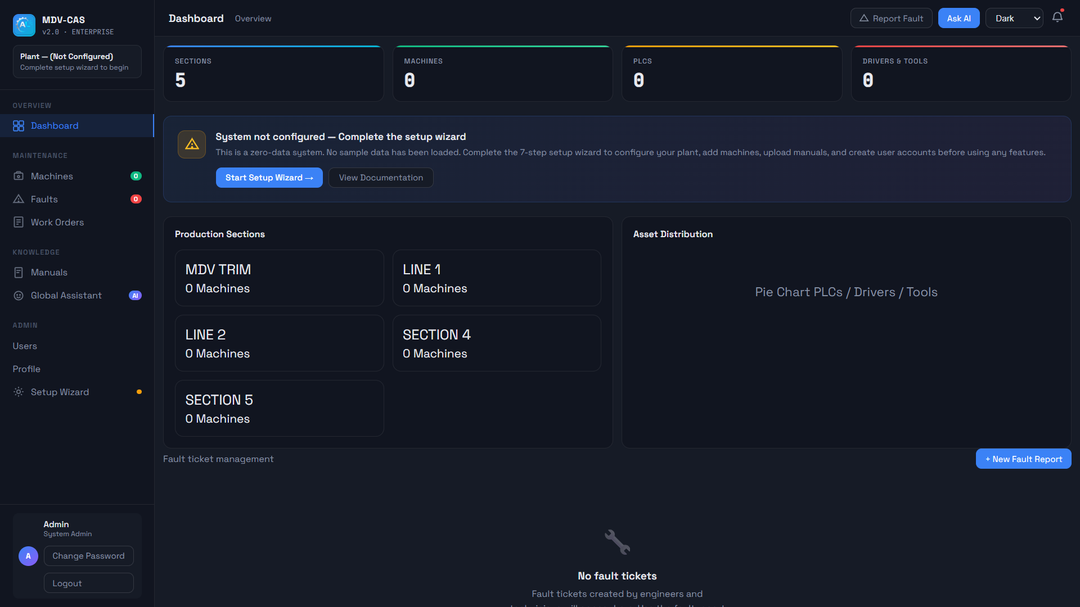

AI Requirement
Client specifically requested:
AI Engine = Microsoft Copilot
Not Gemini.
Not generic AI Assistant.
Everywhere rename:
- Global Assistant
- AI Assistant
- AI Chat
to:
MDV-CAS Copilot

Client Requirements
The client is from Ashok Leyland maintenance operations.
They want a maintenance knowledge system.

REMOVE
These modules are no longer needed:
Remove MTTR
Delete:
- MTTR calculations
- MTTR charts
- MTTR KPI cards

Remove Fault Analytics
Delete:
- Fault graphs
- Monthly fault charts
- Trend charts
- Analytics page

Remove Fault Management
Delete:
- Fault section
- Fault reporting
- Work Orders
Current dashboard still contains Faults and Work Orders.
Those must be removed.

New Dashboard Structure
Dashboard should focus on:
Section Count
5 Production Sections
- MDV TRIM
- LINE 1
- LINE 2
- SECTION 4
- SECTION 5
These are placeholders.
Admin should be able to:
- Add Section
- Rename Section
- Delete Section
No hardcoded section names.

Dashboard KPIs
Keep:
- Sections
- Machines
- PLCs
- Drivers & Tools
Remove:
- Fault KPIs
- MTTR KPIs

Asset Distribution
Current placeholder:
"Pie Chart PLCs / Drivers / Tools"
Client wants actual pie chart.
Show:
- PLC count
- Driver count
- Tool count

Core Hierarchy
This is the most important change.
System hierarchy:
Plant
└─ Section
└─ Machine
├─ PLCs
├─ Drivers
├─ Tools
├─ Manuals
└─ Machine Copilot

Section Page
Each section should have:
+ Add Machine
Example:
MDV TRIM
├─ Machine 1
├─ Machine 2
├─ Machine 3
Machines are created by Admin only.
No demo machines.
No sample data.

Machine Page
When user clicks:
Machine 1
Open machine details page.
Machine page contains:
PLC Module
+ Add PLC
Fields:
- PLC Name
- PLC Model
- PLC Brand
- PLC IP Address
- Notes

Drivers Module
+ Add Driver
Fields:
- Driver Name
- Driver Model
- Driver IP Address

Tools Module
+ Add Tool
Fields:
- Tool Name
- Tool Type
- Notes

Uniqueness Requirement
PLC IP addresses must be unique.
Example:
Machine 1
PLC A
192.168.1.10
Cannot be duplicated elsewhere.
Same validation for drivers.

Manuals Upload
Every machine should support:
Upload Manual
Accepted:
- PDF
- DOCX
- Manuals
- SOPs
Manuals belong only to that machine.
Example:
Machine 1
└─ Siemens PLC Manual
Machine 2 cannot access Machine 1 manuals.

Machine Copilot
Every machine gets its own Copilot.
Example:
Machine 1
└─ Copilot
When user asks:
What is error F004?
Machine Copilot should search ONLY:
Machine 1 manuals
Not other machines.
Not global manuals.

Global Copilot
Dashboard homepage contains:
MDV-CAS Global Copilot
This assistant searches:
- All machines
- All PLCs
- All manuals
- All drivers
- All tools
Example:
Give me all IP addresses of
Machine 2,
Machine 3,
Machine 4
Global Copilot should retrieve information from all machine databases.

Setup Wizard Changes
Current setup wizard exists already.
Keep it.
Improve it.

Validation Requirement
Continue button must work only if:
All mandatory fields are filled.
Current wizard allows empty data.
Must validate before moving to next step.

Theme Requirement
Keep:
- Dark
- Light
- System
Dark theme:
- Industrial dark colors
- Low eye strain
Light theme:
- White
- Light Blue
- Corporate appearance
Theme preference should persist.

Database Design (Future)
Recommended:
Users
Sections
Machines
PLCs
Drivers
Tools
Manuals
CopilotSessions
No Fault table required.
No MTTR table required.

Existing AL-MAAS Stack
The original AL-MAAS roadmap included:
- FastAPI backend
- PostgreSQL
- RAG system
- Authentication
- Analytics
- ESP32 integration
- Voice assistant
Reference:
For MDV-CAS:
Keep:
- FastAPI
- PostgreSQL
- RAG
- Authentication
- Copilot
Remove:
- Fault Analytics
- MTTR Analytics
- ESP32 prototype
- Voice assistant (for now)

Immediate Objective
Do not redesign the whole application.
Modify existing index.html.
Goal:
- Remove unwanted AL-MAAS features.
- Convert to MDV-CAS architecture.
- Build Section → Machine → PLC/Driver/Tool hierarchy.
- Add Machine Copilot.
- Add Global Copilot.
- Prepare frontend structure for future FastAPI + PostgreSQL integration.
- Commit and push changes.
This should be sufficient for a UI review/demo before backend development begins.

