RETAIL SALES
Business Insights Report
Period Covered: January 2024 – December 2025
Dataset: Synthetic multi-region retail sales (5 categories, 25 SKUs, 4 regions, 3 channels)
Prepared as a data analysis mini-project

1. Executive Summary
Across the two-year analysis window, the business generated $836,085 in total revenue and $349,137 in gross profit, holding a healthy 41.8% average margin across 2,661 clean orders. Revenue grew 8.8% year-over-year from 2024 to 2025, with clear seasonal peaks in November–December and a smaller mid-year lift in June. Electronics is the top-performing category, Online is the dominant channel, and heavy discounting (>10%) is measurably eroding margin.
$836.1K  Total Revenue | $349.1K  Total Profit | 41.8%  Avg. Margin | +8.8%  YoY Growth

Total Orders: 2,661 | Units Sold: 9,877 | Avg. Order Value: $314.20

2. Data & Methodology

2.1 Data Source
The dataset simulates 2,703 raw retail transactions from January 2024 through December 2025, spanning 5 product categories (25 SKUs), 4 U.S. regions, 3 sales channels, and 3 customer segments, generated with realistic seasonal and year-over-year growth patterns.

2.2 Data Cleaning Summary
- Removed 42 exact duplicate order records (1.6% of raw rows).
- Standardized inconsistent text formatting in Region and Product Category fields (whitespace, casing).
- Filled missing values: SalesRep → "Unassigned" (40 rows), CustomerSegment → mode (21 rows), DiscountPct → 0 (27 rows).
- Corrected 4 rows with negative Quantity (data-entry sign errors) and recomputed 4 zero-Revenue rows from Quantity × Unit Price.
- Detected and capped 3 extreme Unit Price outliers using the IQR method (values >3×IQR above Q3).
- Final clean dataset: 2,661 rows, engineered with Profit, Profit Margin %, Order Month, and Weekday fields for analysis.

3. Key Findings

3.1 Revenue Trend
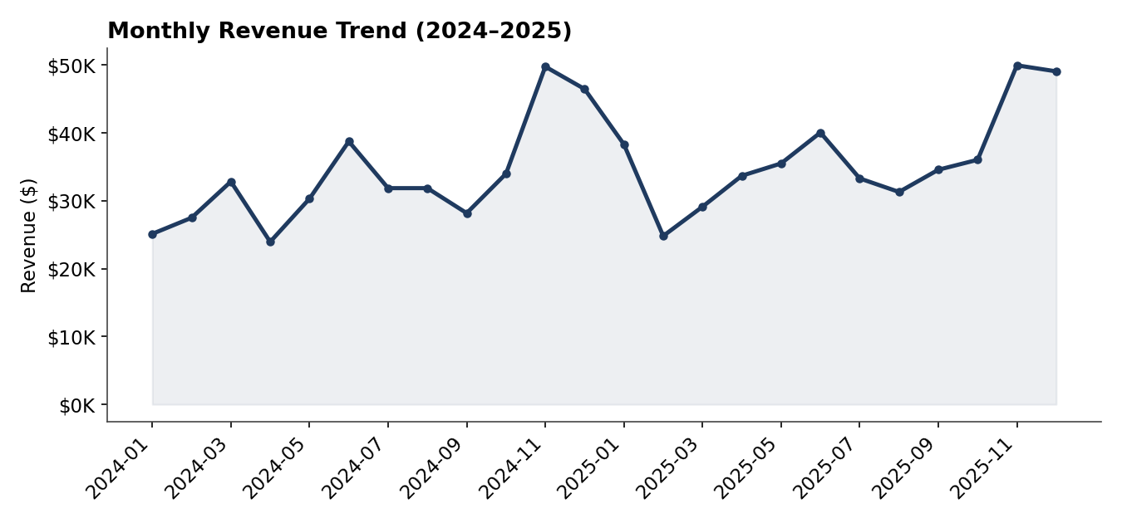
Figure 1. Monthly revenue, Jan 2024 – Dec 2025
Revenue shows a repeatable seasonal pattern: a modest rise in June (mid-year sale) and a sharp peak in November–December (holiday season), roughly 60% above baseline months. The two holiday peaks (Dec 2024 and Nov–Dec 2025) are the strongest months on record, and the year-over-year comparison shows the business entering each peak from a higher baseline, consistent with the 8.8% overall growth.

3.2 Category Performance
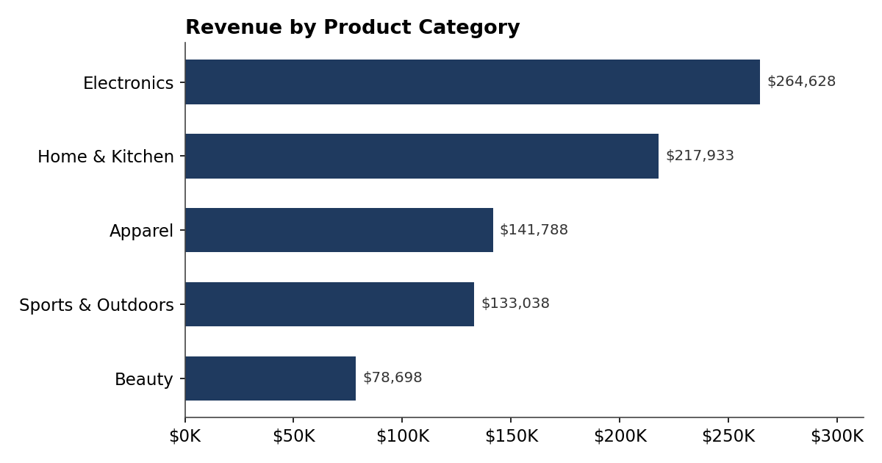
Figure 2. Revenue by product category
Electronics leads with $264.6K in revenue (32% of total) and the highest margin at 42.4%, followed by Home & Kitchen at $217.9K. Beauty is the smallest category at $78.7K, roughly a third the size of Electronics, despite a comparable order count — indicating a lower average order value rather than fewer transactions.

3.3 Regional Performance
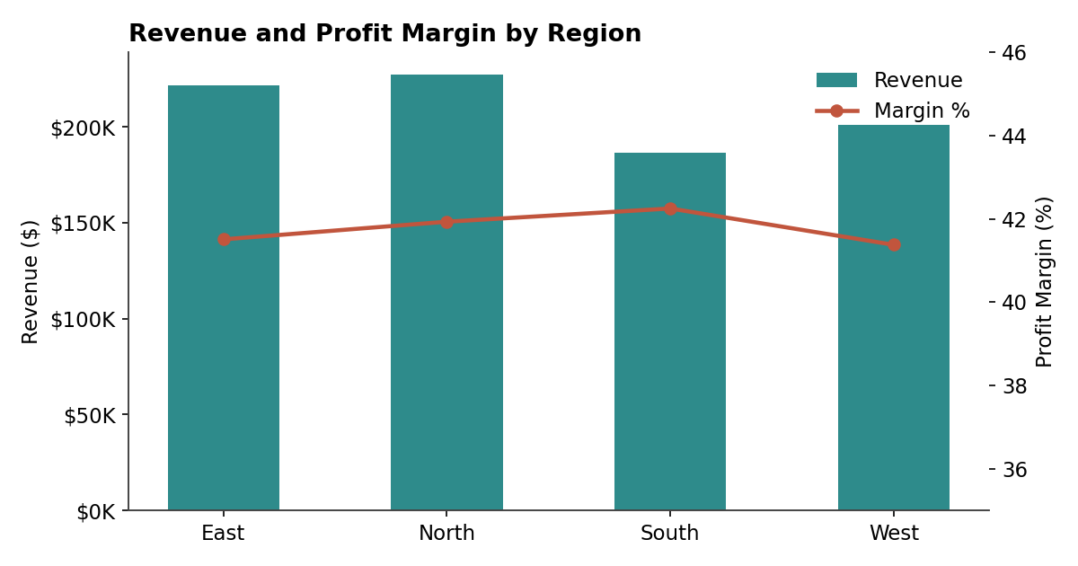
Figure 3. Revenue and profit margin by region
North ($227.4K) and East ($221.4K) are the strongest regions by revenue, together contributing over half of total sales. South trails in revenue but posts the highest margin (42.3%), while West has the lowest margin (41.4%) despite solid volume — suggesting regional differences in discounting or cost structure worth investigating.

3.4 Sales Channel Mix
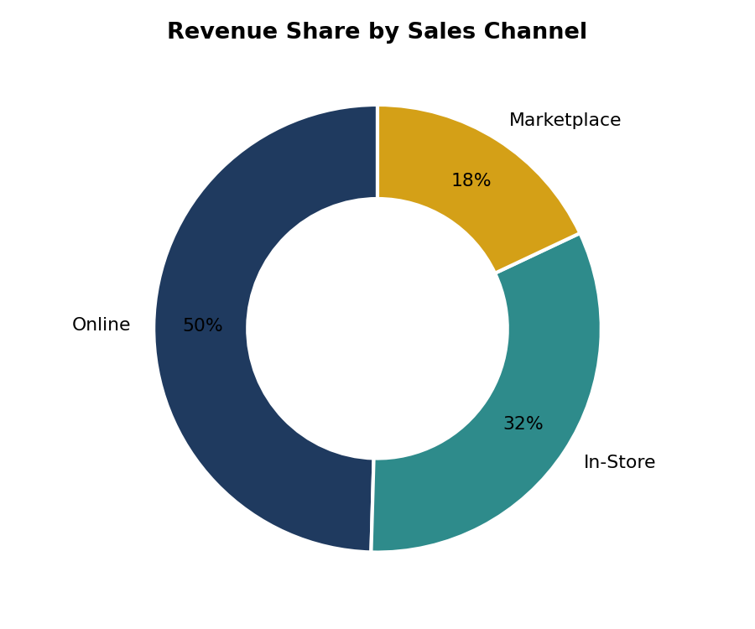
Figure 4. Revenue share by sales channel
Online is the dominant channel at 50% of revenue ($414.2K), roughly 1.5x In-Store ($271.4K) and nearly 3x Marketplace ($150.4K). Marketplace, however, has the highest average order value ($324.87 vs. $309.37 for Online), suggesting Marketplace buyers purchase in larger baskets even though the channel drives fewer total orders.

3.5 Top-Selling Products
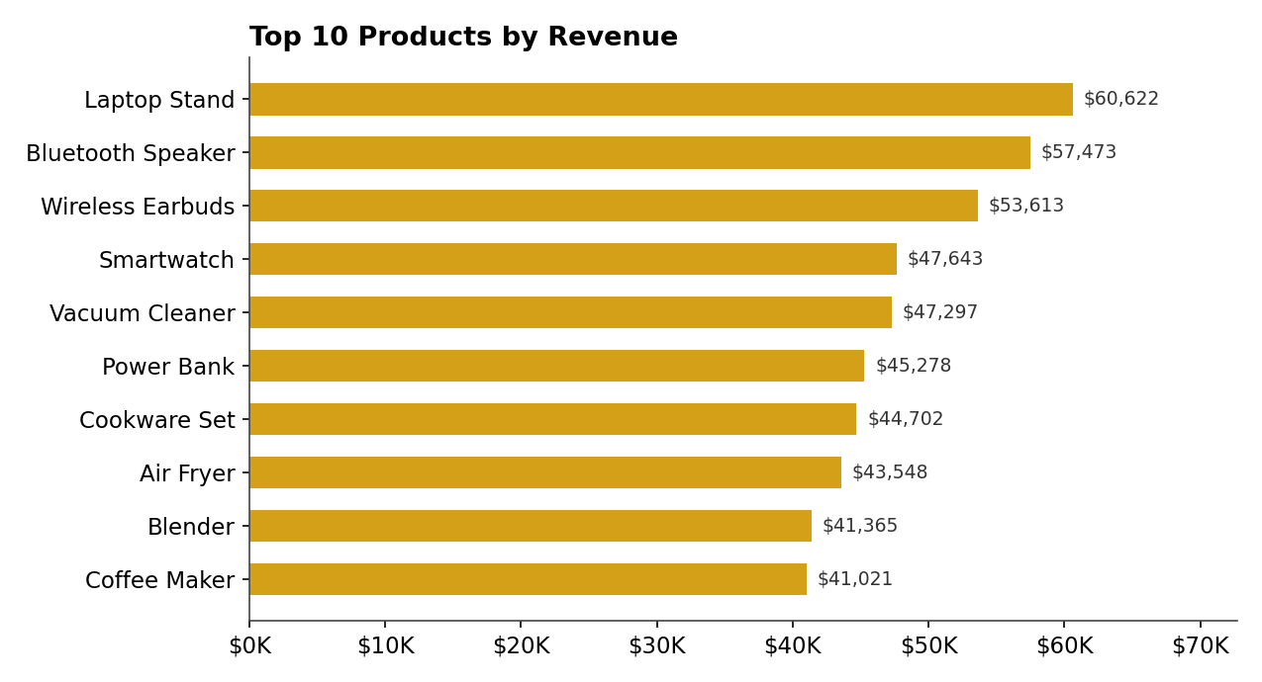
Figure 5. Top 10 products by revenue
Laptop Stand ($60.6K), Bluetooth Speaker ($57.5K), and Wireless Earbuds ($53.6K) are the top 3 SKUs, all from Electronics — reinforcing that category's lead. All top 10 products come from Electronics and Home & Kitchen, meaning the other three categories (Apparel, Sports & Outdoors, Beauty) have no representation in the top sellers despite contributing over 40% of total orders.

3.6 Discount Impact on Margin
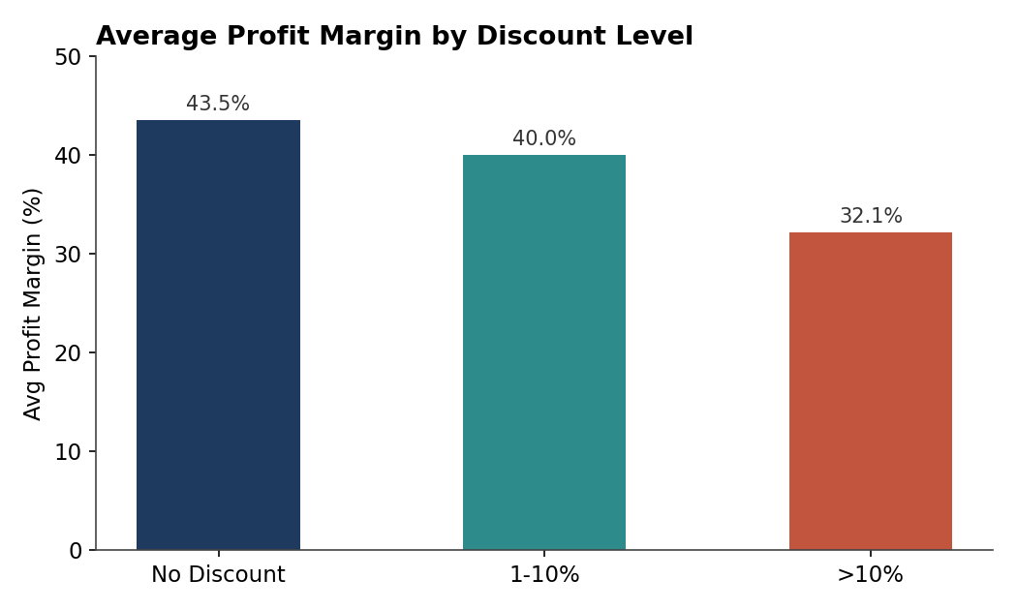
Figure 6. Average profit margin by discount level
Orders with no discount carry a 43.5% average margin. Margin drops to 40.0% at 1–10% discount and falls sharply to 32.1% at discounts above 10%. Deep discounting (>10%) accounts for only 10% of orders but disproportionately compresses overall profitability.

3.7 Customer Segments
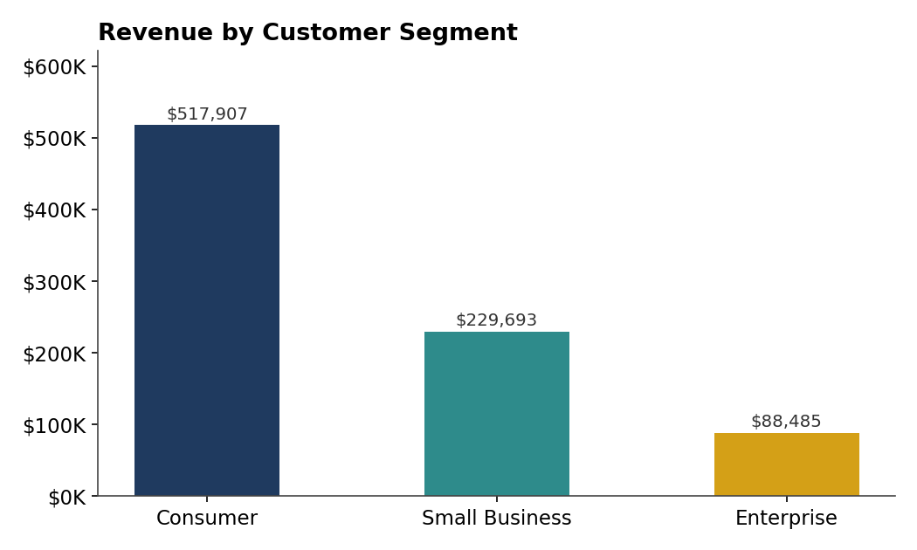
Figure 7. Revenue by customer segment
Consumer is the largest segment at $517.9K (62% of revenue) across 1,681 orders. Enterprise, while smallest by order count (284), represents a segment worth monitoring for account-based growth given typically higher per-deal value in B2B contexts.

4. Actionable Recommendations

4.1 Protect Margin on Discounting
- Cap standard promotional discounts at 10% for standard SKUs; require manager approval for any discount above 10%, since these orders average 32.1% margin vs. 43.5% at full price.
- Model the profit impact of deep discounts before running campaigns — a 10%+ discount tier needs a clear volume-lift justification to be worth the margin loss.

4.2 Double Down on Electronics, Rebalance the Rest
- Increase marketing spend and inventory depth for Electronics and Home & Kitchen — they combine for over half of total revenue and hold the strongest margins.
- Investigate why Apparel, Sports & Outdoors, and Beauty have no products in the top 10 despite ~40% of order volume — consider bundling, cross-sell placement, or repricing to lift their average order value.

4.3 Prepare for Seasonality
- Build inventory and staffing plans around the confirmed November–December demand spike (~60% above baseline) and the smaller June lift.
- Use the quieter months (Feb–Mar, Sep) to test new products or promotions where a dip in baseline demand carries less opportunity cost.

4.4 Grow the Online and Marketplace Channels
- Online drives half of revenue — prioritize UX and checkout investment here first.
- Marketplace has the highest average order value; test bundle offers on Marketplace specifically to capture more of that larger-basket behavior.

4.5 Close the Regional Margin Gap
- Review West region's pricing and discount practices — it has the lowest margin (41.4%) despite strong volume, closing part of this gap could add meaningful profit with no added revenue.
- Study South region's discount discipline (highest margin at 42.3%) as a potential best-practice playbook for other regions.

4.6 Data & Process Improvements
- Enforce required fields at point of sale for Sales Rep and Customer Segment to eliminate the missing-value cleanup needed this cycle.
- Add input validation to prevent negative quantities and zero-revenue entries at the source system level.

