Analysis of Fin and Tube Heat Exchanger for Liquid to Liquid Heat Transfer Applications

V. Jaya chandran* T. Raja**
PG Student, Sri Venkateswara College of Engg Professor, Sri Venkateswara College of Engg
Sriperumbudur, India Sriperumbudur, India
jaibe510@gmail.com traja@svce.ac.in

Abstract

Fin and tube heat exchangers designs rely heavily upon copper and aluminium construction of fin and tube heat exchangers. The temperature was controlled by circulating water through copper tubes. The pin hole leaks were observed in the copper tubes at the time of its failure. On inspecting the Cutting the tubes in longitudinally direction to its half revealed extensive corrosive attack by primary pitting on the inside diameter of heat exchangers. The corrosive attack was due to a high level of chloride which most likely present in the water. The main aim of this work is to prevent the heat exchanger from corrosion and determining the amount of heat transfer by using chromium copper alloy material for heat exchanger tubes. Heat exchanger designs are explored, redesigning and changing the heat exchanger tube material from existing design is accomplished and the use of new material with dramatic changes in heat exchanger configuration. This project is going to analysis the pressure drop, velocity and heat transfer characteristics of heat exchanger. The design of heat exchanger was done using solidworks and analysis of heat was done exchanger using Computational fluid dynamics (CFD) geometry.
Keywords— Heat exchanger, chromium copper alloy, CFD and Solidworks.

1. Introduction

A heat exchanger is a device that is used to transfer or exchange thermal energy between two or more fluids, between a solid surface and a fluid, or between solid particulates and a fluid, at different temperatures and in thermal contact. Heat exchangers are widely used in many industrial applications and energy recovery systems. There are several ongoing researches to improve the efficiency of heat exchanger. The most important approaches followed to improve the efficiency of heat exchanger are changing the heat exchanger material and redesigning. Increasing fin and tube heat exchanger performance usually means transferring more duty or operating the exchanger at a closer temperature approach. This can be without a dramatic increase in surface area this constraint directly translates to increasing the overall heat transfer coefficient. The overall heat transfer coefficient is related to the surface area. A high efficiency compact heat exchanger is effective to achieve such as goals as improving energy efficiency and reduction of co₂ emission. The total thermal resistance for such kind of heat exchangers is comprised of three parts
- Air side thermal resistance the wall convective thermal resistance and the liquid side convective thermal resistance.
- The heat transfer coefficient on the air side is typically low due to the thermo physical properties of air.
- Thus the air side thermal resistance is the dominant part of the heat transfer process and efforts to improve the performance of these heat exchanger should focus on the air side surface

2. Related works
Pressure drop and heat transfer characteristics of a titanium brazed plate-fin heat exchanger with offset strip fins (2012) Jose Fernandez-Seara, Ruben Diz, Francisco J. Uhia This paper is concerned with the experimental analysis of a titanium brazed plate-fin heat exchanger with offset strip fins in liquid to liquid heat transfer processes. We analyzed a titanium brazed plate heat exchanger with offset strip-fins. Experiments were conducted using water and 10 to 30 % ethylene glycol solutions. An empirical correlation for the single-phase convection coefficients was determined. The results were validated against experimental data and other correlations.
CFD analysis of fin tube heat exchanger with a pair of delta winglet vortex generators(2012) Seong Won Hwang1, Dong Hwan Kim, June Kee Min And Ji Hwan Jeong. In this paper, the flow field around delta winglet vortex generators in a common flow up arrangement was analysed in terms of flow characteristics and heat transfer using computational fluid dynamics methods. Efforts to enhance the performance of these heat exchangers included variations in the fin shape from a plain fin to a slit and louver type. In the context of heat transfer augmentation, the performance of vortex generators has also been investigated. Delta winglet vortex generators have recently attracted research interest, partly due to experimental data showing that their addition to fin-tube heat exchangers considerably reduces pressure loss at heat transfer capacity of nearly the same level.
3. Description of problem statement

Copper tubing with aluminum fins was employed in a heat exchanger system. It was failed before 5 years of operation the failure was caused by pits on the tube outside surface Developing until its perforation Pin hole leaks were observed in the copper tubing at the time of failure. It was found that the tube damage was caused by corrosion induced by two factors water containing suspended solid particles chemical composition of water rich in chlorides.
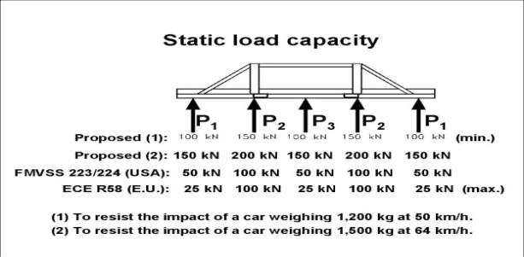
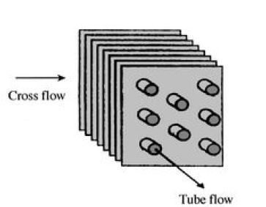
Figure 1: Fin and tube heat exchanger
Cutting the tubes in half longitudinally revealed extensive corrosive attack, primarily pitting on the inside diameter.SEM (scanning electron microscope) equipped with EDS (energy dispersive x-ray spectroscopy) was used to identify the elemental components of the various corrosion products observed. A high level of chlorine along with lower levels of sulphur and iron were detected in the inside diameter of heat exchanger. Corrosive attack was due to a high level of chloride and sulphur compound most likely present in the water. The presence of iron indicates contamination due to corrosion occurring elsewhere in the system.
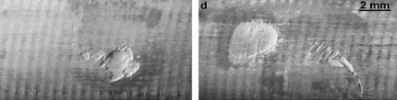
Figure.2: corrosion in heat exchanger
3.1 Selection of heat exchanger

Heat exchangers are complicated devices and the results obtained with the simplified approaches presented above should be used with care. Heat transfer enhancement in heat exchangers is usually accompanied by increased pressure drop, and the higher pumping power therefore any gain from the enhancement in the heat transfer should be weighed against the cost of the accompanying pressure drop.
The factors influencing selection of heat exchanger
- Heat transfer rate
- Cost
- Pumping power
- Size and weight
- Type
- Material

3.2 Modified heat exchanger tube material

For this project I selected Chromium copper alloy for heat exchanging tubes. Generally Chromium copper material strength is twice the pure copper Chromium Copper is a heat treatable copper alloy offering good electrical conductivity, resistance to softening at elevated temperatures and good strength and hardness. This combination of properties makes C18200 one of the preferred resistance welding electrode materials for a variety of applications. Nominally composed of 99.1% copper and 0.9% chromium, this heat treatable alloy can be brought to its softest condition by annealing it at 1000°C (1850°F) for one-half hour at temperature, then rapidly quenching it in water.

4 Methodology for heat exchanger design

Design methodology for a heat exchanger as a component must be consistent with life cycle design of a system. Life cycle design assumes considerations organized in the following stages.

- Problem specification
- Concept development
- Detailed heat exchanger design
- Thermal and hydraulic design
- Mechanical design
- manufacturing considerations and cost

Process or design specification includes all necessary information to design and optimize an exchange for a specific application. It includes problem specification for operating conditions, exchange type, flow arrangement, materials and design/manufacturing/operating considerations. In addition, the heat exchanger design engineer provides necessary and missing information on the minimum input specifications required.
A plan for increasing heat exchanger performance for considers the following Steps.
1) Determine that the exchanger is operating correctly as designed. Correcting flaws in construction and piping that may have a detrimental effect on heat transfer and pressure drop may be the solution.
2) Estimate how much pressure drop is available. For single phase heat transfer coefficients, higher fluid velocity increases heat transfer coefficients and pressure drop.
3) Estimate fouling factors that are not overstated. Excessive fouling factors at the design state result in oversized exchangers with low velocities. These low velocities may exacerbate the fouling problem. More liberal fouling factors and periodic cleaning may increase the heat exchanger’s performance.
Problem specification
Operating conditions
Heat exchanger construction, flow arrangements surface selection
NTU result

Fin efficiency

Heat transfer & pressure drop analysis and velocity analysis
Thermo-physical properties of fluid and material
Surface characteristics and geometrical properties

Fluid distribution s
Mechanical/structural
Design
Heat exchanger core

Supporting /mounting

Methodology for heat exchanger design flow chart

4.1 Modeling Of Heat Exchanger

The dimensions of the heat exchanger are being taken from the literature survey based on the equipped aspects of the data and the new design of heat exchanger has been created. The modeling is done using solidworks its basically standard in 3D product design. The new design for fin and tube heat exchanger was shown in the figure3. The tube material is changed from copper to chromium copper. And new types of spline fins are designed for better heat transfer. Generally copper straight tube with flat aluminium fins are employed in the heat exchanger.
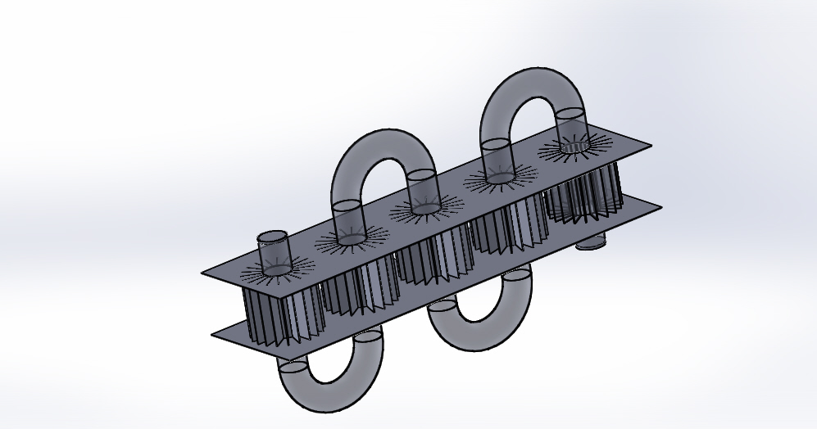
Figure.3 Design of fin and tube heat exchanger
In this project instead copper straight tube has been changed to chromium copper alloy for U – tube heat exchanger and instead of flat fin changed in to spline fin.

4.2. Design Parameters

The design parameter of heat exchanger is shown in figure the length of the heat exchanger is 500mm and height of the heat exchanger is 150mm. The radius of the heat exchanger tubes are inner radius r34 and outer radius r66.
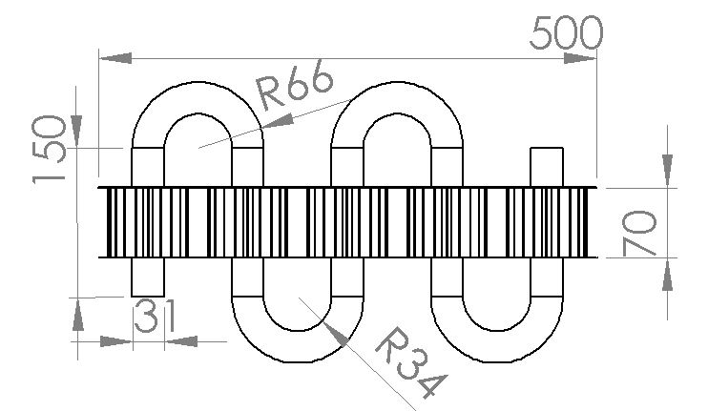
Figure.4: Dimension of fin and tube heat exchanger

4.3 Finning
Tubes can be finned on both the interior and exterior. This is probably the oldest form of heat transfer enhancement. Finning is usually desirable when the fluid has a relatively low heat transfer film coefficient as does a gas. The fin not only increases the film coefficient with added turbulence but also increases the heat transfer surface area. This added performance results in higher pressure drop. However, as with any additional surface area, the fin area must be adjusted by efficiency. This fin efficiency leads to an optimum fin height with respect to heat transfer. Most of the heat transfer and film coefficients for finned tubes are available in the open literature and supported in most commercial heat exchanger rating packages. Recent papers also describe predicting finned tube performance.
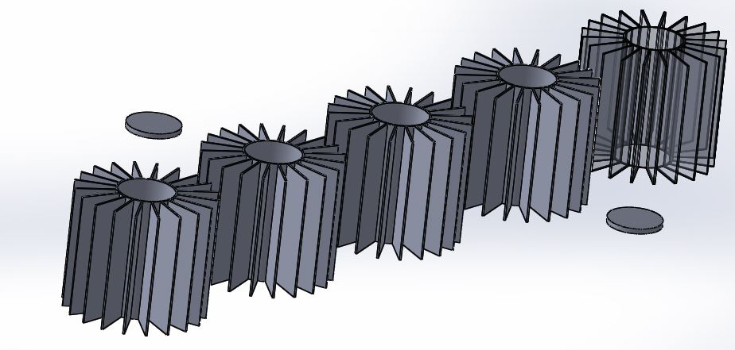
Figure.5: spline fins
5 NUMERICAL FORMATIONS
This section is a summary of the governing equations used in CFD to mathematically solve for fluid flow and heat transfer, based on the principles of conservation of mass, momentum, and energy. Details of how they are actually used in the CFD computations are described in Appendix : CFD Computations.

5.1 CFD Governing Equations
Law of Conservation of Mass: Fluid mass is always conserved.
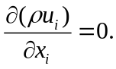
Newton’s 2nd Law: The sum of the forces on a fluid particle is equal to the rate of change of momentum.
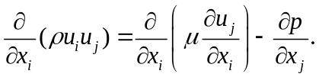
First Law of Thermodynamics: The rate of head added to a system plus the rate of work done on a fluid particle equals the total rate of change in energy.
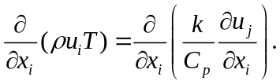

5.2 Pressure Drop
The pressure drop determines the amount of pumping power needed to run a heat exchanger. It is therefore important to characterize the pressure drop for design. This section describes how the pressure drop relates to the pumping power, followed by a description of what causes the pressure drop and finally the pressure drop equations for tube-and-fin heat exchangers are presented.
Pumping power 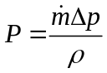
Pressure drop
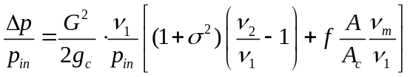

5.3 Heat Transfer and Efficiency
To determine the value of j from the simulations, a series of equations related to heat transfer, efficiency, and the Nusselt and Reynolds numbers are worked through. These equations for determining the Colburn j-factor are provided in this section.
LMTD Method: The efficiency factor F is a function of P, R, and flow arrangement, and is a ratio of actual mean temperature difference to the log-mean temperature difference (LMTD).
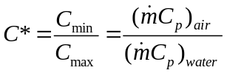

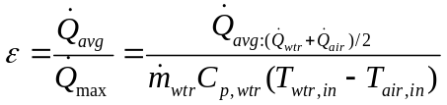

The overall heat transfer resistance is determined with the following equation
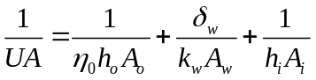
5.4 CFD model
Sl.no | Description | Value / type
1 | Overall dimension | 500*150mm
2 | Tube inner diameter | 31mm
3 | Tube outer diameter | 32mm
4 | Tube length | 1000mm
5 | Length of flat fin | 500mm
6 | Height of spline fin | 70mm
Table1: CFD model
5.5 Boundary Conditions
The inlet velocity & temperature are set to a constant value. The turbulence intensity at the inlet is set as 2%. The relative pressure value is set to 1 bar at the outlet cell surface. The operating boundary conditions of heat exchanger are presented in Table2
Sl.no | Input parameter | unit | value
1 | Temperature of water at inlet | oC | 375
2 | Volumetric flow rate | Kg/sec | 0.05
3 | Pressure at inlet | bar | 1.06
4 | Velocity at inlet | m/sec | 0.17

Table2: Boundary Conditions
6. Results and discussions
The observations of CFD simulation results are discussed below for the boundary conditions as mentioned in Table 2.
6.1 Pressure distribution in heat exchanger
The high pressure gradient along the tube length is due to friction between air and the tube wall. A small amount of negative pressure is observed nearby the outlet of fluid due to jet effect of fluid exiting from the tube. The pressure decreases from top to bottom of the heat exchanger inlet pressure 1.8 bar and the outlet pressure is 1.2 bar.
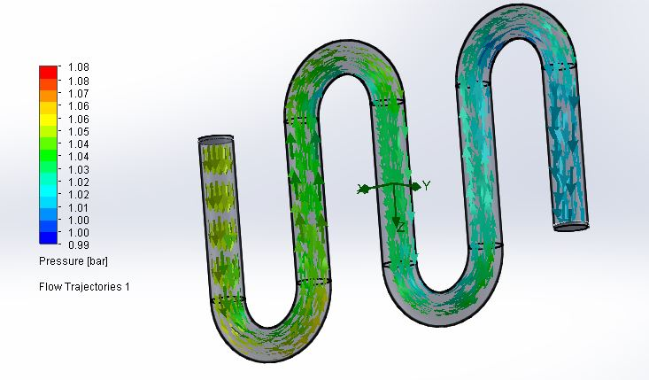
Figure.6: pressure drop

6.2 Velocity distribution in heat exchanger
In this project I am going decreased the velocity of the fluid in the heat exchanger because the water containing suspended solid particles so if the velocity of fluid increases suspended solid particles creates pitting in heat exchanger tubes.
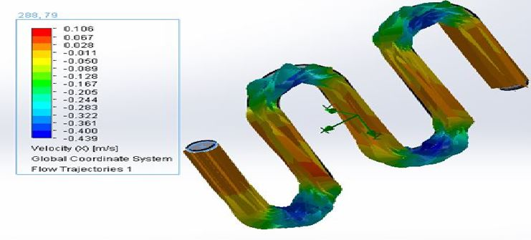
Figure.7: velocity analysis
6.3 Thermal transient analysis of a fin
Thermal transient analysis is known has time to reach steady state. The temperature distribution after 50 seconds and 150seconds and 250 seconds reach the steady state.
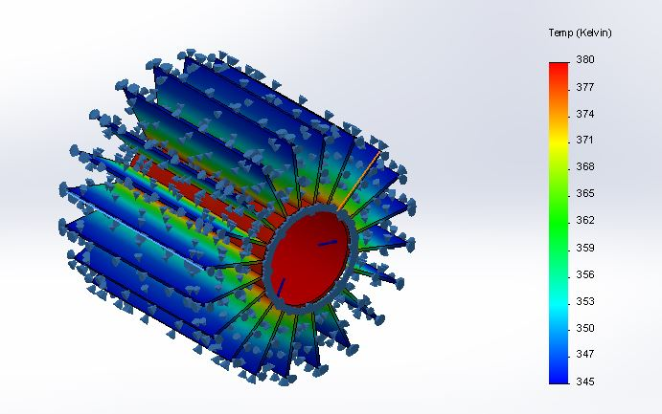
Figure.8: spline Thermal transient analysis
6.4 Flat fin Thermal transient analysis of a fin
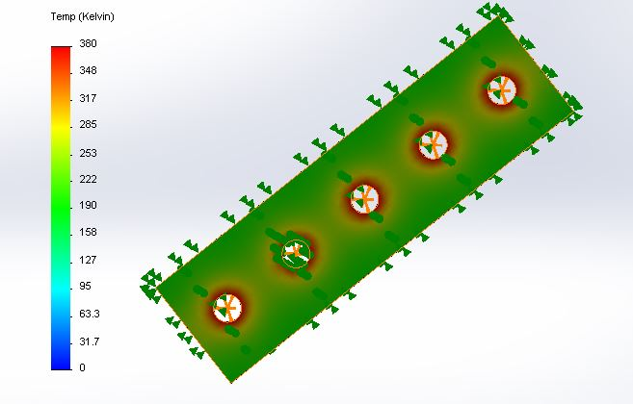
Figure.9: flat fin Thermal transient analysis
6.5 Temperature distribution in heat exchanger
Figure 10 shows the temperature distribution of heat exchanger in a vertical plane along its in X-Y plane inside the tube the temperature of hot fluid increases along its length as its picks up the heat from hot fluid while moving towards oulet
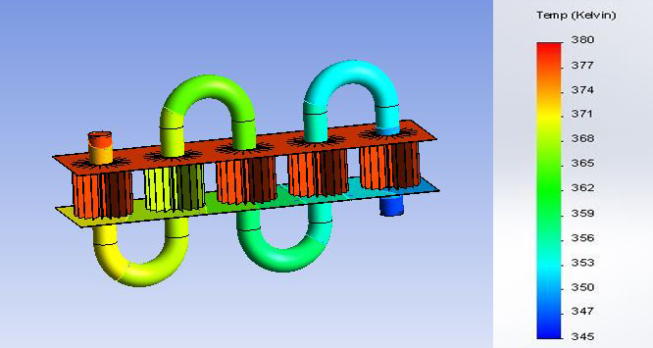
Figure.10: heat transfer analysis
7. Conclusions
The design of heat exchanger in which the existing design is in the form of straight tube with flat fin, the modified design is created in the form of manometer tube with spline fin which is designed using solidworks. The pressure drop decreased and the velocity of the fluid increased in the heat exchanger. The result of safe design is achieved after analysing the pressure drop characteristics. A method for predicting the pressure, velocity & temperature distribution in the fin-tube type heat exchanger associated with CFD software. The simulated results predict the temperature distribution reasonably at different locations of heat exchanger. The CFD model may be used to optimize its thermal performance by varying the location of fin & partition plate in the heat exchanger and in turn improve the performance of heat exchanger.

Nomenclature
h | Heat-transfer coefficient
j | Colburn factor: Nu/RePr^{1/3}
k | Thermal conductivity
K_{c} | Abrupt contraction  pressure-loss coefficient
K_{e} | Abrupt expansion  pressure-loss coefficient
L | Depth of heat exchanger  in airflow direction
N | Number of tube row
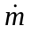 | Mass flow rate (mass*velocity)
Δp | Pressure drop
 | Heat-transfer rate
Pl | Longitudinal pitch
Pr | Prandtl number: μ Cp/k
Reference
1)CFDonline.www.cfdonline.com/wiki/Turbulence_intensity, accessed June 2008.
2) Chen, Han-Taw; Chou, Juei-Che; Wang, Hung-Chih. “Estimation of heat transfer coefficient on the vertical plate fin of finned-tube heat exchangers for various air speeds and fin spacings”, International Journal of Heat and Mass Transfer, Vol. 50 (2006) pp. 45-57.
3) Erek, Aytunc; Õzerdem, Baris; Bilir, Levent; Ilken, Zafer. ”Effect of geometrical parameters on heat transfer and pressure drop characteristics of plate fin and tube heat exchangers”, Applied Thermal Engineering, Vol. 25 (2005) pp. 2421-2431.
4) Fornasieri, E.; Mattarolo, L. “Air-side heat transfer and pressure loss in finned tube heat exchangers: state of art”, Proceedings of the European Conference on Finned Tube Heat Exchangers, Lyon, France, (April 1991).
5) Gnielinski, V. “New Equation for heat and mass transfer in turbulent pipe and channel flow”, International Chemical Engineering, (1976) 359-368.
6) Gray, D. L.; Webb, R.L. “Heat transfer and friction correlations for plate fin-and-tube heat exchangers having plain fins”, Proceedings of the Ninth International Heat Transfer Conference, San Francisco (1986).
7) Hjertager, Bjørn H. “Turbulence Theory and Modelling”, Lecture Notes, Aalborg University Esbjerg, Denmark (2005).
8) Hjertager, Bjørn H. “Computational Analysis of Fluid Flow Processes”, Lecture Notes, Aalborg University Esbjerg, Denmark (2007).

