Github Repository URL: https://github.com/ajaykuk/StreamingApp

Github Repository URL: https://github.com/ajaykuk/StreamingApp

Please refer to below FOLDER in Repo for documentation StreamingApp/ScreenShot_Documentation

This word file is just FYI only and for complete documentation please refer to above folder in git

URL: http://a2cd20bcacc2d418587b1c44f1104d1b-1535451979.us-east-1.elb.amazonaws.com/

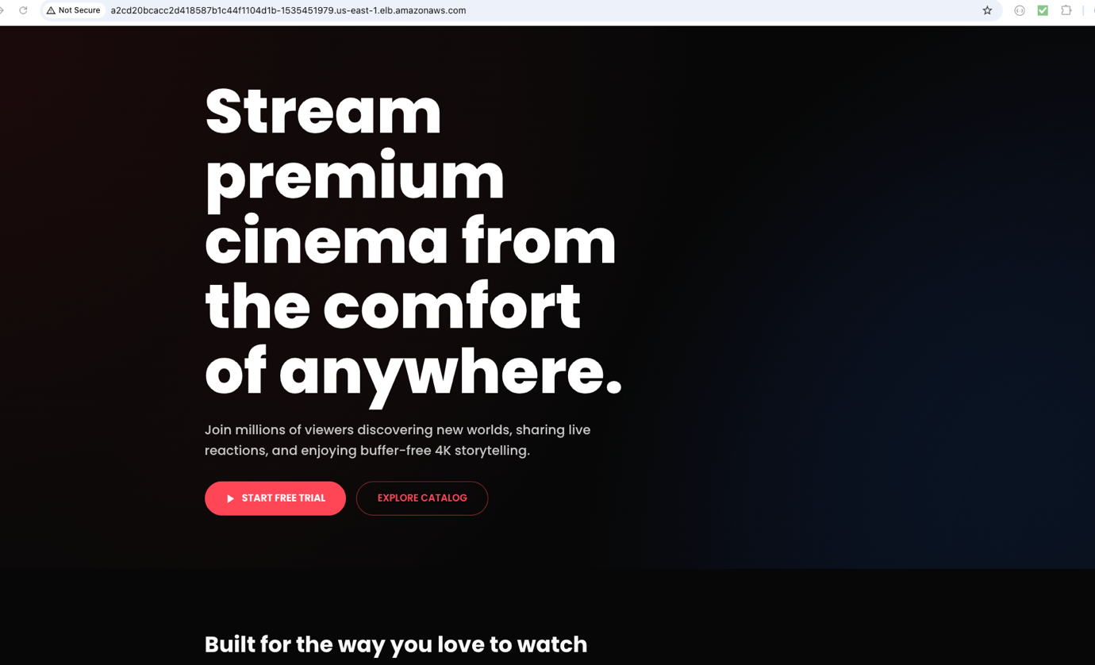

STEPS START FROM HERE

- Docker login from EC2 :
- AWS login from EC2 :

- ECR login from EC2 :
aws ecr get-login-password --region us-east-1 | docker login --username AWS --password-stdin YOUR_ACCOUNT_ID.dkr.ecr.us-east-1.amazonaws.com

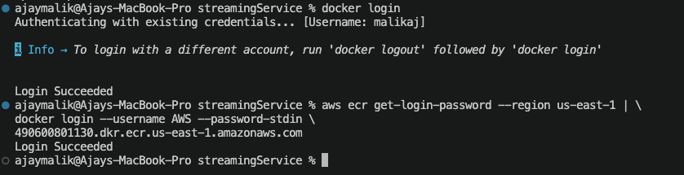
Docker build:
docker build -t malikaj/streaming-app-frontend:latest .
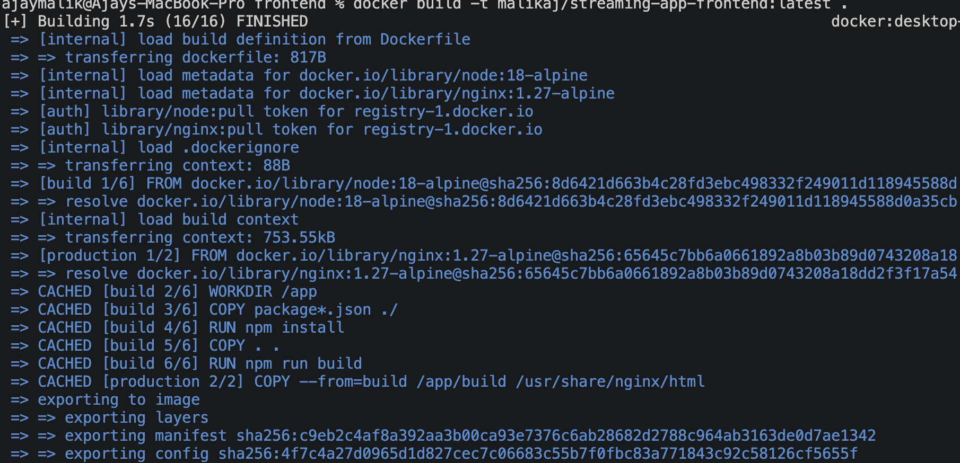

Tag image with the ECR repository URI:
docker tag malikaj/streaming-app-frontend:latest 490600801130.dkr.ecr.us-east-1.amazonaws.com/malik/streaming-app-frontend:latest

Push to ECR
docker push 490600801130.dkr.ecr.us-east-1.amazonaws.com/malik/streaming-app-frontend:latest
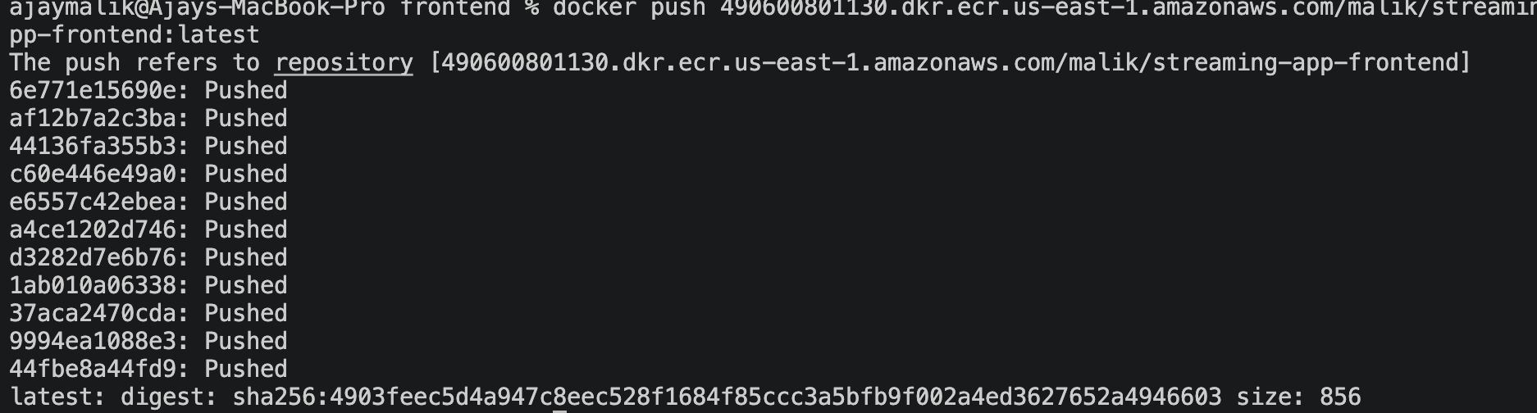
Corresponding Repository in ECR:

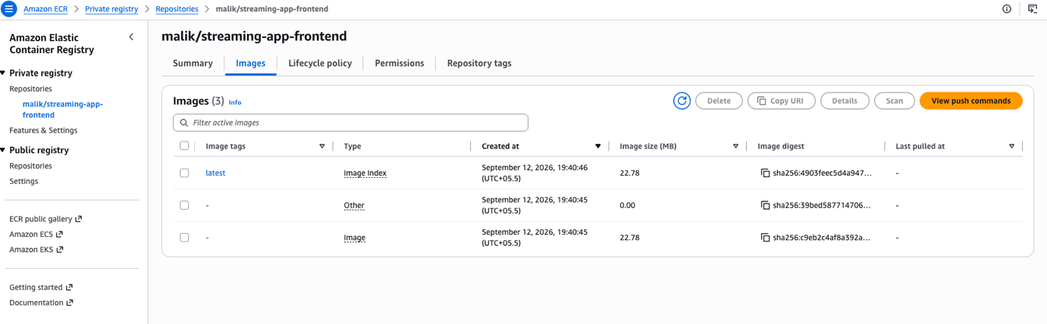

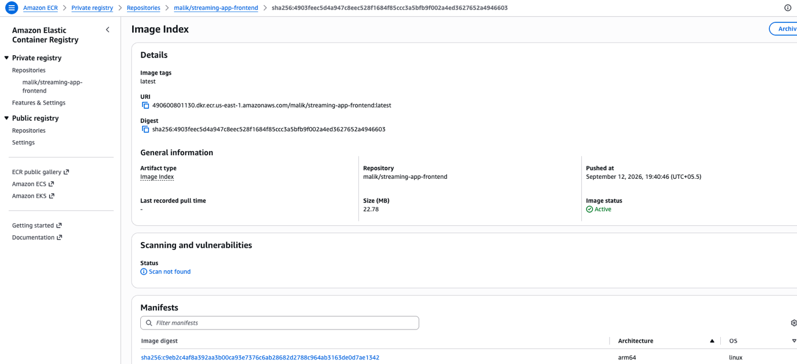

This is done for frontend image, do it for all the backend images as well.
adminService image :
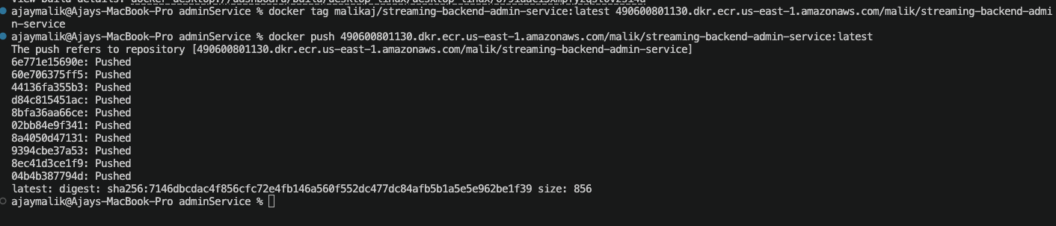
Corresponding admin-service Repository in ECR:

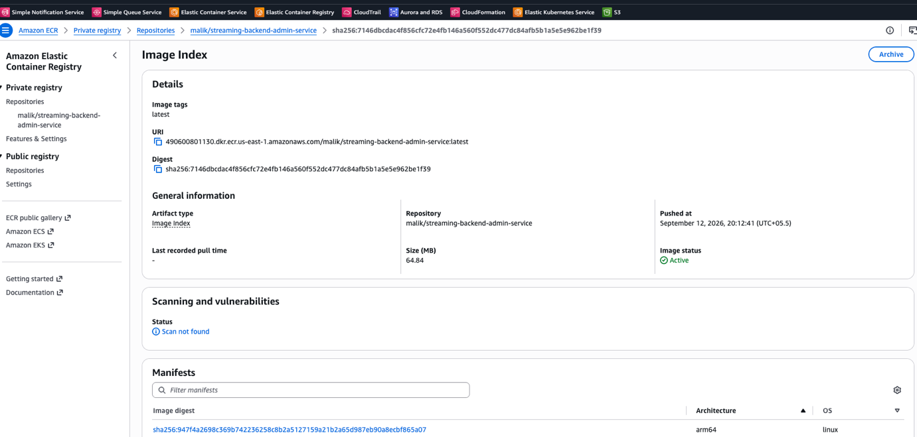

authService image :

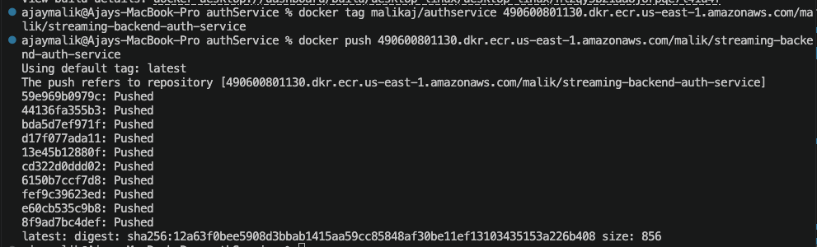

Corresponding auth-service Repository in ECR:
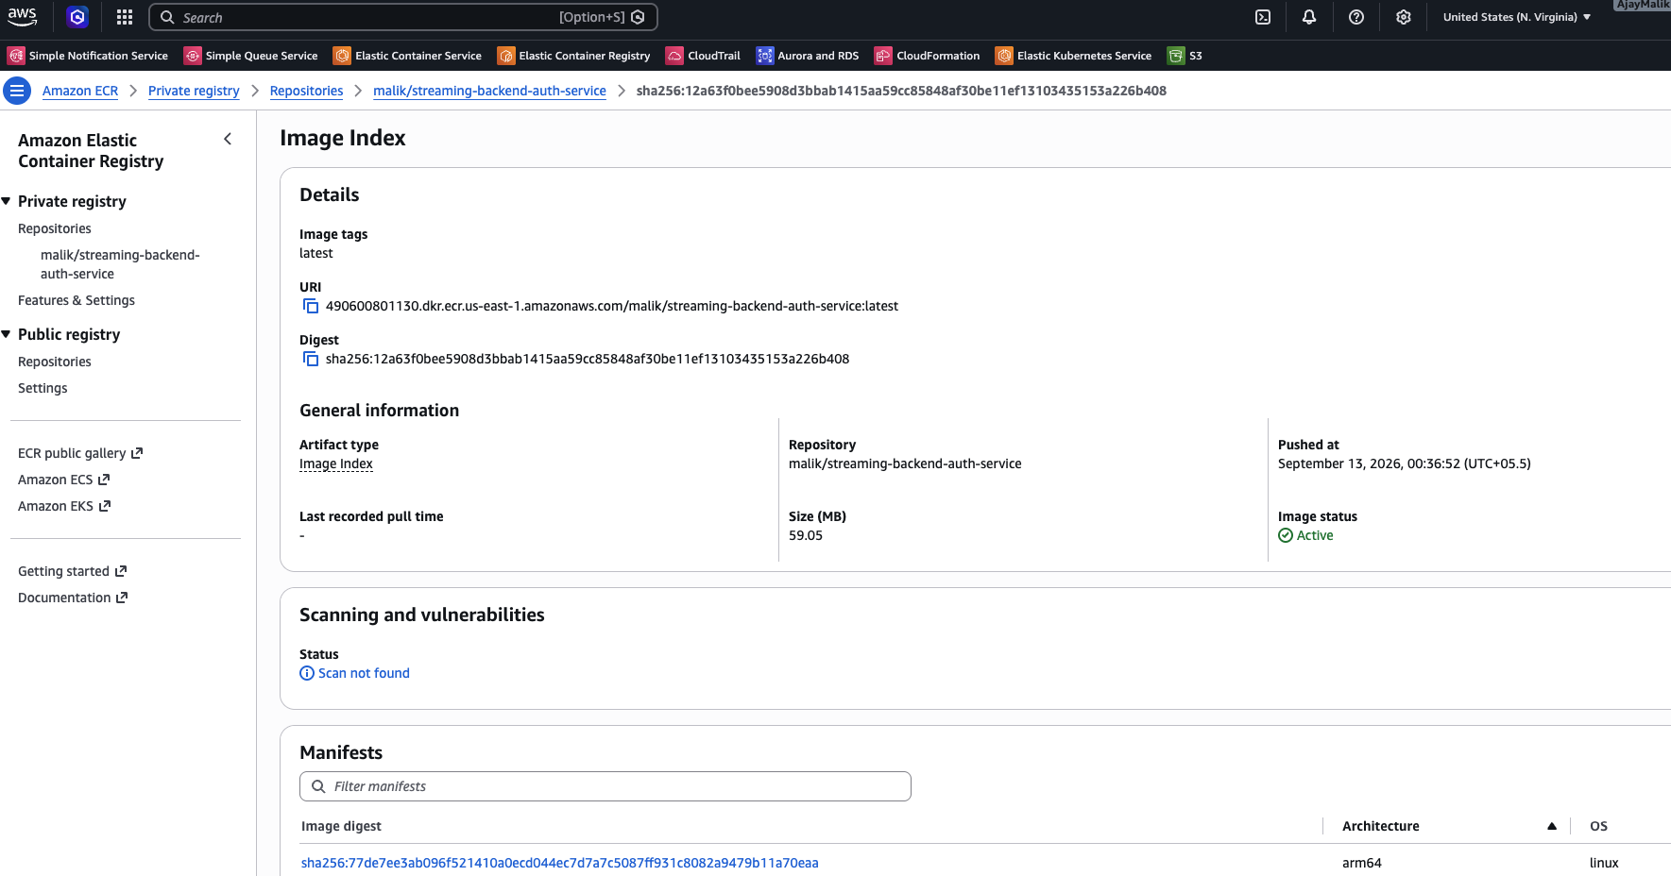

chatService image :
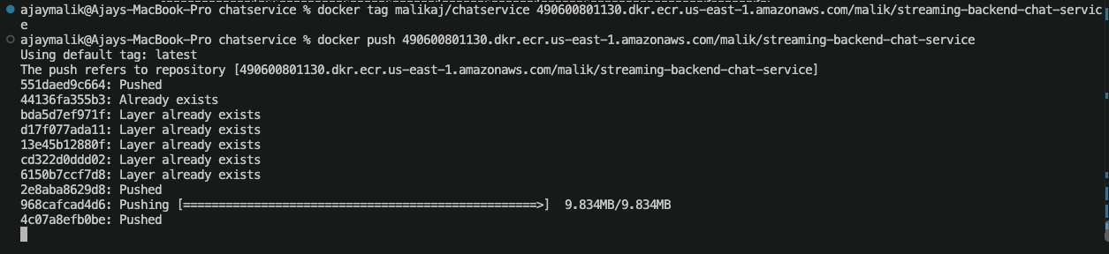
Corresponding chat-service Repository in ECR:
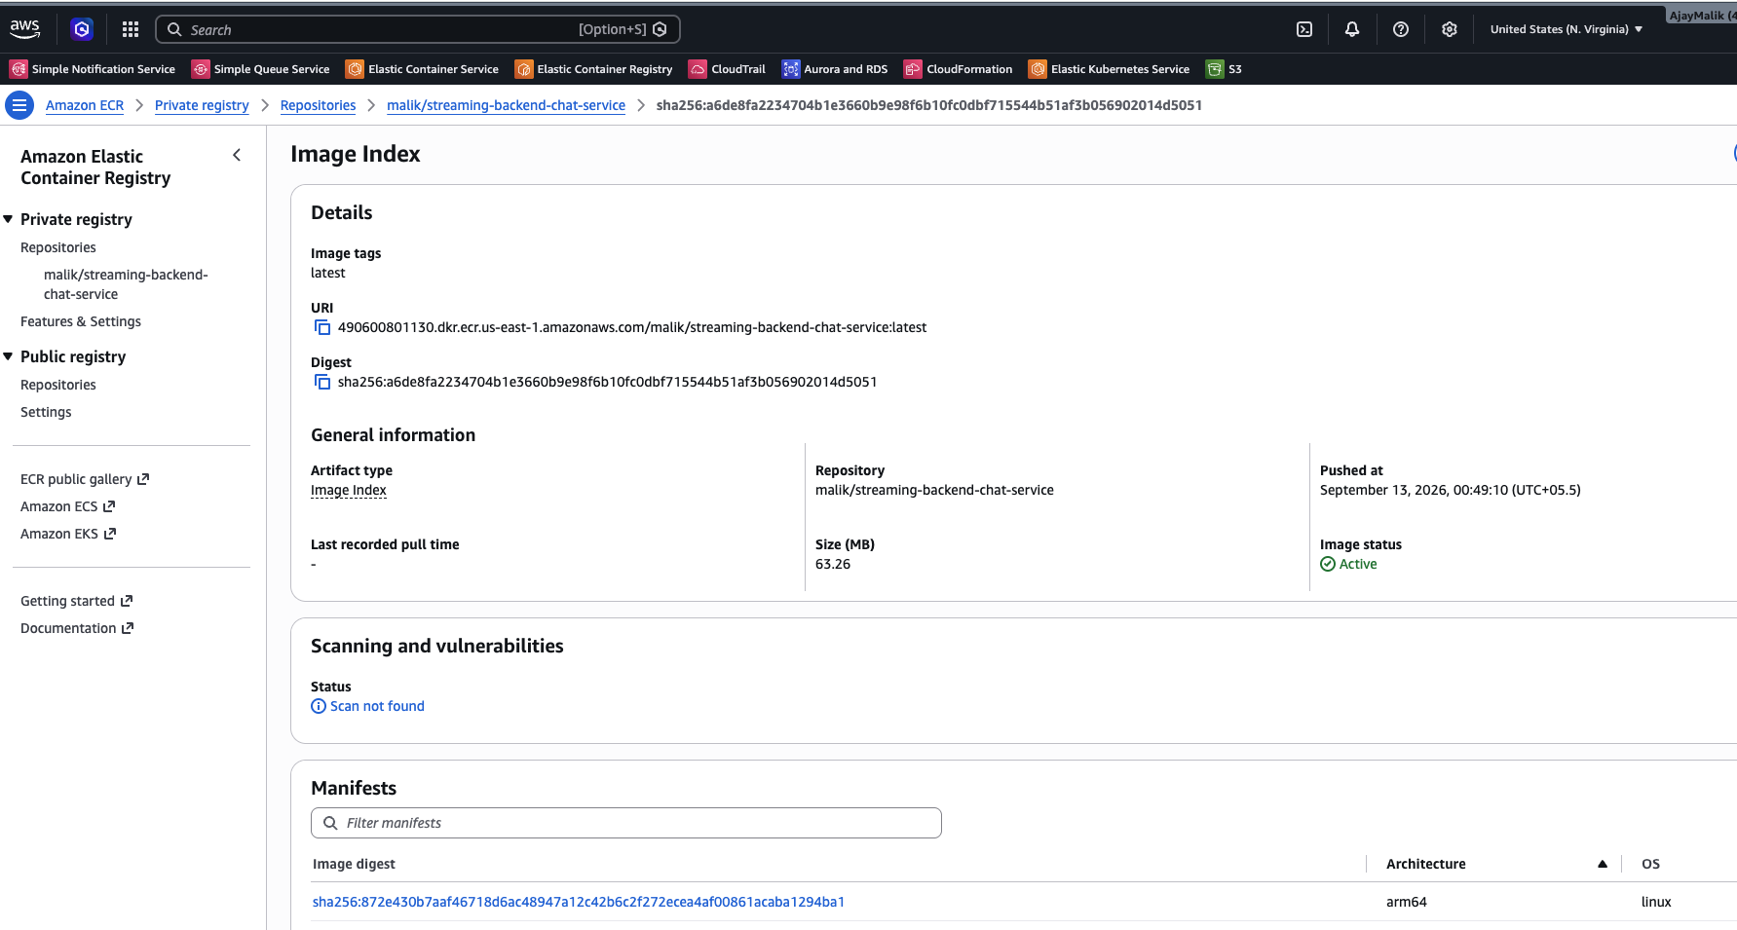

streamingService image :
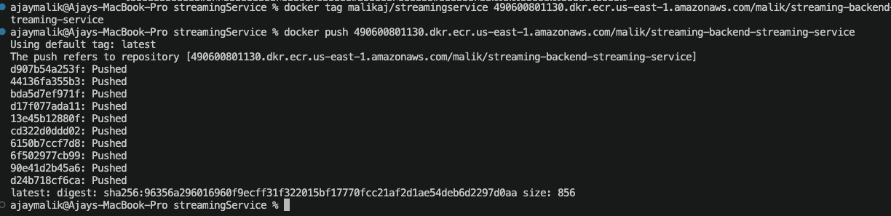

Corresponding streaming-service Repository in ECR:
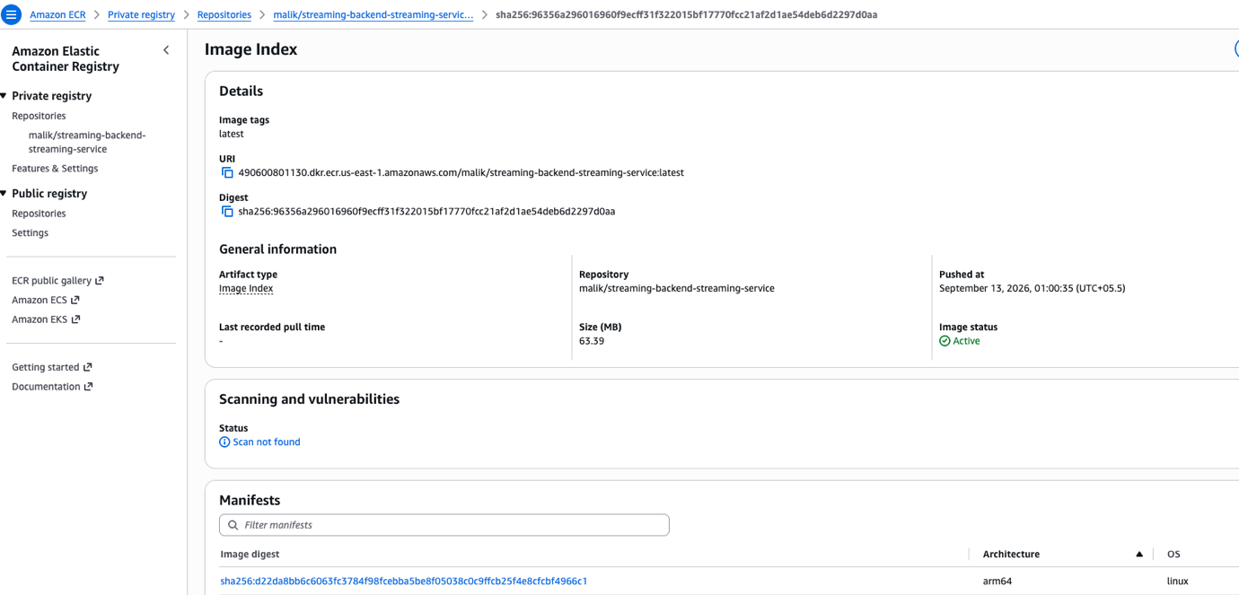

On EC2 Install git , docker , Jenkins.

On EC2 Install kubectl
"https://dl.k8s.io/release/$(curl -L -s https://dl.k8s.io/release/stable.txt)/bin/linux/amd64/kubectl"
# 2. Make the binary executable
chmod +x ./kubectl
# 3. Move it to your system PATH sudo
mv ./kubectl /usr/local/bin/kubectl

Give the aws access to EC2 via IAM role and permission policy.

Reset Workspace Ownership: Restores write access.

Jenkins

Get admin password for jenkins using:
sudo cat /var/lib/jenkins/secrets/initialAdminPassword

Run this command to recursively give ownership of all workspace files back to Jenkins:
sudo chown -R jenkins:jenkins /var/lib/jenkins/workspace/
Reset Permissions: Ensures clean state.
Run this command to ensure Jenkins has full read and write permissions to those folders:
sudo chmod -R 755 /var/lib/jenkins/workspace/

Create a Jenkinsfile in git repo.

Add credentials and upload .env as secrets in jenkins.

To securely supply the environment variables to this pipeline, you need to upload your .env file into Jenkins' Credentials Manager:
1.Navigate to Credentials:
From the main Jenkins dashboard, click Manage Jenkins in the left menu, then select Credentials.
2.Add New Credential:
Click on System (under the Stores scoped to Jenkins section), click Global credentials (unrestricted), and click the Add Credentials button.
3.Upload the .env file:Keeps variables encrypted.
Change the "Kind" dropdown menu to Secret file. Click the Choose File button and upload your .env file from your local computer.
4.Set the ID:
Type my-env-file exactly as written into the ID field. This ID must match the credentialsId string in the Jenkinsfile. Click Create.

Pipeline jobs that build each Docker image and push it to ECR.
Jenkins Build finished with success:

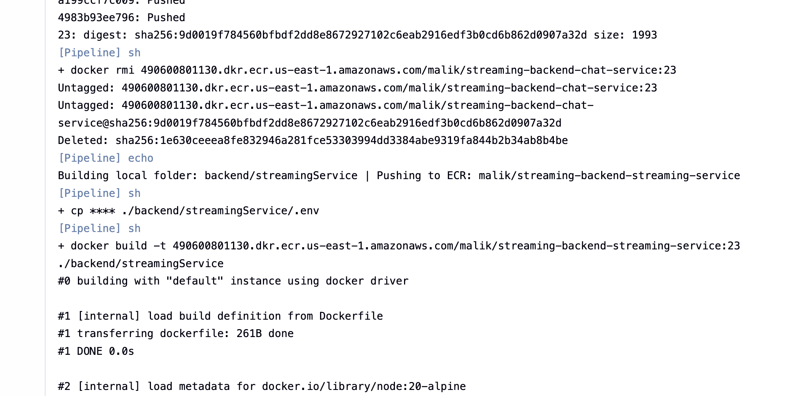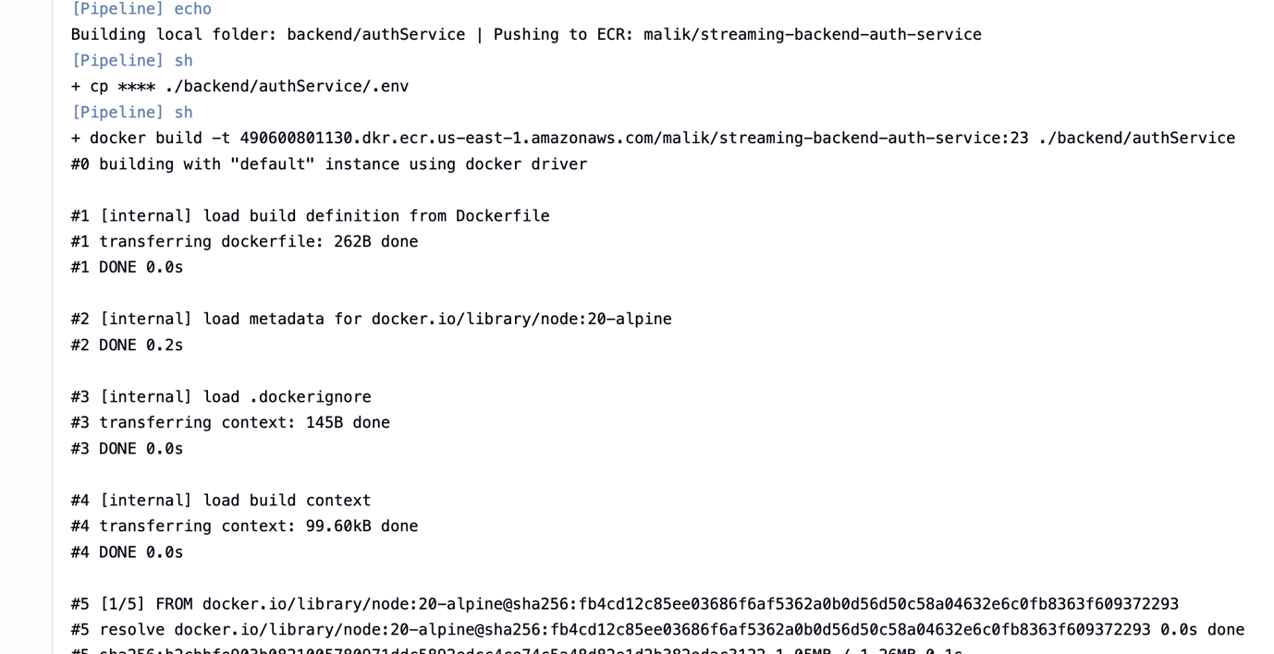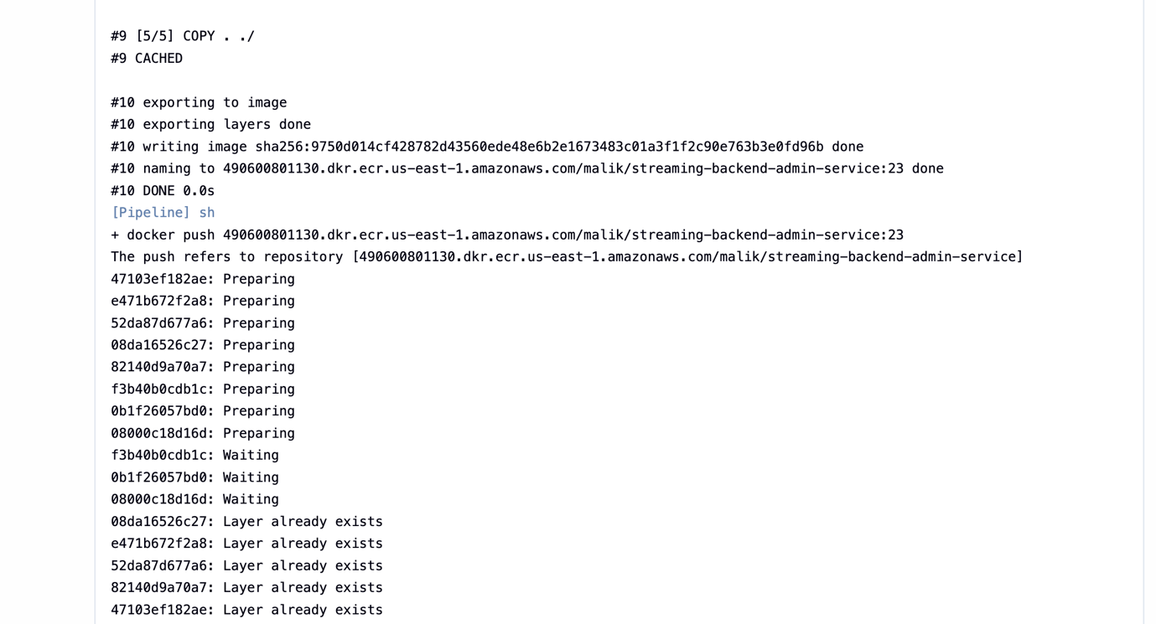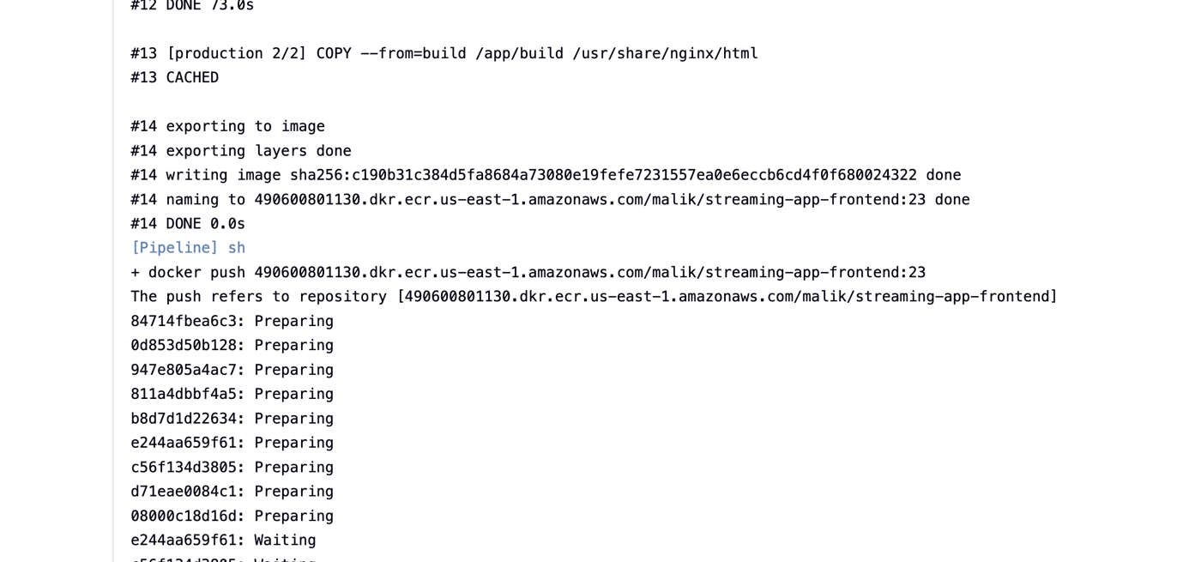
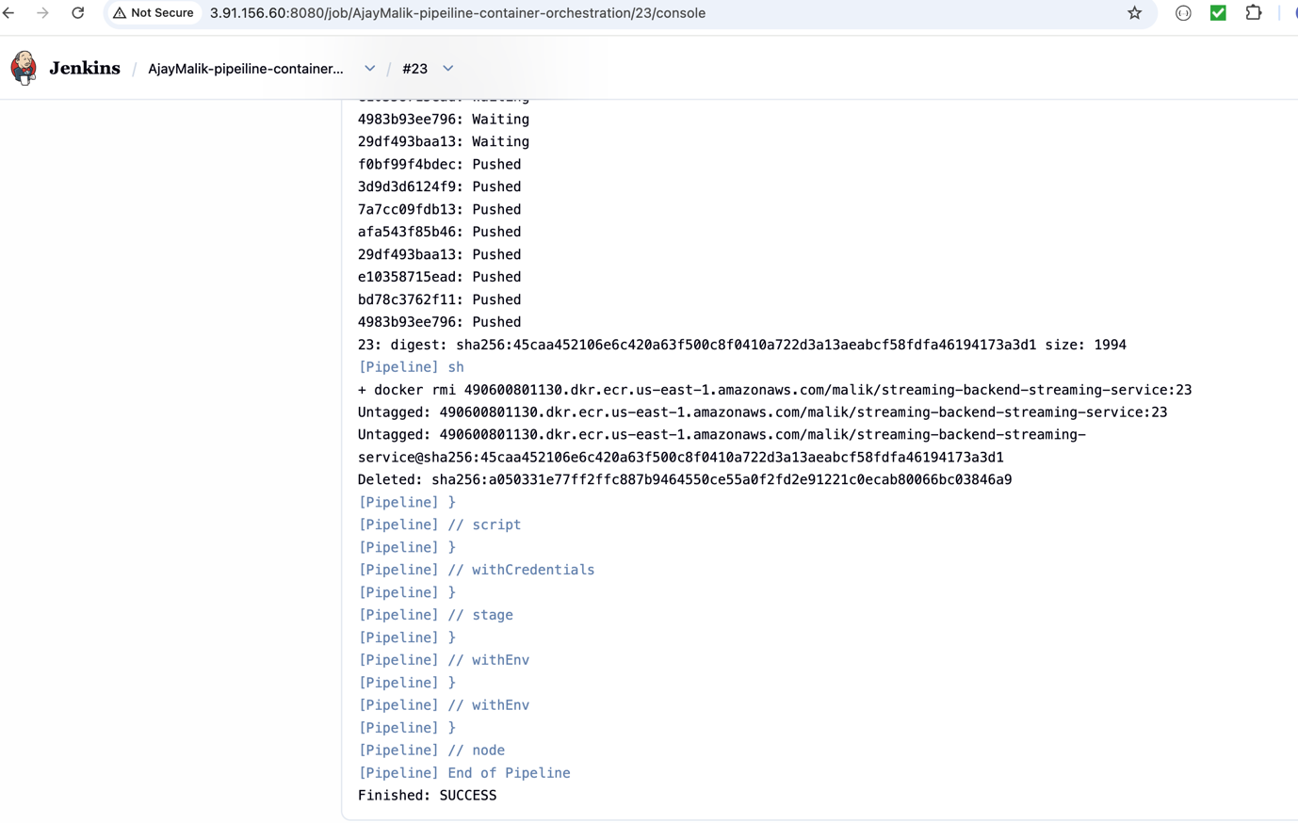

Apply webhooks to trigger automatically on new commits:

Apply webhooks in github:
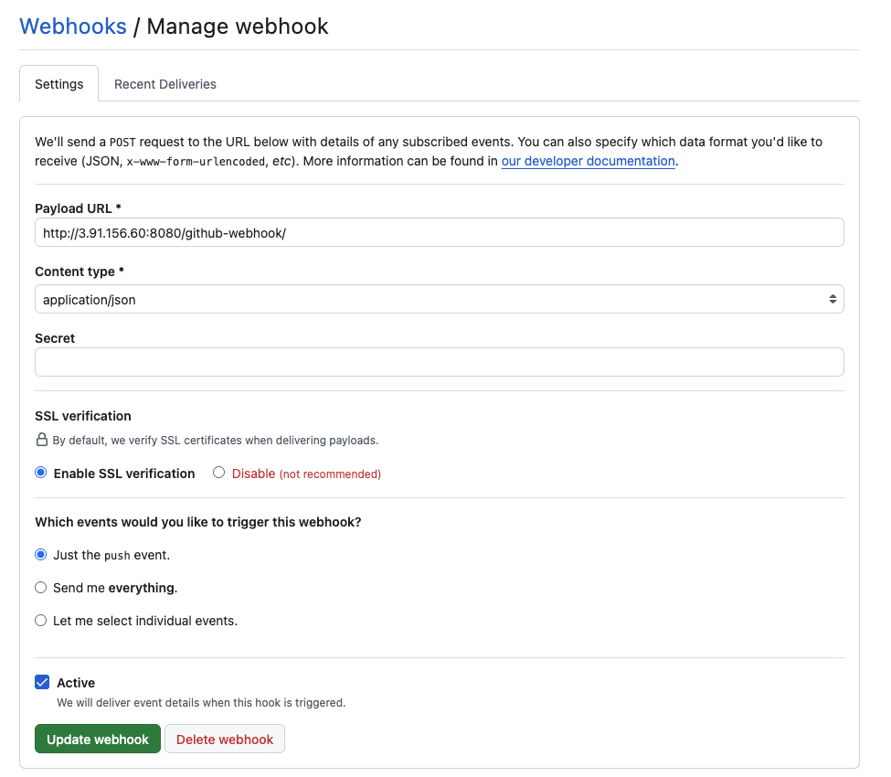

Configure Repository URL in Jenkins

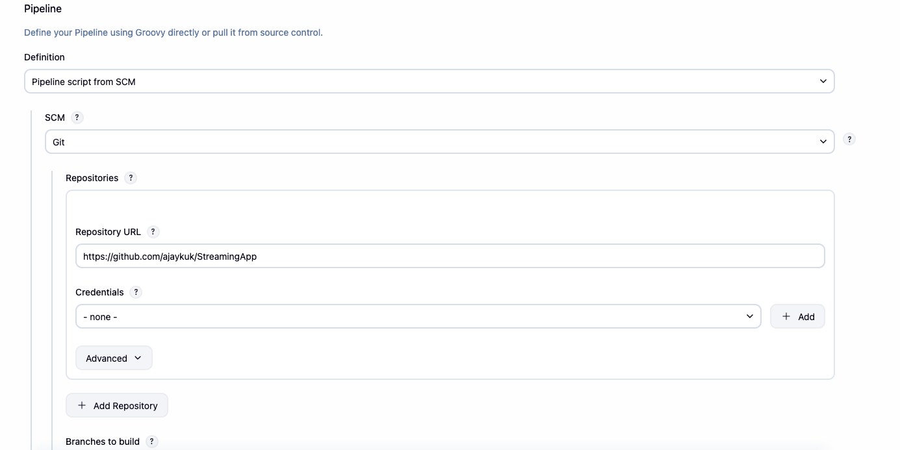

Apply githubPush triggers in Jenkinsfile
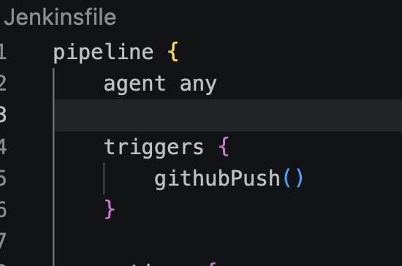

Use eksctl to build and manages the underlying AWS infrastructure for Kubernetes cluster, and use kubectl to manage the applications and workloads running inside that cluster.

Using eksctl is the fastest and official way to provision an Amazon EKS cluster, as it automatically provisions the underlying CloudFormation templates, VPC networking, and IAM roles required for the cluster

Install Prerequisites: Required CLI tools.
Install the following installed on your machine:

AWS CLI: To authenticate and interact with your AWS account.
kubectl: To interact with the Kubernetes API once the cluster is running.
eksctl: The cluster creation tool itself.

Install k3s using command on EC2: curl -sfL https://get.k3s.io | sh –

Install eksstl:
# Download the latest eksctl release for Linux x86_64
curl --silent --location "https://github.com/eksctl-io/eksctl/releases/latest/download/eksctl_Linux_amd64.tar.gz" | tar xz -C /tmp

# Move the extracted binary to /usr/local/bin sudo
mv /tmp/eksctl /usr/local/bin

# Verify the installation
eksctl version

Install Kubectl:

# Download the latest stable release of kubectl
# Download the latest stable release of kubectl

curl -LO "https://dl.k8s.io/release/$(curl -L -s https://dl.k8s.io/release/stable.txt)/bin/linux/amd64/kubectl"

# Make the kubectl binary executable
chmod +x ./kubectl

# Move the binary to /usr/local/bin so it is available system-widesudo mv ./kubectl /usr/local/bin/kubectl

# Verify the installation
kubectl version --client

Configure standard kubectl access:
By default, K3s places the cluster configuration file in a protected directory. To use standard kubectl commands without typing k3s or using sudo every time, copy the configuration to user profile:

mkdir -p ~/.kube
sudo k3s kubectl config view --raw | tee ~/.kube/config
chmod 600 ~/.kube/config

Create a Deployment manifest to pull the image from ECR. (Make sure EC2 instances or EKS Node roles have IAM permission to pull from ECR, but usually, managed node groups have this).

Create Cluster: eksctl create cluster -f cluster-config.yaml

Run aws eks update-kubeconfig to generate or update your ~/.kube/config file. This links kubectl directly to your EKS cluster using AWS CLI authentication
aws eks update-kubeconfig --region <YOUR-REGION> --name <YOUR-CLUSTER-NAME>
cluster IAM Role: AMAmazonEKSAutoClusterRole successfully created.
Node IAM Role: AmazonEKSAutoNodeRole successfully created.
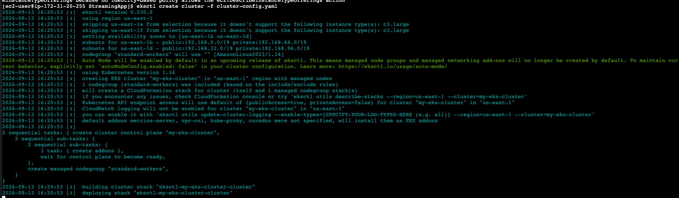

Install helm: brew install helm
Verify version: helm version

Initialize helm chart:
helm create streaming-mern-stack

This generates a folder named streaming-mern-stack containing default files. Delete everything inside the templates/ directory so we can start fresh:

rm -rf streaming-mern-stack/templates/*

Initialize the Helm Chart

helm install streaming-app ./streaming-mern-stack --set imageTag=36

helm upgrade --install streaming-app ./streaming-mern-stack --set imageTag=43

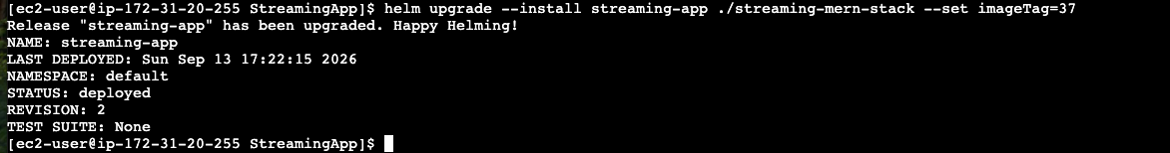

URL: a1c92ef7da62e45da97519d6d2efd251-339780998.us-east-1.elb.amazonaws.com
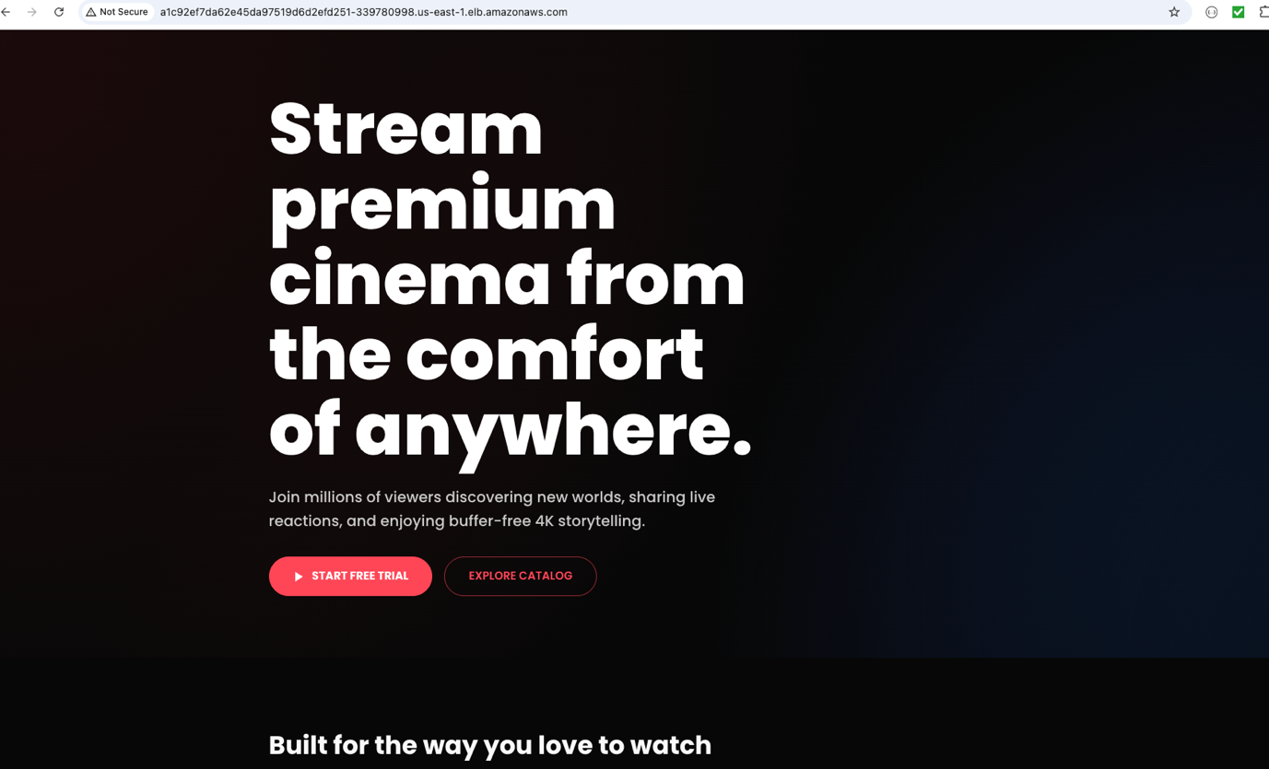

sudo kubectl get svc
kubectl get pods

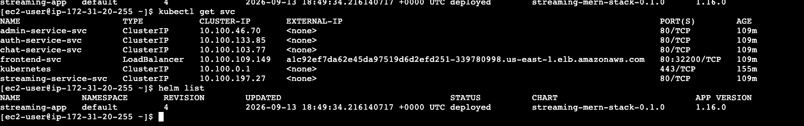

kubectl get svc

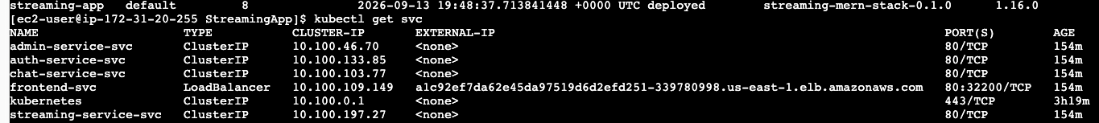

kubectl get pods

helm list

Install the NGINX Ingress Controller:Terminal.
Run these commands in EC2 terminal to install the NGINX Ingress controller.
These together will install NGINX Ingress Controller into Kubernetes cluster using Helm.
This will automatically provision a single AWS Load Balancer that will act as the master entry point for your entire cluster.
helm repo add ingress-nginx https://kubernetes.github.io/ingress-nginx
helm repo update
helm install ingress-nginx ingress-nginx/ingress-nginx --namespace ingress-nginx --create-namespace
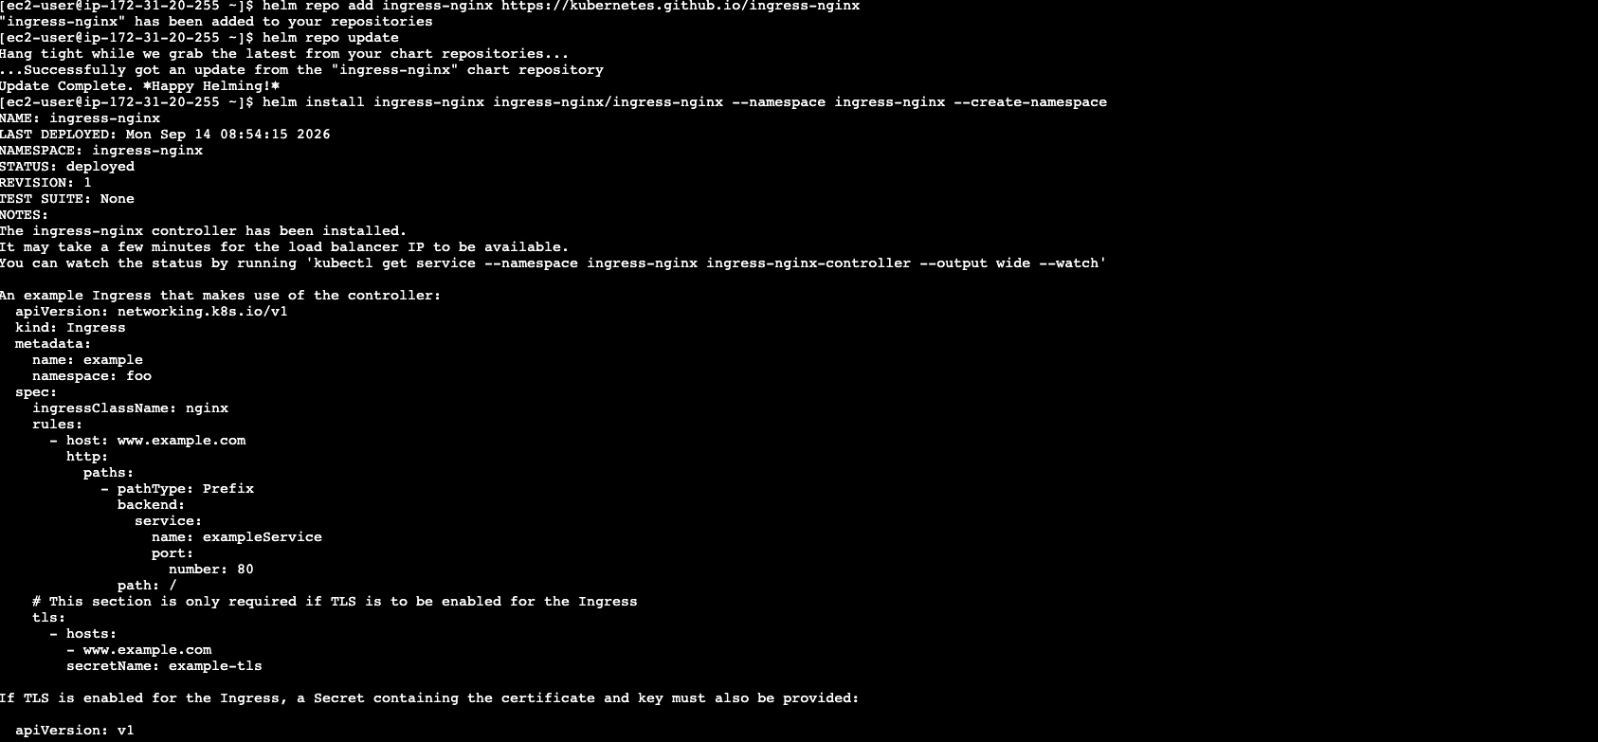

Convert everything to ClusterIP:values.yaml.

Since the Ingress will now handle internet traffic, frontend no longer needs its own dedicated Load Balancer. In Helm chart's values.yaml set every single service (frontend and all backends) is to ClusterIP.

3.Create the Ingress Template:templates/.
Inside Helm chart's templates/ folder, create a new file named ingress.yaml. This file defines the routing rules.

Note: Sometimes terminal "forgot" that you switched to Amazon EKS. When you run export KUBECONFIG=~/.kube/config, it only lasts for your current terminal session. If your SSH connection drops, or you open a new terminal window, Linux forgets the setting and defaults back to the broken local k3s cluster.
Run this command again to tell your current terminal to look at AWS EKS instead of k3s:
export KUBECONFIG=~/.kube/config

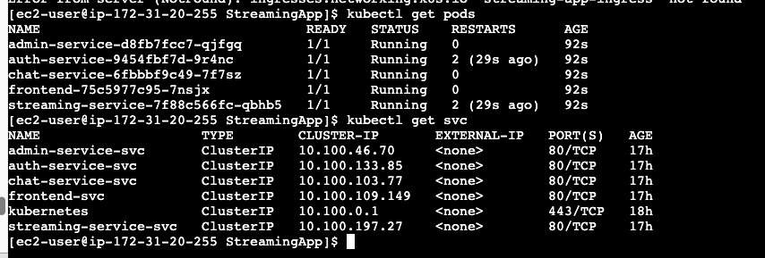

Ingress Routing All 5 paths resolve correctly through one host and Smoke tests passed.

- curl -I http://a2cd20bcacc2d418587b1c44f1104d1b-1535451979.us-east-1.elb.amazonaws.com/

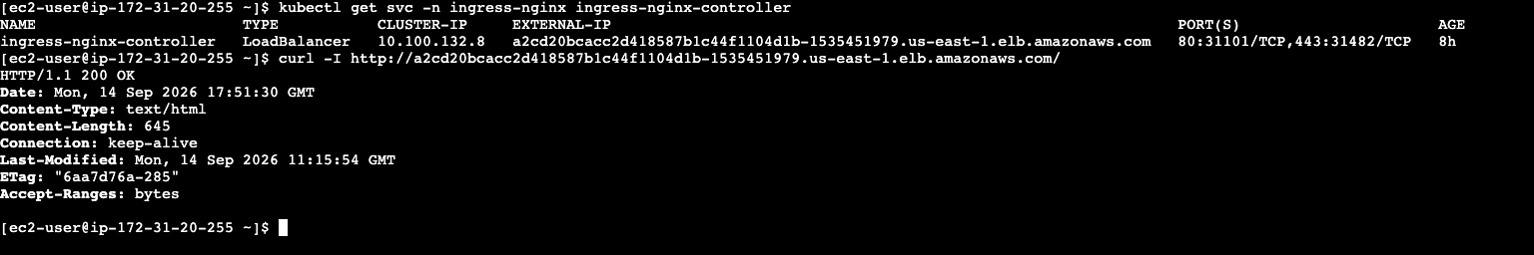

- curl -I http://a2cd20bcacc2d418587b1c44f1104d1b-1535451979.us-east-1.elb.amazonaws.com/auth/api/health
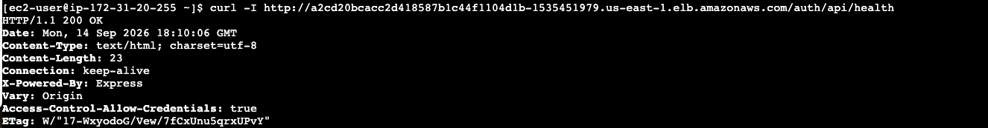

- curl -I http://a2cd20bcacc2d418587b1c44f1104d1b-1535451979.us-east-1.elb.amazonaws.com/admin/api/health
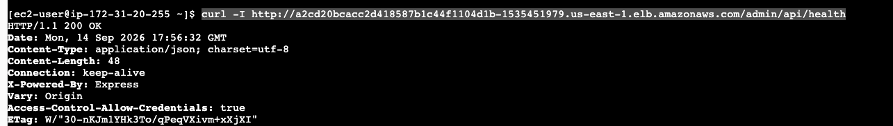

- curl -I http://a2cd20bcacc2d418587b1c44f1104d1b-1535451979.us-east-1.elb.amazonaws.com/chat/api/health
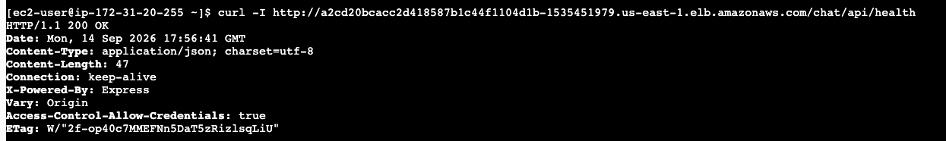

- curl -I http://a2cd20bcacc2d418587b1c44f1104d1b-1535451979.us-east-1.elb.amazonaws.com/streaming/api/health
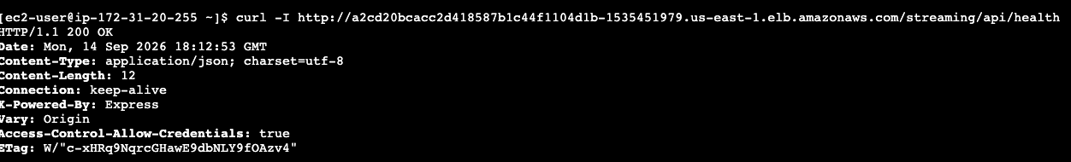

Replica scaling and rolling updates demonstration.
2 Replica for auth service.

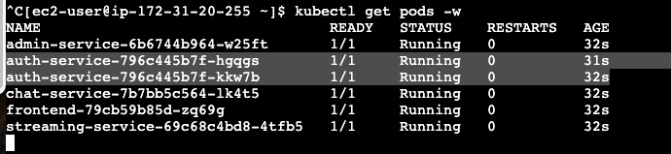

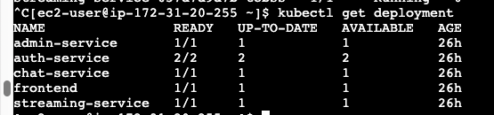

Application Login Screen.

