- Docker login:
- AWS login:

- ECR login:
aws ecr get-login-password --region us-east-1 | \
docker login --username AWS --password-stdin \
YOUR_ACCOUNT_ID.dkr.ecr.us-east-1.amazonaws.com

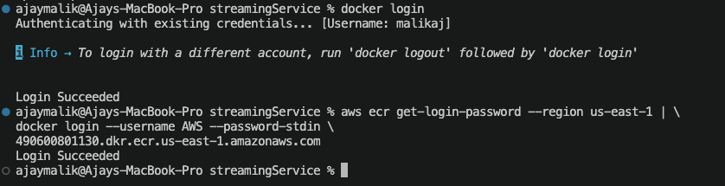
Docker build:
docker build -t malikaj/streaming-app-frontend:latest .
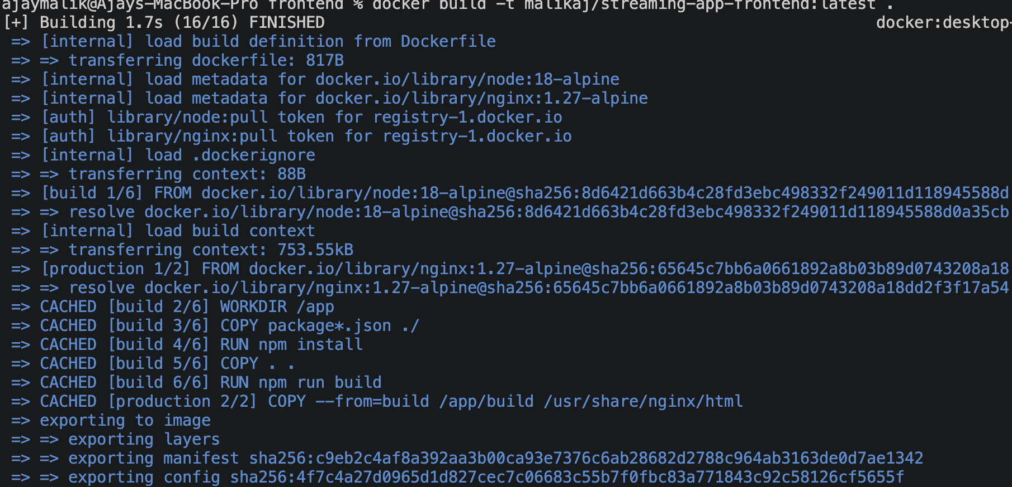

Tag image with the ECR repository URI:
docker tag malikaj/streaming-app-frontend:latest 490600801130.dkr.ecr.us-east-1.amazonaws.com/malik/streaming-app-frontend:latest

Push to ECR
docker push 490600801130.dkr.ecr.us-east-1.amazonaws.com/malik/streaming-app-frontend:latest
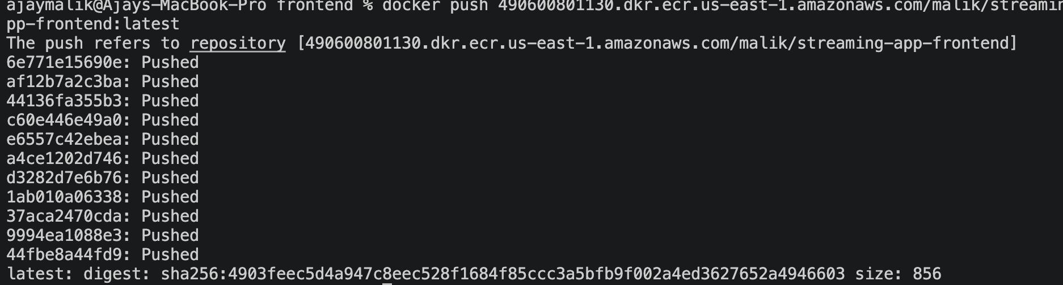
Corresponding Repository in ECR:

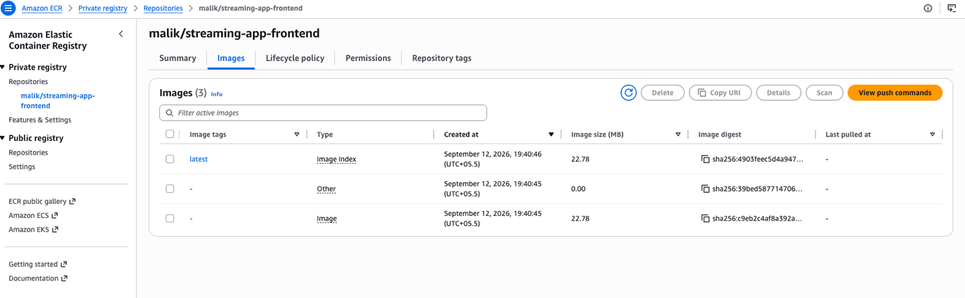

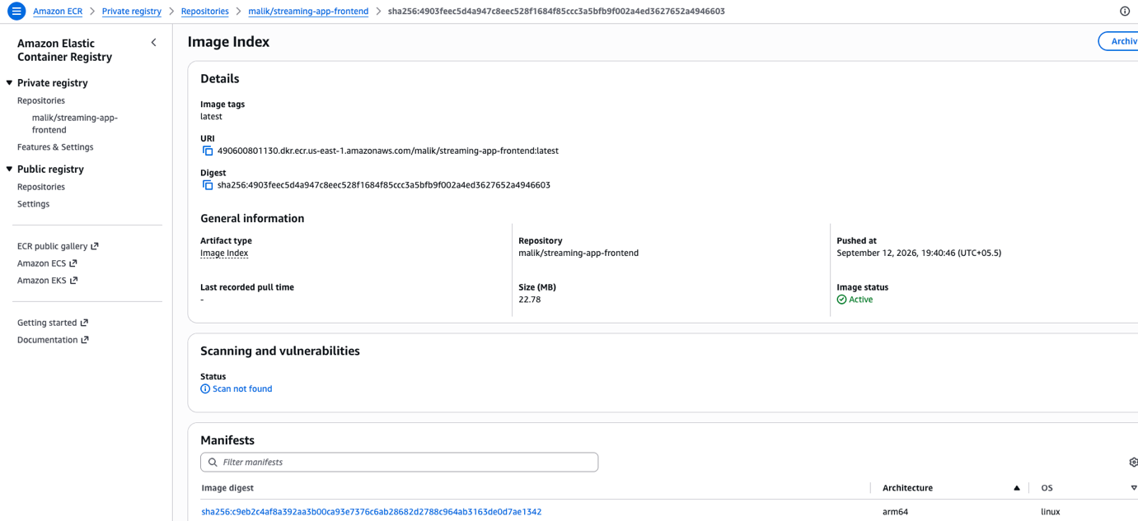

This is done for frontend image, do it for all the backend images as well.
adminService image :
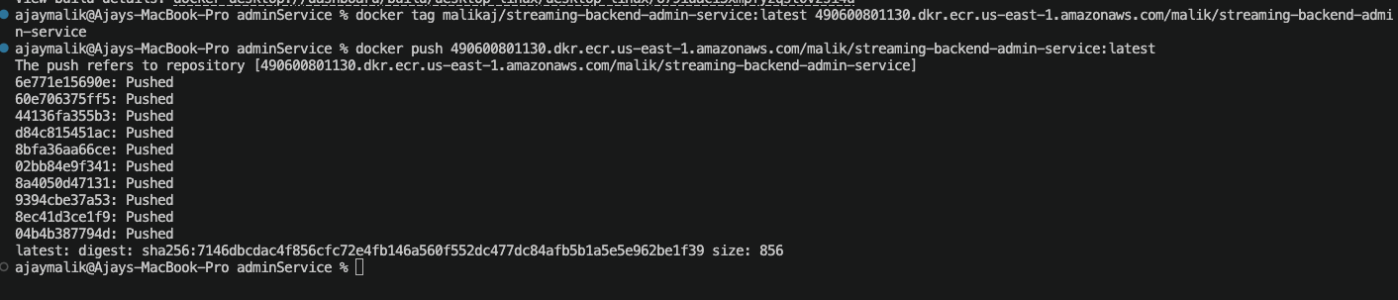
Corresponding admin-service Repository in ECR:

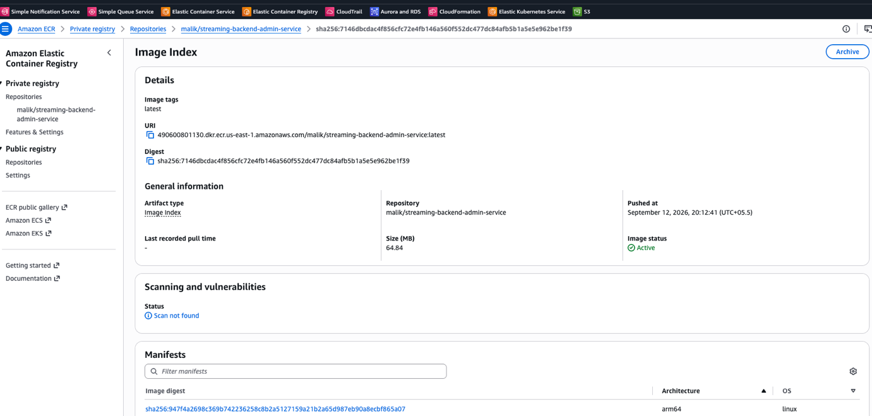

authService image :

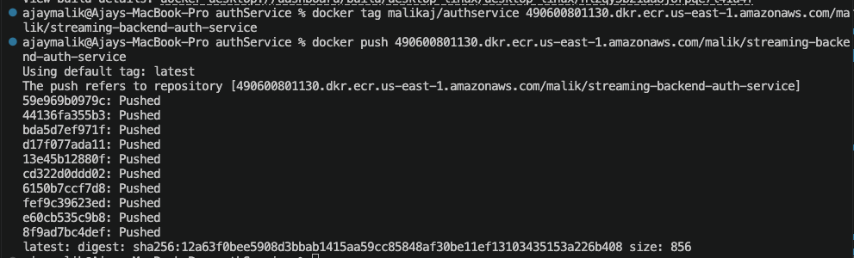

Corresponding auth-service Repository in ECR:
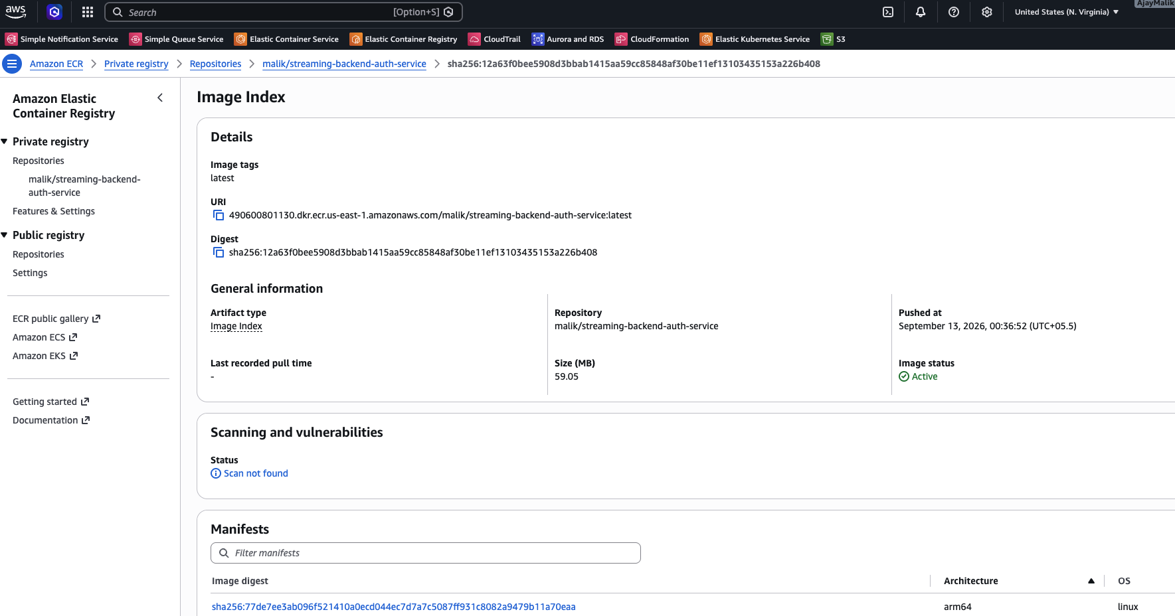

chatService image :
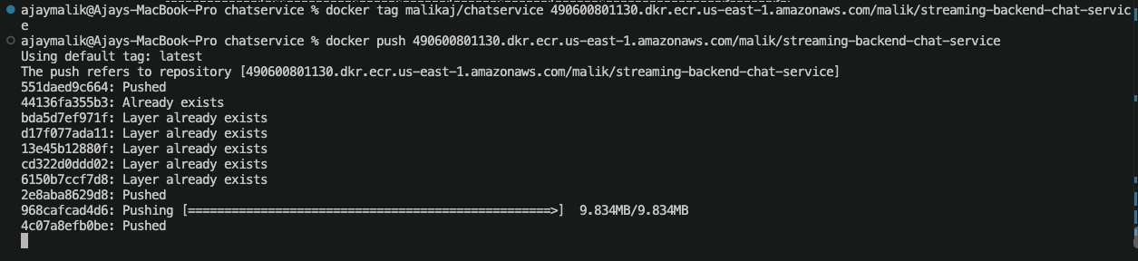
Corresponding chat-service Repository in ECR:
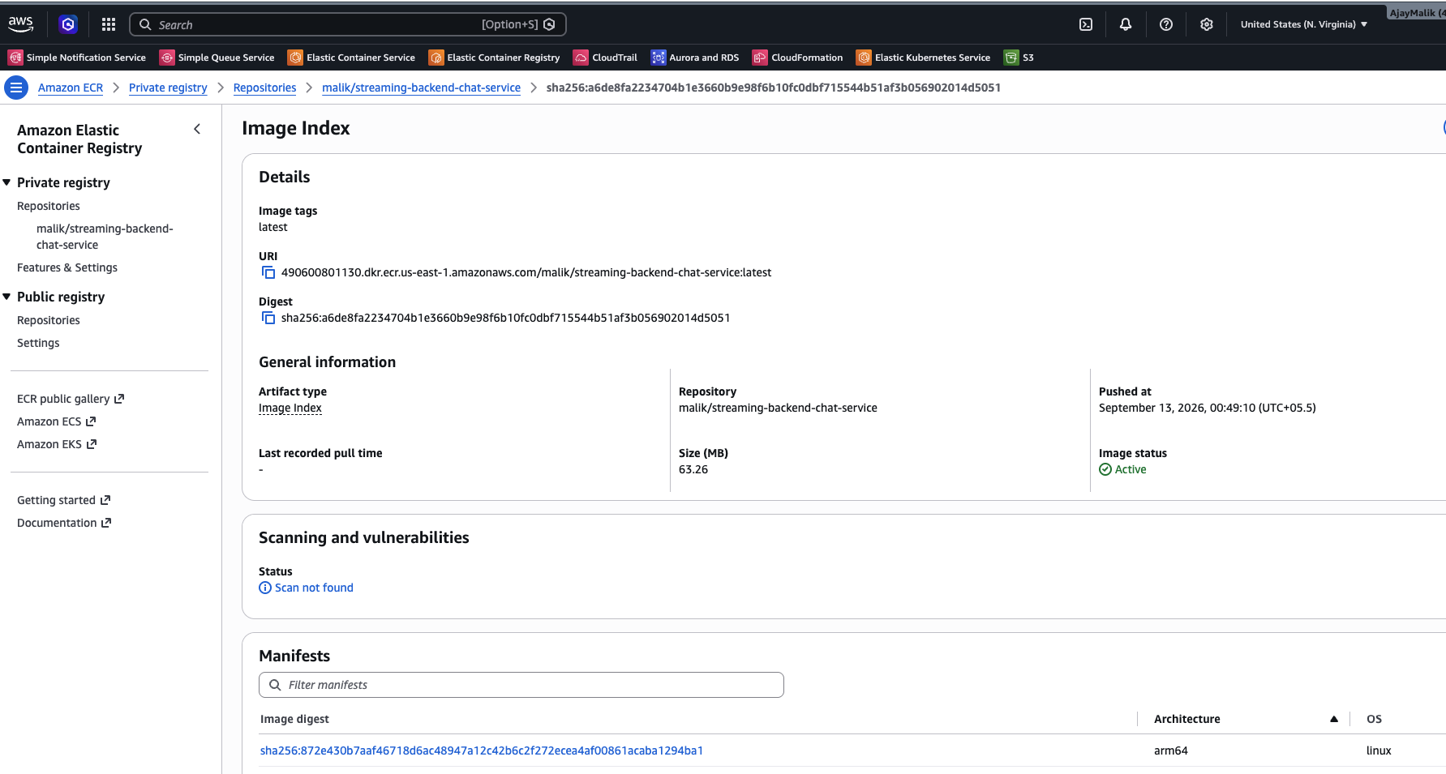

streamingService image :
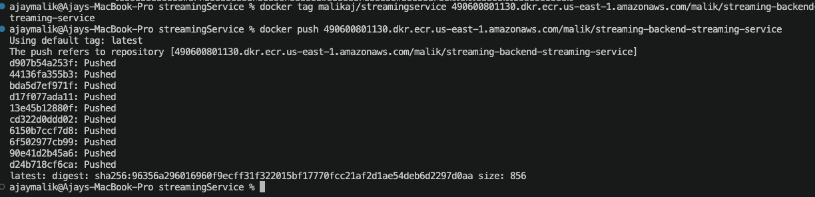

Corresponding streaming-service Repository in ECR:
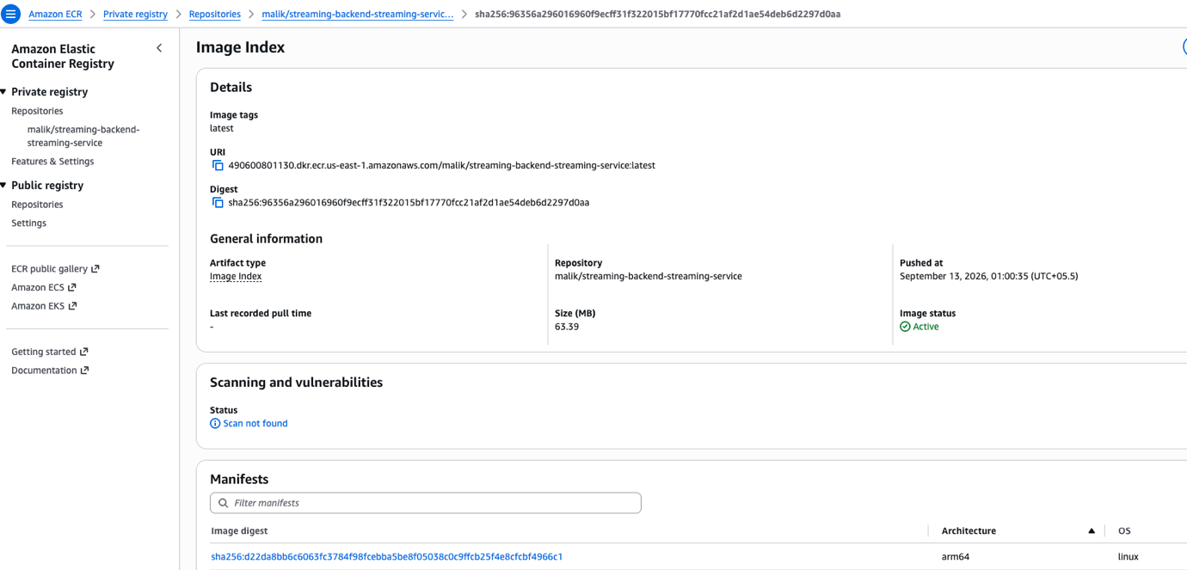

On EC2 Install git , docker , Jenkins etc.

Reset Workspace Ownership: Restores write access.

Run this command to recursively give ownership of all workspace files back to Jenkins:
sudo chown -R jenkins:jenkins /var/lib/jenkins/workspace/
Reset Permissions: Ensures clean state.
Run this command to ensure Jenkins has full read and write permissions to those folders:
sudo chmod -R 755 /var/lib/jenkins/workspace/

Create a Jenkinsfile in git repo.

Add credentials and upload .env as secrets in jenkins.

To securely supply the environment variables to this pipeline, you need to upload your .env file into Jenkins' Credentials Manager:
1.Navigate to Credentials:
From the main Jenkins dashboard, click Manage Jenkins in the left menu, then select Credentials.
2.Add New Credential:
Click on System (under the Stores scoped to Jenkins section), click Global credentials (unrestricted), and click the Add Credentials button.
3.Upload the .env file:Keeps variables encrypted.
Change the "Kind" dropdown menu to Secret file. Click the Choose File button and upload your .env file from your local computer.
4.Set the ID:
Type my-env-file exactly as written into the ID field. This ID must match the credentialsId string in the Jenkinsfile. Click Create.

Pipeline jobs that build each Docker image and push it to ECR.
Jenkins Build finished with success:

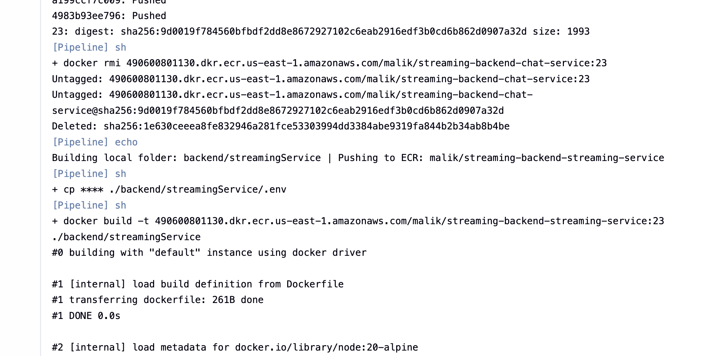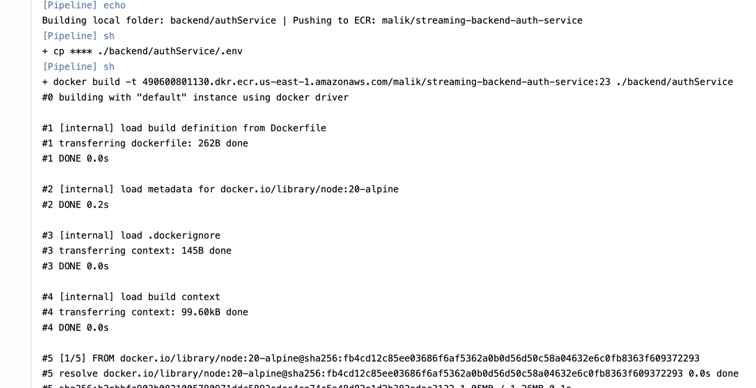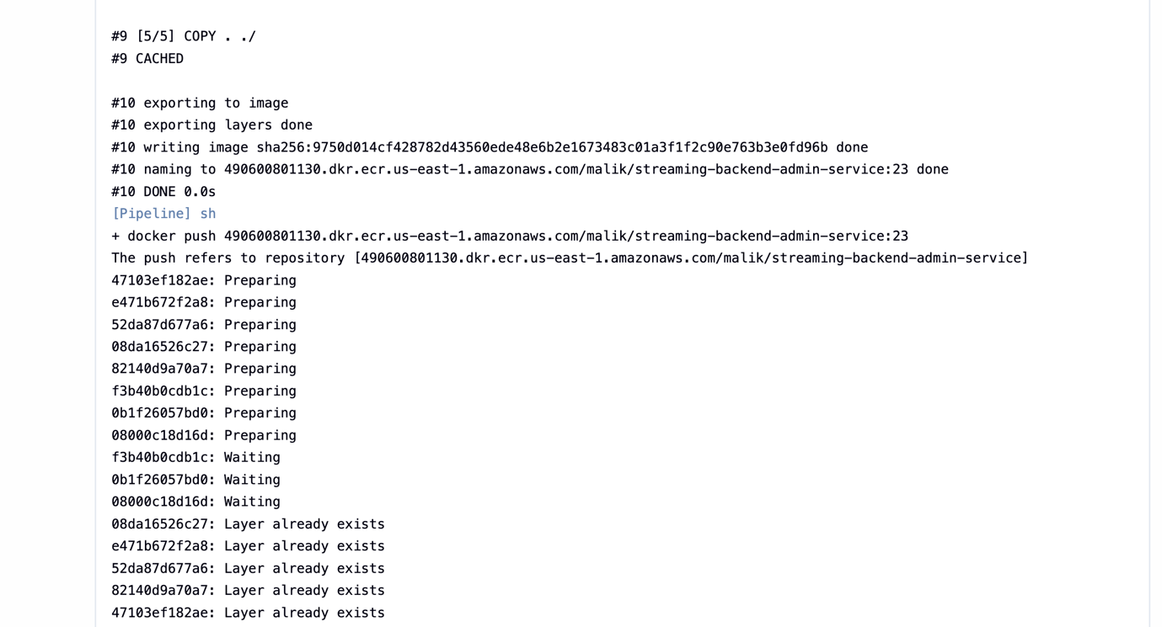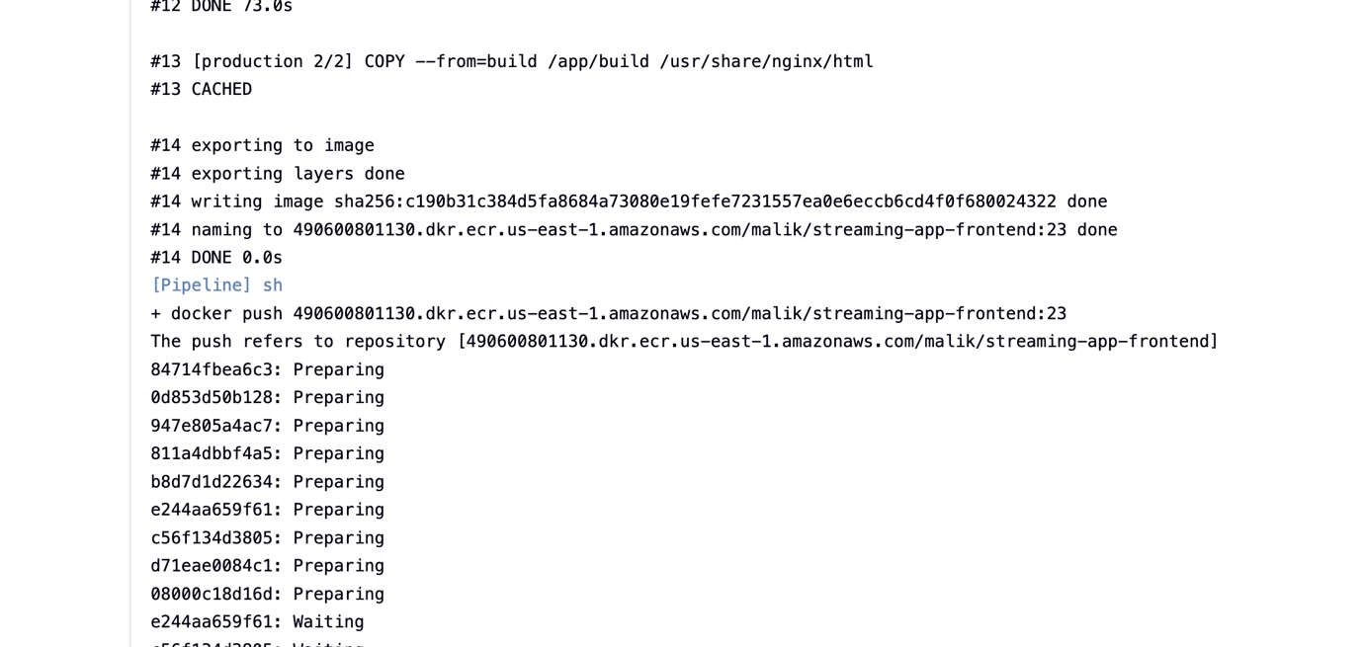
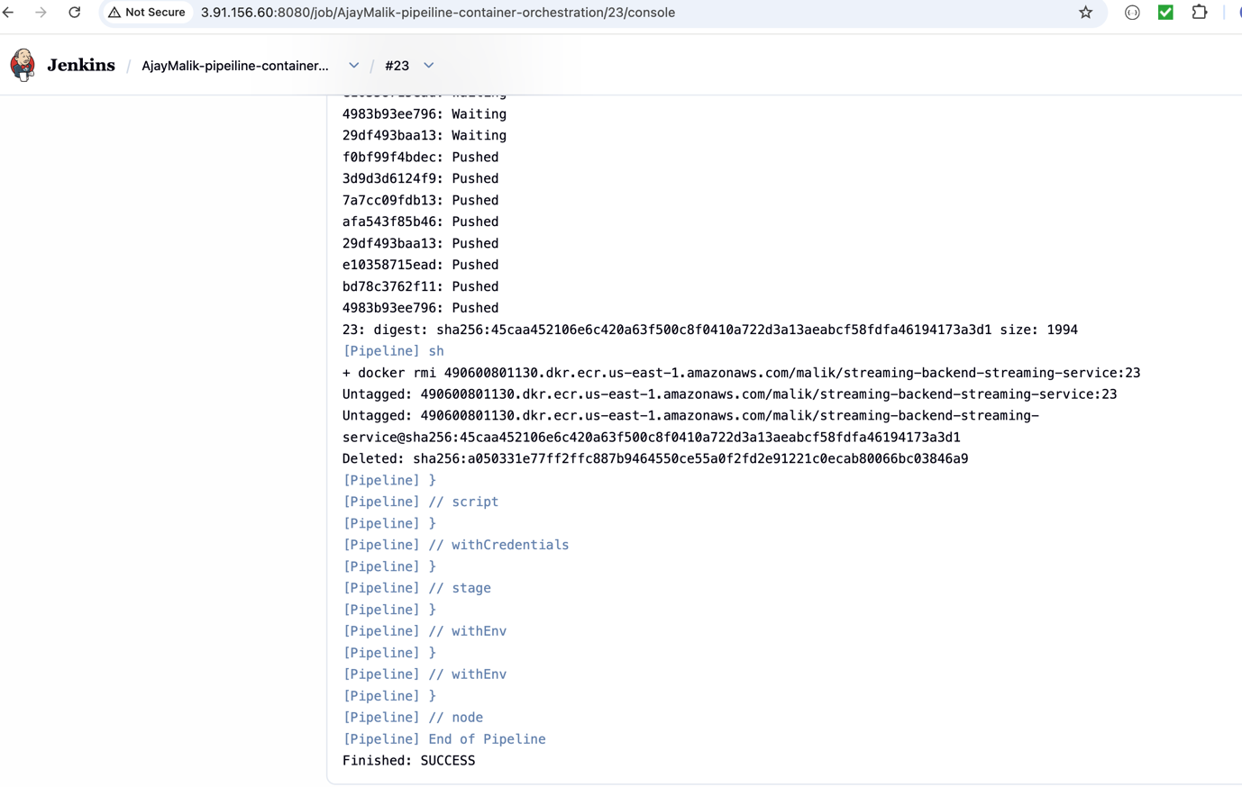

Apply webhooks to trigger automatically on new commits:
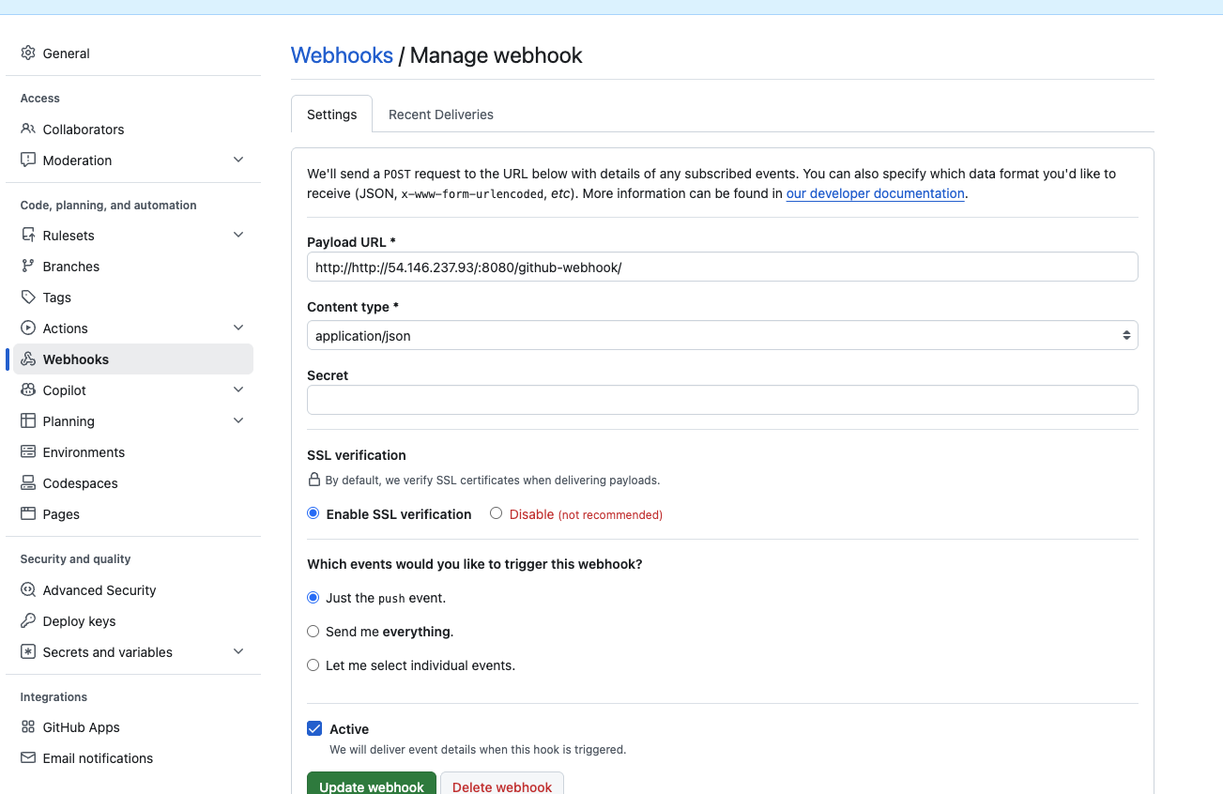

Use eksctl to builds and manages the underlying AWS infrastructure for Kubernetes cluster, and use kubectl to manage the applications and workloads running inside that cluster.

Using eksctl is the fastest and official way to provision an Amazon EKS cluster, as it automatically provisions the underlying CloudFormation templates, VPC networking, and IAM roles required for the cluster

Install Prerequisites: Required CLI tools.
Install the following installed on your machine:

AWS CLI: To authenticate and interact with your AWS account.
kubectl: To interact with the Kubernetes API once the cluster is running.
eksctl: The cluster creation tool itself.

Install k3s using command on EC2: curl -sfL https://get.k3s.io | sh -

Configure standard kubectl access:
By default, K3s places the cluster configuration file in a protected directory. To use standard kubectl commands without typing k3s or using sudo every time, copy the configuration to user profile:

mkdir -p ~/.kube
sudo k3s kubectl config view --raw | tee ~/.kube/config
chmod 600 ~/.kube/config

Create a Deployment manifest to pull the image from ECR. (Make sure EC2 instances or EKS Node roles have IAM permission to pull from ECR, but usually, managed node groups have this).

