**Car Backup Camera Simulation**

*Files Legend:*

1. backup_sim.py - main python file for simulation and trajectory overlay
2. video1_final.mp4 - 10 seconds video taken from my mobile phone camera
3. video1_overlay_final.mp4 - output video with rear-wheel trajectory overlay
4. ADAS_assignment_backup_camera_sim.ipynb - all preparation code

*Assumptions:*

For this task, I’ve assumed the dimensions of a BMX X1 with the following dimensions:

Wheelbase = 2.69 m

Track width = 1.58 m

Steering angle range= +/- 35 degrees

*Workflow:*

The ‘backup_sim.py’ file contains the concise main code which takes in the input video file named ‘video1_final.mp4’, calculates the rear-wheels trajectory, overlays the plot on the video frames and saves the final video. The steering angle throughout the video was measured using a compass and is stored as an array at the beginning.

The ‘ADAS_assignment_backup_camera_sim.ipynb’ file contains all the preparation code/rough work, including solving the ODE based on Ackermann’s to calculate the trajectory using Sympy. Below are the equations used to compute the x and y trajectory of the rear wheel:

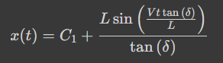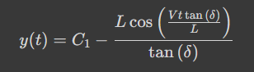

A sample plot of the rear wheel trajectory without image overlay would look like this:

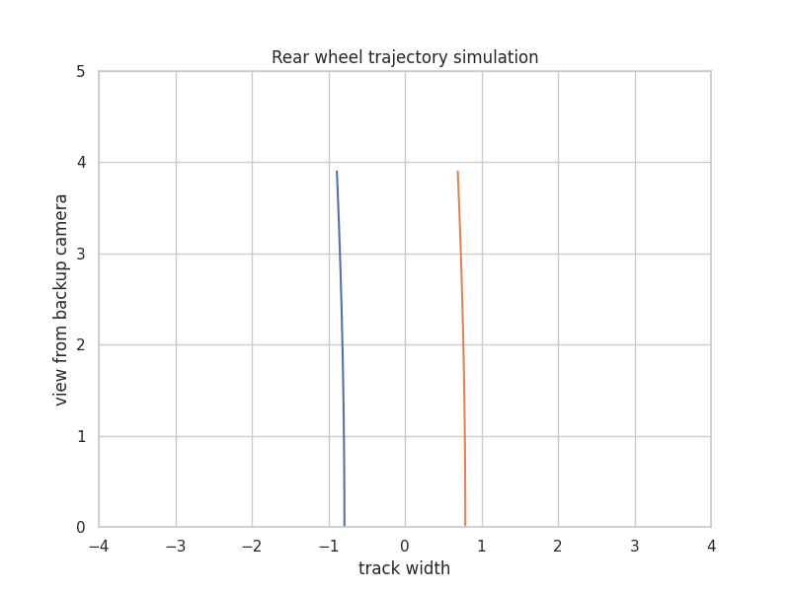

The ‘video1_overlay_final.mp4’ contains the video with overlaid rear wheel trajectory simulation.